**❓Question ❓**

⚠️ Carefully follow the instructions below ⚠️

----------------------------------------------------------------------

1️⃣Your task is to replicate the provided design.

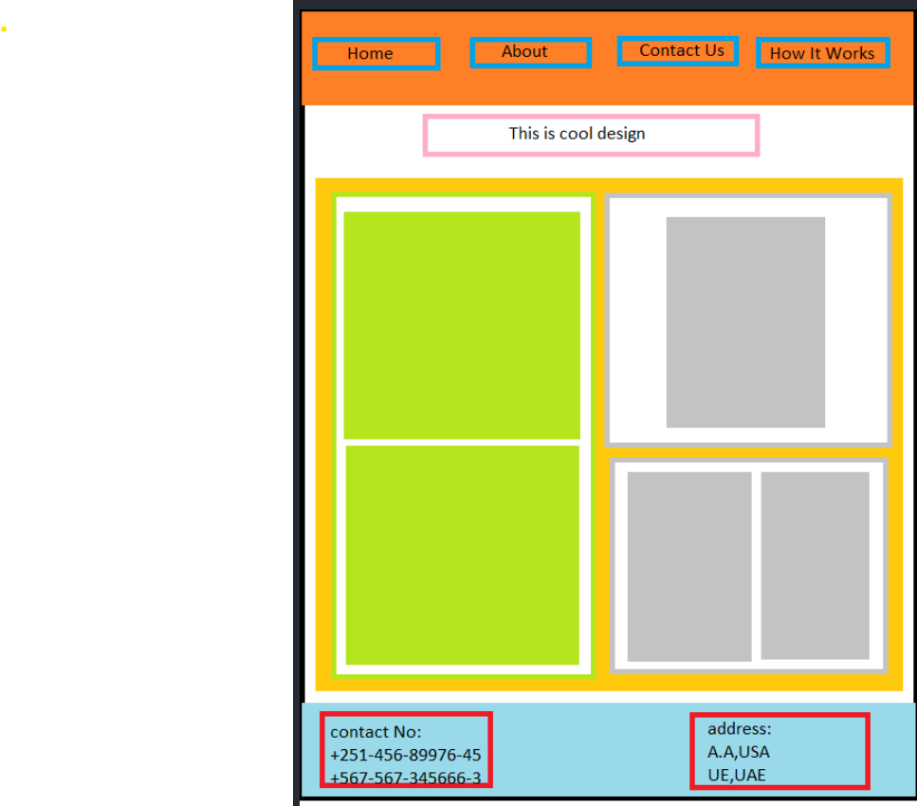

2️⃣ Employ a mobile-first approach, incorporating one breakpoint for larger screens.

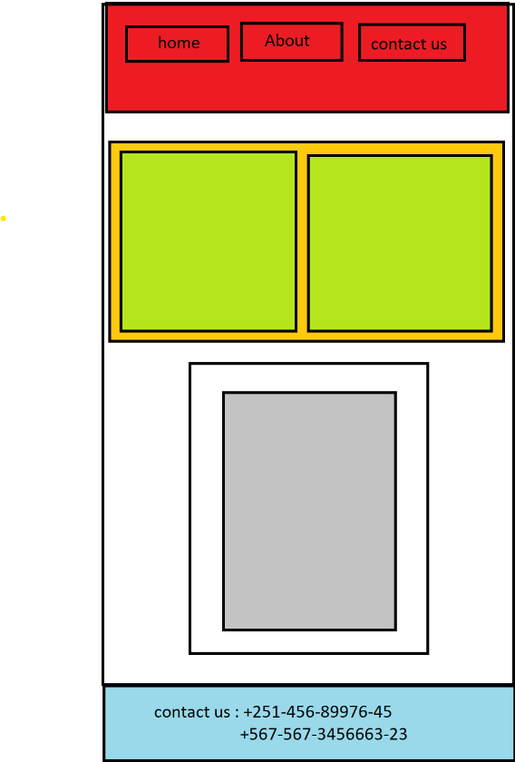

3️⃣ Ensure accurate usage of the colors specified in the design.

😄 Tip: Utilize a color picker extension in Chrome or a tool of your preference.

4️⃣ All text within the header section should function as hyperlinks.

😄 Tip: Utilize HTML tags to create the links.

5️⃣ Customize box dimensions as per your discretion.

😄 Tip: Use Chrome's developer tool for visual assessment

🕥 1:30 hr 🕥

💻 Happy coding! 💻