**❓ solution ❓**

Step one : login/sign up to Netlify.com

Here some students may face some problem signing up due to verification so you can tell all to do in a group

Step two : go to the sites option on the left-hand side



Step three: click on the button named “Add new site” drop-down and select Deploy manually



step four : drag and drop on the site

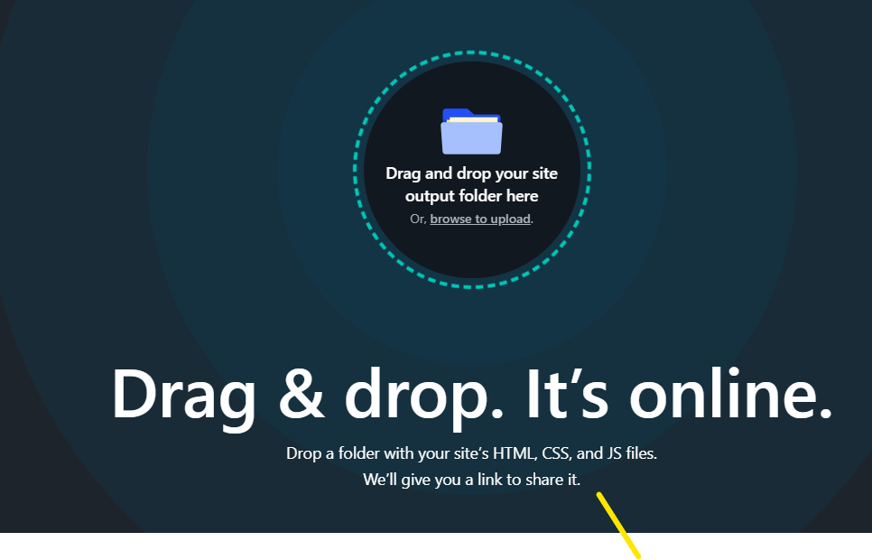

step five : after deployment go to the deployed site setting and click on site configuration



Step six: navigate to the change site name button



Step seven : edit the name and save

