**❓ Questions ❓**

**🏗️Instructions 🏗️**

⚠️ Read the questions carefully ⚠️

⚠️ Make sure to discuss all questions ⚠️

1️⃣ Create a class component named DisplayCard. This component is designed to accept props including full name, state, country, and district, which will be utilized for display purposes.

2️⃣ Create another class component named Display. This component will serve to pass props for full name, state, country, and district of three sets of information, as per your selection.

3️⃣ When displaying the components, alternate between using the background colors silver and tomato for each displayed component.

😊 Hint: Define the class name as a prop, and prior to that, establish the corresponding styling within your CSS file."

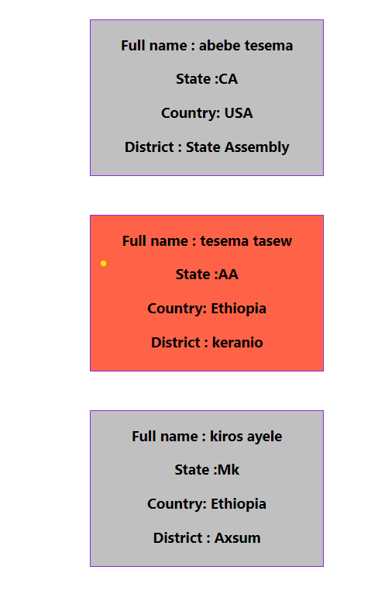

💻 Happy coding 💻

⌚1:30 hr⌚