**INSTRUCTION**

**INSTALLATION GUIDE**

1. Using XAMPP

*Step 1 : Download* **XAMPP** *from* <https://www.apachefriends.org/index.html>. *Click XAMPP for Windows* (if you use Windows – similar to other OS)

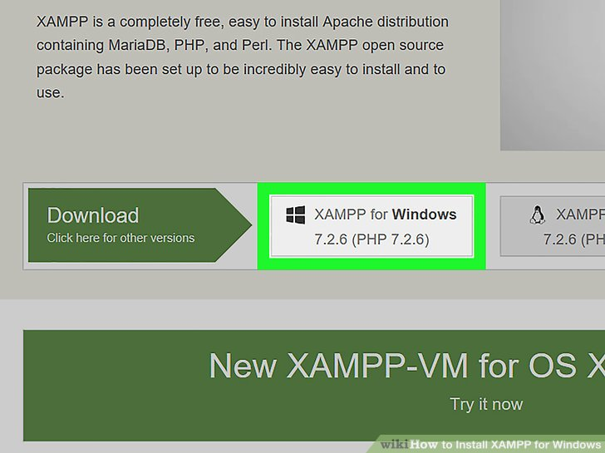

*Step 2 : Install XAMPP*. The file name should be started with **xampp-xxx-VC15.installer.exe** (for this example **xampp-win32-7.2.6-0-VC15.installer.exe**)

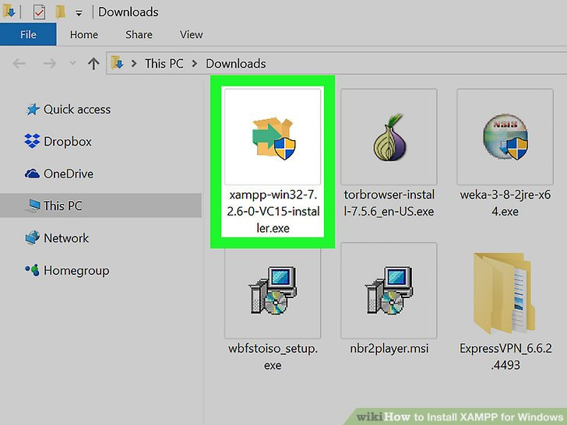

*Step 3:* *Click Next then Select aspects of XAMPP to install*. By default, all attributes are included in XAMPP installation.

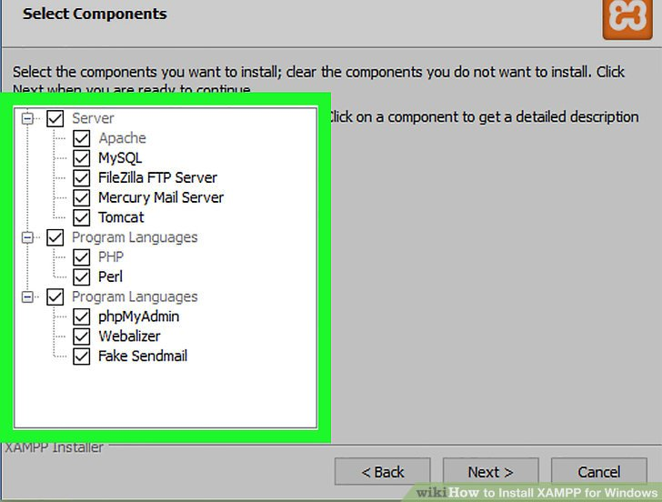

*Step 4: Click Next then Select folder to install* **XAMPP.**

* Avoid installing XAMPP in OS (C:) hard drive’s folder if you have UAC activated on your computer.
* You can select a folder (e.g., **Desktop**) and then click **Make New Folder** to create a new folder and select it as the installation destination.

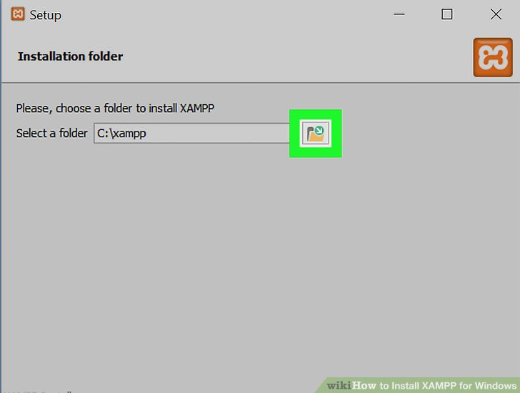

Step 5: Keep clicking Next, then click Finish. Doing so will close the window and open XAMPP Control Panel, which is where you’ll access your servers.

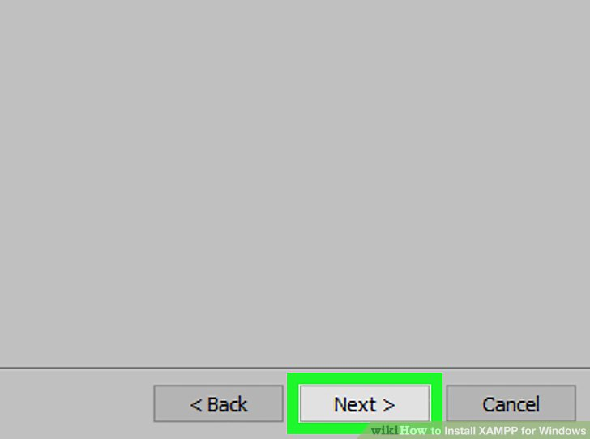

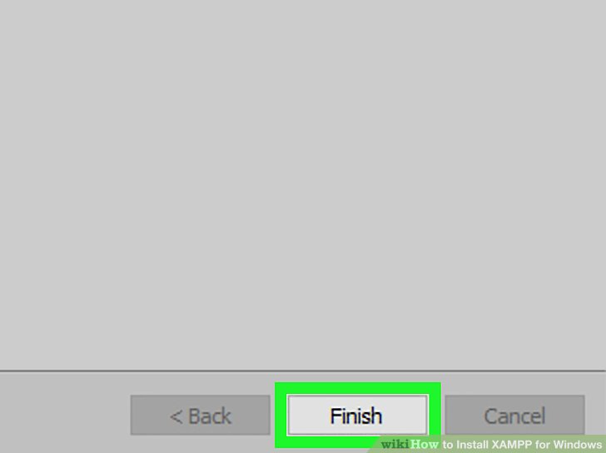

Step 6: Select a language then click Save.

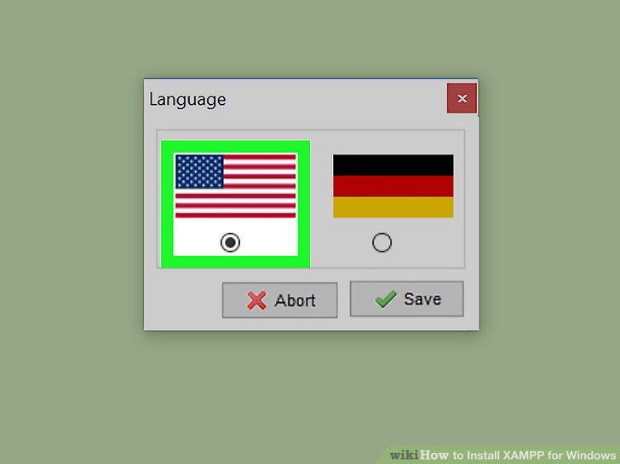

Step 7: **Start XAMPP from its installation point.** Right-clicking the orange-and-white **xampp-control** icon, clicking **Run as administrator**, and clicking **Yes** when prompted.

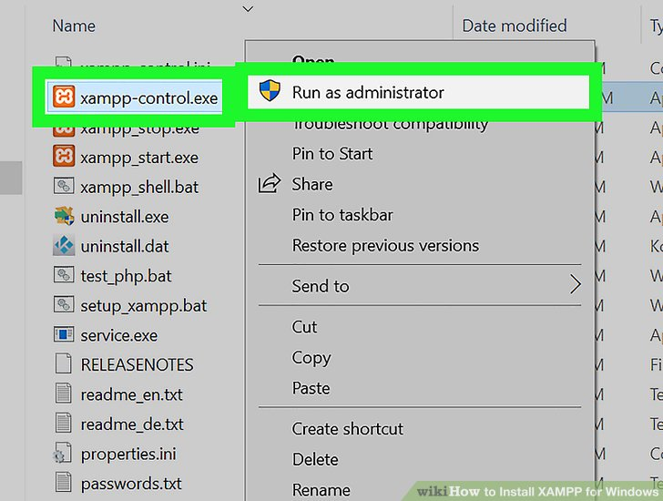

Step 8: Config to resolve issues with Apache refusing to run.

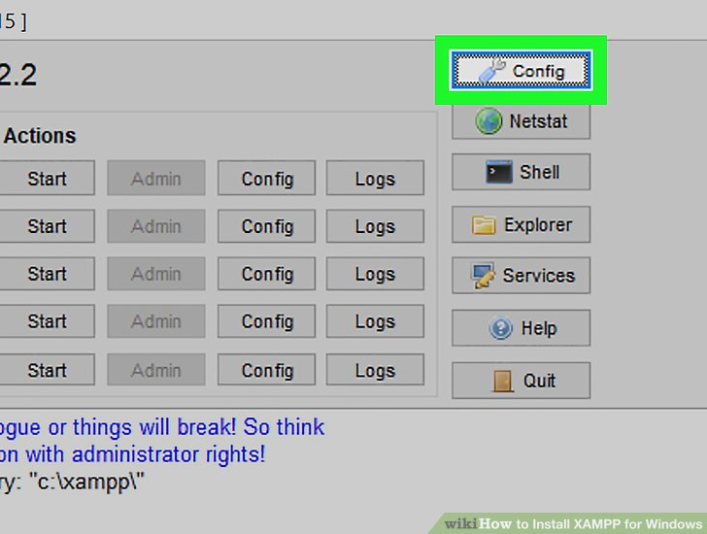

* Click **Config** to the right of the "Apache" heading.
* Click **Apache (httpd.conf)** in the menu.
* Scroll down to the "Listen 80" section (you can press Ctrl+F and type in listen 80 to find it faster).
* Replace 80 with any open port (e.g., 81 or 9080).
* Press Ctrl+S to save the changes, then exit the text editor.
* Restart XAMPP by clicking **Quit** and then re-opening it in administrator mode from its folder.

Step 9: Copy php web folder into htdocs folder inside xampp folder to run.



1. Using Laragon

Step 1: Download Laragon from <https://laragon.org/download/>

Recommended to download Full Edition.

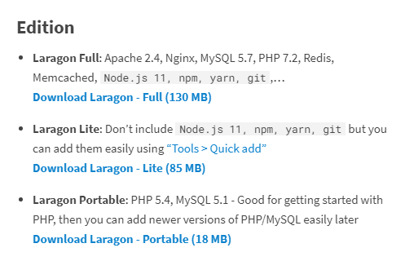

Step 2: Install by run file **laragon-full.exe** (or **laragon-wamp.exe** for Lite Edition and **laragon.7z** for Portable Edition)

Step 3: Setup – Welcome page

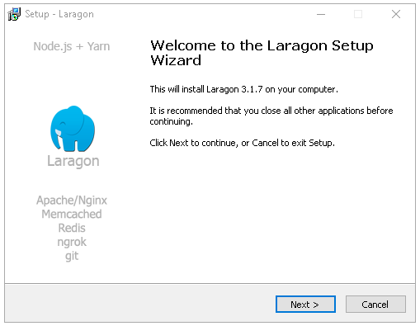

Step 4: Setup – Select location

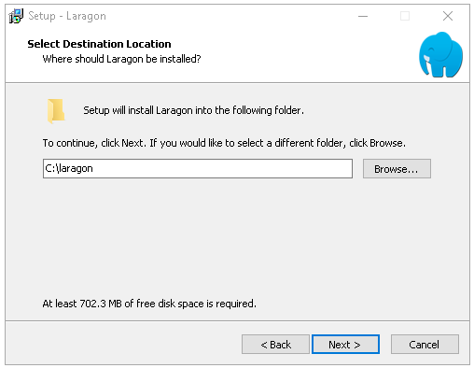

Step 5: Setup – Options

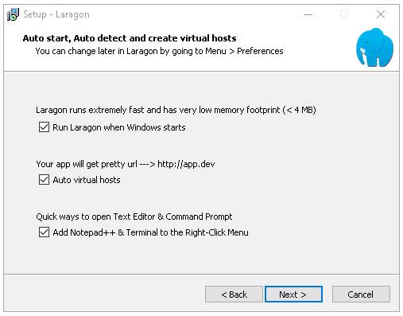

Step 6: After installed Laragon, you need to add phpMyAdmin plugin. Click on Menu > Tools > Quick-add > phpmyadmin

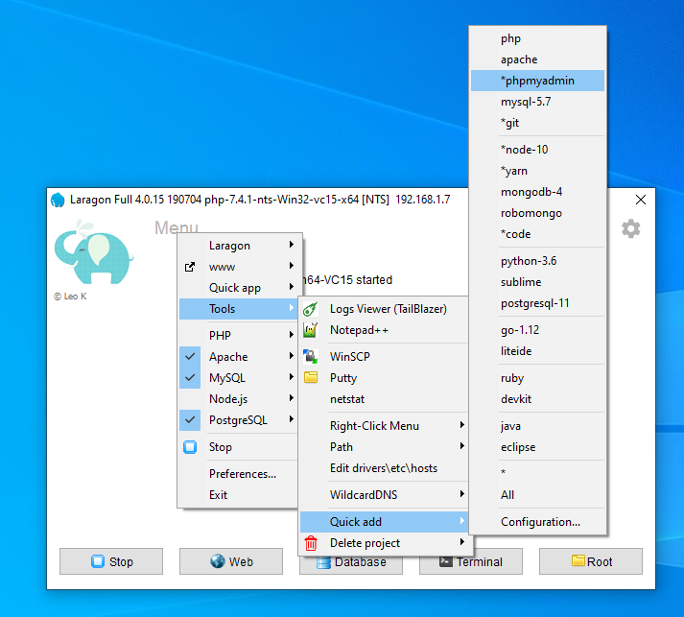

Step 7: Click on Root with Folder icon at right-bottom corner then copy php web file into www folder.

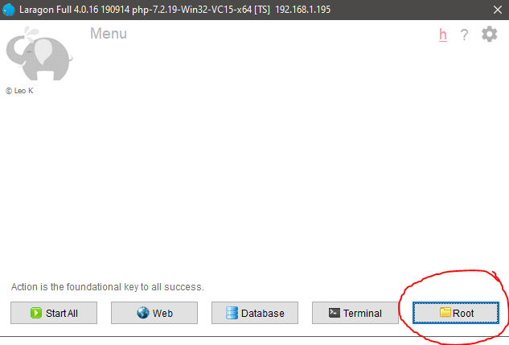

Step 8: Click Start All to run server.

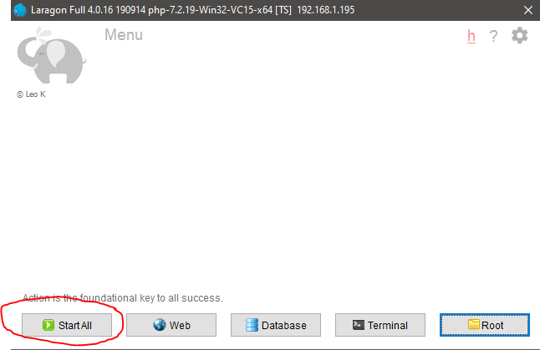

**Configuration before run the server**

Step 1: Log into phpMyAdmin and import database from the SQL file in **database** folder (**rw.sql**). Click on Import tab on the top then click Choose File to select the sql file. After that click on Go to start importing the database.

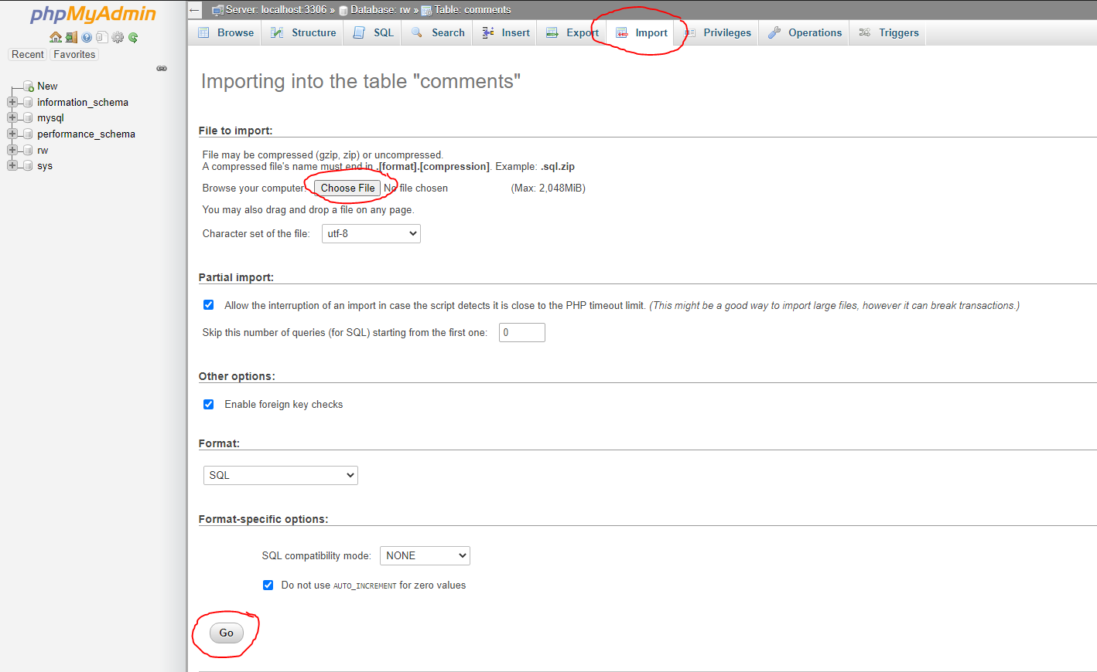

Step 2: Change the configuration to fit the server in some files that contained connection to database.

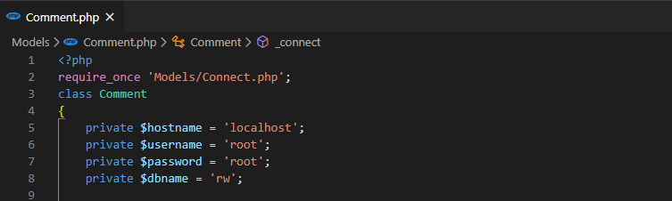

**Models/Comment.php**

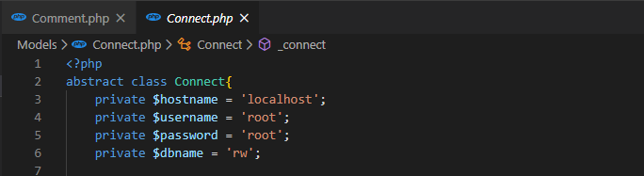

**Models/Connect.php**

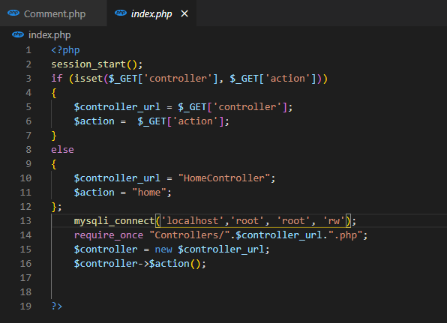

**index.php**

That is the end of Installation Guide for our PHP web.

You can access to the Admin Dashboard from the web by logging in to existed user accounts or adding new accounts in the database.

|  |  |  |
| --- | --- | --- |
| Email | Password | Role |
| [admin@gmail.com](mailto:admin@gmail.com) | 12345678 | Admin |
| [staff@gmail.com](mailto:staff@gmail.com) | 12345678 | Staff |