 

**FPT UNIVERSITY**

**CAPSTONE PROJECT REPORT**

**Transport Connection System**

**Report No 3**

**Software Requirement Specification**

**Group 2 – SE0702**

**Da Nang, May 04, 2015**

**System Requirements Specifications (SRS)**

# 3.1. User Requirement Specification

## 3.1.1. Account Requirement

* System has 5 type accounts: **Admin, Normal Admin, Guest, Users** and **Drivers.**
* **Admin** is available account in the system, it cannot delete.
* **Normal Admin** are created and management by **Admin**.
* **Guests** are users who don’t need login to system. They can view and find all posting.
* **User** is a type of account created by people who want to post or search information about the car that rent to shipping products.
* **Driver** is also users, that is a person who has car and want to post or search information to receive product that want to shipping**.**

## 3.1.2. Admin

* **Admin** is available account that used to manage system, it can't delete and always available in database.
* **They** can create account of **Normal Admin** and view all users in system.
* **Admin** can search or block Normal Admin.
* **Admin** can view users be blocked by normal admin, the posting be deleted by normal admin and cancel it.
* **Admin** can reset password for normal admin when they forgot password
* **Admin** can view statistic number of posting, number of register new user and number of contract by date.
* **Admin** also view range of drivers.

## 3.1.3. Normal Admin

* **Normal Admin** is someone who helps admin manager system and is created by Admin. Normal Admin can manage all users of system.
* Normal Admin can authorize information of drivers when they register.
* Normal Admin can view all information of users. Block or disable users account.
* They also view all posting of users or delete it when they receive report of someone.
* Normal Admin can view personal page of users
* Normal Admin can view update their profile.

## 3.1.4. Guest

* Guest is someone who don’t need login to system.
* They can view all posting in system
* They can register new users of system
* They can search to view personal page of users
* They can find some posting to view information.
* They can comment below of posting

## 3.1.5. Users

* Users can post when they want to find someone who have cars to shipping products.
* They can search and view personal page of other people.
* They can register to receive posting information of someone.
* They can report someone or some posting.
* Users also get back password when they forget it.
* User can view all transaction and accept any one who register receive to shipping their product. They also cancel and edit it.
* User can video call for people who they have accepted to discuss about the transaction
* After transaction successfully, user can rate for drivers.

## 3.1.6. Drivers

* Drivers also users, they have all function like normal users.
* To register drivers, users send image about the cars, driving license… and must be approved by Normal Admin
* They can posting to find customer who need to shipping products.
* After finish a transaction, customer will rate the driver service and mark it.
* Driver can view list customer of them.

# 3.2. System Requirement Specification (Specific Requirements)

## 3.2.1. External Interface Requirement

### 3.2.1.1. User Interface

* Flat Design.
* The interface of website is simple and friendly, user doesn’t need any training to use the website’s function.
* The website use attractive colors and not showy, easy to read text.

### 3.2.1.2. Hardware Interface

* Transport System can run on dives which have Internet connection and browser with JavaScript and HTML5 support ability

### 3.2.1.3. Communications Protocol

* The system use HTTPs protocol to create communication between clients and server.

## 3.2.2. Functional Requirements

### 3.2.2.1. Functional Requirement

#### 3.2.2.1.1. Use Case Diagram

Admin

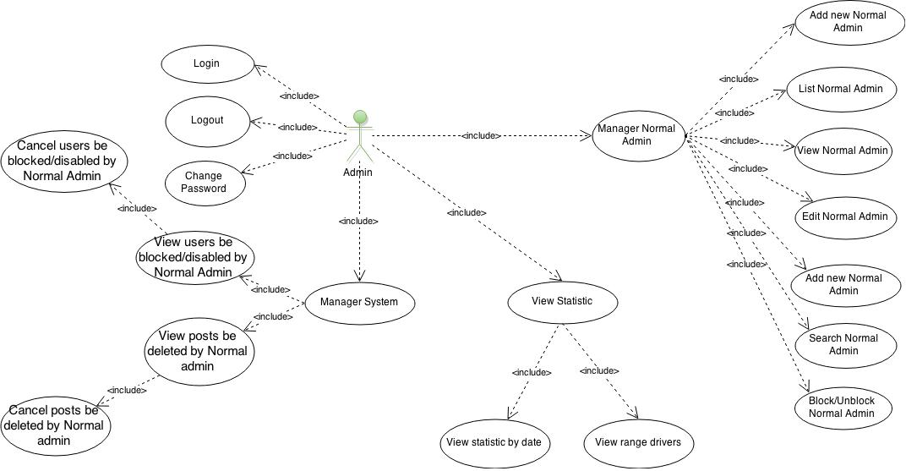

Figure 1 - Admin

Normal Admin

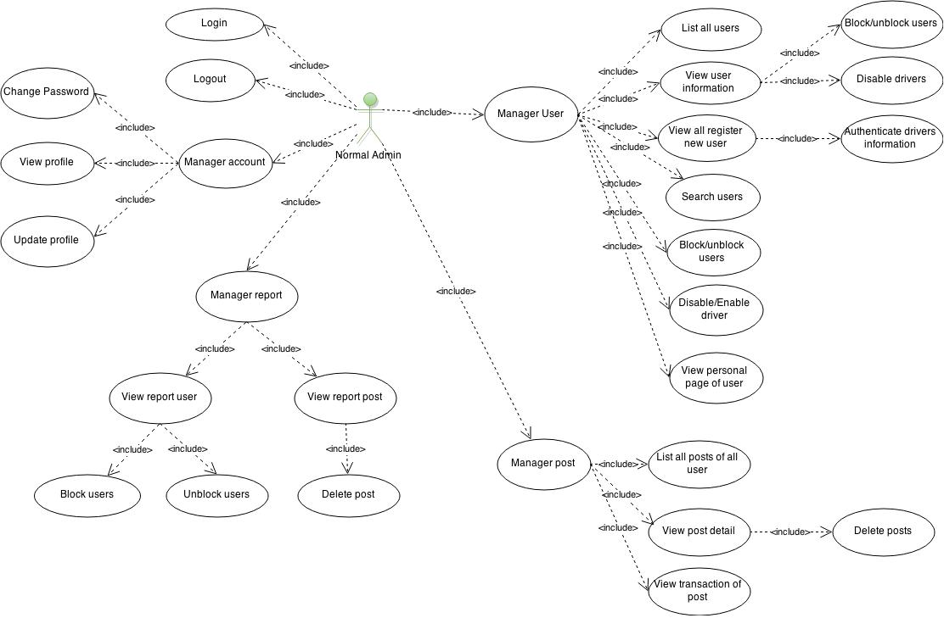

Guest

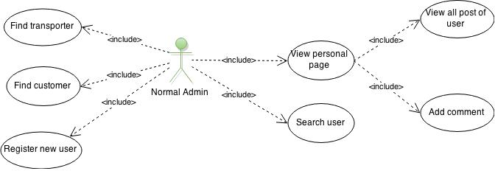

User

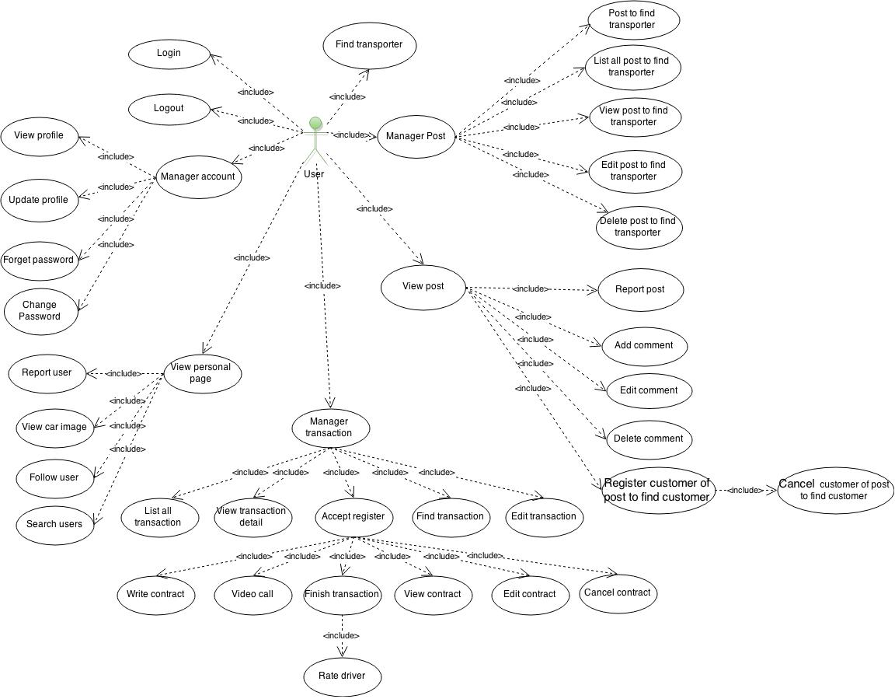

Drivers

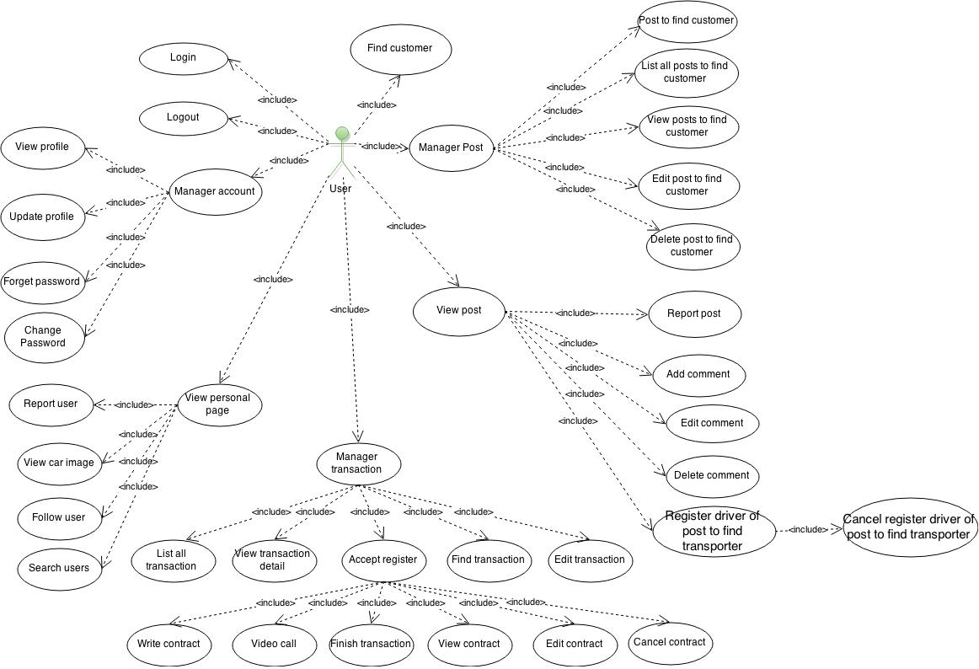

##### Actor description

|  |  |  |
| --- | --- | --- |
| # | Actor Name | Definition & Interests |
| 1 | Admin | The user manage all normal admin |
| 2 | Normal Admin | The user manager system, users. Review, block, unblock, delete users, posting of system |
|  | Guest | The user don’t need to login into system. |
| 3 | Users | The user use all function of system |
| 4 | Drivers | The user has the car who want to receive shipping products |

##### Use case description

|  |  |  |  |
| --- | --- | --- | --- |
| # | Code | Name | Brief Description |
| Login/Logout | | | |
| 1 | UC1.1 | Login | Allow admin, normal admin, user login to system |
| 2 | UC1.2 | Logout | Allow admin, normal admin, user logout to system |
| 3 | UC1.3 | Change password | Allow everyone change password when they forgot it |
| Admin | | | |
| 4 | UC2.1 | List Normal Admin | Allow admin view and manage all normal admin |
| 5 | UC2.2 | View normal admin | Allow admin view normal admin detail |
| 6 | UC2.3 | Add new Normal Admin | Allow admin add new normal admin |
| 5 | UC2.4 | Search Normal Admin |  |
| 6 | UC2.5 | Edit Normal Admin |  |
| 7 | UC2.6 | Block/Unblock Normal Admin |  |
| 8 | UC2.7 | View users be blocked/disabled by Normal Admin |  |
| 9 | UC2.8 | Cancel users be blocked/disabled by Normal Admin |  |
| 10 | UC2.9 | View posts be deleted by Normal Admin |  |
| 11 | UC2.10 | Cancel posts be deleted by Normal Admin |  |
| 12 | UC2.11 | View statistic by date |  |
| 13 | UC2.12 | View range drivers |  |
| Normal Admin | | | |
| 17 | UC3.1 | List all users |  |
| 18 | UC3.2 | View user information |  |
| 15 | UC3.3 | Search users |  |
| 16 | UC3.4 | Block/unblock users |  |
| 17 | UC3.5 | Disable/enable drivers |  |
| 18 | UC3.6 | View report user |  |
| 19 | UC3.7 | View report posting |  |
| 20 | UC3.8 | View all register new users | Hỏi thầy có nên xem tất cả user đkí hay ko |
| 21 | UC3.9 | Authenticate driver information |  |
| 22 | UC3.10 | View all posts of all user |  |
| 23 | UC3.11 | Delete post | Cho cả user, normal admin, driver |
| 24 | UC3.12 | View profile |  |
| 25 | UC3.13 | Update profile | Cho cả user, driver |
| 26 | UC3.14 | View personal page of users | Cho cả user, normal admin, driver |
|  | UC3.15 | View post detail of users |  |
|  | UC3.16 | View transaction of post |  |
| Guest | | | |
| 27 | UC4.1 | Find transporter |  |
| 28 | UC4.2 | Search user |  |
| 29 | UC4.3 | Find customer |  |
| 30 | UC4.4 | Register new user |  |
| 31 | UC4.5 | View personal page |  |
| 32 | UC4.6 | View all post of all users |  |
| 33 | UC4.7 | Add comment |  |
| Users | | | |
| 27 | UC5.1 | Post to find transporter |  |
| 28 | UC5.2 | Edit post to find transporter |  |
|  |  | Delete post to find transporter |  |
| 29 | UC5.3 | Edit comment |  |
| 30 | UC5.4 | Delete comment |  |
| 31 | UC5.5 | Forget password |  |
| 32 | UC5.6 | Report user |  |
| 33 | UC5.7 | Report posting |  |
| 34 | UC5.8 | Follow user |  |
| 35 | UC5.9 | List all transaction |  |
| 36 | UC5.10 | Accept register |  |
| 37 | UC5.11 | View transaction detail |  |
| 38 | UC5.12 | Find transaction |  |
| 39 | UC5.13 | Edit transaction |  |
| 40 | UC5.14 | Write contract |  |
| 41 | UC5.15 | Video call |  |
| 42 | UC5.16 | View contract |  |
| 43 | UC5.17 | Edit contract |  |
| 44 | UC5.18 | Cancel contract |  |
| 45 | UC5.19 | Rate drivers |  |
| 46 | UC5.20 | Register customer of post to find customer |  |
| 47 | UC5.21 | Cancel register customer of post to find customer |  |
| 48 | UC5.22 | View car image |  |
| 49 | UC5.23 | Register receive post information by Email |  |
| 50 | UC5.24 | Register receive post information by SMS |  |
|  |  | Statistic list drivers. |  |
| Drivers | | | |
| 51 | UC6.1 |  |  |
| 52 | UC6.2 | Import image |  |
| 53 | UC6.3 | Post to find customer |  |
| 54 | UC6.4 | Edit post to find customer |  |
| 55 | UC6.5 | Delete post to find customer |  |
| 56 | UC6.6 | Register driver of post to find driver |  |
| 57 | UC6.7 | Cancel register driver of post to find driver. |  |
| 58 | UC6.8 | Statistic list customer |  |

#### 3.2.2.1.2 .Use Case Specification

##### 3.2.2.1.2.1 Login/logout

##### 3.2.2.1.2.2 Admin

###### 3.2.2.1.2.2.1 List Normal Admin

|  |  |  |  |
| --- | --- | --- | --- |
| USE CASE-UC2.1 SPECIFICATION | | | |
| Use-case No | UC 2.1 | Use-case Version | 1.0 |
| Use-case Name | List Normal Admin | | |
| Author | DucPM | | |
| Date | 05/05/2015 | Priority | Normal |
| Actor:  Admin  Summary:  Allow actor can see all normal admin of system.  Goal:  Actor can view all normal admin with their information  Trigger:  Actor click [Manage Normal Admin] at taskbar.  Pre-conditions:  Actor have already login to the system.  Post-conditions:  Display all normal admin in system with their information.  Main Success Scenario:   1. Actor click on [Manage Normal Admin] at taskbar: 2. All normal admin will be displayed.   Alter Success Scenario:  N/A  Exception:  N/A  Relationships:  N/A  Business Rule:  N/A | | | |

###### 3.2.2.1.2.2.2 View Normal Admin

|  |  |  |  |
| --- | --- | --- | --- |
| USE CASE-UC2.2 SPECIFICATION | | | |
| Use-case No | UC 2.2 | Use-case Version | 1.0 |
| Use-case Name | View Normal Admin | | |
| Author | DucPM | | |
| Date | 05/05/2015 | Priority | Normal |
| Actor:  Admin  Summary:  Allow actor can view a normal admin of system.  Goal:  Actor can view all information of a normal admin.  Trigger:  Actor click [Manage Normal Admin] at taskbar.  Pre-conditions:  Actor has moved to List Normal Admin page.  Post-conditions:  Display all information of a normal admin who has been chosen.  Actor can edit, block or unblock normal admin information.  Main Success Scenario:   1. Actor click [Manage Normal Admin] on taskbar. 2. Actor click on username of any normal admin on list normal admin. 3. The system forward to View Normal Admin page.   Alter Success Scenario:   * Actor can click on avatar of Normal Admin.   Exception:  N/A  Relationships:  N/A  Business Rule:  N/A | | | |

###### 3.2.2.1.2.2.3 Add new Normal Admin

|  |  |  |  |
| --- | --- | --- | --- |
| USE CASE-UC2.3 SPECIFICATION | | | |
| Use-case No | UC 2.3 | Use-case Version | 1.0 |
| Use-case Name | Add new Normal Admin | | |
| Author | DucPM | | |
| Date | 05/05/2015 | Priority | Normal |
| Actor:  Admin  Summary:  Allow actor add new normal admin of system.  Goal:  Actor can add new normal admin successfully.  Trigger:  Actor click [Add New Normal Admin] on taskbar.  Pre-conditions:  Actor have already login to the system and go to Add New Normal Admin page.  Post-conditions:  Add new normal admin success and the normal admin can use this account to login into system.  Main Success Scenario:   1. Actor click [Add New Normal Admin] on taskbar. 2. Input valid data:   + Username  + Full Name  + Day Of Birth  + Address  + Telephone  + Email  + Type   1. Click button Add   Alter Success Scenario:  N/A  Exception:   * [Username] value is empty. * [Full Name] value is empty. * [Day Of Birth] value is empty. * [Address] value is empty. * [Telephone] value is empty. * [Email] value is empty. * [Username] value has existed in system. * [Day Of Birth] value is invalid. * [Telephone] value is invalid. * [Email] value is wrong format or has existed in system.   Relationships:  N/A  Business Rule:   * Valid [Username] field: Max length of [Username] filed is 20 characters. * Valid [Full Name] field: Max length of [Name] filed is 100 characters * Valid [Date Of Birth] field: Max length of [Date Of Birth] filed is 10 characters. Day of birth format is dd/MM/yyyy. * Valid [Address] field: Max length of [Address] field is 255 characters. * Valid [Telephone] field: Max length of [Telephone] field is 20 characters. All characters are digits. * Valid [Email] field: Max length of [Address] field is 255 characters. Email format is [x@y.z](mailto:x@y.z) | | | |

###### 3.2.2.1.2.2.4 Search Normal Admin

|  |  |  |  |
| --- | --- | --- | --- |
| USE CASE-UC2.4 SPECIFICATION | | | |
| Use-case No | UC 2.4 | Use-case Version | 1.0 |
| Use-case Name | Search Normal Admin | | |
| Author | DucPM | | |
| Date | 05/05/2015 | Priority | Normal |
| Actor:  Admin  Summary:  Allow actor can search normal admin of system.  Goal:  Actor can search and view all information of some normal admin.  Trigger:  Admin click [Manage Normal Admin] in taskbar.  Pre-conditions:  Actor have already login to the system and go to List Normal Admin page.  Post-conditions:  Display all information of some normal admin who have username like characters inputted.  Actor can edit, block or unblock normal admin information.  Main Success Scenario:   1. Actor click [Manage Normal Admin] in taskbar 2. Actor input username of normal admin on search textbox in menu bar. 3. Click button Search   Alter Success Scenario:  N/A  Exception:   * Not found anyone   Relationships:  N/A  Business Rule:  N/A | | | |

###### 3.2.2.1.2.2.5 Edit Normal Admin

|  |  |  |  |
| --- | --- | --- | --- |
| USE CASE-UC2.5 SPECIFICATION | | | |
| Use-case No | UC 2.5 | Use-case Version | 1.0 |
| Use-case Name | Edit Normal Admin | | |
| Author | DucPM | | |
| Date | 05/05/2015 | Priority | Normal |
| Actor:  Admin  Summary:  Allow actor can edit normal admin of system.  Goal:  Actor can view and edit information of normal admin.  Trigger:  Actor click [Manage Normal Admin] in taskbar, then click button Edit in the end of each normal admin.  Pre-conditions:  Actor have already login to the system and go to List Normal Admin page.  Post-conditions:  Edit information of normal admin successfully.  Main Success Scenario:   1. Actor click [Manage Normal Admin] in taskbar 2. Actor click button Edit in the end of each normal admin. 3. Edit valid data:   + Full Name  + Day Of Birth  + Address  + Telephone  + Email  + Type  Alter Success Scenario:  N/A  Exception:   * [Full Name] value is empty. * [Day Of Birth] value is empty. * [Address] value is empty. * [Telephone] value is empty. * [Email] value is empty. * [Day Of Birth] value is invalid. * [Telephone] value is invalid. * [Email] value is wrong format or has existed in system.   Relationships:  N/A  Business Rule:   * Valid [Name] field: Max length of [Name] filed is 100 characters * Valid [Date Of Birth] field: Max length of [Date Of Birth] filed is 10 characters. Day of birth format is dd/MM/yyyy. * Valid [Address] field: Max length of [Address] field is 255 characters. * Valid [Telephone] field: Max length of [Telephone] field is 20 characters. All characters are digits.   Valid [Email] field: Max length of [Address] field is 255 characters. Email format is x@y.z | | | |

###### 3.2.2.1.2.2.6 Block/unblock Normal Admin

|  |  |  |  |
| --- | --- | --- | --- |
| USE CASE-UC2.6 SPECIFICATION | | | |
| Use-case No | UC 2.6 | Use-case Version | 1.0 |
| Use-case Name | Block/Unblock Normal Admin | | |
| Author | DucPM | | |
| Date | 05/05/2015 | Priority | Normal |
| Actor:  Admin  Summary:  Allow actor can block or unblock normal admin of system.  Goal:  Actor can block or unblock normal admin successfully.  Trigger:  Actor click [Manage Normal Admin] in taskbar, then click button Block/Unblock in the end of each normal admin.  Pre-conditions:  Actor have already login to the system and go to List Normal Admin page.  Post-conditions:  Block or Unblock normal admin information successfully. Normal Admin can’t use this account to login into system  Main Success Scenario:   1. Actor click on [Manage Normal Admin] on taskbar. 2. Actor click button Block or unblock in the end of each normal admin. 3. Click button OK.   Alter Success Scenario:  N/A  Exception:  N/A  Relationships:  N/A  Business Rule:   * If normal admin are available then button is Block. * If normal admin has been blocked then button is Unblock. | | | |

###### 3.2.2.1.2.2.7 View users be blocked/disabled by Normal Admin

|  |  |  |  |
| --- | --- | --- | --- |
| USE CASE-UC2.7 SPECIFICATION | | | |
| Use-case No | UC 2.7 | Use-case Version | 1.0 |
| Use-case Name | View users be blocked/disabled by Normal Admin | | |
| Author | DucPM | | |
| Date | 05/05/2015 | Priority | Normal |
| Actor:  Admin  Summary:  Allow actor view all users be blocked or disable by normal admin.  Goal:  Actor can view all users be blocked or disabled by one or all normal admin in the system.  Trigger:  Actor click [Manage System] at the taskbar, then select “View user be blocked”  Pre-conditions:  Actor have already login into system  Post-conditions:  Display all users be blocked or disabled by one or all normal admin with reason be blocked.  Main Success Scenario:   1. Actor click [Manage System] at the taskbar 2. Select “View user be blocked” 3. The system will display all users be blocked by all normal admin 4. Actor can input name of normal admin at the search textbox to view by one normal admin 5. Click button View   Alter Success Scenario:  N/A  Exception:  N/A  Relationships:  N/A  Business Rule:  N/A | | | |

###### 3.2.2.1.2.2.8 Cancel users be blocked/disabled by Normal Admin

|  |  |  |  |
| --- | --- | --- | --- |
| USE CASE-UC2.8 SPECIFICATION | | | |
| Use-case No | UC 2.8 | Use-case Version | 1.0 |
| Use-case Name | Cancel users be blocked/disabled by Normal Admin | | |
| Author | DucPM | | |
| Date | 05/05/2015 | Priority | Normal |
| Actor:  Admin  Summary:  Allow actor can cancel users be blocked or disable by normal admin.  Goal:  Actor cancel users be blocked or disabled successfully. Users can login to access to the system again.  Trigger:  Actor click [Manage System] at the taskbar, then select “View user be blocked”.  Pre-conditions:  Actor have already login into system  Post-conditions:  Cancel users be blocked or disabled by one or all normal admin successfully.  Main Success Scenario:   1. Actor click [Manage System] at the taskbar 2. Select “View user be blocked” 3. Click button Cancel in the end of each user 4. Click button OK   Alter Success Scenario:  N/A  Exception:  N/A  Relationships:  N/A  Business Rule:  N/A | | | |

###### 3.2.2.1.2.2.9 View post be deleted by Normal Admin

|  |  |  |  |
| --- | --- | --- | --- |
| USE CASE-UC2.9 SPECIFICATION | | | |
| Use-case No | UC 2.9 | Use-case Version | 1.0 |
| Use-case Name | View post be deleted by Normal Admin | | |
| Author | DucPM | | |
| Date | 05/05/2015 | Priority | Normal |
| Actor:  Admin  Summary:  Allow actor can view all posting be deleted by normal admin.  Goal:  Actor view all posting be deleted by one or all normal admin in the system.  Trigger:  Actor click [Manage System] at the taskbar, then select “View post be deleted”  Pre-conditions:  Admin have already login into system  Post-conditions:  Display all posting be deleted by one or all normal admin with reason be deleted.  Main Success Scenario:   1. Actor click [Manage System] at the taskbar 2. Select “View post be deleted” 3. Actor can input name of normal admin at the search textbox to view by one normal admin 4. Click button View   Alter Success Scenario:  N/A  Exception:  N/A  Relationships:  N/A  Business Rule:  N/A | | | |

###### 3.2.2.1.2.2.10 Cancel posting be deleted by Normal Admin

|  |  |  |  |
| --- | --- | --- | --- |
| USE CASE-UC2.10 SPECIFICATION | | | |
| Use-case No | UC 2.10 | Use-case Version | 1.0 |
| Use-case Name | Cancel post be deleted by Normal Admin | | |
| Author | DucPM | | |
| Date | 05/05/2015 | Priority | Normal |
| Actor:  Admin  Summary:  Allow actor can cancel post be deleted by normal admin.  Goal:  Actor can cancel post be deleted by normal admin successfully.  Trigger:  Actor click [Manage System] at the taskbar, then select “View post be deleted”  Pre-conditions:  Actor have already login into system  Post-conditions:  Cancel post be deleted by normal admin successfully. The post will be displayed again.  Main Success Scenario:   1. Actor click [Manage System] at the taskbar 2. Select “View posting be deleted” 3. Actor can input name of normal admin at the search textbox to view by one normal admin 4. Click button View 5. Click button Cancel in the end of each post 6. Click button OK   Alter Success Scenario:  N/A  Exception:  N/A  Relationships:  N/A  Business Rule:  N/A | | | |

###### 3.2.2.1.2.2.11 View Statistic By Date

|  |  |  |  |
| --- | --- | --- | --- |
| USE CASE-UC2.11 SPECIFICATION | | | |
| Use-case No | UC 2.11 | Use-case Version | 1.0 |
| Use-case Name | View Statistic By Date | | |
| Author | DucPM | | |
| Date | 05/05/2015 | Priority | Normal |
| Actor:  Admin  Summary:  Allow actor can view statistic number of post, number of register new users and number of transaction successfully by date.  Goal:  Display the number of posting, number of register new users, number of transaction successfully by date for actor  Trigger:  Actor click [View Statistic] in the taskbar, then select [Statistic By Date]  Pre-conditions:  Actor have already login into system  Post-conditions:  Display number of post, number of register new users and number of transaction successfully by each date.  Main Success Scenario:   1. Actor click [View Statistic] at the taskbar, then select [Statistic By Date] 2. Select Date From, Date To 3. Click button View 4. Display data :   - Number of posts by date  - Numbers of register new users by date  - Number of transaction successfully by date  Alter Success Scenario:  N/A  Exception:   * [Date From] value is larger than [Date To] value * [Date From] value is larger than Today   Relationships:  N/A  Business Rule:   * [Date From] less than or equal [Date To] * [Date From] less than or equal Today | | | |

###### 3.2.2.1.2.2.12 View Range Drivers

|  |  |  |  |
| --- | --- | --- | --- |
| USE CASE-UC2.12 SPECIFICATION | | | |
| Use-case No | UC 2.12 | Use-case Version | 1.0 |
| Use-case Name | View Range Drivers | | |
| Author | DucPM | | |
| Date | 05/05/2015 | Priority | Normal |
| Actor:  Admin  Summary:  Allow actor can view top 10 drivers who are rated the best about the service.  Goal:  Actor can view top 10 drivers with score and star of them.  Trigger:  Actor click [View Statistic] at the taskbar, then select [View Range Drivers]  Pre-conditions:  Actor have already login into system  Post-conditions:  Display range of top 10 drivers with score and star of them.  Main Success Scenario:   1. Actor click [View Statistic] at the taskbar 2. Select [View Range Drivers] 3. Top 10 drivers will be displayed.   Alter Success Scenario:  N/A  Exception:  N/A  Relationships:  N/A  Business Rule:  N/A | | | |

##### 3.2.2.1.2.3 Normal Admin

###### 3.2.2.1.2.3.1 List all users

|  |  |  |  |
| --- | --- | --- | --- |
| USE CASE-UC3.1 SPECIFICATION | | | |
| Use-case No | UC 3.1 | Use-case Version | 1.0 |
| Use-case Name | **List all users** | | |
| Author | MinhDD | | |
| Date | 05/05/2015 | Priority | Normal |
| Actor:  Normal Admin.  Summary:  Allow actor view all users of system.  Goal:  Actor can view all users of system that include drivers with their information and status.  Trigger:  Actor click on [Manage Users] on taskbar. The system will forward to List All Users page.  Pre-conditions:  Actor have already login into system.  Post-conditions:  Display all users of system with their information and status, actor can edit or change status of users.  Main Success Scenario:   1. Normal Admin clicks on [Manage Users] link. 2. Information of all users will display on List Users page.   Alter Success Scenario:  N/A  Exception:  N/A  Relationships:  N/A  Business Rule:  N/A | | | |

###### 3.2.2.1.2.3.2 View users information

|  |  |  |  |
| --- | --- | --- | --- |
| USE CASE-UC3.2 SPECIFICATION | | | |
| Use-case No | UC 3.2 | Use-case Version | 1.0 |
| Use-case Name | **View User Information** | | |
| Author | MinhDD | | |
| Date | 05/12/2015 | Priority | Normal |
| Actor:  Normal Admin.  Summary:  Allow Normal Admin can view all information of users.  Goal:  Admin can view all information of users and drivers that include avatar, car image, username...  Trigger:  Normal Admin click on [Manage Users] on taskbar, then click username of user to view information of users.  Pre-conditions:  Normal Admin have already login into system and go to List All Users page  Post-conditions:  Display all information of users. So normal admin can edit, block or unblock users.  Main Success Scenario:   * + - 1. Normal Admin clicks on [Manage Users] on taskbar.       2. Normal Admin clicks on username of users.       3. The system will forward to View User page and display all Information of user.   Alter Success Scenario:  Normal admin can click on avatar to view user detail.  Exception:  N/A  Relationships:  N/A  Business Rule:  N/A | | | |

###### 3.2.2.1.2.3.3 Search users

|  |  |  |  |
| --- | --- | --- | --- |
| USE CASE-UC3.3 SPECIFICATION | | | |
| Use-case No | UC 3.3 | Use-case Version | 1.0 |
| Use-case Name | **Search Users** | | |
| Author | MinhDD | | |
| Date | 05/12/2015 | Priority | Normal |
| Actor:  Normal Admin.  Summary:  Allow Normal Admin search users.  Goal:  Admin can view all information of user who normal admin want to search that includes: username, full name, avatar, address, phone…  If users are drivers then display all information of drivers.  Trigger:  Normal Admin click on [Manage Users] on taskbar, input username of users.  Pre-conditions:  Normal Admin have already login into system and redirect to List User page.  Post-conditions:  Display all users who have username contain in characters inputted.  Main Success Scenario:   1. Normal Admin clicks on [Manage Users] on taskbar. 2. Input username on textbox search 3. Click button Search 4. Display all users who have username contain in characters inputted.   Alter Success Scenario:  N/A  Exception:   * Not found anyone * Not allow to use special character.   Relationships:  N/A  Business Rule:  N/A | | | |

###### 3.2.2.1.2.3.4 Block/unblock users

|  |  |  |  |
| --- | --- | --- | --- |
| USE CASE-UC1 SPECIFICATION | | | |
| Use-case No | UC 3.4 | Use-case Version | 1.0 |
| Use-case Name | **Block/Unblock Users.** | | |
| Author | MinhDD | | |
| Date | 05/12/2015 | Priority | Normal |
| Actor:  Normal Admin.  Summary:  Allow Normal Admin block/unblock users of system.  Goal:  Normal Admin can block/unblock users of system.  Trigger:  Normal Admin click on [Manage Users] on taskbar, clicks on button Block or Unblock at the end of each user.  Pre-conditions:  Normal Admin have already login into system and redirect to List User page.  Post-conditions:  User has been block or unblock successfully.  Main Success Scenario:   1. Normal Admin clicks on [Manage Users] link. 2. Normal Admin clicks on button Block or Unblock at the end of each user. 3. Normal Admin clicks button OK   Alter Success Scenario:  N/A  Exception:  N/A  Relationships:  N/A  Business Rule:   * If normal admin are available then button is Block. * If normal admin has been blocked then button is Unblock. | | | |

###### 3.2.2.1.2.3.5 Disable drivers

|  |  |  |  |
| --- | --- | --- | --- |
| USE CASE-UC3.5 SPECIFICATION | | | |
| Use-case No | UC 3.5 | Use-case Version | 1.0 |
| Use-case Name | **Disable/Enable Drivers** | | |
| Author | MinhDD | | |
| Date | 05/12/2015 | Priority | Normal |
| Actor:  Normal Admin.  Summary:  This is a function that Normal Admin uses to Disable Drivers.  Goal:  Admin can disable user to login to driver, user cannot use some function of driver.  Trigger:  Normal Admin click on [Manage Users] on taskbar, click on username of users who are drivers. Click button Disable or Enable.  Pre-conditions:  Normal Admin have already login into system and go to View User Information page. Click username of users, the system forward to View Users page.  Post-conditions:  After click button Disable/Enable, users have been disabled or enabled to use function of drivers.  Main Success Scenario:  1. Normal Admin clicks on [Manage Users] on taskbar.  2. Normal Admin clicks on username of driver.  3. Normal Admin clicks on button Disable/Enable.  4. Click button OK  Alter Success Scenario:  N/A  Exception:  N/A  Relationships:  N/A  Business Rule:  N/A | | | |

###### 3.2.2.1.2.3.6 View report users

|  |  |  |  |
| --- | --- | --- | --- |
| USE CASE-UC3.6 SPECIFICATION | | | |
| Use-case No | UC 3.6 | Use-case Version | 1.0 |
| Use-case Name | **View Report User.** | | |
| Author | MinhDD | | |
| Date | 05/12/2015 | Priority | Normal |
| Actor:  Normal Admin.  Summary:  Allow normal admin view all report about user.  Goal:  Normal Admin can view all report about users from someone with username, reason, name of reporter, date report…  Normal admin can view and block users.  Trigger:  Normal Admin click on [Manage Report] and select on [View Report Users] on taskbar.  Pre-conditions:  Normal Admin have already login into system.  Post-conditions:  Display all report about users for normal admin  Main Success Scenario:   1. Normal Admin clicks on [Manage Report] on taskbar. 2. Normal Admin selects [View Report Users]. 3. All report that reason will be displayed.   Alter Success Scenario:  N/A  Exception:  N/A  Relationships:  N/A  Business Rule:  N/A | | | |

###### 3.2.2.1.2.3.7 View report posts

|  |  |  |  |
| --- | --- | --- | --- |
| USE CASE-UC3.7 SPECIFICATION | | | |
| Use-case No | UC 3.7 | Use-case Version | 1.0 |
| Use-case Name | **View Report Posts** | | |
| Author | MinhDD | | |
| Date | 05/12/2015 | Priority | Normal |
| Actor:  Normal Admin.  Summary:  Normal Admin can view all report about posts of users from someone.  Goal:  Normal Admin can view all report about posts of users and drivers that include some title of post, name of reporter, reason, status of post...  Normal Admin can view and delete posts.  Trigger:  Normal Admin click on [Manage Report] on taskbar, and select on [View Report Post].  Pre-conditions:  Normal Admin have already login into system and go to Manage Report page.  Post-conditions:  After click into then click on [Manage Report] on taskbar, then click on [View Report Post], all report with that reason will display.  Main Success Scenario:   1. Normal Admin clicks on [Manage Report] on taskbar. 2. Normal Admin selects [View Report Posting]. 3. All report with reason will be displayed.   Alter Success Scenario:  N/A  Exception:  N/A  Relationships:  N/A  Business Rule:  N/A | | | |

###### View all register new users

|  |  |  |  |
| --- | --- | --- | --- |
| USE CASE-UC3.8 SPECIFICATION | | | |
| Use-case No | UC 3.8 | Use-case Version | 1.0 |
| Use-case Name | **View All Register New User** | | |
| Author | MinhDD | | |
| Date | 05/12/2015 | Priority | Normal |
| Actor:  Normal Admin  Summary:  All Normal Admin view all register new user.  Goal:  Normal Admin can view all information register new user, include date register, username, phone number, email, address.  Normal Admin also can view all register drivers, who has authenticated or not.  Trigger:  Normal Admin clicks on [View all register new users] on taskbar to view all information of new User.  Pre-conditions:  Normal Admin have already login into system and go to Manage User Page.  Post-conditions:  All register of users will be displayed.  If users register are drivers then display who has authenticated or not  Main Success Scenario:   1. Normal Admin clicks on [View all register new users] on taskbar 2. All register new users, drivers will be displayed.   Alter Success Scenario:  N/A  Exception:  N/A  Relationships:  N/A  Business Rule:  N/A | | | |

###### 3.2.2.1.2.3.9 Authenticate driver information

|  |  |  |  |
| --- | --- | --- | --- |
| USE CASE-UC3.9 SPECIFICATION | | | |
| Use-case No | UC 3.9 | Use-case Version | 1.0 |
| Use-case Name | **Authenticate driver information** | | |
| Author | MinhDD | | |
| Date | 05/12/2015 | Priority | Normal |
| Actor:  Normal Admin  Summary:  Allow Normal Admin can authenticate driver information and approve to allow users use all function of drivers.  Goal:  Admin can view information of user, view all information if they register drivers and approve it.  Trigger:  Normal Admin click on [Manage User] on taskbar, click on [View all register new users] to view all register new user.  Click to username of users who register driver to view all information. The system forward to View Register Detail page.  Pre-conditions:  Normal Admin have already login into system and List Register New Users page.  Post-conditions:  Users are approved to use all function of drivers.  Main Success Scenario:   1. Normal Admin clicks on [View all register new users] on taskbar. 2. Normal Admin clicks on username of user who register driver 3. Normal Admin view all image of driver about license, car image, identify card and authenticate it 4. Click button Approve or Disapprove. 5. Click button OK   Alter Success Scenario:  N/A  Exception:  N/A  Relationships:  N/A  Business Rule:  N/A | | | |

###### 3.2.2.1.2.3.10 View all post of all users

|  |  |  |  |
| --- | --- | --- | --- |
| USE CASE-UC1 SPECIFICATION | | | |
| Use-case No | UC 3.10 | Use-case Version | 1.0 |
| Use-case Name | **View all post of user** | | |
| Author | MinhDD | | |
| Date | 05/12/2015 | Priority | Normal |
| Actor:  Normal Admin.  Summary:  Admin can view all Post of all users in system.  Goal:  Admin can view all post of all users and drivers with status of posting, detail of post.  Trigger:  Normal Admin click on [Manage Post] on taskbar. The system will forward to List all post page.  Pre-conditions:  Normal Admin have already login into system.  Post-conditions:  Display all posts of all users with detail of post.  Normal Admin can edit or delete post.  Main Success Scenario:   1. Normal Admin clicks on [Manage Post] link. 2. All post of all users will be displayed.   Alter Success Scenario:  N/A  Exception:  N/A  Relationships:  N/A  Business Rule:  N/A | | | |

###### 3.2.2.1.2.3.11 Delete Post

|  |  |  |  |
| --- | --- | --- | --- |
| USE CASE-UC3.8 SPECIFICATION | | | |
| Use-case No | UC 3.8 | Use-case Version | 1.0 |
| Use-case Name | **Delete Post** | | |
| Author | MinhDD | | |
| Date | 05/12/2015 | Priority | Normal |
| Actor:  Normal Admin  Summary:  Allow Normal Admin can delete some posting when they consider not legal.  Goal:  Normal Admin can delete the posting successfully. This post won’t be displayed.  Trigger:  Normal Admin click on [Manage Post] on taskbar. Click button Delete at the end of each post.  Pre-conditions:  Normal Admin have already login into system.  Post-conditions:  Delete post successfully. This post won’t be displayed.  Main Success Scenario:   1. Normal Admin clicks on [Manage Post] link. 2. All post of all users will be displayed. 3. Click button Delete at the end of each post.   Alter Success Scenario:  N/A  Exception:  N/A  Relationships:  N/A  Business Rule:  N/A | | | |

###### 3.2.2.1.2.3.12 View Profile

|  |  |  |  |
| --- | --- | --- | --- |
| USE CASE-UC3.9 SPECIFICATION | | | |
| Use-case No | UC 3.12 | Use-case Version | 1.0 |
| Use-case Name | **View Profile** | | |
| Author | MinhDD | | |
| Date | 05/12/2015 | Priority | Normal |
| Actor:  Normal Admin, Users, Drivers.  Summary:  Allow Normal Admin, Users and Drivers can view their profile information.  Goal:  Normal Admin, Users and Driver can view all information of his/her that include avatar, username, full name, address, phone, email…  Trigger:  Normal Admin, Users and Drivers click [View Profile] on menu bar.  Pre-conditions:  Normal Admin, Users and Drivers have already login into system.  Post-conditions:  Display all profile information of Normal Admin, Users and Drivers.  Main Success Scenario:   1. Normal Admin, Users and Drivers click [View Profile] on menu bar. 2. All profile information will be displayed.   Alter Success Scenario:  N/A  Exception:  N/A  Relationships:  N/A  Business Rule:  N/A | | | |

###### 3.2.2.1.2.3.13 Update Profile

|  |  |  |  |
| --- | --- | --- | --- |
| USE CASE-UC3.13 SPECIFICATION | | | |
| Use-case No | UC 3.13 | Use-case Version | 1.0 |
| Use-case Name | **Update Profile** | | |
| Author | MinhDD | | |
| Date | 05/12/2015 | Priority | Normal |
| Actor:  Normal Admin, Users, Drivers.  Summary:  Allow Normal Admin, Users and Driver can update their profile.  Goal:  Normal Admin, Users, Drivers can change his/her profile includes avatar, full name, address, email, telephone…  Trigger:  Normal Admin, Users and Drivers click [View Profile] on menu bar.  Click button Edit Profile.  Pre-conditions:  Normal Admin, Users and Drivers have already login into system and go to View Profile page.  Post-conditions:  Normal Admin, Users and Drivers update profile successfully.  Main Success Scenario:   1. Normal Admin, Users and Drivers click on [View Profile]. 2. Normal Admin, Users and Drivers click button Edit Profile. 3. Input valid data :   - Name  - Address  - Email  - Phone  - Avatar  - Date Of Birth  4. Input valid data of Drivers (if users are drivers)  - Company name  - Company address  - Identity card  - Car number  - Car owner  - License number  - Weight car  - Type car  - Car image  - License image  - Identity card image  5. Click button Update  Alter Success Scenario:  N/A  Exception:   * [Name] value is empty. * [Day Of Birth] value is empty. * [Address] value is empty. * [Telephone] value is empty. * [Email] value is empty. * [Day Of Birth] value is invalid. * [Telephone] value is invalid. * [Email] value is wrong format or has existed in system. * [Company Name] value is empty * [Company Address] value is empty * [Identify Card] value is empty * [Identify Card] value is invalid. * [Car Number] value is empty * [Car Owner] value is empty * [License Number] value is empty * [Weight Car] value is empty * [Weight Car] value is not positive numbers.   Relationships:  N/A  Business Rule:   * Valid [Name] field: Max length of [Name] filed is 100 characters * Valid [Date Of Birth] field: Max length of [Date Of Birth] filed is 10 characters. Day of birth format is dd/MM/yyyy. * Valid [Address] field: Max length of [Address] field is 255 characters. * Valid [Telephone] field: Max length of [Telephone] field is 20 characters. All characters are digits. * Valid [Email] field: Max length of [Address] field is 255 characters. Email format is x@y.z * Valid [Company Name] field : Max length of [Company Name] is 200 characters * Valid [Company Address] field : Max length of [Company Address] is 255 characters * Valid [Identify Card] field: Max length of [Identify Card] is 10 characters. Al characters are digit * Valid [Weight Car] field: [Weight Car] is positive number * Valid [Car Owner] field: Max length of [Car Owner] is 100 characters. * Valid [License Number] field: Max length of [License Number] is 20 characters. All characters are digit | | | |

###### 3.2.2.1.2.3.14 View Personal Page for Normal Admin

|  |  |  |  |
| --- | --- | --- | --- |
| USE CASE-UC3.14 SPECIFICATION | | | |
| Use-case No | UC 3.14 | Use-case Version | 1.0 |
| Use-case Name | **View Personal Page for Normal Admin** | | |
| Author | MinhDD | | |
| Date | 05/12/2015 | Priority | Normal |
| Actor:  Normal Admin.  Summary:  Normal Admin can view personal page of users like normal users.  Goal:  Normal Admin can view personal page of users. They can block users, delete post or disable drivers.  Trigger:  Normal Admin click [Manage User] on taskbar. Click button [View Personal Page] at the end of each user.  Pre-conditions:  Normal Admin have already login into system and go to List All User page  Post-conditions:  They system forward to Personal Page of users and display all users information.  Main Success Scenario:   1. Normal Admin clicks on [Manage Users] on taskbar. 2. Click button [View Personal Page] at the end of each user. 3. Personal page of users will be displayed for Normal Admin   Alter Success Scenario:  N/A  Exception:  N/A  Relationships:   * Users didn’t be blocked.   Business Rule:  N/A | | | |

##### 3.2.2.1.2.4 Guest

###### 3.2.2.1.2.4.1 Find transporter

|  |  |  |  |
| --- | --- | --- | --- |
| USE CASE-UC4.1 SPECIFICATION | | | |
| Use-case No | UC 4.1 | Use-case Version | 1.0 |
| Use-case Name | **Find transporter** | | |
| Author | DucPM | | |
| Date | 05/05/2015 | Priority | Normal |
| Actor:  Guest, Users.  Summary:  Allow guests, users can find some post of drivers when they need to shipping products.  Goal:  Users, guests can find and view some post of drivers who have the car and want to receive shipping product. The post will be found by some condition of users inputted.  Trigger:  Users, guests click [Homepage] on menu. Select Find Transporter.  Pre-conditions:  Users, guests move to Homepage. All post will be displayed.  Post-conditions:  Display some post of drivers which satisfy conditions. They can view and add comment in the post.  Users can register customer of driver’s post and contact with drivers.  Main Success Scenario:   1. Guest or users click [Homepage] on menu bar. 2. Select Find Transporter. 3. Input valid data :   - From Date  - To Date  - From (Location)  - To (Location)  - Weight  - Type weight  - Price  - Type Price   1. Click button Search   Alter Success Scenario:  N/A  Exception:  - [From Date] value larger than To Date  - [From Date] value less than Today  - [Weight] value is negative number or is not number.  - [Price] value is negative number or is not number.  Relationships:  N/A  Business Rule:  - [From Date] is selected by select box  - [To Date] is selected by select box  - [Weight] is positive number  - [Type weight] is selected by select box  - [Price] is positive number  - [Type Price] is selected by select box | | | |

###### 3.2.2.1.2.4.2 Search users

|  |  |  |  |
| --- | --- | --- | --- |
| USE CASE-UC4.2 SPECIFICATION | | | |
| Use-case No | UC 4.2 | Use-case Version | 1.0 |
| Use-case Name | **Search Users** | | |
| Author | DucPM | | |
| Date | 05/05/2015 | Priority | Normal |
| Actor:  Guest, Users.  Summary:  Allow guests, users can search someone who users of system.  Goal:  Guests, users can search someone have name like characters are inputted. The system will search by username, full name of users. Users, guest can click any one to view their personal page.  Trigger:  Users, guests input username at Search User textbox on menu bar.  Pre-conditions:  Users, guests input username at Search User textbox on menu bar.  Post-conditions:  Display some users who have username like that with avatar and full name of them. ...  Users can click icon Search to view all users who are searched  Main Success Scenario:   1. Guest or users input character at Search User textbox on menu bar. 2. Some users will be displayed at suggestion dropdown list. 3. Guest, users click any one to view personal page. 4. Guest, users can click icon Search to view all users who have name like that.   Alter Success Scenario:  N/A  Exception:  N/A  Relationships:  N/A  Business Rule:  - Users didn’t be blocked. | | | |

###### 3.2.2.1.2.4.3 Find customer

|  |  |  |  |
| --- | --- | --- | --- |
| USE CASE-UC4.3 SPECIFICATION | | | |
| Use-case No | UC 4.3 | Use-case Version | 1.0 |
| Use-case Name | **Find Customer** | | |
| Author | DucPM | | |
| Date | 05/05/2015 | Priority | Normal |
| Actor:  Guest, users.  Summary:  Allow guests, users can find some post to find transporter of users when they need to receive to shipping products.  Goal:  Users, guests can find and view some post to find transporter of users who have product and want to ship product. The post will be found by some condition inputted.  If users are drivers then they can register drivers of post to find transporter of users  Trigger:  Users, guests click [Homepage] on menu. Select Find Customer.  Pre-conditions:  Users, guests move to Homepage. All posting will be displayed.  Post-conditions:  Display some posting of users which satisfy conditions. They can view and add comment in the posting.  Drivers can register drivers of post to find transporter of users.  Main Success Scenario:   1. Guest or users click [Homepage] on menu bar. 2. Select Find Customer. 3. Input valid data :   - From Date  - To Date  - From (Location)  - To (Location)  - Weight  - Type weight  - Price  - Type Price   1. Click button Search   Alter Success Scenario:  N/A  Exception:  - [From Date] value larger than To Date  - [From Date] value less than Today  - [Weight] value is negative number or is not number.  - [Price] value is negative number or is not number.  Relationships:  N/A  Business Rule:  - [From Date] is selected by select box  - [To Date] is selected by select box  - [Weight] is positive number  - [Type weight] is selected by select box  - [Price] is positive number  - [Type Price] is selected by select box | | | |

###### 3.2.2.1.2.4.4 Register new users

|  |  |  |  |
| --- | --- | --- | --- |
| USE CASE-UC4.4 SPECIFICATION | | | |
| Use-case No | UC 4.4 | Use-case Version | 1.0 |
| Use-case Name | **Register New Users** | | |
| Author | DucPM | | |
| Date | 05/05/2015 | Priority | Normal |
| Actor:  Guest  Summary:  Allow guests can register new users of system.  Goal:  Guest can register new users of system successfully. They also register is driver to use all function of system.  Trigger:  Guest click [Login] on menu bar, then click [Register]. The system redirect to Register page.  Pre-conditions:  Guest input all information.  Post-conditions:  Guest register new user successfully. The system will forward to login page  Main Success Scenario:   1. Guests click [Login] on menu bar. 2. Guests click [Register] 3. Input valid data :   - Username  - Name  - Gender  - Password  - Confirm Password  - Email  - Telephone  - Date Of Birth  - Address  - Avatar   1. Click button Register Driver if users want to register Drivers. 2. Input valid data driver:   - Company name  - Company address  - Identity card  - Car number  - Car owner  - License number  - Weight car  - Type car  - Car image  - License image  - Identity card image  Alter Success Scenario:  N/A  Exception:   * [Name] value is empty. * [Day Of Birth] value is empty. * [Address] value is empty. * [Telephone] value is empty. * [Email] value is empty. * [Day Of Birth] value is invalid. * [Telephone] value is invalid. * [Email] value is wrong format or has existed in system. * [Company Name] value is empty * [Company Address] value is empty * [Identify Card] value is empty * [Identify Card] value is invalid. * [Car Number] value is empty * [Car Owner] value is empty * [License Number] value is empty * [Weight Car] value is empty * [Weight Car] value is not positive numbers.   Relationships:  N/A  Business Rule:   * Valid [Name] field: Max length of [Name] filed is 100 characters * Valid [Date Of Birth] field: Max length of [Date Of Birth] filed is 10 characters. Day of birth format is dd/MM/yyyy. * Valid [Address] field: Max length of [Address] field is 255 characters. * Valid [Telephone] field: Max length of [Telephone] field is 20 characters. All characters are digits. * Valid [Email] field: Max length of [Address] field is 255 characters. Email format is x@y.z * Valid [Company Name] field : Max length of [Company Name] is 200 characters * Valid [Company Address] field : Max length of [Company Address] is 255 characters * Valid [Identify Card] field: Max length of [Identify Card] is 10 characters. Al characters are digit * Valid [Weight Car] field: [Weight Car] is positive number * Valid [Car Owner] field: Max length of [Car Owner] is 100 characters.   Valid [License Number] field: Max length of [License Number] is 20 characters. All characters are digit | | | |

###### 3.2.2.1.2.4.5 View personal page

|  |  |  |  |
| --- | --- | --- | --- |
| USE CASE-UC4.5 SPECIFICATION | | | |
| Use-case No | UC 4.5 | Use-case Version | 1.0 |
| Use-case Name | **View Personal Page** | | |
| Author | DucPM | | |
| Date | 05/05/2015 | Priority | Normal |
| Actor:  Guest, Users.  Summary:  Allow guests, users can view personal page of anyone who are users of system.  Goal:  Guests, users can view personal page of anyone. View all post of them and can add comment on post. Users can register customers or divers of post...  Trigger:  Users, guests click name of users.  Pre-conditions:  Users, guests click name of users.  Post-conditions:  Forward to personal page of users, all post of users will be displayed. Users, guest can comment on post.  Users can register customers or divers of post, register to follow users.  Main Success Scenario:   1. Users, guests click name of users.   Alter Success Scenario:  - Users, guest can click on avatar of users.  Exception:  N/A  Relationships:  N/A  Business Rule:  - Users didn’t be blocked. | | | |

###### 3.2.2.1.2.4.6 View all post of all users

|  |  |  |  |
| --- | --- | --- | --- |
| USE CASE-UC4.6 SPECIFICATION | | | |
| Use-case No | UC 4.6 | Use-case Version | 1.0 |
| Use-case Name | **View all post of all users** | | |
| Author | DucPM | | |
| Date | 05/05/2015 | Priority | Normal |
| Actor:  Guest, Users.  Summary:  Allow guests, users can view all posting of all users.  Goal:  Users, guests can view all posting of all users. They also view all posting to find transporter or all posting to find customer.  Trigger:  Users, guests click [Homepage] on menu. Select type view.  Pre-conditions:  Users, guests move to Homepage.  Post-conditions:  Display all posting follow:  - All posting  - All posting to find transporter  - All posting to find customer  Main Success Scenario:   1. Guest or users click [Homepage] on menu bar. 2. Select type view. 3. The system will display all posting follow type view. 4. Click button View   Alter Success Scenario:  N/A  Exception:  N/A  Relationships:  N/A  Business Rule:  N/A | | | |

###### 3.2.2.1.2.4.7 Add comment

|  |  |  |  |
| --- | --- | --- | --- |
| USE CASE-UC4.7 SPECIFICATION | | | |
| Use-case No | UC 4.7 | Use-case Version | 1.0 |
| Use-case Name | **Add Comment** | | |
| Author | DucPM | | |
| Date | 05/05/2015 | Priority | Normal |
| Actor:  Guest, Users.  Summary:  Allow guests, users can add comments in any posting.  Goal:  Guest, users can add comment on posting successfully.  Trigger:  Users, guests view any posting. Click button Add Comment  Pre-conditions:  Users, guests input comment.  Post-conditions:  Comment is displayed on posting with name or email of users, guests  Main Success Scenario:   1. Guest or users click button Add Comment. 2. If person comment is guest, they must input:   - Email or phone  - Name display   1. Input comment. 2. Click button OK.   Alter Success Scenario:  N/A  Exception:  - [Email] value is wrong format  - [Phone] value is not digit  - [Comment] is too long.  Relationships:  N/A  Business Rule:  - [Email] format is [x@y.z](mailto:x@y.z)  - [Phone] is digit  - [Comment] max length is 1000 characters. | | | |

##### 3.2.2.1.2.5 Users

##### 3.2.2.1.2.6 Drivers

## 3.2.3. Non-Functional Requirements

### 3.2.3.1 Reliability

* + No data error.
  + Guarantee saving data correct
  + Initial data must be collected carefully and correctly
  + Mean Time To Repair (MTTR): immediately when admin finds out problem or system is attacked by someone. Average 1 day.

### 3.2.3.2 Availability

* + The server can run 24/7 and should be turned off 1 hour for maintaining every 3 months.
  + People can use the application every time through internet connection by their computer, ipad or mobile and internet connection.
  + Percent of time available is about 97-98%. Because the system uses client/server protocol through Internet network, we can’t control cases of force majeure such as power failure, disconnected network, etc.

### 3.2.3.3 Security

* + Privacy: Detailed information of clients is secure and no one except them can see it.
  + The password is encrypted with MD5 for better client information security. The system uses SSL data encryption (HTTPS), preventing user information from being stolen.
  + The system must provide methods to prevent common security attacks such as SQL injection, Distributed Denial of Service (DDoS).
  + The system uses two firewall in web service and web server to prevent hacking from outside.

### Maintainability

* Coding standards and naming conventions:
  + Output of the project must include coding standards and naming conventions documentations. Implementation code must be easy to maintain.
  + All code must be clearly commented, including class, method documentations.
* Design:
  + The design of the system must be loosely coupled that chances on some module will not affect others.
* Logging:
  + All the errors should be logged, supporting for bug fixing and maintenance.

### 3.2.3.5 Portability

* Website can be used by any people with a browser and an Internet connection.

### 3.2.3.6 Performance