 | HO CHI MINH CITY UNIVERSITY OF TECHNOLOGY  INSTITUTE OF INTERNATIONAL EDUCATION

FINAL ASSIGNMENT REPORT

Major: INFORMATION TECHNOLOGY
Course code: CMP179
Course name: Software Testing &Quality Assurance
Lecturer’s name: Master. Trinh Cong Nhut
Student’s name:
- Trần Lê Tấn Đức ID: 1811060187 Class: 18DTHQA1
- Võ Thành Trung ID: 1811062027 Class: 18DTHQA1

Ho Chi Minh City
<2021-2022>
SOCIALIST REPUBLIC OF VIETNAM
Independence – Freedom - Happiness
---------
COMMENTS OF THE LECTURER

Student’s full name:
(1) ..Trần Lê Tấn Đức……………………….. ID: .. 1811060187………….
(2) ..Võ Thành Trung…………………………... ID: ..1811062027………….
(3)…………………………………………… ID: …………………………
(4)…………………………………………… ID: …………………………
(5)…………………………………………… ID: …………………………

Lecturer’s comments:

HCMC, ………. (date)

Please sign here

Lecturer’s full name

Content
Prologue 4
Chapter 1:TEST COMPLETE 5
1.What is Test Complete? 5
2. Why use Test Complete? 5
3. Types of testing supported 6
4. Minimum configuration 7
5. General comments about TestComplete 7
6. Compare TestComplete with other test automation tools. 8
7. Download TestComplete: 9
8. Create Project in TestComplete: 10
9.TestComplete's UI: 11
Chapter 2: TEST CASES 12
- Summary of test case: 14
- Details of test cases: 15
Chapter 3: CONCLUSION 18
REFERENCES 19

Prologue

In the era of technology 4.0, almost everywhere, organizations, individuals and businesses are growing strongly. The need to use software to perform tasks quickly, accurately and efficiently is increasing day by day. Software quality assurance is becoming more and more important. Besides traditional software, people also use web-based software. Therefore, the website is more and more widely used.

Website is the medium capable of doing that job in the best way, to meet the needs of information sharing, as well as to quickly transmit information to everyone.

Nowadays, websites are developed in a very powerful and fast way. However, along with that great development, there are also many leads to poor quality websites. Therefore, it is necessary to check and ensure the quality of the website.

With the guidance of the teacher, our group carried out the topic "Testing and deploying software on a website product that has been built. Due to limited knowledge, there are errors in the implementation process, The group that I made this report is looking forward to the help and guidance of teachers and friends.

By implementing this topic, it will help my team learn more deeply and apply the learned knowledge to be able to design effective test-cases. The report was completed under the dedicated guidance of M.Sc. Trinh Cong Nhut, who helped my group complete this topic.

Chapter 1: TEST COMPLETE

1.What is Test Complete?

A comprehensive toolkit for testing web and mobile application automation. The tool includes a full package of powerful features that help overcome common challenges in web interface test automation, such as pop-ups, iFrames and wait-times. This flexible and user-friendly solution helps testers to perform better testing, work faster and launch high quality software thanks to the intelligence it provides to the entire test automation process.


2. Why use Test Complete?

TestComplete provides a wide range of test automation capabilities. One of them is listed below:
- Keyword Testing: Using the built-in Keyword editor so testers can develop frameworks that control Keyword very easily.
- Scripted Testing: Testers can write test scripts from scratch or modify the recorded scripts in the built-in editor.
- Test Record and Playback: Provides the basic mechanism of recording and playing back the initiated tests. The recorded test cases can be modified as needed.
- Distributed Testing: TestComplete can run automated tests on separate workstations or virtual machines.
- Access to Methods and Properties of Internal Objects: TestComplete reads the names of display elements and many internal elements of Delphi, C++Builder, .NET, WPF, Java, and Visual Basic applications and enables scripts test access these values ​​for verification or use in tests.
- Integration to Bug Tracking Software: Integrate with various bug tracking software like Jira, Bugzilla, etc. It can be used to modify or create entries in bug tracking software with problem tracking templates.
- Data Driven Testing: Extract data easily from CSV files, database tables, Excel sheets, and more.
- COM-based, Open Architecture: TestComplete's tool is based on COM interface, open API. It is independent of the source language and can read the debugger informationand use it at runtime through the TestComplete Debug Info Agent.
- Test Visualizer: Taking screenshots during test execution allows us to distinguish between desired and actual screens.
- Extensions and SDK - Everything that shows up in TestComplete - tables, project items, specific script objects, and others - is implemented as plug-ins. These plugins are built into the product and installed on your computer along with other TestComplete modules. You can create your own plug-ins to extend TestComplete and provide specific functionality for your own needs.

Types of testing supported

- Functional (or GUI) Testing
- Regression testing
- Unit testing
- Keyword testing
- Web Testing
- Mobile application testing
- Distributed Testing
- Functional and load testing of web services
- Coverage Testing
- Data-Driven Testing

Minimum configuration

- Operating System: Microsoft Windows 7 with Service Pack 1
- Browser: Microsoft Internet Explorer 10.0 or higher
- Chip: Intel Core 2 Duo 2 GHz or higher
- RAM: 2 GB
- System Disk: 4 GB of free space on the system disk 1.5 GB of free space for installation, plus space for temporary files during testing
- Resolution 1024×768 or higher.
- Mouse or other pointing device.

General comments about TestComplete
Advantages:

- Ease of use: Built-in editor allows users with knowledge of any programming
language to add and remove tests, modify parameters, and change test order.

- Customization: Besides using an intuitive interface, you are allowed to write
or edit scripts manually if you find the editing tools inadequate.

- Timely Updates: Since this is a commercial product, you can expect a high
level of maintenance, customer support, and of course updates. The tool's
documentation has also been and always is perfect, so you don't have to
spend time accessing and searching the forums for a tip or solution for this
software.

- Supports Desktop Applications: While Selenium can only execute
tests in the browser (and mobile apps using Appium), TestComplete
supports Windows applications.

- Also functional testing is taken to the next level when you integrate
your Selenium test scripts.

Weakness:

- Only supported on Windows operating system, if you want to use it on other operating systems, typically MacOS, you need to install a virtual machine and of course install a virtual machine, the performance cannot be equal to the real machine.

- This is a one-time-use fee software, but you still have to pay an additional annual maintenance fee (but according to the commentsof the online user community, it is a support tool worth spending this money) .

Compare TestComplete with other test automation tools.

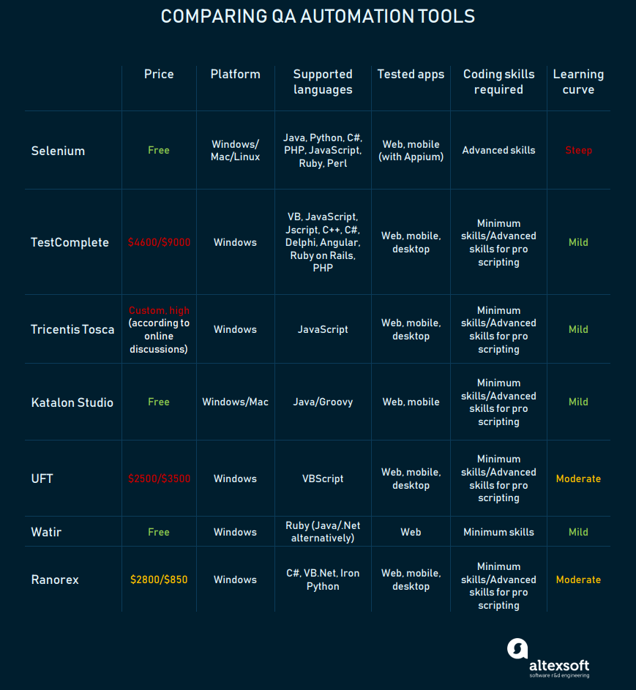

Download TestComplete:

Download => TestComplete can be downloaded from the homepage of SmartBear: https://smartbear.com/product/testcomplete/free-trial/
Once downloaded, follow these steps to install TestComplete:
1) Double-click the downloaded TestComplete installation package. Software installation will begin and the license agreement will be displayed.
2) Specify the path of the folder where you want to install the software.

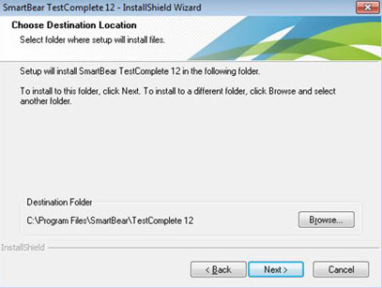
3) Now that the welcome dialog is displayed asking to activate the license, we can start by clicking on the 30 day trial license.
4) Then restart the computer, we have completed the installation of TestComplete.

8. Create Project in TestComplete:
Launch the application and you will see the start page.
Follow these steps to create a new Project.
1. Go to the menu file.
2. Click New Menu from the menu.
3. Click New Project.

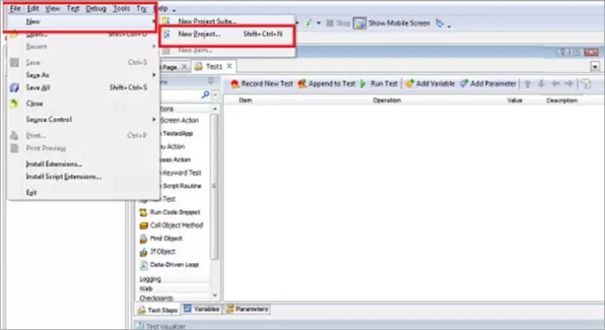
4. Or alternatively, you can use the keyboard shortcut (shift + ctrl + N) to create a New Project.
5. A window will appear, and you give the Project a name.
6. Click to Finish
7. So we have created the first Project in TestComplete.

9.TestComplete's UI:
TestComplete's user interface is well organized and divided into different sections.
- The Project Explorer panel on the left side of the window, showing project suites, projects, and assets
- The workspace console is where you can modify and test
- The Test Visualizer panel (at the bottom) shows screenshots saved during test case execution.

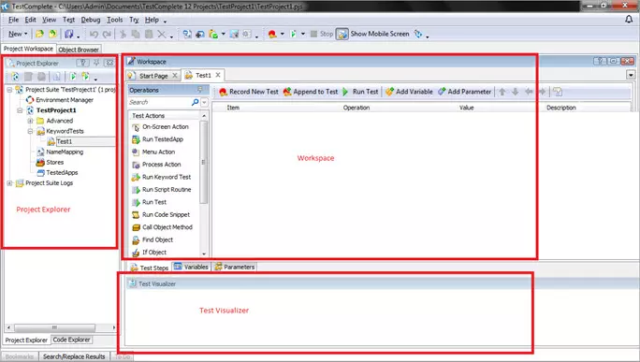

Chapter 2: TEST CASES

website Introduction:
- http://store.nhanh.vn/demo?id=199 Website specializing in selling coffee, soft drinks and raw materials, accessories...
- The website has the following features: order, purchase, search for products, list of items, filter prices by face value and register, log in to an account...

Images of the interface and functions of the website:
- Website interface:

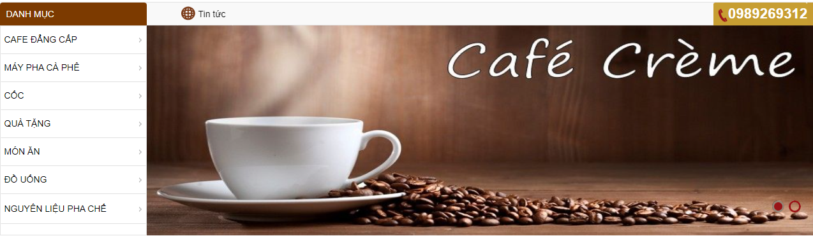

- Login interface:

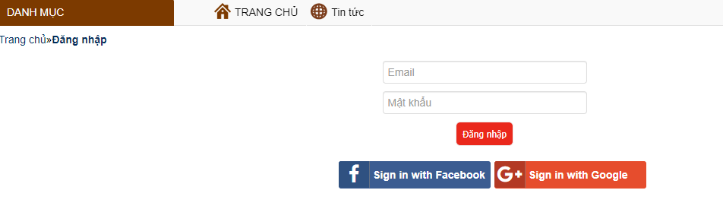

- Registration interface

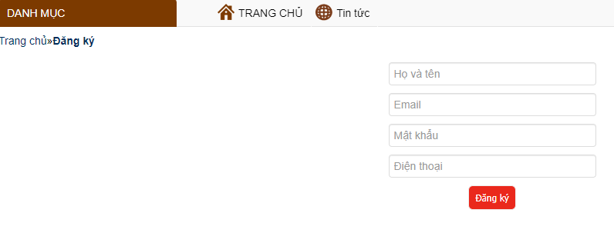

- Menu website



- Cart interface:

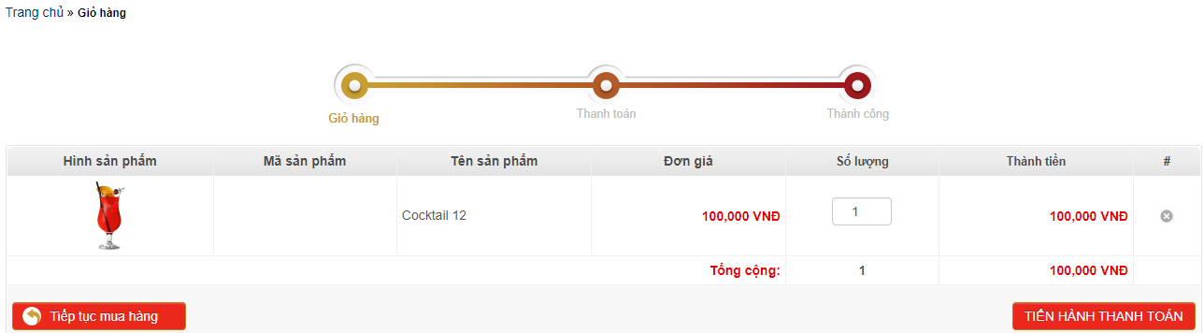

- Section “Nguyên Liêu Pha Chế”:

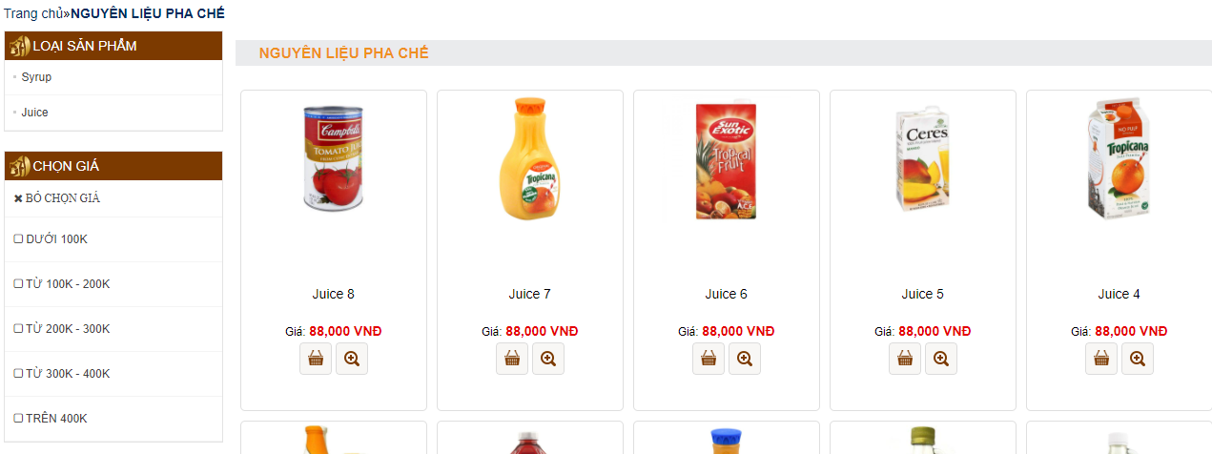

- Section “ Quà Tặng”:

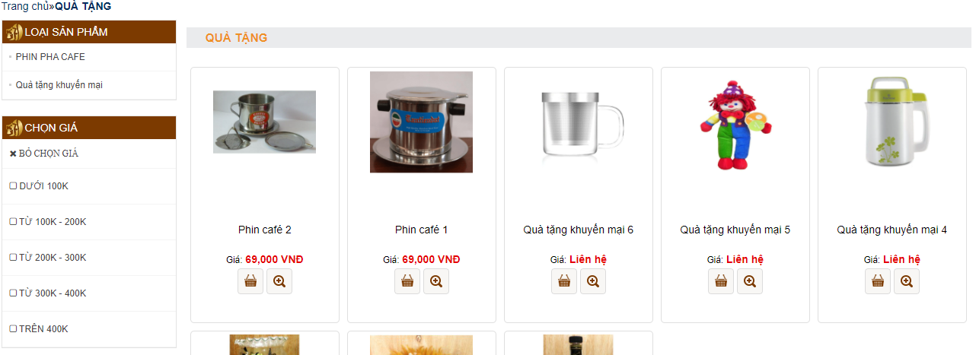

TC ID | TC Description | Basic/Advanced | Author
TC-01 | Verify Invalid account registration | Basic | Trần Lê Tấn Đức
TC-02 | Verify Invalid account login | Basic | Trần Lê Tấn Đức
TC-03 | Verify to order successfully | Basic | Trần Lê Tấn Đức
TC-04 | Verify products under 100k when choosing products with the same price 100k | Basic | Trần Lê Tấn Đức
TC-05 | Verify Invalid product search | Basic | Trần Lê Tấn Đức
TC-06 | Verify filter products by number | Basic | Trần Lê Tấn Đức
TC-07 | Verify search for products on the search bar | Basic | Võ Thành Trung
TC-08 | Verify the total product in “NGUYÊN LIỆU PHA CHẾ” | Advanced | Võ Thành Trung
TC-09 | Add 1 product multiple times | Advanced | Võ Thành Trung
TC-10 | Verify the total product in “Qùa Tặng” | Advanced | Võ Thành Trung
TC-11 | Verify Compare product prices when added to cart | Advanced | Võ Thành Trung
- Summary of test case:

- Details of test cases:
TC ID | TC Description | Steps | Expected Result | Test Result
TC-01 | Verify Invalid account registration | 1. Open: http://store.nhanh.vn/demo?id=199  2. Click register on the menu bar.  3. Enter login information.  4.Verify text: “ Email này đã được sử dụng”. | Show invalid account registration | Pass
TC-02 | Verify Invalid account login | 1. Open: http://store.nhanh.vn/demo?id=199  2. Click login on the menu bar.  3. Enter login information.  4.Verify text: “Tên đăng nhập hoặc mật khẩu không chính xác”. | Show Invalid account login | Pass
TC-03 | Verify to order successfully | 1. Open: http://store.nhanh.vn/demo?id=199  2. Click to buy on the homepage.  3. Select proceed to checkout in the cart.  4. Fill in the payment information.  5. Choose payment.  6. Verify text: “ Đặt hàng thành công ” | Expected result: Order successfully | Pass
TC-04 | Verify products under 100k when choosing products with the same price 100k | 1.Open: http://store.nhanh.vn/demo?id=199  2.Click on the dish in the menu bar.  3.Click below the price of 100k on the menu bar.  4.Verify text: Check out some items under 100k. | Show products under 100k on the current page | Pass
TC-05 | Verify Invalid product search | 1.Open: http://store.nhanh.vn/demo?id=199  2. Click the search bar in the menu bar.  3. Find the product in the search bar.  4. Verify text: CÓ 0 KẾT QUẢ TÌM KIẾM VỚI TỪ KHÓA: WWW”. | Show invalid product search | Pass
TC-06 | Verify filter products by number | 1.Open: http://store.nhanh.vn/demo?id=199  2.Click the search bar in the menu bar.  3. Find products by number on the search bar.  4. verify text: Products by number searched. | Show filter products by number | Pass
TC-07 | Verify search for products on the search bar | 1. Open: http://store.nhanh.vn/demo?id=199  2. Click on the sreach bar.  3. Enter the name of the product you want to search for.  4. Verify “CÓ 29 KẾT QUẢ TÌM KIẾM VỚI TỪ KHÓA: CAFE”. | Show search for products on the search bar | Pass
TC-08 | Verify the total product in “NGUYÊN LIỆU PHA CHẾ”: | 1. Open: http://store.nhanh.vn/demo?id=199  2. Select “NGUYÊN LIỆU PHA CHẾ”.  3. Select 1 product in “NGUYÊN LIỆU PHA CHẾ” (total).  4. Select “Syrup”.  5. Select 1 produtct in “Syrup” (n1).  6. Select “Juice”.  7. Select 1 produtct in “Juice” (n2).  8. “NGUYÊN LIỆU PHA CHẾ”= “Syrup”+“Juice” (Total =n1 +n2).  9. Close website. | Show the total product in “NGUYÊN LIỆU PHA CHẾ” | Pass
TC-09 | Add one product multiple times | 1. Open: http://store.nhanh.vn/demo?id=199  2. Select “CAFE ĐẲNG CẤP”  3. Add any 1 product to your cart (count)  4. verify text: Compare the number of products added to the cart  5. Close website | Show one product multiple times | Pass
TC-10 | Verify the total product in “Qùa Tặng” | 1. Open: http://store.nhanh.vn/demo?id=199  2. Select “Quà Tặng”  3.Select 1 product in “Quà Tặng” (I)  4. Add product to cart  5. Verify total  6. Close website | Show the total product in “Qùa Tặng” | Pass
TC-11 | Verify Compare product prices when added to cart | 1.Open: http://store.nhanh.vn/demo?id=199  2.Select 1 product in “Quà Tặng”  3.Store price product (price1)  4.Add product to cart  5.Store price product in cart (price2)  6.Verify “price1” and “${price2}”  7.Close website | Show Compare product prices when added to cart | Pass

Chapter 3: CONCLUSION

Conclusion To get the most out of Selenium, you must build and run tests for your test cases with Selenium 2 or Selenium in conjunction with a supported programming language. However, the tool of choice is very much up to you and in Selenium writing time, the developers are all planning to let the Selenium -webdriver API become the future guide of Selenium. This is now, it all 2 both have advantages and disadvantages discussed in the respective program of the series document. However, for those who are adopting Selenium for the first time, you will want to try Selenium 2 as well because this is the part of Selenium that will be continued in the future.

REFERENCES

- https://viblo.asia/p/huong-dan-cach-dungtestcomplete-cho-nguoi-moi-bat-dau-part-i-Ljy5VoxjKra
- https://smartbear.com/product/testcomplete/features/
- https://en.wikipedia.org/wiki/TestComplete
- https://www.gartner.com/reviews/market/software-test-automation/vendor/smartbear/product/testcomplete

