UPDATE PROJECT

1. Team
Members: Trần Xuân Đức – 20176720
Lê Đình Quyền – 20176859
Vũ Ngọc Nam – 20176832
Topic: Visualization Sorting Algorithm
2. Update after report
2.1: Redistribute package ObjectModel
- add 2 classes TopObj and BottomObj
- there is aggregation relationship between class ColumnObj and 2 classes TopObj and BottomObj. Instances of two classes TopObj and BottomObj are made up of instances of class ColumnObj.
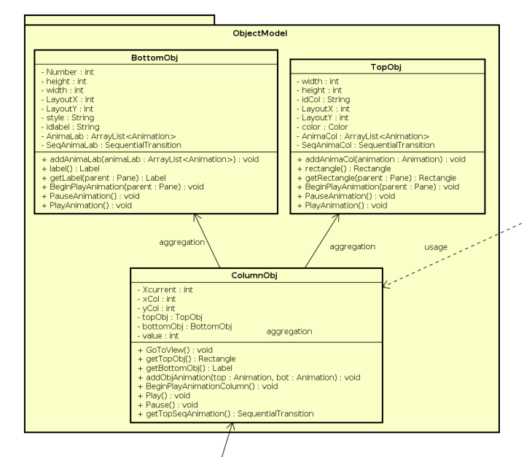

2.2: The usage properties of Inheritance relationship
- There is relationship: 3 classes QuickSort, RadixSort, ThreeWayRadixSort extends class AnimationSort. In this relationship, all methods, functions uses this.getListObj() to call the list of initialized ColumnObj.

2.3: Polymophism
- Update class: AnimationSort
+ add a method Sort().
- Update class: QuickSort, RadixSort, ThreeRadixSort
+ Override method Sort() of class AnimationSort for each above class.
+ In each above class, the method Sort() implements some separate functions.
- Update class: Controller
+ Initial a object: AnimationSort aS = new AnimationSort().
+ Depending on the selected option, downcasting the aS
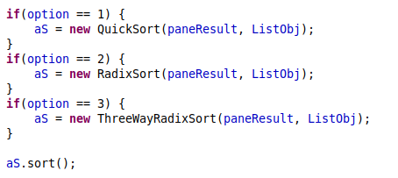

+ Depending on the type of aS, method Sort() will implement compatible with override method written in 3 classes QuickSort, RadixSort and ThreeWayRadixSort

3. Contribution
- Each member joins 33,3% of project

- Vũ Ngọc Nam:
+ Class ThreeWayRadixSort
+ Class InputControl: getNumberCharacters(), toStringColumnHeight()
+ Class ColumnObj
+ Class BottomObj
+ Class TopObj
- Lê Đình Quyền:
+ Class AnimationSort
+ Class QuickSort
+ Class InputControl: TestInput(), toArray()
+ Class ColumnObj
+ Class BottomObj
+ Class TopObj
- Trần Xuân Đức:
+ Class RadixSort
+ Class Controller
+ Package ViewFXML
+ Class ColumnObj
+ Class BottomObj
+ Class TopObj

