Assignment 1

COS30017 - Software Development for Mobile Devices

Nguyen Huu Duc Anh 104176235



Table of Contents
Introduction 3
Development Plan and Time Logs 3
1. Development Plan 3
2. Time Logs 3
Key Design Decisions 3
1. UI/UX Design 4
2. Functionality 5
3. Localization 5
Issues Encountered and Solutions 6
Issue 1: Stable Data Across Orientation Changes 6
Problem 6
Solution 6
Issue 2: Localization/ Language Challenges 6
Problem 6
Solution 6
Reflection 7
1. What work well 7
2. What Could Be Improved 7

https://github.com/DucAnh04/COS30017

Introduction
The Climb Application is a mobile application which is designed to track the progress of a climber on a modified climbing wall. When climbers reach certain grips on the wall, the app lets users record their ratings. The application's clean layout, which enables localization in both English and Vietnamese, and its ability to adjust to multiple screen orientations are examples of its simple and user-friendly design.

Development Plan and Time Logs
1. Development Plan
The application was developed over two weeks to fulfill the deadline, emphasizing essential functionality and comprehensive testing to assure superior quality.
Week 3: UI/UX Design and Basic Features Important features were created, such as score tracking, reset buttons, and timers. Additionally, both portrait and landscape orientations were considered when designing the user interface.
Week 4: Testing, Debugging, and Enhancements Extensive testing was performed on a range of devices, and any issues were resolved while adding upgrades such as sound effects, animations, and localization.
2. Time Logs
Week 3: 10 hours - Core functionality development and UI/UX design.
Week 4: 20 hours - Testing, debugging, localization, and feature enhancements.

Key Design Decisions
The creation of a user-friendly interface that works well in both portrait and landscape orientations was given top importance. The app's structure easily adjusts to multiple screen sizes, ensuring a consistent user experience across tablets and phones.
Example result on Pixel 6 Pro API 33
Portrait
English Version
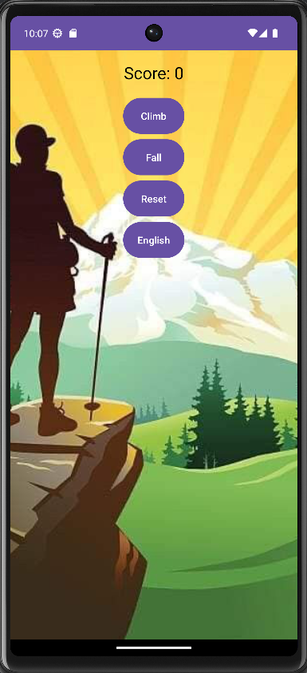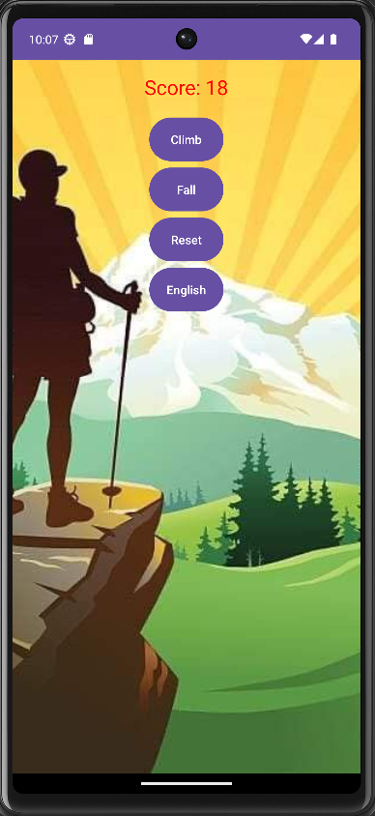
Vietnamese version
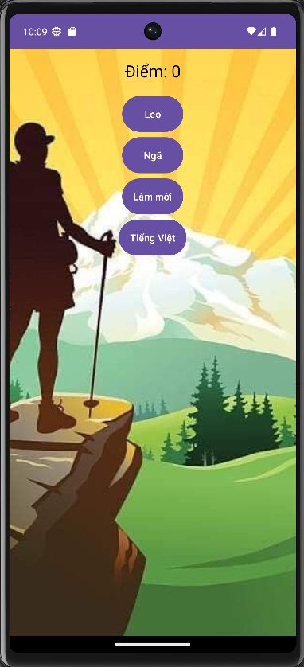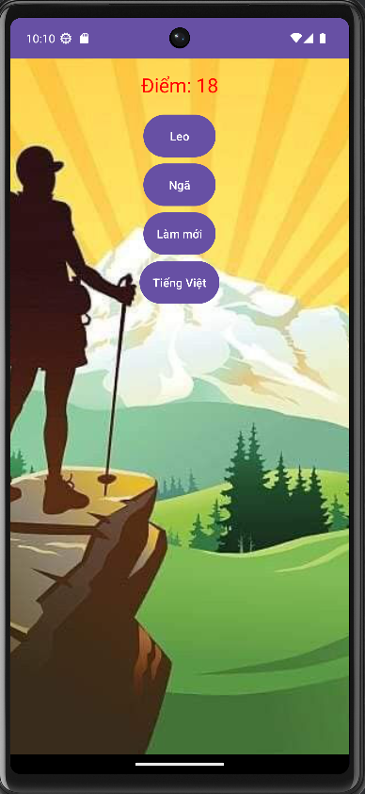
Landscape
English Version
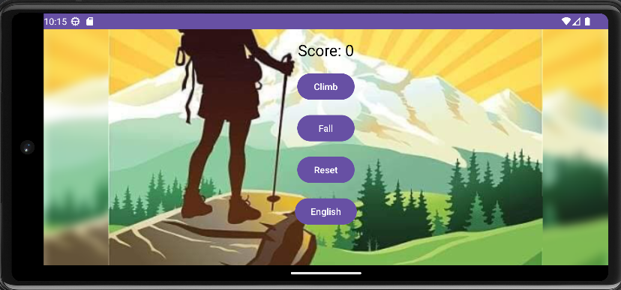

Vietnamese Version
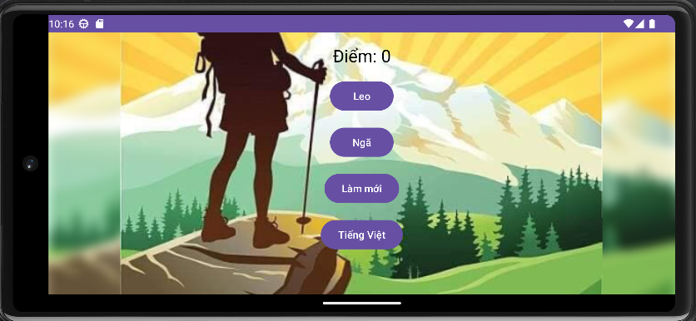

2. Functionality
The program has all the required functions, such as a climb button that helps players collect points, a fall function that reduces points, a reset function that restarts the game, and score monitoring.
3. Localization
The installation of localization allowed users to switch between English and Vietnamese. To ensure that the user interface text adjusts dynamically based on the language selected, string resources must be carefully controlled.

Issues Encountered and Solutions
Detail the issues encountered during development and how they were addressed.
Issues Encountered and Solutions:
Issue 1: Stable Data Across Orientation Changes
Scores and holds values were resetting when the device orientation is switched between Portrait and Landscape.
Solution: This issue was resolved by saving the current state using `onSaveInstanceState`.
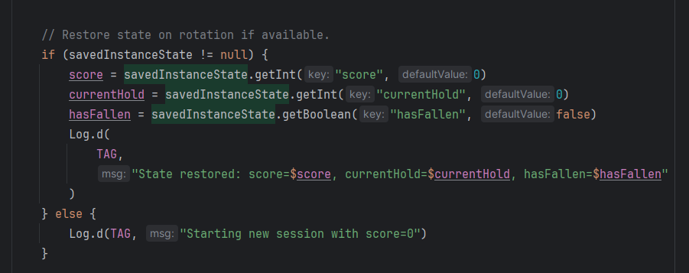

Issue 2: Localization/ Language Challenges
Problem: When switching from English to Vietnamese, several strings were incorrectly translated, and UI components did not update.
Solution: The problem was resolved by controlling string resources where two files had to match and ensuring that all UI elements updated dynamically dependent on the language selected.
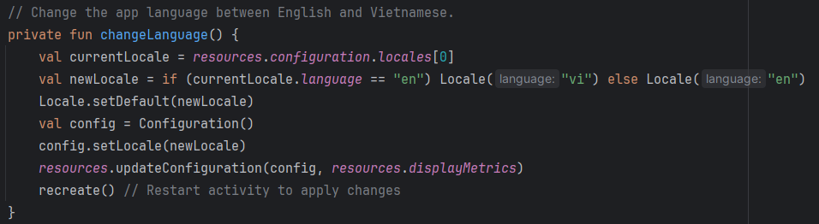

Reflection
- What work well
UI/UX: The design I created is well-structured and appropriate for a variety of devices with varied screen sizes.
Function: I meet all the assignment's requirements and guarantee that nothing in my application is unsuitable.
Testing and Debugging: I use "Log.d" to observe messages when the application is running, which allows me to easily debug. I also develop test functions to ensure that the application's functions perform properly.
- What Could Be Improved
Device Compatibility: Although this app was tested on a specific set of devices, there are many more UIs that need to be worked through. Additional time spent on larger and smaller devices would increase the app's versatility.
Player Management: A function that help the app to store the record of player: name, date, time, and rank would make it perfectly.

