**Flowchart:**

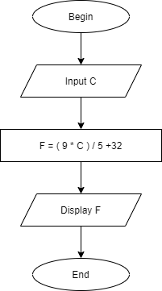

**Pseudo-code:**

Begin

Input C

F = (9*C) / 5 + 32

Display F

END