Evaluation wine base on description

Duc Duong(mindu931)

16 January 2019

# Abstract

Wine sensory examination and assessment is never easy, even with a wine specialist. However, the description which is printed on each bottle can bring us some helpful information. Base on that ideal, I decided to analyze the data about wine review (take form Kaggle) and help the consumers make the decision on two different aspects. The first one is which is a good and excellent wine. The second aspect is which is the valueble bottle (high value with a acceptable amount of money). I use different techniques to process the text data, then compare Naive Bayes, SVM linear and SVM RBF kernel when building the best model for predicting. The final results are quite impressive with accuracy 78.69% for the first issue and 77.09% for the second one. Base on these model, some suggestions are provided for the consumers to choose a satisfied bottle.

# Introduction

## Motivation

I always confuse when standing in a wine cellar. How can I choose an excellent wine for my family? What is the best wine I can choose with my budget? The problem can be solved easier if I had a good sense. But, sadly, I don’t, like many people in this world. The problems still continue when I listen to the advice of the salesman and even taste some wine. So, I usually choose randomly a bottle based on these advices for my event. Unluckily, sometimes my relatives don’t think that it is an excellent wine.

## Aim

I guess that the information from the provider (description, country, region, designation…) should bring some important information. So, I try to solve the problems base on text mining ideal: Take the wine data which is already reviewed and marked by some specialists, then process these data together with the points and build a model to prediction in order to figure out which bottle is good or excellent, which one have high benefit or just medium. ## Content of this report In this report, Firstly, I will provide information about the data as well as the way I define the class for each bottle. Then, I briefly summary relevant theory. The method I used will be presented in details. It includes the steps for preprocessing, techiques for comparing and choosing the best model. Finally is some suggestions for choosing wine, some discussions and my conclusion.

# Data

Wine review data is taken form Kaagle ([link](https://www.kaggle.com/zynicide/wine-reviews)). I choose the second .csv version of this dataset. In this version, duplicated data is removed. The data include 120975 samples about wine. Each sample contains the following information: country, description, designation, points, price, province, region, more specific region (region2), tester name, taster_twitter handle, title, variety, and winery. Here is the overlook of the data:

head(wine)

## X country  
## 1 0 Italy  
## 2 1 Portugal  
## 3 2 US  
## 4 3 US  
## 5 4 US  
## 6 5 Spain  
## description  
## 1 Aromas include tropical fruit, broom, brimstone and dried herb. The palate isn't overly expressive, offering unripened apple, citrus and dried sage alongside brisk acidity.  
## 2 This is ripe and fruity, a wine that is smooth while still structured. Firm tannins are filled out with juicy red berry fruits and freshened with acidity. It's already drinkable, although it will certainly be better from 2016.  
## 3 Tart and snappy, the flavors of lime flesh and rind dominate. Some green pineapple pokes through, with crisp acidity underscoring the flavors. The wine was all stainless-steel fermented.  
## 4 Pineapple rind, lemon pith and orange blossom start off the aromas. The palate is a bit more opulent, with notes of honey-drizzled guava and mango giving way to a slightly astringent, semidry finish.  
## 5 Much like the regular bottling from 2012, this comes across as rather rough and tannic, with rustic, earthy, herbal characteristics. Nonetheless, if you think of it as a pleasantly unfussy country wine, it's a good companion to a hearty winter stew.  
## 6 Blackberry and raspberry aromas show a typical Navarran whiff of green herbs and, in this case, horseradish. In the mouth, this is fairly full bodied, with tomatoey acidity. Spicy, herbal flavors complement dark plum fruit, while the finish is fresh but grabby.  
## designation points price province  
## 1 VulkÃ  Bianco 87 NA Sicily & Sardinia  
## 2 Avidagos 87 15 Douro  
## 3 87 14 Oregon  
## 4 Reserve Late Harvest 87 13 Michigan  
## 5 Vintner's Reserve Wild Child Block 87 65 Oregon  
## 6 Ars In Vitro 87 15 Northern Spain  
## region_1 region_2 taster_name  
## 1 Etna Kerin Oâ\200\231Keefe  
## 2 Roger Voss  
## 3 Willamette Valley Willamette Valley Paul Gregutt  
## 4 Lake Michigan Shore Alexander Peartree  
## 5 Willamette Valley Willamette Valley Paul Gregutt  
## 6 Navarra Michael Schachner  
## taster_twitter_handle  
## 1 @kerinokeefe  
## 2 @vossroger  
## 3 @paulgwineÂ   
## 4   
## 5 @paulgwineÂ   
## 6 @wineschach  
## title  
## 1 Nicosia 2013 VulkÃ  Bianco (Etna)  
## 2 Quinta dos Avidagos 2011 Avidagos Red (Douro)  
## 3 Rainstorm 2013 Pinot Gris (Willamette Valley)  
## 4 St. Julian 2013 Reserve Late Harvest Riesling (Lake Michigan Shore)  
## 5 Sweet Cheeks 2012 Vintner's Reserve Wild Child Block Pinot Noir (Willamette Valley)  
## 6 Tandem 2011 Ars In Vitro Tempranillo-Merlot (Navarra)  
## variety winery  
## 1 White Blend Nicosia  
## 2 Portuguese Red Quinta dos Avidagos  
## 3 Pinot Gris Rainstorm  
## 4 Riesling St. Julian  
## 5 Pinot Noir Sweet Cheeks  
## 6 Tempranillo-Merlot Tandem

Points are important information in this data. Points are marked by wine specialists, which make it reliable. The owner only public data which have at least 80 point (out of 100) which means the data contain only good and excellent wine. Here is the distribution of the points:

boxplot(wine$points, main="Boxplot of points")

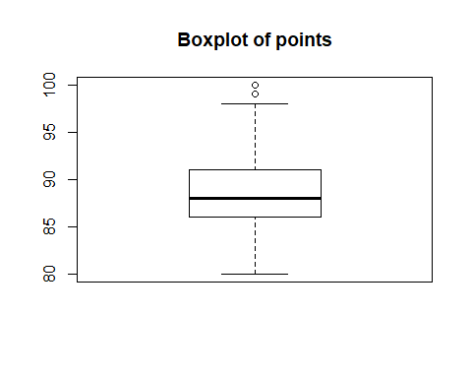

## Theory

In this section, I will briefly talk about some theory in nature language processing(NLP) and machine learning(ML) in a simple way of reviewing. For some terms, only the aspect that relevant to this project is presented. I assume that the reader already has some basic knowledge about NLP and ML before(this part is not a guide for a person with a blank background). I also noticed that we are processing the text written in English.

* Terms in preprocessing:
* Stop words: This is the term for useless words in the text. To be specific, these words usually have no (or very low) meaning but represent a lot. For example: a, an, the… When processing text data. We usually remove these words.
* Steaming: This is the process of reducing a word to its root form. For example: processes, processing and processed are 3 different words, but it just 3 different representatives of the word “process”. Another example is evaluated and evaluation.
* Tokenization: the process of splitting text into smaller parts. Each part can consider as a feature when training in machine learning kernels. If the smaller part here is the single word (split the text to single words) then all words we have will become the bag of words.
* Corpus: You can understand simply that corpus is a collection of all features in NLP, used for training. For example, all word in the bag of words is a corpus.
* Document term matrix(Dtm) is a matrix, which has column is all words of the corpus and column is the document ID. The cross between row and column is the point for that word in that document. Points can be calculated in some different ways. In this project, I use tf-idf.
* Tf-idf: Stand for term frequency-inverse document frequency. This is a statistic method for calculating the importance of each word following this formula:

number of documents where the term t appears. If this value equal 0, it will be adjust to 1  
D: total number of documents in the corpus

* Machine learning kernels: a kernel can understand as a core algorithm used when training a model in ML. Here are the three kernels that I use in this report:
* Naive Bayes: Let initial with we have a vector X of a document, which builds in document-term matrix. The probability of assign a class label y to that vector is:
* Naive-Bayes theory make an asump that all features are independent. The assumption is not realistic, somehow, it works well.
* SVM: Stands for support vector machine. In the previous kernel, we have vector X for each document. immage that each document is represent by vector X in a multi-dimension space. (The number of dimension is the number of features). The aim is finding a hyperplane to seperate the space into two classes.
* SVM linear and RBF kenels: SVM Linear will decide the hyperplane as a flat. SVM RBF will use an other dimension to solve the problem. Let’s see an example of how linear and RBF kerels work in some pictures:

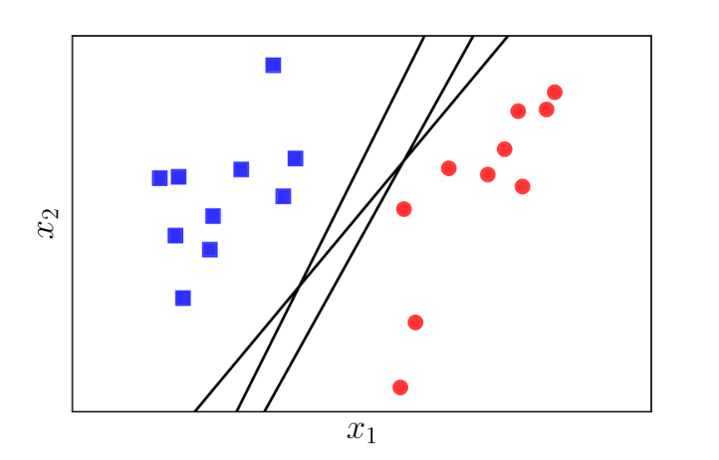

SVM linear kernel

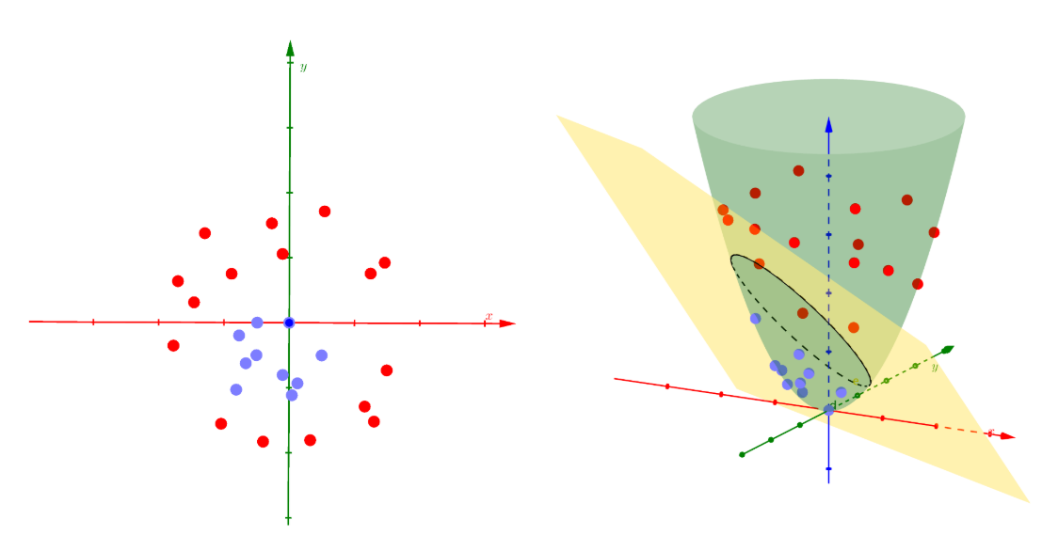

SVM RBF kernel

* Ngram: n-gram is n continue sequence words. In this project, n-gram is used for making corpus. An example is n=2 continue words wil be features. To be more specific, the sentence: “this is a sentence” will have “this_is”, “is_a”, “a_sentence” as features.
* Part-Of-Speech Tagger (POS Tagger): This is the method to process text and decided each word is nouns, ajdtive, adverb…

## Method

In this part, I’ll talk about the method for the first problem of this project: Which is the “good” and “excellent” wine. The second problem about wine that has “high” and “medium” value is solved using a similar method but will be discussed in details in a different part.

* Define the class: The first step is to define the class for each document. Base on the distribution of the point, I will take the point 88 as the boundary because it is the median value, which will make the data become balance. So, the wine that has higher than 88 will be the excellent wine, while the rest is the good wine.
* Preprocess data:
* Split train and test: I use 80% of the data as the training set and 20% as the testing set. Then, the training data is processed as follow:
* Make the text ready: I decided that the information about the country, designation, province, region, and wine variety is important. So, I decided to merge that information into the description as a paragraph. That paragraph is the one that I will process.
* Language convert: In the data set. there is some name of variety that is not unified (same type but written in the different language). So I convert it to the most famous word as follow:
* ++ Replace German names with English names: “weissburgunder” is replaced as “chardonnay”. “spatburgunder” is replaced as “pinot noir”. “grauburgunder” is replaced as “pinot gris”.  
  ++ Replace the Spanish “garnacha”" with the french “grenache”.  
  ++ Replace the Italian “pinot nero”" with the french “pinot noir”.  
  ++ Replace the Portugues “alvarinho”" with the spanish “albarino”.
* Remove non-ASCII characters.
* Remove punction .
* Make words to lower from.
* Remove number.
* Remove stop words: I use the default stop words lists in the tm library and then adjust it. Firstly, the lists have the word “very”. In my opinion, very is a valuable word in this data. Because in the descriptions, for example, “sweet” and “very sweet” are different levels of flavor. So, I remove that word on the list. Then, I add three words “the”, “and” and “wine” to the stop word list because, in this data set, it doesn’t have any meaning. Here is the final stop word list:
* Steamming: I steam the word by using SnowballC steam.
* Tonkenzine and making the bag of words as the corpus. Then I only keep 99% spare term, which mean that only the words that appear in at least 1% of documents are kept. It makes sense because there are some rare words which only appear in one or a small number of documents. That words are not helpful for training because maybe we never meet it again in the testing set.
* Create the document terms matrix base on tf-idf.
* Now the data is ready for training. For testing data, the preprocess is similar, except the Dtm. Dtm of testing data will be create based on the corpus of training data (which means some words that don’t appear in the training data will be drop)
* Compare kernels: At this step, I’ll use the ready Dtm for training model, then test with the testing Dtm. Three kernel Naive-Bayes, SVM linear and SVM RBF are used to compare. In this step, because of the limit in my resource (Laptop core i5 7th gen, 8GB) and time. I only use the sample 20% of the data (16% - 19356 samples for training and 4% - 4839 samples for testing) to compute. Different parameters used for training is also reported. Notice that the time for training NB and SVM linear is quite fast (a few minutes) but It takes a long time for training SVM RBF (~14 hours, for 505 terms in Dtm, include time for tunning model)
* Improve the best model: After comparing, the best model is selected. Then I continue to improve the model when using n-gram and adjust the weight for some terms using Part-Of-Speech Tagger (POS Tagger).
* Final result: Final model is selected and run again with 100% data. The final result is reported based on this model.

## Result and explain

* Firstly, Let’s takes a look at the original paragraph and the paragraphs after preprocessing to see how it work:

train$description[1]

## [1] "This smells mostly of oak and barrel spice, with barely any fruit seeping through all the wood grain that's on display. Plump on the palate, this overoaked Chardonnay tastes almost entirely of resin and spice. Throw in clove and vanilla flavors on the finish, and you get the picture. Chile Duette Casablanca Valley Chardonnay"

wine_train_set[[1]]$content

## [1] "smell most oak barrel spice bare fruit seep wood grain that display plump palat overoak chardonnay tast almost entir resin spice throw clove vanilla flavor finish get pictur chile duett casablanca valley chardonnay"

Then, Here is the Dtm for the first sentence of training set:

wine_train_set[1,]

## accent acid across add   
## 0.00000000 0.00000000 0.00000000 0.00000000   
## africa aftertast age alcohol   
## 0.00000000 0.00000000 0.00000000 0.00000000   
## almond almost along alongsid   
## 0.00000000 0.15504157 0.00000000 0.00000000   
## alreadi alsac also although   
## 0.00000000 0.00000000 0.00000000 0.00000000   
## ampl anis anoth appeal   
## 0.00000000 0.00000000 0.00000000 0.00000000   
## appl approach apricot argentina   
## 0.00000000 0.00000000 0.00000000 0.00000000   
## aroma aromat around astring   
## 0.00000000 0.00000000 0.00000000 0.00000000   
## attract australia austria back   
## 0.00000000 0.00000000 0.00000000 0.00000000   
## bake balanc barbara barolo   
## 0.00000000 0.00000000 0.00000000 0.00000000   
## barrel beauti berri best   
## 0.15305057 0.00000000 0.00000000 0.00000000   
## better big bit bitter   
## 0.00000000 0.00000000 0.00000000 0.00000000   
## black blackberri blanc blend   
## 0.00000000 0.00000000 0.00000000 0.00000000   
## blossom blue blueberri bodi   
## 0.00000000 0.00000000 0.00000000 0.00000000   
## bold bordeaux bordeauxstyl bottl   
## 0.00000000 0.00000000 0.00000000 0.00000000   
## bouquet boysenberri brambl bright   
## 0.00000000 0.00000000 0.00000000 0.00000000   
## bring brisk brut burgundi   
## 0.00000000 0.00000000 0.00000000 0.00000000   
## butter cab cabernet california   
## 0.00000000 0.00000000 0.00000000 0.00000000   
## can candi caramel carnero   
## 0.00000000 0.00000000 0.00000000 0.00000000   
## carri cassi catalonia cedar   
## 0.00000000 0.00000000 0.00000000 0.00000000   
## cellar central champagn char   
## 0.00000000 0.00000000 0.00000000 0.00000000   
## charact chardonnay cherri chewi   
## 0.00000000 0.19943433 0.00000000 0.00000000   
## chile chocol chunki cinnamon   
## 0.14711002 0.00000000 0.00000000 0.00000000   
## citrus citrusi classic classico   
## 0.00000000 0.00000000 0.00000000 0.00000000   
## clean close clove coast   
## 0.00000000 0.00000000 0.15208806 0.00000000   
## cocoa coffe cola color   
## 0.00000000 0.00000000 0.00000000 0.00000000   
## columbia combin come complex   
## 0.00000000 0.00000000 0.00000000 0.00000000   
## concentr cool core counti   
## 0.00000000 0.00000000 0.00000000 0.00000000   
## cranberri creami creek crisp   
## 0.00000000 0.00000000 0.00000000 0.00000000   
## cru crush ctes currant   
## 0.00000000 0.00000000 0.00000000 0.00000000   
## cut cuve dark deep   
## 0.00000000 0.00000000 0.00000000 0.00000000   
## del delic delici deliv   
## 0.00000000 0.00000000 0.00000000 0.00000000   
## dens depth despit develop   
## 0.00000000 0.00000000 0.00000000 0.00000000   
## doesnt domin dri drink   
## 0.00000000 0.00000000 0.00000000 0.00000000   
## dusti earth earthi easi   
## 0.00000000 0.00000000 0.00000000 0.00000000   
## edg eleg element end   
## 0.00000000 0.00000000 0.00000000 0.00000000   
## enjoy enough espresso estat   
## 0.00000000 0.00000000 0.00000000 0.00000000   
## even excel exot express   
## 0.00000000 0.00000000 0.00000000 0.00000000   
## extra extract fair famili   
## 0.00000000 0.00000000 0.00000000 0.00000000   
## featur feel ferment fill   
## 0.00000000 0.00000000 0.00000000 0.00000000   
## find fine finger finish   
## 0.00000000 0.00000000 0.00000000 0.04989804   
## firm first flavor fleshi   
## 0.00000000 0.00000000 0.02956396 0.00000000   
## floral flower focus follow   
## 0.00000000 0.00000000 0.00000000 0.00000000   
## food foothil forest forward   
## 0.00000000 0.00000000 0.00000000 0.00000000   
## fragrant frame franc french   
## 0.00000000 0.00000000 0.00000000 0.00000000   
## fresh front fruit fruiti   
## 0.00000000 0.00000000 0.04106600 0.00000000   
## full fullbodi generous gentl   
## 0.00000000 0.00000000 0.00000000 0.00000000   
## germani get give glass   
## 0.00000000 0.18456806 0.00000000 0.00000000   
## good grand grape grapefruit   
## 0.00000000 0.00000000 0.00000000 0.00000000   
## graphit great green grenach   
## 0.00000000 0.00000000 0.00000000 0.00000000   
## grill grip gris grown   
## 0.00000000 0.00000000 0.00000000 0.00000000   
## hard heavi herb herbal   
## 0.00000000 0.00000000 0.00000000 0.00000000   
## high highlight hill hint   
## 0.00000000 0.00000000 0.00000000 0.00000000   
## hold honey honeysuckl hot   
## 0.00000000 0.00000000 0.00000000 0.00000000   
## impress includ integr intens   
## 0.00000000 0.00000000 0.00000000 0.00000000   
## interest intrigu invit itali   
## 0.00000000 0.00000000 0.00000000 0.00000000   
## jam jammi juic juici   
## 0.00000000 0.00000000 0.00000000 0.00000000   
## just keep lack lake   
## 0.00000000 0.00000000 0.00000000 0.00000000   
## last layer lead leaf   
## 0.00000000 0.00000000 0.00000000 0.00000000   
## lean least leather leav   
## 0.00000000 0.00000000 0.00000000 0.00000000   
## lemon lend length les   
## 0.00000000 0.00000000 0.00000000 0.00000000   
## licoric lift light like   
## 0.00000000 0.00000000 0.00000000 0.00000000   
## lime linger littl live   
## 0.00000000 0.00000000 0.00000000 0.00000000   
## load loir long lot   
## 0.00000000 0.00000000 0.00000000 0.00000000   
## love lush made make   
## 0.00000000 0.00000000 0.00000000 0.00000000   
## malbec mango mani mark   
## 0.00000000 0.00000000 0.00000000 0.00000000   
## matur meat medium mediumbodi   
## 0.00000000 0.00000000 0.00000000 0.00000000   
## melon mendoza merlot midpal   
## 0.00000000 0.00000000 0.00000000 0.00000000   
## mild miner mint mix   
## 0.00000000 0.00000000 0.00000000 0.00000000   
## mocha moder montalcino month   
## 0.00000000 0.00000000 0.00000000 0.00000000   
## mountain mourvdr mouth mouthfeel   
## 0.00000000 0.00000000 0.00000000 0.00000000   
## much napa napasonoma natur   
## 0.00000000 0.00000000 0.00000000 0.00000000   
## nebbiolo nectarin need new   
## 0.00000000 0.00000000 0.00000000 0.00000000   
## next nice noir north   
## 0.00000000 0.00000000 0.00000000 0.00000000   
## northeastern northern nose note   
## 0.00000000 0.00000000 0.00000000 0.00000000   
## now nuanc oak oaki   
## 0.00000000 0.00000000 0.08861248 0.00000000   
## offer old oliv one   
## 0.00000000 0.00000000 0.00000000 0.00000000   
## open opul orang oregon   
## 0.00000000 0.00000000 0.00000000 0.00000000   
## overal pack pair palat   
## 0.00000000 0.00000000 0.00000000 0.05340088   
## paso peach pear peel   
## 0.00000000 0.00000000 0.00000000 0.00000000   
## pepper pepperi perfect perfum   
## 0.00000000 0.00000000 0.00000000 0.00000000   
## persist petit pie piedmont   
## 0.00000000 0.00000000 0.00000000 0.00000000   
## pineappl pinot play pleasant   
## 0.00000000 0.00000000 0.00000000 0.00000000   
## plenti plum plump polish   
## 0.00000000 0.00000000 0.19247727 0.00000000   
## pomegran portug portugues potenti   
## 0.00000000 0.00000000 0.00000000 0.00000000   
## power present pretti price   
## 0.00000000 0.00000000 0.00000000 0.00000000   
## produc provid provinc prune   
## 0.00000000 0.00000000 0.00000000 0.00000000   
## pure purpl qualiti quit   
## 0.00000000 0.00000000 0.00000000 0.00000000   
## raci raisin ranch raspberri   
## 0.00000000 0.00000000 0.00000000 0.00000000   
## rather readi red refresh   
## 0.00000000 0.00000000 0.00000000 0.00000000   
## region remain reserv reserva   
## 0.00000000 0.00000000 0.00000000 0.00000000   
## reveal rhnestyl rich riesl   
## 0.00000000 0.00000000 0.00000000 0.00000000   
## right rioja ripe riserva   
## 0.00000000 0.00000000 0.00000000 0.00000000   
## river roast robl ros   
## 0.00000000 0.00000000 0.00000000 0.00000000   
## rose round russian rustic   
## 0.00000000 0.00000000 0.00000000 0.00000000   
## sage sangioves santa sardinia   
## 0.00000000 0.00000000 0.00000000 0.00000000   
## sauvignon savori scent seem   
## 0.00000000 0.00000000 0.00000000 0.00000000   
## select sens set sharp   
## 0.00000000 0.00000000 0.00000000 0.00000000   
## show sicili side sierra   
## 0.00000000 0.00000000 0.00000000 0.00000000   
## silki simpl sip sirah   
## 0.00000000 0.00000000 0.00000000 0.00000000   
## skin slight smell smoke   
## 0.00000000 0.00000000 0.17657168 0.00000000   
## smoki smooth soft soften   
## 0.00000000 0.00000000 0.00000000 0.00000000   
## soil solid somewhat sonoma   
## 0.00000000 0.00000000 0.00000000 0.00000000   
## soon sour sourc south   
## 0.00000000 0.00000000 0.00000000 0.00000000   
## southern southwest spain sparkl   
## 0.00000000 0.00000000 0.00000000 0.00000000   
## spice spici start still   
## 0.15574770 0.00000000 0.00000000 0.00000000   
## stone straightforward strawberri streak   
## 0.00000000 0.00000000 0.00000000 0.00000000   
## strong structur style subtl   
## 0.00000000 0.00000000 0.00000000 0.00000000   
## sugar suggest superior suppl   
## 0.00000000 0.00000000 0.00000000 0.00000000   
## support sweet syrah take   
## 0.00000000 0.00000000 0.00000000 0.00000000   
## tangerin tangi tannic tannin   
## 0.00000000 0.00000000 0.00000000 0.00000000   
## tart tast tea tempranillo   
## 0.00000000 0.12918828 0.00000000 0.00000000   
## textur that there thick   
## 0.00000000 0.15647508 0.00000000 0.00000000   
## though tight time toast   
## 0.00000000 0.00000000 0.00000000 0.00000000   
## toasti tobacco togeth tomato   
## 0.00000000 0.00000000 0.00000000 0.00000000   
## tone toscana touch tropic   
## 0.00000000 0.00000000 0.00000000 0.00000000   
## turn tuscani two underbrush   
## 0.00000000 0.00000000 0.00000000 0.00000000   
## valley vanilla variet varieti   
## 0.05228140 0.11012388 0.00000000 0.00000000   
## velveti veneto verdot veri   
## 0.00000000 0.00000000 0.00000000 0.00000000   
## vibrant vine vineyard vintag   
## 0.00000000 0.00000000 0.00000000 0.00000000   
## viognier violet warm washington   
## 0.00000000 0.00000000 0.00000000 0.00000000   
## way weight well wet   
## 0.00000000 0.00000000 0.00000000 0.00000000   
## whiff white wild will   
## 0.00000000 0.00000000 0.00000000 0.00000000   
## willamett wine winemak wineri   
## 0.00000000 0.00000000 0.00000000 0.00000000   
## without wonder wood wrap   
## 0.00000000 0.00000000 0.14000828 0.00000000   
## year yellow yet york   
## 0.00000000 0.00000000 0.00000000 0.00000000   
## young zealand zest zesti   
## 0.00000000 0.00000000 0.00000000 0.00000000   
## zinfandel   
## 0.00000000

And let see the first line of Dtm for testing set see make sure that the prepared data is correct. As we can see, the term remains. Just the points are different.

wine_test_set[1,]

## accent acid across add   
## 0.00000000 0.00000000 0.00000000 0.00000000   
## africa aftertast age alcohol   
## 0.00000000 0.00000000 0.00000000 0.00000000   
## almond almost along alongsid   
## 0.00000000 0.00000000 0.16027711 0.00000000   
## alreadi alsac also although   
## 0.00000000 0.00000000 0.00000000 0.00000000   
## ampl anis anoth appeal   
## 0.00000000 0.00000000 0.00000000 0.00000000   
## appl approach apricot argentina   
## 0.00000000 0.00000000 0.00000000 0.00000000   
## aroma aromat around astring   
## 0.05810157 0.00000000 0.00000000 0.00000000   
## attract australia austria back   
## 0.00000000 0.00000000 0.00000000 0.00000000   
## bake balanc barbara barolo   
## 0.00000000 0.00000000 0.00000000 0.00000000   
## barrel beauti berri best   
## 0.00000000 0.00000000 0.00000000 0.00000000   
## better big bit bitter   
## 0.00000000 0.00000000 0.00000000 0.00000000   
## black blackberri blanc blend   
## 0.08717125 0.00000000 0.00000000 0.00000000   
## blossom blue blueberri bodi   
## 0.00000000 0.00000000 0.00000000 0.00000000   
## bold bordeaux bordeauxstyl bottl   
## 0.00000000 0.00000000 0.00000000 0.14176587   
## bouquet boysenberri brambl bright   
## 0.00000000 0.00000000 0.00000000 0.00000000   
## bring brisk brut burgundi   
## 0.00000000 0.00000000 0.00000000 0.00000000   
## butter cab cabernet california   
## 0.00000000 0.00000000 0.00000000 0.05886771   
## can candi caramel carnero   
## 0.00000000 0.00000000 0.00000000 0.00000000   
## carri cassi catalonia cedar   
## 0.00000000 0.00000000 0.00000000 0.00000000   
## cellar central champagn char   
## 0.00000000 0.10262244 0.00000000 0.00000000   
## charact chardonnay cherri chewi   
## 0.00000000 0.00000000 0.00000000 0.00000000   
## chile chocol chunki cinnamon   
## 0.00000000 0.00000000 0.00000000 0.00000000   
## citrus citrusi classic classico   
## 0.00000000 0.00000000 0.00000000 0.00000000   
## clean close clove coast   
## 0.00000000 0.00000000 0.00000000 0.10710576   
## cocoa coffe cola color   
## 0.00000000 0.00000000 0.00000000 0.16347060   
## columbia combin come complex   
## 0.00000000 0.00000000 0.00000000 0.00000000   
## concentr cool core counti   
## 0.00000000 0.00000000 0.00000000 0.00000000   
## cranberri creami creek crisp   
## 0.18309503 0.00000000 0.00000000 0.00000000   
## cru crush ctes currant   
## 0.00000000 0.19399253 0.00000000 0.00000000   
## cut cuve dark deep   
## 0.00000000 0.00000000 0.00000000 0.00000000   
## del delic delici deliv   
## 0.00000000 0.00000000 0.00000000 0.00000000   
## dens depth despit develop   
## 0.00000000 0.00000000 0.00000000 0.00000000   
## doesnt domin dri drink   
## 0.00000000 0.00000000 0.00000000 0.00000000   
## dusti earth earthi easi   
## 0.00000000 0.00000000 0.00000000 0.00000000   
## edg eleg element end   
## 0.00000000 0.00000000 0.00000000 0.00000000   
## enjoy enough espresso estat   
## 0.00000000 0.00000000 0.00000000 0.00000000   
## even excel exot express   
## 0.00000000 0.00000000 0.00000000 0.00000000   
## extra extract fair famili   
## 0.00000000 0.00000000 0.00000000 0.00000000   
## featur feel ferment fill   
## 0.00000000 0.00000000 0.00000000 0.00000000   
## find fine finger finish   
## 0.00000000 0.00000000 0.00000000 0.00000000   
## firm first flavor fleshi   
## 0.00000000 0.00000000 0.03361649 0.00000000   
## floral flower focus follow   
## 0.00000000 0.00000000 0.00000000 0.00000000   
## food foothil forest forward   
## 0.00000000 0.00000000 0.00000000 0.00000000   
## fragrant frame franc french   
## 0.00000000 0.00000000 0.00000000 0.00000000   
## fresh front fruit fruiti   
## 0.00000000 0.00000000 0.00000000 0.00000000   
## full fullbodi generous gentl   
## 0.00000000 0.00000000 0.00000000 0.00000000   
## germani get give glass   
## 0.00000000 0.00000000 0.00000000 0.00000000   
## good grand grape grapefruit   
## 0.00000000 0.00000000 0.15286684 0.00000000   
## graphit great green grenach   
## 0.00000000 0.00000000 0.00000000 0.00000000   
## grill grip gris grown   
## 0.00000000 0.00000000 0.00000000 0.00000000   
## hard heavi herb herbal   
## 0.00000000 0.00000000 0.00000000 0.00000000   
## high highlight hill hint   
## 0.00000000 0.00000000 0.00000000 0.00000000   
## hold honey honeysuckl hot   
## 0.00000000 0.00000000 0.00000000 0.00000000   
## impress includ integr intens   
## 0.00000000 0.00000000 0.00000000 0.00000000   
## interest intrigu invit itali   
## 0.00000000 0.00000000 0.00000000 0.00000000   
## jam jammi juic juici   
## 0.00000000 0.00000000 0.00000000 0.00000000   
## just keep lack lake   
## 0.00000000 0.00000000 0.00000000 0.00000000   
## last layer lead leaf   
## 0.00000000 0.00000000 0.00000000 0.00000000   
## lean least leather leav   
## 0.00000000 0.00000000 0.00000000 0.00000000   
## lemon lend length les   
## 0.00000000 0.00000000 0.00000000 0.00000000   
## licoric lift light like   
## 0.00000000 0.00000000 0.21708525 0.00000000   
## lime linger littl live   
## 0.00000000 0.00000000 0.00000000 0.00000000   
## load loir long lot   
## 0.00000000 0.00000000 0.00000000 0.00000000   
## love lush made make   
## 0.00000000 0.00000000 0.00000000 0.00000000   
## malbec mango mani mark   
## 0.00000000 0.00000000 0.00000000 0.00000000   
## matur meat medium mediumbodi   
## 0.00000000 0.00000000 0.00000000 0.00000000   
## melon mendoza merlot midpal   
## 0.00000000 0.00000000 0.00000000 0.00000000   
## mild miner mint mix   
## 0.00000000 0.00000000 0.00000000 0.00000000   
## mocha moder montalcino month   
## 0.00000000 0.00000000 0.00000000 0.00000000   
## mountain mourvdr mouth mouthfeel   
## 0.00000000 0.00000000 0.00000000 0.00000000   
## much napa napasonoma natur   
## 0.00000000 0.00000000 0.00000000 0.00000000   
## nebbiolo nectarin need new   
## 0.00000000 0.00000000 0.00000000 0.00000000   
## next nice noir north   
## 0.00000000 0.00000000 0.00000000 0.00000000   
## northeastern northern nose note   
## 0.00000000 0.00000000 0.00000000 0.00000000   
## now nuanc oak oaki   
## 0.00000000 0.00000000 0.00000000 0.00000000   
## offer old oliv one   
## 0.10675293 0.20729912 0.00000000 0.00000000   
## open opul orang oregon   
## 0.00000000 0.00000000 0.00000000 0.00000000   
## overal pack pair palat   
## 0.00000000 0.00000000 0.00000000 0.06026340   
## paso peach pear peel   
## 0.00000000 0.00000000 0.00000000 0.00000000   
## pepper pepperi perfect perfum   
## 0.12844115 0.00000000 0.00000000 0.00000000   
## persist petit pie piedmont   
## 0.00000000 0.00000000 0.00000000 0.00000000   
## pineappl pinot play pleasant   
## 0.00000000 0.00000000 0.00000000 0.00000000   
## plenti plum plump polish   
## 0.00000000 0.00000000 0.00000000 0.00000000   
## pomegran portug portugues potenti   
## 0.00000000 0.00000000 0.00000000 0.00000000   
## power present pretti price   
## 0.00000000 0.00000000 0.00000000 0.00000000   
## produc provid provinc prune   
## 0.00000000 0.00000000 0.00000000 0.00000000   
## pure purpl qualiti quit   
## 0.00000000 0.00000000 0.00000000 0.00000000   
## raci raisin ranch raspberri   
## 0.00000000 0.00000000 0.00000000 0.00000000   
## rather readi red refresh   
## 0.00000000 0.00000000 0.00000000 0.00000000   
## region remain reserv reserva   
## 0.00000000 0.00000000 0.00000000 0.00000000   
## reveal rhnestyl rich riesl   
## 0.00000000 0.00000000 0.00000000 0.00000000   
## right rioja ripe riserva   
## 0.00000000 0.00000000 0.00000000 0.00000000   
## river roast robl ros   
## 0.00000000 0.00000000 0.00000000 0.00000000   
## rose round russian rustic   
## 0.18517684 0.00000000 0.00000000 0.00000000   
## sage sangioves santa sardinia   
## 0.00000000 0.00000000 0.00000000 0.00000000   
## sauvignon savori scent seem   
## 0.00000000 0.00000000 0.00000000 0.00000000   
## select sens set sharp   
## 0.00000000 0.00000000 0.00000000 0.00000000   
## show sicili side sierra   
## 0.09596939 0.00000000 0.00000000 0.00000000   
## silki simpl sip sirah   
## 0.00000000 0.00000000 0.00000000 0.00000000   
## skin slight smell smoke   
## 0.00000000 0.00000000 0.00000000 0.00000000   
## smoki smooth soft soften   
## 0.16658973 0.00000000 0.00000000 0.00000000   
## soil solid somewhat sonoma   
## 0.00000000 0.00000000 0.00000000 0.00000000   
## soon sour sourc south   
## 0.00000000 0.00000000 0.00000000 0.00000000   
## southern southwest spain sparkl   
## 0.00000000 0.00000000 0.00000000 0.00000000   
## spice spici start still   
## 0.00000000 0.00000000 0.00000000 0.00000000   
## stone straightforward strawberri streak   
## 0.00000000 0.00000000 0.00000000 0.00000000   
## strong structur style subtl   
## 0.00000000 0.00000000 0.00000000 0.00000000   
## sugar suggest superior suppl   
## 0.00000000 0.00000000 0.00000000 0.00000000   
## support sweet syrah take   
## 0.00000000 0.00000000 0.27086967 0.00000000   
## tangerin tangi tannic tannin   
## 0.00000000 0.00000000 0.00000000 0.00000000   
## tart tast tea tempranillo   
## 0.00000000 0.00000000 0.20864375 0.00000000   
## textur that there thick   
## 0.10817950 0.00000000 0.00000000 0.00000000   
## though tight time toast   
## 0.00000000 0.00000000 0.00000000 0.00000000   
## toasti tobacco togeth tomato   
## 0.00000000 0.00000000 0.00000000 0.00000000   
## tone toscana touch tropic   
## 0.00000000 0.00000000 0.00000000 0.00000000   
## turn tuscani two underbrush   
## 0.00000000 0.00000000 0.00000000 0.00000000   
## valley vanilla variet varieti   
## 0.00000000 0.00000000 0.00000000 0.00000000   
## velveti veneto verdot veri   
## 0.00000000 0.00000000 0.00000000 0.12898784   
## vibrant vine vineyard vintag   
## 0.00000000 0.00000000 0.09436784 0.00000000   
## viognier violet warm washington   
## 0.00000000 0.19008872 0.00000000 0.00000000   
## way weight well wet   
## 0.00000000 0.00000000 0.00000000 0.00000000   
## whiff white wild will   
## 0.00000000 0.11183840 0.00000000 0.00000000   
## willamett wine winemak wineri   
## 0.00000000 0.00000000 0.00000000 0.00000000   
## without wonder wood wrap   
## 0.00000000 0.00000000 0.00000000 0.00000000   
## year yellow yet york   
## 0.00000000 0.00000000 0.00000000 0.00000000   
## young zealand zest zesti   
## 0.00000000 0.00000000 0.00000000 0.00000000   
## zinfandel   
## 0.00000000

Now, the data is ready. I train that dataset with threes different kernels as mentioned. And here is the results:

train_nb_model

## Naive Bayes   
##   
## 19356 samples  
## 505 predictor  
## 2 classes: 'excellent', 'good'   
##   
## No pre-processing  
## Resampling: Bootstrapped (25 reps)   
## Summary of sample sizes: 19356, 19356, 19356, 19356, 19356, 19356, ...   
## Resampling results across tuning parameters:  
##   
## usekernel Accuracy Kappa   
## FALSE 0.7513089 0.5033206  
## TRUE 0.5757021 0.1881251  
##   
## Tuning parameter 'laplace' was held constant at a value of 0  
##   
## Tuning parameter 'adjust' was held constant at a value of 1  
## Accuracy was used to select the optimal model using the largest value.  
## The final values used for the model were laplace = 0, usekernel =  
## FALSE and adjust = 1.

confusionMatrix(conf_nb_train)

## Confusion Matrix and Statistics  
##   
## Actual class  
## Predicted class excellent good  
## excellent 1525 487  
## good 738 2089  
##   
## Accuracy : 0.7468   
## 95% CI : (0.7343, 0.7591)  
## No Information Rate : 0.5323   
## P-Value [Acc > NIR] : < 2.2e-16   
##   
## Kappa : 0.4881   
## Mcnemar's Test P-Value : 9.141e-13   
##   
## Sensitivity : 0.6739   
## Specificity : 0.8109   
## Pos Pred Value : 0.7580   
## Neg Pred Value : 0.7389   
## Prevalence : 0.4677   
## Detection Rate : 0.3151   
## Detection Prevalence : 0.4158   
## Balanced Accuracy : 0.7424   
##   
## 'Positive' Class : excellent   
##

train_svmLinear_model

## L2 Regularized Support Vector Machine (dual) with Linear Kernel   
##   
## 19356 samples  
## 505 predictor  
## 2 classes: 'excellent', 'good'   
##   
## No pre-processing  
## Resampling: Bootstrapped (25 reps)   
## Summary of sample sizes: 19356, 19356, 19356, 19356, 19356, 19356, ...   
## Resampling results across tuning parameters:  
##   
## cost Loss Accuracy Kappa   
## 0.25 L1 0.7843732 0.5673696  
## 0.25 L2 0.7861278 0.5709545  
## 0.50 L1 0.7854490 0.5696725  
## 0.50 L2 0.7854986 0.5697548  
## 1.00 L1 0.7853391 0.5694828  
## 1.00 L2 0.7847845 0.5683523  
##   
## Accuracy was used to select the optimal model using the largest value.  
## The final values used for the model were cost = 0.25 and Loss = L2.

confusionMatrix(conf_svmLinear_train)

## Confusion Matrix and Statistics  
##   
## Actual class  
## Predicted class excellent good  
## excellent 1676 449  
## good 587 2127  
##   
## Accuracy : 0.7859   
## 95% CI : (0.7741, 0.7974)  
## No Information Rate : 0.5323   
## P-Value [Acc > NIR] : < 2.2e-16   
##   
## Kappa : 0.5684   
## Mcnemar's Test P-Value : 2.078e-05   
##   
## Sensitivity : 0.7406   
## Specificity : 0.8257   
## Pos Pred Value : 0.7887   
## Neg Pred Value : 0.7837   
## Prevalence : 0.4677   
## Detection Rate : 0.3464   
## Detection Prevalence : 0.4391   
## Balanced Accuracy : 0.7832   
##   
## 'Positive' Class : excellent   
##

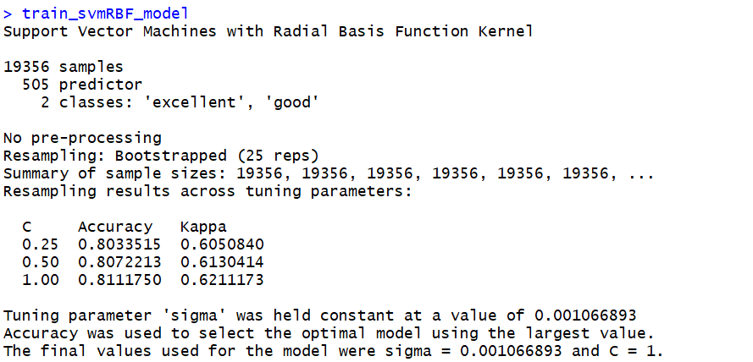

SVMRBF kenel

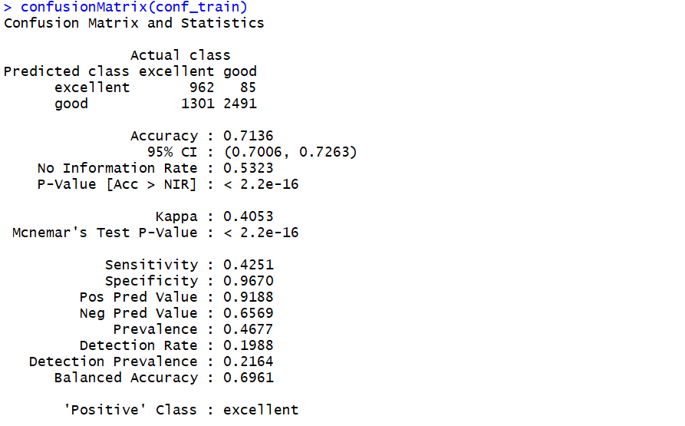

SVMRBF result

As we can see in the result, The accuracy when training data for NB, SVM Linear and SVM RBF is 75.1%, 78.6%, and 81.1%. As a result, I expected that the accuracy when testing with test data will be similar. But they are 74.68% for NB, 78.59% for SVM Linear and 71.36%. SVM Linear is the kernel which has the highest value of accuracy for testing. Noticed that No information rate (NIR) 0.5323 mean that a class takes 53.23%(Good class), which mean the data is balanced. We can judge that the model is actually work.

But, accuracy is just one side of the story. Let see about the classification: We have two classes “good” and “excellent”. If the class is predicted exactly, it’s perfect. Obviously, excellent wine is better than good wine. So, if a good wine is predicted as excellent wine, it’s hard to accept (Similar to false negative-FN). In contrast, If you pretend to buy good wine but have excellent wine. You are just lucky and nothing happened. (similar with false positive-FP)

SVM RBF kernel show the lowest number of false negative. But, I also see that the predicted result is biased to the “good” class: The number of good wine is predicted is triple as the number of excellent wine. It’s quite hard for understand. On the other hand, SVM Linear is better than NB in all indicators.

After all, I consider the accuracy, the number of confusion matrix and the training time for choosing the best model. In my opinion, It’s SVM Linear. (SVM RBF is interesting but it’s hard when I try to improve the model with that high training time, consider the scope of this project)

* Improve the model: I’ll try to improve the SVM linear model with the following methods:
* Improve with n-gram: Firstly, I try to train the model with 2-gram, (the preprocess still remain) here is the first line of Dtm:

wine_train_set[1,]

## acid_us age_drink alsac_alsac   
## 0.0000000 0.0000000 0.0000000   
## appl_pear aroma_flavor aroma_lead   
## 0.0000000 0.0000000 0.0000000   
## bake_spice barolo_nebbiolo berri_aroma   
## 0.0000000 0.0000000 0.0000000   
## berri_flavor berri_fruit black_cherri   
## 0.0000000 0.0000000 0.0000000   
## black_currant black_fruit black_pepper   
## 0.0000000 0.0000000 0.0000000   
## black_plum blackberri_cherri blend_cabernet   
## 0.0000000 0.0000000 0.0000000   
## bordeaux_bordeaux bordeauxstyl_red bright_acid   
## 0.0000000 0.0000000 0.0000000   
## cabernet_franc cabernet_sauvignon california_california   
## 0.0000000 0.0000000 0.0000000   
## california_napa california_paso california_russian   
## 0.0000000 0.0000000 0.0000000   
## california_santa california_sonoma central_coast   
## 0.0000000 0.0000000 0.0000000   
## central_valley champagn_blend champagn_champagn   
## 0.0000000 0.0000000 0.0000000   
## cherri_flavor cherri_fruit cherri_raspberri   
## 0.0000000 0.0000000 0.0000000   
## coast_chardonnay coast_pinot coast_sonoma   
## 0.0000000 0.0000000 0.0000000   
## columbia_valley counti_central counti_sonoma   
## 0.0000000 0.0000000 0.0000000   
## crisp_acid ctes_de dark_chocol   
## 0.0000000 0.0000000 0.0000000   
## dark_fruit di_montalcino dri_herb   
## 0.0000000 0.0000000 0.0000000   
## drink_franc drink_itali drink_now   
## 0.0000000 0.0000000 0.0000000   
## drink_portug estat_california estat_grown   
## 0.0000000 0.0000000 0.0000000   
## finger_lake finish_drink finish_itali   
## 0.0000000 0.0000000 0.0000000   
## finish_us firm_tannin flavor_blackberri   
## 0.0000000 0.0000000 0.0000000   
## flavor_finish flavor_us franc_bordeaux   
## 0.1711132 0.0000000 0.0000000   
## french_oak fresh_acid fruit_flavor   
## 0.0000000 0.0000000 0.0000000   
## full_bodi green_appl itali_tuscani   
## 0.0000000 0.0000000 0.0000000   
## lake_finger lead_nose linger_finish   
## 0.0000000 0.0000000 0.0000000   
## loir_valley long_finish medium_bodi   
## 0.0000000 0.0000000 0.0000000   
## mendoza_provinc montalcino_sangioves napa_cabernet   
## 0.0000000 0.0000000 0.0000000   
## napa_valley new_york new_zealand   
## 0.0000000 0.0000000 0.0000000   
## northeastern_itali northern_spain nose_palat   
## 0.0000000 0.0000000 0.0000000   
## now_franc now_us old_vine   
## 0.0000000 0.0000000 0.0000000   
## open_aroma oregon_willamett palat_deliv   
## 0.0000000 0.0000000 0.0000000   
## palat_offer palat_show paso_robl   
## 0.0000000 0.0000000 0.0000000   
## petit_sirah petit_verdot piedmont_barolo   
## 0.0000000 0.0000000 0.0000000   
## pinot_gris pinot_noir portugues_red   
## 0.0000000 0.0000000 0.0000000   
## provinc_mendoza raspberri_cherri readi_drink   
## 0.0000000 0.0000000 0.0000000   
## red_berri red_blend red_cherri   
## 0.0000000 0.0000000 0.0000000   
## red_currant red_fruit reserv_california   
## 0.0000000 0.0000000 0.0000000   
## rhnestyl_red ripe_fruit river_valley   
## 0.0000000 0.0000000 0.0000000   
## robl_central russian_river santa_barbara   
## 0.0000000 0.0000000 0.0000000   
## sauvignon_blanc sicili_sardinia sierra_foothil   
## 0.0000000 0.0000000 0.0000000   
## sonoma_chardonnay sonoma_coast sonoma_counti   
## 0.0000000 0.0000000 0.0000000   
## sonoma_pinot south_africa south_australia   
## 0.0000000 0.0000000 0.0000000   
## southwest_franc spain_rioja sparkl_blend   
## 0.0000000 0.0000000 0.0000000   
## spice_flavor stone_fruit tannin_drink   
## 0.0000000 0.0000000 0.0000000   
## tropic_fruit us_california us_estat   
## 0.0000000 0.0000000 0.0000000   
## us_oregon us_reserv us_washington   
## 0.0000000 0.0000000 0.0000000   
## valley_cabernet valley_central valley_chardonnay   
## 0.0000000 0.0000000 0.1922822   
## valley_napa valley_pinot valley_red   
## 0.0000000 0.0000000 0.0000000   
## valley_sonoma valley_syrah valley_wa   
## 0.0000000 0.0000000 0.0000000   
## valley_willamett vineyard_california vineyard_washington   
## 0.0000000 0.0000000 0.0000000   
## wa_columbia washington_columbia white_blend   
## 0.0000000 0.0000000 0.0000000   
## white_peach white_pepper willamett_valley   
## 0.0000000 0.0000000 0.0000000   
## wood_age year_us york_finger   
## 0.0000000 0.0000000 0.0000000

Here is the result:

train_svmLinear_model

## L2 Regularized Support Vector Machine (dual) with Linear Kernel   
##   
## 19356 samples  
## 156 predictor  
## 2 classes: 'excellent', 'good'   
##   
## No pre-processing  
## Resampling: Bootstrapped (25 reps)   
## Summary of sample sizes: 19356, 19356, 19356, 19356, 19356, 19356, ...   
## Resampling results across tuning parameters:  
##   
## cost Loss Accuracy Kappa   
## 0.25 L1 0.6436272 0.2823927  
## 0.25 L2 0.6494504 0.2968135  
## 0.50 L1 0.6455226 0.2896008  
## 0.50 L2 0.6498153 0.2976152  
## 1.00 L1 0.6466283 0.2928574  
## 1.00 L2 0.6499836 0.2979705  
##   
## Accuracy was used to select the optimal model using the largest value.  
## The final values used for the model were cost = 1 and Loss = L2.

confusionMatrix(conf_svmLinear_train)

## Confusion Matrix and Statistics  
##   
## Actual class  
## Predicted class excellent good  
## excellent 1200 668  
## good 1063 1908  
##   
## Accuracy : 0.6423   
## 95% CI : (0.6286, 0.6558)  
## No Information Rate : 0.5323   
## P-Value [Acc > NIR] : < 2.2e-16   
##   
## Kappa : 0.2739   
## Mcnemar's Test P-Value : < 2.2e-16   
##   
## Sensitivity : 0.5303   
## Specificity : 0.7407   
## Pos Pred Value : 0.6424   
## Neg Pred Value : 0.6422   
## Prevalence : 0.4677   
## Detection Rate : 0.2480   
## Detection Prevalence : 0.3860   
## Balanced Accuracy : 0.6355   
##   
## 'Positive' Class : excellent   
##

The result is worse than the previous in all indicator, which means 2-gram is not useful. Based on my observation. After preprocess and steaming, the description is quite discrete. I mean the words are likely not connected to each other. It leads to the 2-gram model does not work.

* I continue with both bag of words and 2-gram (which means 1-2gram). Here is the first line of Dtm:

wine_train_set_ngram[1,]

## accent acid acid_us   
## 0.00000000 0.00000000 0.00000000   
## across add africa   
## 0.00000000 0.00000000 0.00000000   
## aftertast age age_drink   
## 0.00000000 0.00000000 0.00000000   
## alcohol almond almost   
## 0.00000000 0.00000000 0.07871341   
## along alongsid alreadi   
## 0.00000000 0.00000000 0.00000000   
## alsac alsac_alsac also   
## 0.00000000 0.00000000 0.00000000   
## although ampl anis   
## 0.00000000 0.00000000 0.00000000   
## anoth appeal appl   
## 0.00000000 0.00000000 0.00000000   
## appl_pear approach apricot   
## 0.00000000 0.00000000 0.00000000   
## argentina aroma aroma_flavor   
## 0.00000000 0.00000000 0.00000000   
## aroma_lead aromat around   
## 0.00000000 0.00000000 0.00000000   
## astring attract australia   
## 0.00000000 0.00000000 0.00000000   
## austria back bake   
## 0.00000000 0.00000000 0.00000000   
## bake_spice balanc barbara   
## 0.00000000 0.00000000 0.00000000   
## barolo barolo_nebbiolo barrel   
## 0.00000000 0.00000000 0.07770259   
## beauti berri berri_aroma   
## 0.00000000 0.00000000 0.00000000   
## berri_flavor berri_fruit best   
## 0.00000000 0.00000000 0.00000000   
## better big bit   
## 0.00000000 0.00000000 0.00000000   
## bitter black black_cherri   
## 0.00000000 0.00000000 0.00000000   
## black_currant black_fruit black_pepper   
## 0.00000000 0.00000000 0.00000000   
## black_plum blackberri blackberri_cherri   
## 0.00000000 0.00000000 0.00000000   
## blanc blend blend_cabernet   
## 0.00000000 0.00000000 0.00000000   
## blossom blue blueberri   
## 0.00000000 0.00000000 0.00000000   
## bodi bold bordeaux   
## 0.00000000 0.00000000 0.00000000   
## bordeaux_bordeaux bordeauxstyl bordeauxstyl_red   
## 0.00000000 0.00000000 0.00000000   
## bottl bouquet boysenberri   
## 0.00000000 0.00000000 0.00000000   
## brambl bright bright_acid   
## 0.00000000 0.00000000 0.00000000   
## bring brisk brut   
## 0.00000000 0.00000000 0.00000000   
## burgundi butter cab   
## 0.00000000 0.00000000 0.00000000   
## cabernet cabernet_franc cabernet_sauvignon   
## 0.00000000 0.00000000 0.00000000   
## california california_california california_napa   
## 0.00000000 0.00000000 0.00000000   
## california_paso california_russian california_santa   
## 0.00000000 0.00000000 0.00000000   
## california_sonoma can candi   
## 0.00000000 0.00000000 0.00000000   
## caramel carnero carri   
## 0.00000000 0.00000000 0.00000000   
## cassi catalonia cedar   
## 0.00000000 0.00000000 0.00000000   
## cellar central central_coast   
## 0.00000000 0.00000000 0.00000000   
## central_valley champagn champagn_blend   
## 0.00000000 0.00000000 0.00000000   
## champagn_champagn char charact   
## 0.00000000 0.00000000 0.00000000   
## chardonnay cherri cherri_flavor   
## 0.10125128 0.00000000 0.00000000   
## cherri_fruit cherri_raspberri chewi   
## 0.00000000 0.00000000 0.00000000   
## chile chocol chunki   
## 0.07468663 0.00000000 0.00000000   
## cinnamon citrus citrusi   
## 0.00000000 0.00000000 0.00000000   
## classic classico clean   
## 0.00000000 0.00000000 0.00000000   
## close clove coast   
## 0.00000000 0.07721394 0.00000000   
## coast_chardonnay coast_pinot coast_sonoma   
## 0.00000000 0.00000000 0.00000000   
## cocoa coffe cola   
## 0.00000000 0.00000000 0.00000000   
## color columbia columbia_valley   
## 0.00000000 0.00000000 0.00000000   
## combin come complex   
## 0.00000000 0.00000000 0.00000000   
## concentr cool core   
## 0.00000000 0.00000000 0.00000000   
## counti counti_central counti_sonoma   
## 0.00000000 0.00000000 0.00000000   
## cranberri creami creek   
## 0.00000000 0.00000000 0.00000000   
## crisp crisp_acid cru   
## 0.00000000 0.00000000 0.00000000   
## crush ctes ctes_de   
## 0.00000000 0.00000000 0.00000000   
## currant cut cuve   
## 0.00000000 0.00000000 0.00000000   
## dark dark_chocol dark_fruit   
## 0.00000000 0.00000000 0.00000000   
## deep del delic   
## 0.00000000 0.00000000 0.00000000   
## delici deliv dens   
## 0.00000000 0.00000000 0.00000000   
## depth despit develop   
## 0.00000000 0.00000000 0.00000000   
## di_montalcino doesnt domin   
## 0.00000000 0.00000000 0.00000000   
## dri dri_herb drink   
## 0.00000000 0.00000000 0.00000000   
## drink_franc drink_itali drink_now   
## 0.00000000 0.00000000 0.00000000   
## drink_portug dusti earth   
## 0.00000000 0.00000000 0.00000000   
## earthi easi edg   
## 0.00000000 0.00000000 0.00000000   
## eleg element end   
## 0.00000000 0.00000000 0.00000000   
## enjoy enough espresso   
## 0.00000000 0.00000000 0.00000000   
## estat estat_california estat_grown   
## 0.00000000 0.00000000 0.00000000   
## even excel exot   
## 0.00000000 0.00000000 0.00000000   
## express extra extract   
## 0.00000000 0.00000000 0.00000000   
## fair famili featur   
## 0.00000000 0.00000000 0.00000000   
## feel ferment fill   
## 0.00000000 0.00000000 0.00000000   
## find fine finger   
## 0.00000000 0.00000000 0.00000000   
## finger_lake finish finish_drink   
## 0.00000000 0.02533285 0.00000000   
## finish_itali finish_us firm   
## 0.00000000 0.00000000 0.00000000   
## firm_tannin first flavor   
## 0.00000000 0.00000000 0.01500940   
## flavor_blackberri flavor_finish flavor_us   
## 0.00000000 0.08424033 0.00000000   
## fleshi floral flower   
## 0.00000000 0.00000000 0.00000000   
## focus follow food   
## 0.00000000 0.00000000 0.00000000   
## foothil forest forward   
## 0.00000000 0.00000000 0.00000000   
## fragrant frame franc   
## 0.00000000 0.00000000 0.00000000   
## franc_bordeaux french french_oak   
## 0.00000000 0.00000000 0.00000000   
## fresh fresh_acid front   
## 0.00000000 0.00000000 0.00000000   
## fruit fruit_flavor fruiti   
## 0.02084889 0.00000000 0.00000000   
## full full_bodi fullbodi   
## 0.00000000 0.00000000 0.00000000   
## generous gentl germani   
## 0.00000000 0.00000000 0.00000000   
## get give glass   
## 0.09370379 0.00000000 0.00000000   
## good grand grape   
## 0.00000000 0.00000000 0.00000000   
## grapefruit graphit great   
## 0.00000000 0.00000000 0.00000000   
## green green_appl grenach   
## 0.00000000 0.00000000 0.00000000   
## grill grip gris   
## 0.00000000 0.00000000 0.00000000   
## grown hard heavi   
## 0.00000000 0.00000000 0.00000000   
## herb herbal high   
## 0.00000000 0.00000000 0.00000000   
## highlight hill hint   
## 0.00000000 0.00000000 0.00000000   
## hold honey honeysuckl   
## 0.00000000 0.00000000 0.00000000   
## hot impress includ   
## 0.00000000 0.00000000 0.00000000   
## integr intens interest   
## 0.00000000 0.00000000 0.00000000   
## intrigu invit itali   
## 0.00000000 0.00000000 0.00000000   
## itali_tuscani jam jammi   
## 0.00000000 0.00000000 0.00000000   
## juic juici just   
## 0.00000000 0.00000000 0.00000000   
## keep lack lake   
## 0.00000000 0.00000000 0.00000000   
## lake_finger last layer   
## 0.00000000 0.00000000 0.00000000   
## lead lead_nose leaf   
## 0.00000000 0.00000000 0.00000000   
## lean least leather   
## 0.00000000 0.00000000 0.00000000   
## leav lemon lend   
## 0.00000000 0.00000000 0.00000000   
## length les licoric   
## 0.00000000 0.00000000 0.00000000   
## lift light like   
## 0.00000000 0.00000000 0.00000000   
## lime linger linger_finish   
## 0.00000000 0.00000000 0.00000000   
## littl live load   
## 0.00000000 0.00000000 0.00000000   
## loir loir_valley long   
## 0.00000000 0.00000000 0.00000000   
## long_finish lot love   
## 0.00000000 0.00000000 0.00000000   
## lush made make   
## 0.00000000 0.00000000 0.00000000   
## malbec mango mani   
## 0.00000000 0.00000000 0.00000000   
## mark matur meat   
## 0.00000000 0.00000000 0.00000000   
## medium medium_bodi mediumbodi   
## 0.00000000 0.00000000 0.00000000   
## melon mendoza mendoza_provinc   
## 0.00000000 0.00000000 0.00000000   
## merlot midpal mild   
## 0.00000000 0.00000000 0.00000000   
## miner mint mix   
## 0.00000000 0.00000000 0.00000000   
## mocha moder montalcino   
## 0.00000000 0.00000000 0.00000000   
## montalcino_sangioves month mountain   
## 0.00000000 0.00000000 0.00000000   
## mourvdr mouth mouthfeel   
## 0.00000000 0.00000000 0.00000000   
## much napa napa_cabernet   
## 0.00000000 0.00000000 0.00000000   
## napa_valley napasonoma natur   
## 0.00000000 0.00000000 0.00000000   
## nebbiolo nectarin need   
## 0.00000000 0.00000000 0.00000000   
## new new_york new_zealand   
## 0.00000000 0.00000000 0.00000000   
## next nice noir   
## 0.00000000 0.00000000 0.00000000   
## north northeastern northeastern_itali   
## 0.00000000 0.00000000 0.00000000   
## northern northern_spain nose   
## 0.00000000 0.00000000 0.00000000   
## nose_palat note now   
## 0.00000000 0.00000000 0.00000000   
## now_franc now_us nuanc   
## 0.00000000 0.00000000 0.00000000   
## oak oaki offer   
## 0.04498787 0.00000000 0.00000000   
## old old_vine oliv   
## 0.00000000 0.00000000 0.00000000   
## one open open_aroma   
## 0.00000000 0.00000000 0.00000000   
## opul orang oregon   
## 0.00000000 0.00000000 0.00000000   
## oregon_willamett overal pack   
## 0.00000000 0.00000000 0.00000000   
## pair palat palat_deliv   
## 0.00000000 0.02711122 0.00000000   
## palat_offer palat_show paso   
## 0.00000000 0.00000000 0.00000000   
## paso_robl peach pear   
## 0.00000000 0.00000000 0.00000000   
## peel pepper pepperi   
## 0.00000000 0.00000000 0.00000000   
## perfect perfum persist   
## 0.00000000 0.00000000 0.00000000   
## petit petit_sirah petit_verdot   
## 0.00000000 0.00000000 0.00000000   
## pie piedmont piedmont_barolo   
## 0.00000000 0.00000000 0.00000000   
## pineappl pinot pinot_gris   
## 0.00000000 0.00000000 0.00000000   
## pinot_noir play pleasant   
## 0.00000000 0.00000000 0.00000000   
## plenti plum plump   
## 0.00000000 0.00000000 0.09771923   
## polish pomegran portug   
## 0.00000000 0.00000000 0.00000000   
## portugues portugues_red potenti   
## 0.00000000 0.00000000 0.00000000   
## power present pretti   
## 0.00000000 0.00000000 0.00000000   
## price produc provid   
## 0.00000000 0.00000000 0.00000000   
## provinc provinc_mendoza prune   
## 0.00000000 0.00000000 0.00000000   
## pure purpl qualiti   
## 0.00000000 0.00000000 0.00000000   
## quit raci raisin   
## 0.00000000 0.00000000 0.00000000   
## ranch raspberri raspberri_cherri   
## 0.00000000 0.00000000 0.00000000   
## rather readi readi_drink   
## 0.00000000 0.00000000 0.00000000   
## red red_berri red_blend   
## 0.00000000 0.00000000 0.00000000   
## red_cherri red_currant red_fruit   
## 0.00000000 0.00000000 0.00000000   
## refresh region remain   
## 0.00000000 0.00000000 0.00000000   
## reserv reserv_california reserva   
## 0.00000000 0.00000000 0.00000000   
## reveal rhnestyl rhnestyl_red   
## 0.00000000 0.00000000 0.00000000   
## rich riesl right   
## 0.00000000 0.00000000 0.00000000   
## rioja ripe ripe_fruit   
## 0.00000000 0.00000000 0.00000000   
## riserva river river_valley   
## 0.00000000 0.00000000 0.00000000   
## roast robl robl_central   
## 0.00000000 0.00000000 0.00000000   
## ros rose round   
## 0.00000000 0.00000000 0.00000000   
## russian russian_river rustic   
## 0.00000000 0.00000000 0.00000000   
## sage sangioves santa   
## 0.00000000 0.00000000 0.00000000   
## santa_barbara sardinia sauvignon   
## 0.00000000 0.00000000 0.00000000   
## sauvignon_blanc savori scent   
## 0.00000000 0.00000000 0.00000000   
## seem select sens   
## 0.00000000 0.00000000 0.00000000   
## set sharp show   
## 0.00000000 0.00000000 0.00000000   
## sicili sicili_sardinia side   
## 0.00000000 0.00000000 0.00000000   
## sierra sierra_foothil silki   
## 0.00000000 0.00000000 0.00000000   
## simpl sip sirah   
## 0.00000000 0.00000000 0.00000000   
## skin slight smell   
## 0.00000000 0.00000000 0.08964408   
## smoke smoki smooth   
## 0.00000000 0.00000000 0.00000000   
## soft soften soil   
## 0.00000000 0.00000000 0.00000000   
## solid somewhat sonoma   
## 0.00000000 0.00000000 0.00000000   
## sonoma_chardonnay sonoma_coast sonoma_counti   
## 0.00000000 0.00000000 0.00000000   
## sonoma_pinot soon sour   
## 0.00000000 0.00000000 0.00000000   
## sourc south south_africa   
## 0.00000000 0.00000000 0.00000000   
## south_australia southern southwest   
## 0.00000000 0.00000000 0.00000000   
## southwest_franc spain spain_rioja   
## 0.00000000 0.00000000 0.00000000   
## sparkl sparkl_blend spice   
## 0.00000000 0.00000000 0.07907191   
## spice_flavor spici start   
## 0.00000000 0.00000000 0.00000000   
## still stone stone_fruit   
## 0.00000000 0.00000000 0.00000000   
## straightforward strawberri streak   
## 0.00000000 0.00000000 0.00000000   
## strong structur style   
## 0.00000000 0.00000000 0.00000000   
## subtl sugar suggest   
## 0.00000000 0.00000000 0.00000000   
## superior suppl support   
## 0.00000000 0.00000000 0.00000000   
## sweet syrah take   
## 0.00000000 0.00000000 0.00000000   
## tangerin tangi tannic   
## 0.00000000 0.00000000 0.00000000   
## tannin tannin_drink tart   
## 0.00000000 0.00000000 0.00000000   
## tast tea tempranillo   
## 0.06558790 0.00000000 0.00000000   
## textur that there   
## 0.00000000 0.07944119 0.00000000   
## thick though tight   
## 0.00000000 0.00000000 0.00000000   
## time toast toasti   
## 0.00000000 0.00000000 0.00000000   
## tobacco togeth tomato   
## 0.00000000 0.00000000 0.00000000   
## tone toscana touch   
## 0.00000000 0.00000000 0.00000000   
## tropic tropic_fruit turn   
## 0.00000000 0.00000000 0.00000000   
## tuscani two underbrush   
## 0.00000000 0.00000000 0.00000000   
## us_california us_estat us_oregon   
## 0.00000000 0.00000000 0.00000000   
## us_reserv us_washington valley   
## 0.00000000 0.00000000 0.02654286   
## valley_cabernet valley_central valley_chardonnay   
## 0.00000000 0.00000000 0.09466201   
## valley_napa valley_pinot valley_red   
## 0.00000000 0.00000000 0.00000000   
## valley_sonoma valley_syrah valley_wa   
## 0.00000000 0.00000000 0.00000000   
## valley_willamett vanilla variet   
## 0.00000000 0.05590905 0.00000000   
## varieti velveti veneto   
## 0.00000000 0.00000000 0.00000000   
## verdot veri vibrant   
## 0.00000000 0.00000000 0.00000000   
## vine vineyard vineyard_california   
## 0.00000000 0.00000000 0.00000000   
## vineyard_washington vintag viognier   
## 0.00000000 0.00000000 0.00000000   
## violet wa_columbia warm   
## 0.00000000 0.00000000 0.00000000   
## washington washington_columbia way   
## 0.00000000 0.00000000 0.00000000   
## weight well wet   
## 0.00000000 0.00000000 0.00000000   
## whiff white white_blend   
## 0.00000000 0.00000000 0.00000000   
## white_peach white_pepper wild   
## 0.00000000 0.00000000 0.00000000   
## will willamett willamett_valley   
## 0.00000000 0.00000000 0.00000000   
## wine winemak wineri   
## 0.00000000 0.00000000 0.00000000   
## without wonder wood   
## 0.00000000 0.00000000 0.07108113   
## wood_age wrap year   
## 0.00000000 0.00000000 0.00000000   
## year_us yellow yet   
## 0.00000000 0.00000000 0.00000000   
## york york_finger young   
## 0.00000000 0.00000000 0.00000000   
## zealand zest zesti   
## 0.00000000 0.00000000 0.00000000   
## zinfandel   
## 0.00000000

And here is the result:

train_svmLinear_model

## L2 Regularized Support Vector Machine (dual) with Linear Kernel   
##   
## 19356 samples  
## 661 predictor  
## 2 classes: 'excellent', 'good'   
##   
## No pre-processing  
## Resampling: Bootstrapped (25 reps)   
## Summary of sample sizes: 19356, 19356, 19356, 19356, 19356, 19356, ...   
## Resampling results across tuning parameters:  
##   
## cost Loss Accuracy Kappa   
## 0.25 L1 0.7804824 0.5592447  
## 0.25 L2 0.7903403 0.5793207  
## 0.50 L1 0.7862217 0.5711220  
## 0.50 L2 0.7911250 0.5810424  
## 1.00 L1 0.7893797 0.5776108  
## 1.00 L2 0.7902474 0.5793807  
##   
## Accuracy was used to select the optimal model using the largest value.  
## The final values used for the model were cost = 0.5 and Loss = L2.

confusionMatrix(conf_svmLinear_train)

## Confusion Matrix and Statistics  
##   
## Actual class  
## Predicted class excellent good  
## excellent 1603 371  
## good 660 2205  
##   
## Accuracy : 0.7869   
## 95% CI : (0.7751, 0.7984)  
## No Information Rate : 0.5323   
## P-Value [Acc > NIR] : < 2.2e-16   
##   
## Kappa : 0.5687   
## Mcnemar's Test P-Value : < 2.2e-16   
##   
## Sensitivity : 0.7084   
## Specificity : 0.8560   
## Pos Pred Value : 0.8121   
## Neg Pred Value : 0.7696   
## Prevalence : 0.4677   
## Detection Rate : 0.3313   
## Detection Prevalence : 0.4079   
## Balanced Accuracy : 0.7822   
##   
## 'Positive' Class : excellent   
##

The accuracy is slightly increased. Good news is the False negative is really better (371 compare to 448) of course the false positive shows an increase. It’s like the trade-off between models.To explain, I see that there are some important pairs that impove the model. Consider that and the dimension of Dtm is large (which lead to high training time), while there are too many features with 0 point. I conclude that 1-2 gram is a little bit better.

* The other attempt to improve is adjusted the weight for DTM (with bag of words). As I observed in the data. The description usually talk about ingredients: lemon, cherry or region: California… So, the first idea is double the point for nouns and see how it works. On the other hand, Adjective used to describe the flavor of wine could make an important role. So, the second ideal is double the point for adj only. To do these. I implement POS tagger and see which word is nouns, adj, verb…

Here are the list nouns that I extracted:`

nouns

## [1] "accent" "acid" "age" "alcohol"   
## [5] "almond" "alreadi" "alsac" "appeal"   
## [9] "approach" "apricot" "argentina" "aroma"   
## [13] "austria" "bake" "balanc" "barbara"   
## [17] "barolo" "barrel" "beauti" "berri"   
## [21] "bit" "blanc" "blend" "bodi"   
## [25] "bordeaux" "bordeauxstyl" "bottl" "bouquet"   
## [29] "boysenberri" "brambl" "brut" "butter"   
## [33] "cab" "cabernet" "california" "caramel"   
## [37] "carnero" "carri" "cassi" "catalonia"   
## [41] "cedar" "cellar" "champagn" "char"   
## [45] "charact" "chardonnay" "cherri" "chewi"   
## [49] "chile" "chocol" "chunki" "cinnamon"   
## [53] "citrus" "classico" "clove" "coast"   
## [57] "cocoa" "coffe" "cola" "color"   
## [61] "columbia" "combin" "concentr" "core"   
## [65] "creek" "crisp" "cru" "crush"   
## [69] "cut" "delic" "depth" "despit"   
## [73] "domin" "dri" "drink" "earth"   
## [77] "earthi" "eleg" "element" "end"   
## [81] "espresso" "estat" "express" "ferment"   
## [85] "fill" "finger" "firm" "flavor"   
## [89] "flower" "focus" "food" "foothil"   
## [93] "forest" "frame" "franc" "french"   
## [97] "front" "fruit" "fruiti" "gentl"   
## [101] "glass" "grape" "grapefruit" "grenach"   
## [105] "grill" "grip" "herb" "high"   
## [109] "highlight" "hill" "hint" "honey"   
## [113] "integr" "interest" "invit" "jam"   
## [117] "jammi" "lack" "lake" "layer"   
## [121] "lead" "leaf" "leather" "leav"   
## [125] "lemon" "length" "lift" "light"   
## [129] "lime" "linger" "load" "mango"   
## [133] "mark" "matur" "meat" "medium"   
## [137] "melon" "mendoza" "merlot" "midpal"   
## [141] "miner" "mint" "mix" "mocha"   
## [145] "moder" "month" "mountain" "mourvdr"   
## [149] "mouth" "mouthfeel" "napa" "napasonoma"   
## [153] "natur" "nebbiolo" "nectarin" "noir"   
## [157] "north" "nose" "note" "oak"   
## [161] "oaki" "one" "opul" "oregon"   
## [165] "pack" "pair" "palat" "paso"   
## [169] "peach" "pear" "peel" "pepper"   
## [173] "pepperi" "perfum" "pie" "piedmont"   
## [177] "pineappl" "play" "plum" "plump"   
## [181] "polish" "pomegran" "portug" "power"   
## [185] "present" "price" "produc" "provinc"   
## [189] "prune" "purpl" "qualiti" "ranch"   
## [193] "raspberri" "region" "reserva" "rhnestyl"   
## [197] "rioja" "riserva" "river" "roast"   
## [201] "sage" "sardinia" "sauvignon" "scent"   
## [205] "show" "side" "sierra" "silki"   
## [209] "sip" "skin" "smell" "smoke"   
## [213] "soil" "sonoma" "sourc" "southwest"   
## [217] "spain" "sparkl" "spice" "stone"   
## [221] "streak" "structur" "style" "sugar"   
## [225] "support" "syrah" "tangerin" "tannin"   
## [229] "tart" "tast" "tea" "textur"   
## [233] "time" "toast" "toasti" "tobacco"   
## [237] "tone" "touch" "tropic" "turn"   
## [241] "valley" "vanilla" "varieti" "velveti"   
## [245] "veneto" "verdot" "veri" "vine"   
## [249] "vineyard" "vintag" "viognier" "violet"   
## [253] "way" "weight" "will" "wine"   
## [257] "winemak" "wineri" "wonder" "wood"   
## [261] "wrap" "year" "yellow" "zealand"   
## [265] "zest" "zesti" "zinfandel"

Let’s take a look at the Dtm of the first document to make sure that the points for nouns is doubled. As we can see below, the points for the word “california” is 0.139. It’s just 0.064 before.

wine_train_set[1,]

## accent acid across add   
## 0.00000000 0.00000000 0.00000000 0.00000000   
## africa aftertast age alcohol   
## 0.00000000 0.00000000 0.00000000 0.00000000   
## almond almost along alongsid   
## 0.00000000 0.15504157 0.00000000 0.00000000   
## alreadi alsac also although   
## 0.00000000 0.00000000 0.00000000 0.00000000   
## ampl anis anoth appeal   
## 0.00000000 0.00000000 0.00000000 0.00000000   
## appl approach apricot argentina   
## 0.00000000 0.00000000 0.00000000 0.00000000   
## aroma aromat around astring   
## 0.00000000 0.00000000 0.00000000 0.00000000   
## attract australia austria back   
## 0.00000000 0.00000000 0.00000000 0.00000000   
## bake balanc barbara barolo   
## 0.00000000 0.00000000 0.00000000 0.00000000   
## barrel beauti berri best   
## 0.30610113 0.00000000 0.00000000 0.00000000   
## better big bit bitter   
## 0.00000000 0.00000000 0.00000000 0.00000000   
## black blackberri blanc blend   
## 0.00000000 0.00000000 0.00000000 0.00000000   
## blossom blue blueberri bodi   
## 0.00000000 0.00000000 0.00000000 0.00000000   
## bold bordeaux bordeauxstyl bottl   
## 0.00000000 0.00000000 0.00000000 0.00000000   
## bouquet boysenberri brambl bright   
## 0.00000000 0.00000000 0.00000000 0.00000000   
## bring brisk brut burgundi   
## 0.00000000 0.00000000 0.00000000 0.00000000   
## butter cab cabernet california   
## 0.00000000 0.00000000 0.00000000 0.00000000   
## can candi caramel carnero   
## 0.00000000 0.00000000 0.00000000 0.00000000   
## carri cassi catalonia cedar   
## 0.00000000 0.00000000 0.00000000 0.00000000   
## cellar central champagn char   
## 0.00000000 0.00000000 0.00000000 0.00000000   
## charact chardonnay cherri chewi   
## 0.00000000 0.39886867 0.00000000 0.00000000   
## chile chocol chunki cinnamon   
## 0.29422005 0.00000000 0.00000000 0.00000000   
## citrus citrusi classic classico   
## 0.00000000 0.00000000 0.00000000 0.00000000   
## clean close clove coast   
## 0.00000000 0.00000000 0.30417613 0.00000000   
## cocoa coffe cola color   
## 0.00000000 0.00000000 0.00000000 0.00000000   
## columbia combin come complex   
## 0.00000000 0.00000000 0.00000000 0.00000000   
## concentr cool core counti   
## 0.00000000 0.00000000 0.00000000 0.00000000   
## cranberri creami creek crisp   
## 0.00000000 0.00000000 0.00000000 0.00000000   
## cru crush ctes currant   
## 0.00000000 0.00000000 0.00000000 0.00000000   
## cut cuve dark deep   
## 0.00000000 0.00000000 0.00000000 0.00000000   
## del delic delici deliv   
## 0.00000000 0.00000000 0.00000000 0.00000000   
## dens depth despit develop   
## 0.00000000 0.00000000 0.00000000 0.00000000   
## doesnt domin dri drink   
## 0.00000000 0.00000000 0.00000000 0.00000000   
## dusti earth earthi easi   
## 0.00000000 0.00000000 0.00000000 0.00000000   
## edg eleg element end   
## 0.00000000 0.00000000 0.00000000 0.00000000   
## enjoy enough espresso estat   
## 0.00000000 0.00000000 0.00000000 0.00000000   
## even excel exot express   
## 0.00000000 0.00000000 0.00000000 0.00000000   
## extra extract fair famili   
## 0.00000000 0.00000000 0.00000000 0.00000000   
## featur feel ferment fill   
## 0.00000000 0.00000000 0.00000000 0.00000000   
## find fine finger finish   
## 0.00000000 0.00000000 0.00000000 0.04989804   
## firm first flavor fleshi   
## 0.00000000 0.00000000 0.05912793 0.00000000   
## floral flower focus follow   
## 0.00000000 0.00000000 0.00000000 0.00000000   
## food foothil forest forward   
## 0.00000000 0.00000000 0.00000000 0.00000000   
## fragrant frame franc french   
## 0.00000000 0.00000000 0.00000000 0.00000000   
## fresh front fruit fruiti   
## 0.00000000 0.00000000 0.08213201 0.00000000   
## full fullbodi generous gentl   
## 0.00000000 0.00000000 0.00000000 0.00000000   
## germani get give glass   
## 0.00000000 0.18456806 0.00000000 0.00000000   
## good grand grape grapefruit   
## 0.00000000 0.00000000 0.00000000 0.00000000   
## graphit great green grenach   
## 0.00000000 0.00000000 0.00000000 0.00000000   
## grill grip gris grown   
## 0.00000000 0.00000000 0.00000000 0.00000000   
## hard heavi herb herbal   
## 0.00000000 0.00000000 0.00000000 0.00000000   
## high highlight hill hint   
## 0.00000000 0.00000000 0.00000000 0.00000000   
## hold honey honeysuckl hot   
## 0.00000000 0.00000000 0.00000000 0.00000000   
## impress includ integr intens   
## 0.00000000 0.00000000 0.00000000 0.00000000   
## interest intrigu invit itali   
## 0.00000000 0.00000000 0.00000000 0.00000000   
## jam jammi juic juici   
## 0.00000000 0.00000000 0.00000000 0.00000000   
## just keep lack lake   
## 0.00000000 0.00000000 0.00000000 0.00000000   
## last layer lead leaf   
## 0.00000000 0.00000000 0.00000000 0.00000000   
## lean least leather leav   
## 0.00000000 0.00000000 0.00000000 0.00000000   
## lemon lend length les   
## 0.00000000 0.00000000 0.00000000 0.00000000   
## licoric lift light like   
## 0.00000000 0.00000000 0.00000000 0.00000000   
## lime linger littl live   
## 0.00000000 0.00000000 0.00000000 0.00000000   
## load loir long lot   
## 0.00000000 0.00000000 0.00000000 0.00000000   
## love lush made make   
## 0.00000000 0.00000000 0.00000000 0.00000000   
## malbec mango mani mark   
## 0.00000000 0.00000000 0.00000000 0.00000000   
## matur meat medium mediumbodi   
## 0.00000000 0.00000000 0.00000000 0.00000000   
## melon mendoza merlot midpal   
## 0.00000000 0.00000000 0.00000000 0.00000000   
## mild miner mint mix   
## 0.00000000 0.00000000 0.00000000 0.00000000   
## mocha moder montalcino month   
## 0.00000000 0.00000000 0.00000000 0.00000000   
## mountain mourvdr mouth mouthfeel   
## 0.00000000 0.00000000 0.00000000 0.00000000   
## much napa napasonoma natur   
## 0.00000000 0.00000000 0.00000000 0.00000000   
## nebbiolo nectarin need new   
## 0.00000000 0.00000000 0.00000000 0.00000000   
## next nice noir north   
## 0.00000000 0.00000000 0.00000000 0.00000000   
## northeastern northern nose note   
## 0.00000000 0.00000000 0.00000000 0.00000000   
## now nuanc oak oaki   
## 0.00000000 0.00000000 0.17722495 0.00000000   
## offer old oliv one   
## 0.00000000 0.00000000 0.00000000 0.00000000   
## open opul orang oregon   
## 0.00000000 0.00000000 0.00000000 0.00000000   
## overal pack pair palat   
## 0.00000000 0.00000000 0.00000000 0.10680177   
## paso peach pear peel   
## 0.00000000 0.00000000 0.00000000 0.00000000   
## pepper pepperi perfect perfum   
## 0.00000000 0.00000000 0.00000000 0.00000000   
## persist petit pie piedmont   
## 0.00000000 0.00000000 0.00000000 0.00000000   
## pineappl pinot play pleasant   
## 0.00000000 0.00000000 0.00000000 0.00000000   
## plenti plum plump polish   
## 0.00000000 0.00000000 0.38495454 0.00000000   
## pomegran portug portugues potenti   
## 0.00000000 0.00000000 0.00000000 0.00000000   
## power present pretti price   
## 0.00000000 0.00000000 0.00000000 0.00000000   
## produc provid provinc prune   
## 0.00000000 0.00000000 0.00000000 0.00000000   
## pure purpl qualiti quit   
## 0.00000000 0.00000000 0.00000000 0.00000000   
## raci raisin ranch raspberri   
## 0.00000000 0.00000000 0.00000000 0.00000000   
## rather readi red refresh   
## 0.00000000 0.00000000 0.00000000 0.00000000   
## region remain reserv reserva   
## 0.00000000 0.00000000 0.00000000 0.00000000   
## reveal rhnestyl rich riesl   
## 0.00000000 0.00000000 0.00000000 0.00000000   
## right rioja ripe riserva   
## 0.00000000 0.00000000 0.00000000 0.00000000   
## river roast robl ros   
## 0.00000000 0.00000000 0.00000000 0.00000000   
## rose round russian rustic   
## 0.00000000 0.00000000 0.00000000 0.00000000   
## sage sangioves santa sardinia   
## 0.00000000 0.00000000 0.00000000 0.00000000   
## sauvignon savori scent seem   
## 0.00000000 0.00000000 0.00000000 0.00000000   
## select sens set sharp   
## 0.00000000 0.00000000 0.00000000 0.00000000   
## show sicili side sierra   
## 0.00000000 0.00000000 0.00000000 0.00000000   
## silki simpl sip sirah   
## 0.00000000 0.00000000 0.00000000 0.00000000   
## skin slight smell smoke   
## 0.00000000 0.00000000 0.35314335 0.00000000   
## smoki smooth soft soften   
## 0.00000000 0.00000000 0.00000000 0.00000000   
## soil solid somewhat sonoma   
## 0.00000000 0.00000000 0.00000000 0.00000000   
## soon sour sourc south   
## 0.00000000 0.00000000 0.00000000 0.00000000   
## southern southwest spain sparkl   
## 0.00000000 0.00000000 0.00000000 0.00000000   
## spice spici start still   
## 0.31149539 0.00000000 0.00000000 0.00000000   
## stone straightforward strawberri streak   
## 0.00000000 0.00000000 0.00000000 0.00000000   
## strong structur style subtl   
## 0.00000000 0.00000000 0.00000000 0.00000000   
## sugar suggest superior suppl   
## 0.00000000 0.00000000 0.00000000 0.00000000   
## support sweet syrah take   
## 0.00000000 0.00000000 0.00000000 0.00000000   
## tangerin tangi tannic tannin   
## 0.00000000 0.00000000 0.00000000 0.00000000   
## tart tast tea tempranillo   
## 0.00000000 0.25837656 0.00000000 0.00000000   
## textur that there thick   
## 0.00000000 0.15647508 0.00000000 0.00000000   
## though tight time toast   
## 0.00000000 0.00000000 0.00000000 0.00000000   
## toasti tobacco togeth tomato   
## 0.00000000 0.00000000 0.00000000 0.00000000   
## tone toscana touch tropic   
## 0.00000000 0.00000000 0.00000000 0.00000000   
## turn tuscani two underbrush   
## 0.00000000 0.00000000 0.00000000 0.00000000   
## valley vanilla variet varieti   
## 0.10456280 0.22024776 0.00000000 0.00000000   
## velveti veneto verdot veri   
## 0.00000000 0.00000000 0.00000000 0.00000000   
## vibrant vine vineyard vintag   
## 0.00000000 0.00000000 0.00000000 0.00000000   
## viognier violet warm washington   
## 0.00000000 0.00000000 0.00000000 0.00000000   
## way weight well wet   
## 0.00000000 0.00000000 0.00000000 0.00000000   
## whiff white wild will   
## 0.00000000 0.00000000 0.00000000 0.00000000   
## willamett wine winemak wineri   
## 0.00000000 0.00000000 0.00000000 0.00000000   
## without wonder wood wrap   
## 0.00000000 0.00000000 0.28001657 0.00000000   
## year yellow yet york   
## 0.00000000 0.00000000 0.00000000 0.00000000   
## young zealand zest zesti   
## 0.00000000 0.00000000 0.00000000 0.00000000   
## zinfandel   
## 0.00000000

Here is the resut:

train_svmLinear_model

## L2 Regularized Support Vector Machine (dual) with Linear Kernel   
##   
## 19356 samples  
## 505 predictor  
## 2 classes: 'excellent', 'good'   
##   
## No pre-processing  
## Resampling: Bootstrapped (25 reps)   
## Summary of sample sizes: 19356, 19356, 19356, 19356, 19356, 19356, ...   
## Resampling results across tuning parameters:  
##   
## cost Loss Accuracy Kappa   
## 0.25 L1 0.7835696 0.5658319  
## 0.25 L2 0.7845502 0.5679076  
## 0.50 L1 0.7843196 0.5674399  
## 0.50 L2 0.7840762 0.5670011  
## 1.00 L1 0.7842031 0.5672562  
## 1.00 L2 0.7835764 0.5660250  
##   
## Accuracy was used to select the optimal model using the largest value.  
## The final values used for the model were cost = 0.25 and Loss = L2.

confusionMatrix(conf_svmLinear_train)

## Confusion Matrix and Statistics  
##   
## Actual class  
## Predicted class excellent good  
## excellent 1651 433  
## good 612 2143  
##   
## Accuracy : 0.784   
## 95% CI : (0.7722, 0.7956)  
## No Information Rate : 0.5323   
## P-Value [Acc > NIR] : < 2.2e-16   
##   
## Kappa : 0.5642   
## Mcnemar's Test P-Value : 3.664e-08   
##   
## Sensitivity : 0.7296   
## Specificity : 0.8319   
## Pos Pred Value : 0.7922   
## Neg Pred Value : 0.7779   
## Prevalence : 0.4677   
## Detection Rate : 0.3412   
## Detection Prevalence : 0.4307   
## Balanced Accuracy : 0.7807   
##   
## 'Positive' Class : excellent   
##

We can see that The accuracy is decreasing 0.2%. FN is decreasing a few units. I conclude that the model is not better.

Now double the point only for adjectives: Here is the list adjectives that I extracted:

adj

## [1] "aftertast" "ampl" "appl"   
## [4] "australia" "big" "bitter"   
## [7] "black" "blackberri" "blue"   
## [10] "blueberri" "bold" "bright"   
## [13] "brisk" "central" "classic"   
## [16] "clean" "close" "complex"   
## [19] "cool" "creami" "currant"   
## [22] "cuve" "dark" "deep"   
## [25] "doesnt" "edg" "enough"   
## [28] "exot" "extra" "fair"   
## [31] "fine" "floral" "fragrant"   
## [34] "fresh" "full" "generous"   
## [37] "good" "grand" "great"   
## [40] "green" "hard" "heavi"   
## [43] "hot" "juic" "last"   
## [46] "lean" "licoric" "littl"   
## [49] "live" "lush" "malbec"   
## [52] "mild" "new" "next"   
## [55] "nice" "northeastern" "northern"   
## [58] "nuanc" "old" "oliv"   
## [61] "open" "overal" "perfect"   
## [64] "petit" "pleasant" "pure"   
## [67] "readi" "red" "refresh"   
## [70] "rich" "right" "ripe"   
## [73] "robl" "russian" "rustic"   
## [76] "select" "sharp" "sicili"   
## [79] "simpl" "slight" "smooth"   
## [82] "soft" "solid" "sour"   
## [85] "south" "southern" "straightforward"  
## [88] "strawberri" "strong" "superior"   
## [91] "suppl" "sweet" "tannic"   
## [94] "tempranillo" "thick" "tight"   
## [97] "variet" "vibrant" "warm"   
## [100] "wet" "white" "wild"   
## [103] "young"

And here is the result after double the point for adjetives:

train_svmLinear_model

## L2 Regularized Support Vector Machine (dual) with Linear Kernel   
##   
## 19356 samples  
## 505 predictor  
## 2 classes: 'excellent', 'good'   
##   
## No pre-processing  
## Resampling: Bootstrapped (25 reps)   
## Summary of sample sizes: 19356, 19356, 19356, 19356, 19356, 19356, ...   
## Resampling results across tuning parameters:  
##   
## cost Loss Accuracy Kappa   
## 0.25 L1 0.7812716 0.5612232  
## 0.25 L2 0.7844977 0.5676142  
## 0.50 L1 0.7827696 0.5642357  
## 0.50 L2 0.7840476 0.5667318  
## 1.00 L1 0.7826981 0.5640836  
## 1.00 L2 0.7839151 0.5664589  
##   
## Accuracy was used to select the optimal model using the largest value.  
## The final values used for the model were cost = 0.25 and Loss = L2.

confusionMatrix(conf_svmLinear_train)

## Confusion Matrix and Statistics  
##   
## Actual class  
## Predicted class excellent good  
## excellent 1667 443  
## good 596 2133  
##   
## Accuracy : 0.7853   
## 95% CI : (0.7734, 0.7968)  
## No Information Rate : 0.5323   
## P-Value [Acc > NIR] : < 2.2e-16   
##   
## Kappa : 0.567   
## Mcnemar's Test P-Value : 2.41e-06   
##   
## Sensitivity : 0.7366   
## Specificity : 0.8280   
## Pos Pred Value : 0.7900   
## Neg Pred Value : 0.7816   
## Prevalence : 0.4677   
## Detection Rate : 0.3445   
## Detection Prevalence : 0.4360   
## Balanced Accuracy : 0.7823   
##   
## 'Positive' Class : excellent   
##

It’s clearly that this model is more or less the same with the original one. **I conclude that the best model for “good” - “excellent” wine classify is SVM linear with 1-2gram.**

To explain why double the point is not working. When reviewing the dataset. I see there are three reasons: Firstly, most important nouns is the ingredients, country, region… They can use the same ingredients, plant in the same region. But, the experts may have some unique techniques to make it become excellent wine. So, nouns are not so helpful. I also see that only famous ingredients are mentioned. Maybe they the secret one is not public. Secondly, because I steam when process data. Many original words are steamed to nouns but it is not the nouns in the original paragraph. (we can see that the number of nouns is higher than the number of adjectives) Which leads to the method is not as useful as expected. Finally, One factor can affect the system is POS tagger doesn’t work perfectly, especially in the adjective list. For example, the word “blackberri” should be in the noun list but it appears in the adjective list, and vice versa for the words “yellow”.

# Second aspect: High value wine

## The problem

In most of the time, the price of the bottle can reflect the quality of the wine. For example, If you want to buy excellent wine, choose the 1000$ bottle. That method should work. But, most of us don’t have the financial condition for buying like this. The point is if we have a limit amount of money, or we just don’t want to pay too much for a bottle, how can we choose? It’s my idea for the second problem: Spend money in the right way.

Just want to confirm that the problem is real and solvable. Let see the scatter plot of price vs points for wines 100$ and under:

ggplot(subset(wine, price <= 100),  
 aes(x = price, y = points)) +  
 geom_point(alpha = 0.3, position = position_jitter()) +   
 stat_smooth(method = "lm", size =2) +  
 labs(title = 'Price vs Point for Wines 100$ and under') +  
 theme_bw()

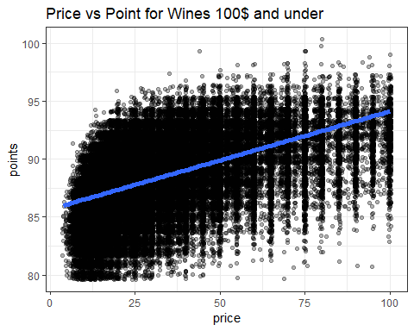

As we can see. There is a positive relationship between the points and the price. But, the points for bottles with the same price can be very different. Very cheap wine(<10$) can have up to 92 points while many 25 dollar wines just have less than 85 points.

The thing that I see from this graph is: We can have a strategy for choosing excellent wine with a low budget, while there is a high probability of having just a good bottle when choosing randomly even with a quite high price (~50$).

## Aim

The aim is similar with the first problem: Using NLP and compare ML kernel to solve this problems.

## Method and result

Let’s take a look at the price of our data:

par(mfrow=c(1,2))  
boxplot(wine$price, main = "Box plot of the price")  
boxplot(log(wine$price), main = " Boxplot of log of the price")

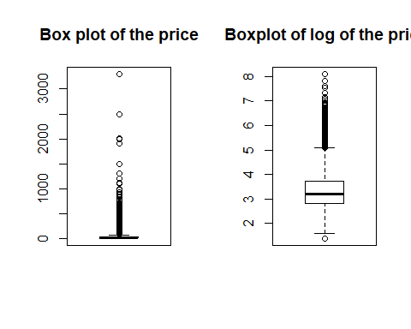

The price range quite high. Prices have a lot of outliers and high value of SD. otherwise, the log of the price looks better and quite similar to the point.

I define the Here is the value:

boxplot(wine$value, main = "Value of the price")

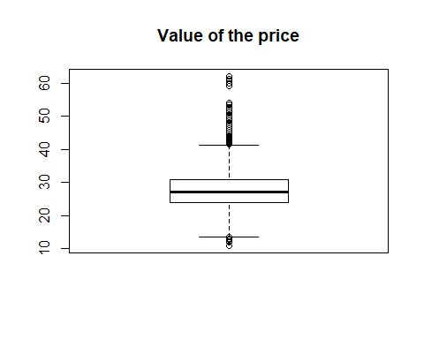

The median number for value is ~27. So the bottle with a higher value than 27 will have a “high” benefit. The rest have “medium” benefit. This way of define class will make all data become interesting. For example. there is a bottle with just 4$ but have 80 points. It becomes the bottle with the highest benefit. In contrast. many bottles with the price higher than 1000 dollar. Of course, they are an excellent wine. But is just have a medium benefit because it’s too expensive.

I do the same preprocessing for the text. Then continue to compare models with sample 20% of the data. Here is the result.

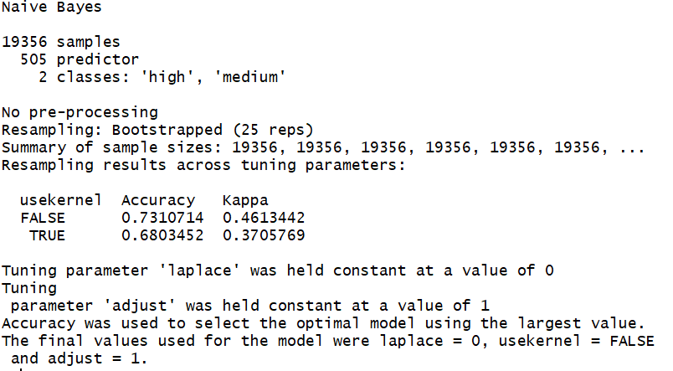

NB benefit

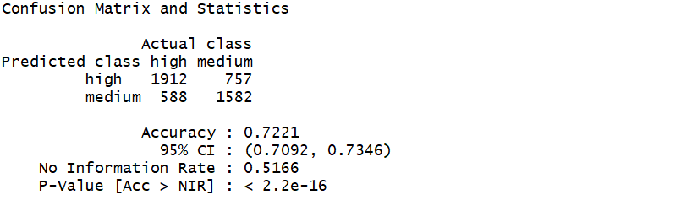

NB benefit predict

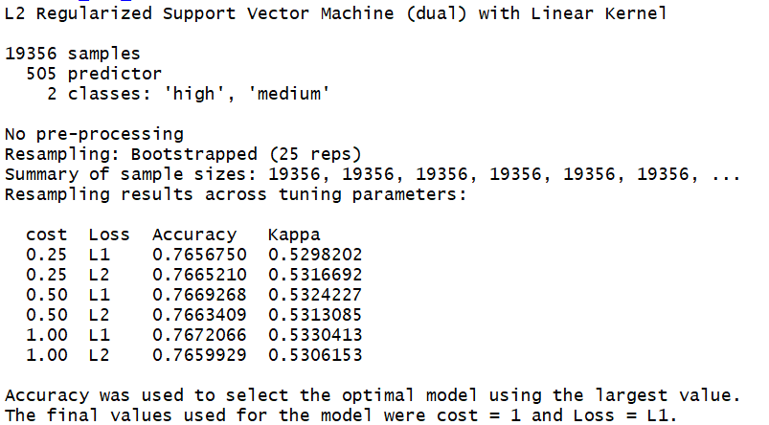

SVM benefit

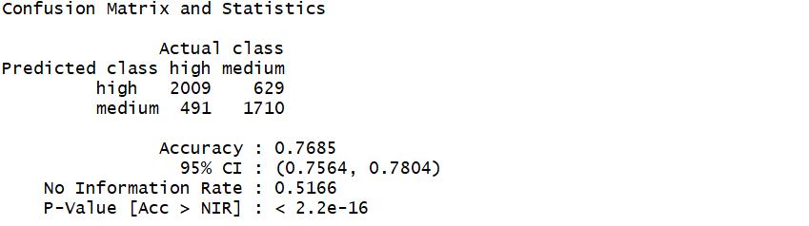

SVMLinear_benefit

As we can see, SVM Linear is better than NB in both accuracy and how the bottle is classified. Now I’ll try with POS Tagger

Here is the result when double the point for nouns: 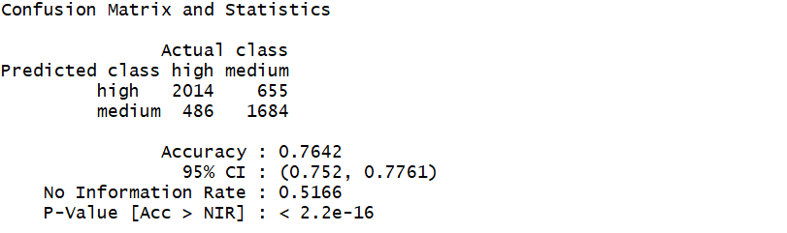

And here is the result when double the point for adjectives: 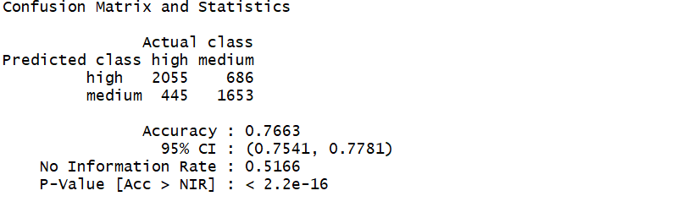

In this case, POS Tagger doesn’t show any clear effect either with double the point for nouns or adjective. All indicator is more or less the same, or even worse. As I said before, The way of classifying here is quite strange. I still don’t too much ideal about how the description should be for each class.

And here is with 1-2gram model 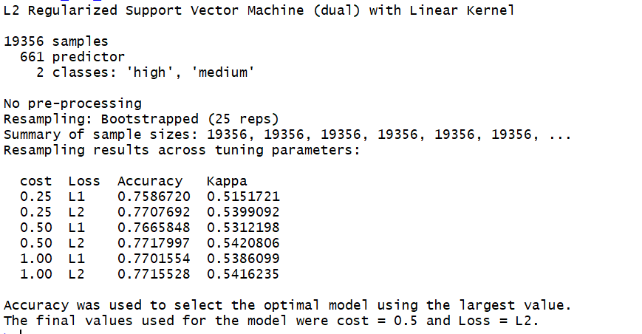

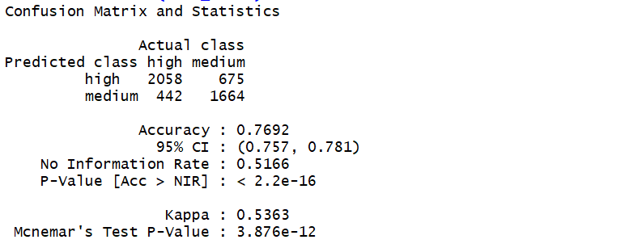

SVM benefit 1-2gram predict

In this case, 1-2gram doesn’t improve the model.

**I conclude that the final model for “high” - “medium” wine value classify is SVM linear with tf-idf, bag of words**

# Futher discusssion

## Suggession for choosing wine

Because both problems is solve uing SVMLinear model, which use vector based on tf-idf points. As a result, top points of each class should be the most influences of the class. In this section, I’ll extract the top influences of each class and draw by word cloud.

Here is the result from the SVM Linear for “good” - “excellent” wine model: The first cloud is for excellent wine and the second one is for good wine

wordcloud(rownames(excellent), excellent[,1], max.words=100, colors=brewer.pal(8, "Dark2"), scale=c(4,.5))

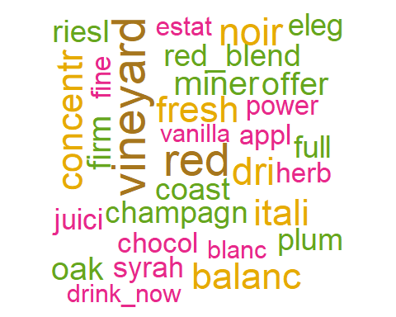

wordcloud(rownames(good), good[,1], max.words=100, colors=brewer.pal(8, "Dark2"), scale=c(4,.5))

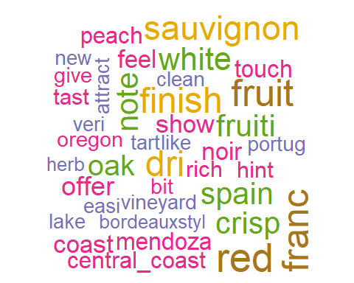

Suggesstion for choosing wine:…

Here is the top influences from the SVM Linear for “high” - “medium” wine model. The first cloud is for high benefit wine and the second one is for medium benefit wine

wordcloud(rownames(high), high[,1], max.words=100, colors=brewer.pal(8, "Dark2"), scale=c(4,.5))

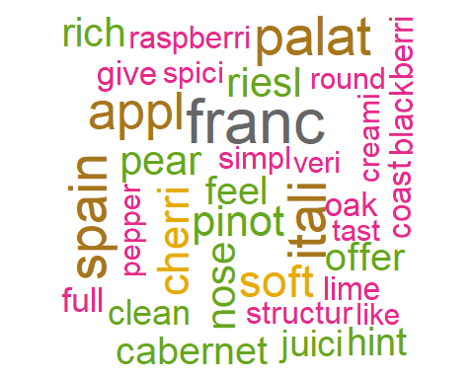

wordcloud(rownames(medium), medium[,1], max.words=100, colors=brewer.pal(8, "Dark2"), scale=c(4,.5))

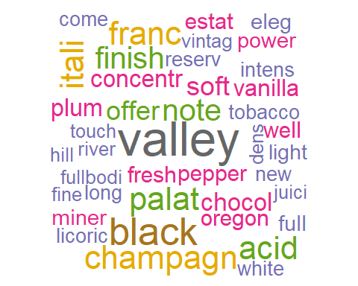

Suggesstion for choosing wine:…

## Future work:

* Here are some points that can improve from the project:
* Check again the SVM RBF kernel with a bigger data set and more powerful computer. In my experiments, SVM RBF is better than SVM Linear in most the cases.
* Take the advice from wine specialist to improve the model. In my opinion, we should fully understand the dataset before thinking about machine learning. In this case. Because my knowledge of wine is limited. I often don’t clearly understand about a bottle after reading the description. It leads to the ideal for improving the model are limited.
* Improve the POS tagger function.
* Check again the result for 1-2gram with a bigger data set. I try with full data but mycomputer is crashed when train the model because DTM for full data is very heavy (we have a lot of terms)

# Conclusion

The issues raised at the beginning are solved with a good result. We figure out that the description and other information printed in a bottle can bring us some ideal about how good the bottle is or how high level of benefit it has. We also have some idea about how can we choose a satified bottle. In the NLP and ML aspect. SVM linear with 1-2gram is the best model for predicting the quality with 78.69% accuracy. For predicting the benefit of a bottle, SVM linear is an acceptable model, with accuracy 77.09%.

# References

1. Slide of this course
2. <https://fderyckel.github.io/2016-12-07-Texts_Classification_in_R/>
3. <https://www.kaggle.com/carkar/classifying-wine-type-by-review>
4. <https://stackoverflow.com/questions/28764056/could-not-find-function-tagpos>

# Apendix

Here is the code used in this project. For some models that require a long time for trainning, I run it independently and attach the pitures of results.

library(dplyr)  
library(tm)  
library(stringr)  
library(NLP)  
library(openNLP)  
library(caret)  
library(wordcloud)  
library(RColorBrewer)  
knitr::opts_chunk$set(echo = TRUE, warning=FALSE, message=FALSE, include=FALSE)  
wine <- read.csv("C:/Users/Duong Minh Duc/Documents/GitHub/Text-Mining-Project/wine.csv")  
head(wine)  
boxplot(wine$points, main="Boxplot of points")  
stopwords <- stopwords("english")  
stopwords <- stopwords[!stopwords=="very"]  
stopwords <- c("the", "and", "wine", stopwords)  
  
stopwords  
# Use for check the not available and duplicate data, but not necessary  
wine <- na.omit(wine)  
#wine[duplicated(wine),]  
  
#Assign class  
wine$quality <- wine$points > 88  
wine$quality[wine$quality == TRUE] <- "excellent"  
wine$quality[wine$quality == FALSE] <- "good"  
wine$quality <- as.factor(wine$quality)  
wine$value <- wine$points/log(wine$price)  
wine$benefit <- wine$value > 27  
wine$benefit[wine$benefit == TRUE] <- "high"  
wine$benefit[wine$benefit == FALSE] <- "medium"  
wine$benefit <- as.factor(wine$benefit)  
wine$description <- paste(wine$description, wine$country, wine$designation, wine$province, wine$region_1, wine$region_2, wine$variety)  
wine$description <- as.character(wine$description)  
  
#Language convert  
wine$description <- gsub("weissburgunder", "chardonnay", wine$description)  
wine$description <- gsub("spatburgunder", "pinot noir", wine$description)  
wine$description <- gsub("grauburgunder", "pinot gris", wine$description)  
  
#Replace the Spanish garnacha with the french grenache  
wine$description <- gsub("garnacha", "grenache", wine$description)  
  
#Replace the Italian pinot nero with the french pinot noir  
wine$description <- gsub("pinot nero", "pinot noir", wine$description)  
  
#Replace the Portugues alvarinho with the spanish albarino  
wine$description <- gsub("alvarinho", "albarino", wine$description)  
  
#clean non ASCII  
wine$description <- iconv(wine$description, from = "UTF-8", to = "ASCII", sub = "")  
  
#Spit train test  
n = dim(wine)[1]  
set.seed(12345)  
  
id2 = sample(1:n, floor(n*0.2))  
wine_sample <- wine[id2,]  
n2 = length(id2)  
id_test = sample(1:n2, floor(n2*0.8))  
train = wine_sample[id_test,]  
test = wine_sample[-id_test,]  
  
##clean function  
clean <- function(text_vector)  
 {  
 wine_corpus = VCorpus(VectorSource(text_vector))  
 wine_corpus = tm_map(wine_corpus, removePunctuation)  
 wine_corpus = tm_map(wine_corpus, content_transformer(tolower))  
 wine_corpus = tm_map(wine_corpus, removeNumbers)  
 wine_corpus = tm_map(wine_corpus, removeWords, stopwords )  
 #wine_corpus = tm_map(wine_corpus, stripWhitespace)  
 wine_corpus <- tm_map(wine_corpus, stemDocument)  
   
   
 return(wine_corpus)  
 }  
  
##create the train set  
wine_train_set <- clean(train$description)  
  
train$description[1]  
wine_train_set[[1]]$content  
  
train_dtm_tfidf <- DocumentTermMatrix(wine_train_set, control = list(weighting = weightTfIdf))  
train_dtm_tfidf <- removeSparseTerms(train_dtm_tfidf, 0.99)  
  
  
#create the test set  
wine_test_set <- clean(test$description)  
wine_test_set <- DocumentTermMatrix(wine_test_set, control = list(dictionary = Terms(train_dtm_tfidf) ,weighting = weightTfIdf))  
  
#create matrix for training  
wine_train_set <<- as.matrix(train_dtm_tfidf)  
wine_test_set <- as.matrix(wine_test_set)  
wine_test_set <- wine_test_set[,Terms(train_dtm_tfidf)]  
  
#create the test result  
wine_testing_result <- test$quality  
  
wine_train_set[1,]  
wine_test_set[1,]  
#train model  
train_nb_model <- train(x= wine_train_set, y=train$quality , method = 'naive_bayes')  
  
model_nb_result <- predict(train_nb_model, newdata = wine_test_set)  
conf_nb_train <- table(model_nb_result, wine_testing_result)  
names(dimnames(conf_nb_train)) <- c("Predicted class", "Actual class")  
  
train_nb_model  
confusionMatrix(conf_nb_train)  
#Here is the SVM Linear kenel  
train_svmLinear_model <- train(x= wine_train_set, y=train$quality , method = 'svmLinear3')  
  
model_svmLinear_result <- predict(train_svmLinear_model, newdata = wine_test_set)  
conf_svmLinear_train <- table(model_svmLinear_result, wine_testing_result)  
names(dimnames(conf_svmLinear_train)) <- c("Predicted class", "Actual class")  
  
train_svmLinear_model  
confusionMatrix(conf_svmLinear_train)  
# #Here is the SVM RBF kenel  
# # Because the trainning time is long. I'll not run this code and only attach images of the previous run.  
# train_svmRBF_model <- train(x= wine_train_set, y=train$quality , method = 'svmRadial')  
# train_svmRBF_model  
# model_svmRBF_result <- predict(train_svmRBF_model, newdata = wine_test_set)  
#   
# conf_svmRBF_train <- table(model_svmRBF_result, wine_testing_result)  
# names(dimnames(conf_svmRBF_train)) <- c("Predicted class", "Actual class")  
# confusionMatrix(conf_svmRBF_train)  
NLP_tokenizer <- function(x) {  
 unlist(lapply(ngrams(words(x), 2:2), paste, collapse = "_"), use.names = FALSE)  
}  
  
wine_train_set <- clean(train$description)  
  
train_dtm_tfidf <- DocumentTermMatrix(wine_train_set, control = list(weighting = weightTfIdf, tokenize=NLP_tokenizer))  
train_dtm_tfidf <- removeSparseTerms(train_dtm_tfidf, 0.99)  
  
#create the test set  
wine_test_set <- clean(test$description)  
wine_test_set <- DocumentTermMatrix(wine_test_set, control = list(dictionary = Terms(train_dtm_tfidf) ,weighting = weightTfIdf, tokenize=NLP_tokenizer))  
  
  
#create matrix for training  
wine_train_set <<- as.matrix(train_dtm_tfidf)  
wine_test_set <- as.matrix(wine_test_set)  
wine_test_set <- wine_test_set[,Terms(train_dtm_tfidf)]  
#create the test result  
wine_testing_result <- test$quality  
  
  
wine_train_set[1,]  
train_svmLinear_model <- train(x= wine_train_set, y=train$quality , method = 'svmLinear3')  
  
model_svmLinear_result <- predict(train_svmLinear_model, newdata = wine_test_set)  
conf_svmLinear_train <- table(model_svmLinear_result, wine_testing_result)  
names(dimnames(conf_svmLinear_train)) <- c("Predicted class", "Actual class")  
train_svmLinear_model  
confusionMatrix(conf_svmLinear_train)  
NLP_tokenizer <- function(x) {  
 unlist(lapply(ngrams(words(x), 1:2), paste, collapse = "_"), use.names = FALSE)  
}  
  
wine_train_set <- clean(train$description)  
  
train_dtm_tfidf <- DocumentTermMatrix(wine_train_set, control = list(weighting = weightTfIdf, tokenize=NLP_tokenizer))  
train_dtm_tfidf <- removeSparseTerms(train_dtm_tfidf, 0.99)  
  
  
#create the test set  
wine_test_set <- clean(test$description)  
wine_test_set <- DocumentTermMatrix(wine_test_set, control = list(dictionary = Terms(train_dtm_tfidf) ,weighting = weightTfIdf, tokenize=NLP_tokenizer))  
  
#create matrix for training  
wine_train_set_ngram <<- as.matrix(train_dtm_tfidf)  
wine_test_set <- as.matrix(wine_test_set)  
wine_test_set_ngram <- wine_test_set[,Terms(train_dtm_tfidf)]  
#create the test result  
wine_testing_result_ngram <- test$quality  
  
wine_train_set_ngram[1,]  
train_svmLinear_model <- train(x= wine_train_set_ngram, y=train$quality , method = 'svmLinear3')  
  
model_svmLinear_result <- predict(train_svmLinear_model, newdata = wine_test_set_ngram)  
  
conf_svmLinear_train <- table(model_svmLinear_result, wine_testing_result_ngram)  
names(dimnames(conf_svmLinear_train)) <- c("Predicted class", "Actual class")  
  
train_svmLinear_model  
confusionMatrix(conf_svmLinear_train)  
#tagPos  
tagPOS <- function(x, ...) {  
 s <- as.String(x)  
 word_token_annotator <- Maxent_Word_Token_Annotator()  
 a2 <- Annotation(1L, "sentence", 1L, nchar(s))  
 a2 <- NLP::annotate(s, word_token_annotator, a2)  
 a3 <- NLP::annotate(s, Maxent_POS_Tag_Annotator(), a2)  
 a3w <- a3[a3$type == "word"]  
 POStags <- unlist(lapply(a3w$features, `[[`, "POS"))  
 POStagged <- paste(sprintf("%s/%s", s[a3w], POStags), collapse = " ")  
 list(POStagged = POStagged, POStags = POStags)  
}  
wine_train_set <- clean(train$description)  
  
train_dtm_tfidf <- DocumentTermMatrix(wine_train_set, control = list(weighting = weightTfIdf))  
train_dtm_tfidf <- removeSparseTerms(train_dtm_tfidf, 0.99)  
  
#create the test set  
wine_test_set <- clean(test$description)  
wine_test_set <- DocumentTermMatrix(wine_test_set, control = list(dictionary = Terms(train_dtm_tfidf) ,weighting = weightTfIdf))  
  
  
#create matrix for training  
wine_train_set <<- as.matrix(train_dtm_tfidf)  
wine_test_set <- as.matrix(wine_test_set)  
wine_test_set <- wine_test_set[,Terms(train_dtm_tfidf)]  
#create the test result  
wine_testing_result <- test$quality  
  
  
#extract nouns and adj  
tag <- tagPOS(Terms(train_dtm_tfidf))  
tag <- tag$POStags  
noun_id <- which( tag=="NN")  
nouns <- colnames(wine_train_set)[noun_id]  
adj_id <- which( tag=="JJ")  
adj <- colnames(wine_train_set)[adj_id]  
  
nouns  
  
column_id <- c()  
  
#multify for noun  
for (i in 1:dim(wine_train_set)[2]) {  
 check <- colnames(wine_train_set)[i] %in% nouns  
 if(check)  
 {  
 column_id <- c(column_id, i)  
 }  
}  
  
wine_train_set[,column_id] <- wine_train_set[,column_id]*2  
wine_test_set[,column_id] <- wine_test_set[,column_id]*2  
  
wine_train_set[1,]  
train_svmLinear_model <- train(x= wine_train_set, y=train$quality , method = 'svmLinear3')  
  
model_svmLinear_result <- predict(train_svmLinear_model, newdata = wine_test_set)  
conf_svmLinear_train <- table(model_svmLinear_result, wine_testing_result)  
names(dimnames(conf_svmLinear_train)) <- c("Predicted class", "Actual class")  
  
train_svmLinear_model  
confusionMatrix(conf_svmLinear_train)  
adj  
#remove double point for nouns  
wine_train_set[,column_id] <- wine_train_set[,column_id]/2  
wine_test_set[,column_id] <- wine_test_set[,column_id]/2  
  
#multify for adj  
column_id <- c()  
for (i in 1:dim(wine_train_set)[2]) {  
 check <- colnames(wine_train_set)[i] %in% adj  
 if(check)  
 {  
 column_id <- c(column_id, i)  
 }  
}  
  
wine_train_set[,column_id] <- wine_train_set[,column_id]*2  
wine_test_set[,column_id] <- wine_test_set[,column_id]*2  
  
train_svmLinear_model <- train(x= wine_train_set, y=train$quality , method = 'svmLinear3')  
  
model_svmLinear_result <- predict(train_svmLinear_model, newdata = wine_test_set)  
conf_svmLinear_train <- table(model_svmLinear_result, wine_testing_result)  
names(dimnames(conf_svmLinear_train)) <- c("Predicted class", "Actual class")  
  
train_svmLinear_model  
confusionMatrix(conf_svmLinear_train)  
ggplot(subset(wine, price <= 100),  
 aes(x = price, y = points)) +  
 geom_point(alpha = 0.3, position = position_jitter()) +   
 stat_smooth(method = "lm", size =2) +  
 labs(title = 'Price vs Point for Wines 100$ and under') +  
 theme_bw()  
par(mfrow=c(1,2))  
boxplot(wine$price, main = "Box plot of the price")  
boxplot(log(wine$price), main = " Boxplot of log of the price")  
boxplot(wine$value, main = "Value of the price")  
good<- which(train$quality=="good")  
good <- wine_train_set_ngram[good,]  
good = data.frame(sort(colSums(good), decreasing=TRUE))  
excellent<- which(train$quality=="excellent")  
excellent <- wine_train_set_ngram[excellent,]  
excellent = data.frame(sort(colSums(excellent), decreasing=TRUE))  
  
wordcloud(rownames(excellent), excellent[,1], max.words=100, colors=brewer.pal(8, "Dark2"), scale=c(4,.5))  
  
wordcloud(rownames(good), good[,1], max.words=100, colors=brewer.pal(8, "Dark2"), scale=c(4,.5))  
#remove double points for adj  
wine_train_set[,column_id] <- wine_train_set[,column_id]/2  
wine_test_set[,column_id] <- wine_test_set[,column_id]/2  
  
high<- which(train$benefit=="high")  
high <- wine_train_set[high,]  
medium<- which(train$benefit=="medium")  
medium <- wine_train_set[medium,]  
  
high = data.frame(sort(colSums(high), decreasing=TRUE))  
  
medium = data.frame(sort(colSums(medium), decreasing=TRUE))  
  
wordcloud(rownames(high), high[,1], max.words=100, colors=brewer.pal(8, "Dark2"), scale=c(4,.5))  
  
wordcloud(rownames(medium), medium[,1], max.words=100, colors=brewer.pal(8, "Dark2"), scale=c(4,.5))