Lab 4 – Flutter UI Fundamentals

Exercise 1 – Core Widgets: Text, Image, Icon, Card, ListTile
Code trong bài:
class CoreWidgetsDemo extends StatelessWidget {
const CoreWidgetsDemo({super.key});
@override
Widget build(BuildContext context) {
return Scaffold(
appBar: AppBar(
title: const Text('Exercise 1 – Core Widgets'),
),
body: Padding(
padding: const EdgeInsets.all(16),
child: Column(
children: [
const Text(
'Welcome to Flutter UI',
style: TextStyle(
fontSize: 22,
fontWeight: FontWeight.bold,
),
),
const SizedBox(height: 20),
const Icon(
Icons.movie,
size: 60,
color: Colors.blue,
),
const SizedBox(height: 20),
Image.network(
'https://ik.imagekit.io/tvlk/blog/2022/07/phim-hanh-dong-my-8.jpeg',
height: 160,
width: double.infinity,
fit: BoxFit.cover,
),
const SizedBox(height: 20),
const Card(
elevation: 4,
child: ListTile(
leading: Icon(Icons.star),
title: Text('Movie Item'),
subtitle: Text('This is a sample ListTile inside a Card.'),
trailing: Icon(Icons.arrow_forward_ios),
),
),
],
),
),
);
}
}
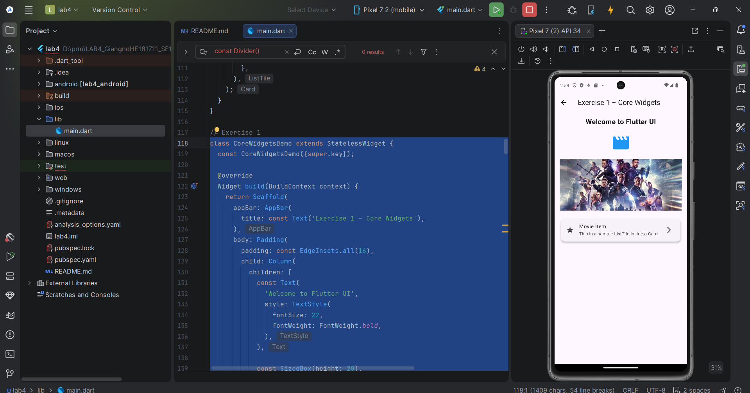

Exercise 2 – Input Widgets: Slider, Switch, RadioListTile, DatePicker
Code trong bài:
class InputControlsDemo extends StatefulWidget {
const InputControlsDemo({super.key});
@override
State<InputControlsDemo> createState() => _InputControlsDemoState();
}
class _InputControlsDemoState extends State<InputControlsDemo> {
double rating = 50;
bool isActive = false;
String? selectedGenre;
DateTime? selectedDate;
Future<void> openDatePicker() async {
final DateTime? pickedDate = await showDatePicker(
context: context,
initialDate: DateTime.now(),
firstDate: DateTime(2000),
lastDate: DateTime(2035),
);
if (pickedDate != null) {
setState(() {
selectedDate = pickedDate;
});
}
}
@override
Widget build(BuildContext context) {
return Scaffold(
appBar: AppBar(
title: const Text('Exercise 2 – Input Controls'),
),
body: SingleChildScrollView(
padding: const EdgeInsets.all(16),
child: Column(
crossAxisAlignment: CrossAxisAlignment.start,
children: [
const Text(
'Rating (Slider)',
style: TextStyle(fontWeight: FontWeight.bold),
),
Slider(
value: rating,
min: 0,
max: 100,
label: rating.round().toString(),
onChanged: (value) {
setState(() {
rating = value;
});
},
),
Text('Current value: ${rating.round()}'),
const SizedBox(height: 20),
const Text(
'Active (Switch)',
style: TextStyle(fontWeight: FontWeight.bold),
),
SwitchListTile(
title: const Text('Is movie active?'),
value: isActive,
onChanged: (value) {
setState(() {
isActive = value;
});
},
),
Text(
isActive ? 'Movie is active' : 'Movie is inactive',
),
const SizedBox(height: 20),
const Text(
'Genre (RadioListTile)',
style: TextStyle(fontWeight: FontWeight.bold),
),
RadioListTile<String>(
title: const Text('Action'),
value: 'Action',
groupValue: selectedGenre,
onChanged: (value) {
setState(() {
selectedGenre = value;
});
},
),
RadioListTile<String>(
title: const Text('Comedy'),
value: 'Comedy',
groupValue: selectedGenre,
onChanged: (value) {
setState(() {
selectedGenre = value;
});
},
),
Text('Selected genre: ${selectedGenre ?? "None"}'),
const SizedBox(height: 20),
SizedBox(
width: double.infinity,
child: ElevatedButton(
onPressed: openDatePicker,
child: const Text('Open Date Picker'),
),
),
const SizedBox(height: 12),
Text(
selectedDate == null
? 'No date selected'
: 'Selected date: ${selectedDate!.day}/${selectedDate!.month}/${selectedDate!.year}',
),
],
),
),
);
}
}
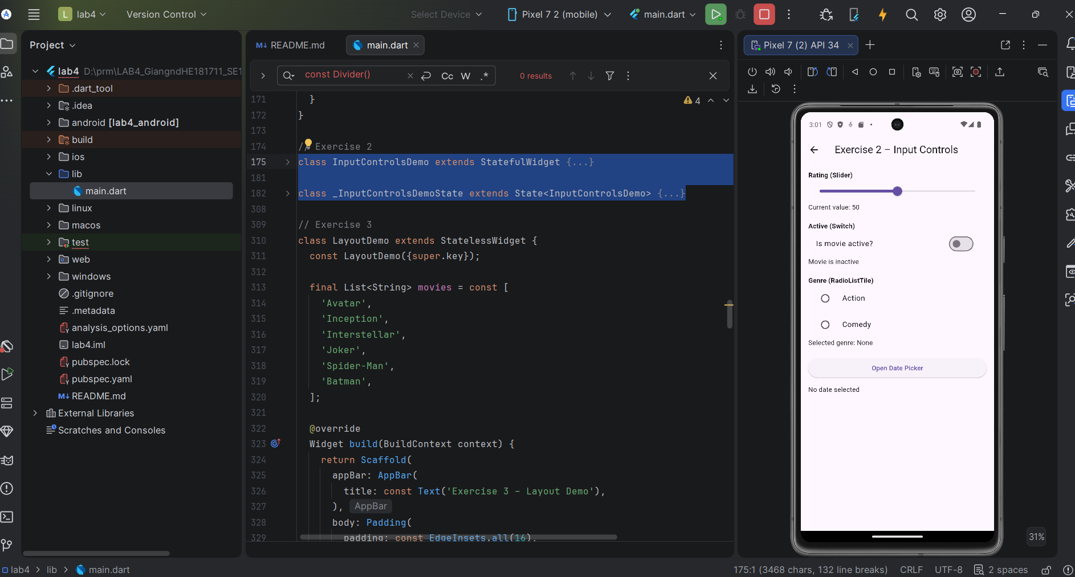

Exercise 3 – Layout Basics: Column, Row, Padding, ListView
Code trong bài:
class LayoutDemo extends StatelessWidget {
const LayoutDemo({super.key});
final List<String> movies = const [
'Avatar',
'Inception',
'Interstellar',
'Joker',
'Spider-Man',
'Batman',
];
@override
Widget build(BuildContext context) {
return Scaffold(
appBar: AppBar(
title: const Text('Exercise 3 – Layout Demo'),
),
body: Padding(
padding: const EdgeInsets.all(16),
child: Column(
children: [
Row(
mainAxisAlignment: MainAxisAlignment.center,
children: const [
Text(
'Now Playing',
style: TextStyle(
fontSize: 22,
fontWeight: FontWeight.bold,
),
),
],
),
const SizedBox(height: 16),
Expanded(
child: ListView.builder(
itemCount: movies.length,
itemBuilder: (context, index) {
return Card(
margin: const EdgeInsets.only(bottom: 12),
child: ListTile(
leading: CircleAvatar(
child: Text(movies[index][0]),
),
title: Text(movies[index]),
subtitle: const Text('Sample description'),
),
);
},
),
),
],
),
),
);
}
}
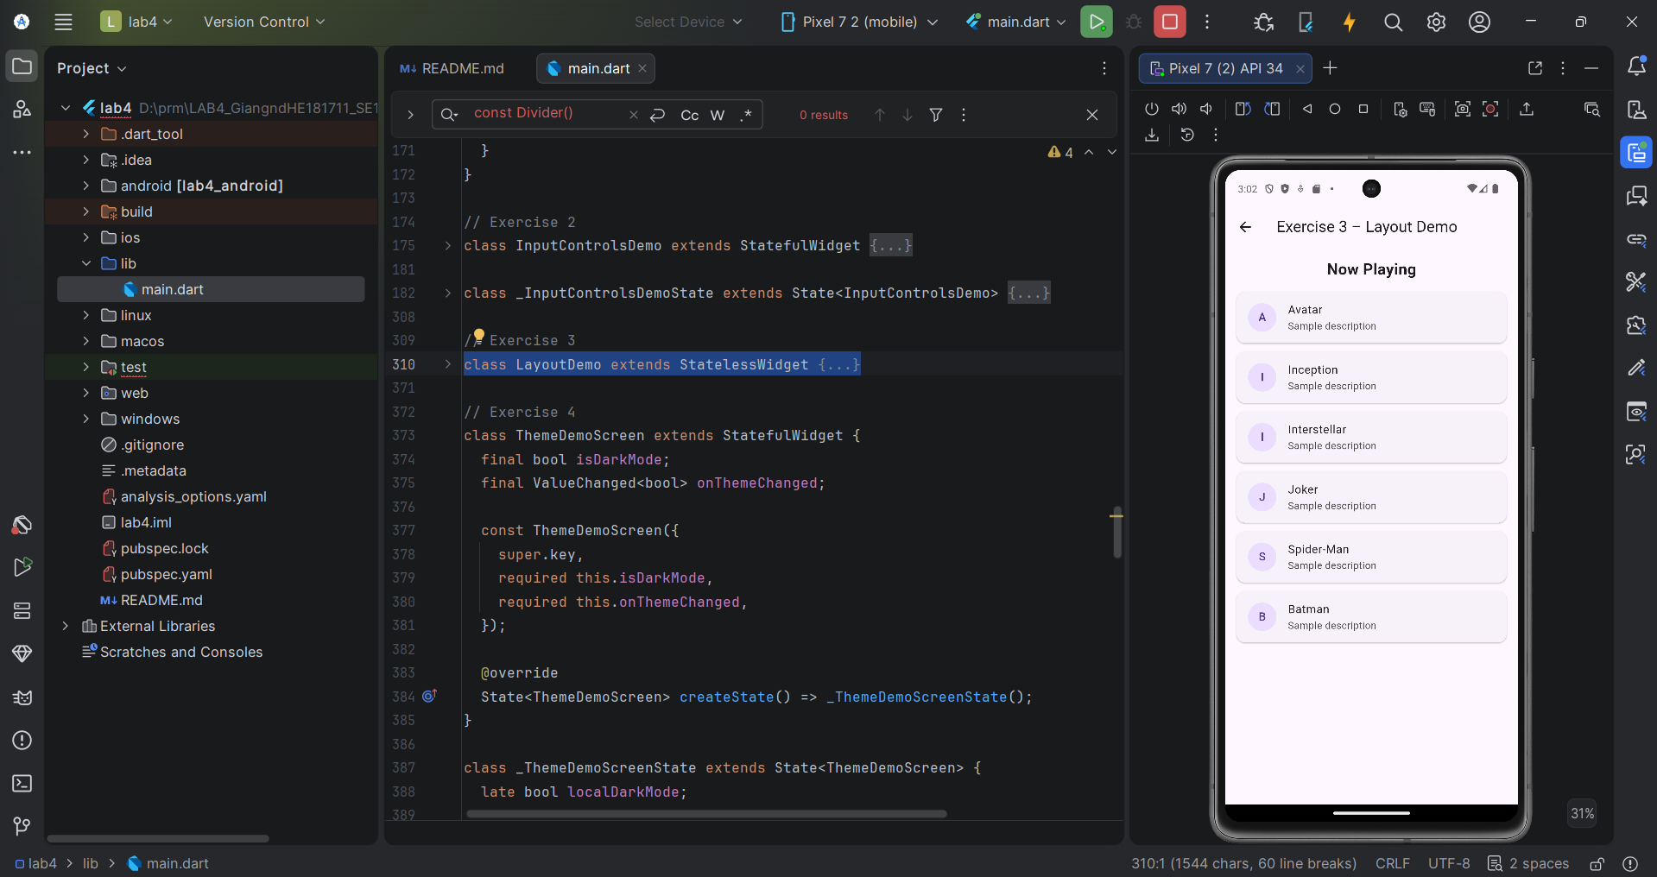

Exercise 4 – App Structure with Scaffold, AppBar, FAB & Theme
Code trong bài:
class ThemeDemoScreen extends StatefulWidget {
final bool isDarkMode;
final ValueChanged<bool> onThemeChanged;
const ThemeDemoScreen({
super.key,
required this.isDarkMode,
required this.onThemeChanged,
});
@override
State<ThemeDemoScreen> createState() => _ThemeDemoScreenState();
}
class _ThemeDemoScreenState extends State<ThemeDemoScreen> {
late bool localDarkMode;
@override
void initState() {
super.initState();
localDarkMode = widget.isDarkMode;
}
@override
Widget build(BuildContext context) {
return Scaffold(
appBar: AppBar(
title: const Text('Exercise 4 – App Structure & Theme'),
actions: [
Row(
children: [
const Text('Dark'),
Switch(
value: localDarkMode,
onChanged: (value) {
setState(() {
localDarkMode = value;
});
widget.onThemeChanged(value);
},
),
],
),
],
),
body: const Center(
child: Padding(
padding: EdgeInsets.all(16),
child: Text(
'This is a simple screen with AppBar, Body, FloatingActionButton and Theme toggle.',
textAlign: TextAlign.center,
),
),
),
);
}
}
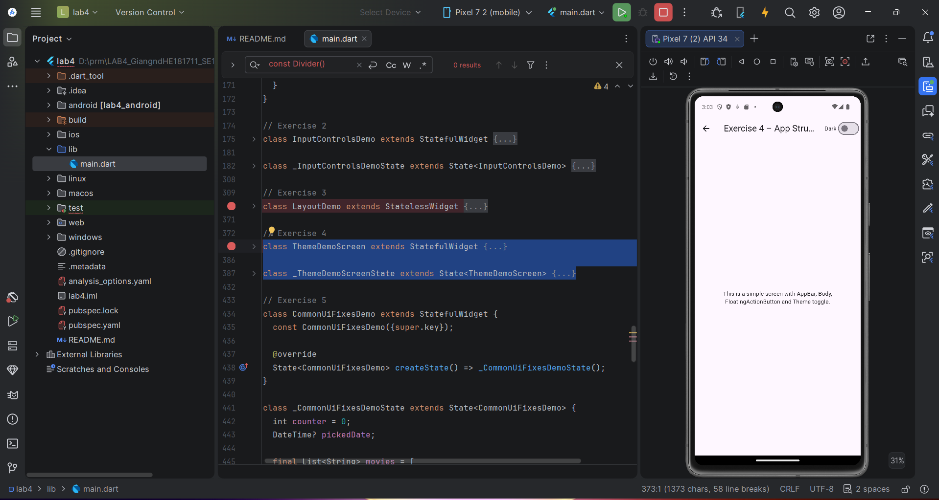
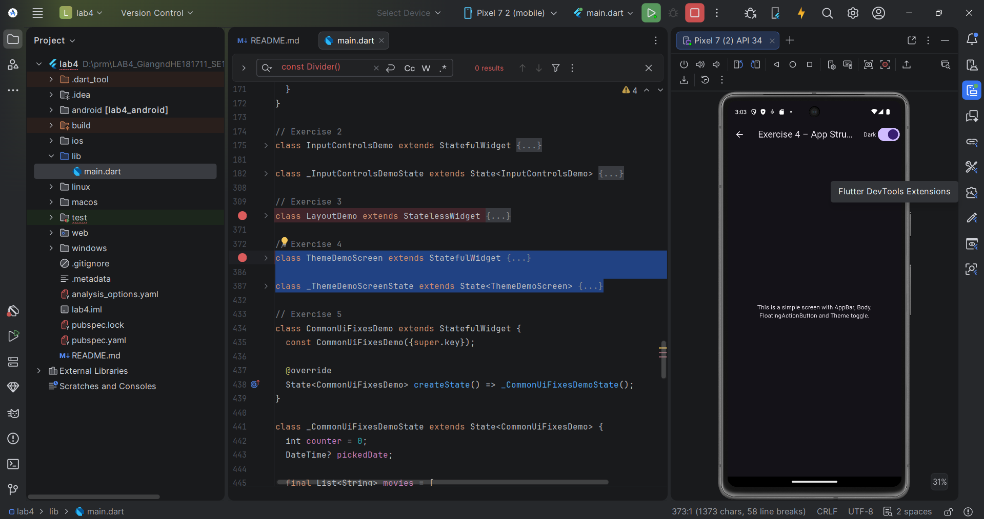

Exercise 5 – Debug & Fix Common UI Errors
Code trong bài:
class CommonUiFixesDemo extends StatefulWidget {
const CommonUiFixesDemo({super.key});
@override
State<CommonUiFixesDemo> createState() => _CommonUiFixesDemoState();
}
class _CommonUiFixesDemoState extends State<CommonUiFixesDemo> {
int counter = 0;
DateTime? pickedDate;
final List<String> movies = [
'Movie A',
'Movie B',
'Movie C',
'Movie D',
];
Future<void> pickDateSafely() async {
final DateTime? date = await showDatePicker(
context: context,
initialDate: DateTime.now(),
firstDate: DateTime(2020),
lastDate: DateTime(2035),
);
if (date != null) {
setState(() {
pickedDate = date;
});
}
}
void increaseCounter() {
setState(() {
counter++;
});
}
@override
Widget build(BuildContext context) {
return Scaffold(
appBar: AppBar(
title: const Text('Exercise 5 – Common UI Fixes'),
),
body: SingleChildScrollView(
padding: const EdgeInsets.all(16),
child: SizedBox(
height: MediaQuery.of(context).size.height - 120,
child: Column(
crossAxisAlignment: CrossAxisAlignment.start,
children: [
const Text(
'Correct ListView inside Column using Expanded',
style: TextStyle(
fontSize: 18,
fontWeight: FontWeight.bold,
),
),
const SizedBox(height: 12),
Expanded(
child: ListView.builder(
itemCount: movies.length,
itemBuilder: (context, index) {
return ListTile(
leading: const Icon(Icons.movie),
title: Text(movies[index]),
);
},
),
),
],
),
),
),
);
}
}
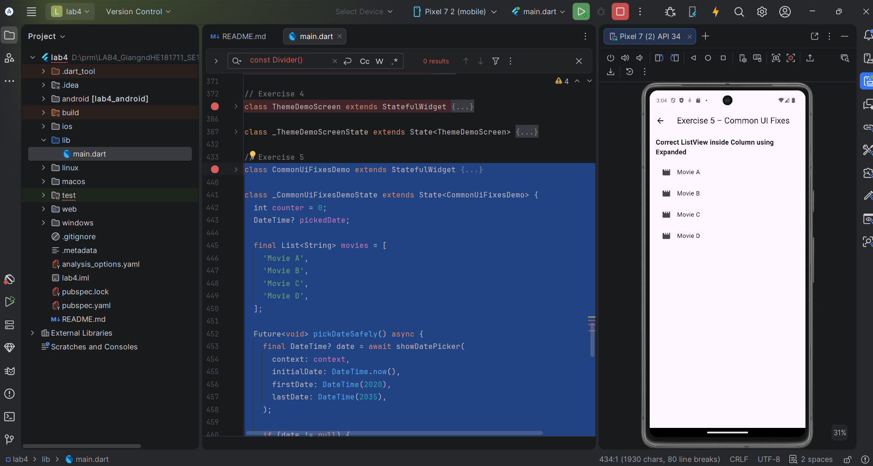

Short explanation for fixes in Exercise 5:
Exercise 5 demonstrates how to fix common Flutter UI errors.
- ListView inside Column
ListView and Column are both vertical widgets, so when we put ListView inside Column, the Column cannot know the height of the ListView because it scrolls infinitely. So we need to put it inside an Expanded.
- Overflow on small screens
When content is taller than the screen, it will overflow. So we need to make it scrollable by using SingleChildScrollView.
- State not updating
Flutter does not automatically know that the data has changed, so we need something to update the UI again by using setState().
- DatePicker context error
showDatePicker() must be called using a valid BuildContext, usually inside a button’s onPressed method after the widget is already built.

