TECHNICAL SOLUTION PROPOSAL

AI-Powered Conversational
Business Intelligence System
Architecture Proposal Template based on arc42
Prepared by | Bui Duc Hoang
Organization
Version | 1.1
Date | 14/10/2026
Document Status | Proposed
Based on arc42 Template Version 9.0-EN (July 2025)
Revision History
Version 1.1 describes the prototype as of 14/10/2026. The table lists, day by day, when each behavior now described in this document entered the prototype; the document itself was revised on 14/10/2026, as itemized in the last rows.
Version | Date | Sections | Change
1.0 | 17/9/2026 | All | Initial proposal.
1.1 | 20/9/2026 | 3.2, 6.2, 8.3 | Scope subquery around generated SQL and exact match of standard-path queries to the predefined statement (8.3); SQL proposals only when approved metadata may be sent, with the setting EXTERNAL_METADATA_ENABLED (3.2); IT Administrator role refused before the AI service is called (6.2).
1.1 | 21/9/2026 | 3.2, 6.1, 8.3, 8.4, 8.5, 9.4 | Optional reading of plain questions by backend rules (3.2, 6.1); replies about the data and the previous answer (3.2); query time limit of 15 seconds (8.3); no assumed period when the question has no time wording (8.4); chart chosen by rules from the shape of the result, with the AI service as fallback (8.5, 9.4).
1.1 | 24/9/2026 | 6.1, 8.4, 8.6 | Several requests in one message, up to five (8.4); comparison across named periods (8.4); a period named in the question takes precedence over the one the AI service chose (8.4); plain questions and short follow-ups still answered when the AI service is unavailable (6.1, 8.6).
1.1 | 10/10/2026 | 8.3, 8.4, 8.6 | Correction of SQL that departs from the approved shape, at most twice (8.3); row limits of 100, 250 and 400 with a notice when a list is cut (8.3); provider limits reported as a busy service instead of a failure (8.6); a named factory always applied as a filter (8.4).
1.1 | 13/10/2026 | 3.2, 8.4 | Amounts and decimal ratios of earlier answers replaced by a placeholder in the context sent to the AI service (3.2, 8.4); a comparison of named factories shows only those factories and states what was left out (8.4).
1.1 | 14/10/2026 | 3.2 | Added the section Data Sent to External Services: what each external AI call carries, what it never carries and which setting controls it.
1.1 | 14/10/2026 | 6.1, 6.2 | Interpretation step now reads plain questions by rules when enabled or when the AI service is unavailable; IT Administrator refusal described before the AI call.
1.1 | 14/10/2026 | 8.3 | Query limits (15 seconds, row limits), the correction rule for SQL that departs from the approved shape, and the scope subquery around generated SQL.
1.1 | 14/10/2026 | 8.4 | Conversation context limited to six turns with amounts masked; period check against the question; comparisons; several requests in one message.
1.1 | 14/10/2026 | 8.5, 9.4 | Visualization chosen by backend rules first, with the AI service as fallback.
1.1 | 14/10/2026 | 8.6, 9.2 | Busy-service handling for provider limits; provider operation for production and the temporary rotation of free providers during the demonstration period.
1.1 | 14/10/2026 | 11.2, 11.3 | Additional mitigations: provider terms review, data classification, independent penetration test, paid plan or offline model.
1.1 | 14/10/2026 | Appendix B | Indicative AI cost for the API and the offline server, with break-even range.
1.1 | 14/10/2026 | Document | Revision history, spelling corrections and section numbering.

Table of Contents
Contents
Table of Contents 2
1. Introduction and Goals 3
1.1 Requirements Overview 3
1.2 Quality Goals 4
1.3 Stakeholders 4
2. Architecture Constraints 5
2.1 Technical Constraints 5
2.2 Organizational and Business Constraints 5
Business Definition Constraints 5
2.3 Conventions 5
3. Context and Scope 6
3.1 Business Context 6
3.2 Technical Context 6
4. Solution Strategy 8
4.1 System Overview 8
4.2 AI Processing Strategy 8
5. Building Block View 11
5.1 Whitebox Overall System – Level 1 11
5.2 Level 2 12
6. Runtime View 14
6.1 Successful Data Request 14
6.2 Unauthorized Data Request 15
6.3 6.3 No Data Found 16
6.4 Clarification Request 16
7. Deployment View 18
7.1 Docker Deployment 18
8. Cross-cutting Concepts 19
8.1 Authentication and Authorization 19
8.2 Business Definitions and Metadata 19
8.3 AI Output and Query Validation 20
8.4 Conversation Context and Clarification 21
8.5 Result Presentation and Traceability 22
8.6 Error Handling and External Service Calls 22
9. Architecture Decisions 23
9.1 Hybrid Query Processing 23
9.2 External LLM Service 23
9.3 Backend-Controlled Data Access 24
9.4 AI-Proposed Visualizations 24
9.5 Modular FastAPI Backend 24
9.6 Docker Compose Deployment 25
10. Quality Requirements 25
10.1 Quality Requirements Overview 25
10.2 Quality Scenarios 25
11. Risks and Technical Debts 26
11.1 Incorrect Business Results 26
11.2 Unauthorized Data Disclosure 27
11.3 External AI Service Dependency 27
11.4 Limited Initial Validation Coverage 27
12. Glossary 27
Appendix A. Implementation Roadmap 29
Appendix B. Cost and Resource Estimation 30

1. Introduction and Goals
The AI-Powered Conversational Business Intelligence System (ACBI) System allows users to query business data through voice or chat using AI chatbot.

1.1 Requirements Overview
The overall goal of the ACBI System is to enable users to access business data through an AI chatbot and receive clear, data-backed answer in the form of summaries, tables and chart within their access permissions
The system aims to simplify access to business information through natural language, reducing reliance on manually navigating management dashboards and reports.
As the functional requirements are still being defined, this document primarily focuses on quality goals and evaluates technologies, architectural patterns and frameworks suitable for implementing the application.

Main features
- Accept user questions through text or voice and identify their intent and query conditions.
- Identify relevant data sources and query the standardized data warehouse.
- Generate clear, data-backed answers using standardized business metrics.
- Present result as summaries, tables or charts including comparisons when requested
- Restrict data access based on each user’s permissions
- Provide traceable data sources and indicate when available data is insufficient to answer reliably
Data Reliability
The system must not fabricate data or present unsupported conclusions. If the available data is insufficient to answer a questions, it must clearly state this limitation
Question Clarification and Conversation Context
The system must ask follow-up question when a request is ambiguous, such as “ Are there any problems?” or “How has production been recently” It must use relevant context from the current conversation to interpret follow-up questions and avoid asking for information already provided.
Result History
The application must save generated answers, tables and charts, together with the underlying query results, data source references and timestamps for future review.
Data Visualization
The system should select visualizations based on the data and the user’s intent:
- Bar/column charts: Compare values across categories.
- Line charts: Show trends over time.
- Pie/donut charts: Show proportions of a whole with a small number of categories.
- Stacked bar charts: Compare totals and their composition across categories.
- Scatter plots: Show relationships between two numerical variables.
- Tables: Present detailed, precise values.
- KPI cards: Highlight key metrics, such as revenue or production output

1.2 Quality Goals
# Quality Motivation

1 Accuracy Answer must be supported by actual business data and standardized metric
definitions. The system must indicate when insufficient data
prevents a reliable answer
2 Security User must only access data and saved result within their assigned permissions
3 Traceability Answer must be traceable to their data sources, executed queries, query parameters and retrieval timestamps
4 Usability User should be able to ask questions in natural language and understand the result without SQL knowledge
5 Performance The system should return answer within an agreed response time under expected workloads.

1.3 Stakeholders

Role / Name | Expectations
Management | Access reliable business insights through natural language to support decision-making.
Production Manager | Monitor production output, defect rates, and production line performance.
Sales Manager | Monitor revenue, compare sales performance across periods, and identify trends.
IT Administrator | Manage user permissions and monitor system security and availability.
Developer | Maintain and extend the system using clear documentation and a modular architecture.

2. Architecture Constraints

2.1 Technical Constraints
Data Source and Integration Constraints
# | Constraint | Background
TC1 | Business data must be retrieved only from approved, standardized data sources. | Answers must be based on authorized company data rather than unsupported information generated by AI.
TC2 | Access to business data sources must be read-only | The application is intended for analysis and reporting, without modifying operational data
TC3 | The system must use an existing pretrained LLM. Training an LLM from scratch is outside the project scope. | The project focuses on integrating AI with business data rather than developing a foundation model.

Access Control Constraints
# | Constraint | Background
AC1 | Data retrieval and access to saved results must follow company-defined user permissions. | Users may have different access scopes across departments, factories, or business functions.

2.2 Organizational and Business Constraints
Business Definition Constraints
# | Constraint | Background
OC1 | All calculations must follow approved business metric definitions. | Shared definitions ensure consistent results across questions, reports, and query-generation methods.

2.3 Conventions
# | Constraint | Background
C1 | Architecture documentation | The architecture documentation follows the arc42 template, adapted to the scope of the ACBI System.
C2 | Coding conventions | Python code follows PEP 8. Consistent naming conventions are used for API fields, database objects, and business metric identifiers.
C3 | Language | Technical documentation and code identifiers use English. The user interface and conversational interactions support Vietnamese.

3. Context and Scope

3.1 Business Context

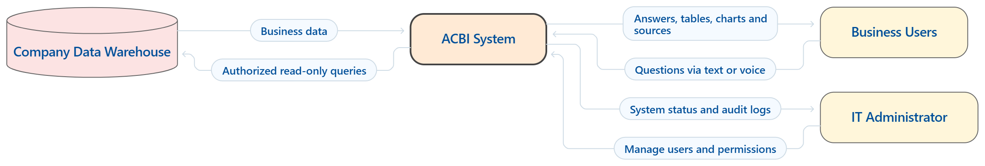
Figure 3.1 — ACBI Context Diagram
Company Data Warehouse
An external, company-managed source of standardized business data, such as sales, production, quality,… It supplies data requested by ACBI
Business Users
Management, production managers, sale managers personnel who request business information to support monitoring and decision-making. They receive result within their assigned access permissions
IT Administrator
The person responsible for administering user access and monitoring system status and access activity.

3.2 Technical Context

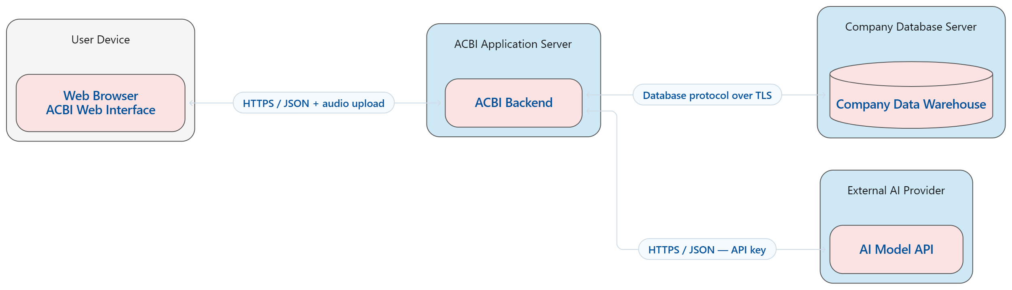
Figure 3.2 — ACBI Technical Context Diagram
Backend (ACBI Backend)
The backend runs on an application server and exposes HTTPS endpoints for the frontend. It handles user authentication, permission checks, conversation context, query processing, and result history.
The backend communicates with the external AI service through an HTTPS API using a server-side API key. It sends questions and approved context to obtain structured intents or SQL candidates. Supported requests are processed through the Structured Intent query builder; other supported analytical requests use RAG Text-to-SQL to retrieve relevant metadata and business definitions before generating SQL.
The backend validates queries and enforces access permissions before execution. It connects to the company data warehouse through an encrypted database connection using read-only credentials. Query results are formatted for presentation and may be sent to the AI service for summarization where company policy permits.
Frontend (ACBI Web Interface)
The frontend runs in a web browser and communicates with the backend over HTTPS. Users can submit text questions or upload voice recordings and receive answers, clarification requests, tables, charts, and source references.
Authorized administrators use the interface to manage user access and inspect system status and access activity. The frontend does not connect directly to the company data warehouse or hold the external AI API key.
Voice Input and Speech-to-Text
For voice questions, the frontend uploads the recording to the backend over HTTPS. The backend sends the audio to a pretrained speech-to-text service through an HTTPS API using server-side credentials. The service returns a transcript, which the backend processes through the same authentication, authorization, and query-processing flow as a typed question.
The transcript is displayed to the user for review and correction. If transcription fails or produces no usable text, the system asks the user to record again or enter the question manually. Only audio permitted by company policy is transmitted to the external service. The specific model and provider will be selected during prototyping based on Vietnamese transcription quality, latency, and cost.
Data Sent to External Services
The external AI service has no access path to the company data warehouse, but information still leaves the system. The table lists what each external call carries and the setting that controls it.
Call | Content sent | Not sent | Control
Question interpretation | The question (up to 1,000 characters); the data date; the full approved catalogue of metrics, dimensions and their members (up to 40 per dimension, with factory identifiers), not filtered by role; the request slots and any pending clarification from the previous turn; up to 6 recent turns, in which formatted amounts and decimal ratios of earlier answers are replaced by a placeholder | Result rows; passwords, keys, roles and user identifiers | Used for questions the backend rules cannot read. Reading plain questions by rules is an optional setting (LOCAL_INTENT_ENABLED, off by default) and is also the fallback when the AI service is unavailable
Questions about the data or the previous answer | The question; approved metadata visible to the user's role (metrics, dimensions and members, data coverage dates, permitted table and column names); a description of the previous answer, including its answer text with figures | Result tables | Used when AI is enabled
SQL proposal (RAG Text-to-SQL) | The question; the request slots without dates, factory or territory (growth metrics keep them); approved metric definitions and source mappings; table and column names permitted for the role; at most 2 approved example statements | Result rows; the full schema | EXTERNAL_METADATA_ENABLED, off by default; without it only the standard query builder runs
Visualization proposal | Only when the backend rules find no suitable chart: the question, the number of rows, and for each column its kind (numeric, temporal, category), whether it is sorted, its number of distinct values and whether it is complete | Values in the result | EXTERNAL_METADATA_ENABLED; without it results are shown as a table
AI summary | The question and the result rows | - | SEND_RESULTS_TO_LLM and EXTERNAL_RESULTS_ENABLED, both off by default
Speech-to-text | The audio recording when the user records a question | - | Requires a speech-service key

Technical Communication with External Systems
External System | Background
Company Data Warehouse | Provides standardized business data through its supported database protocol over an encrypted connection. ACBI executes authorized, read-only queries and retrieves results without modifying business records.
External AI Service | Provides pretrained model capabilities through an HTTPS API. It receives approved prompts and relevant context and returns structured intents, SQL candidates, or summaries. It has no direct access to the company data warehouse.
Speech-to-Text Service | Converts uploaded voice recordings into text through an HTTPS API. The backend submits approved audio and receives the transcript. The service has no direct access to the company data warehouse.

4. Solution Strategy
ACBI is developed as a web application that enables users to retrieve and compare business data through natural language, reducing manual navigation of dashboards and reports. Python/FastAPI is selected for the backend to support integration with AI libraries, document retrieval, and data processing. The system accesses a pretrained LLM through an external API, while data queries and numerical calculations are executed in the database.

4.1 System Overview
The frontend receives questions and displays results. The backend manages conversation context, routes requests through Structured Intent or RAG Text-to-SQL, validates SQL, and enforces access permissions. Business data is accessed through read-only connections, while conversation history and traceability records are stored in application storage. The backend formats query results and validates chart configurations before presentation. A separate model is not required for structured output: the same LLM can support multiple tasks, while application code validates the output structure.
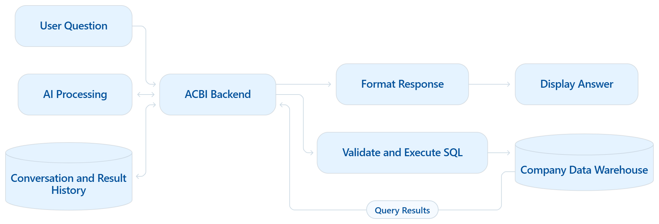
Figure 4.1 — ACBI System Workflow

4.2 AI Processing Strategy
The first approach considered is Direct Text-to-SQL, which provides the LLM with a question, database schema, and business definitions to generate SQL. This approach is flexible and suitable for a limited data scope. However, providing complete schema descriptions for a database with many tables increases context size and can make it harder to select the correct tables, relationships, and formulas. Generated SQL may execute successfully while producing incorrect business results.
To improve control, Structured Intent is considered. The LLM converts questions into structured requests containing metrics, reporting periods, filters, and analytical operations. The backend validates these requests and generates SQL using predefined formulas and supported operations. Different phrasings can therefore share the same query logic, but this approach is limited to combinations supported by the backend.
To support a broader range of questions, the system incorporates RAG Text-to-SQL. RAG, or Retrieval-Augmented Generation, retrieves relevant table and column descriptions, data relationships, KPI definitions, and SQL examples. This context is supplied to the LLM to generate SQL candidates, reducing the need to include the entire database schema in every request. However, correctness still depends on the quality of the retrieved information and the generated query.
The selected approach therefore combines Structured Intent and RAG Text-to-SQL. Once a question is sufficiently clear, the backend checks whether the standard query builder can fully process the request. Supported requests use the standard path; other requests use RAG Text-to-SQL. Both paths share approved business definitions. Missing information or unclear formulas lead to clarification requests or explicit limitations. Requests outside the user’s permissions are denied.
An alternative extension is RAG + Agent Text-to-SQL, which allows the AI to select tools, retrieve additional information, and refine queries across multiple steps. This offers greater flexibility but increases testing complexity and makes the number of model calls less predictable. The initial release therefore uses a backend-controlled workflow with a limited number of query correction attempts. Agent-based processing will be reconsidered if testing demonstrates a clear need.

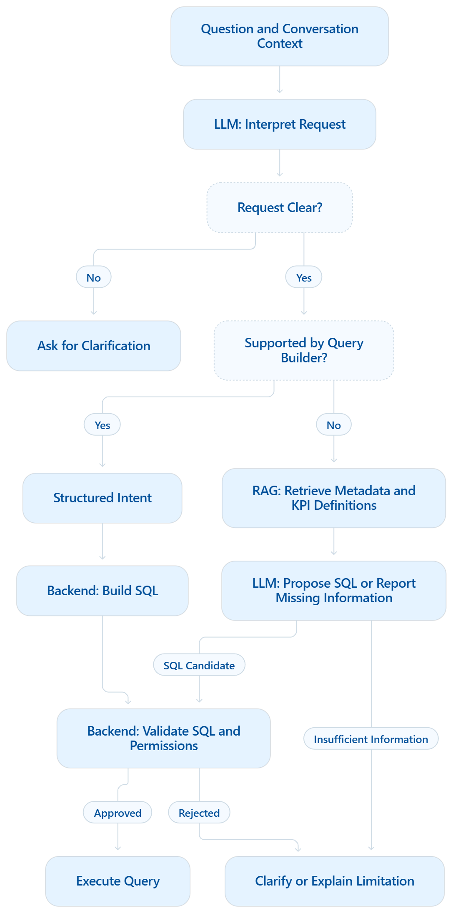
Figure 4.2 — ACBI AI Processing Workflow

5. Building Block View

5.1 Whitebox Overall System – Level 1
ACBI consists of three main building blocks: Web Frontend, Application Backend, and Application Storage. This separation keeps user interaction, processing logic, and data storage distinct, allowing each component to be maintained with fewer changes to the others. The backend coordinates AI processing and controls access to business data.

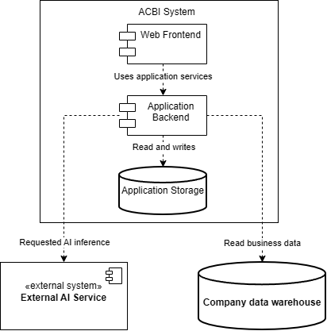
Figure 5.1 — ACBI Building Block View — Level 1

Element | Responsibility
Web Frontend | Provides text and voice input, displays answers and visualizations, and supports authorized administration functions.
Application Backend | Manages conversation context, coordinates AI and query processing, enforces permissions, and formats results.
Application Storage | Stores conversation history, saved results, audit logs, and application metadata.
External AI Service | Interprets questions and generates structured intents, SQL candidates, or summaries through an API.
Company data warehouse | Provides standardized business data for authorized, read-only queries.

The frontend exchanges questions and results with the backend. The backend reads and writes application data in Application Storage and communicates with both external systems. Neither the frontend nor the external AI service accesses the company data warehouse directly. External communication protocols are described in Section 3.2.

5.2 Level 2
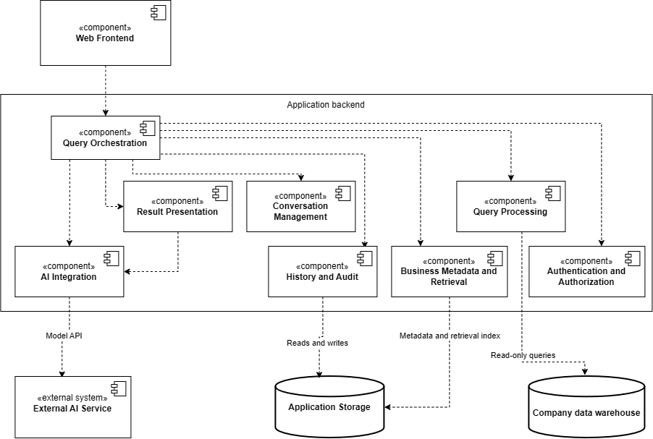
Figure 5.2 — Application Backend — Level 2

Component | Responsibility
Query Orchestration | Coordinates request processing and selects Structured Intent or RAG Text-to-SQL based on whether the standard query builder fully supports the request.
Authentication and Authorization | Identifies users and enforces permissions for business data, saved results, and administration functions.
Conversation Management | Maintains conversation context and pending clarification requests, using stored history where relevant.
AI Integration | Prepares approved prompts, calls the external LLM API, and validates the structure of model outputs.
Business Metadata and Retrieval | Provides approved KPI definitions, supported capabilities, schema descriptions, and relationships. Retrieves relevant context for SQL generation.
Query Processing | Builds SQL for supported structured requests, validates queries from both paths, and executes authorized, read-only queries with resource limits.
Result Presentation | Formats query results and validates chart configurations. Uses AI Integration for optional summarization when permitted.
History and Audit | Stores and retrieves conversations, saved results, query records, and source references through Application Storage.

Query Orchestration coordinates the modules, while Query Processing uses authorization rules and approved business metadata to control data access and calculations. AI Integration is the connection point to the External AI Service; Query Processing is the connection point to the Company Data Warehouse.
Web Frontend and Application Storage remain part of ACBI but are outside the backend boundary shown here. The External AI Service and Company Data Warehouse remain external dependencies, as described in Level 1.

6. Runtime View

6.1 Successful Data Request
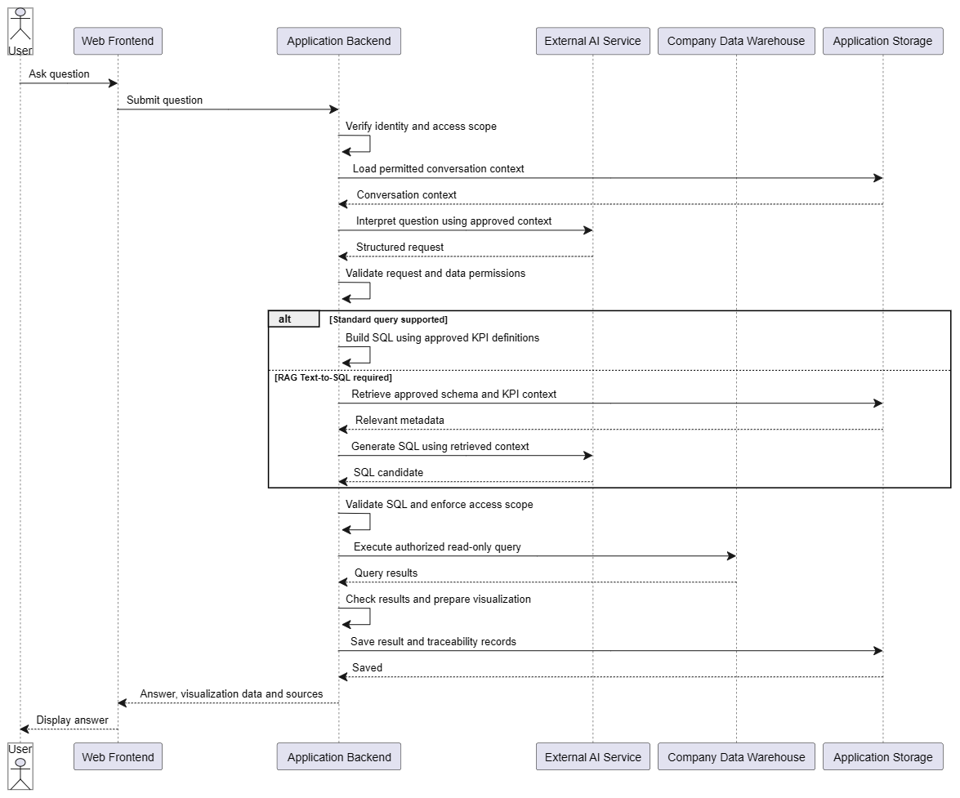
Figure 6.1 — Success Sequence Diagram
- Submit question: User asks a question through the frontend.
- Verify identity and access scope: Backend authenticates the user and loads their permissions.
- Load conversation context: Backend retrieves relevant history from Application Storage.
- Interpret question: External AI Service converts the question into a structured request; the backend reads plain questions by rules when that option is enabled, or when the AI service is unavailable.
- Check permissions: Backend validates the request against the user's access scope.
- Build SQL: Backend uses Structured Intent for supported requests, or retrieves schema/KPI context and calls the AI Service for RAG Text-to-SQL.
- Validate SQL: Backend re-checks the generated query and enforces access scope.
- Execute query: Backend runs the read-only query against the Company Data Warehouse.
- Save and respond: Result and traceability records are saved; the answer is returned to the user.

6.2 Unauthorized Data Request
Prerequisite: The user is authenticated but requests data outside their assigned access scope. The permission check is performed by the backend: the External AI Service never has visibility into the user's specific access rights, only non-sensitive context. The IT Administrator role has no access to business data and is refused right after authentication, before the AI service is called and before any query is built.

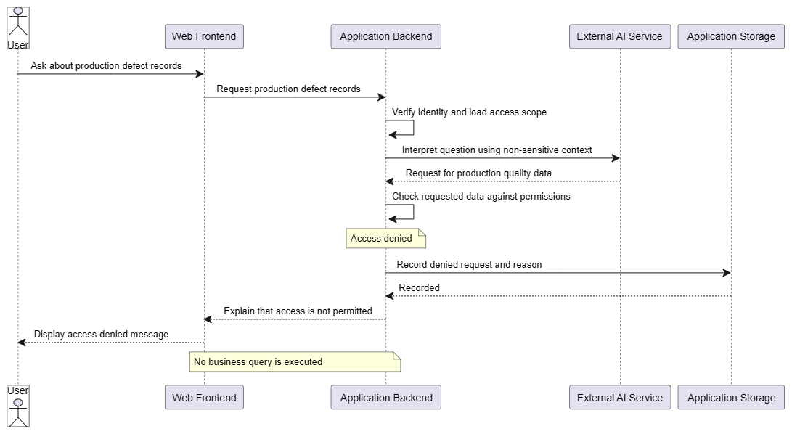
Figure 6.2 — Unauthorized Data Sequence Diagram
- Submit question: User requests data outside their permission scope.
- Verify identity and access scope: Backend authenticates the user. An IT Administrator is refused at this point, so the interpretation step does not take place for this role.
- Interpret question: AI Service identifies the data being requested, using only non-sensitive context.
- Check permissions: Backend determines the request is not allowed.
- Record denial: The denied request and reason are logged to Application Storage.
- Respond: User receives an explanation; no SQL is built and no data warehouse query is executed.

6.3 No Data Found
Prerequisite: The question is syntactically valid and within the user's permissions — interpretation, permission check, and SQL validation all succeed, exactly as in Scenario 6.1. The absence of data can only be determined after query execution, so steps 1–7 are identical to the happy path.
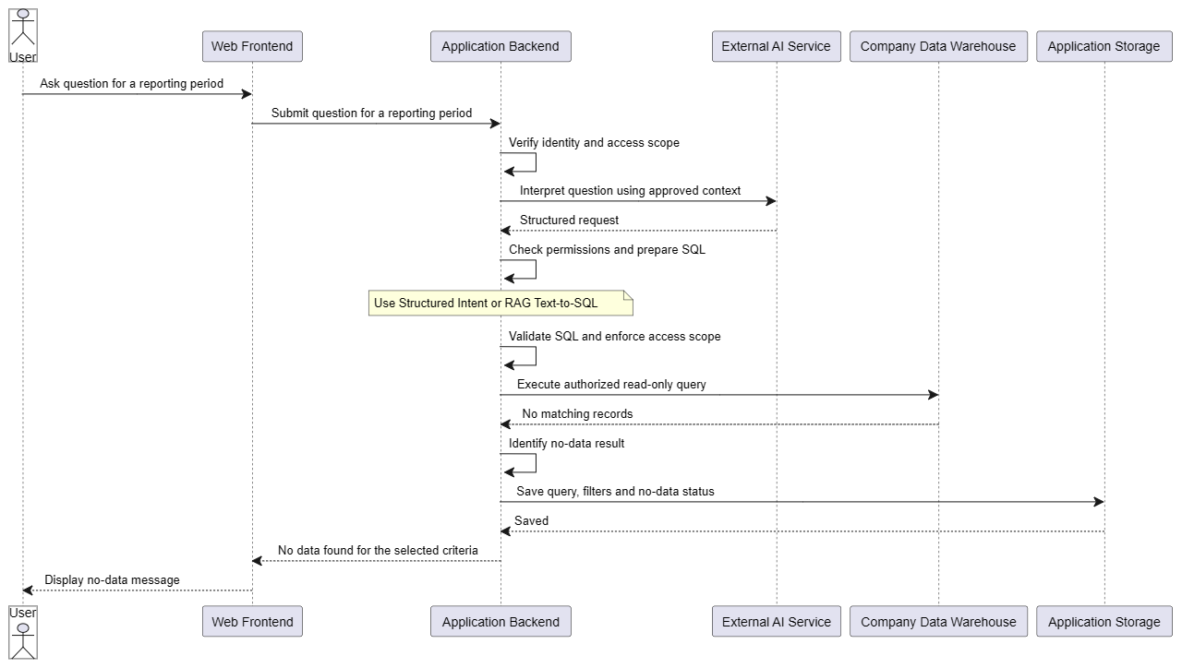
Figure 6.3 — No Data Sequence Diagram
- Submit question: User asks a valid, permitted question for a reporting period.
- Steps 2–7 proceed identically to Scenario 6.1 (interpret, check permissions, build and validate SQL).
- Execute query: Company Data Warehouse returns no matching records.
- Identify no-data result: Backend explicitly flags the empty result rather than fabricating an answer.
- Save and respond: Query, filters, and no-data status are saved; user is told no data was found.

6.4 Clarification Request
Prerequisite: The question is ambiguous — the AI Service cannot produce a fully resolved structured request from the available conversation context alone (e.g. "Are there any problems?"). This scenario shows how ACBI recovers instead of guessing at intent or executing an incorrect query.
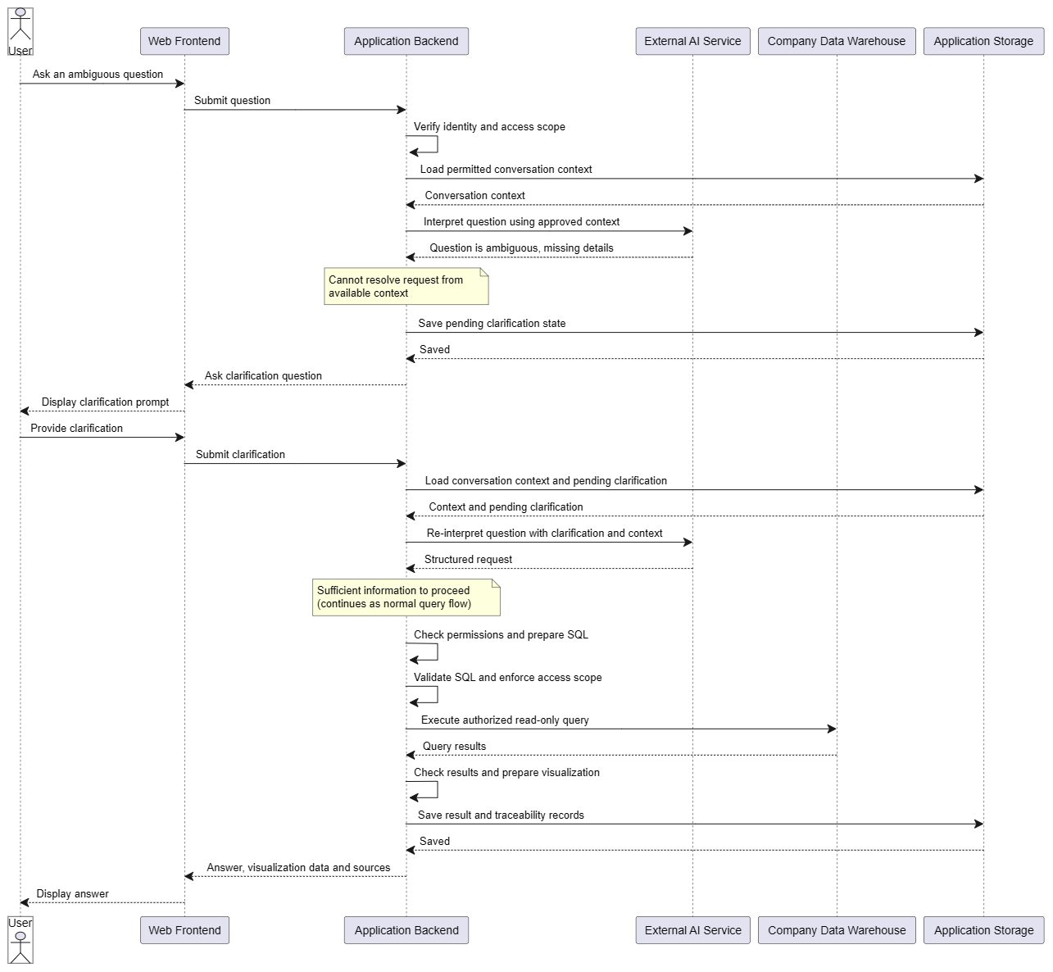
Figure 6.4 — Clarification Request Sequence Diagram
- Submit question: User asks an ambiguous question.
- Interpret question: AI Service cannot resolve a structured request from the available context.
- Save pending clarification: Backend stores the unresolved state in Application Storage.
- Ask clarification: User is prompted for the missing detail.
- Re-interpret: Backend reloads context and pending clarification, then re-sends to the AI Service with the user's reply.
- Once resolved, processing continues as in Scenario 6.1.

7. Deployment View
ACBI will be deployed on a server with Docker Engine and Docker Compose installed. The server must have network access to the Company Data Warehouse and the External AI Service.

7.1 Docker Deployment
Docker Compose will manage three containers: a web server serving the frontend, the FastAPI backend, and the application database. This approach provides a consistent deployment configuration across development and production environments.
Deployment involves obtaining the application images and Compose configuration, supplying the required credentials, and starting the containers. Users access the web interface through HTTPS. The frontend runs in the browser and sends requests to the backend, while the application database is accessible only through the internal Docker network.
The backend accesses the Company Data Warehouse through an encrypted, read-only connection and communicates with the External AI Service through HTTPS. Both systems remain outside the Docker deployment.
Application data is stored in a persistent volume so that conversation history, saved results, and audit logs survive container replacement. Backups are managed separately. API keys and database credentials are supplied at deployment time and excluded from container images and source control.
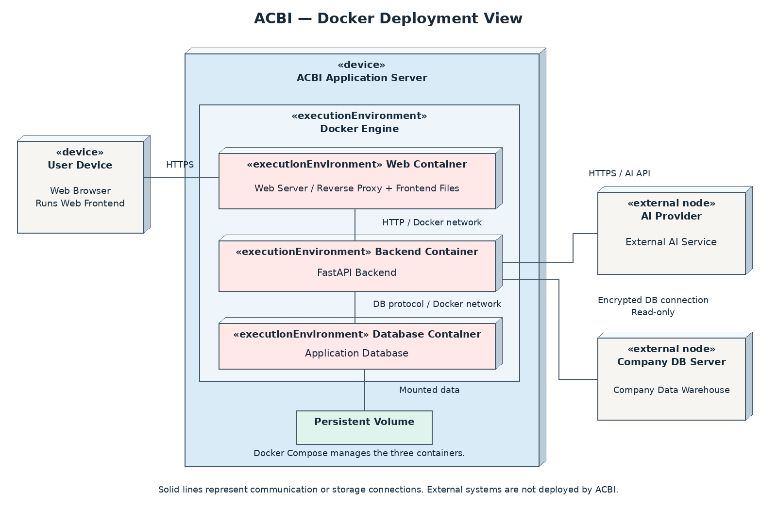
Figure 7.1 — Docker UML Deployment Diagram

8. Cross-cutting Concepts

8.1 Authentication and Authorization
Authentication verifies the user's identity, while authorization determines which resources they can access. In ACBI, users are assigned roles and access scopes based on their business responsibilities. For example, the prototype may allow managers to access all approved business reporting data, while sales staff can access only sales and revenue information. These initial roles are used for testing and will be adjusted to match company-defined policies.

The backend verifies the user's identity and enforces permissions when accessing business data, metadata, conversation history, and saved results. Access checks apply to both Structured Intent and RAG Text-to-SQL processing, including metadata retrieval and query execution. Requests outside the user's permitted scope are denied and recorded in the audit log. The AI service interprets requests but cannot grant or override access permissions.

8.2 Business Definitions and Metadata
ACBI maintains a shared business dictionary containing approved KPI definitions and metadata. Each metric had a unique identifier and versioned definitions specifying its calculation formula, unit, supported dimensions, and required data sources. For example, production output maybe analyzed by date, factory or production line according to its approved definition.
Both Structured Intent and RAG Text-to-SQL use this dictionary. The standard query builder applies predefined calculation rules, while the RAG path retrieves relevant definitions, table and column descriptions and data relationships to support SQL generation. Retrieved metadata is restricted to the user’s authorized scope.
Metric changes create new definition versions and the version used is recorded with each query for traceability. If the required definition or data mapping is missing or ambiguous, the system request clarification or explain the limitation instead of inventing a calculation.
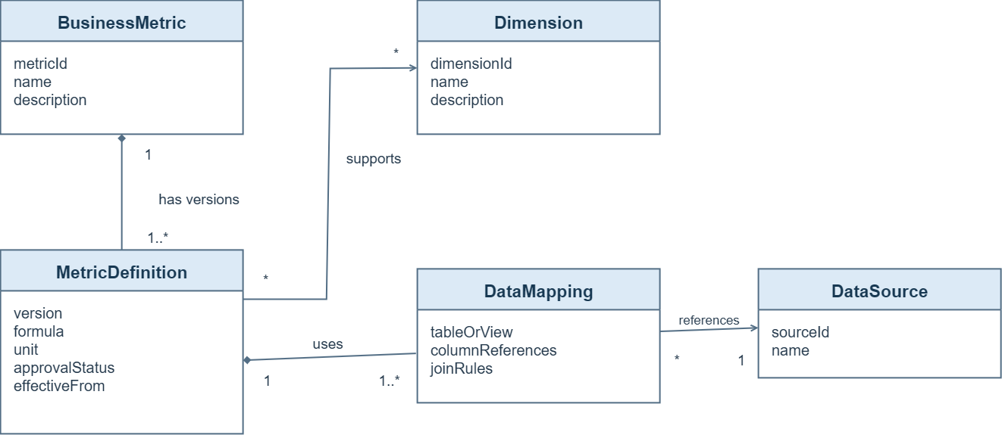
Figure 8.1 — Business Dictionary UML Class Diagram

8.3 AI Output and Query Validation
ACBI treats AI-generated output as a proposal that must be checked by the backend before use. For structured requests, the backend validates the output format, required fields, metric identifiers where applicable, time ranges, and filters against the available business definitions and metadata. Requests with missing or ambiguous business information lead to clarification rather than query execution. Malformed AI output is rejected and may be regenerated within a limited number of attempts.
SQL produced by either the standard query builder or RAG Text-to-SQL passes through a shared validation process. The backend parses the SQL to check permitted operations, tables, columns, and functions, and enforces the user's access scope. User-supplied filter values are passed as query parameters. Approved queries are executed using read-only credentials, with execution time and result-size limits. By default a query is stopped after 15 seconds or the remaining request time, whichever is shorter, and returns at most 100 rows (250 for stacked charts, 400 when grouped by day, week or month); when a result reaches the limit and the user did not ask for a top N, the answer says that only the first rows are shown.
For example, if a generated query references a restricted table or attempts to modify business data, the backend rejects it before execution. Only a departure from the approved query shape (for example literal dates instead of the bound period, an extra filter or join, or a table outside the metric's approved mapping) or a syntax error is returned to the AI service for correction, at most twice, and every revised query must pass validation again. Security violations (writes, tables or functions outside the role's allowlist, scope violations) are denied and never retried, and authorization failures are not retried through another query path.
For generated SQL the backend also wraps each source table in a subquery limited to the user's period and permissions, so the query can only see rows the user may see. The date condition therefore appears in both the scope subquery and the outer query, and both are bound to the resolved period (for growth metrics the scope covers both compared periods). Queries from the standard builder must match the predefined statement exactly and do not need the wrapper.
User questions and retrieved content cannot override these controls. SQL validation reduces execution risks but does not guarantee business correctness; queries must also follow the approved definitions described in Section 8.2. Validation of AI-proposed visualization configurations is described in Section 8.5.
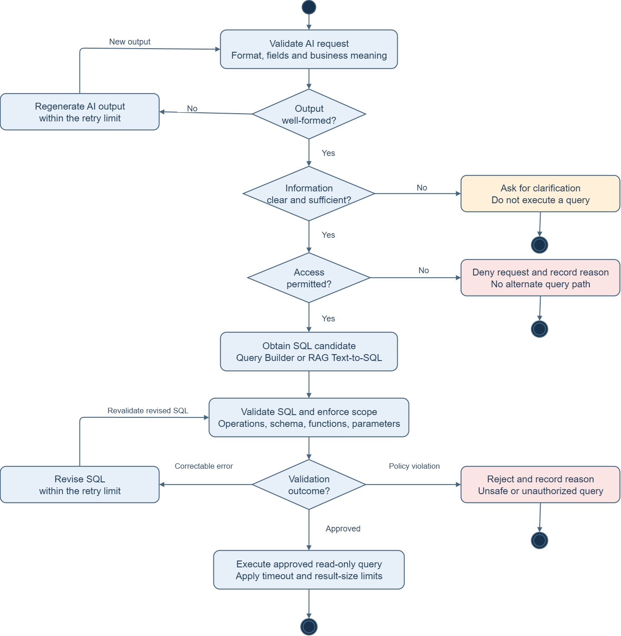
Figure 8.2 — AI Request and SQL Validation Activity Diagram

8.4 Conversation Context and Clarification
ACBI stores conversation history and pending clarification requests in Application Storage. For each question, the backend retrieves relevant context belonging to the current user and conversation, subject to current access permissions. Context may include previously selected metrics, reporting periods, filters, and comparison criteria.
For example, after asking about this month's revenue for Factory A, the user may ask “What about last month?”. The system retains the metric and factory while updating the reporting period. Conversation context helps interpret the request but does not override approved business definitions or access permissions.
When required information remains missing or ambiguous, the system asks a focused follow-up question and stores the unresolved request. The user's reply is combined with the relevant context and validated again before query processing continues. If clarification is still insufficient, the system asks again or explains the limitation rather than guessing.
Only the six most recent turns are kept as conversational context. Before they are sent to the AI service, formatted amounts and decimal ratios in earlier answers are replaced by a placeholder, so the service can resolve references such as “the top territory” from names and dates without receiving earlier figures.
The backend checks the reporting period chosen by the AI service against the question. A question that names exactly one year, quarter or month uses that period; a question with no time wording and no earlier period to inherit leads to a clarification request instead of an assumed period. A factory named by the user is always applied as a filter.
Comparisons of one metric across up to four periods of the same kind are handled by a dedicated component. Each period runs as an ordinary validated query under the same permission checks, and the differences are computed by the backend from the returned rows, not by the AI service. A comparison of named factories is an ordinary grouped query limited to those factories, and the answer states which factories were left out.
A message containing several requests is split into separate requests, by backend rules or as marked by the AI service, up to five per message. Each request runs through the full processing flow, including its own permission check, and appears as a numbered block in the answer. A refused request, or one that needs more detail, affects only its own block; requests beyond the limit are listed as not performed.

8.5 Result Presentation and Traceability
Both Structured Intent and RAG Text-to-SQL use the same presentation process. After query execution, the backend prepares the results and approved metadata, including column names, data types, units, and reporting periods. The backend first applies deterministic rules to the shape of the result: a single value becomes a KPI card, a date axis a line chart, two groupings stacked bars, and a small whole a pie or donut chart; other results use bars. Only when no rule fits does the AI propose a visualization configuration based on this information and the user’s question. Supported outputs include bar, line, pie/donut, stacked bar, and scatter charts, as well as tables and KPI cards.
The backend validates the proposed chart type and column mappings against the actual results and supported visualization rules. Invalid configurations may be returned to the AI for correction within a limited number of attempts. If no valid configuration is obtained, the system displays the results as a table. The frontend renders the validated configuration using the query results; the AI does not generate replacement data values.
Optional AI-generated summaries use only results permitted for transmission to the external service. Numerical statements are checked against the query results, and summaries containing unsupported claims are withheld or replaced with a factual response. No matching records are distinguished from a measured value of zero.
The system saves the question, answer, underlying query results, visualization configuration, executed SQL, parameters, source references, retrieval timestamp, and applicable metric-definition versions. These records link each answer to the data and calculation used. Saved results show their original retrieval time and remain subject to current access permissions when reopened.

8.6 Error Handling and External Service Calls
ACBI distinguishes clarification needs, authorization failures, empty results, and technical failures. The backend returns a clear status and an appropriate message without exposing credentials, restricted schema details, or raw internal errors.

Situation | System response
Missing or ambiguous information | Ask for clarification before executing a query.
Unauthorized request | Deny access and record the reason without querying restricted data.
No matching records | Explain that no data matches the selected criteria.
Invalid AI output or correctable SQL error | Apply the bounded correction process described in Section 8.3.
AI service timeout or temporary unavailability | Retry within configured limits, then explain that the request could not be completed.
Database failure or query timeout | Stop processing and report a technical failure; do not present it as an empty result.
Invalid visualization or failed optional summary | Present validated query results as a table or factual response.
Result-storage failure | Report that the result could not be saved; do not claim that history or traceability records were stored successfully.

External AI calls use server-side credentials and include only information permitted by company policy. Each call has a timeout, and temporary failures may be retried with a delay. Both retries and SQL-correction attempts are constrained by an overall request budget to prevent indefinite processing; by default the budget is 30 seconds and four AI calls. When a provider reports that a rate limit has been reached (HTTP 429, or 403 mentioning a limit) or that it is overloaded (5xx), the user is told that the AI service is busy and should retry later, and no partial or guessed answer is returned. While the AI service is unavailable, plain questions and short follow-ups that backend rules can read are still answered.
Technical failures are logged with a request identifier so related processing steps can be investigated. Credentials and unnecessary sensitive content are excluded from logs. Authorization failures and permanently invalid requests are not retried through alternative processing paths.

9. Architecture Decisions

9.1 Hybrid Query Processing
Problem: ACBI must support varied business questions while maintaining consistent calculations. Structured Intent is designed to handle common requests using predefined business rules and supported query patterns. However, it cannot process requests that require unsupported analytical operations or data mappings. Unrestricted SQL generation offers greater flexibility but may reference incorrect tables, use inappropriate joins, or apply incorrect business formulas, even when the SQL executes successfully. The system therefore needs a controlled way to support requests beyond the standard query builder without assuming that every generated query is correct.
Decision: Combine Structured Intent with RAG Text-to-SQL. The backend uses the standard query builder when it fully supports a request; otherwise, it retrieves approved metadata and business definitions for AI-generated SQL. Both paths undergo validation. This extends coverage but requires maintained metadata and does not guarantee that every question can be answered.
Alternatives: Structured Intent only, Direct Text-to-SQL, or RAG with agent-based query processing. Agent-based processing is deferred because it introduces additional orchestration, testing, and model-call complexity.

9.2 External LLM Service
Problem: ACBI requires language understanding and SQL-generation capabilities, but operating a local model adds infrastructure and maintenance requirements.
Decision: Use a pretrained LLM through an external API. Only company-approved information is transmitted, and API credentials remain on the server. This reduces model-hosting responsibilities but introduces provider dependency, network requirements, and usage costs. The AI calls sit behind one interface in the AI Integration module: providers whose API follows the OpenAI chat-completions format need only configuration, other providers may need an adapter. Production is intended to use one paid provider; hosting a model offline on a dedicated server remains the alternative, and Appendix B compares the cost of both. During the demonstration period several free providers and keys are rotated to avoid cost; this is a temporary arrangement that is removed when a paid plan is adopted.
Alternatives: Host a pretrained model locally to gain more control over data processing and availability, while accepting responsibility for model infrastructure and operation.

9.3 Backend-Controlled Data Access
Problem: AI-generated requests and SQL may reference unauthorized data or propose unsafe operations. Access restrictions must remain effective across both query paths.
Decision: The backend validates requests and SQL, enforces access permissions, and executes queries using read-only credentials and resource limits. The AI service has no direct database access. These controls reduce execution risks, while business correctness also depends on approved definitions and query evaluation.
Alternatives: Allow an AI agent to invoke a database tool that independently enforces equivalent access controls. This would still require trusted validation outside the model and would add tool-orchestration complexity.

9.4 AI-Proposed Visualizations
Problem: Users may request different analyses, making it difficult to define a chart-selection rule for every possible question. However, AI-generated chart configurations may be incompatible with the returned data.
Decision: Choose the visualization by backend rules for common result shapes, and let the AI propose the visualization type and column mappings when no rule fits. The backend validates the configuration, and the frontend renders it using actual query results. Invalid proposals may be corrected within a limited number of attempts; otherwise, results are displayed as a table.
Alternatives: Select all visualizations through backend rules only, or require users to choose a chart type. Backend rules are more predictable, while manual selection requires additional user interaction.

9.5 Modular FastAPI Backend
Problem: ACBI must integrate AI services, metadata retrieval, database queries, and access controls while remaining manageable to develop and maintain. The backend technology should support rapid experimentation and provide suitable libraries for these tasks.
Decision: Implement a single Python/FastAPI backend with separate modules for its main responsibilities. Python is selected for its readable syntax, extensive library ecosystem for AI, and ability to integrate with lower-level languages such as C and C++. This allows developers to use native libraries for performance-sensitive operations when needed.
FastAPI provides API development features, including Pydantic-based data validation and automatic OpenAPI documentation.
For ACBI, LLM inference runs through an external service and business calculations run in the database. Python therefore primarily coordinates processing rather than performing all computation itself. Backend performance will be evaluated under the expected workload. The modules are maintained separately within one application but share its deployment lifecycle.
Alternatives: A .NET, Java, or TypeScript backend could implement the same architecture. C/C++ could also be considered if measured local processing requirements justify the additional implementation effort. Independently deployed services offer separate scaling but introduce more deployment and communication complexity for the initial release.

9.6 Docker Compose Deployment
Problem: ACBI needs a repeatable way to deploy the web server, backend, and application database without excessive operational complexity.
Decision: Run these components as separate containers on a single server using Docker Compose. Application data uses persistent storage, with backups managed separately. This simplifies the initial deployment but does not provide automatic multi-server failover.
Alternatives: Install components directly on the server, or use a multi-node container orchestration platform. Direct installation requires more manual environment management, while multi-node orchestration introduces additional operational complexity.

10. Quality Requirements

10.1 Quality Requirements Overview
ACBI prioritizes accuracy, security, traceability, usability, and performance, as defined in Section 1.2. This section specifies scenarios and acceptance criteria for evaluating these goals.
Evaluation uses a controlled dataset, approved business definitions, test user accounts, and reference results verified independently of AI-generated SQL. The test set covers both query-processing paths, ambiguous questions, unauthorized requests, and empty results.
The numerical targets below are provisional and will be reviewed after prototype testing.

10.2 Quality Scenarios
ID | Quality | Scenario and Expected Response | Acceptance Criteria
QS1 | Accuracy | An authorized user asks a clear question within the declared supported scope. The system returns results consistent with the approved business definition. | At least 90% of the agreed answerable test questions produce correct results. Dates, filters, units, and values must match the reference results within predefined rounding tolerances. Clarifications or refusals do not count as correct answers for these clear, answerable questions. Results are reported separately for Structured Intent and RAG Text-to-SQL.
QS2 | Accuracy | A valid query finds no matching records. The system explains that no data matches the selected criteria. | All empty-result test cases return a no-data status without fabricated values. No matching records are distinguished from a measured zero and from a database failure.
QS3 | Security | A user requests business data, metadata, conversation history, or saved results outside their current permissions. | All defined unauthorized-access tests are denied without exposing restricted content. Denied requests are recorded, and no query accessing restricted data is executed.
QS4 | Traceability | A user receives a successfully saved analytical answer and later reviews its origin. | Every saved answer links to its executed SQL, parameters, source references, retrieval timestamp, underlying results, and applicable metric-definition versions. Storage failures are explicitly reported.
QS5 | Usability | A user asks an ambiguous question and then provides the requested clarification. The system uses the reply and relevant conversation context to resolve the request. | Each defined ambiguity test produces a relevant clarification before query execution. Follow-up tests preserve previously specified metrics and filters unless the user changes them.
QS6 | Usability | The AI proposes a visualization for query results. The backend checks the configuration before presentation. | All deliberately invalid chart configurations in the test set are rejected. The system either obtains a valid configuration within the correction limit or displays the validated data as a table.
QS7 | Performance | Users submit questions against the agreed test dataset under a load of five concurrent requests, with external services operating normally. | At least 95% of requests return an answer or clarification within 15 seconds, measured from backend receipt to the complete response. Errors and timeouts are reported separately and do not count as successful responses.
QS8 | Failure Handling | The AI service or database times out during request processing. The system terminates processing and informs the user. | Every timeout test returns a controlled failure response within the configured overall request deadline, provisionally 30 seconds. Retries remain bounded, and no fabricated answer or misleading no-data response is returned.

Passing these scenarios demonstrates behavior within the tested scope; it does not guarantee correctness or security for every possible request. Test datasets, workloads, model versions, and configuration settings are recorded so results can be compared across releases.

11. Risks and Technical Debts
This section describes the main risks of the proposed ACBI architecture and the measures intended to reduce them.

11.1 Incorrect Business Results
Description: AI may misunderstand a question, retrieve irrelevant metadata, or generate SQL that executes successfully but uses incorrect formulas or joins. Incomplete or outdated business definitions may also produce misleading answers.
Mitigation: Use approved KPI definitions and verified data mappings for both query paths. Ask for clarification when necessary, compare results against independently verified reference answers, and retain query and source information for investigation. Revalidate affected mappings and tests when definitions or schemas change.

11.2 Unauthorized Data Disclosure
Description: Inconsistent permission checks may expose restricted business data, metadata, conversation history, or saved results. Sensitive information could also be included in requests to the external AI provider.
Mitigation: Enforce access scope in the backend and use restricted, read-only database credentials. Check current permissions when accessing stored results and limit external AI requests to company-approved content. Test unauthorized-access scenarios across both query paths. The content of each external call is listed in Section 3.2 and must be kept up to date. Before real company data is used, each provider’s retention and training terms are reviewed, data is classified by sensitivity, and an independent penetration test is performed.

11.3 External AI Service Dependency
Description: Provider outages, slow responses, or excessive model calls may reduce availability and increase operating costs.
Mitigation: Apply timeouts, bounded retries, and an overall request deadline. Monitor latency and usage, limit transmitted context, and return a clear failure message when processing cannot complete. If only chart generation or optional summarization fails, present the validated query results as a table. Free-tier quotas limit concurrent use, so production relies on a paid plan or an offline model (Section 9.2).

11.4 Limited Initial Validation Coverage
Description: The prototype will initially be evaluated against a limited set of KPIs, questions, and datasets. Successful demonstrations may not represent performance on unfamiliar terminology, complex queries, or additional departments. This is a planned limitation that may become technical debt as the system expands.
Mitigation: Define the supported scope explicitly and include ambiguous, unauthorized, empty-result, and incorrect-query cases in testing. Expand the reference test set before introducing new data sources or analytical capabilities, and turn confirmed failures into regression tests.

12. Glossary

Term | Definition
ACBI | The conversational business intelligence system described in this document. It allows users to ask business questions in natural language and receive answers, tables, and visualizations.
API, Application Programming Interface | An interface through which software components exchange requests and responses. ACBI uses APIs for frontend–backend communication and external AI service calls.
Audit Log | A record of system activities, such as query execution and access denials, used for investigation and accountability.
BI, Business Intelligence | The use of business data to produce reports and insights that support decision-making.
Business Dictionary | A shared collection of approved business terms, metric definitions, calculation rules, and units used to interpret questions consistently.
Data Mapping | The association between business concepts and actual database tables, columns, and join relationships.
Data Warehouse | A repository of standardized business data used for reporting and analysis. ACBI accesses the company data warehouse through authorized, read-only queries.
Dimension | An attribute used to group or filter data, such as date, production line, or sales region.
Docker Compose | Docker Compose is a tool for defining and running applications with multiple containers. ACBI uses it to configure and manage its deployment services.
FastAPI | FastAPI is a Python framework for building APIs using type annotations. It is used to implement the ACBI application backend.
Hallucination | AI-generated content that appears plausible but is unsupported or incorrect, such as an invented database column or an explanation inconsistent with query results.
KPI, Key Performance Indicator | A measurable value used to evaluate progress toward a business objective, such as a production target or sales target.
LLM, Large Language Model | An AI model that processes and generates language. In ACBI, it interprets questions and proposes structured intents, SQL queries, summaries, and visualization configurations.
Metadata | Information describing data, including table names, column types, relationships, and business meanings. It helps ACBI interpret and query the available data.
Metric | A quantitative measure with a defined calculation and unit, such as total revenue or production output.
Pydantic | Pydantic is a Python library for data validation using type annotations. In ACBI, it supports checking the structure and types of request and response data.
Python | Python is a general-purpose programming language with an extensive library ecosystem. It is used to implement ACBI’s backend processing and integrations.
Query Builder | A backend component that converts validated structured intents into SQL using supported query patterns and approved data mappings.
RAG, Retrieval-Augmented Generation | An approach that retrieves relevant reference information and supplies it to an AI model as context for generating a response.
RAG Text-to-SQL | A query-processing approach that supplies retrieved schema information and business definitions to an AI model to generate SQL candidates for backend validation.
SQL, Structured Query Language | A language for accessing and manipulating relational data. ACBI restricts query execution to approved read-only operations.
Structured Intent | A machine-readable representation of a user’s question, containing fields such as metrics, dimensions, time ranges, and filters.
Traceability | The ability to connect an answer to its originating question, executed query, and relevant data and business definitions.
Visualization Configuration | A structured specification describing a chart type and its data-field assignments. The AI proposes the configuration, the backend validates it, and the frontend renders it.

Appendix A. Implementation Roadmap
The prototype is planned for two weeks of preparation and eight weeks of implementation, focusing on agreed business metrics and approved data sources.

Period | Main Activities
Preparation — 2 weeks | Confirm requirements, architecture, business definitions, and evaluation scope.
Implementation — Weeks 1–2 | Set up the application, authentication, database connections, and verified data mappings.
Implementation — Weeks 3–4 | Implement Structured Intent, query building, clarification, and access controls.
Implementation — Weeks 5–6 | Implement RAG Text-to-SQL, shared query validation, and AI-proposed visualizations.
Implementation — Weeks 7–8 | Complete history, saved results, voice input, and error handling; evaluate and deploy the prototype.

The schedule depends on timely access to approved data and AI services. Scope will be adjusted if these dependencies are delayed.

Appendix B. Cost and Resource Estimation
The following items may incur additional costs during prototype deployment and operation.
Resource | Estimation Basis
External AI API | Model usage, including question interpretation, SQL generation, correction attempts, summaries, and visualization proposals.
Server hosting | Rental of a server to run the frontend, backend, and application database.
Voice transcription | Audio usage if a paid speech-to-text service is selected.
Storage and backups | Additional storage beyond the hosting package for conversation history, saved results, audit logs, and backups.
Domain name | Registration and renewal if a custom domain is required.

The final budget depends on provider selection and expected usage. Existing company resources may reduce additional expenditure.
Indicative AI Cost
An indicative estimate for the AI service alone, at October 2026 prices. It assumes the worst case, in which every question calls the AI service for interpretation, SQL proposal and chart selection; it leaves out SQL correction attempts, summaries and replies about the data. Prices and token counts must be confirmed before a decision, and the Claude options have not yet been run against the project test set.
Option | Estimated cost | Notes
Claude Haiku 5.5 API | About USD 4 (5,000 questions), 16 (20,000) and 79 (100,000) per month | Not yet benchmarked on the project test set
Claude Sonnet 5.5 API | About 20 times the Haiku cost | Only if Haiku quality is insufficient
GPU server with an offline model | About USD 200 to 500 per month, fixed | Excludes staff cost; data stays inside the company
Break-even between the API and the server | About 250,000 questions per month at USD 200, about 630,000 at USD 500 | Below this volume the API is cheaper
Operating staff cost is not yet estimated and is to be completed.

