# 

# 

# 

# 

# 

# 

# 

# 

# 

# 

# 

# 

# 

# 

# 

# 

# 

# 

# 

# 

# 

# 

# CHAPTER 3: DESIGN AND IMPLEMENTATION

**CHAPTER OUTLINE**

**CHAPTER 3: DESIGN AND IMPLEMENTATION 1**

**3.1: BLOCK DIAGRAM: 2**

3.1.1: Block Listing 2

3.1.2: Block Diagram 3

**3.2: OPERATIONAL DESCRIPTION: 4**

**3.3: MECHANICAL DESIGN: 4**

3.3.1: Calculation and Selection 4

A. Selecting frame material 4

B. Selecting the gear-motor: 4

3.3.2 Draft drawing 6

3.3.3: CAD drawing 8

**3.4: Electrical design 12**

**3.5: Control Design 12**

3.5.1: Flow chart 12

3.5.2: Flow chart explanation 13

# 3.1: BLOCK DIAGRAM:

## 3.1.1: Block Listing

**MAIN CONTROLLER**

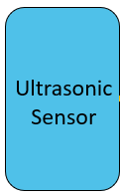

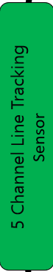

**SENSOR**

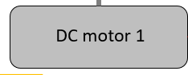 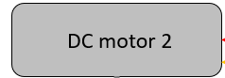 **MOTOR**

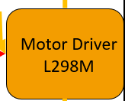 **MOTOR CONTROL**

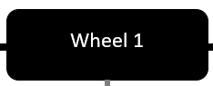 **WHEEL**

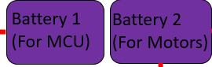 **POWER SUPPLY**

## 

## 

## 

## 

## 

## 

## 

## 3.1.2: Block Diagram

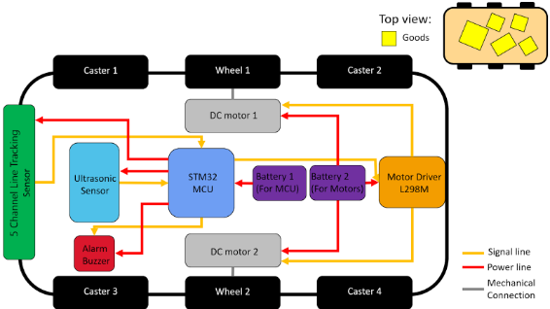

# 3.2: OPERATIONAL DESCRIPTION:

Power from **Batteries** supply for the whole system. **STM32** works as the brain of the AGV. **Line Tracking Sensor** tracks the line and sends a signal to STM32. STM32 bases on the signal it receives, if Line Tracking Sensor detects a line, it will control the AGV to move forward by sending a signal to **Motor Driver L298M**, which is controlling 2 **DC Motors** on each side. Those motors will control 2 **wheels** and make the 4 **casters** go the same way. However, if an obstacle is in front of the AGV, the **Ultrasonic Sensor** will detect it and send a signal back to the STM32. Then the **Alarm Buzzer** goes off and the STM32 will control the AGV to stop. If the obstacle is removed, Alarm Buzzer will turn off and the AGV continues its way.

# 3.3: MECHANICAL DESIGN:

## 3.3.1: Calculation and Selection

### Selecting frame material

There are many types of materials we can use to make the frame such as mica, cardboard, wood, etc. We decided to use Mica bars to make the base because it has several advantages:

+ Mica: The base of the AGV is made from Mica because this material ensures the technical requirements of the bridge. Ensuring physical and mechanical properties, meeting machinability, light weight, and low price.

We create drawings of AGV parts using CAD software and then process these details on an automatic laser cutting machine. It ensures more dimensional accuracy than manual processing and ensures aesthetics for the AGV.

### Selecting the gear-motor:

AGV’s Parameters:

+ Maximum weight: 5(kg)

+ The diameter of wheels: d = 2*r = 65(mm)

+ Maximum speed of the robots: v = 0.2(m/s)

- Calculate the required speed:

n = (v/r)*(60/2π) = (0.2/28.10^-3)*(60/2π) = 58.76 (rpm)

P = m*g=5 * 9,8= 49 (N)

+ The friction force Ff of 2 driving wheels with μ=0.7:

Ff = P* μ = 49 * 0.7 = 34.3 (N)

+Assume AGV can accelerate up to 0.2 m/s in 5s:

a = v/t = 0.2 / 5 = 0.04 (m/s2)

+Acceleration force Fa of the AGV:

Fa = m*a = 5 * 0.04 = 0.2 (N)

+ Equilibrium equation of the AGV:

F = Ff + Fa=34.3 + 0.2 = 34.5 (N)

⇒ The torque requires of AGV: T = Fd = 34.5*65/2 = 1121.25(Nmm)=1.121(Nm)

⇒ The torque required for single motor: Ti = T/2=1.121/2=0.56(Nm)

-With safety coefficient = 2, the rated torque: T(rated) = Ti *1.5=0.56*1.5=0.84 (Nm)

From the torque T(rated)=0.84 (Nm), n= 58.76 (rpm), We choose the DC servo motors GA25 370 12V 60rpm, which is 12VDC and 60 rpm speed.

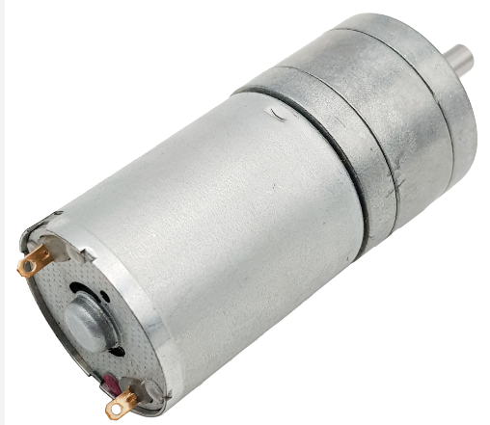

* Supply voltage: 6 ~ 18VDC
* Speed: 620 rpm
* Torque: 1 kg.cm = 0.098 N.m
* No-load current: 50mA

## 

## 

## 

## 

## 3.3.2 Draft drawing:

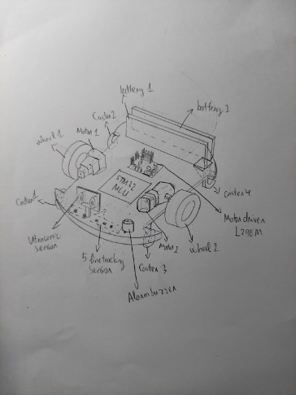

AGV base drawing with many details including:

- Power supply

- frame

- wheel and caster

- servo motor

- Main controller

- Sensor

and the base is made from mica.

## 

## 3.3.3: CAD drawing

Made of mica material, each piece is 5mm thick.

* **Cage’s frame part:**

**Position**: above the upper part.

**Use:** protect the goods safely when AGV is moving.

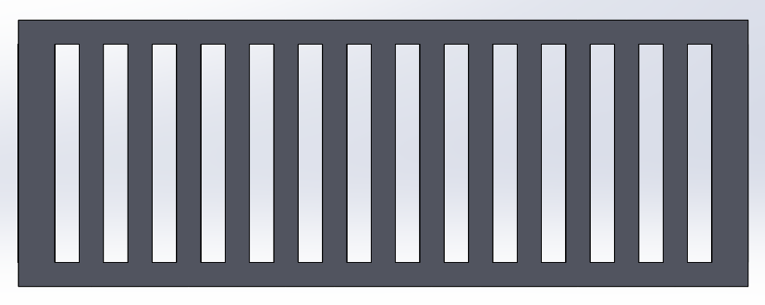

* **Lower part:**

**Position**: below the accessories.

**Use:** its function is to protect all the accessories and framing for AGV and keep accessories above it safely.

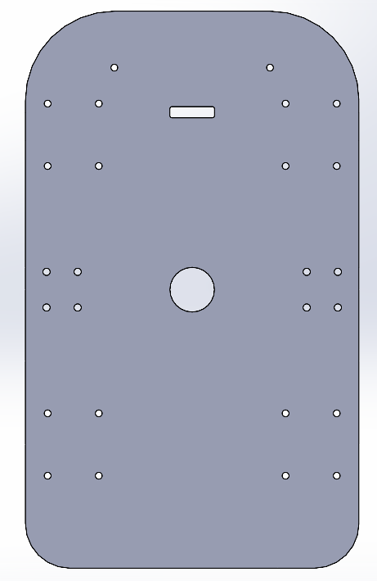

* **Upper part:**

**Position**: above the accessories.

**Use:** its function is to protect all the accessories and framing for AGV. Also, it lifts the goods above it.

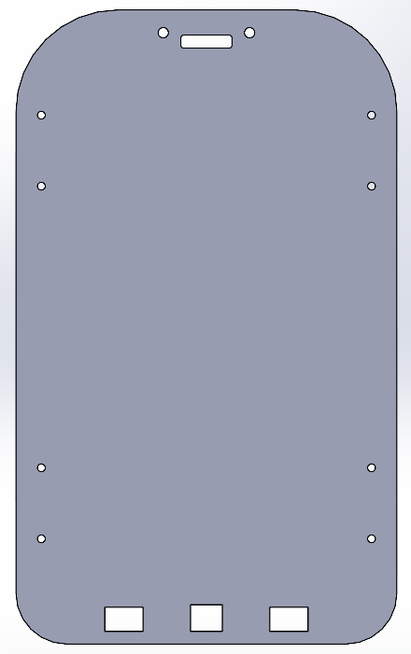

The overall cad drawing will be going like this:

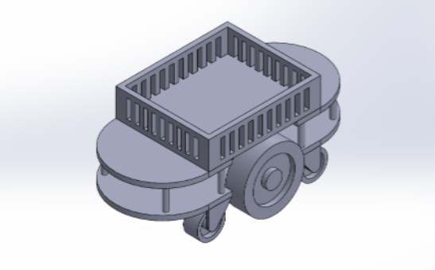

# 

# 

# 

# This is the actual model of AGV:

# 

# 

# 3.4: Electrical design

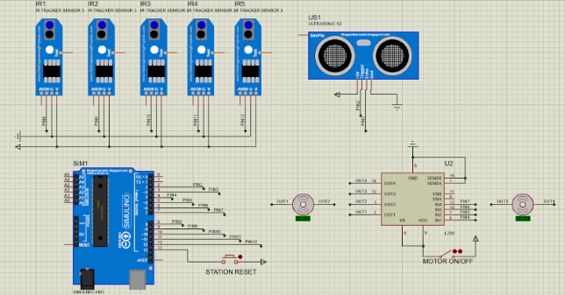

# Explanation of the electrical block diagram: The power supply will provide power to the Arduino, motor driver, sensors and two motors. Arduino will activate and deactivate the line tracking and ultrasonic sensors through the conditions set on the code and collect feedback signals from the line tracking sensors to analyze and compare to control the next steps.

# 3.5: Control Design

## 3.5.1: Flow chart

## 

## 3.5.2: Flow chart explanation

Starting from the beginning of the flow diagram, the power switch is turned on. This supplies power to the system. Next, the ultrasonic sensor and road tracking sensor are turned on. This allows the sensors to start working.

Ultrasonic sensors emit sound waves and measure the time it takes for the sound waves to reflect back. Based on the reflection time, the sensor can calculate the distance to the object. In this case, the object is an unexpected obstacle

The sensor tracks the light emitted and measures the intensity of the light reflected back. Based on the intensity of reflected light, the sensor can recognize the moving line

If the ultrasonic sensor does not detect an obstacle and the line tracking sensor detects a line, the vehicle will move along the line.

When the ultrasonic sensor detects an obstacle, the engine will be turned off until the obstacle is gone

At the end of the flow diagram, the system returns to its initial state. This is done by turning off the logic gate.