# CHAPTER 4:

# EXPERIMENTS AND DESIGN ANALYSIS

**CHAPTER OUTLINE**

**CHAPTER 4: 1**

**EXPERIMENTS AND DESIGN ANALYSIS 1**

**4.1 DESIGN EXPERIMENTS: 1**

4.1.1 Needs: 1

4.1.2 Metrics: 2

**4.2 OPERATION EXPERIMENTS: 5**

4.2.1 Static Test: 5

4.2.1.1 Mechanical Design: 5

4.2.1.2 Electrical Design: 6

4.2.2 Dynamic test: 7

4.2.2.1 Free load test:

4.2.2.2 Half-Load test: 10

4.2.2.3 Full-Load test: 13

4.2.2.4 Product quality: 16

**4.3 DESIGN ANALYSIS: 17**

4.1 Productivity Test 17

4.2 Accuracy Test 17

# 4.1 DESIGN EXPERIMENTS:

## 4.1.1 Needs:

To determine the readiness level of AGV robots, we conducted a survey to capture people's opinions on which aspects they think the robot performs well.

After collecting all the data and considering the capabilities of each factor, we have classified 5 core needs that directly affect customers' choice of AGV robots.

The needs are arranged in order of importance:

| **NEEDS OF THE A LINE FOLLOWING AGV PROTOTYPE** | | |
| --- | --- | --- |
| ***NO*** | ***NEEDS*** | ***IMPORTANT RATE(%)*** |
| N1 | Accuracy | 30% |
| N2 | Sensor fast detect | 25% |
| N3 | Moving speed | 20% |
| N4 | Load capacity | 15% |
| N5 | Less noise | 10% |

**Table 4.1: Needs table**

## 4.1.2 Metrics:

Based on the above needs, we analyze the factors that contribute to creating that need. All elements come directly from the AGV robot's specifications. Three of the indicators below can be measured with devices such as rulers, watches, etc. The remaining indicators are based on estimates through observation and theoretical calculations during robot operation. The units of these metrics will represent the rules mentioned above.

| ***NoM*** | ***NoN*** | ***Metrics*** | ***Units*** |
| --- | --- | --- | --- |
| M1 | N1 | Accuracy | % |
| M2 | N1 | Assembly tolerance | $μm$ |
| M3 | N4, N3 | Power | W |
| M4 | N2 | Efficiency | % |
| M5 | N3 | Motor speed | rpm |
| M6 | N4 | Bending stress | MPa |
| M7 | N4 | Friction force | N |
| M8 | N5 | Noise level | dB |
| M9 | N2 | Response time | s |

**Table 4.2: Metrics table**

**4.1.3 Needs – Metrics Correlation:**

| Need Metric | M1 | M2 | M3 | M4 | M5 | M6 | M7 | M8 | M9 |
| --- | --- | --- | --- | --- | --- | --- | --- | --- | --- |
| N1 | D | D |  |  |  |  |  |  |  |
| N2 |  |  |  | I |  |  |  |  | D |
| N3 |  |  | I |  | D |  |  |  |  |
| N4 |  |  | I |  |  | D | I |  |  |
| N5 |  |  |  |  |  |  |  | I |  |

**Table 4.3: Needs-Metrics Correlation**

D: stand for direct test which means we can directly measure that entity using equipment like scale, ruler, multimeter…

I: stand for indirect test which means that an entity is interchangeable and measure depends on the idea of a different person.

**4.1.4 Machine’s specification:**

| No | Specification | Unit | Ideal value | Marginal value | Type |
| --- | --- | --- | --- | --- | --- |
| 1 | Dimension | mm | 25x15x15 |  | Basic |
| 2 | Weight | kg | 1 |  | Basic |
| 3 | Motor Rotation Speed | rpm | 60 |  | Basic |
| 4 | Sensor | list |  |  | Basic |
| 5 | Material | list | mica Acrylic |  | Basic |
| 6 | Speed | m/s | 0.2 | >0.1 | Basic |
| 7 | Battery | mAh | 4 hours | >1 hours | Advance |
| 8 | Carrying weight | Kg | 5 | $±$ 10% | Advance |
| 9 | On/Off switch | Quantity | 2 |  | Additional |

**Table 4.4: Machine Specification**

**4.1.5 Method of experiment:**

| No | Specification | Unit | Sampling Time | Method Description |
| --- | --- | --- | --- | --- |
| 1 | Dimension | mm | 1 | Use a ruler with millimeter divisions to measure the size of the machine |
| 2 | Weight | kg | 1 | Use scale to measure the weight of the machine |
| 3 | Motor Rotation Speed | rpm |  |  |
| 4 | Sensor | list | 1 | Compare the list of sensors. |
| 5 | Material | list | 1 | Compare the list of materials. |
| 6 | Speed | m/s |  | Use timer to measure speed of AGV |
| 7 | Battery | mAh | 2 |  |
| 8 | Carrying weight | Kg | 2 | Use scale to measure the weight of the transport’s object |
| 9 | On/Off switch | Quantity | 1 |  |
| 10 | Accuracy | % |  | Calculated from times the vehicle moves out of line or stops at the wrong end point |
| 11 | Noise | Decibel | 10 | Use an app to measure sound intensity. |

**Table 4.5: Experiment method**

# 4.2 OPERATION EXPERIMENTS:

To check the accuracy and completeness of the machine, we rely on two real-life tests, called Static Tests, which estimate static parameters such as size, weight, stiffness, and non-static parameters. Use other electricity. And dynamic testing aims to estimate machine performance such as free load test and full load test, the power consumed by the machine during working time.

Both tests will show whether the machine is running as expected, they also provide an overview of the machine: mechanical design, electrical design and control design to ensure all parts work. work well together and create a product that fits the customer's needs.

## 4.2.1 Static Test:

To ensure the electrical design and control design operate smoothly under all conditions, we need to carefully check the mechanical design because it directly affects machine stability and output quality. In mechanical design, we perform two different tests: machine weight, machine size and the weight and size of the object to be transported, in addition to the sturdiness and space of the container.

### 4.2.1.1 Mechanical Design:

The weight of the machine determines the vehicle's moving speed and braking ability when there are obstacles. Along with weight, the size of the machine also determines the size and mass of the object that needs to be transported so that the machine can function fully.

In addition, the storage compartment is also important in preserving the transported object if there is an obstacle in the path of movement and emergency braking is required.

In fact, the speed and acceleration of the machine will not cause too much damage to the object in case of emergency braking, but it can still happen that the object to be transported is small and light compared to the container so it can still fall out. storage chamber. If this happens, it will have a negative impact on the entire shipping process

### 4.2.1.2 Electrical Design:

Once we ensure that the mechanical design works well, we move on to testing the electrical design. This part provides power for the entire machine. If the power source is stable, the machine will operate normally. On the contrary, if the power source fluctuates or lacks power, it will cause a voltage drop in the electrical system, causing the controller to become unstable and unable to read the sensor signal. Furthermore, if the controller runs at fluctuating voltage, the controller may be damaged.

**→** We have the table

| No | Specification | Ideal value | Marginal value | Measured value | Result  (%) |
| --- | --- | --- | --- | --- | --- |
| 1 | Dimension | 25x15x15 | 25x15x15 | 25x15x15 | 100% |
| 2 | Weight | 1 | 1 | 1 | 100% |
| 3 | Sensor type |  |  | TCRT5000 | 100% |
| 4 | Material | Mica Acrylic | Mica Acrylic | Mica Acrylic | 100% |
| 5 | Transport object’s weight | 2 | 2 | 2 | 100% |
| 6 | Controller |  |  | Arduino+Motor Driver L298M | 96.67% |
| 7 | Motor |  |  | GA25 370 | 100% |

**Table 4.6: Static test criteria**

## 

## 

## 

## 4.2.2 Dynamic test:

After checking all static entities to ensure that everything is well prepared for operational tests. We move on to the next step: dynamics test. These tests are performed to check whether the sorting algorithm is good or not and the performance of AGV. In this section, we use a total of 14 experiments including 2 experiments in free mode, 6 experiments in half-load mode and 6 in full-load mode.

Free load testing checks the accuracy of the AGV as well as the time it takes the AGV to complete a transportation process.

Check half load to check moving speed, accuracy as well as noise and power consumption to make a comparison with no load to review and adjust before letting the AGV run full load

Full load testing checks the machine's productivity, the actual maximum load that the AGV can transport, power consumption and noise. For example, the speed at which heavy loads can be transported can be faster than expected, but it produces too much noise and consumes too much power, reducing the amount of load that can be transported.

These three series of tests will determine the machine's stability and how much we can trust it for transportation.

### 

### 

### 

### 

### 

### 

### 

### 4.2.2.1 Free load test:

Speed ​​affects the time to complete one transport cycle of the machine, so check the speed in idle mode or ideal mode to adjust the AGV speed accordingly before switching to half-load mode and full load.

| **Velocity (cm/s)** | | | | | | | |
| --- | --- | --- | --- | --- | --- | --- | --- |
| **Ideal value** | **Marginal value** | **Test no** | **Measure value** | **Result**  **(%)** | **Test no** | **Measure value** | **Result**  **(%)** |
| 1.5 | 1 | 1 | 1.41 | 82% | 11 | 1.45 | 90% |
| 2 | 1.35 | 70% | 12 | 1.43 | 86% |
| 3 | 1.4 | 80% | 13 | 1.48 | 96% |
| 4 | 1.43 | 86% | 14 | 1.48 | 96% |
| 5 | 1.48 | 96% | 15 | 1.44 | 88% |
| 6 | 1.38 | 76% | 16 | 1.47 | 94% |
| 7 | 1.4 | 80% | 17 | 1.45 | 90% |
| 8 | 1.43 | 86% | 18 | 1.46 | 92% |
| 9 | 1.41 | 82% | 19 | 1.4 | 80% |
| 10 | 1.37 | 74% | 20 | 1.49 | 98% |
| **Total** | 1,4305 cm/s | | | | | | 86,1% |

**Table 4.7: Free-load velocity test data**

And we test the accuracy of AGV's movement during transportation to ensure

goods arrive at the right destination.

| **Accuracy(%)** | | | | | |
| --- | --- | --- | --- | --- | --- |
| **Ideal value** | **Marginal value** | **Test no** | **Measure value** | **Result**  **(%)** | |
| 100 | 90 | 1 | 42 | 0% | |
| 2 | 75 | 0% | |
| 3 | 100 | 100% | |
| 4 | 100 | 100% | |
| 5 | 100 | 100% | |
| 6 | 100 | 100% | |
| 7 | 97 | 70% | |
| 8 | 100 | 100% | |
| 9 | 100 | 100% | |
| 10 | 100 | 100% | |
| **Total** | 91.4 | | | | 77% |

**Table 4.8: Free-load accuracy test data**

We then test the vehicle's transit time in 1 transit cycle without a load:

| **Transport period** | | | | | | | | |
| --- | --- | --- | --- | --- | --- | --- | --- | --- |
| **Ideal value** | **Marginal value** | **Test no** | **Measure value** | **Result**  **(%)** | | **Test no** | **Measure value** | **Result**  **(%)** |
| 180 | 200 | 1 | 192 | 40% | | 11 | 183 | 85% |
| 2 | 203 | 0% | | 12 | 184 | 80% |
| 3 | 201 | 0% | | 13 | 182 | 90% |
| 4 | 187 | 65% | | 14 | 182 | 90% |
| 5 | 181 | 95% | | 15 | 190 | 50% |
| 6 | 183 | 85% | | 16 | 185 | 75% |
| 7 | 183 | 85% | | 17 | 185 | 75% |
| 8 | 183 | 85% | | 18 | 184 | 80% |
| 9 | 185 | 75% | | 19 | 183 | 85% |
| 10 | 189 | 55% | | 20 | 183 | 85% |
| **Total** | 195.6 s | | | | 69 % | | | |

**Table 4.9: Free-load Transport period test data**

Check the noise level of the AGV when idling to consider the level of discomfort the machine can cause before running the machine at half load and full load.

| **Noise** | | | | | |
| --- | --- | --- | --- | --- | --- |
| **Ideal value** | **Marginal value** | **Test no** | **Measure value** | **Result**  **(%)** | |
| 60 | 70 | 1 | 60.5 | 95% | |
| 2 | 63.8 | 62% | |
| 3 | 61.7 | 83% | |
| 4 | 59.1 | 0% | |
| 5 | 60.6 | 94% | |
| 6 | 62.2 | 78% | |
| 7 | 68.1 | 19% | |
| 8 | 62.9 | 71% | |
| 9 | 63.2 | 68% | |
| 10 | 61.2 | 88% | |
| **Total** | 62,33 dB | | | | 65,8% |

**Table 4.10: Free-load noise test data**

### 

### 

### 

### 

### 4.2.2.2 Half-Load test:

After finishing the free-load test we begin with a half-load test to adjust the vehicle's speed to achieve the target of transporting packages in half-load in 1 minute.

| **Velocity (cm/s)** | | | | | | | |
| --- | --- | --- | --- | --- | --- | --- | --- |
| **Ideal value** | **Marginal value** | **Test no** | **Measure value** | **Result**  **(%)** | **Test no** | **Measure value** | **Result**  **(%)** |
| 1.3 | 0.9 | 1 | 0.99 | 82% | 11 | 0.83 | 58% |
| 2 | 1.23 | 76% | 12 | 1.27 | 96% |
| 3 | 1.12 | 0% | 13 | 1.27 | 66% |
| 4 | 1.14 | 64% | 14 | 1.16 | 94% |
| 5 | 1.18 | 50% | 15 | 1.29 | 92% |
| 6 | 1.27 | 44% | 16 | 1.3 | 56% |
| 7 | 1.26 | 38% | 17 | 1.3 | 80% |
| 8 | 1.28 | 72% | 18 | 1.28 | 94% |
| 9 | 1.23 | 86% | 19 | 1.22 | 62% |
| 10 | 1.23 | 100% | 20 | 1.27 | 58% |
| **Total** | 1,206 cm/s | | | | | | 68,4% |

**Table 4.11: Half-load velocity test data**

Twenty trials will be performed to check how long it takes to complete one round of transport and how many packages per minute. From the data we can calculate the machine's productivity in hours or days for half-load.

| **Transport period** | | | | | | | | |
| --- | --- | --- | --- | --- | --- | --- | --- | --- |
| **Ideal value** | **Marginal value** | **Test no** | **Measure value** | **Result**  **(%)** | | **Test no** | **Measure value** | **Result**  **(%)** |
| 200 | 230 | 1 | 213 | 56.7% | | 11 | 205 | 83.33% |
| 2 | 216 | 46.7% | | 12 | 207 | 76.67% |
| 3 | 226 | 13.4% | | 13 | 201 | 96.67% |
| 4 | 222 | 26.67% | | 14 | 201 | 96.67% |
| 5 | 210 | 66.67% | | 15 | 202 | 93.33% |
| 6 | 209 | 70% | | 16 | 201 | 96.67% |
| 7 | 212 | 60% | | 17 | 200 | 100% |
| 8 | 208 | 73.33% | | 18 | 203 | 90% |
| 9 | 209 | 70% | | 19 | 204 | 86.67% |
| 10 | 212 | 60% | | 20 | 202 | 93.33% |
| **Total** | 208 s | | | | 72,84% | | | |

**Table 4.12: Half-load transport period test data**

After we checked the time to complete 1 transport cycle of AGV, we created a table of AGV's productivity in 5 minute

| **AGV's productivity** | | | | | | | | |
| --- | --- | --- | --- | --- | --- | --- | --- | --- |
| **Ideal value** | **Marginal value** | **Test no** | **Measure value** | **Result**  **(%)** | | **Test no** | **Measure value** | **Result**  **(%)** |
| 2 | 0 | 1 | 1 | 50% | | 11 | 1 | 50% |
| 2 | 1 | 50% | | 12 | 2 | 100% |
| 3 | 1 | 50% | | 13 | 2 | 100% |
| 4 | 2 | 100% | | 14 | 2 | 100% |
| 5 | 2 | 100% | | 15 | 2 | 100% |
| 6 | 1 | 50% | | 16 | 2 | 100% |
| 7 | 1 | 50% | | 17 | 2 | 100% |
| 8 | 1 | 50% | | 18 | 2 | 100% |
| 9 | 1 | 50% | | 19 | 2 | 100% |
| 10 | 1 | 50% | | 20 | 2 | 100% |
| **Total** | 1.55 units/5 minute | | | | 77.5% | | | |

**Table 4.13: Half-load productivity test data**

### 

### 

### 4.2.2.3 Full-Load test:

After finishing the half-load test we begin with a half-load test to adjust the vehicle's speed to achieve the target of transporting packages in full-load in 1 minute to .

| **Velocity (cm/s)** | | | | | | | |
| --- | --- | --- | --- | --- | --- | --- | --- |
| **Ideal value** | **Marginal value** | **Test no** | **Measure value** | **Result**  **(%)** | **Test no** | **Measure value** | **Result**  **(%)** |
| 1.2 | 0.7 | 1 | 1.11 | 82% | 11 | 0.99 | 58%% |
| 2 | 1.08 | 76% | 12 | 1.18 | 96% |
| 3 | 1.26 | 0% | 13 | 1.03 | 66% |
| 4 | 1.02 | 64% | 14 | 1.17 | 94% |
| 5 | 0.95 | 50% | 15 | 1.16 | 92% |
| 6 | 0.92 | 44% | 16 | 0.98 | 56% |
| 7 | 0.89 | 38% | 17 | 1.1 | 80% |
| 8 | 1.06 | 72% | 18 | 1.17 | 94% |
| 9 | 1.13 | 86% | 19 | 1.01 | 62% |
| 10 | 1.21 | 100% | 20 | 0.99 | 58% |
| **Total** | 1,0705 cm/s | | | | | | 68,4% |

**Table 4.14: Full-load velocity test data**

Twenty trials will be performed to check how long it takes to complete one round of transport and how many packages per minute. From the data we can calculate the machine's productivity in hours or days for half-load.

| **Transport period** | | | | | | | | |
| --- | --- | --- | --- | --- | --- | --- | --- | --- |
| **Ideal value** | **Marginal value** | **Test no** | **Measure value** | **Result**  **(%)** | | **Test no** | **Measure value** | **Result**  **(%)** |
| 230 | 280 | 1 | 248 | 64% | | 11 | 249 | 85% |
| 2 | 240 | 80% | | 12 | 251 | 58% |
| 3 | 248 | 64% | | 13 | 248 | 64% |
| 4 | 239 | 82% | | 14 | 266 | 28% |
| 5 | 241 | 78% | | 15 | 259 | 42% |
| 6 | 230 | 100% | | 16 | 251 | 58% |
| 7 | 230 | 100% | | 17 | 234 | 92% |
| 8 | 232 | 96% | | 18 | 233 | 94% |
| 9 | 231 | 98% | | 19 | 276 | 8% |
| 10 | 238 | 84% | | 20 | 276 | 8% |
| **Total** | 246 s | | | | 69,15% | | | |

**Table 4.15: Full-load transport period test data**

After we checked the time to complete 1 transport cycle of AGV, we created a table of AGV's productivity in 5 minute

| **AGV's productivity** | | | | | | | | |
| --- | --- | --- | --- | --- | --- | --- | --- | --- |
| **Ideal value** | **Marginal value** | **Test no** | **Measure value** | **Result**  **(%)** | | **Test no** | **Measure value** | **Result**  **(%)** |
| 2 | 0 | 1 | 1 | 50% | | 11 | 1 | 50% |
| 2 | 1 | 50% | | 12 | 1 | 50% |
| 3 | 1 | 50% | | 13 | 2 | 100% |
| 4 | 1 | 50% | | 14 | 2 | 100% |
| 5 | 1 | 50% | | 15 | 2 | 100% |
| 6 | 1 | 50% | | 16 | 1 | 50% |
| 7 | 1 | 50% | | 17 | 1 | 50% |
| 8 | 2 | 100% | | 18 | 2 | 100% |
| 9 | 1 | 50% | | 19 | 2 | 100% |
| 10 | 1 | 50% | | 20 | 2 | 100% |
| **Total** | 1.35 units/5 minute | | | | 67.5% | | | |

**Table 4.16: Full-load productivity test data**

### 

### 

### 

### 

### 4.2.2.4 Product quality:

After checking the entire number of operational experiments, we move on to the final step of checking the quality of the transported packages when the AGV encounters obstacles to ensure they are intact or not. This test will show how good the mechanical design is. It also shows whether the machine can be used in unexpected cases.

Below is a table of the number of intact packages:

| **TRANSPORTED PACKAGES QUALITY** | | | | | | | | |
| --- | --- | --- | --- | --- | --- | --- | --- | --- |
| **Ideal value** | **Marginal value** | **Test no** | **Measure value** | **Result**  **(%)** | | **Test no** | **Measure value** | **Result**  **(%)** |
| 2 | 1 | 1 | 2 | 100% | | 11 | 2 | 100% |
| 2 | 2 | 100% | | 12 | 2 | 100% |
| 3 | 2 | 100% | | 13 | 2 | 100% |
| 4 | 2 | 100% | | 14 | 2 | 90% |
| 5 | 2 | 100% | | 15 | 2 | 90% |
| 6 | 2 | 100% | | 16 | 2 | 100% |
| 7 | 2 | 100% | | 17 | 2 | 100% |
| 8 | 2 | 100% | | 18 | 2 | 100% |
| 9 | 2 | 100% | | 19 | 2 | 100% |
| 10 | 2 | 90% | | 20 | 2 | 100% |
| **Total** | 2 units/2 units | | | | 98.5% | | | |

**Table 4.17: Transported packages quality test data**

# 

# 4.3 DESIGN ANALYSIS:

In this section, we analyze the results of static and dynamic testing, finding out why a particular test cannot achieve a 100% success rate. We consider any test that achieves 100% success to be good and stable because we perform 20 tests per entity. In this analysis, we only focus on a few experiments with failure rates because it directly affects the entire process.

In the static test, all basic technical parameters such as weight, AGV size, and chamber size are consistent with preset values and ready for operation.

In dynamic testing, the failure rate in 4 main issues is the machine's productivity, the accuracy of the moving process, and the moving speed of the AGV.

## 4.1 Productivity Test

The weight of the machine determines the vehicle's moving speed and braking ability when there are obstacles. Along with weight, the size of the machine also determines the size and mass of the object that needs to be transported so that the machine can operate at full capacity.

In addition, the storage compartment also plays an important role in preserving transported objects if there are obstacles on the way and emergency braking is required.

In fact, the speed and acceleration of the machine will not cause too much damage to the object in case of emergency braking, but it can still happen that the object to be transported is small and light compared to the container, so it still may fall out. . storage chamber. If this happens, it will negatively affect the entire shipping process

*diagram

*Nhận xét

## 

## 

## 

## 

## 

## 

## 

## 4.2 Velocity Test

Because the accuracy test is divided into 2 test modes: straight test and corner test, we can detect when the AGV often goes off course.

Based on the results of x trials, of which y trials are failed at the turn and 1 trial is completed. So it can be seen that an error occurs in recognizing curved lines.

**Free:**

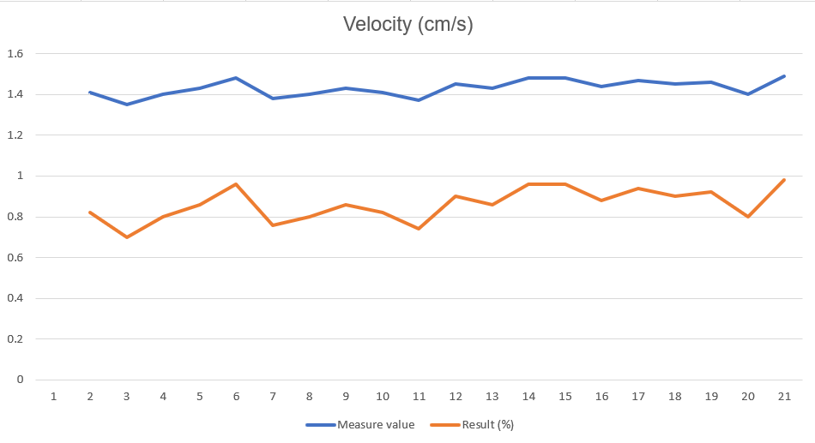

**Half:**

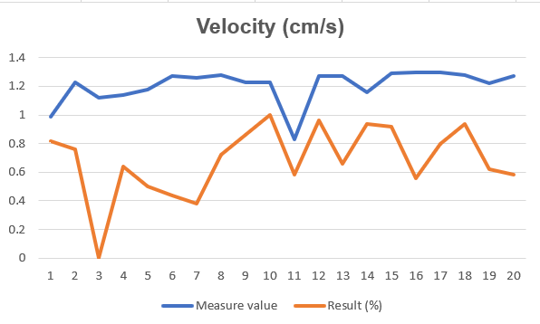

**Full:**

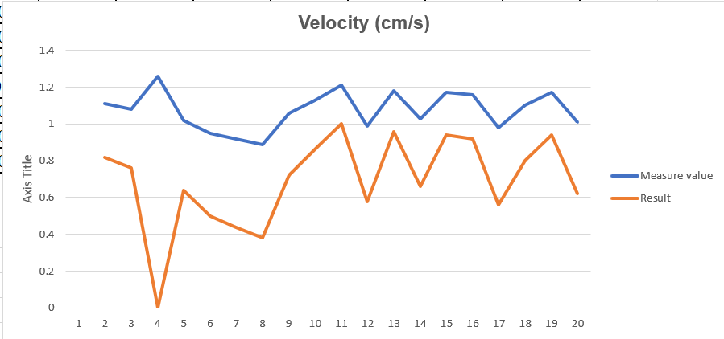

→ We can see the influence of the mass of transported objects on the vehicle's speed through the 3 charts that we drew based on actual measurement data. The speed of the AGV begins to gradually decrease when we increase the load and can cause vehicle failure in velocity.

**4.3 Transport period Test**

**Free:**

**Half:**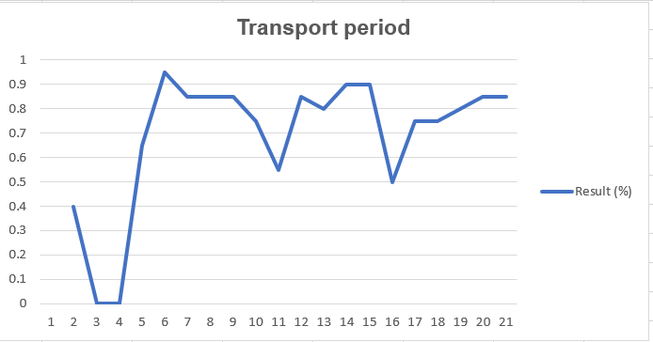

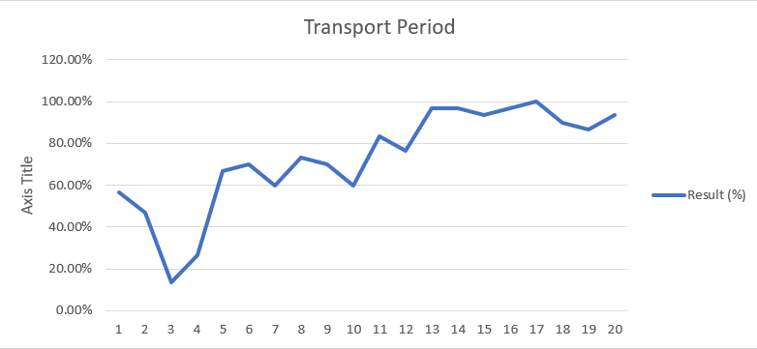

**Full:**

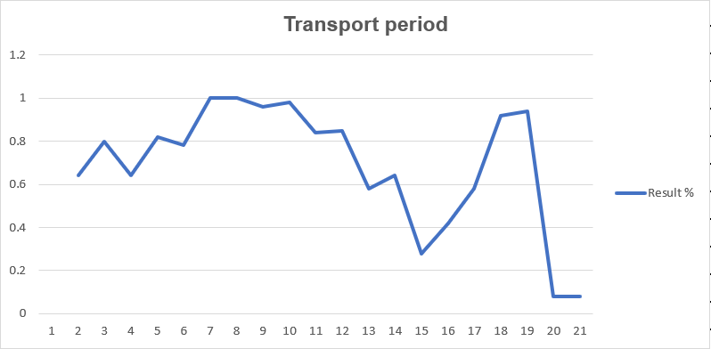

→ Changing speed will greatly affect the time it takes AGV to complete one round of transport. This can be clearly seen on the graph and so when we improve speed, the improvement will also increase in time. Complete 1 shipping cycle

**4.4 AGV's productivity:**

**Half:**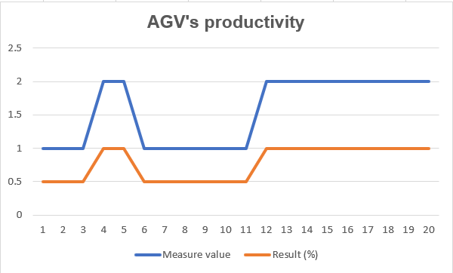

**Full:**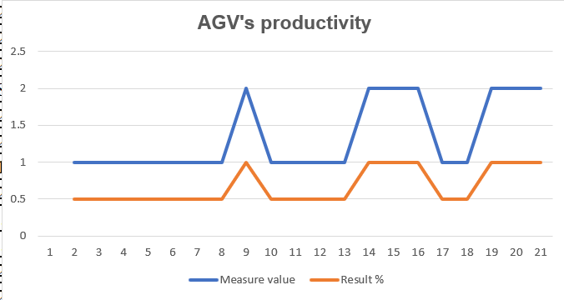

**→**When the load increases, because the time to complete a cycle increases, completing a transport cycle takes a lot of time and thereby affects the number of goods transported in 5 minutes of the AGV.

**SYNTHESIZE RESULT:**