PRN232 Assignment 01 - Building ASP.NET Core Web API and Web Application

1. Introduction
A News Management System (NMS) is a software application that helps universities and educational institutions to efficiently manage, organize, and publish news and content to their website and other channels. The NMS typically includes features such as content creation, approval workflow, scheduling, publishing, and analytics. This can help universities to arrange appropriately their news operations, improve communication with students and the wider community, and better engage with their target audience.
Imagine you're a developer of a News Management System named FUNewsManagementSystem. To implement a part of this system your tasks include:
- Manage account information.
- Manage news article.
The application has a default account (admin account) whose email is “admin@FUNewsManagementSystem.org” and password is “@@abc123@@” that stored in the appsettings.json.
The application has to support adding, viewing, modifying, and removing information - a
standardized usage action verb better known as Create, Read, Update, Delete (CRUD) and Search.
This assignment explores creating an ASP.NET Core Web API OData with C# and Entity Framework Core, the client application can be used as Web Application (ASP.NET Core
Web MVC or Razor Pages). An MS SQL Server database will be
created to persist the data and it will be used for reading and managing data.

2. Assignment Objectives
In this assignment, you will:
- Use the Visual Studio.NET to create a Web application and ASP.NET Core Web API
project (with OData support).
- Perform CRUD actions using Entity Framework Core.
- Apply 3-layers architecture to develop the application.
- Apply Repository pattern and Singleton pattern in a project.
- Add CRUD and searching actions to the Client application with ASP.NET Core Web API.
- Apply to validate data type for all fields.
- Run the project and test the actions of the Client Web app and ASP.NET Core Web API

3. Database Design
A part of News Management Database:

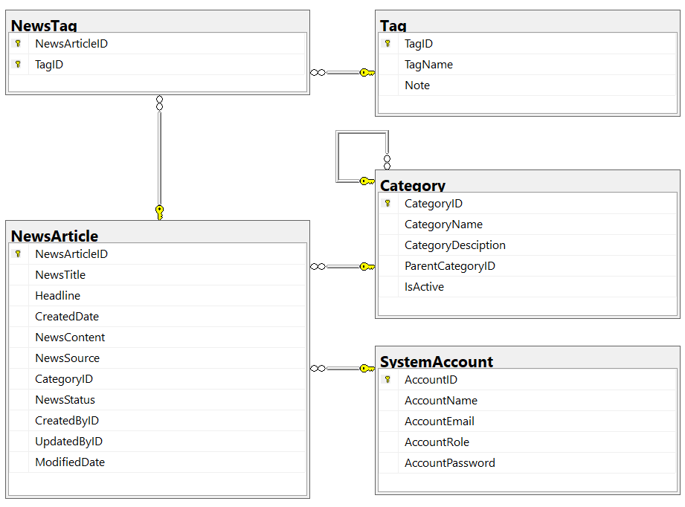
- A news article will belong to only one news category (Category).
- An account with staff’s role can create many news articles in this system. (Staff role = 1, Lecturer role = 2; Admin role will get from appsettings.json file).
- A news article will have many tags and one tag will belong to zero or one news article (News status = active(1)/inactive(0)).
- Category status = active(1)/inactive(0).

4. Main Functions
Do not need authentication to view the news article (news status must be active) in this system.
- Member (Admin/Staff) authentication by Email and Password.
- Create Web API:
  - “Admin” role: Account management (CRUD, the delete action will delete an account in the case this account is not belong to any news articles (created), if the account is already created any news article, cannot delete.)
  - “Staff” role:
    - Category management (The delete action will delete an item in the case this item is not belong to any news articles. If the item is already stored in a news article cannot delete.)
    - , and News article management (Read, Create, Update and Delete actions).
- Create Client application (with Desktop/Web application) interactive with Web API to
perform these functions:
  - If the user is an “Admin” then his/her is allowed
    - Manage account information.
    - Create a report statistic by the period from StartDate to EndDate (it depends to the news’ created date), and sort data in descending order.
  - If user is a “Staff”, this staff role is allowed to:
    - Manage category information.
    - Manage news article (includes tags)
    - Manage his/her the profile.
    - View news history created by him/her.
  - Note that: News article Management, Account Management, and Category Management: Read, Create, Update, Delete and Search actions. Creating and Updating actions must be performed by popup dialog. Delete action always combines with confirmation.
4.1 Access Control and User Roles
- Viewing published news (NewsStatus = 1 = Active) does not require login.
- Authentication is performed with AccountEmail + AccountPassword from SystemAccount.
- User roles (AccountRole):
  - 1 = Staff – manage categories and articles.
  - 2 = Lecturer – read and search articles only.
  - Admin – default account from appsettings.json, full system control.

4.2 Account Management (Admin Only)
- Perform CRUD operations on the SystemAccount table.
- Deletion rule: an account cannot be deleted if it has created any record in NewsArticle.CreatedByID.
- Search accounts by AccountName, AccountEmail, or AccountRole.
- Password update requires verification of the current password.
- Filtering by role (Staff / Lecturer) is supported.
- Duplicate emails are not allowed when creating or updating accounts.

4.3 Category Management (Staff Only)
- Perform CRUD operations on the Category table.
- When creating, CategoryName and CategoryDescription are mandatory.
- When editing, ParentCategoryID cannot be changed if the category is already used by articles.
- When deleting, the category may be removed only if no records exist in NewsArticle.CategoryID.
- Toggle category visibility with IsActive.
- Search categories by name or description.
- Display the number of articles per category using JOIN + COUNT.

4.4 News Article Management (Staff Only)
- Perform CRUD operations on NewsArticle.
  - On creation: set CreatedByID to the current user.
  - On update: set UpdatedByID and ModifiedDate.
  - On deletion: remove related records from NewsTag as well.
- Multiple tags can be attached through the NewsTag junction table.
- Search articles by NewsTitle, author name, category name, or status.
- Filter articles by CreatedDate range and sort in descending order.
- Provide a “Duplicate Article” option – copy the content with a new NewsArticleID.

4.5 Tag Management
- Perform CRUD on the Tag table.
- A tag cannot be deleted if it is referenced in NewsTag.
- Edit Note for better description.
- Search tags by TagName.
- Show all articles that use a specific tag via JOIN (NewsTag → NewsArticle).

4.6 News–Tag Link Management
- Manage relationships in the NewsTag table.
- When editing an article:
  - Add new tags by inserting new rows into NewsTag.
  - Remove tags by deleting rows from NewsTag.
- Display all tags assigned to a given article.
- Primary key (NewsArticleID, TagID) prevents duplicates automatically.

4.7 Reporting and Statistics (Admin Only)
- Generate reports showing the number of articles grouped by:
  - Category (CategoryID)
  - Author (CreatedByID)
  - Status (NewsStatus)
- Filter reports by CreatedDate.
- Show totals of Active vs Inactive articles.
- Sort results by CreatedDate descending.
- (Optional) Export reports to Excel through the Web API.

4.8 Advanced Search
- Global search page allowing keyword queries across:
  - NewsTitle, Headline, NewsContent.
- Additional filters: CategoryName, TagName, CreatedByID, CreatedDate.
- Combine conditions using OData syntax, for example:
- /api/news?$filter=CategoryID eq 2 and NewsStatus eq true and contains(NewsTitle,'AI')
- Sort results by CreatedDate or NewsTitle.

4.9 Related News Recommendation
- When a user views one article, display up to 3 related articles that:
  - Share the same CategoryID, or
  - Share at least one common Tag (via NewsTag).
- Only articles with NewsStatus = 1 are suggested.
- Example query:
SELECT TOP 3 n.*
FROM NewsArticle n
WHERE n.CategoryID = @CurrentCategoryID
OR n.NewsArticleID IN (
SELECT nt2.NewsArticleID
FROM NewsTag nt1
JOIN NewsTag nt2 ON nt1.TagID = nt2.TagID
WHERE nt1.NewsArticleID = @CurrentNewsID
AND nt2.NewsArticleID <> @CurrentNewsID
)

4.10 Change Audit Simulation (Without New Tables)
Use existing fields instead of creating a separate log table.
- Each time a Staff user updates an article:
  - Set UpdatedByID to the user ID.
  - Set ModifiedDate to the current timestamp.
- Admin can review the last editor by joining NewsArticle.UpdatedByID with SystemAccount.

4.11 Client Application (ASP.NET Core MVC or Razor Pages)
- Implement CRUD via Bootstrap modals for quick inline editing.
- Use Fetch API / AJAX to communicate with Web API endpoints (/api/news, /api/category, /api/account, /api/tag).
- Always ask for confirmation before deleting records.
- Support pagination for news and category lists.
- UI must display status colors (e.g., Active = green, Inactive = gray) and show category/tag names via JOIN.

5. Note
5.1 Development Tools
- You must use Visual Studio 2019 or later, with .NET 8.0 and SQL Server 2012 or later.
- Backend (BE) must be built using ASP.NET Core Web API.
- Frontend (FE) must be built using ASP.NET Core MVC or Razor Pages.

5.2 Project Structure
You must create two separate solutions:
- StudentName_ClassCode_A01_BE.sln → for Backend API
- StudentName_ClassCode_A01_FE.sln → for Frontend Web Application
Both should follow the 3-Layer Architecture pattern:
/DataAccess → Context, Entities (Models), Repositories
/BusinessLogic → Services, Validation, Processing Rules
/Presentation → Controllers (API or MVC), Views, ViewModels
- The Backend API exposes RESTful endpoints for all CRUD and search operations.
- The Frontend Web Application consumes these APIs through AJAX, Fetch API, or HttpClient.

5.3 Repository and Pattern Requirements
- You are not allowed to connect directly to the database from the API controller.
All data access must go through Repository and Data Access Object (DAO) classes.
- Each entity (e.g., NewsArticle, Category, Tag, SystemAccount) should have its own repository interface and implementation.
- Apply the Singleton Pattern for the database context or configuration loading if appropriate.
- The Connection String must be stored and retrieved from appsettings.json.

5.4 Data Validation Rules
- All input fields must include both server-side and client-side validation, such as:
  - Required fields ([Required] attribute)
  - String length limits ([StringLength])
  - Proper formats for email, date, and password.
- Prevent creating duplicate records where uniqueness is expected:
  - Duplicate AccountEmail or TagName must not be allowed.
  - Category names under the same parent should be unique.
- For every Delete operation, show a confirmation dialog in the client app.
- When editing or adding data, use a popup dialog (modal form) instead of page reloads.

5.5 Web API Implementation Guidelines
- APIs must support OData query options such as:
  - $filter, $orderby, $top, $skip for pagination and filtering.
- Include the following endpoints (minimum):
- /api/account
- /api/category
- /api/news
- /api/tag
- /api/report
- Return data in JSON format.
- For failed operations, return a clear HTTP status code and message (e.g., 400 Bad Request, 404 Not Found).

5.6 Business Logic and Behavior
- When deleting a Category or Account, check foreign key dependencies first.
If related records exist → disallow deletion and show a meaningful message.
- When creating a NewsArticle, automatically set:
  - CreatedByID = current user ID.
  - CreatedDate = current date/time.
- When updating, set:
  - UpdatedByID = current user ID.
  - ModifiedDate = current date/time.
- All date/time values should be in local timezone and formatted consistently.

5.7 UI and User Experience
- Use Bootstrap 5 or an equivalent modern UI framework.
- Apply consistent color themes for Active/Inactive states (e.g., green for active).
- Use modals for Create and Update actions to avoid page reload.
- Implement responsive layout for different screen sizes.
- Add loading indicators for asynchronous operations.
- Provide clear success/error messages using alerts or toast notifications.

5.8 Reporting and Filtering
- Implement a reporting feature (Admin only) that:
  - Filters articles by CreatedDate range (StartDate – EndDate).
  - Groups data by category or author.
  - Displays total Active vs Inactive articles.
- The report view should allow sorting by CreatedDate descending.
- Optional: allow exporting the report to Excel (using EPPlus or ClosedXML).

5.9 Testing and Demo
- You must run and test both the API and the client application.
- Verify all CRUD, Search, and Filter actions work correctly.
- Demonstrate:
  - Admin account management.
  - Staff category and article management.
  - Data validation and prevention of illegal deletions.
- Include at least five meaningful records in each table for testing.

5.10 Deliverables
Submit the following items:
- Two solutions (_BE and _FE) with working source code.
- The SQL database file (or .sql script).
- A short README file describing:
  - How to configure and run both projects.
  - API endpoints overview.
  - Roles and login credentials for testing (Admin / Staff / Lecturer).
  - Screenshots or sample outputs.

