1. A Boolean value is either true or false. It is named after the British mathematician, George Boole, who first formulated Boolean algebra — some rules for reasoning about and combining these values. This is the basis of all modern computer logic.

>>> 5 == (3 + 2)

True

>>> 5 == 6

False

>>> j = "hel"

>>> j + "lo" == "hello"

True

2.Flow chart is sơ đồ

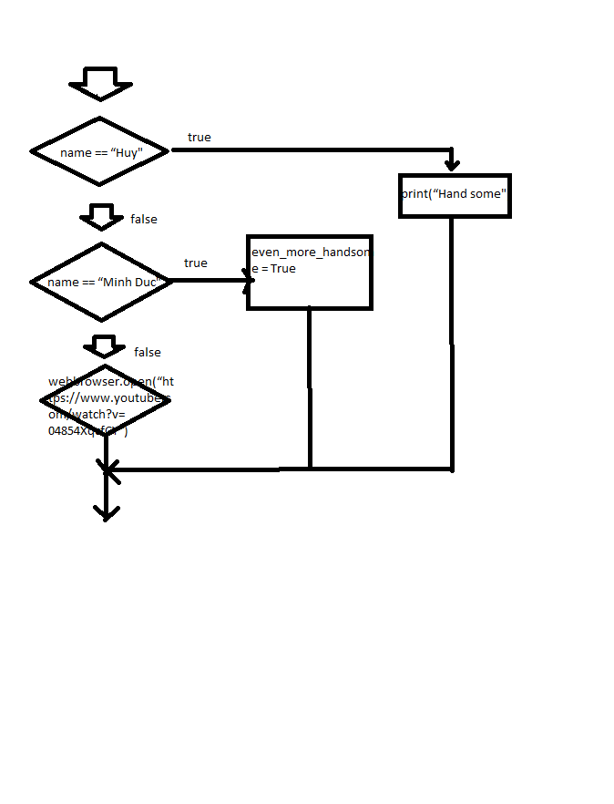

1. nested conditionals is nested conditionals

ex:

1 if x < y:

2 STATEMENTS_A

3 else:

4 if x > y:

5 STATEMENTS_B

6 else:

7 STATEMENTS_C