In this section, the study will develop a multivariate time series model using the daily stock price of HPG, HSG, and NKG to forecast the future price of the three stock codes.

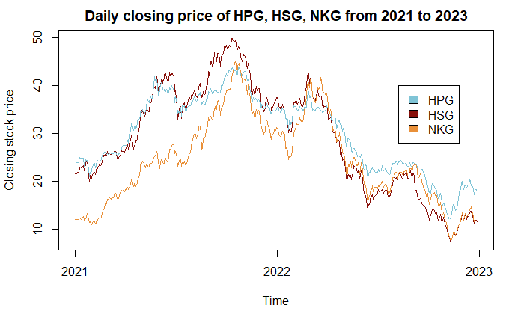

All three series follow a common trend: increase in the year 2021 and decrease in 2022. Additionally, stock price of all three groups peaked in October of 2021 and hit their bottoms in November of 2022, which is an indication that they may be cointegrated.

In the previous sections, the three closing price series were shown to be stationary after first-order difference. The series’ cointegration relationships are examined using the Johansen test:

|  |  |  |  |  |
| --- | --- | --- | --- | --- |
|  | Test | 10% | 5% | 1% |
| r <= 2 | 2.79 | 6.50 | 8.18 | 11.65 |
| r <= 1 | 13.04 | 12.91 | 14.90 | 19.19 |
| r = 0 | 20.35 | 18.90 | 21.07 | 25.75 |

The first hypothesis r = 0 tests for the presence of cointegration. As can be seen from the test result, the test statistic did not exceed the 5% level, therefore there is not enough evidence to reject the null hypothesis of no cointegration relationship between the series. Furthermore, by testing the stationary of residual using Augmented Dickey-Fuller unit root test, there is enough evidence to show that the residual is stationary at 5% level:

|  |  |  |  |  |
| --- | --- | --- | --- | --- |
|  | Test | 1% | 5% | 10% |
| Tau1 | -3.8345 | -2.58 | -1.95 | -1.62 |

Based on the test result, the three series don’t have cointegration relationships and they are stationary in residuals, thus, there is no need to develop an error correction model (ECM). To decide whether the three stock price series have causality relationship on each other, the Granger causality test gave following result:

|  |  |  |  |
| --- | --- | --- | --- |
| X (differenced) |  | Y (differenced) | P-value |
| HPG |  | HSG | 0.8941 |
| HPG |  | NKG | 0.3634 |
| HSG | Is cause of | HPG | 0.5539 |
| HSG |  | NKG | 0.1216 |
| NKG |  | HSG | 0.7537 |
| NKG |  | HPG | 0.8018 |

The tests suggest that the series have no Granger causality effect on each other, however, for forecasting purposes, a VAR(1) model can still be developed:

$$HP{G.d}_{t}=-0.009245+ 0.049576 HPG.d_{t-1}+ 0.068379 HSG.d_{t-1}-0.054868 NKG.d_{t-1}+u_{1t}$$

$${HSG.d}_{t}=-0.018245-0.006957 HPG.d_{t-1}+0.105173 HSG.d_{t-1}-0.025657 NKG.d_{t-1}+u_{2t}$$

$${NKG.d}_{t}= 0.002812+0.019175 HPG.d_{t-1}+0.107953 HSG.d_{t-1}-0.041052 NKG.d_{t-1}+u_{3t}$$

Where $HPG.d$ is the lagged difference of stock price of Hoa Phat Group, similar denotations for Hoa Sen Group (HSG) and Nam Kim Group (NKG).

From the VAR model, the impulse response function is shown below:

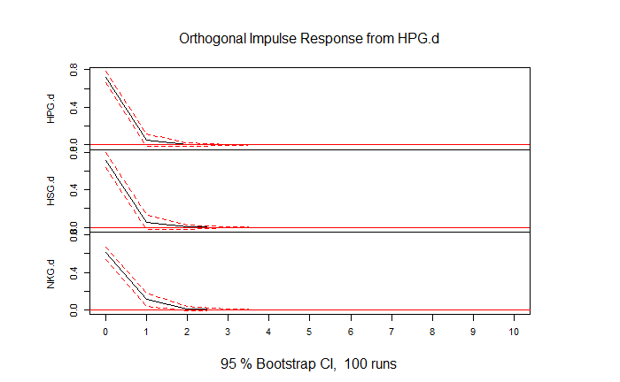When there is a shock in the price movement of HPG in the past, HPG, HSG, and NKG all have a strong impact right away, followed by a strong downward trend after one period. that, after two periods, gradually stabilized

When the price movement of HSG is past-shocked, HSG and NKG's price movements are strongly impacted right away, followed by a strong downward trend after one period, and then gradually. stayed steady after two periods. Even though this shock had no immediate impact on HPG's price movement after one period, there was only a slight upward correction.

.

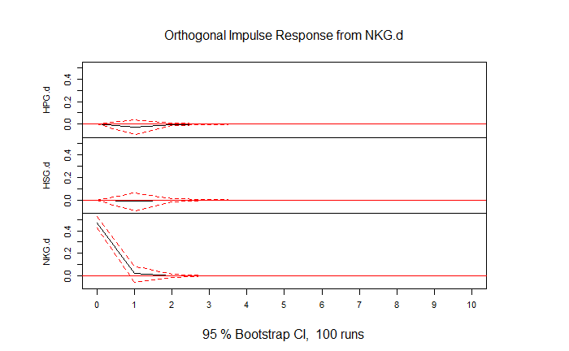 The price movement of HPG and HSG was almost nonexistent when there was a shock to NKG's price movement in the past; this effect was only slightly reduced after 1 period and then gradually decreased. stayed steady after two periods. However, this shock directly affects the movement of NKG's price, with the impact sharply decreasing after one period and stabilizing after two.

Overall, it can be seen that the price movement of the HPG stock directly and significantly affects the price movement of the other two stocks. The price movement of NKG shares, in contrast, largely has no impact on the price movement of the other two stocks and only has an internal impact. On the other hand, while HSG's price movement affects NKG's intrinsic value and price movement, HPG's price movement is unaffected by HSG's price movement. We can infer from this that the price movement of HPG has a significant impact on the price movements of the other stocks. The price movement of NKG, in contrast, largely has no impact on the price movement of the remaining stocks and only influences it internally.

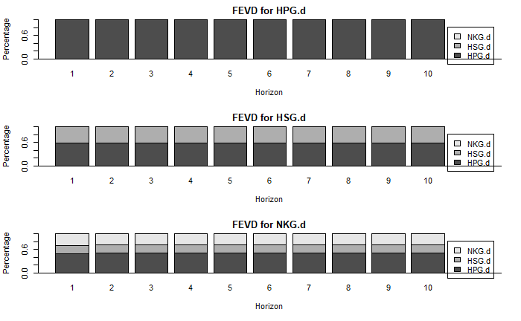

The forecast error variance decomposition shows how much a shock to one variable impacts the forecast error of a different one. In this case, a shock to HPG stock price affects around 60% of the forecast error of HSG and 50% of NKG. 20% of the forecast error variance of NKG is also explained by a shock to HSG’s stock price. On the other hand, forecast error variance of HPG is not explained by the shock on the other two stock prices.

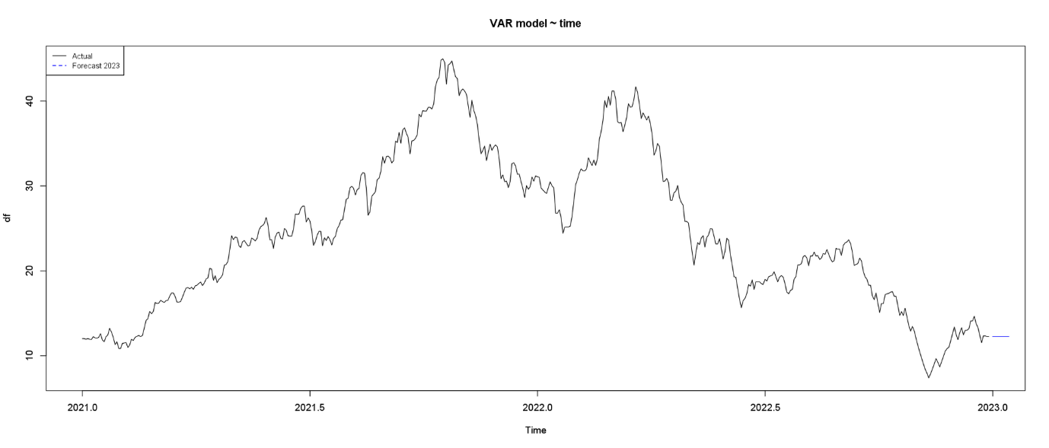

|  |  |  |  |  |  |  |
| --- | --- | --- | --- | --- | --- | --- |
|  | HPG | | HSG | | NKG | |
| Model | VAR(1) | ARIMA  (0, 1, 2) | VAR(1) | ARIMA  (1, 1, 1) | VAR(1) | ARIMA  (0,1,1) |
| RMSE  (whole data) | 0.714 | 0.71 | 0.927 | 0.925 | 0.865 | 0.867 |
| MAPE  (whole data) |  | 1.9% |  | 2.7% |  | 2.8% |
| RMSE  (last 10 observation) |  | 0.651 |  | 0.489 |  | 0.3 |
| MAPE  (last 10 observation) |  | 2.6% |  | 3.3% |  | 1.7% |
| RMSE  (first 10 days of 2023) | 1.865 | 1.795 | 1.38 | 1.379 | 1.49 | 2.83 |
| MAPE  (first 10 days of 2023) | 10.2% | 8.9% | 11.2% | 9.86% | 11.5% | 17.8% |

Overall, the VAR(1) model gives a decent forecast on the stock prices as RMSE on the forecast for the first 10 days of 2023 is relatively low, however, ARIMA models’ forecast is still more accurate. Moreover, the VAR(1) suffers from serial correlation in the residuals, which makes the forecast less reliable.