1. About Hoa Phat Group:

Founded in August 1992 as a company in the trade of building equipment and pieces of machinery, Hoa Phat Group is now the leading industrial manufacturing group in Vietnam operates in five sectors: Iron and steel, Steel Products, Agriculture, Real Estate, Home appliances. Since November 15, 2007, Hoa Phat has been officially listed on the Stock Exchange under the stock ticker symbol “HPG” and is currently holding the highest market share in Vietnam for construction steel and steel pipes. This study will analyze and forecast the quarterly profit after corporate income tax (Net profit) of HPG, which will provide some insight into the business’s health and helps predict the stock price of the company.

1. Net profit of Hoa Phat Group:

This study collected data about net profit in 63 quarters (from 2007 to the third quarter of 2022) from the group’s financial report.

Visually, this time series exhibits a positive time trend as it increases in the long run. The year 2021 was the most successful year for HPG in terms of profit as it reached 10,351 billion VND, the highest in the group’s history despite the impact of Covid-19. However, throughout the period, HPG experienced losses twice in the fourth quarter of 2008 and second quarter of 2022 with the latter being more severe. The reason for the lowest profit point is reported to be the decrease in both domestic and international demand, the increase in input material’s price, exchange rate and interest rate.

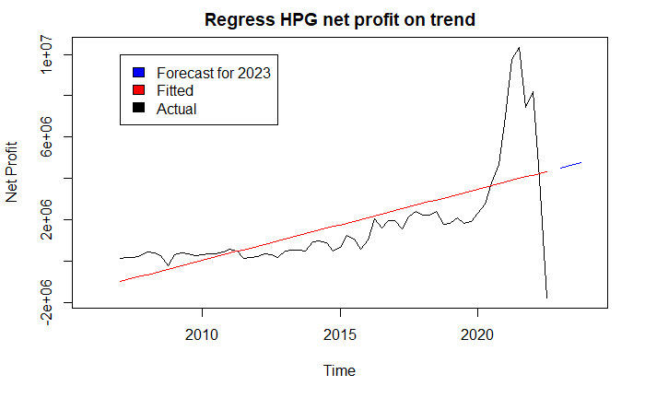By regressing Net profit on trend and seasonality, some insights can be interpreted from the coefficients of the models:

Regress on linear trend:

$$Netp=-1094272+86074t$$

Overall, the net profit series has a positive trend. Based on the model, when other factors remain constant, after one quarter, net profit is expected to increase 86 billion VND.

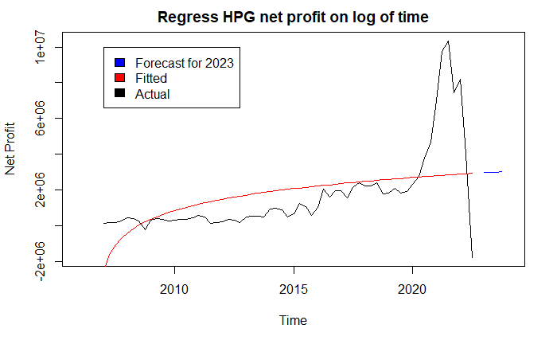 Applying log on time, we have following model:

$$Netp= -2545239+1318028 log⁡(t)$$

Even though the parameter for trend cannot be interpreted, the model still has value in prediction. In the first quarter of 2023, when only trend is considered, Hoa Phat group will make 2,957 billion VND in profit.

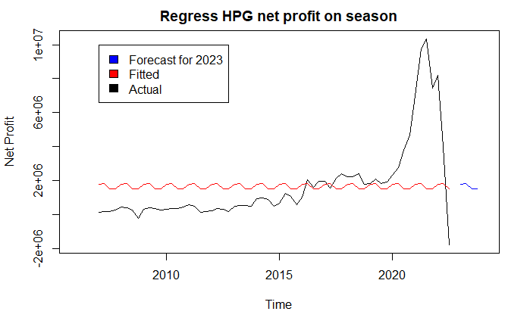Regressing net profit on seasonality:

$Netp= 1510591+ 268039 Q_{1}+ 314060 Q_{2}+ 6558 Q_{3}$

Regressing net profit on seasonality, it can be see that within a year, net profit average the highest in the second quarter and in the fourth quarter, it is the lowest with 314 billion VND between them, although the effect may not be statistically significant.

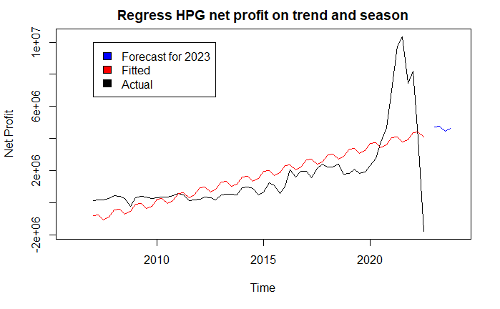Adding trend to seasonal model:

Additive form: $Netp= -1254446+ 86407 t+ 354446 Q_{1}+ 314060 Q_{2}-79849 Q_{3}$

Mixed form:

In additive seasonal model, the magnitude of the seasonal fluctuations does not vary with the level of time series, which means after accounting for trend, net profit in the first quarter will average 354 billion VND higher than the fourth quarter.

In mixed form, the multiplicative elements makes the seasonal fluctuations increase or decrease proportionally with the level of series.

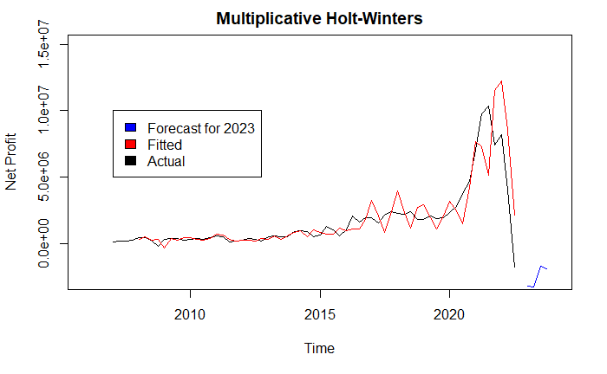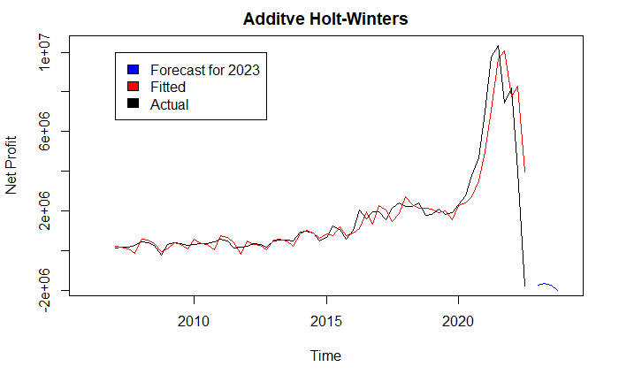Addtionally, Holt-winters models can also be utilized to forecast future profit for HPG:

|  |  |  |  |  |  |  |  |  |  |
| --- | --- | --- | --- | --- | --- | --- | --- | --- | --- |
|  | Linear-Linear trend | Linear-Log trend | Log-Linear trend | Seasonality | Seasonal + Trend | | Seasonal * Trend | Additive Holt-Winters | Multiplicative Holt-Winters |
| RMSE  (whole data) | 1713286 | 1997210 | 2853247 | 2316076 | | 1702693 | 1689016 | 1107052 | 2327727 |
| RMSE  (last 4 observation) | 4032712 | 4262831 | 5953164 | 4795025 | | 3930466 | 3597627 | 3819690 | 5741293 |
| MAPE  (whole data) | 148% | 233% | 100% | 278% | | 143% | 147% | 45% | 74% |
| MAPE  (last 4 observation) | 111% | 104% | 100% | 99% | | 108% | 99% | 117% | 101% |
| Forecasted  average profit 2023 | 4629640 | 2986602 | 627909.4 | 1657755 | | 4638811 | 4651495 | -1796685 | -2529453 |

Regressing the net profit series on trend gives a positive forecast, which suggest that on a long run trend HPG will make profit in the future. On the other hand, Holt-Winters models forecast a negative profit in 2023 suggesting Hoa Phat group will suffer loss in 2023.

1. Stock price of HPG:

As the analysis on quarterly net profit pointed out that in 2021, Hoa Phat group experienced record high profit in the third quarter whereas in the third quarter of 2022, the record loss hit. Consequently, the stock price of HPG also reflect the opposite trends between two years as in 2021, the stock price has a positive trend whereas in 2022, it is negative.

After testing for unit root, the series was found to be stationary with drift after first order difference, therefore the order of d in ARIMA(p, d, q) is 1. Furthermore, to identify two remaining orders of ARIMA model, PACF and ACF plots can be utilized:

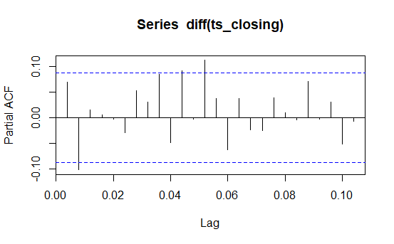

The plots suggests that an AR(1) model fits here due to a clear cut off after lag 1 in the PACF plot and only one autocorrelation that is significantly non-zero at a lag of 0. To provide comparision, a few more ARIMA model was fitted on the HPG stock price series:

|  |  |  |  |  |  |
| --- | --- | --- | --- | --- | --- |
|  | ARIMA  (1,1,0) | ARIMA  (2,1,1) | ARIMA  (1,1,1) | ARIMA  (4,2,1) | ARIMA  (0,1,2) |
| AIC | 1084.76 | 1082.82 | 1080.74 | 1087.61 | 1079.01 |
| BIC | 1110.02 | 1103.87 | 1097.58 | 1112.86 | 1091.64 |
| RMSE  (whole data) | 0.71 | 0.71 | 0.71 | 0.71 | 0.71 |
| MAPE  (whole data) | 1.9% | 1.9% | 1.9% | 1.9% | 1.9% |
| RMSE  (last 10 observation) | 0.694 | 0.646 | 0.656 | 0.64 | 0.651 |
| MAPE  (last 10 observation) | 2.6% | 2.5% | 2.6% | 2.5% | 2.6% |
| RMSE  (first 10 days of 2023) | 1.866 | 1.85 | 1.913 | 2.05 | 1.795 |
| MAPE  (first 10 days of 2023) | 9.2% | 9.1% | 9.5% | 10.08% | 8.9% |

The ARIMA(4,2,1) fits best on the last 10 days of 2022, however, it provided the worst prediction on the first 10 days of 2023. On the other hand, the ARIMA(0, 1, 2) model have minimum AIC, BIC as well as smallest forecast error on the whole series and 10 first days of 2023.

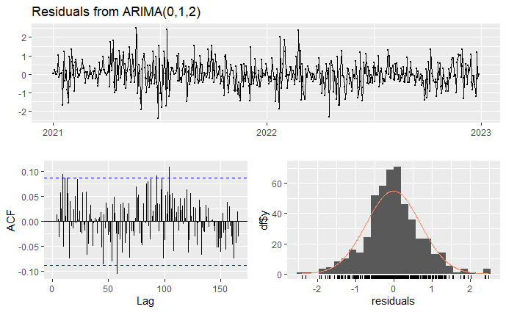

To evaluate the MA(2) model, inverse roots are inside the unit circle and a p-value of 0.1474 from Ljung-box test says that the model’s residuals are whitenoise, therefore, the model is valid. Finally, the forecast result of MA(2) model on first order difference on stock price of HPG is presented below:

