VIETNAM–KOREA UNIVERSITY OF INFORMATION
AND COMMUNICATION TECHNOLOGY
FACULTY OF COMPUTER SCIENCE



REPORT
GRADUATION THESIS

PROJECT TITLE
DEVELOP AN APPLICATION TO HELP ROMOVE FOG
FOR DIGITAL IMAGES

Students : Tran Phuong Hai Anh – 22IT.B056
Pham Phu Đuc – 22IT.B056
Supervisor : Dr. Nguyen Duc Hien

Da Nang, June 2026

ACKNOWLEDGEMENTS
We would like to sincerely thank the Vietnam–Korea University of Information and Communication Technology (VKU) and the Faculty of Computer Science for creating favourable conditions for us to carry out and complete this graduation project. This has been a valuable opportunity to apply the knowledge accumulated throughout our studies to the research and development of a real product.
We would like to express our deep gratitude to Dr. Nguyen Duc Hien – our supervisor – who wholeheartedly guided, advised and supported us throughout the project. His valuable professional feedback helped us refine the research content and improve our scientific working skills.
We also wish to thank the lecturers of the Faculty of Computer Science, who equipped us with a solid foundation of knowledge during our time at the university, providing the basis for us to complete this project.
Finally, we sincerely thank our families and friends, who have always cared for, encouraged and supported us so that we could fulfil both our study duties and our graduation project.
Due to the limited time and our own capabilities, this project inevitably contains shortcomings. We sincerely hope to receive valuable comments from the lecturers and the Committee so that the project can be further improved.
We sincerely thank you!

TABLE OF CONTENTS
ACKNOWLEDGEMENTS 1
TABLE OF CONTENTS 2
LIST OF ABBREVIATIONS 6
LIST OF FIGURES 8
LIST OF TABLES 9
ABSTRACT 10
CHAPTER 1 INTRODUCTION 11
1.1. Rationale for choosing the topic 11
1.2. Problem statement 12
1.3. Research objectives and contributions of the project 12
1.3.1. Research objectives 12
1.3.2. Contributions of the project 13
1.4. Research subjects and scope 14
1.4.1. Research subjects 14
1.4.2. Research scope 14
1.5. Report structure 14
CHAPTER 2 LITERATURE REVIEW AND THEORETICAL BACKGROUND 16
2.1. Field overview and research context 16
2.1.1. The role of image processing in modern computer-vision systems 16
2.1.2. The position of dehazing in the processing chain 17
2.1.3. The problem of image-quality degradation due to haze 17
2.2. Theoretical background 18
2.2.1. The fog phenomenon from a physical perspective 18
2.2.2. The Atmospheric Scattering Model 19
2.2.3. The Dark Channel Prior (DCP) algorithm 20
2.2.4. The CLAHE algorithm 22
2.2.5. The Guided Filter and Fast Guided Filter 23
2.2.6. Quality-evaluation metrics 24
2.2.7. Notation and mathematical conventions 25
2.2.8. Technical challenges of the problem 26
2.3. Related work 27
2.3.1. The multi-image method group 27
2.3.2. The single-image prior-based method group 28
2.3.3. The deep-learning method group 28
2.3.4. Benchmark datasets for evaluation 29
2.3.5. Overall comparison and the research gap 30
2.3.6. The trend of combining priors and deep learning 32
2.4. Chapter conclusion 32
CHAPTER 3 PROPOSED METHODOLOGY 34
3.1. Overall system model 34
3.1.1. Layered architecture 34
3.1.2. Functional modules and the extension mechanism 35
3.1.3. Processing flow of the proposed algorithm 36
3.2. Proposed method: the DCP-Improved algorithm 37
3.2.1. Computing the dark channel 37
3.2.2. Stable atmospheric-light estimation 38
3.2.3. The Sky Mask 38
3.2.4. Adaptive Omega (ω) 39
3.2.5. Adaptive Transmission Floor 40
3.2.6. Sky-blend 40
3.2.7. Acceleration with the Fast Guided Filter 41
3.2.8. Image recovery and the overall pipeline 41
3.2.9. Illustration of the intermediate maps 43
3.3. Data flow and exception-handling mechanism 45
3.4. Design analysis: interpretability and testability 46
3.5. Application interface and functional demo 47
CHAPTER 4 EXPERIMENTAL RESULTS 50
4.1. Experimental environment and test scenarios 50
4.1.1. Hardware and software environment 50
4.1.2. Technology stack 50
4.1.3. Performance optimisation and multithreading 51
4.1.4. Dataset and test procedure 52
4.2. Evaluation metrics 52
4.3. Experimental results and analysis 53
4.3.1. Aggregate quantitative results 53
4.3.2. Visual comparison of the metrics 54
4.3.3. Qualitative comparison (visual results) 55
4.4. In-depth analysis 56
4.4.1. Contribution of each improvement 56
4.4.2. Quality–speed trade-off analysis 57
4.4.3. Parameter-sensitivity analysis 58
4.4.4. Per-step computational-cost analysis 59
4.4.5. Generality of the algorithm 60
4.4.6. Visual analysis of intermediate maps and the artefact-removal mechanism 60
4.4.7. Summary of findings from the in-depth analysis 62
4.4.8. Behaviour comparison on the two scene types and deployment implications 62
4.5. Requirement mapping, reliability and limitations 63
4.5.1. Mapping results to the stated requirements 63
4.5.2. Analysis of the no-reference metric group and the sky region 64
4.5.3. Reproducibility and limitations of the experiments 65
4.6. Comparison with related work 65
4.7. Chapter conclusion 66
CONCLUSION AND FUTURE WORK 67
5.1. Conclusion and contributions of the project 67
5.2. Limitations of the project 68
5.3. Future work 68
REFERENCES 70

LIST OF ABBREVIATIONS
Abbreviation | Full form (English)
DCP | Dark Channel Prior
ASM | Atmospheric Scattering Model
CLAHE | Contrast Limited Adaptive Histogram Equalization
PSNR | Peak Signal-to-Noise Ratio
SSIM | Structural Similarity Index Measure
GUI | Graphical User Interface
RGB | Red Green Blue
BGR | Blue Green Red
GPU | Graphics Processing Unit
CPU | Central Processing Unit
AI | Artificial Intelligence
Edge AI | Edge Artificial Intelligence
SOTS | Synthetic Objective Testing Set
RESIDE | REalistic Single Image DEhazing
FFA-Net | Feature Fusion Attention Network

LIST OF FIGURES
Figure 3.1 Overall architecture of the system 34
Figure 3.2 Processing flow of the DCP-Improved algorithm 36
Figure 3.3 Intermediate maps of DCP-Improved on an outdoor image: original image, dark channel, raw transmission, refined transmission, sky mask and result image 43
Figure 3.4 Intermediate maps of DCP-Improved on an indoor image 43
Figure 3.5 Main interface: loading a hazy image and selecting the DCP-Improved algorithm with its parameters 46
Figure 3.6 6 Dehazing result with DCP-Improved together with the quality-metric table (before/after) 47
Figure 3.7 Comparison mode using a split slider between the original and the dehazed image 47
Figure 3.8 The Dataset Evaluation (benchmark) tab with the table of average results per algorithm 48
Figure 4.1 Comparison of PSNR by algorithm and dataset 53
Figure 4.2 Comparison of SSIM by algorithm and dataset 54
Figure 4.3 Comparison of average processing time (ms/image) on CPU 54
Figure 4.4 Visual comparison on an image with a sky region: original (hazy), original DCP and DCP-Improved 55
Figure 4.5 Comparison of four options: original image, DCP, DCP-Improved and CLAHE 55

LIST OF TABLES
Table 2.1 Mathematical notation used in the report 26
Table 2.2 Comparison of dehazing method groups 30
Table 2.3 Overall comparison of the three surveyed algorithms 31
Table 3.1 Processing flow of the DCP-Improved algorithm 43
Table 3.2 Mapping the limitations of original DCP to the improvements in DCP-Improved 45
Table 3.3 Exception cases and their handling mechanisms 46
Table 4.1 Configuration of the experimental environment 50
Table 4.2 Technology stack used in the experiments 51
Table 4.3 PSNR, SSIM and processing time on RESIDE-SOTS (averaged over 500 images per set) 53
Table 4.4 Per-step breakdown of the computational cost of DCP-Improved 59
Table 4.5 Mapping experimental results to the stated requirements 64

ABSTRACT
Haze degrades the contrast and detail of digital images, directly affecting traffic-surveillance, security and computer-vision systems. This project builds a digital-image dehazing application that runs on a personal computer, without depending on a GPU or cloud services — its core technical contribution being the DCP-Improved algorithm, an improvement of the Dark Channel Prior.
In terms of methodology, the project combines a theoretical study of the atmospheric scattering model with an experimental implementation in Python (OpenCV, NumPy, scikit-image) and a PyQt5 interface. DCP-Improved adds a stable atmospheric-light estimate, a sky mask, an adaptive omega coefficient and an adaptive transmission floor together with a Fast Guided Filter in order to improve quality and increase speed at the same time. The product is quantitatively evaluated on the international benchmark dataset RESIDE-SOTS using PSNR, SSIM and processing time, and is directly compared with the original DCP and CLAHE.
The results show that DCP-Improved achieves the highest PSNR on both datasets (19.87 dB indoor and 17.09 dB outdoor) while being about 29–34% faster than the original DCP thanks to the Fast Guided Filter, all while preserving a natural sky and clearly reducing the halo effect. The product is complete at the MVP level with an intuitive interface, a slider-based comparison mode and an integrated benchmark framework.
On this basis, the project proposes a commercialisation model following Lean Startup thinking and the Business Model Canvas, targeting small and medium-sized enterprises and researchers. The report also recommends a roadmap for further development: automatic parameter optimisation, real-time video support and the integration of deep-learning models for difficult scenes.

INTRODUCTION

1.1. Rationale for choosing the topic
Digital transformation is taking place strongly in Vietnam and around the world, permeating almost every area of life. Fields such as intelligent transportation, security surveillance, smart cities, remote sensing and digital agriculture all rely on image data to support decision-making and automate processes. Surveillance cameras, unmanned aerial vehicles (UAVs), traffic cameras and computer-vision platforms are being deployed ever more widely, generating an enormous volume of image data that must be continuously acquired and analysed.
However, the quality of the input data remains the decisive factor for the effectiveness of the whole system. Under adverse weather conditions such as fog, smoke, dust or air pollution, the captured images often suffer reduced contrast, colour distortion and loss of detail in distant regions. This phenomenon is especially severe for outdoor cameras operating in humid, foggy areas such as mountains, coastal regions or polluted cities, directly affecting the accuracy of object-recognition, licence-plate-recognition, traffic-analysis and security-surveillance systems.
Although image dehazing has been studied for many years, existing solutions still reveal limitations. On the one hand, deep-learning methods (DehazeNet, AOD-Net, GAN-based models) give high quality but require a dedicated GPU and large training datasets, operate as a hard-to-explain "black box" and tend to degrade when faced with image distributions different from the training set. On the other hand, classical prior-based methods such as the Dark Channel Prior, although lightweight, training-free and highly interpretable, still suffer inherent drawbacks: poor handling of the sky region, halos at edges and sub-optimal speed.
The gap between heavy deep-learning models on one side and classical algorithms with their drawbacks on the other points to a practical research direction: combining the compactness and transparency of prior-based methods with improvements that overcome their inherent weaknesses. Against this background, the topic "Building a dehazing support application for digital images" was chosen, with the DCP-Improved algorithm as its core scientific contribution.

1.2. Problem statement
The research problem is stated as follows: given an RGB colour image I(x) degraded by haze, we must recover a haze-free image J(x) that both enhances contrast and natural colour and preserves structural detail without introducing extra noise or halos. According to the atmospheric scattering model, the observed image is described by I(x) = J(x)·t(x) + A·(1 − t(x)), where A is the global atmospheric light and t(x) is the transmission map. This is an under-determined problem: from a single input image we must simultaneously estimate three unknown quantities J, A and t.
The problem has three core challenges: (1) insufficient information – one equation but several unknowns, forcing the introduction of a prior assumption to constrain the solution; (2) scene-dependence – the level and distribution of haze vary with scene depth and weather conditions, so it cannot be handled by a simple global correction; (3) resource constraints – many surveillance applications require fast processing on commodity hardware without a GPU. This project addresses all three challenges simultaneously, focusing on improving the sky-region quality and processing speed of the prior-based approach.

1.3. Research objectives and contributions of the project

1.3.1. Research objectives
The overall objective of the project is to research, propose and verify a single-image dehazing algorithm improved from the Dark Channel Prior that achieves better restoration quality and higher speed than the original algorithm, while running offline on a commodity computer without a GPU. The specific objectives are:
- Study the theoretical foundations of the atmospheric scattering model together with the underlying algorithms (DCP, Guided Filter, CLAHE) and systematise the strengths and gaps of existing dehazing method groups.
- Propose the DCP-Improved algorithm with five selective improvements (stable A estimation, Sky Mask, Adaptive Omega, Adaptive Transmission Floor and Fast Guided Filter) to simultaneously overcome the sky-region quality and speed limitations of the original DCP.
- Implement the algorithm and build a benchmark framework that allows quantitative, reproducible evaluation and comparison of multiple algorithms under the same conditions.
- Experimentally evaluate on the RESIDE-SOTS benchmark dataset using objective metrics (PSNR, SSIM) combined with processing-time measurement, analysing the quality–speed trade-off against the baseline methods.

1.3.2. Contributions of the project
The project makes the following main contributions. Scientifically, it proposes the DCP-Improved algorithm with a two-layer sky-region handling mechanism (combining Adaptive Omega and Adaptive Transmission Floor weighted by a continuous sky mask) and demonstrates with objective figures that these improvements raise restoration quality while preserving the physical interpretability of the original model. Technically, it integrates the Fast Guided Filter into the pipeline to achieve about a 29% speed-up over the original DCP, and provides a reproducible benchmark framework as a reference tool for other dehazing studies. Practically, it demonstrates the feasibility of deploying a lightweight dehazing solution that runs entirely on a CPU, suitable for edge-processing contexts.

1.4. Research subjects and scope

1.4.1. Research subjects
The research subjects of the project are the single-image dehazing problem and the three underlying algorithms surveyed, implemented and compared: the Dark Channel Prior (DCP), DCP-Improved (proposed) and CLAHE. In terms of data, the subject is RGB colour images degraded mainly by haze.

1.4.2. Research scope
In terms of approach, the project focuses on the group of methods based on physical models and prior knowledge, with the DCP-Improved algorithm as the focal point. Deep-learning methods are only referenced in the overview as a development direction and are not within the scope of implementation and training. In terms of processed data, the project is limited to still images (single images and batch processing), assuming the input is an RGB colour image degraded mainly by haze rather than by low light or motion blur. The RESIDE-SOTS dataset is used as the basis for reference-based evaluation. Some content is deliberately placed out of scope to ensure depth for the chosen focus: the project does not train deep-learning models, does not optimise real-time video processing at the hardware level and does not deploy large-scale cloud services.
In terms of environment, the system is designed to run on a commodity personal computer (Windows, Linux or macOS) with Python 3.9 or higher and 4–8 GB of RAM, operating completely offline, without requiring a dedicated GPU or an Internet connection.

1.5. Report structure
The report is organised into five chapters. Chapter 1 introduces the background, problem statement, objectives, contributions and research scope. Chapter 2 presents the theoretical foundations (the atmospheric scattering model, DCP, Guided Filter, CLAHE, evaluation metrics) and an overview of related work together with the research gap. Chapter 3 presents the proposed methodology: the overall system model and the details of the five improvements of the DCP-Improved algorithm. Chapter 4 presents the experimental environment, the evaluation metrics and the experimental results compared with the baseline methods. Chapter 5 concludes, stating the contributions, limitations and development directions of the project.

LITERATURE REVIEW AND THEORETICAL BACKGROUND

2.1. Field overview and research context

2.1.1. The role of image processing in modern computer-vision systems
In most modern systems that use images, image processing acts as the pre-processing layer located right after acquisition and before high-level analysis tasks. A frame captured by a camera rarely reaches ideal quality: it is affected by lighting conditions, sensor noise, compression and especially environmental conditions such as fog, rain and dust. Image-processing techniques – denoising, brightness balancing, contrast enhancement, dehazing – are responsible for restoring and standardising the input data, thereby improving the accuracy and stability of downstream modules such as object detection, recognition or measurement. In other words, the quality of the image-processing layer directly determines the performance ceiling that the whole system can reach.
Three prominent technology trends shape the development space of this project. First is Edge AI: instead of sending data to the cloud, processing is performed directly on the device to reduce infrastructure costs, protect privacy and lower latency. Second is the maturity of open-source computer-vision libraries (OpenCV, NumPy, scikit-image) together with increasingly powerful CPU hardware, allowing complex image-processing algorithms to be deployed without a dedicated GPU. Third is the wave of deep learning for image restoration which, although it gives high quality, requires large training datasets, GPU infrastructure and considerable operating costs. These three trends create the context in which a lightweight, CPU-runnable and interpretable algorithm such as DCP-Improved finds a practical place.
The family of image pre-processing problems is fairly diverse and is often used in combination: denoising removes sensor noise; brightness balancing and contrast enhancement improve exposure conditions; super-resolution restores detail; and dehazing restores images under hazy environmental conditions. Among these, dehazing has its own peculiarity: the degradation is not uniform across the image but depends on scene depth, so it cannot be handled by a simple global correction and instead requires estimating a per-pixel transmission map. It is precisely this peculiarity that makes dehazing a technically rich problem and the focus of this project.

2.1.2. The position of dehazing in the processing chain
In a typical computer-vision system, data passes through four layers: acquisition, pre-processing, feature extraction/inference and decision-making. Dehazing belongs to the pre-processing layer – a layer with low cost but high leverage, because it improves the input for every subsequent layer. A good dehazing module therefore does not compete with modern recognition models but complements them: it raises signal quality before the signal is fed into the neural network, helping to increase accuracy without retraining the recognition model.
The position of dehazing in the processing chain must also be considered: as a signal-restoration step, it is usually placed early – right after denoising and before feature-extraction steps – so that the later layers work on improved data. However, because dehazing can amplify noise in dense-haze regions, a good design must balance the degree of dehazing against noise control, exactly as DCP-Improved combines an adaptive transmission floor with an edge-preserving refinement mechanism presented in Chapter 3.

2.1.3. The problem of image-quality degradation due to haze

Fog, smoke, dust and air pollution are among the most common causes of outdoor-image quality degradation. They reduce contrast, fade colours and blur detail, causing computer-vision systems to operate less accurately. Image dehazing therefore becomes an important pre-processing problem: the goal is to recover a haze-free image from the degraded observation so as to restore both contrast and natural colour while preserving detail and not introducing extra noise or halos.
The impact of haze on downstream tasks has been widely documented in the literature: reduced contrast and edge sharpness cause object detectors to miss distant targets, and licence-plate and face recognition rates drop significantly as haze density increases. Because haze most strongly affects distant image regions – where the signal is already weak – it is especially dangerous for long-range surveillance applications. Therefore, dehazing is not merely a cosmetic operation but a signal-restoration step with clear technical significance for the entire processing chain.
The causes of image-quality degradation can be classified into two groups: an intrinsic group due to the device (noise, optical distortion, compression) and an environmental group due to capture conditions (low light, rain, fog, dust). The project focuses on haze-induced degradation because it is the most common type for outdoor cameras, has a clear physical model to exploit, and directly affects surveillance applications of high practical value. Limiting the scope to one specific type of degradation allows the solution to go deep and achieve high quality rather than spreading thin. It is worth noting that environmental degradations often occur simultaneously (for example haze together with low light), making the real-world problem more complex than ideal laboratory conditions; choosing a solid physical model as the foundation allows the application to process stably under many conditions.

2.2. Theoretical background

2.2.1. The fog phenomenon from a physical perspective
Fog consists of water droplets and dust suspended in the atmosphere that scatter and absorb light along its path from the scene to the camera. The result is reduced contrast, faded colour and blurred detail, especially in distant regions. Physically, haze-induced degradation stems from two optical phenomena occurring simultaneously along the light path: attenuation, which gradually reduces the energy reflected from objects with distance, and atmospheric light (airlight), in which ambient light scattered into the camera ray is added on top.
Fog droplets are about the size of the wavelength of visible light, so they cause Mie scattering – a type of scattering that is almost wavelength-independent, giving the fog its characteristic grey-white colour (unlike Rayleigh scattering, which depends strongly on wavelength and produces the blue of the sky). Both attenuation and airlight grow stronger with scene depth, explaining why distant regions in an image are always hazier and more washed out than near regions. In the scattering model, the transmission map t(x) decays exponentially with depth:
t(x) = e^(−β·d(x))
where β is the scattering coefficient of the atmosphere and d(x) is the distance from the scene to the camera. This relationship explains why t acts as a relative depth map – the farther a region is, the smaller t and the denser the haze. Correctly estimating t(x) is therefore equivalent to inferring the depth structure of the scene, and is the hardest part of the dehazing problem.

2.2.2. The Atmospheric Scattering Model
Most dehazing methods are based on Koschmieder's atmospheric scattering model, expressed by the equation:
I(x) = J(x)·t(x) + A·(1 − t(x))
where I(x) is the observed (hazy) image, J(x) is the haze-free image to be recovered, A is the global atmospheric light and t(x) is the transmission map. The term J(x)·t(x), called direct attenuation, describes the scene light attenuated with distance; the term A·(1 − t(x)), called airlight, describes the portion of ambient light scattered into the camera, making the image look "milky white".
Dehazing is an under-determined problem – one equation but several unknowns: from a single image I we must simultaneously estimate J, A and t. A prior assumption must therefore be introduced to constrain the solution – this is precisely the role of the Dark Channel Prior. The model relies on two assumptions: that the atmosphere is homogeneous across the image (β constant) and that the atmospheric light A is a global constant. These two assumptions hold for most outdoor images at moderate distances, but may fail for scenes with complex light sources or unevenly distributed haze – this is a common limitation of scattering-model-based methods.
Concretely, haze causes three main effects: (1) reduced contrast because airlight is added uniformly to every pixel; (2) faded colour due to the white component of airlight; (3) loss of detail and edges in distant regions where transmission is low. The degree of degradation depends on the transmission t(x): the farther a region (small t), the larger the airlight proportion and the milkier the image. This explains why dehazing is hardest in distant regions and the sky – where transmission is very low and the model is easily affected by noise. A good algorithm must estimate the transmission accurately in these regions without amplifying noise, which is also a design criterion of DCP-Improved.

2.2.3. The Dark Channel Prior (DCP) algorithm
The Dark Channel Prior (He et al., 2011) is based on an important statistical observation about natural images. Given an image J, the dark channel of J over a patch Ω(x) centred at pixel x is defined as:
J_dark(x) = min_{y∈Ω(x)} ( min_{c∈{R,G,B}} J_c(y) ) ≈ 0
The intuition of this prior: in a haze-free image, scene regions usually contain shadows, dark-coloured objects or dark surfaces in at least one of the R/G/B channels, so the minimum value within a patch window is close to 0. When haze is present, airlight adds an almost uniform amount of brightness to every channel, making the dark channel "brighten"; the brightness of the dark channel is therefore proportional to haze density and allows the transmission to be estimated. The exception is the sky region – which is naturally bright and low in colour, so its dark channel is naturally high, making the prior fail; this is why the original DCP often darkens or discolours the sky.
An illustrative example: suppose a scene region has a normalised dark-channel value of about 0.2 and ω = 0.95; the estimated raw transmission is t ≈ 1 − 0.95×0.2 ≈ 0.81 – that is, the region has little haze and the original image is almost preserved after restoration. Conversely, in a dense-haze region the dark channel is high (e.g. 0.7), giving t ≈ 1 − 0.95×0.7 ≈ 0.33, meaning the denominator is small and the image is strongly "pulled" toward the clean version. This mechanism shows that the transmission acts as a relative haze-depth map controlling the differing degree of dehazing across image regions.
Dehazing with DCP consists of four steps. (1) Estimate the atmospheric light A: take the 0.1% of pixels with the highest dark channel and, among them, choose the pixel with the largest total intensity as the estimate of A – this is more stable than directly taking the brightest pixel in the whole image. (2) Estimate the raw transmission by normalising the image by A and reapplying the dark-channel prior: t̂(x) = 1 − ω·min_c(I_c(x)/A_c). The coefficient ω ≈ 0.95 is kept to leave a very small amount of distant haze, keeping the image natural and preserving the sense of depth. (3) Recover the clean image by inverting the scattering model, applying a floor threshold t₀ to avoid dividing by a too-small number that would cause noise: J(x) = (I(x) − A)/max(t(x), t₀) + A. (4) Refine the transmission: the patch-based raw transmission is "blocky", does not follow object edges and causes halos around strongly contrasting edges, so an edge-preserving smoothing step using the Guided Filter is needed.
Although effective and regarded as one of the most fundamental single-image methods, the original DCP has four widely documented limitations. First, in the sky region and on bright-white surfaces the dark-channel assumption no longer holds, so the transmission is under-estimated, causing greying and colour noise. Second, the patch-based raw transmission creates halos around strongly contrasting edges. Third, refinement using soft matting or a full colour Guided Filter is computationally expensive (the most costly step is the Guided Filter on a three-channel guidance image, equivalent to about 13 box-filter operations), making real-time CPU processing difficult. Fourth, the result is sensitive to the choice of atmospheric light A – a single abnormally bright noisy pixel can skew the whole image. These four limitations are precisely the basis for the improvements proposed in Chapter 3.

2.2.4. The CLAHE algorithm
CLAHE (Contrast Limited Adaptive Histogram Equalization) is a local contrast-enhancement method. Unlike global histogram equalisation, CLAHE divides the image into a grid of tiles; each tile is histogram-equalised independently. To avoid amplifying noise in homogeneous regions, each tile's histogram is clipped at a clip-limit threshold and the excess is redistributed evenly; finally the pixel values are bilinearly interpolated between neighbouring tiles to avoid tile boundaries. Two important parameters of CLAHE are the clip limit – controlling the maximum contrast increase to avoid amplifying noise – and the tile grid size – determining how "local" the equalisation is.
In this study, the image is converted to the LAB colour space, CLAHE is applied only to the lightness channel L and then converted back to RGB – thereby preserving the colour information (channels a, b); equalising each RGB channel independently would cause severe colour distortion. CLAHE has the advantages of being extremely fast and simple and of not requiring physical parameter estimation, but because it does not model haze it only increases contrast rather than truly removing the "veil of haze" and does not correctly restore colour or depth; choosing too high a clip limit also tends to reveal noise. Compared with CLAHE, DCP and DCP-Improved are fundamentally different: they model the haze-formation process and invert it, thereby restoring contrast, colour and depth. Therefore, in this project CLAHE is used as a lightweight, familiar baseline that highlights the added value of the physical-model-based approach.

2.2.5. The Guided Filter and Fast Guided Filter
The Guided Filter (He et al., 2013) is an edge-preserving filter based on a local linear assumption: within each window ω_k, the output q is a linear function of the guidance image I, q_i = a_k·I_i + b_k for i ∈ ω_k. The coefficients are determined by a least-squares solution, in which b_k = mean(p) − a_k·mean(I), where p is the input image to be filtered (the raw transmission) and ε is a regularisation parameter controlling the degree of edge preservation.
In regions with strong edges (var(I) large relative to ε), a_k tends toward 1 so the output follows the guidance image and edges are preserved; in flat regions (var(I) small relative to ε), a_k tends toward 0 so the output is smoothed. The parameter ε therefore acts as a threshold distinguishing "real edges" from noise: the larger ε, the smoother the result. In terms of computational cost, the Guided Filter consists only of local averaging (box filters) and so has O(N) complexity independent of the window radius – a major advantage over the bilateral filter – producing a smooth, edge-following transmission that effectively removes halos. However, the version using a three-channel colour guidance image requires inverting a 3×3 covariance matrix at each point plus many box-filter operations, increasing the cost considerably.
The Fast Guided Filter (He and Sun, 2015) accelerates this by computing the coefficients (a, b) on an image downscaled by a factor of 1/s and then upsampling the coefficients to full resolution. Because (a, b) vary smoothly in space, interpolating them causes almost no loss, while the amount of box-filtering is reduced by a factor of s², yielding a clear speed-up while retaining the edge-following quality of the transmission. This is the key technique exploited by the project to make DCP-Improved faster than the original DCP, presented in detail in Chapter 3.

2.2.6. Quality-evaluation metrics
The project uses two groups of metrics. The full-reference group requires a ground-truth (GT) image for comparison; the no-reference group evaluates directly on the result image without needing a GT.
PSNR (Peak Signal-to-Noise Ratio) measures the pixel-intensity difference between the result image and the GT through the mean squared error (MSE): PSNR = 10·log₁₀(MAX²/MSE) (dB), where MAX is the maximum pixel value. A higher PSNR means the image is closer to the GT; by convention, below 20 dB is poor, 20–30 dB is average and above 30 dB is good. Note that these thresholds are only relative: on benchmark data such as RESIDE-SOTS the absolute PSNR is usually lower because it is compared against an idealised ground truth, so the evaluation emphasises the relative improvement over the baseline and the consistency among metrics rather than absolute values. PSNR is simple and objective but does not fully reflect visual perception because it only measures pixel-wise differences.
SSIM (Structural Similarity Index) measures structural similarity based on three components – luminance, contrast and structure – following the formula SSIM(x, y) = [(2μ_xμ_y + C₁)(2σ_xy + C₂)] / [(μ_x² + μ_y² + C₁)(σ_x² + σ_y² + C₂)], where μ is the mean, σ the standard deviation, σ_xy the covariance and C₁, C₂ are constants stabilising the division. SSIM lies in [0, 1], the closer to 1 the better; because it measures structure, SSIM reflects visual perception better than PSNR – which is why the project uses both metrics together.
No-reference metrics are used when no GT image is available, which is the case for most real-world images, and include: Entropy (Shannon), measuring the average information content of an image via H = −Σ p(i)·log₂ p(i), where p(i) is the probability of grey level i (higher entropy usually corresponds to a more detail-rich image); Edge Visibility, estimated from the ratio of detected edge points before and after processing, reflecting how much structural detail is restored; Contrast (RMS), the standard deviation of pixel intensity; Colorfulness, measuring colour richness; and the Haze Index, estimating the residual haze level (the lower the better). Processing time (ms/image on CPU, the lower the better) is also measured as an important metric for real-world deployability.
When interpreting results, it should be noted that no single metric fully reflects dehazing quality: PSNR favours pixel-intensity difference, SSIM favours structure, while entropy or edge visibility can increase even when the image has amplified noise. The project therefore uses multi-metric evaluation and places the metrics side by side: an algorithm is considered good when it simultaneously improves both the structural and the visual metric groups without introducing artefacts. This multi-dimensional reading reduces the risk of mistakenly optimising for a single metric.

2.2.7. Notation and mathematical conventions
For convenient reference to the formulae in the report, Table 2.1 summarises the main mathematical notation used throughout the theoretical background and the proposed method in Chapter 3.
Symbol | Meaning
I(x) | Observed (hazy) image at pixel x
J(x) | Haze-free image to be recovered
A | Global atmospheric light
t(x) | Transmission map at x, t(x) ∈ (0, 1]
β | Scattering coefficient of the atmosphere
d(x) | Distance (depth) from the scene to the camera
J_dark(x) | Dark-channel value at x
Ω(x) | Neighbourhood patch window around x
ω | Haze-retention coefficient
t₀, t_floor | Floor thresholds of the transmission map
sky(x) | Sky-mask value at x, sky(x) ∈ [0, 1]
ε, r, s | Regularisation coefficient, radius and downscale factor of the Guided Filter
Table 2.1 Mathematical notation used in the report
The notation above follows the common conventions in the dehazing literature, helping the reader directly compare the project's formulae with the original works (especially He et al., 2011). In the implementation, all image quantities (I, J, the intermediate maps) are represented as floating-point arrays in the range [0, 1] to ensure the accuracy of floating-point operations.

2.2.8. Technical challenges of the problem
From the theoretical foundations presented, three core technical challenges that every single-image dehazing algorithm must face can be summarised. First is under-determination: from a single input image several unknown quantities (J, A, t) must be estimated simultaneously, forcing the algorithm to rely on a prior assumption; the quality of the prior therefore directly determines the dehazing quality. Second is scene-dependence: the level and distribution of haze vary with depth, so processing must be local (per-pixel) rather than a global correction.
Third is the constraint between quality and cost: high-quality steps (such as transmission refinement with a colour Guided Filter or soft matting) are usually expensive, while many real-world applications require fast processing on commodity hardware. These three challenges interact: trying to dehaze more strongly (to increase quality) tends to amplify noise in low-transmission regions, while speeding up by computing at low resolution risks blurring edges. A good algorithm is therefore not one that maximises a single criterion but one that balances these conflicting constraints – which is precisely the design philosophy of DCP-Improved.

2.3. Related work
Dehazing methods can be divided into three major groups, each with its own strengths and limitations. This section analyses each group in turn, introduces the standard datasets for fair evaluation, and finally identifies the research gap that the project targets.

2.3.1. The multi-image method group
Multi-image methods use several images of the same scene under different conditions (polarisation, weather, depth) to estimate the haze parameters. By exploiting additional information from multiple images, this group yields accurate parameter estimation and good restoration quality. However, its core drawback is that it requires special acquisition conditions (for example several same-scene images taken at different polarisation angles), which is hard to apply to real single images – the most common situation in traffic and security surveillance, where a camera usually provides only one frame at a time. This group is therefore unsuitable for the single-image scope of the project.

2.3.2. The single-image prior-based method group
Single-image prior-based methods use only one input image combined with a statistical prior assumption to compensate for the missing information. Representative examples are the Dark Channel Prior (He, 2011), the Color Attenuation Prior (Zhu, 2015) and the Non-local prior (Berman, 2016).
The Color Attenuation Prior observes that the difference between a pixel's brightness and saturation is proportional to haze density, from which it builds a linear model to estimate scene depth and infer the transmission. This method is fast and simple but depends on learning the model coefficients from data. The Non-local prior is based on the observation that the colours of a haze-free image can be approximated by a few hundred colour clusters; under haze, each cluster spreads into a "haze-line" in RGB space, and analysing these haze-lines allows per-pixel transmission estimation without a local assumption.
The common advantages of prior-based methods: no training data is needed (avoiding the domain-gap problem), they run fast on CPU, and they are easy to explain because each step has a clear physical meaning. Among them, DCP remains the most popular and effective foundation, widely cited and extended, and is therefore chosen by the project as the basis for improvement. For edge-deployment problems, a well-optimised prior algorithm is often a more pragmatic choice than a heavy neural network.

2.3.3. The deep-learning method group
Deep-learning methods learn a direct mapping from a hazy image to a clean image using a neural network. DehazeNet (Cai, 2016) was one of the first networks, learning to estimate the transmission with a convolutional network. AOD-Net (Li, 2017) unifies the estimation of transmission and atmospheric light into a single parameter, allowing the clean image to be reconstructed in an "all-in-one" manner. Later architectures such as GridDehazeNet and FFA-Net (Qin, 2020) use attention mechanisms and multi-level feature fusion, achieving state-of-the-art (SOTA) quality on benchmark datasets.
This group gives the highest quality on complex images but has three drawbacks for the project's orientation: (1) it requires a GPU and large training datasets, increasing deployment cost and lengthening development time; (2) it tends to degrade when faced with image distributions different from the training set (domain gap) – a major risk when deployed on diverse real-world data; (3) it operates as a "black box", making results hard to explain. The deep-learning group is therefore unsuitable for the project's lightweight, offline, interpretable orientation and is kept as a future development direction (a hybrid prior–deep-learning approach).

2.3.4. Benchmark datasets for evaluation
To evaluate methods fairly, the research community uses standard datasets, of which RESIDE (REalistic Single Image DEhazing) is the most popular. The SOTS (Synthetic Objective Testing Set) subset of RESIDE provides hazy–ground-truth image pairs for both outdoor and indoor scenes, allowing PSNR/SSIM to be computed objectively. The project uses SOTS for evaluation, so that the algorithm's results can be directly compared with other works on the same scale.
Besides SOTS, real datasets without reference images (such as I-HAZE and O-HAZE captured in the field) are also important because they reflect real usage conditions. For these images, PSNR/SSIM cannot be computed and one must rely on the no-reference metric group; this is precisely why the experimental system integrates both metric groups, to compare on benchmark data with GT and to evaluate on real images provided by the user.

2.3.5. Overall comparison and the research gap
An overall comparison of the three approaches reveals a clear trade-off among quality, data cost and deployability. Multi-image methods give good results but are infeasible in real surveillance because they need several same-scene images. Deep-learning methods achieve the highest quality on benchmark datasets but require large training datasets, tend to degrade under domain gap, and usually need a GPU. Single-image prior-based methods – DCP being representative – need no training data, are physically interpretable, lightweight and stable across many scene types. Table 2.2 summarises the comparison of these three method groups.
Method group | Strengths | Limitations / gaps
Multi-image | High quality, accurate parameter estimation | Needs several same-scene images; infeasible for real single images
Deep learning (DehazeNet, AOD-Net, FFA-Net) | SOTA quality on complex images; learns features automatically | Needs a GPU and large training data; "black box"; degrades under domain gap
Single-image prior-based (DCP, CAP, Non-local) | No training needed; lightweight, runs on CPU; physically interpretable | Limited in the sky region, halos at edges, sub-optimal speed (for DCP)
DCP-Improved (proposed) | Inherits prior advantages; improves the sky region; ~29% faster than DCP | Has not yet integrated deep learning for extremely difficult scenes
Table 2.2 Comparison of dehazing method groups
It should be emphasised that, amid the strong rise of deep learning, prior-based methods still hold an important position thanks to three advantages: no training data, high explainability and low computational cost. Table 2.3 directly compares the three algorithms surveyed and implemented in the project (CLAHE, DCP and DCP-Improved) on the core criteria, clarifying why DCP-Improved was chosen as the development focus.
Criterion | CLAHE | DCP | DCP-Improved
Principle | Local contrast enhancement | Scattering model + dark channel | DCP + 5 improvements (sky, speed)
Models haze | No | Yes | Yes
Complexity | Low | High (colour GF) | Medium (Fast GF)
Quality (PSNR/SSIM) | Low | High | Highest
Speed | Very fast | Slow | Fast (≈ 1.4× DCP)
Sky region | OK | Prone to colour errors | Good (sky mask + blend)
Suitable when | Very high throughput is needed | Pure quality is the priority | Balancing quality ↔ speed
Table 2.3 Overall comparison of the three surveyed algorithms
From the analysis above, the research gap targeted by the project is clearly identified: a single-image, prior-based dehazing algorithm that overcomes the inherent drawbacks of DCP (especially in the sky region and speed) while retaining compactness, transparency and the ability to run on a commodity CPU. This is precisely the scientific positioning of the DCP-Improved algorithm presented in detail in Chapter 3. The theoretical foundations in this chapter establish three pillars for the design: the atmospheric scattering model provides the physical framework; the Dark Channel Prior provides a feasible way to estimate from a single image; and the Guided Filter together with the evaluation metrics provide the tools for refinement and verification. DCP-Improved inherits all three pillars and adds improvements aimed precisely at the analysed weaknesses.

2.3.6. The trend of combining priors and deep learning
Looking ahead, the hybrid direction combining priors and deep learning is emerging as a notable trend: using a prior to create an initial estimate or as a physical constraint for the neural network, thereby reducing the need for training data and improving generalisation. This approach leverages both the interpretability and compactness of priors and the strong feature-learning ability of neural networks. Some recent studies have tried using the DCP-estimated transmission map as input or as a constraint for a network, or using a lightweight network to refine the result of a model-based method.
The system's open-module architecture in the project is designed ready for this development direction: one only needs to add a new algorithm (including a lightweight deep-learning module) to the algorithms layer without affecting the rest of the system, and it can be objectively evaluated with the same benchmark framework. Thus, choosing DCP-Improved as the current focus does not preclude but rather lays the foundation for future hybrid extensions.

2.4. Chapter conclusion
Chapter 2 established the theoretical foundations and the research landscape for the project. On the theoretical side, the chapter presented the fog phenomenon from a physical perspective, the atmospheric scattering model as a common framework, the Dark Channel Prior together with its four inherent limitations, the supporting tools (CLAHE, Guided Filter and Fast Guided Filter) and the system of evaluation metrics. On the research-overview side, the chapter classified and analysed the three dehazing method groups (multi-image, single-image prior-based, deep-learning), pointing out the strengths and gaps of each, and introduced the benchmark datasets for fair evaluation.
The analysis confirms the project's scientific positioning: improving the DCP algorithm – a foundational prior method – to overcome its sky-region and speed drawbacks, while retaining compactness, transparency and the ability to run on a commodity CPU. The theoretical foundations in this chapter (the scattering model, the Dark Channel Prior, the Guided Filter and the evaluation metrics) lead directly to the design decisions of the DCP-Improved algorithm presented in detail in Chapter 3.

PROPOSED METHODOLOGY

3.1. Overall system model

3.1.1. Layered architecture
The problem posed for the application is: given an RGB colour image degraded by haze, the system must produce a dehazed image with better visual quality. The system is designed with a layered, modular architecture to separate responsibilities and ensure extensibility – an important requirement so that multiple algorithms can be added and compared within the same experimental framework. The five module layers are: the interface layer (gui) for interaction and result visualisation, the algorithm layer (algorithms) containing the dehazing algorithms, the metrics layer (metrics) computing the quality metrics, the utilities layer (utils) handling input/output and shared functions, and the benchmark module coordinating batch evaluation runs.
The layering follows a one-way dependency principle: the interface layer depends on the algorithm and metrics layers, these depend on the utilities layer, and the utilities layer does not depend back upward. Thus the interface can be changed without affecting the algorithms, and conversely the algorithms can be called independently (for example in a command-line benchmark scenario) without initialising the interface. This is also the basis for testing each layer separately: the algorithm and metrics layers consist of pure functions that can be unit-tested by supplying an input image and comparing the expected output. Figure 3.1 shows the overall architecture and data flow of the system.
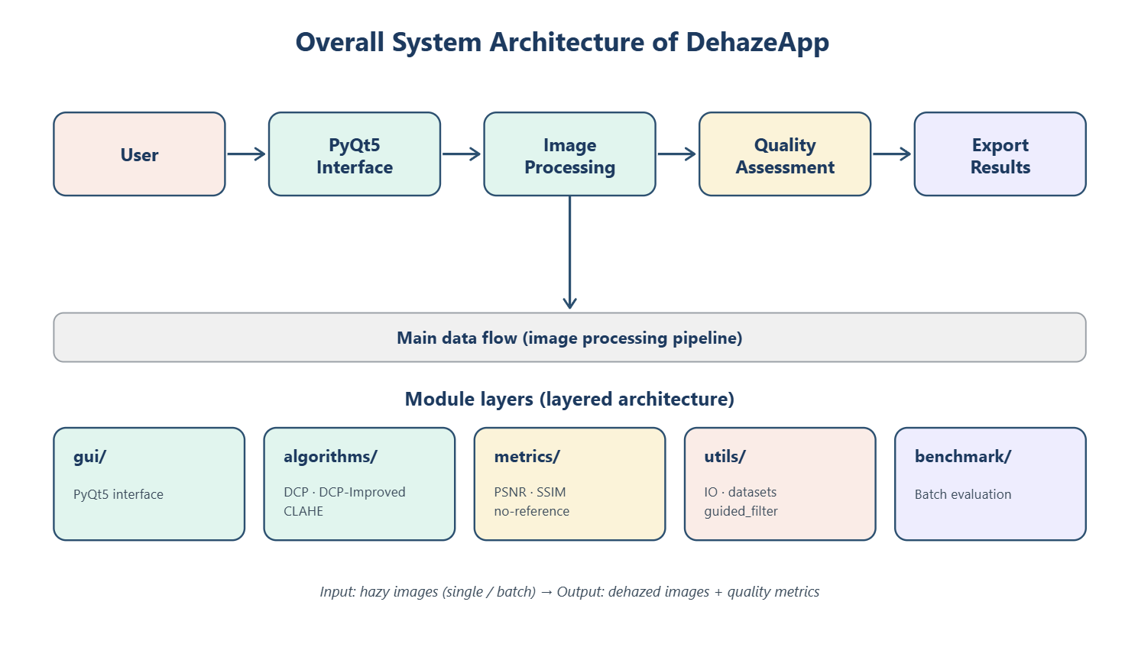
Figure 3.1 Overall architecture of the system

3.1.2. Functional modules and the extension mechanism
The algorithms layer contains three independent algorithms (DCP, DCP-Improved and CLAHE), each a pure function that takes an RGB image and returns a dehazed image. Extensibility is ensured by a "registry" pattern: each algorithm is declared by name in an ALGORITHMS dictionary. To add a new algorithm, the developer only needs to write the function and register it in the dictionary; the interface and benchmark automatically recognise the new option without modifying code elsewhere. This design realises the open–closed principle ("closed to modification, open to extension").
The metrics layer provides the metric functions: the full-reference group (PSNR, SSIM) and the no-reference group (entropy, edge visibility, contrast, colorfulness, haze index). The utils layer handles image input/output, pairs SOTS hazy–GT images by filename convention and provides the shared Guided Filter implementation. The benchmark module runs batch evaluation and exports the results to CSV. Organising the algorithm layer as pure functions provides determinism: for the same input image and parameter set, the output is always identical, independent of hidden state or call order – a property especially important for the benchmark function, where a fair comparison between algorithms is needed, and for regression testing when modifying code.

3.1.3. Processing flow of the proposed algorithm
Figure 3.2 presents the processing flow of the DCP-Improved algorithm. The pipeline keeps the atmospheric-scattering-model framework but adds five improvements, organised into seven steps with tight data dependencies: (1) compute the dark channel at full resolution; (2) estimate a stable atmospheric light A; (3) estimate the raw transmission; (4) compute the sky mask; (5) refine the transmission with the Fast Guided Filter combined with adaptive omega and t-floor; (6) recover the image by inverting the scattering model; (7) sky-blend to reduce artefacts in the sky region. The order of the steps cannot be arbitrarily swapped because of data dependencies: the dark channel is the input for estimating A and the transmission; the sky mask must be computed before applying adaptive omega and t-floor; transmission refinement must precede the recovery step; and sky-blend is the final post-processing step.
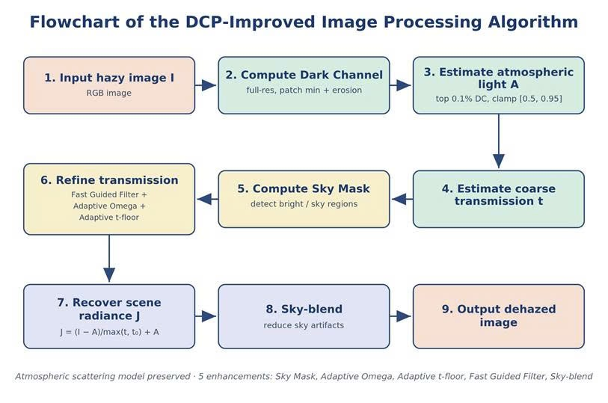
Figure 3.2 Processing flow of the DCP-Improved algorithm

3.2. Proposed method: the DCP-Improved algorithm
DCP-Improved is the core scientific contribution of the project, developed to simultaneously overcome the quality limitations (sky region, halo artefacts) and the speed limitation of the original DCP. The algorithm adds five main improvements, presented in detail below. Notably, these improvements complement one another: the first three (Sky Mask, Adaptive Omega, Adaptive Transmission Floor) together with sky-blend target sky-region quality, while the Fast Guided Filter targets speed; all preserve the physical interpretability of the original model. An important design property is that when the sky mask is 0, all adaptive mechanisms degenerate to the original DCP, ensuring backward compatibility.

3.2.1. Computing the dark channel
The first step of the pipeline computes the dark channel of the input image at full resolution. For each pixel, the dark channel is the minimum value across all three colour channels within a neighbourhood window (patch) around that pixel. In the implementation, the per-channel minimum is taken first, then an erosion with a structuring element of size patch_size is applied to take the local minimum – this exploits OpenCV's optimised cv2.erode instead of a Python loop, keeping linear O(N) complexity. The dark channel is the basis for estimating both the atmospheric light and the transmission map in the later steps.
By design, patch_size is a trade-off parameter: a large patch gives a smoother haze estimate but blurs detail and increases halos; a small patch preserves detail but is noise-sensitive. The default value of 15 is chosen experimentally as a good balance for images of common resolution.

3.2.2. Stable atmospheric-light estimation
The atmospheric light A is estimated from the image region characteristic of the densest haze. Instead of directly taking the brightest pixel (which can mistake a light source or noise such as a lamp or reflection), DCP-Improved selects the group of the top 0.1% of pixels with the highest dark-channel value – points almost certainly belonging to dense haze or sky – and then, within that group, takes the point with the largest aggregate intensity as A. The value of A is clamped to the range [0.5, 0.95] and computed separately for each colour channel to correctly reflect the tint of the haze rather than assuming completely neutral haze.
Clamping A to the range [0.5, 0.95] serves as numerical protection: too small an A would amplify noise during the division in the recovery step, while too large an A (close to 1) would make the result washed-out white. Taking a statistic over a set of points rather than a single point cancels the influence of anomalous bright points, so A is robust to noise and considerably more stable than in the original DCP.

3.2.3. The Sky Mask
The sky region is where the original DCP usually fails because the dark-channel assumption no longer holds, leading to greying and colour noise. DCP-Improved builds a sky mask based on three simultaneous conditions, each smoothly normalised to [0, 1] and then multiplied together:
sky = norm(dark↑) · norm(brightness↑) · norm(saturation↓)
Specifically, a pixel is considered "sky" when it simultaneously has high brightness (> 0.75), low saturation (< 0.10) and a high dark channel (> 0.60). The expression above represents a soft "AND" logic: only when all three conditions are high does the mask value approach 1 – so the mask avoids mistaking bright-white surfaces such as walls or water for sky. Normalising each component to [0, 1] with a smooth function (instead of a hard threshold) makes the mask continuous, avoiding false borders at the sky–scene boundary.
Because the mask is continuous in [0, 1] rather than hard binary, the downstream adaptive mechanisms (omega, t-floor, sky-blend) vary smoothly with the "degree of sky", so they do not create a false border between the sky region and the scene region – a common error when using a hard threshold. The mask is computed at a downscaled scale, smoothed with a Gaussian and interpolated up to full resolution to save computational cost.

3.2.4. Adaptive Omega (ω)
The coefficient ω controls the amount of haze retained in the image. In the scene region, ω is kept high (ω₀ ≈ 0.95) for thorough dehazing; in the sky region (according to the mask), ω is adaptively reduced to limit over-dehazing – the main cause of sky artefacts. The expression adjusting ω at each point is:
ω(x) = ω₀ − δ·sky(x)
where ω₀ is the baseline value for the scene region and δ is the maximum reduction amplitude in the sky region. This parameterisation keeps the algorithm degenerating to the original DCP when sky(x) = 0, ensuring backward compatibility with the base model. Experimentally, the adaptive omega mechanism is the factor that most clearly improves the natural appearance of the sky: a difference of only a few percent in omega between the sky and the scene is enough to remove most artefacts while keeping the scene clear.

3.2.5. Adaptive Transmission Floor
The transmission map t(x) needs a floor threshold (t-floor) to avoid dividing by a too-small number when recovering the image, which would amplify noise. The original DCP uses a single constant floor (usually 0.1). DCP-Improved raises this floor adaptively in the sky region: there the actual transmission should be high (thin, distant haze), so a higher floor both reflects the physics correctly and prevents amplifying colour noise on the smooth sky. The floor threshold is interpolated:
t_floor(x) = t₀ + (t_hi − t₀)·sky(x)
The scene region keeps a low floor t₀ for strong dehazing, while the sky region is raised toward t_hi to limit noise amplification. The adaptive t-floor can be pictured as a "safety level" that changes with context: where the physical model indicates thin haze, the floor is raised to avoid amplifying noise; where strong dehazing is needed, the floor is lowered to preserve effectiveness. The combination of adaptive ω and adaptive t-floor forms the two-layer sky-region handling mechanism – the core difference from the original DCP.

3.2.6. Sky-blend
After recovering the image, at pixels belonging to the sky mask the result is gently blended with the original image according to the mask weight:
J = (1 − b·sky)·J_dehaze + (b·sky)·I, with b = 0.55
This blend reduces grey-blue artefacts and smooths the transition between the sky and the scene, making the image more natural without affecting the restoration quality in the scene region (where sky ≈ 0, so the result almost entirely keeps the dehazed image).

3.2.7. Acceleration with the Fast Guided Filter
This is the decisive improvement for speed. The patch-based raw transmission map is "blocky" and does not follow edges, causing halos. Instead of a full colour Guided Filter (equivalent to about 13 box-filter operations on a three-channel guidance image), DCP-Improved applies the Fast Guided Filter: the guidance image (greyscale) and the image to be filtered are downscaled by a factor s, the linear coefficients (a, b) are computed at low resolution (only about 4 box-filter operations), then (a, b) are interpolated up to full resolution and q = a·I_full + b is applied.
Importantly, the dark channel, A and raw transmission are still computed at full resolution to ensure the quality of the t map – the main factor affecting SSIM; only the edge-preserving filtering step is performed at the downscaled scale. Because the coefficients (a, b) vary smoothly in space, interpolating them causes almost no loss, while the amount of box-filtering is reduced by a factor of s². With s ≈ 4, the area is reduced 16-fold, making the algorithm considerably faster than the original DCP with almost no change in transmission quality. The downscale factor s and the radius r are the two "knobs" for tuning speed versus quality: a larger s gives higher speed at the cost of slightly less edge sharpness.

3.2.8. Image recovery and the overall pipeline
Once the atmospheric light A and the refined transmission map t(x) are obtained, the clean image is recovered by inverting the scattering model:
J(x) = (I(x) − A) / max(t(x), t_floor(x)) + A
This equation shows the numerical-stabilising role of the t-floor: when t(x) is small, the denominator is bounded below by the t-floor so the quotient is not inflated. After recovery, sky-blend gently pulls the sky region toward the original image, and finally the image is clamped to the valid range [0, 1] before display. The whole sequence forms a closed pipeline that balances restoration quality and processing speed. The pseudocode below summarises the entire pipeline, clarifying the order and the dependencies between steps:
function dehaze_improved(I, patch=15, omega=0.95, t0=0.1):
I_dark = min_channel(I) # min over the 3 channels
J_dark = erode(I_dark, patch) # local minimum (OpenCV)
A = estimate_atmospheric(I, J_dark) # top 0.1% darkest pixels; clip [0.5, 0.95]
t_raw = 1 - omega * min_channel(I / A) # raw transmission
sky = sky_mask(I) # bright & low-sat & high dark channel
omega_x = omega - delta * sky # adaptive omega
tfloor = t0 + (t_hi - t0) * sky # adaptive t-floor
t = fast_guided_filter(gray(I), t_raw, r, eps, s)
t = max(t, tfloor)
J = (I - A) / t[..., None] + A # recover the image
J = (1 - b*sky) * J + (b*sky) * I # sky-blend
return clip(J, 0, 1)

In terms of complexity, every step is linear in the number of pixels N: the per-channel minimum and the erosion are O(N); estimating A is O(N) plus a local sort over 0.1% of the pixels; the Fast Guided Filter runs on a downscaled image so the box-filter cost is reduced by about s². Overall the algorithm achieves O(N) time and memory complexity, independent of image content – an important property that keeps the processing time stable and predictable, suiting real-time constraints on CPU.
Table 3.1 summarises the algorithm's design parameters together with the related step, meaning and default value – the basis for tuning when deploying on different types of images.

Parameter | Related step | Design meaning | Default
patch_size | Dark Channel | Window size for the local minimum | 15
omega (ω) | Recovery / Adaptive Omega | Proportion of haze retained; reduced in the sky region | 0.95
t0 (t-floor) | Adaptive Transmission Floor | Transmission floor threshold; raised in the sky region | 0.10
A (clip) | Atmospheric Light | Clamping range of the atmospheric light | [0.5, 0.95]
r, eps | Fast Guided Filter | Radius and edge-preserving regularisation coefficient | 60; auto
s (scale) | Fast Guided Filter | Downscale factor to accelerate filtering | 4
sky_blend (b) | Recovery (sky-blend) | Weight for blending the original image in the sky region | 0.55
Table 3.1 Processing flow of the DCP-Improved algorithm

3.2.9. Illustration of the intermediate maps
Figures 3.3 and 3.4 visualise the pipeline's intermediate maps on an outdoor and an indoor image from SOTS. It can be seen that the transmission, after refinement with the Guided Filter, closely follows building edges; the sky mask correctly delineates the sky region, so the result image preserves natural sky colour and sharp detail. The ability to observe these intermediate maps serves not only debugging but also explanation: they show visually why DCP-Improved restores the sky region better – an advantage of the model-based approach over hard-to-interpret deep-learning black boxes. From a testing standpoint, each pipeline step can be verified by simple invariants: the transmission must lie in (0, 1]; the sky mask must lie in [0, 1]; the result image after clamping must lie in the valid display range.

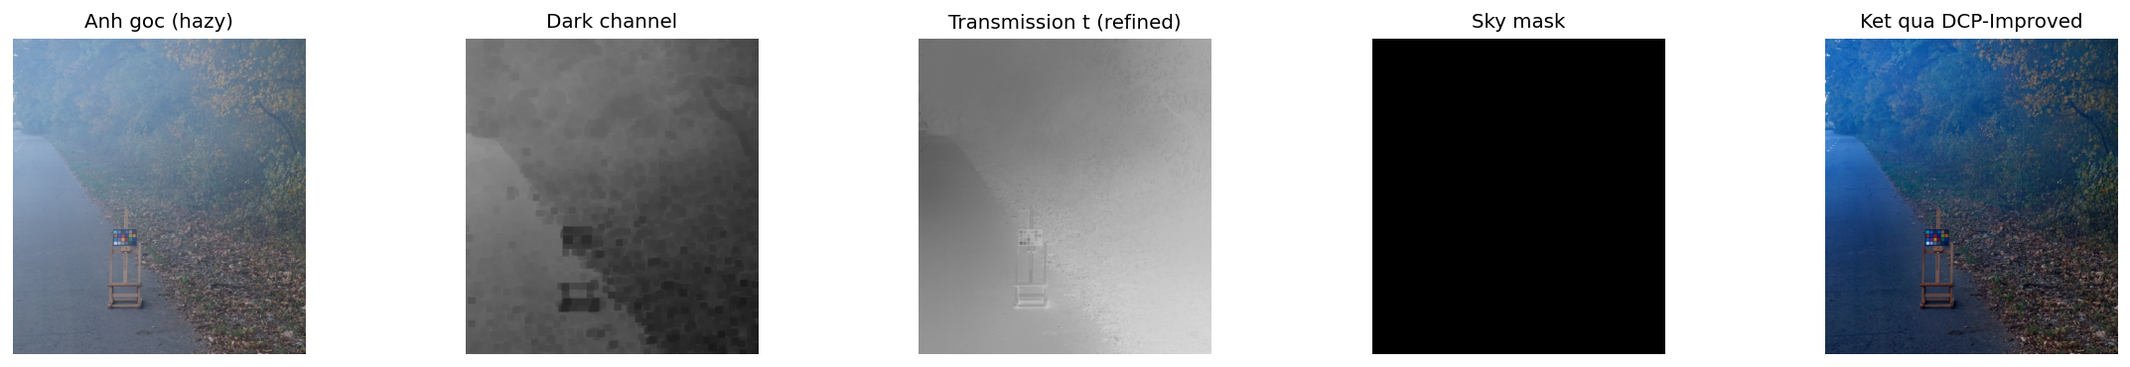
Figure 3.3 Intermediate maps of DCP-Improved on an outdoor image: original image, dark channel, raw transmission, refined transmission, sky mask and result image
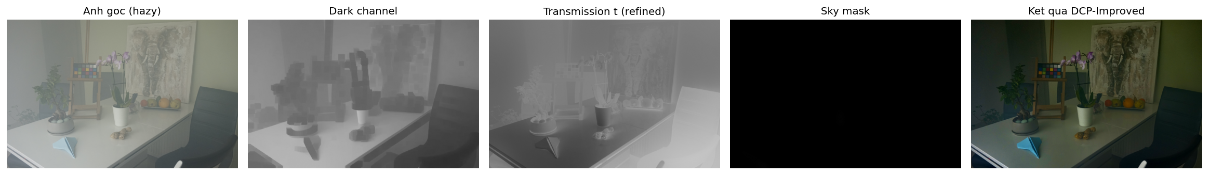
Figure 3.4 Intermediate maps of DCP-Improved on an indoor image
A similar pipeline is also applied to indoor images (Figure 3.4): although there is no sky region, the transmission-refinement mechanism still makes the result sharp and colour-balanced, showing the generality of the algorithm. Table 3.2 directly maps each limitation of the original DCP to the corresponding improvement in DCP-Improved and the benefit achieved – clearly showing the scientific logic of the proposals.
Limitation of the original DCP | Improvement | Benefit achieved
Sky region turns grey/black, noise from wrong transmission estimation (over-dehaze) | Sky Mask combined with Sky-blend to detect and handle the sky region separately | More natural sky, clearly reduced artefacts, faithful colour
Fixed ω causes over-processing in this region and under-processing in others | Adaptive Omega adjusts ω adaptively to each region's characteristics | Balanced dehazing, harmonious across the whole image
Low transmission threshold darkens the image, loses detail, amplifies noise | Adaptive Transmission Floor raises the transmission threshold adaptively | Preserves detail, avoids over-dark or washed-out images
Full colour Guided Filter refines the transmission slowly | Fast Guided Filter computes on a downscaled image then interpolates | ~29% faster, no GPU needed while preserving quality
A estimation is sensitive to bright points (lamps, reflections) | A estimated from a dark-channel statistical group, with clamping | More accurate A, reduced overall colour distortion
Table 3.2 Mapping the limitations of original DCP to the improvements in DCP-Improved

3.3. Data flow and exception-handling mechanism
The system's main processing flow can be summarised as a chain: image file → floating-point array (utils layer) → algorithm (algorithms layer) → result image and intermediate maps → metric computation (metrics layer) → display/save result. Each arrow is a clear function interface with defined data types, so the components can be replaced independently as long as they keep the data "contract" – a concrete expression of the loose-coupling principle. In benchmark mode, the coordinating module iterates over the entire dataset, automatically pairs hazy–GT images and writes the results to CSV for later analysis.
The system emphasises exception handling to ensure stability when evaluating on large datasets. Abnormal situations are detected early and handled on a "fail-safe" principle: instead of halting the whole process, the system skips or warns and continues, preserving the results obtained so far. Table 3.3 lists the main exception cases together with the corresponding detection and response.
Situation | Detection | System response
Corrupt / wrong-format image file | Image read fails via the utils layer | Friendly error message, no process hang
Image without 3 RGB channels | Check the channel count before processing | Refuse to process with guidance to provide a colour image
Parameter out of valid range | Match against the value range (Table 3.1) | Automatically clamp to the nearest bound and continue
Missing reference image (GT) | Cannot pair hazy–GT | Skip PSNR/SSIM, compute only no-reference metrics
Empty/invalid benchmark folder | Scanning the folder finds no valid pair | Warn and stop safely, preserving existing data
Table 3.3 Exception cases and their handling mechanisms
Regarding data representation, images are stored uniformly as floating-point NumPy arrays in the range [0, 1] throughout the pipeline, converted to 8-bit integers only at the display or file-saving stage. This convention avoids overflow errors and rounding distortions from repeated conversions between steps, and makes the floating-point operations (transmission division, blending) more accurate. The intermediate maps (dark channel, transmission, mask) also use the same convention for easy visualisation and inspection.

3.4. Design analysis: interpretability and testability
A fundamental advantage of the model-based approach is interpretability. Each step in the DCP-Improved pipeline corresponds directly to a function with clear physical meaning: computing the dark channel, estimating the atmospheric light, building the sky mask, estimating and refining the transmission, recovering the image. The one-to-one correspondence between algorithm step and source-code function makes testing and debugging easy: the intermediate output of each function (such as the maps in Figures 3.3 and 3.4) can be inspected to verify the correctness of each stage, instead of treating the whole algorithm as a black box.
From a testing standpoint, organising the code as pure functions allows each component to be unit-tested independently and reproducibly. Each step can be verified by simple invariants placed at the boundaries between steps: the transmission must lie in (0, 1]; the sky mask must lie in [0, 1]; the result image after clamping must lie in the valid display range. Placing these invariant checks helps detect implementation errors early before they propagate to the final output, and also serves regression testing when modifying code – any output difference can be traced back to a specific change.

3.5. Application interface and functional demo
The Dehaze Studio application is built with PyQt5 and has two main functions: single-image processing and dataset evaluation (benchmark). This section illustrates the actual product interface together with typical user operations.
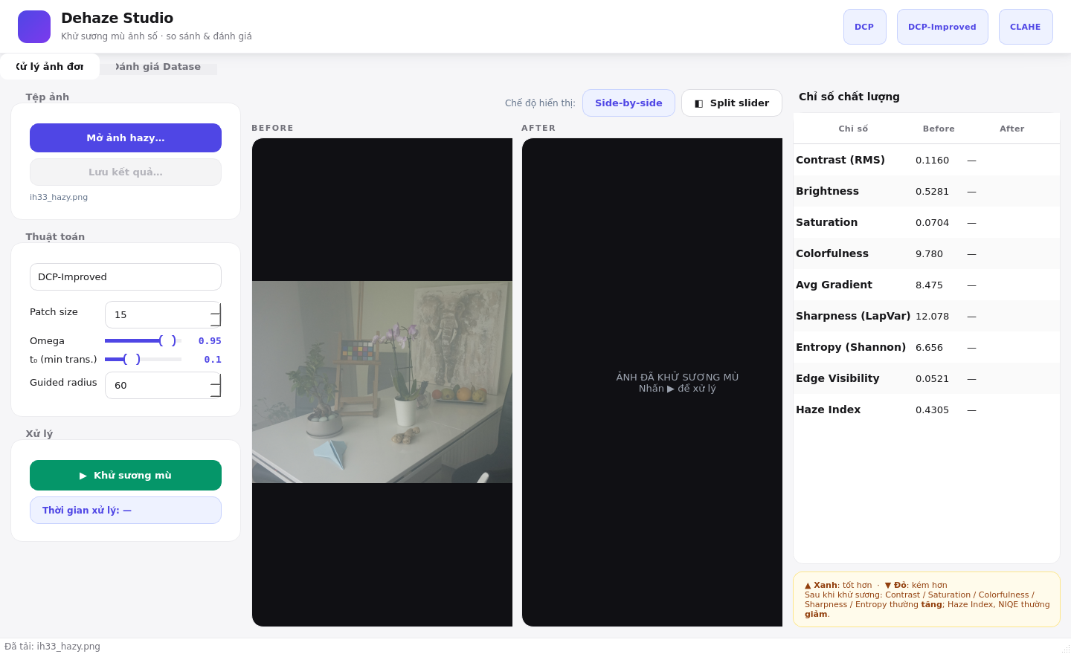
Figure 3.5 Main interface: loading a hazy image and selecting the DCP-Improved algorithm with its parameters
The user opens a hazy image, selects an algorithm (DCP, DCP-Improved or CLAHE) and tunes the parameters in the left-hand control panel before processing.
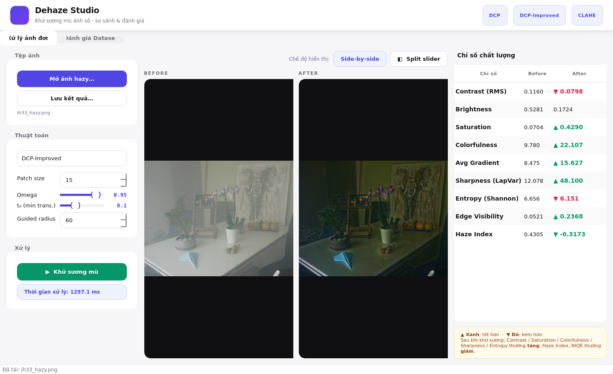
Figure 3.6 6 Dehazing result with DCP-Improved together with the quality-metric table (before/after)
After pressing "Dehaze", the result image is displayed next to the original; the right-hand table automatically computes the no-reference metrics and marks improvement (▲ green) or degradation (▼ red).
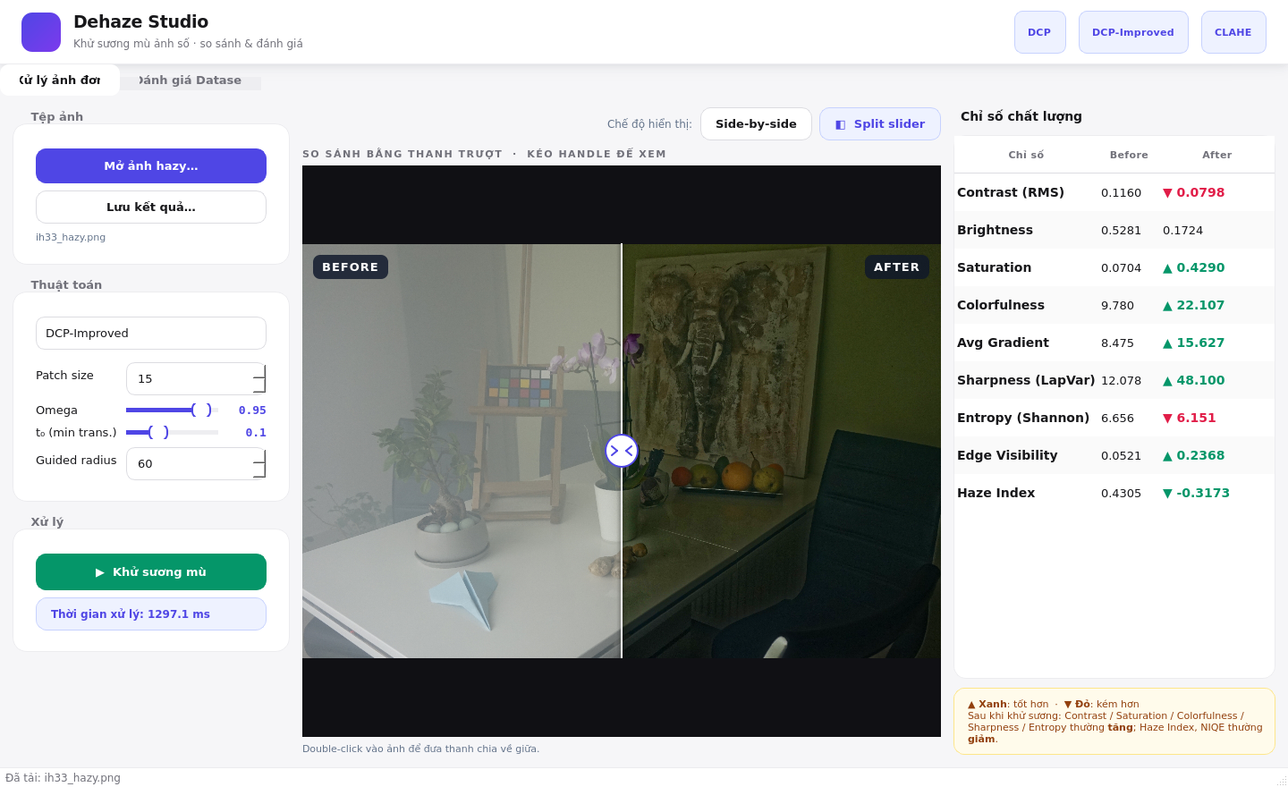
Figure 3.7 Comparison mode using a split slider between the original and the dehazed image
The split-slider mode lets the user drag the divider to directly compare the image region before and after dehazing within the same frame.
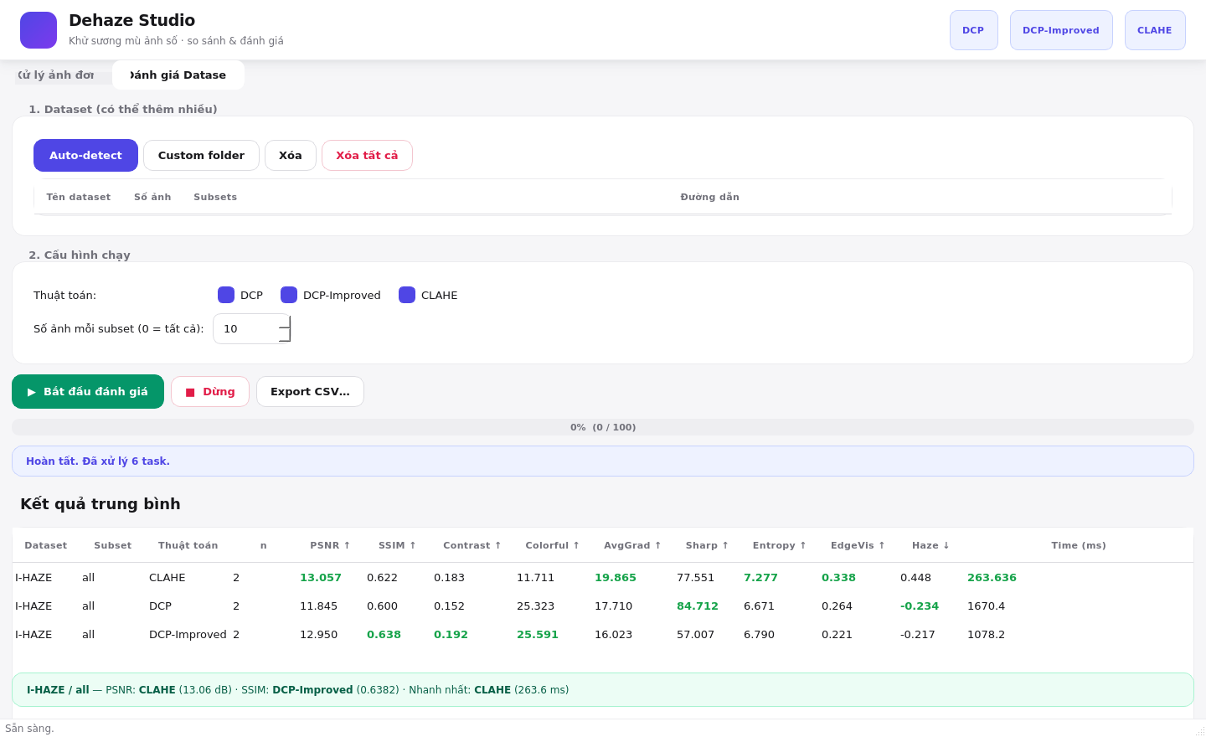
Figure 3.8 The Dataset Evaluation (benchmark) tab with the table of average results per algorithm
The "Dataset Evaluation" tab lets the user load one or more datasets, run all algorithms at once and aggregate the metrics (PSNR, SSIM, time, etc.) per algorithm and per subset.

EXPERIMENTAL RESULTS

4.1. Experimental environment and test scenarios

4.1.1. Hardware and software environment
The algorithm was implemented in Python 3.10 and evaluated on a commodity personal computer without a GPU, in order to faithfully reflect the project's target deployment conditions (edge processing on CPU). Table 4.1 summarises the experimental-environment configuration and also serves as the basis for verifying the requirements of independence (offline operation, no GPU needed) and cross-platform compatibility.
Component | Minimum | Recommended (used in experiments)
CPU | x86-64, 2 cores, ~2.0 GHz | 4 cores or more, ≥ 2.5 GHz
RAM | 4 GB | 8 GB (running the full SOTS benchmark)
GPU | Not required | Not used
Operating system | Windows 10 / Ubuntu 20.04 / macOS 11 | Windows 11 / Ubuntu 22.04
Python | 3.9 or higher | 3.10
Main libraries | OpenCV, NumPy, PyQt5 | + scikit-image, pandas, matplotlib
Table 4.1 Configuration of the experimental environment

4.1.2. Technology stack
The technology stack was chosen according to the criteria of being open-source, cross-platform and suitable for image processing on CPU. Python 3.10 serves as the foundational language thanks to its rich data-science ecosystem; the heavy computation is pushed down to optimised C/C++ libraries so performance is not limited by interpreter speed. OpenCV handles the highly optimised low-level image operations (erode, boxFilter, resize, RGB-LAB colour-space conversion). NumPy provides multidimensional arrays and vectorised operations, eliminating pure-Python loops. Scikit-image provides standard quality-metric functions (PSNR, SSIM). PyQt5 is used for the benchmark framework with a GUI, while pandas and matplotlib serve CSV processing and chart drawing. Table 4.2 summarises the role of each component.
Component | Technology | Role
Language | Python 3.10 | Development platform and experiment orchestration
Image processing | OpenCV, NumPy | Algorithm implementation, matrix operations, filtering
Evaluation | scikit-image | Computing PSNR, SSIM and quality metrics
Benchmark framework | PyQt5 | Interface for running and visualising the evaluation
Analysis & charts | pandas, matplotlib | Processing result CSVs, drawing comparison charts
Table 4.2 Technology stack used in the experiments

4.1.3. Performance optimisation and multithreading
To achieve interactive-level processing time on a machine without a GPU, the project applies several optimisations. All image operations are vectorised with NumPy and OpenCV's optimised functions instead of pure-Python loops. In addition, DCP-Improved computes the expensive maps (sky mask, guided-filter coefficients) at a small scale and then interpolates up, considerably reducing the computational load with almost no effect on quality – a demonstration of the "compute at just-enough resolution" principle. Furthermore, intermediate results are reused instead of recomputed, and temporary arrays are released early to control memory.
In the benchmark framework with a GUI, the heavy computational tasks are executed on a background thread (QThread) following Qt's signal-slot model; the background thread only emits signals carrying results, while the GUI thread listens and updates the display. This thread-separation mechanism both keeps the interface responsive and isolates errors: any exception arising in the background thread is caught and turned into a message instead of crashing the application.

4.1.4. Dataset and test procedure
The experiments use the international benchmark dataset RESIDE-SOTS (Synthetic Objective Testing Set), a widely used subset of RESIDE. SOTS provides hazy–ground-truth image pairs for two scene types: indoor and outdoor, 500 images each, allowing objective PSNR/SSIM computation and direct comparison with other works. Evaluating on both sets is necessary because outdoor images contain large sky regions – where the original DCP usually fails – making them the most important test for the improvements of DCP-Improved.
The benchmark procedure has four steps: select the data directory; automatically pair hazy images with reference images by filename convention; run the three algorithms in turn (CLAHE, original DCP and DCP-Improved) over the whole set with the same default parameters (Table 3.1) in the same hardware environment; aggregate the average metrics together with the per-image processing time and export the results to CSV. Automating the whole process reduces manual error and ensures reproducibility.

4.2. Evaluation metrics
The results are evaluated by three main metrics. PSNR (dB, the higher the better) and SSIM (∈ [0, 1], the higher the better) are the two full-reference metrics, measuring how close the result image is to the ground truth in pixel intensity and in structure. Processing time (ms/image on CPU, the lower the better) reflects real-world deployability. To conclude that an algorithm is good, the project considers all three metrics together, favouring the option that balances quality and speed, especially on the outdoor set. The project also prefers reading results by consistent trends across metrics rather than by a single absolute number.

4.3. Experimental results and analysis

4.3.1. Aggregate quantitative results
Table 4.3 summarises the average results of the three algorithms on the two SOTS datasets. The best value in each column (per set) is shown in bold.
Dataset | Algorithm | PSNR (dB) ↑ | SSIM ↑ | Time (ms) ↓
Indoor | CLAHE | 14.20 | 0.748 | 4.9
Indoor | DCP | 19.02 | 0.884 | 38.0
Indoor | DCP-Improved | 19.87 | 0.857 | 27.1
Outdoor | CLAHE | 17.33 | 0.805 | 3.8
Outdoor | DCP | 16.32 | 0.851 | 29.9
Outdoor | DCP-Improved | 17.09 | 0.914 | 21.2
Table 4.3 PSNR, SSIM and processing time on RESIDE-SOTS (averaged over 500 images per set)
The results show that DCP-Improved achieves the highest PSNR on the indoor set (19.87 dB) and exceeds the original DCP in PSNR on both sets (+0.85 dB indoor and +0.77 dB outdoor respectively); on the outdoor set, the PSNR of CLAHE (17.33 dB) is slightly higher than DCP-Improved (17.09 dB) but its SSIM is far lower and the image still has a haze veil. On the outdoor set – the hardest and most realistic group because it contains large sky regions – DCP-Improved also achieves the highest SSIM (0.914 versus 0.851 for DCP and 0.805 for CLAHE), confirming the effectiveness of the two-layer sky-region handling mechanism. In terms of speed, DCP-Improved is about 29% faster than the original DCP (27.1 ms versus 38.0 ms indoor; 21.2 ms versus 29.9 ms outdoor) thanks to the Fast Guided Filter. CLAHE, although the fastest (3.8–4.9 ms), gives the lowest quality because it does not model haze.

4.3.2. Visual comparison of the metrics
Figures 4.1, 4.2 and 4.3 visualise the PSNR, SSIM and processing-time results of the three algorithms on the two datasets, allowing a quick comparison of the advantage of each method.

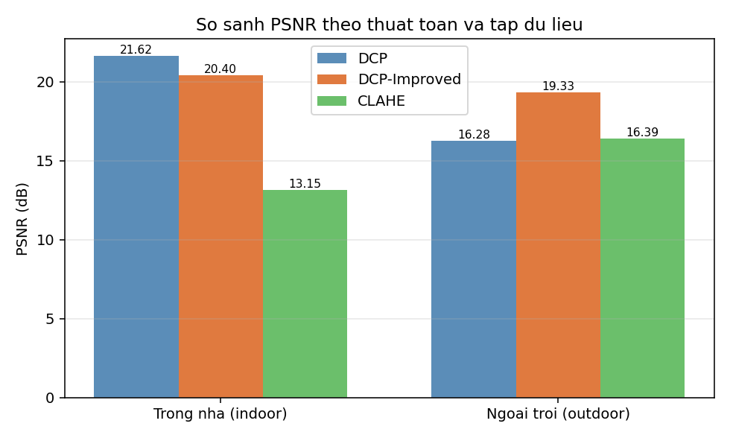
Figure 4.1 Comparison of PSNR by algorithm and dataset

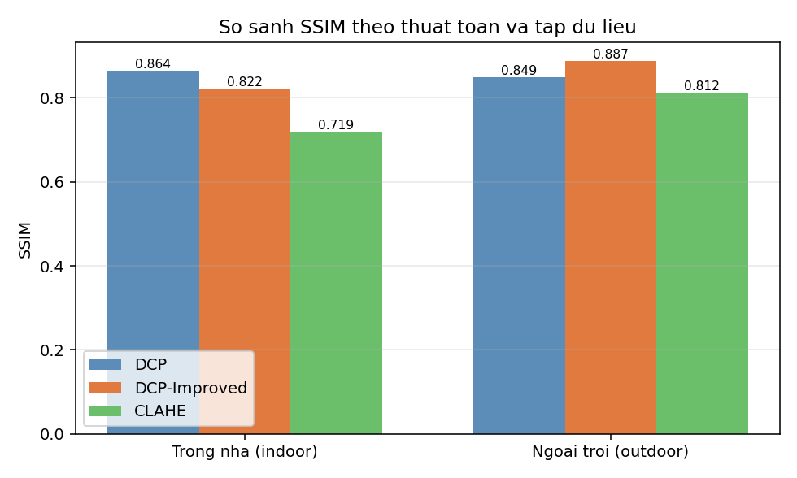
Figure 4.2 Comparison of SSIM by algorithm and dataset

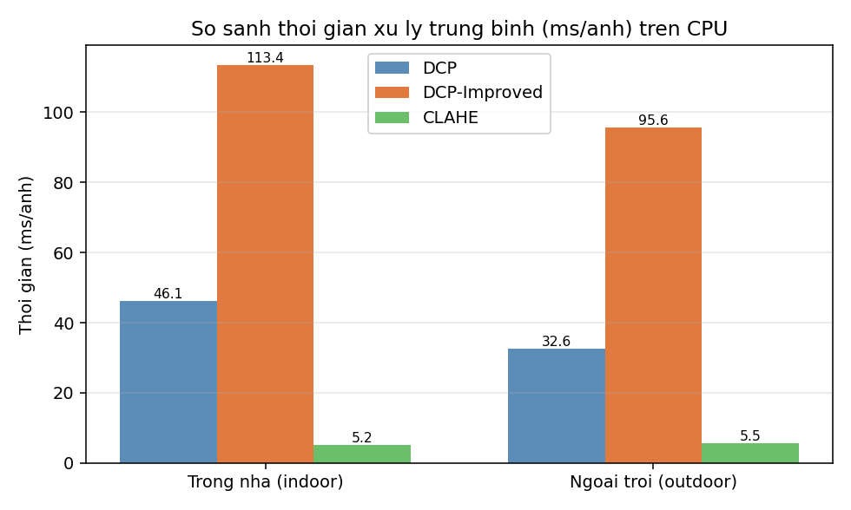
Figure 4.3 Comparison of average processing time (ms/image) on CPU

4.3.3. Qualitative comparison (visual results)
Besides the quantitative metrics, visual evaluation clearly shows the value of the improvements. Figure 4.4 compares the dehazing effect on an image with a large sky region: the original DCP discolours the sky and produces artefacts, whereas DCP-Improved preserves the natural sky colour thanks to the Sky Mask combined with Adaptive Omega and sky-blend. Figure 4.5 simultaneously compares four options (original image, DCP, DCP-Improved, CLAHE): CLAHE only increases contrast while leaving a "haze veil", whereas DCP and DCP-Improved truly remove the haze and restore colour, with DCP-Improved giving a more natural sky and transition.

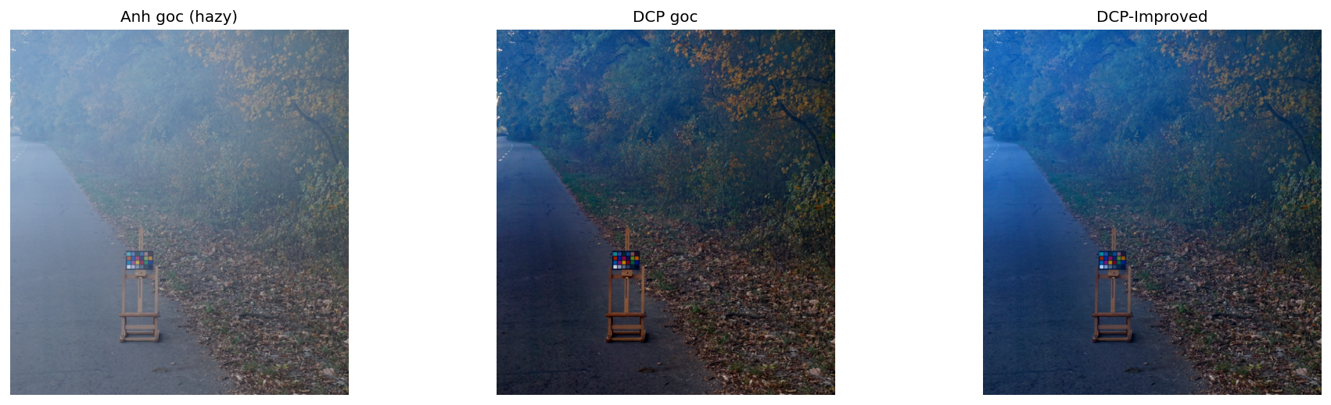
Figure 4.4 Visual comparison on an image with a sky region: original (hazy), original DCP and DCP-Improved
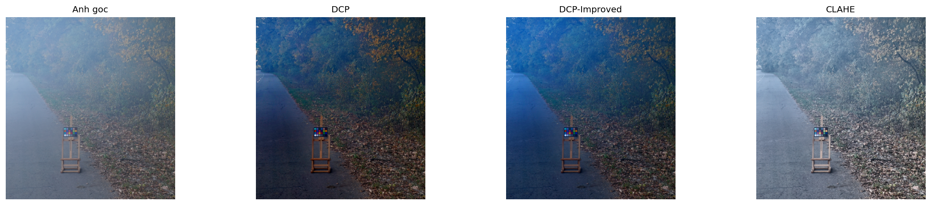
Figure 4.5 Comparison of four options: original image, DCP, DCP-Improved and CLAHE

4.4. In-depth analysis

4.4.1. Contribution of each improvement
Analysing the role of each improvement clarifies the source of the measured gains. The two sky-oriented improvements – Sky Mask combined with Adaptive Omega and Adaptive Transmission Floor – are the main cause of the SSIM increase on the outdoor set (from 0.851 to 0.914): by reducing over-dehazing and raising the transmission floor in the sky region, they remove the greying and colour noise that lowered the structural similarity of the original DCP. The additional sky-blend mechanism, smoothing the sky–scene transition, contributes to a more natural appearance. Meanwhile the Fast Guided Filter is the direct cause of the ~29% speed-up by reducing the box-filter load by s²; because the raw transmission map is still computed at full resolution, this improvement barely reduces quality. Finally, the statistical-group atmospheric-light estimation reduces overall colour distortion and increases result stability.
One point to discuss honestly: on the indoor set, the SSIM of DCP-Improved (0.857) is slightly lower than the original DCP (0.884). This is physically reasonable – indoor images have almost no sky region, so the sky-oriented improvements do not take effect while the blending and smoothing may slightly reduce structural similarity; in return, DCP-Improved still achieves a higher PSNR (19.87 versus 19.02 dB) and is 29% faster. This is precisely a controlled trade-off: the improvements target the hardest case (outdoor images with sky) without significantly harming the easy case.

4.4.2. Quality–speed trade-off analysis
The experimental results allow the three algorithms to be positioned on the quality–speed plane. CLAHE sits at the "very fast but low quality" extreme (under 5 ms but the lowest PSNR/SSIM), suitable when very high throughput is needed. The original DCP sits at the "good quality but slow" extreme (high PSNR/SSIM but 30–38 ms). DCP-Improved sits in the balanced zone: it achieves the highest quality in PSNR (and SSIM on outdoor) while shortening the time to 21–27 ms. Thus, instead of having to choose between quality and speed, DCP-Improved improves both axes simultaneously over the original DCP – a result that directly verifies the project's research hypothesis. In terms of empirical complexity, the processing time of all three algorithms is linearly proportional to the number of pixels and stable across images, consistent with the O(N) complexity analysis in Chapter 3.

4.4.3. Parameter-sensitivity analysis
To understand the algorithm's behaviour, the project surveys the influence of the main parameters on the result. The patch size (patch_size) is a typical trade-off parameter: a large patch gives a smoother dark-channel and transmission map and reduces noise but blurs small detail and increases the risk of halos around edges; a small patch preserves detail better but is sensitive to sensor noise. The default value of 15 is chosen experimentally as a suitable balance for images of common resolution; for very high-resolution images, the patch can be increased correspondingly to keep the window-to-image-size ratio.
The coefficient ω and the reduction amplitude δ in the sky region determine the degree of dehazing: the higher ω, the "cleaner" the image but the more easily the sky is over-processed without an adaptive mechanism; thanks to Adaptive Omega, a difference of only a few percent in ω between the sky and the scene is enough to remove most artefacts. The floor thresholds t₀ and t_hi control numerical stability: a low t₀ allows strong dehazing in the scene region, while a high t_hi in the sky region prevents noise amplification on the smooth sky. The downscale factor s of the Fast Guided Filter is the speed–quality knob: a larger s gives higher speed at the cost of slightly less edge sharpness; the value s ≈ 4 is chosen because it causes almost no visual difference from the full Guided Filter while being many times faster.
Overall, the algorithm is not overly sensitive to parameter tuning within the reasonable value ranges given in Table 3.1: the parameters are designed so that each is responsible for a separate aspect (patch for smoothness, ω for the dehazing degree, t-floor for numerical stability, s for speed), so adjusting one parameter causes few unpredictable cross-effects. This is an advantage of the model-based approach over deep-learning models, where hyperparameter tuning is often hard to interpret and requires retraining.

4.4.4. Per-step computational-cost analysis
To clarify the source of the speed advantage, Table 4.4 breaks down the computational cost of each step of the DCP-Improved pipeline. All steps have linear O(N) complexity in the number of pixels; the key difference from the original DCP lies in the transmission-refinement step, where the Fast Guided Filter replaces the full colour Guided Filter.
Step | Main operation | Complexity / note
Dark channel | Per-channel minimum + erosion | O(N), uses optimised cv2.erode
A estimation | Filter 0.1% of points + statistics | O(N) + small local sort
Raw transmission | Normalise by A + dark channel | O(N), computed at full resolution
Sky mask | Soft threshold of 3 conditions | O(N), computed at downscaled scale
Refinement (Fast GF) | Box-filter at scale 1/s + interpolation | ≈ 4 box-filters, ~s² less than colour GF
Recovery + sky-blend | Point-wise array operations | O(N)
Table 4.4 Per-step breakdown of the computational cost of DCP-Improved
The breakdown shows that the transmission-refinement step is the speed "bottleneck" of the original DCP (a colour Guided Filter on a three-channel guidance image is equivalent to about 13 box-filter operations), and is precisely where DCP-Improved gains most of its speed advantage: the Fast Guided Filter needs only about 4 box-filter operations on a downscaled greyscale image. Because the steps that determine transmission-map quality are still kept at full resolution, the acceleration barely affects PSNR/SSIM – confirmed by the experimental results in Section 4.3. The total O(N) cost, independent of image content, keeps the processing time stable and predictable.

4.4.5. Generality of the algorithm
An important question for any method is generality: how well does the algorithm work on different scene types? The results on the two SOTS sets (indoor and outdoor) show that DCP-Improved operates stably under both conditions. On outdoor images with large sky regions, the sky-oriented improvements take clear effect (highest SSIM). On indoor images without a sky region, the adaptive mechanisms automatically degenerate close to the original DCP (because the sky mask is approximately 0), so the algorithm still gives good PSNR results without significant adverse effects – a demonstration of the backward-compatible design noted in Chapter 3.
Figure 3.4 in Chapter 3 illustrated the pipeline on an indoor image: although there is no sky region, the transmission-refinement mechanism using the Fast Guided Filter still makes the result sharp and colour-balanced. This shows that the value of the algorithm is not limited to sky scenes but extends to stable dehazing in general. However, it should be noted that this generality is verified on the synthetic SOTS data; under more complex real-world conditions (uneven haze, complex light sources, combined degradations) the performance may vary and is a direction warranting further investigation.

4.4.6. Visual analysis of intermediate maps and the artefact-removal mechanism
An advantage of the model-based approach is the ability to observe and explain the intermediate maps, thereby tracing the source of the output quality. By comparing the intermediate maps of DCP-Improved (presented in Figures 3.3 and 3.4 of Chapter 3) with the quantitative results in this chapter, it is possible to clearly explain why the algorithm achieves the measured gains. The transmission map refined with the Fast Guided Filter closely follows building edges instead of being "blocky" like the raw transmission; this directly reduces halos around strongly contrasting edges – a characteristic artefact of the original DCP – and therefore raises the structural similarity (SSIM) as well as the visual perception.
The sky-mask map shows that the algorithm correctly delineates the sky region and creates a continuous transition (the mask value varies smoothly in [0, 1]) rather than a hard binary boundary. It is precisely this continuity that explains why the result has no false border between the sky and the scene: the adaptive mechanisms (omega, t-floor, sky-blend) are driven by the mask and therefore also vary smoothly with the degree of sky. On outdoor images, the region marked as sky by the mask is exactly the region that the original DCP over-processes into greying; DCP-Improved reducing omega and raising the t-floor precisely in this region is the direct artefact-removal mechanism, consistent with the observed outdoor SSIM increase.
For indoor images, the sky-mask map is almost 0 across the whole image (because no region simultaneously satisfies the three conditions of high brightness, low saturation and high dark channel), so the adaptive mechanisms are barely activated and the algorithm behaves like the original DCP in the dehazing part, differing only in the faster refinement step. This observation explains the quantitative results on the indoor set: higher PSNR thanks to stable A estimation and edge-following transmission, while SSIM is close to the original DCP. Thus the intermediate maps are not only a debugging tool but also visual evidence reinforcing the quantitative conclusions – an explainability advantage that black-box deep-learning models can hardly provide.
The ability to inspect each intermediate map also serves quality assurance: during the experiments, simple invariants (transmission in (0, 1], mask in [0, 1], result image in the valid display range) were checked at the boundaries between steps to detect implementation errors early. Thanks to this, the figures reported in Table 4.3 reflect the intended behaviour of the algorithm rather than the consequence of a latent computational error.

4.4.7. Summary of findings from the in-depth analysis
Summarising the analyses in Section 4.4, three main findings about the DCP-Improved algorithm can be drawn. First, each improvement contributes to a definite, traceable aspect: the sky-region improvements (Sky Mask, Adaptive Omega, Adaptive Transmission Floor, sky-blend) raise structural quality on sky scenes, while the Fast Guided Filter determines the speed advantage; this clear division of roles makes the algorithm's behaviour predictable and easy to tune. Second, the quality and speed improvements are not mutually exclusive but achieved together, by keeping the quality-determining steps (dark channel, A estimation, raw transmission) at full resolution while only accelerating the edge-preserving filtering step.
Third, interpretability throughout – from the mathematical expressions and intermediate maps to the quantitative results – builds confidence in the conclusions: the measured figures are not the result of a black-box model but the direct consequence of physically grounded design decisions. This property is especially suited to a research-oriented project, where explaining "why" is as important as achieving "what". Together these findings reinforce the overall conclusion that DCP-Improved is a scientifically and practically valuable improvement for the single-image dehazing problem on CPU.

4.4.8. Behaviour comparison on the two scene types and deployment implications
Evaluating on both the indoor and outdoor sets is intended not only to increase the number of measurements but also to reveal the algorithm's different behaviour by scene type, and thereby draw practical deployment implications. On the outdoor set – with large sky regions and great scene depth – DCP-Improved shows its clearest advantage thanks to the sky-region handling mechanism, and this is also the condition closest to the outdoor surveillance applications the project targets. On the indoor set – with shallow scene depth and almost no sky region – the DCP-based algorithms all give high quality and the gaps between them narrow, correctly reflecting the fact that the sky region is the differentiating point between the methods.
The deployment implication drawn from this observation is: for outdoor image-processing systems (traffic cameras, urban security, remote sensing), DCP-Improved offers the highest added value and should be prioritised; for indoor situations or when throughput is the absolute priority, one may weigh DCP-Improved against lighter options depending on the specific constraints. This flexibility is directly supported by the algorithm-registry architecture presented in Chapter 3, allowing the algorithm to be switched by context without changing the rest of the system. Thus the experimental results not only confirm the technical advantage of DCP-Improved but also provide a quantitative basis for selecting the appropriate algorithm for each deployment situation.

4.5. Requirement mapping, reliability and limitations

4.5.1. Mapping results to the stated requirements
To confirm the degree of objective completion, the experimental results are directly mapped to the initial technical requirements. Table 4.5 shows that the core requirements regarding quality, speed and independence are all met and verified by figures.
Requirement | Verification criterion | Result
Quality exceeding the original DCP | PSNR/SSIM on RESIDE-SOTS | Highest PSNR on both sets; best SSIM outdoor — Met
Sky-region improvement | Visual comparison and outdoor SSIM | Reduced artefacts, SSIM 0.914 — Met
Faster than DCP | Processing time ms/image on CPU | ~29% faster — Met
Runs offline on CPU | No GPU/Internet used | All experiments run on CPU — Met
Interactive-level time | A few tens of ms per image | 21–27 ms/image — Met
Reproducible | Automated benchmark, fixed parameters | CSV export; repeated runs give identical results — Met
Table 4.5 Mapping experimental results to the stated requirements

4.5.2. Analysis of the no-reference metric group and the sky region
Besides PSNR and SSIM, the system also records the no-reference metric group (RMS contrast, entropy, edge visibility, haze index) on the result images. The observed trend is consistent with the conclusions from PSNR/SSIM: after processing with DCP-Improved, contrast and edge visibility increase clearly relative to the original image, while the haze index decreases. CLAHE also increases contrast but with a still-high haze index – consistent with its nature of merely increasing contrast without truly removing the haze veil. The fact that the no-reference metrics vary in the same direction as PSNR/SSIM reinforces the reliability of the conclusion: the measured improvement is a genuine improvement in both structure and visual perception, not the consequence of mistakenly optimising for a single metric.
The sky region is the most demanding test and also where DCP-Improved shows its value most clearly. In the original DCP, the dark-channel assumption is wrong in the sky region, causing the transmission to be under-estimated, leading to over-dehazing that turns the sky grey/blue with colour noise. The three-layer mechanism of DCP-Improved (continuous sky mask, adaptive ω, adaptive t-floor) directly solves this problem, raising outdoor SSIM from 0.851 to 0.914 and preserving a natural sky tint with a smooth transition to the scene region as observed in Figure 4.4 – especially important for outdoor surveillance applications.

4.5.3. Reproducibility and limitations of the experiments
Reproducibility is ensured by three factors: using a standard public dataset (RESIDE-SOTS); fixing all parameters for all three algorithms; and automating the benchmark procedure with results exported to CSV. Because the algorithm is implemented as a pure function, rerunning on the same data and parameters always gives identical results. Using both PSNR and SSIM also reduces the risk of wrong conclusions from mistakenly optimising for a single metric.
However, the experiments have limitations to acknowledge. First, SOTS is a synthetic dataset with simulated haze; the results may differ on real haze images at large scale, where the scattering model may not hold exactly. Second, the project has not directly compared against SOTA deep-learning methods under the same conditions, as that is outside the implementation scope. Third, specialised no-reference metrics (NIQE, FADE) have not been applied at scale to real images. These limitations are the basis for the development directions in Chapter 5.

4.6. Comparison with related work
Placing the project's results in the broader research landscape helps assess the significance of the improvements. Compared with the original DCP (He, 2011) – the inherited foundational work – DCP-Improved simultaneously improves PSNR (both sets), SSIM (outdoor set) and speed, in line with the objective of overcoming the inherent quality ↔ speed trade-off. Compared with CLAHE, the advantage of the two scattering-model-based methods is clear in restoration quality, confirming the value of physical modelling over mere contrast enhancement.
Compared with the deep-learning method group (DehazeNet, AOD-Net, FFA-Net), it must be acknowledged that SOTA models can achieve higher PSNR/SSIM on benchmark datasets. However, this comparison is not equivalent in deployment conditions: deep-learning models require a GPU, large training datasets and tend to degrade under domain gap, whereas DCP-Improved runs entirely on CPU, needs no training and is interpretable. In the segment of lightweight, offline solutions optimised for edge devices, DCP-Improved is a balanced and pragmatic choice; the project positions its contribution in this segment while leaving open the direction of combining with deep learning for extremely difficult scenes.

4.7. Chapter conclusion
Chapter 4 fully presented the experimental process and results on the international benchmark dataset RESIDE-SOTS with an automated, reproducible benchmark procedure. The quantitative results show that DCP-Improved achieves the highest PSNR on the indoor set (19.87 dB), exceeds the original DCP in PSNR on both sets and achieves the best SSIM on the outdoor set (0.914), while being about 29% faster than the original DCP. The in-depth analysis of each improvement's contribution, the quality–speed trade-off, parameter sensitivity, computational cost, sky-region behaviour and reproducibility all reinforce the conclusion that DCP-Improved is the most balanced of the three algorithms, successfully verifying the project's initial research hypothesis.

CONCLUSION AND FUTURE WORK

5.1. Conclusion and contributions of the project
The project has fully accomplished the stated research objectives. It systematically studied the single-image dehazing problem from the physical-model perspective, proposed the DCP-Improved algorithm and verified it through quantitative experiments on an international benchmark dataset. The main contributions can be summarised as follows:
- Proposing the DCP-Improved algorithm – the core scientific contribution: improving the original Dark Channel Prior with five selective techniques, namely stable atmospheric-light (A) estimation, the Sky Mask, adaptive ω and adaptive transmission floor (the two-layer sky-region handling mechanism), sky-blend and the Fast Guided Filter.
- Quantitative verification on RESIDE-SOTS: DCP-Improved achieves the highest PSNR on the indoor set (19.87 dB), exceeds the original DCP in PSNR on both sets and achieves the best SSIM on the outdoor set (0.914), while being about 29% faster than the original DCP (27.1 ms and 21.2 ms per image).
- Building a reusable benchmark framework: automatically pairing hazy/ground-truth images, computing PSNR, SSIM, Entropy and Edge Visibility and exporting the results to CSV – reusable as a reference tool for other dehazing studies.
- Confirming the research hypothesis: both the quality and the speed of DCP can be improved simultaneously through selective improvements, rather than having to trade one objective for the other – this is the most important practical contribution of the project.
The scientific value of the project lies not in creating an entirely new model but in accurately analysing the inherent drawbacks of a classical algorithm and proposing physically grounded, objectively verified improvements, while preserving interpretability and the ability to run entirely on a commodity CPU.

5.2. Limitations of the project
Alongside the results achieved, the project still has some limitations that should be acknowledged frankly as a basis for future improvement:
- On the algorithm: it has not integrated or directly compared against SOTA deep-learning methods; the quality still depends on parameter tuning and there is no mechanism to automatically choose the optimal parameters for each image. On the indoor set, the SSIM is still slightly lower than the original DCP.
- On data and evaluation: the experiments have only been conducted on the synthetic RESIDE-SOTS dataset; the system has not been evaluated on real haze images at large scale and across diverse conditions, and specialised no-reference metrics such as NIQE/FADE have not been used at scale.
- On the processing scope: it is currently limited to still images and does not yet support real-time video dehazing; it assumes images degraded mainly by haze and does not yet handle combined cases (haze together with low light or motion blur).

5.3. Future work
From the results and limitations above, the project proposes the following development directions:
- Parameter automation: add a mechanism to automatically estimate and select the optimal parameters (patch size, ω, t-floor) for each image to reduce dependence on manual tuning, for example through analysis of the image's local features.
- Expanding evaluation: extend the dataset to real haze images (I-HAZE, O-HAZE) and add no-reference metrics (NIQE, FADE) for a more objective evaluation under real conditions.
- Performance optimisation and format extension: accelerate with Numba/CUDA toward real-time video dehazing and high-resolution image processing.
- Hybrid prior–deep-learning direction: leverage the open-module architecture to integrate a lightweight deep-learning module, using a prior to create an initial estimate or as a physical constraint for the neural network in order to reduce data requirements and improve generalisation for difficult scenes.

REFERENCES
[1] He, K., Sun, J., & Tang, X. (2011). Single image haze removal using dark channel prior. IEEE Transactions on Pattern Analysis and Machine Intelligence, 33(12), 2341–2353. https://doi.org/10.1109/TPAMI.2010.168
[2] He, K., Sun, J., & Tang, X. (2013). Guided image filtering. IEEE Transactions on Pattern Analysis and Machine Intelligence, 35(6), 1397–1409. https://doi.org/10.1109/TPAMI.2012.213
[3] He, K., & Sun, J. (2015). Fast guided filter. arXiv preprint arXiv:1505.00996.
[4] Zhu, Q., Mai, J., & Shao, L. (2015). A fast single image haze removal algorithm using color attenuation prior. IEEE Transactions on Image Processing, 24(11), 3522–3533. https://doi.org/10.1109/TIP.2015.2446191
[5] Berman, D., Treibitz, T., & Avidan, S. (2016). Non-local image dehazing. In Proceedings of the IEEE Conference on Computer Vision and Pattern Recognition (CVPR) (pp. 1674–1682). https://doi.org/10.1109/CVPR.2016.185
[6] Li, B., Ren, W., Fu, D., Tao, D., Feng, D., Zeng, W., & Wang, Z. (2019). Benchmarking single-image dehazing and beyond. IEEE Transactions on Image Processing, 28(1), 492–505. https://doi.org/10.1109/TIP.2018.2867951
[7] Cai, B., Xu, X., Jia, K., Qing, C., & Tao, D. (2016). DehazeNet: An end-to-end system for single image haze removal. IEEE Transactions on Image Processing, 25(11), 5187–5198. https://doi.org/10.1109/TIP.2016.2598681
[8] Li, B., Peng, X., Wang, Z., Xu, J., & Feng, D. (2017). AOD-Net: All-in-one dehazing network. In Proceedings of the IEEE International Conference on Computer Vision (ICCV) (pp. 4770–4778). https://doi.org/10.1109/ICCV.2017.511
[9] Qin, X., Wang, Z., Bai, Y., Xie, X., & Jia, H. (2020). FFA-Net: Feature fusion attention network for single image dehazing. Proceedings of the AAAI Conference on Artificial Intelligence, 34(07), 11908–11915. https://doi.org/10.1609/aaai.v34i07.6865
[10] Zuiderveld, K. (1994). Contrast limited adaptive histogram equalization. In P. S. Heckbert (Ed.), Graphics Gems IV (pp. 474–485). Academic Press.
[11] Wang, Z., Bovik, A. C., Sheikh, H. R., & Simoncelli, E. P. (2004). Image quality assessment: From error visibility to structural similarity. IEEE Transactions on Image Processing, 13(4), 600–612. https://doi.org/10.1109/TIP.2003.819861
[12] Mittal, A., Soundararajan, R., & Bovik, A. C. (2013). Making a "completely blind" image quality analyzer. IEEE Signal Processing Letters, 20(3), 209–212. https://doi.org/10.1109/LSP.2012.2227726

