**COVID 19 TRACKING GERMANY PROJECT (AWS)**

***Amazon S3 -> Crawler (Glue) -> Amazon Athena -> AWS Glue -> Amazon Redshift***

1. **Reports**:  
   - Statistic cases and deaths for gender/age_group/state.  
   - Statistic doses/doses_first/doses_second for pfizer/moderna/astrazeneca.  
   - Rates deaths and cases / population for state.
2. **Craw data covid from S3**  
     
   - Data from S3.  
   A screenshot of a computer

   Description automatically generated with medium confidence  
     
   - Using AWS Glue for crawler to get data from S3 into database.  
   A screenshot of a computer

   Description automatically generated  
     
   - Using AWS Athena to query.  
   A screenshot of a computer

   Description automatically generated
3. **DW**  
     
   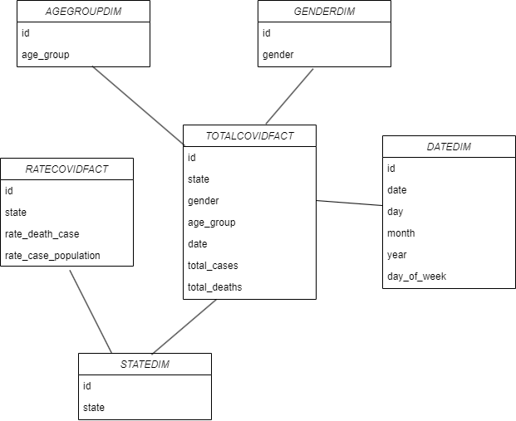
4. **Connect to athena and query data using python**  
     
   A screenshot of a computer program

   Description automatically generated with low confidence
5. **Create Dim and Fact**A screenshot of a computer program

   Description automatically generated with low confidence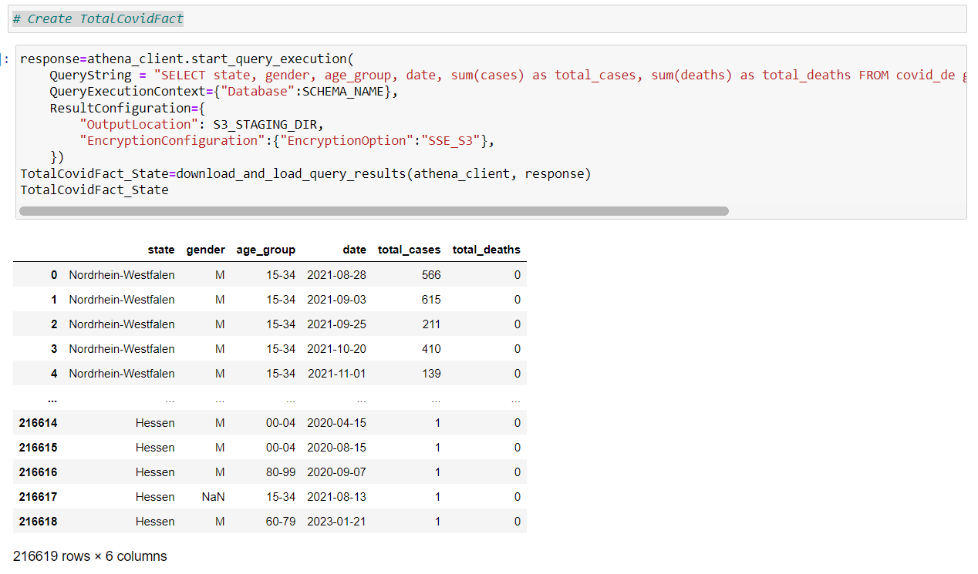
6. **Save data as *.csv into S3**A screenshot of a computer

   Description automatically generated with medium confidenceA screenshot of a computer

   Description automatically generated with medium confidence
7. **Connect Redshift using python**  
   A screenshot of a computer

   Description automatically generated with low confidence
8. **Create Data warehouse**A picture containing text, font, line, screenshot

   Description automatically generated
9. **Copy data from S3 into DW**  
     
   A close-up of a white card

   Description automatically generated with low confidence
10. **Query on AWS RedShift**A screenshot of a computer

    Description automatically generated with medium confidence