PROJECT AIRFLOW AWS CRYPTO API

Architect: Aiflow → S3 → Lambda → Glue → RedShift

Describe: Aiflow to get data from API and save data format json into S3 → Create lambda to automatically convert json to parquet and save into S3 and automatic crawler → Build ETL job to insert data from AWS Glue datacatalog to AWS RedShift

1. Get data from APIs and save in to S3 using Aiflow.
- URL: https://coinmap.org/api/v1/venues/
- Script dag
- Run Airflow
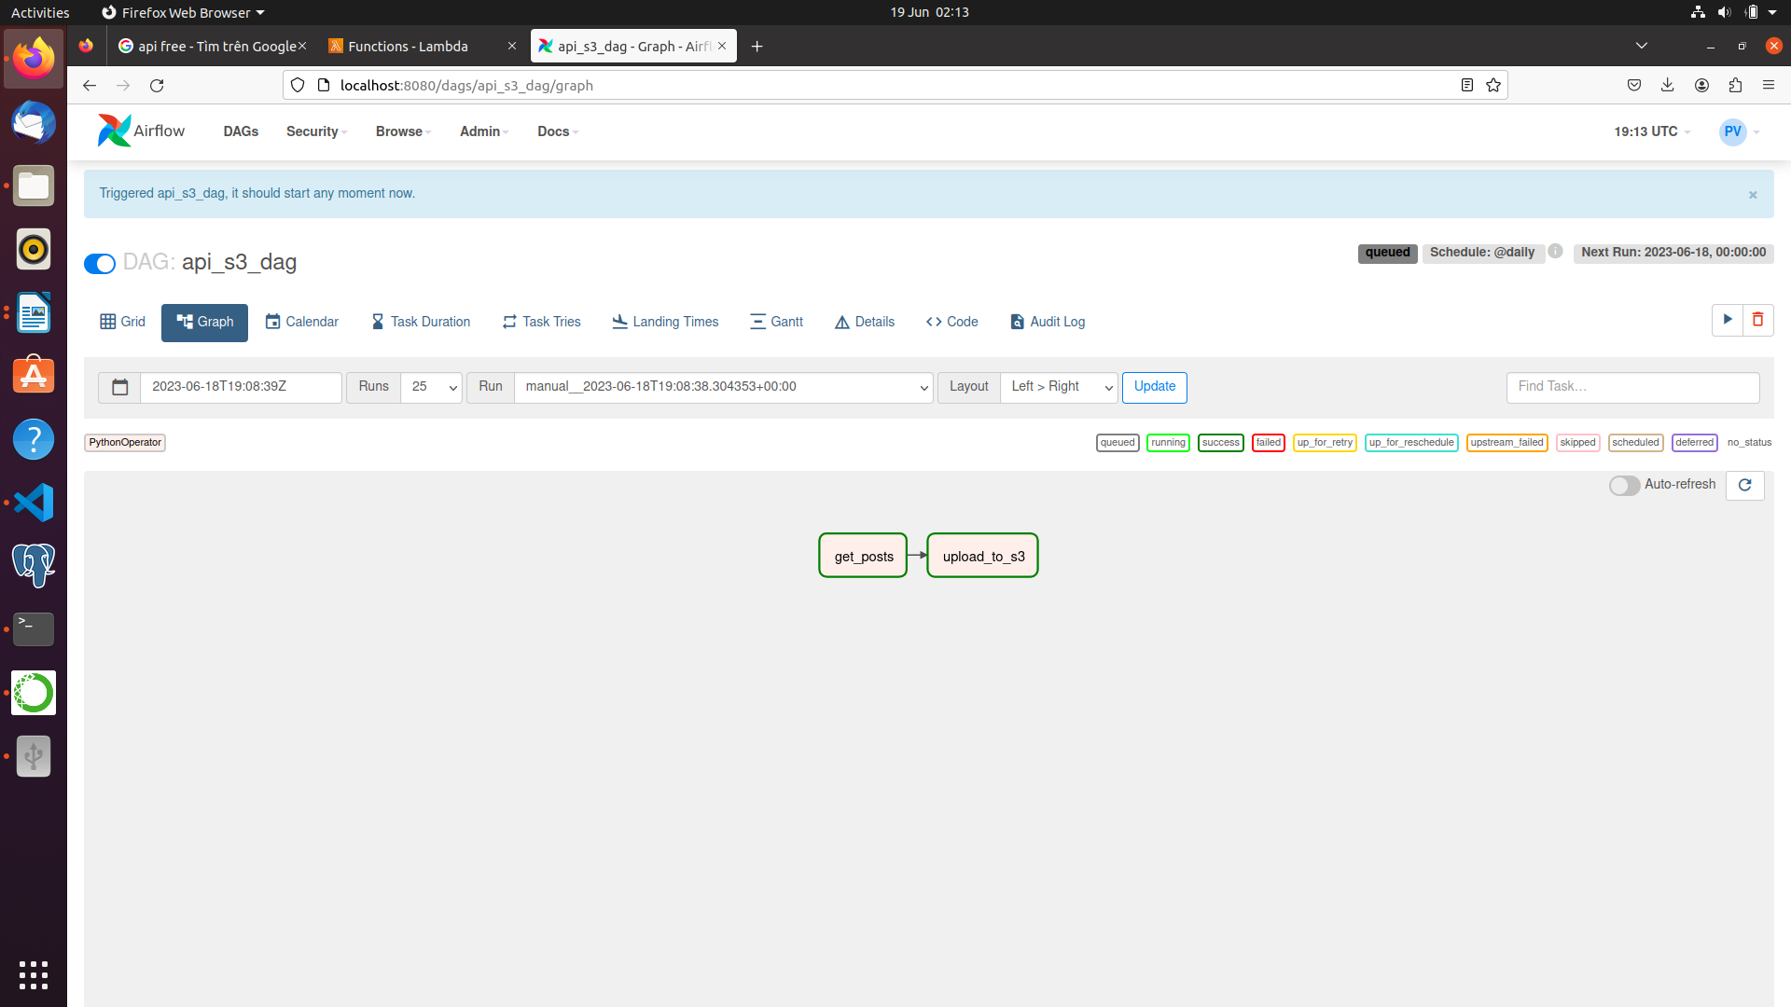
- Data in S3:
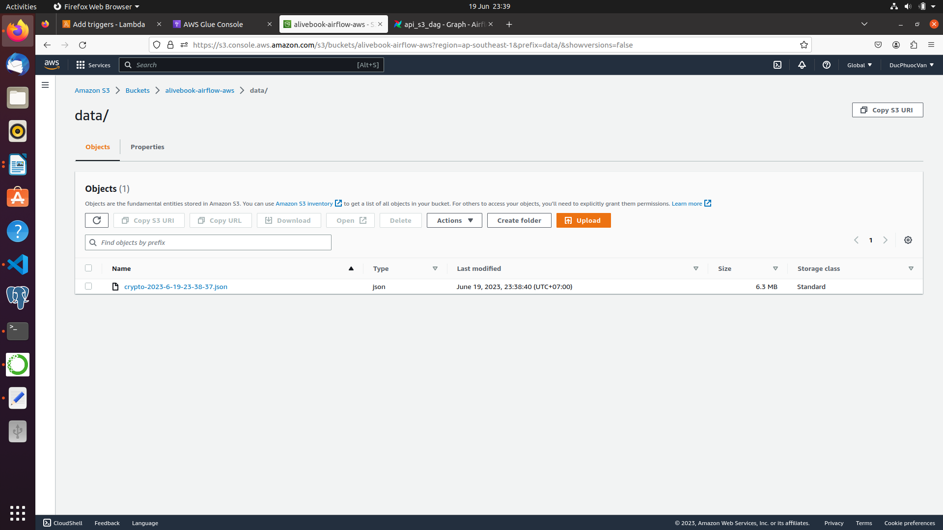

2. Create lambda to automatically convert json to parquet and save into S3.

- Lambda
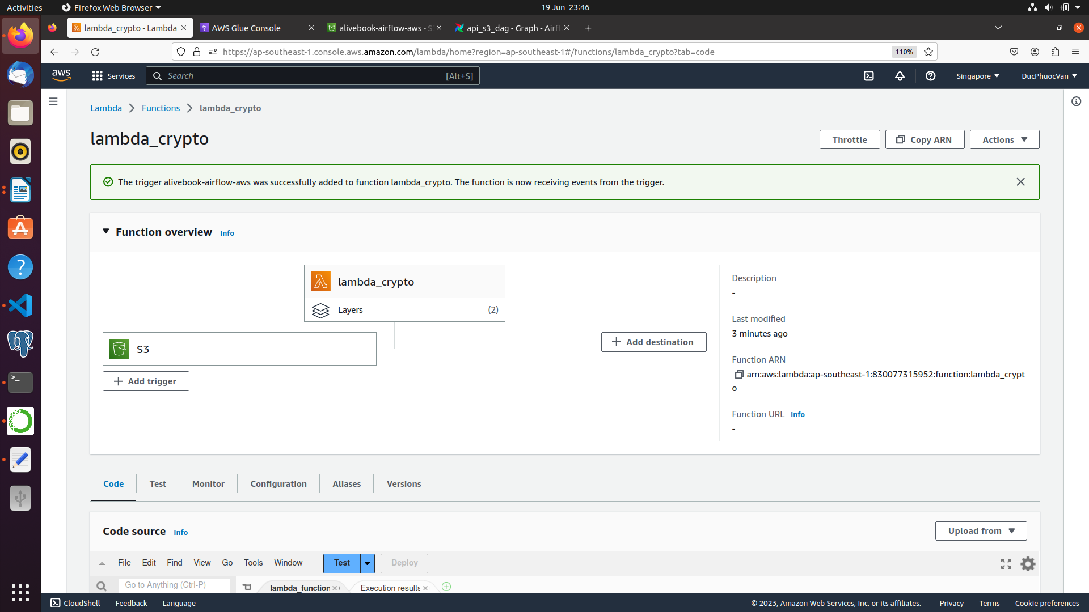
- Run airflow again
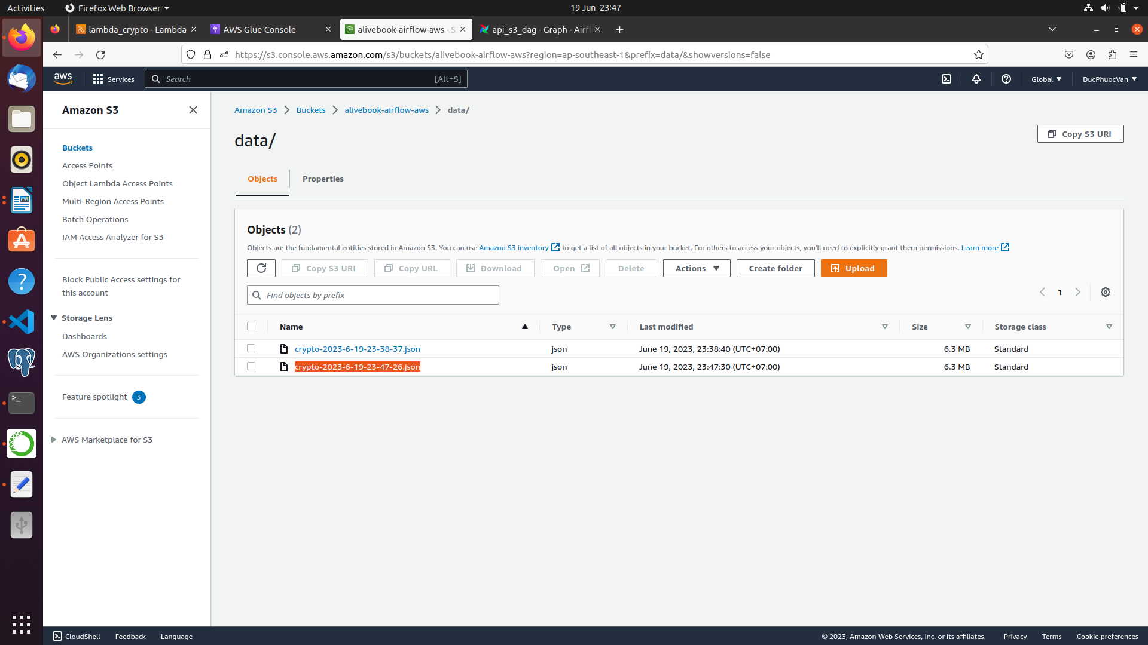
- S3/data_clean after run airflow again
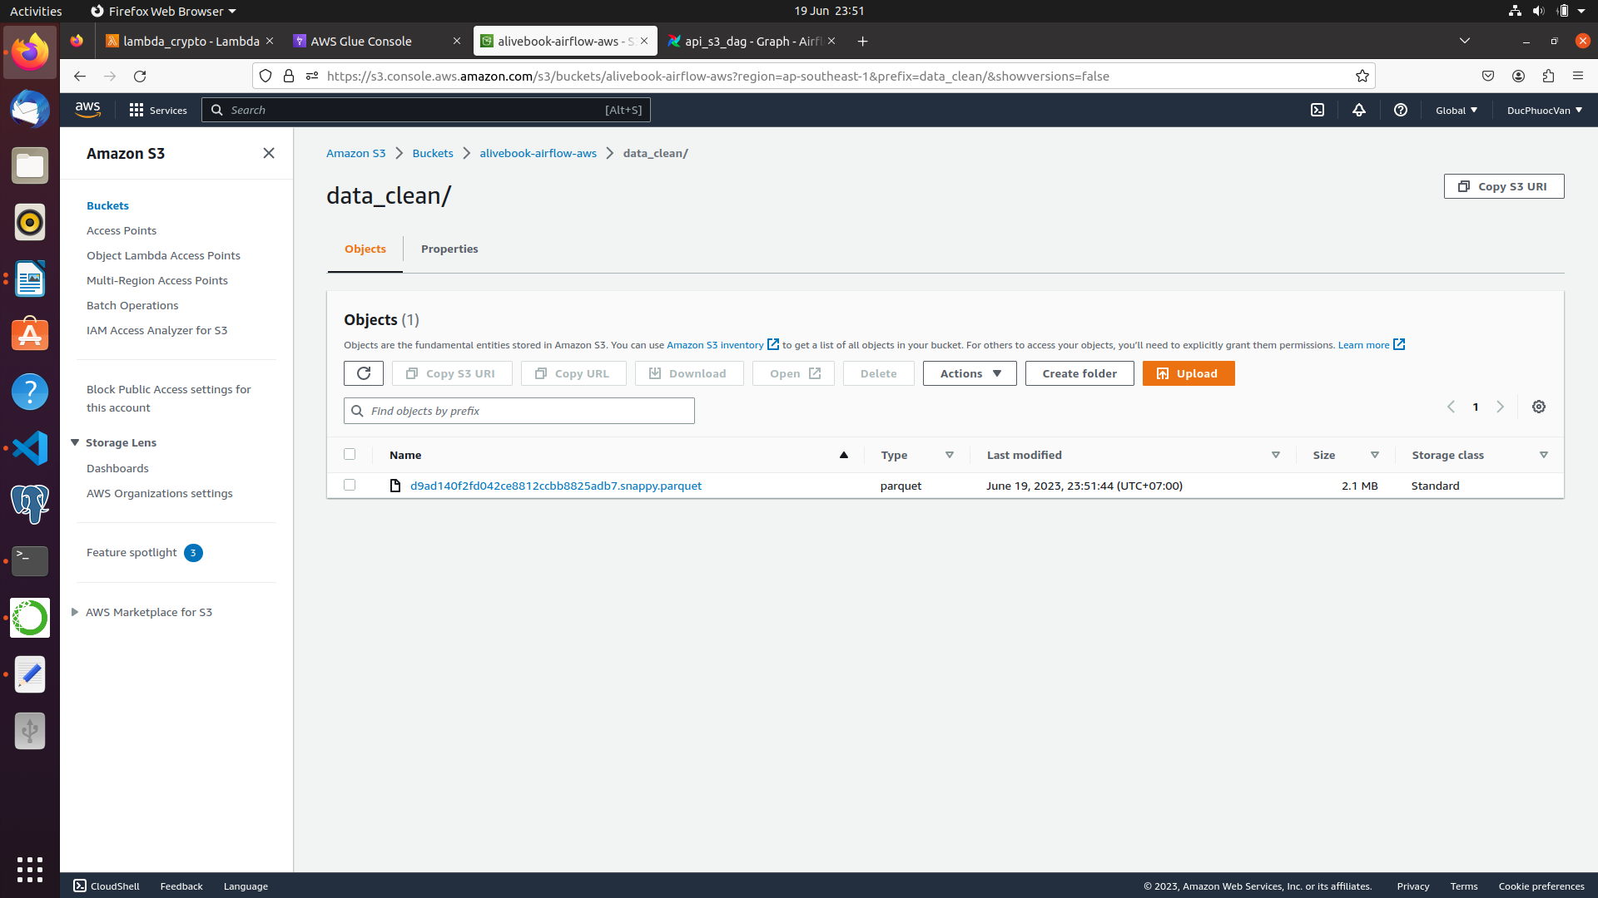
- Automatically crawler

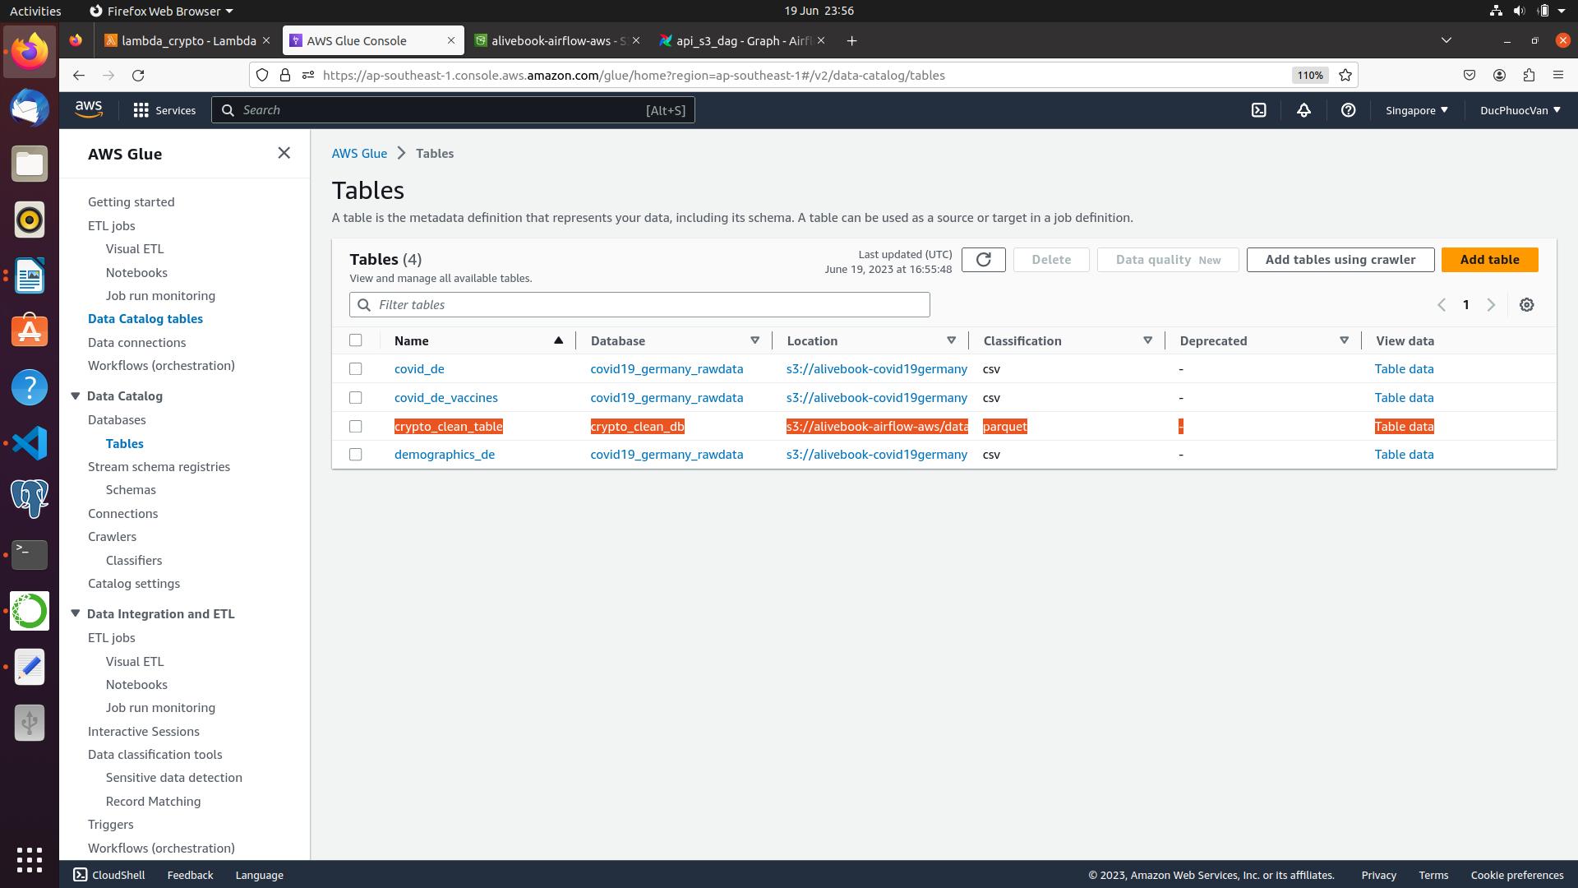
- Using AWS Athena to query

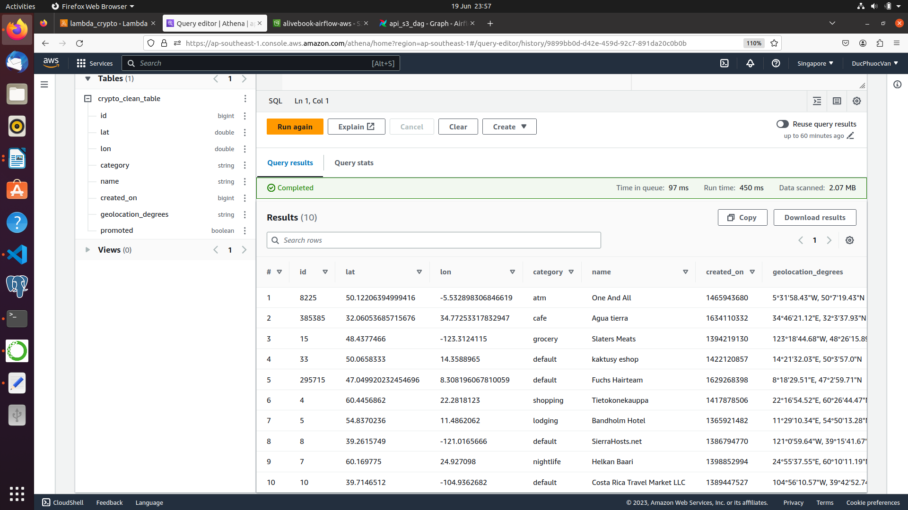
3. Build ETL job to insert data from AWS Glue datacatalog to AWS RedShift
- Build ETL job
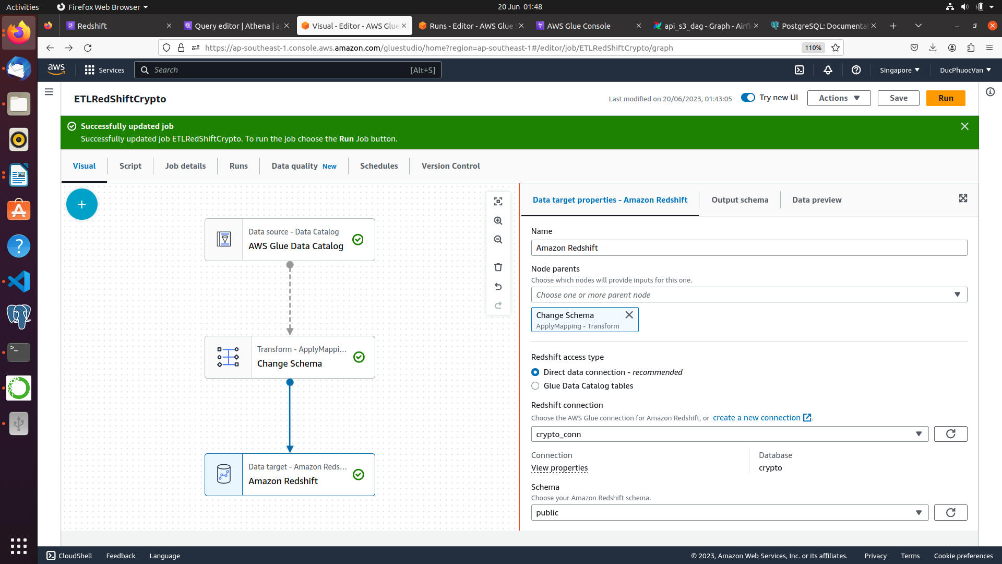
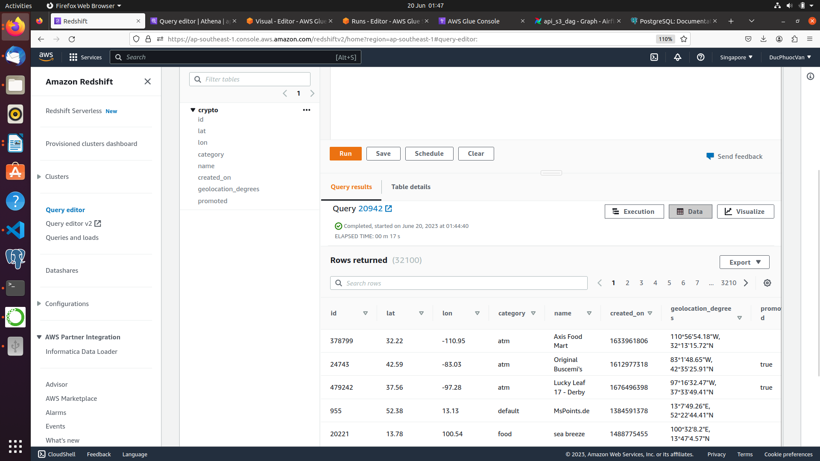
- Query on RedShift

