**University of Information Technology,**

**VietNam National University - Ho Chi Minh City**

-----🙚🙘🕮🙚🙘-----

**HOW TO USE HUMAN RESOURCE MANAGEMENT SOFTWARE**

**Class: SE104.PMCL.L22**

**GROUP 1**

19522166 Trần Đức Tâm

19522074 Cao Nguyễn Minh Quân

19522131 Đặng Hải Hoàng Sơn

19522408 Hoàng Quốc Trọng

**TPHCM, 6/2021**

Category

1 Purpose 3

2 Overview 3

3 Guide 4

3.1 Setting database server 4

3.1.1 Setting Database in Microsoft SQL Server Management 4

3.1.2 Setting Enitites Data Model in Visual Studio 4

3.2 The Login screen 7

3.3 The Employee Screen 8

3.3.1 Information Tab 8

3.3.2 Timekeeping Tab 9

3.3.3 Timekeeping Detailed 10

3.3.4 Salary Tab 11

3.4 The HR Dept Screen 12

3.4.1 Information Tab 12

3.4.2 Salary Tab 13

3.4.3 Home Tab 14

3.4.4 Manage Tab 15

3.4.5 New Employee Tab 16

3.4.6 Manage Detail Tab 19

3.4.7 Report Tab 22

3.4.8 Report Detail Tab 23

3.4.9 Timekeeping Tab 24

3.5 The Accounting Screen 26

3.5.1 Information Tab 26

3.5.2 Timekeeping Tab 27

3.5.3 Timekeeping Detailed 28

3.5.4 Salary Tab 29

3.5.5 Home Tab 30

3.5.6 Report Tab 31

3.5.7 Report Detail Tab 32

3.6 The Director Screen 33

3.6.1 Information Tab 33

3.6.2 Timekeeping Tab 34

3.6.3 Timekeeping Detailed 35

3.6.4 Salary Tab 36

3.6.5 Human Resource Tab 37

3.6.6 Accounting Tab 38

# Purpose

* The purpose of this document is to provide a comprehensive guide to use our software. This guide is built specifically to the one who will be using this software.

# Overview

* In this section, we will give an overview for our system UI so that users will familiarize themselves with the software.
* Our software has five screens include Login, HR Dept, Accounting Dept, Director Dept, Employee. Each screen except Login is designed specifically for each role.
* In this document, we will give each screen a guide as how to use and what user can do in our software.

# Guide

## Setting database server

### Setting Database in Microsoft SQL Server Management

* In this software, we use Microsoft SQL Server Management Studio for the data storage, so you should set up the server with the similar database as ours.
* Before opening the software, we recommend that you should setup the server as following:
* Import the hrms.db into Microsoft SQL Server Management Studio.

### Setting Enitites Data Model in Visual Studio

* Add database into Visual Studio by Create new item.

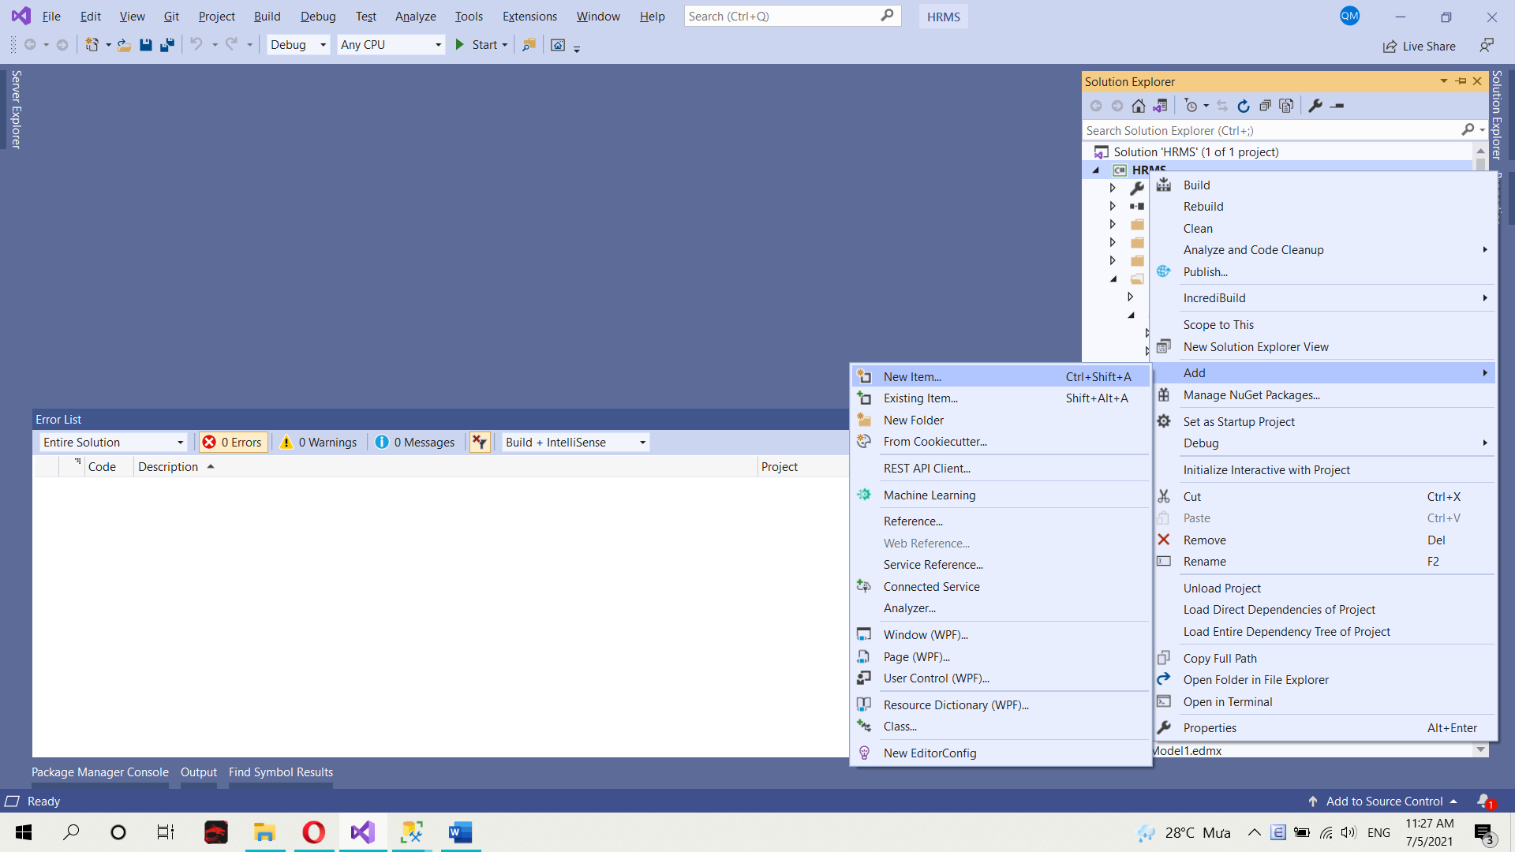

* Choose Data in Visual C# 🡪 ADO.NET Entity Data Model 🡪 Add 🡪 Show Entity Data Model Wizard.

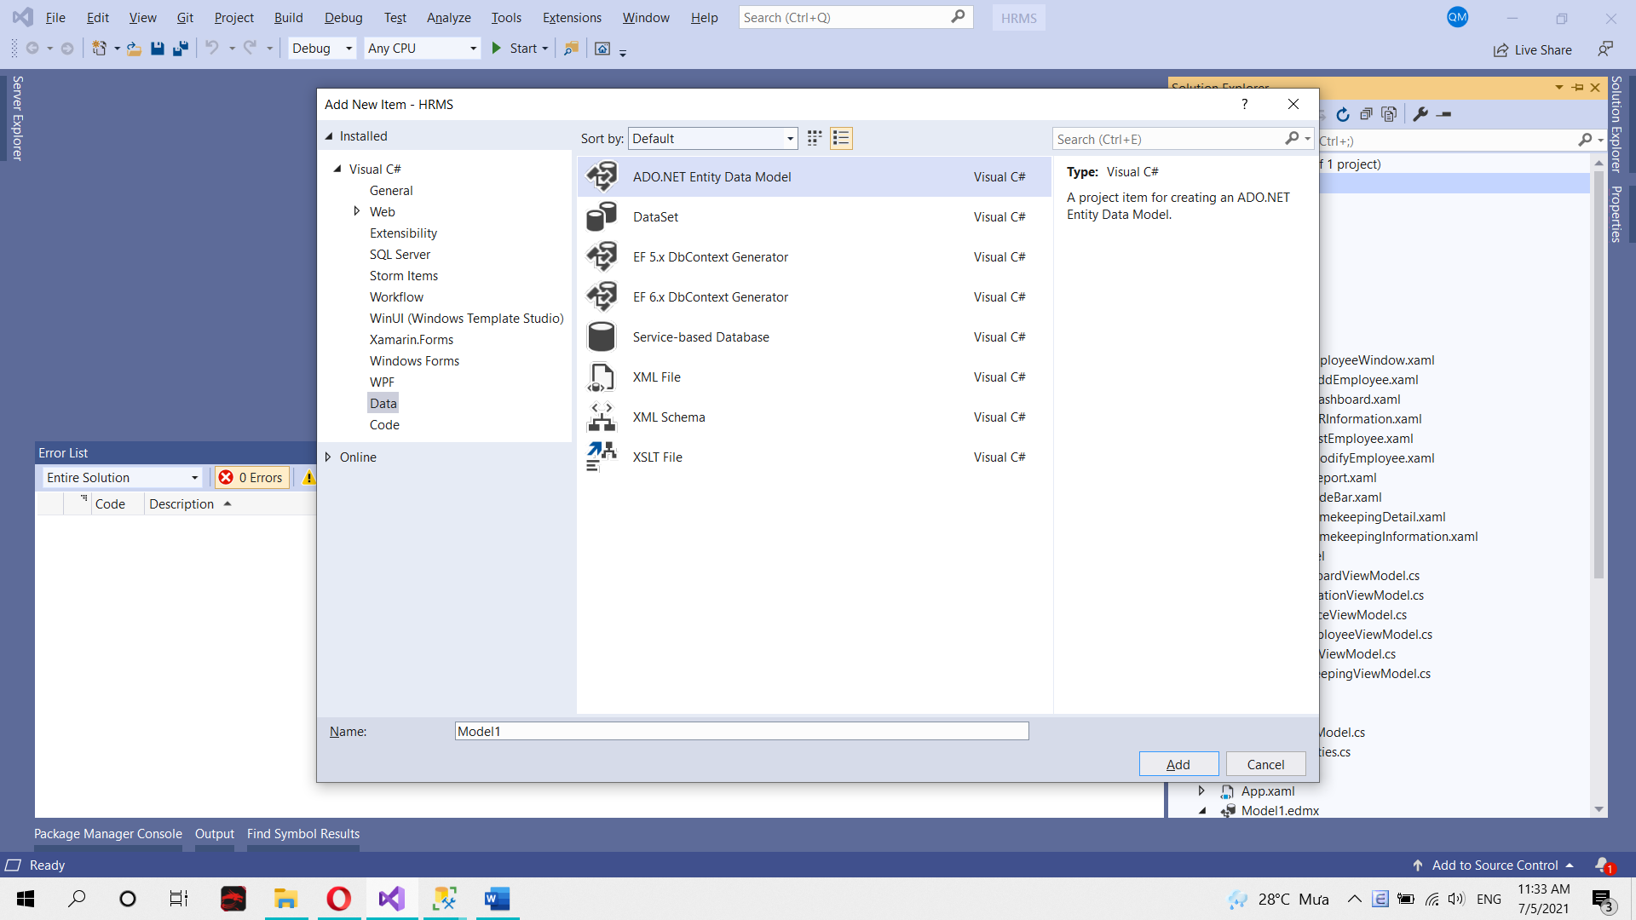

* In Entity Data Model Wizard, choose EF Designer from database 🡪 Click Next.

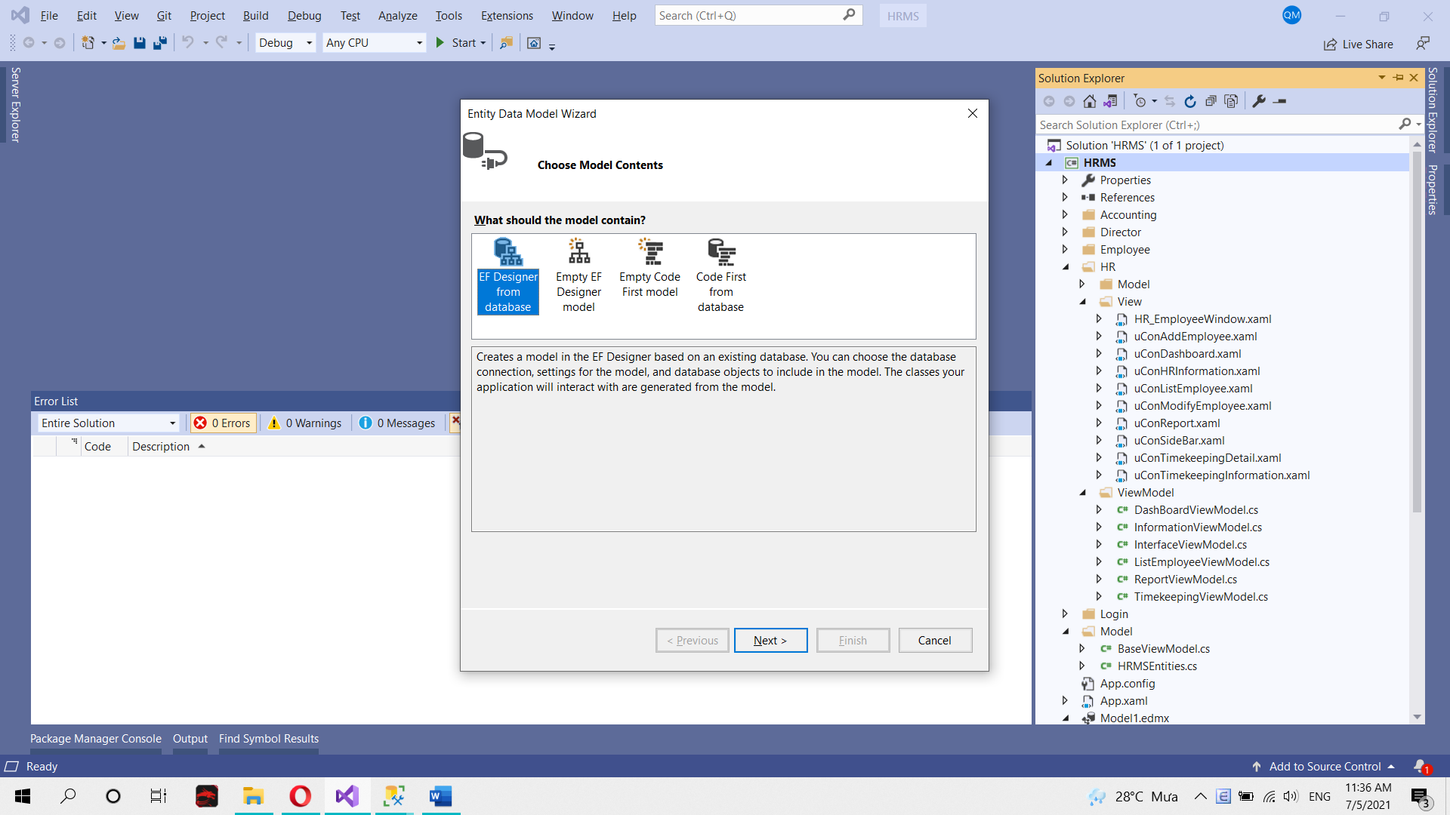

* After click Next, you will see like below image 🡪 click New Connection 🡪 Enter Server Name like Server Name in Microsoft SQL Server Management and choose database name is hrms 🡪 Click OK.

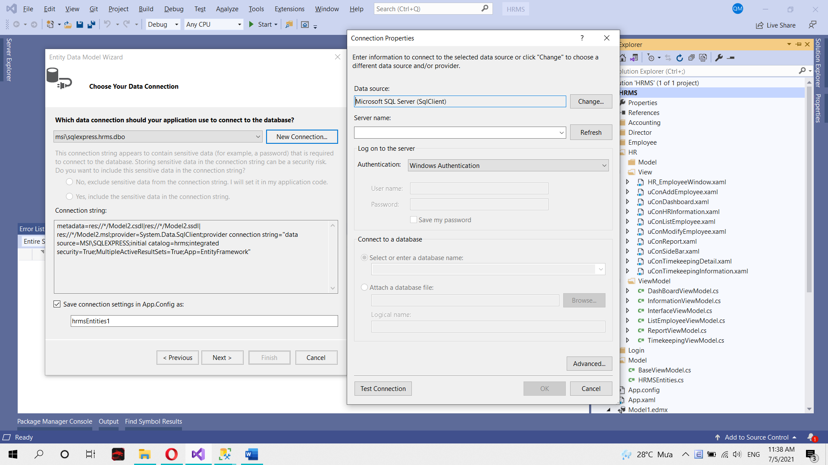

* After that you click Next 🡪 Click in Table Checkbox 🡪 Click Finish.

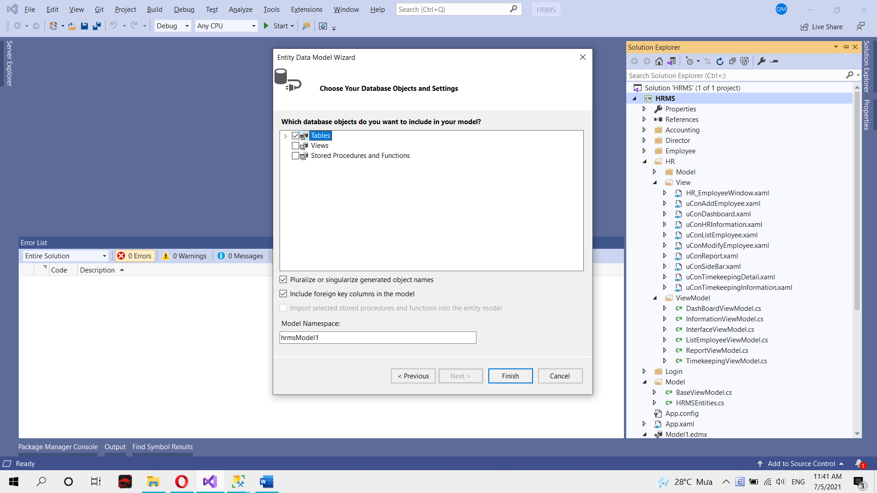

* That is all for prepare database before testing.

## The Login screen

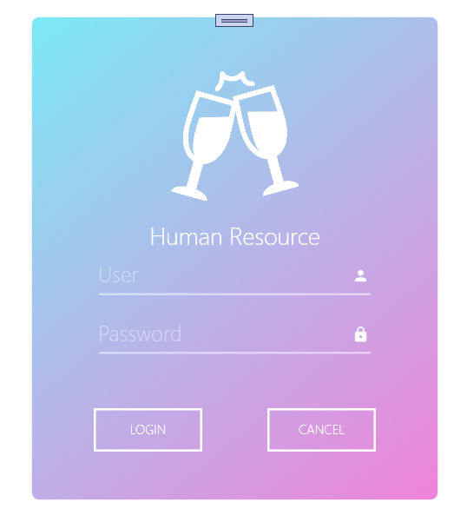

* To start the software, click the HRMS.snl inside the HRMS folder.
* In the login screen, you will see two text box: User and Password. If you have an account, please type your User and Password into two textbox. You will be directed to your home screen if everything is correct. If you enter wrong User or Password, you might encounter “Wrong User or Password” message.

## The Employee Screen

* This is the overall screen in our software, and all employee will see this screen include HR Dept, Accounting Dept and Director Dept. However, in other role, that screen has little change so that it is suitable for each role.

### Information Tab

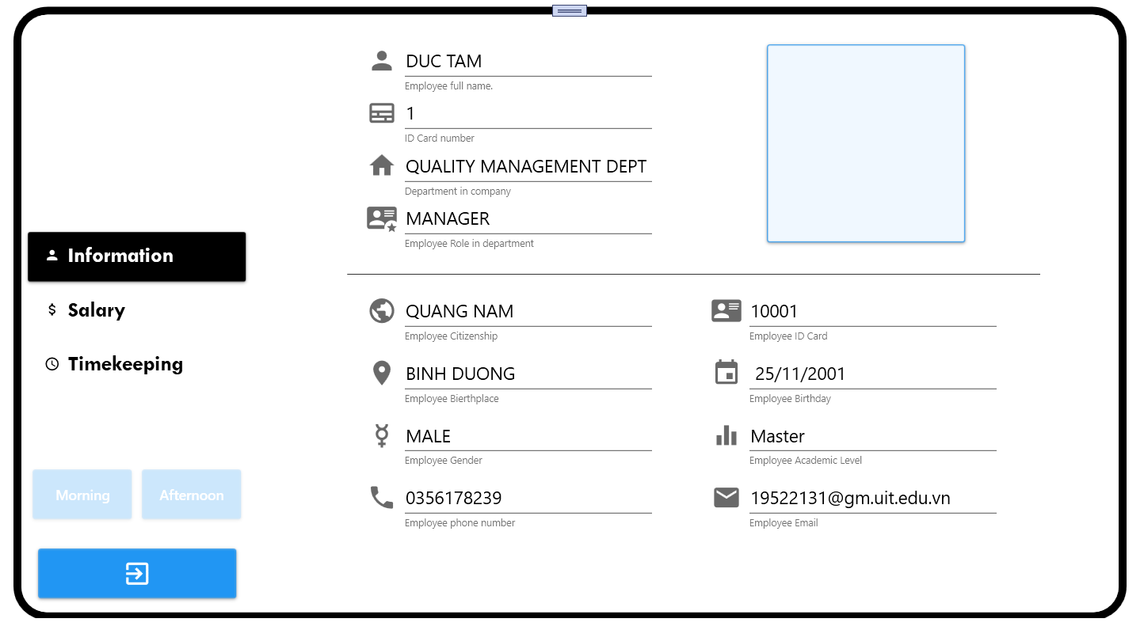

* The purpose of this tab is showing information of user include ID, name, department name, role, citizenship, birthplace, gender, phone number, ID card, birthday, academic level and email.
* User can click close button if user want to quit this software.

### Timekeeping Tab

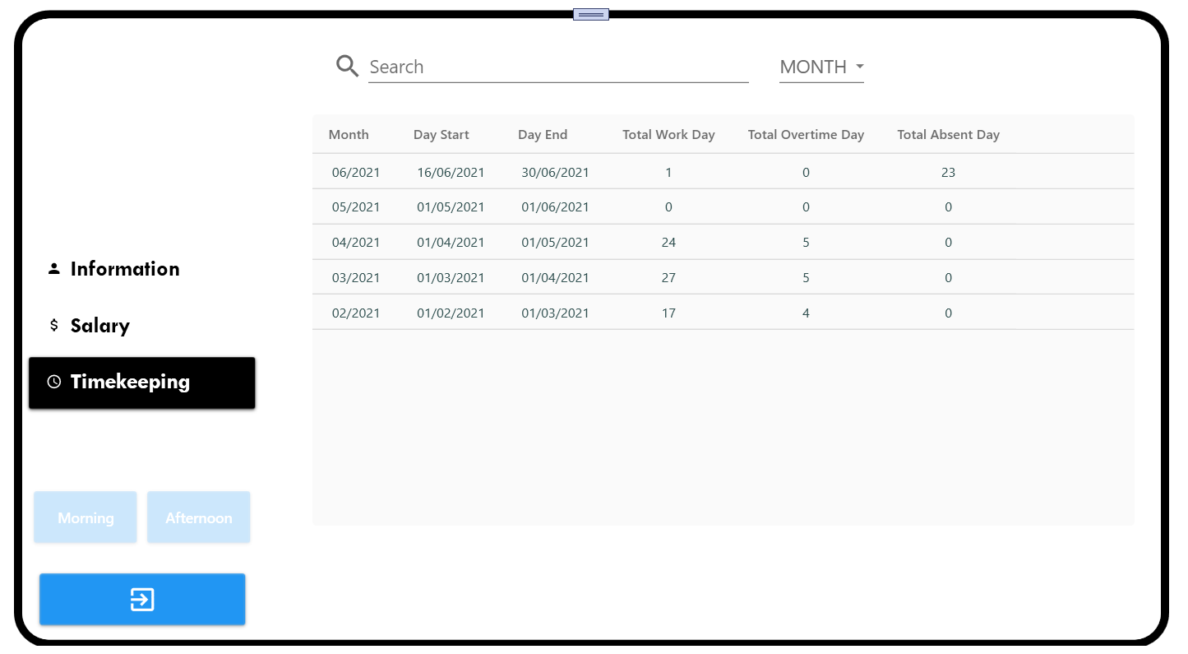

* The purpose of this tab is showing list timekeeping of user.
* User can see the month of timekeeping, day start and day end (it means the day start new month or the day user join into compony if User is new employee; the day end month), total work day, total absent day and total overtime day.
* User can check attendant by click into button name Morning or Afternoon (the button enable after user click that means user checked attendance or the time user check attendance is not the button time).

+ Morning button is able at 7:00 AM to 11:00 AM

+ Afternoon button is able at 1:00 PM to 5:00 PM

* User can search in textbox by any attribute that user choose in combobox.
* If User click into one of these rows, User will see the Timekeeping Detailed.

### Timekeeping Detailed

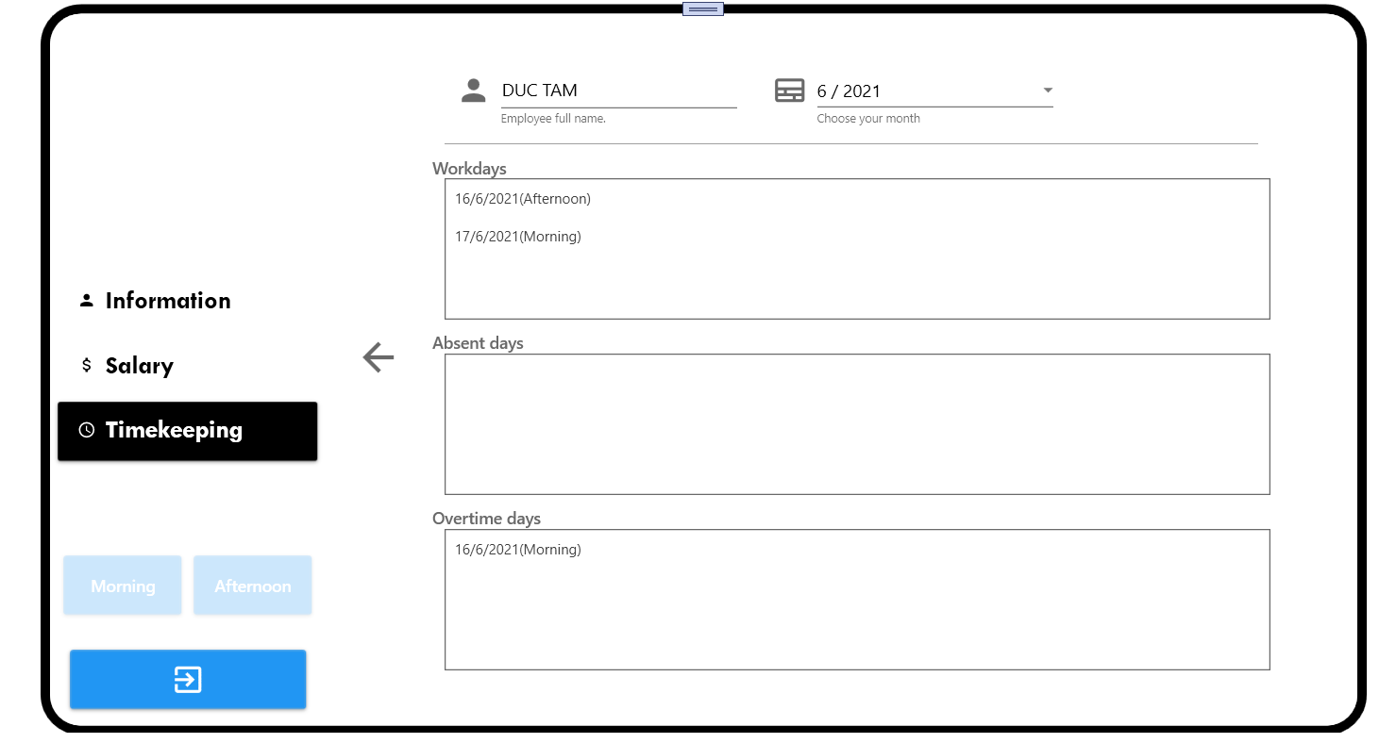

* The purpose of this tab is showing the Timekeeping Detailed of user.
* User can see his/her workdays, absent days and overtime days of the month that user choose in combobox.
* User can click Back button to back to Timekeeping Tab.

### Salary Tab

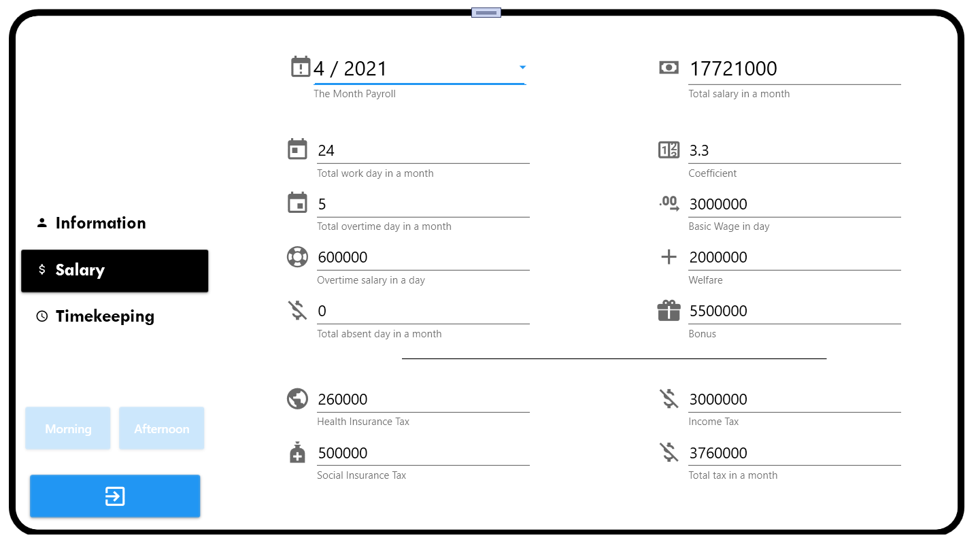

* The purpose of this tab is showing the Salary Report of user include total salary, total workdays, total overtime days, total absent days, coefficient, basic wage, overtime salary, welfare, bonus, health insurance, social insurance and tax.
* User can choose month in combobox to see salary report of that month.

## The HR Dept Screen

* This screen has all tab of Employee Screen and some specifically tab for HR Dept.

### Information Tab

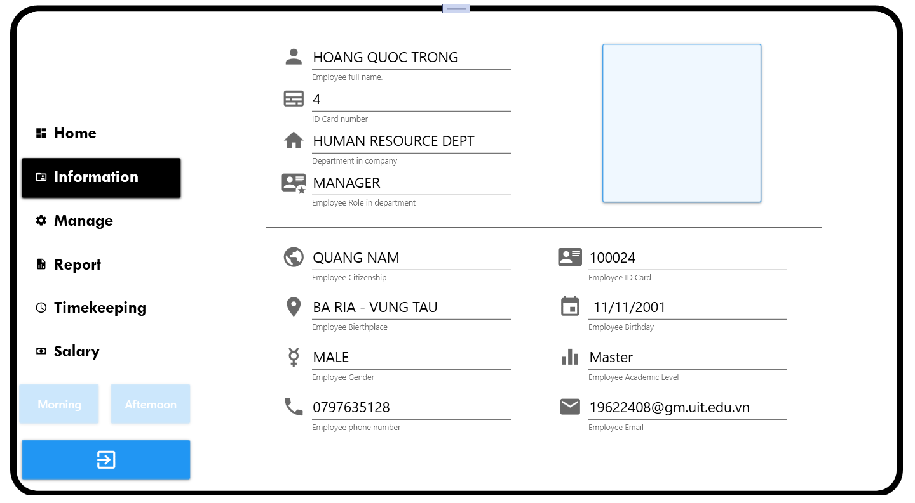

* The purpose of this tab is showing information of user include ID, name, department name, role, citizenship, birthplace, gender, phone number, ID card, birthday, academic level and email.
* User can click close button if user want to quit this software.

### Salary Tab

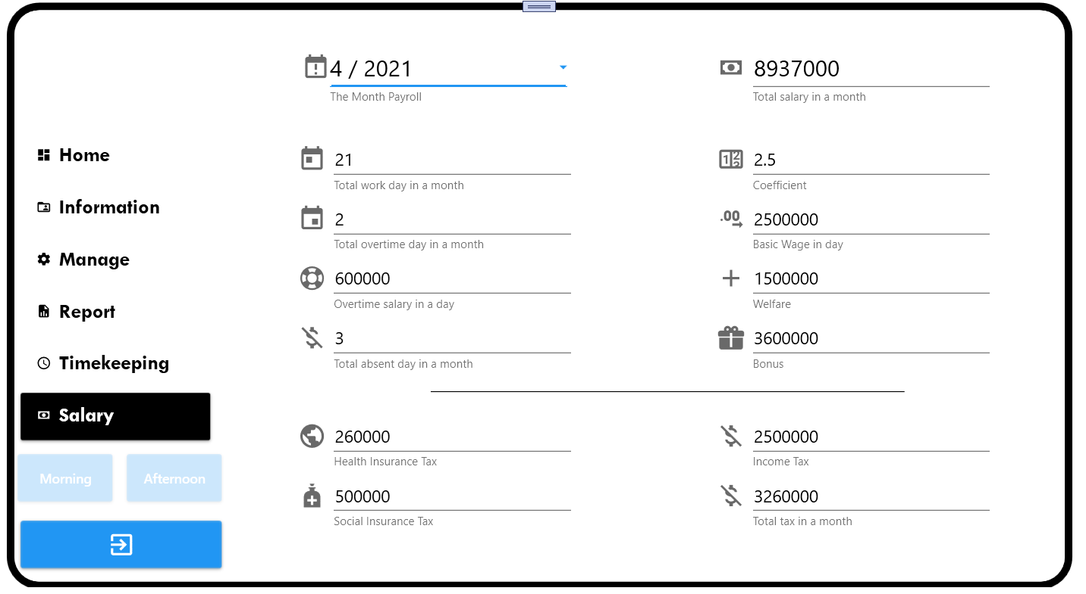

* The purpose of this tab is showing the Salary Report of user include total salary, total workdays, total overtime days, total absent days, coefficient, basic wage, overtime salary, welfare, bonus, health insurance, social insurance and tax.
* User can choose month in combobox to see salary report of that month.

### Home Tab

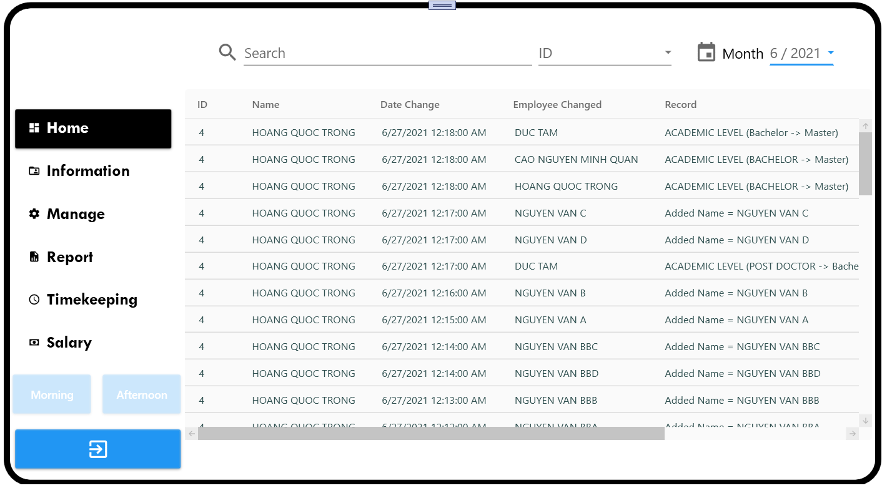

* The purpose of this tab is showing for user the record history. User can see who change or update employee salary, and what attribute they update pr change.
* User can choose month in combobox month to see the history record of that month.
* User can search in textbox to find information which user wanted.

### Manage Tab

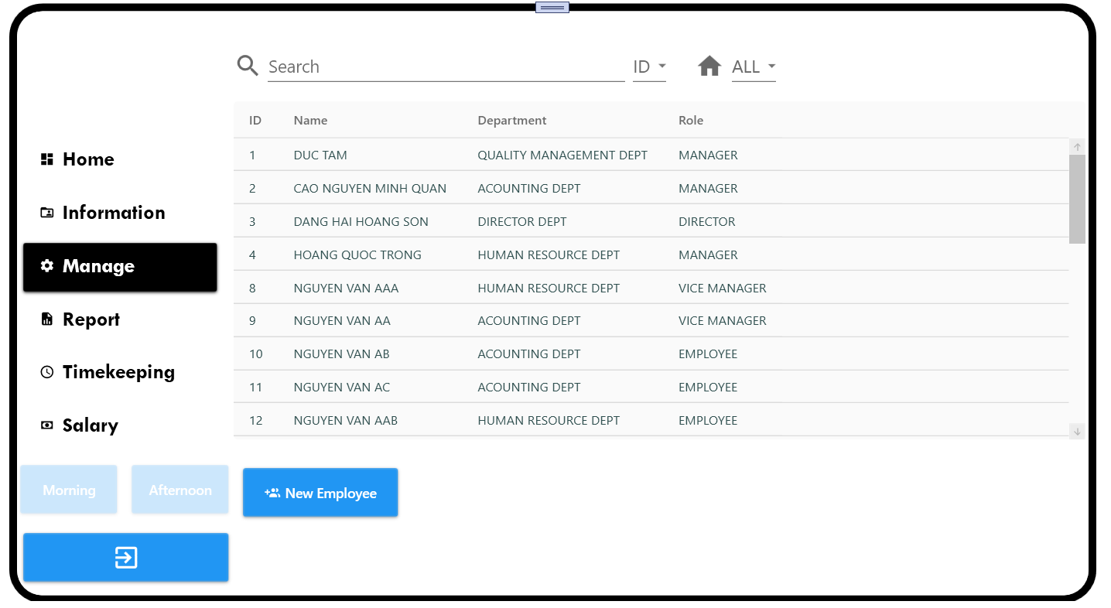

* The purpose of this tab is manage the Employee List of the company include ID, Name, Department, Role.
* User can search in textbox by attribute in combobox beside (ID, Name, Department, Role). User can choose Department in combobox Department to filter list by department.
* User can click to New Employee Button to add new Employee.
* User can click into one row in datagrid to show the detail of this employee.

### New Employee Tab

#### Information Tab

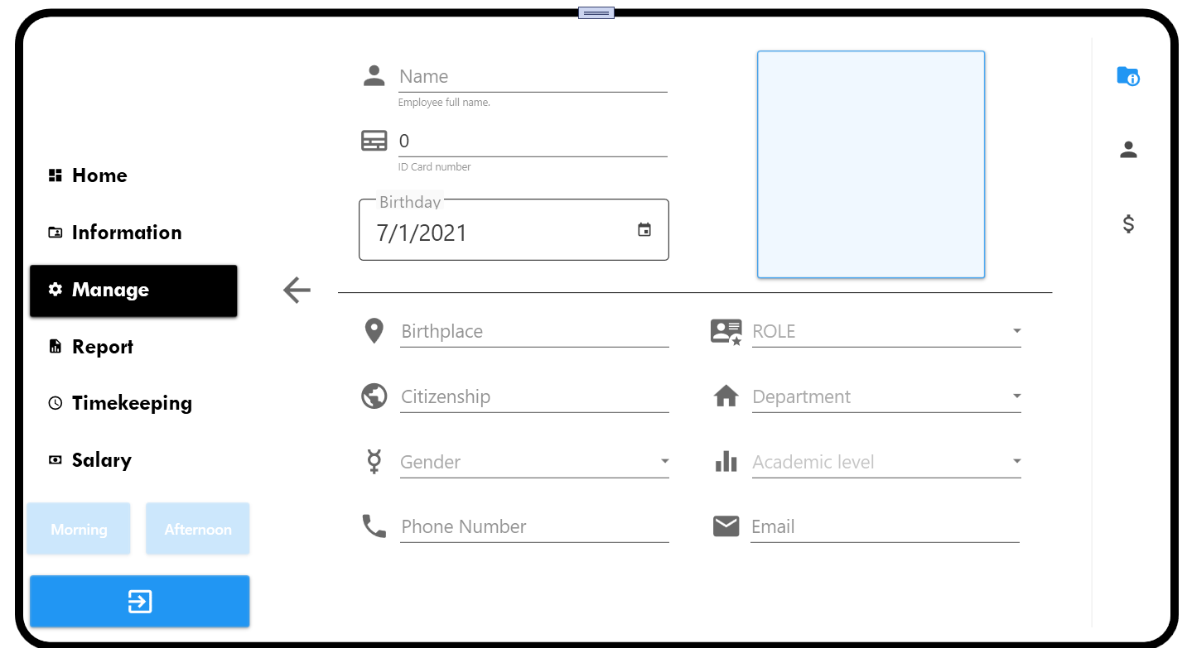

* The purpose of this tab is create new employee.
* User will fill all information include Name, ID Card, Birthday, Birthplace, Role, Citizenship, Department, Gender, Academic Level, Phone Number, Email, Image into these textbox and combobox.
* User can click Back Button to return Manage Tab.

#### User Tab

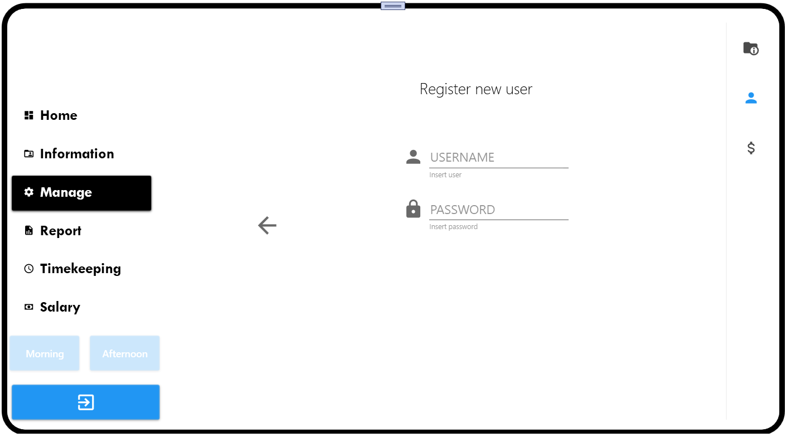

* The purpose of this tab is create new account for employee.
* User will fill all information include Username and Password into these textbox.
* User can click Back Button to return Manage Tab.

#### Salary Init Tab

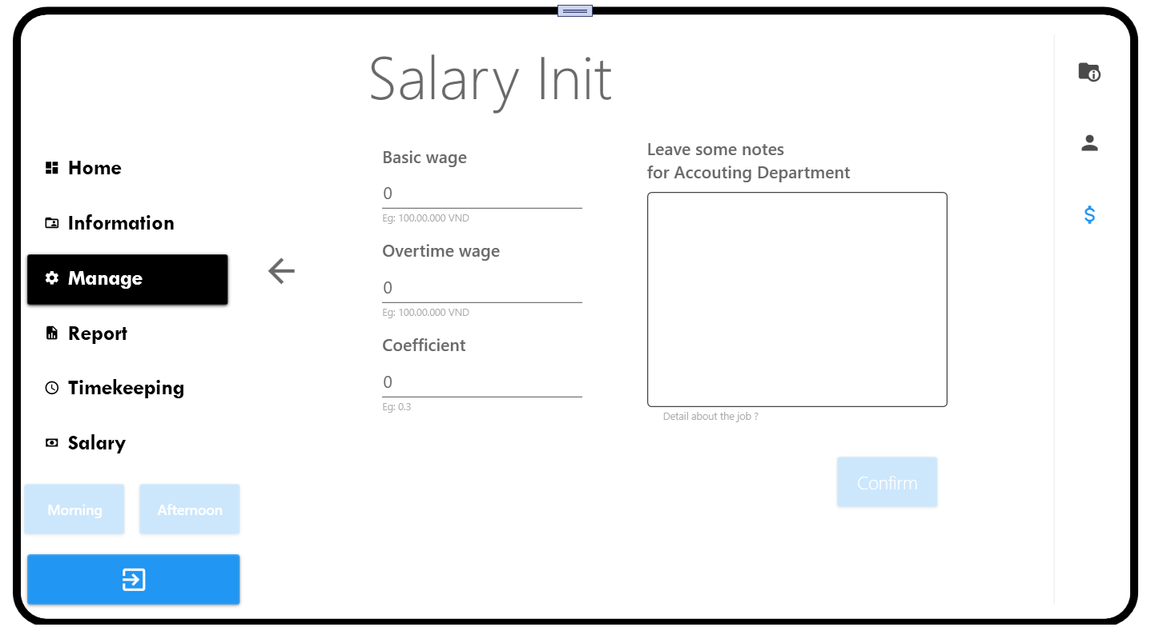

* The purpose of this tab is create default salary information for employee.
* User will fill all information include Basic Wage, Overtime Wage, Coefficient, Note into these textbox.
* User can click Back Button to return Manage Tab.
* User click Confirm Button to save all information above to database, user will encounter the “Success” Message if create success.

### Manage Detail Tab

#### Information Tab

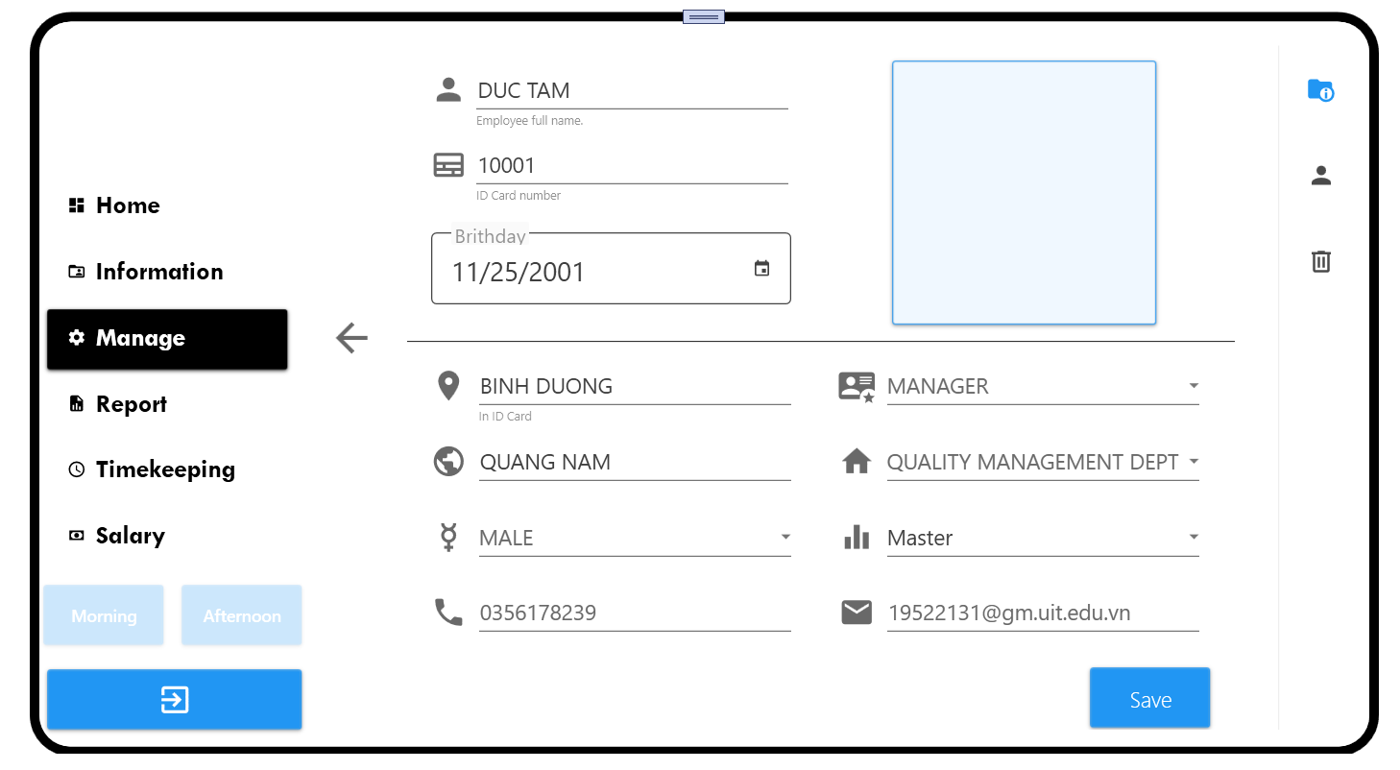

* The purpose of this tab is update employee.
* User will update information of employee include Name, ID Card, Birthday, Birthplace, Role, Citizenship, Department, Gender, Academic Level, Phone Number, Email, Image into these textbox and combobox.
* User can click Back Button to return Manage Tab.
* If user want to save the change then click Save Button and user encounter the “Success” message. The change will be updated in history record at Home tab.

#### User Tab

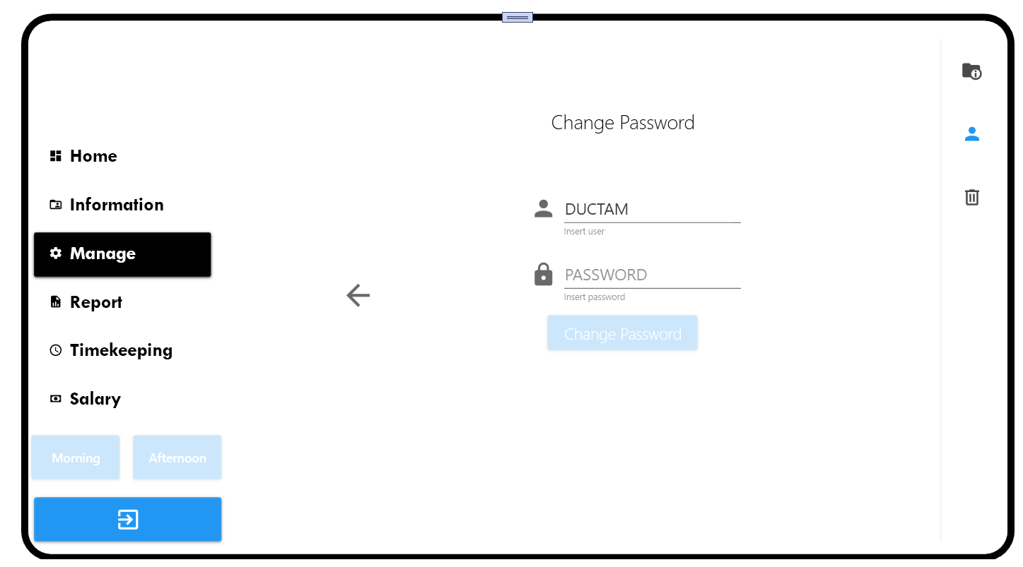

* The purpose of this tab is changing password of employee.
* User can change password by enter new password and click Change Password Button. User will encounter “Success” message if Change Password success.
* User can click Back Button to return Manage Tab.

#### Delete Tab

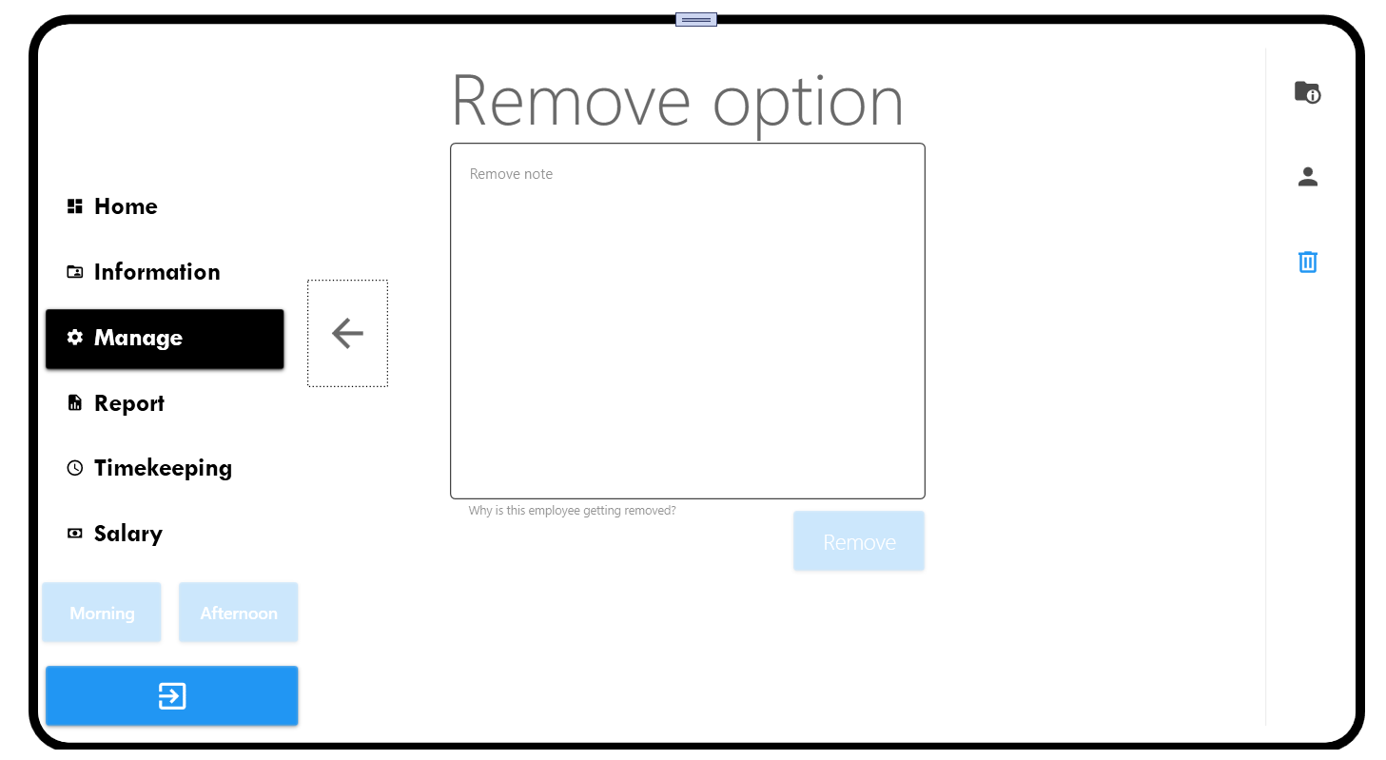

* The purpose of this tab is deleted employee.
* User can delete employee by enter note (optical) and click Remove button. If remove success, user will encounter “Success” message.
* User can click Back Button to return Manage Tab.

### Report Tab

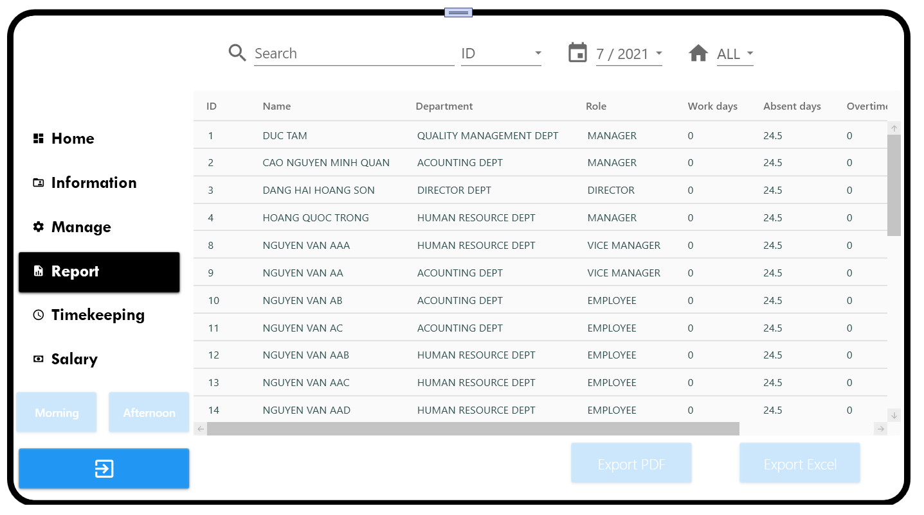

* The purpose of this tab is showing the Timekeeping List in the compony include ID, Name, Department, Role, Workdays, Absent days, Overtime days.
* User can search in textbox by attribute in combobox beside (ID, Name, Department, Role).
* User can choose Month in combobox month to filter list by month and choose Department in combobox Department to filter list by department.
* User can export this timekeeping list in PDF or Excel.
* User can click into one row in list to see the detail timekeeping report of this employee that user chooses.

### Report Detail Tab

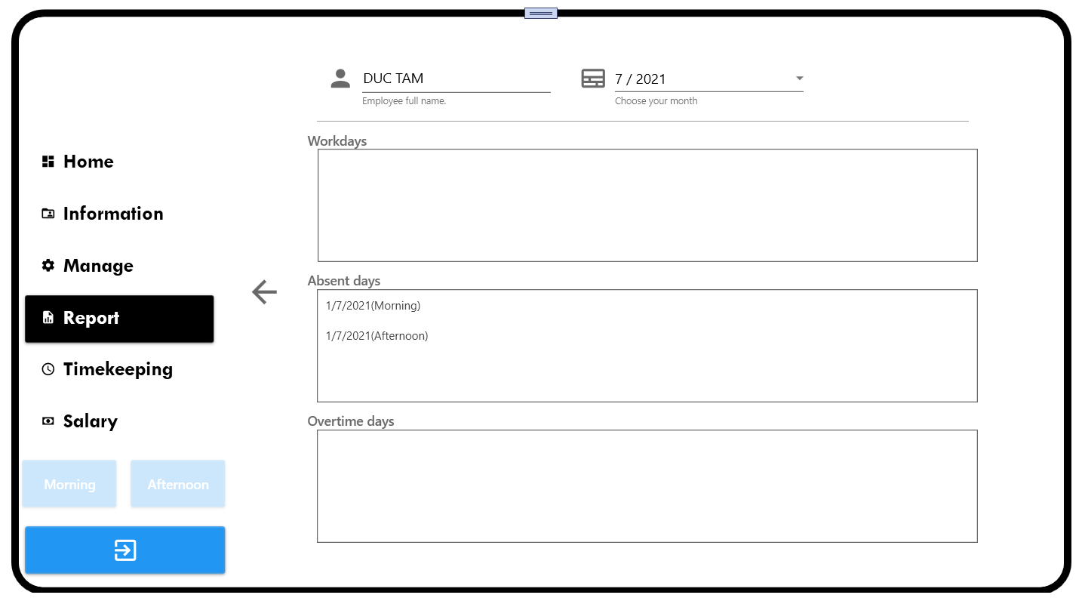

* The purpose of this tab is showing the Timekeeping Detailed of employee.
* User can see employee workdays, absent days and overtime days of the month that user choose in combobox.
* User can click Back button to back to Report Tab.

### Timekeeping Tab

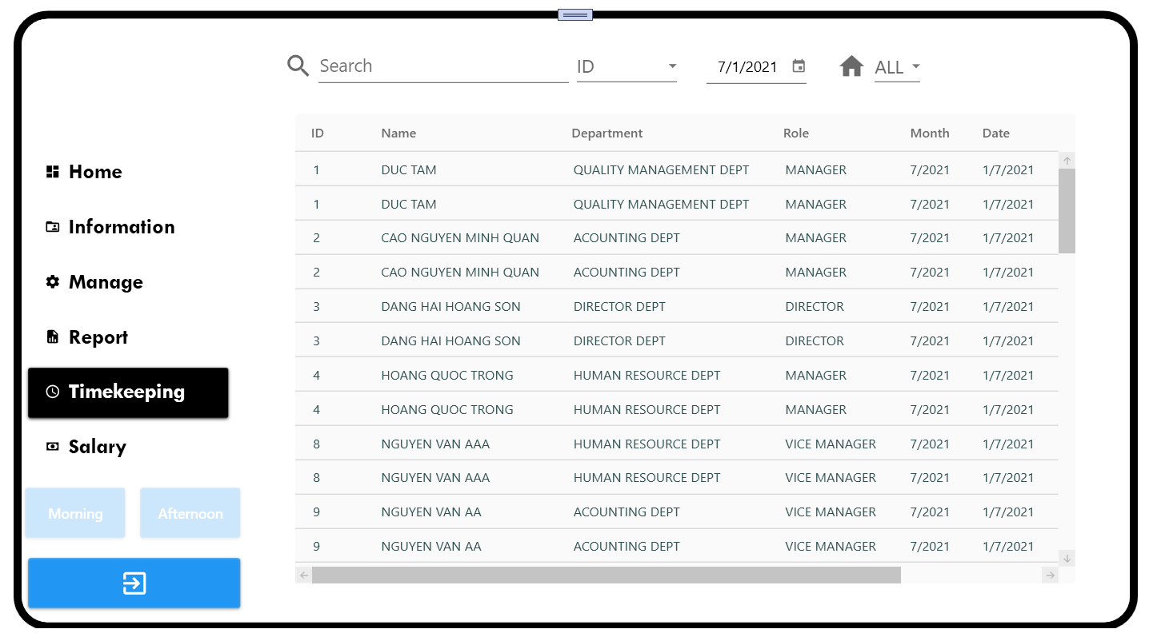

* The purpose of this tab is showing list timekeeping in the company.
* User can see ID employee, Name employee, Department employee, Role employee, the month of timekeeping, day start and day end (it means the day start new month or the day user join into compony if User is new employee; the day end month), total work day, total absent day and total overtime day.
* User can search in textbox by attribute in combobox beside (ID, Name, Department, Role).
* User can choose Month in combobox month to filter list by month and choose Department in combobox Department to filter list by department.
* User can check attendant by click into button name Morning or Afternoon (the button enable after user click that means user checked attendance or the time user check attendance is not the button time).

+ Morning button is able at 7:00 AM to 11:00 AM

+ Afternoon button is able at 1:00 PM to 5:00 PM

* User can search in textbox by any attribute that user choose in combobox.
* If user click into one of these rows, user will update the attendance of that employee.

## The Accounting Screen

* This screen has all tab of Employee Screen and some specifically tab for Accounting Dept.

### Information Tab

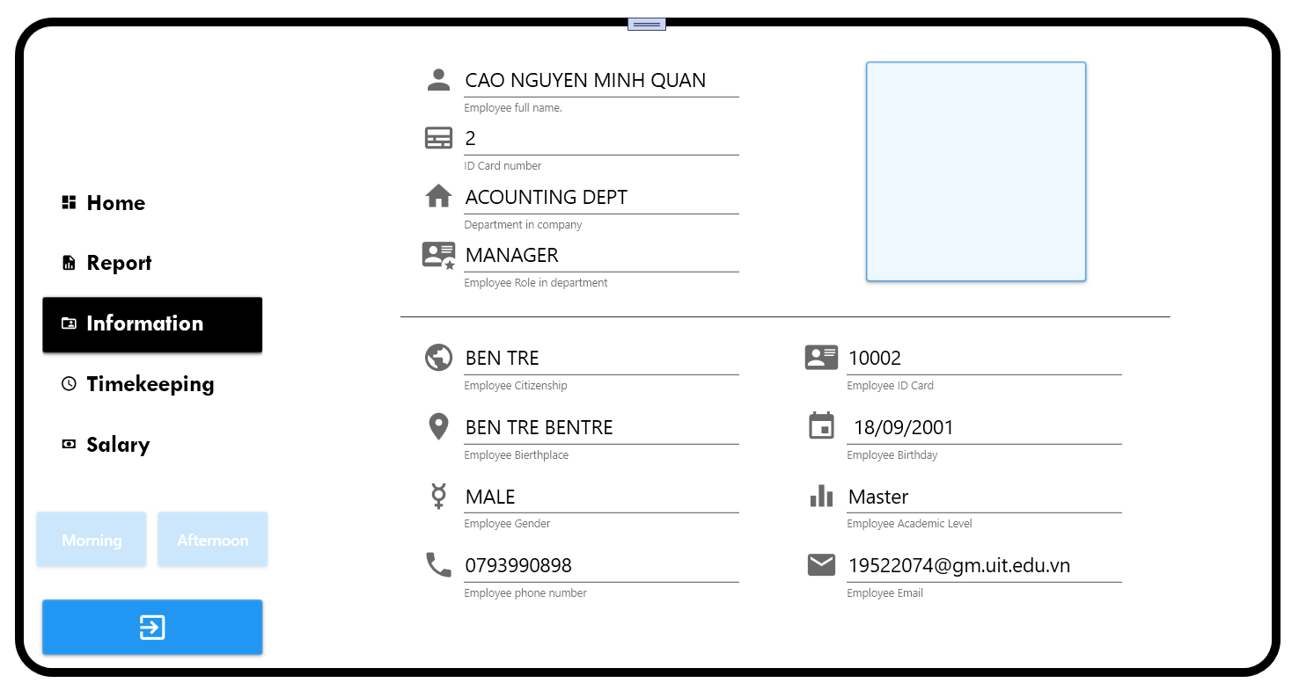

* The purpose of this tab is showing information of user include ID, name, department name, role, citizenship, birthplace, gender, phone number, ID card, birthday, academic level and email.
* User can click close button if user want to quit this software.

### Timekeeping Tab

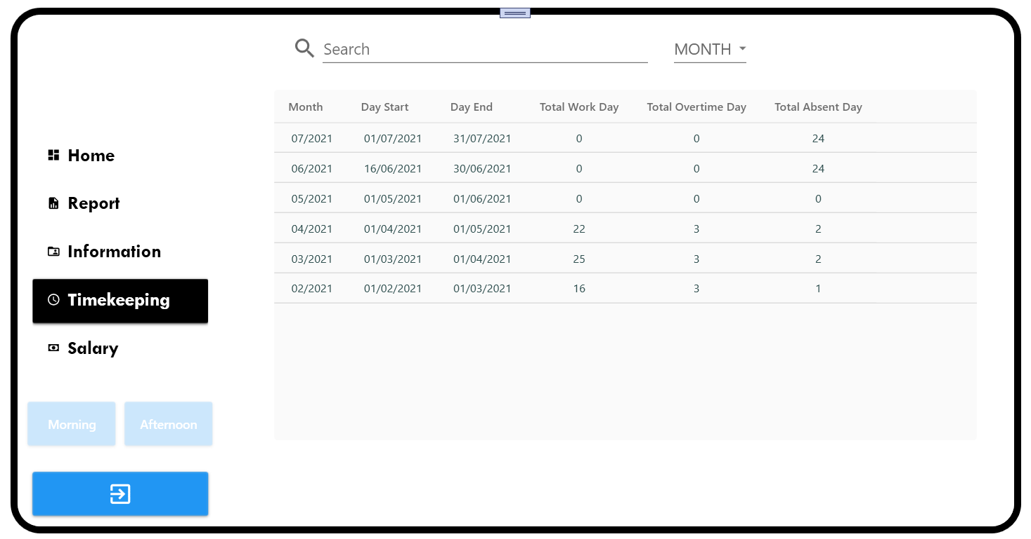

* The purpose of this tab is showing list timekeeping of user.
* User can see the month of timekeeping, day start and day end (it means the day start new month or the day user join into compony if User is new employee; the day end month), total work day, total absent day and total overtime day.
* User can check attendant by click into button name Morning or Afternoon (the button enable after user click that means user checked attendance or the time user check attendance is not the button time).

+ Morning button is able at 7:00 AM to 11:00 AM

+ Afternoon button is able at 1:00 PM to 5:00 PM

* User can search in textbox by any attribute that user choose in combobox.
* If User click into one of these rows, User will see the Timekeeping Detailed.

### Timekeeping Detailed

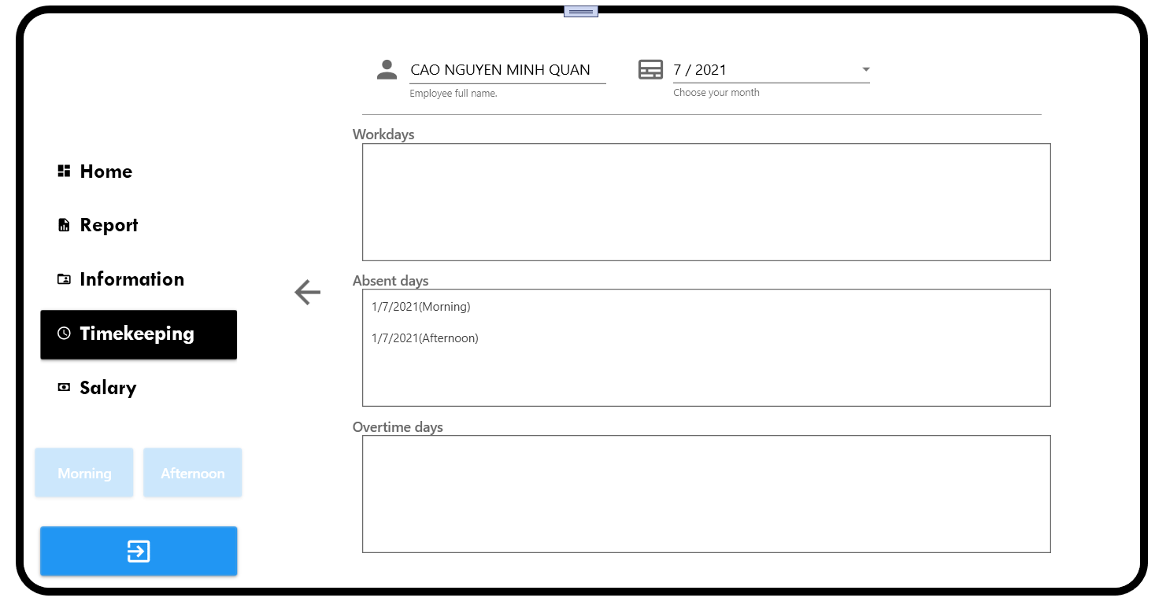

* The purpose of this tab is showing the Timekeeping Detailed of user.
* User can see his/her workdays, absent days and overtime days of the month that user choose in combobox.
* User can click Back button to back to Timekeeping Tab.

### Salary Tab

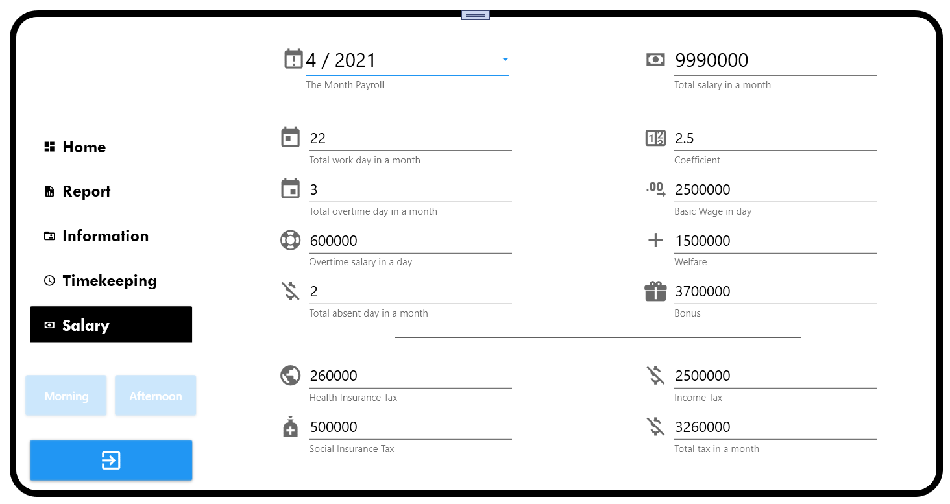

* The purpose of this tab is showing the Salary Report of user include total salary, total workdays, total overtime days, total absent days, coefficient, basic wage, overtime salary, welfare, bonus, health insurance, social insurance and tax.
* User can choose month in combobox to see salary report of that month.

### Home Tab

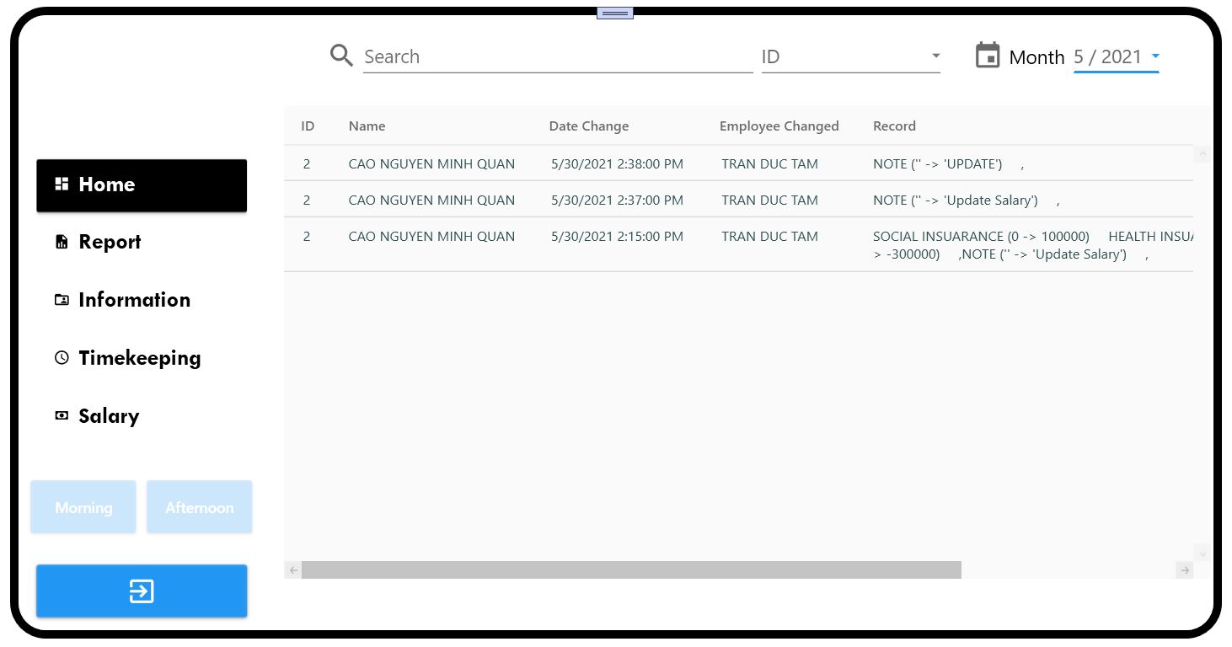

* The purpose of this tab is showing for user the record history. User can see who change or update employee salary, and what attribute they update pr change.
* User can choose month in combobox month to see the history record of that month.
* User can search in textbox to find information which user wanted.

### Report Tab

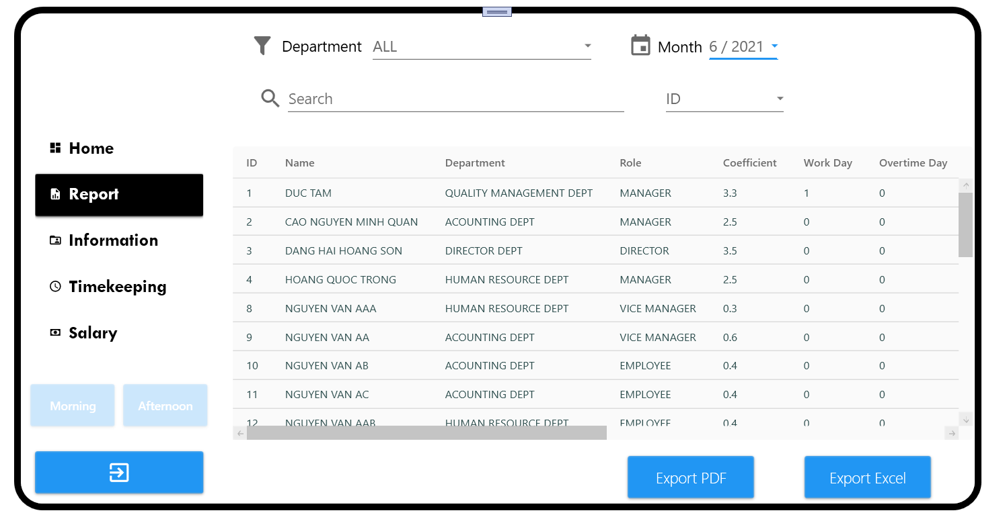

* The purpose of this tab is showing monthly salary list for user include ID, name, Department, Role, Coefficient, Work Day, Overtime Days, Basic Wage, Overtime Salary, Social Insurance, Health Insurance, Welfare, Bonus, Tax and Salary of each employee at month that is chosen in the combobox month.
* User can choose Month in combobox month to filter list by month and choose Department in combobox Department to filter list by department.
* User can search in textbox by attribute in combobox beside.
* User can export this salary list in PDF or Excel.
* User can click into one row in list to see the detail salary report of this employee that user chooses.

### Report Detail Tab

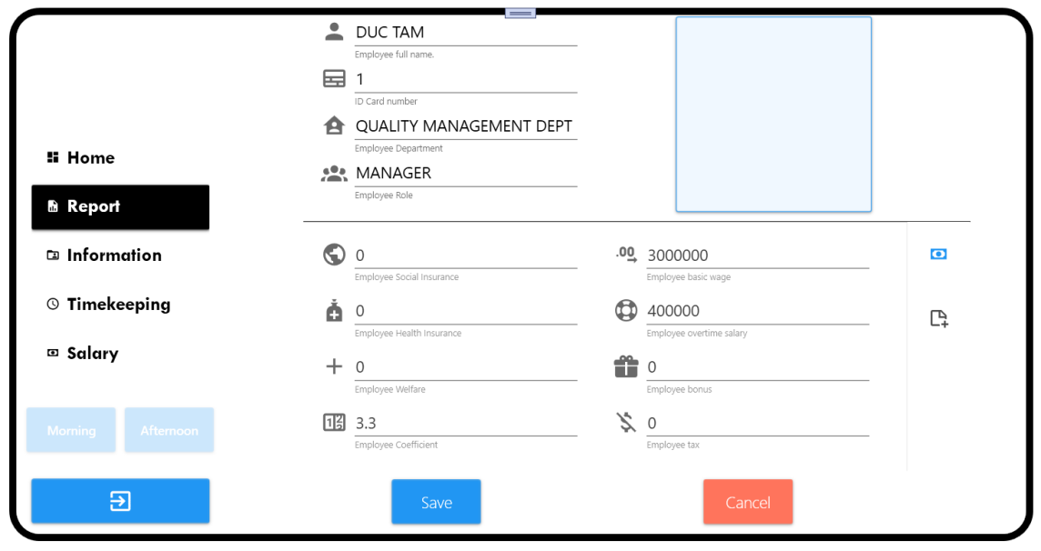

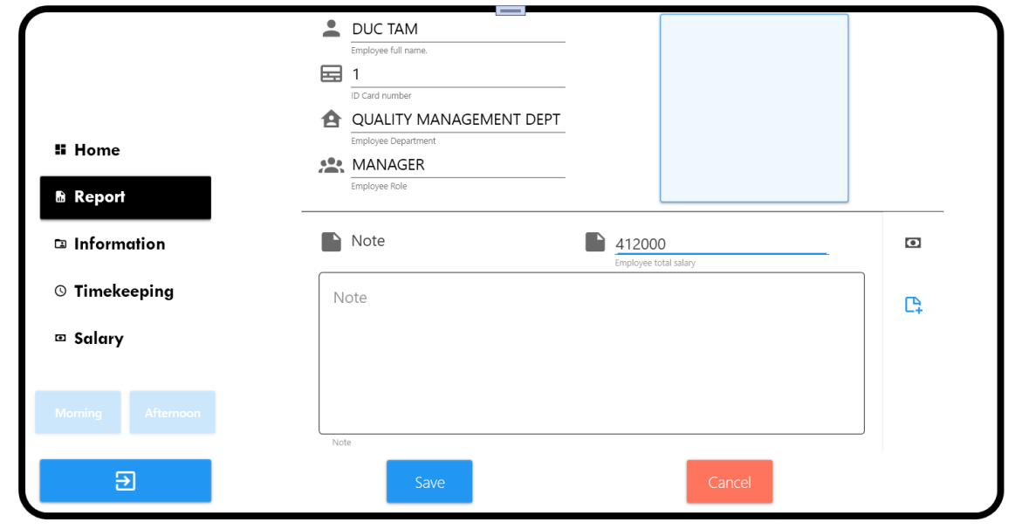

* The purpose of this tab is changed or updated salary attributes of employee that user click in Report Tab.
* User can updated Social Insurance, Health Insurance, Welfare, Basic Wage, Overtime Salary, Coefficient, Bonus, Tax, Note. If user want to save the change then click Save Button and user encounter the “Success” message. The change will be updated in history record at Home tab. If not, user can click Cancel button to back Report Tab.

## The Director Screen

* This screen has all tab of Employee Screen and some specifically tab for Director Council.

### Information Tab

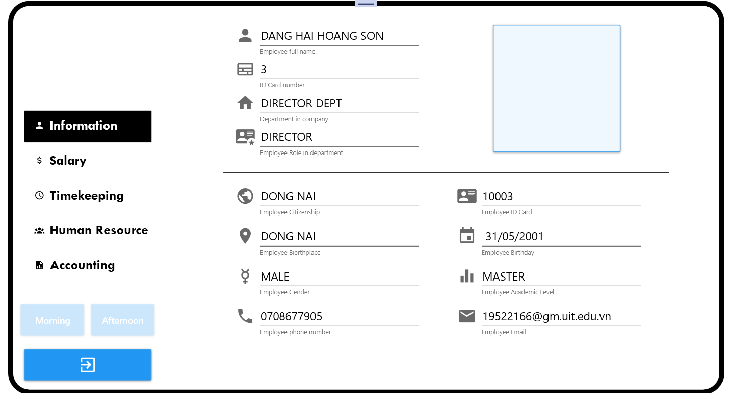

* The purpose of this tab is showing information of user include ID, name, department name, role, citizenship, birthplace, gender, phone number, ID card, birthday, academic level and email.
* User can click close button if user want to quit this software.

### Timekeeping Tab

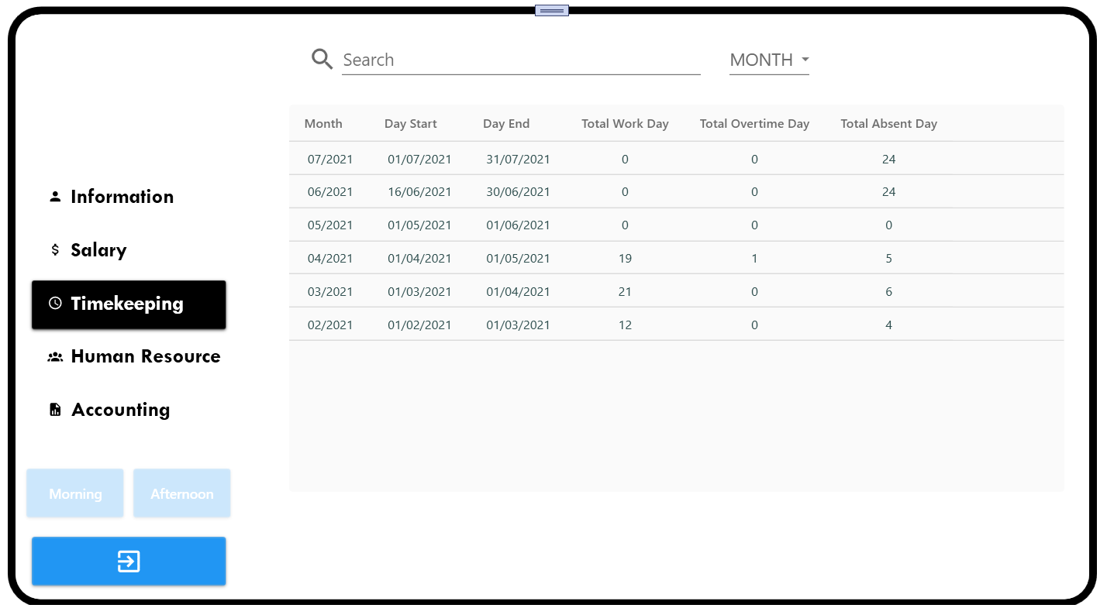

* The purpose of this tab is showing list timekeeping of user.
* User can see the month of timekeeping, day start and day end (it means the day start new month or the day user join into compony if User is new employee; the day end month), total work day, total absent day and total overtime day.
* User can check attendant by click into button name Morning or Afternoon (the button enable after user click that means user checked attendance or the time user check attendance is not the button time).

+ Morning button is able at 7:00 AM to 11:00 AM

+ Afternoon button is able at 1:00 PM to 5:00 PM

* User can search in textbox by any attribute that user choose in combobox.
* If User click into one of these rows, User will see the Timekeeping Detailed.

### Timekeeping Detailed

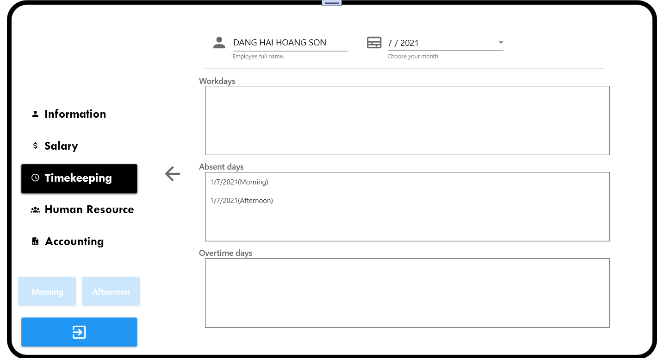

* The purpose of this tab is showing the Timekeeping Detailed of user.
* User can see his/her workdays, absent days and overtime days of the month that user choose in combobox.
* User can click Back button to back to Timekeeping Tab.

### Salary Tab

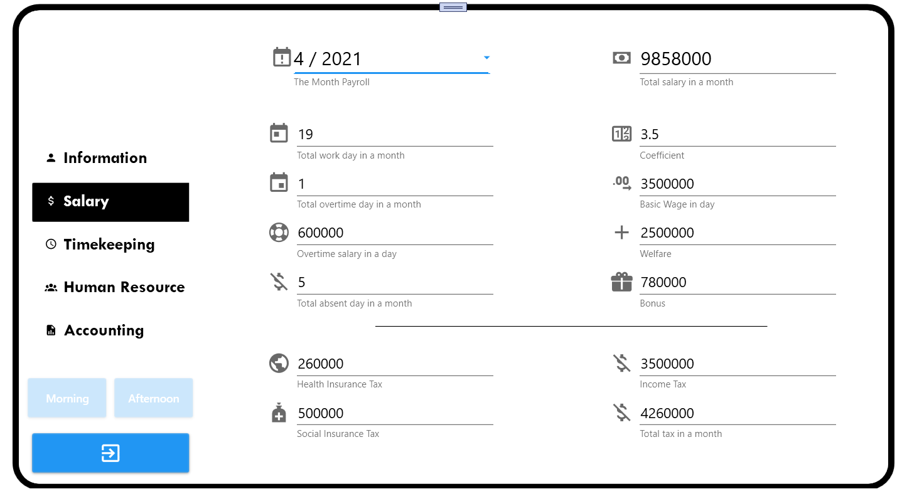

* The purpose of this tab is showing the Salary Report of user include total salary, total workdays, total overtime days, total absent days, coefficient, basic wage, overtime salary, welfare, bonus, health insurance, social insurance and tax.
* User can choose month in combobox to see salary report of that month.

### Human Resource Tab

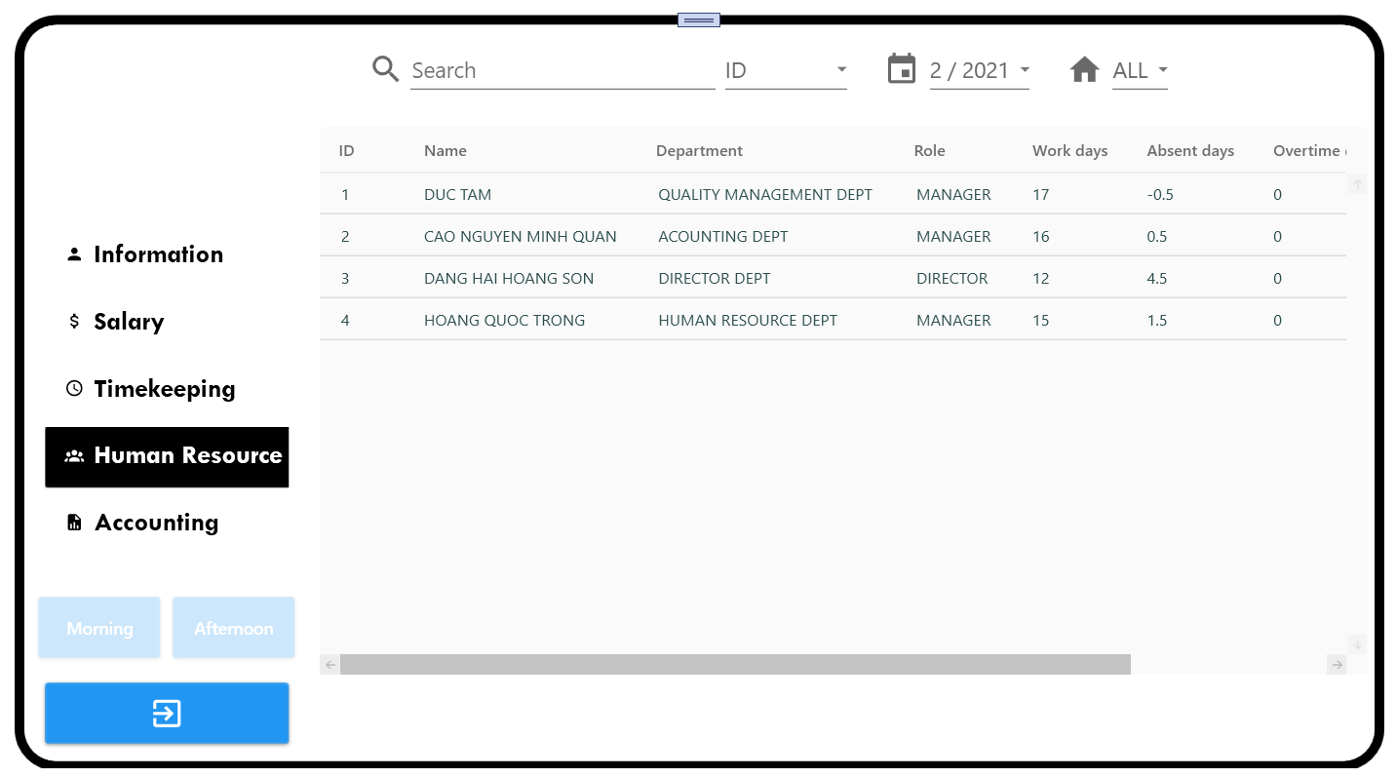

* The purpose of this tab is showing the Employee list in the company.
* User can choose Month in combobox month to filter list by month and choose Department in combobox Department to filter list by department.
* User can search in textbox by attribute in combox beside (ID, Name, Department, Role).

### Accounting Tab

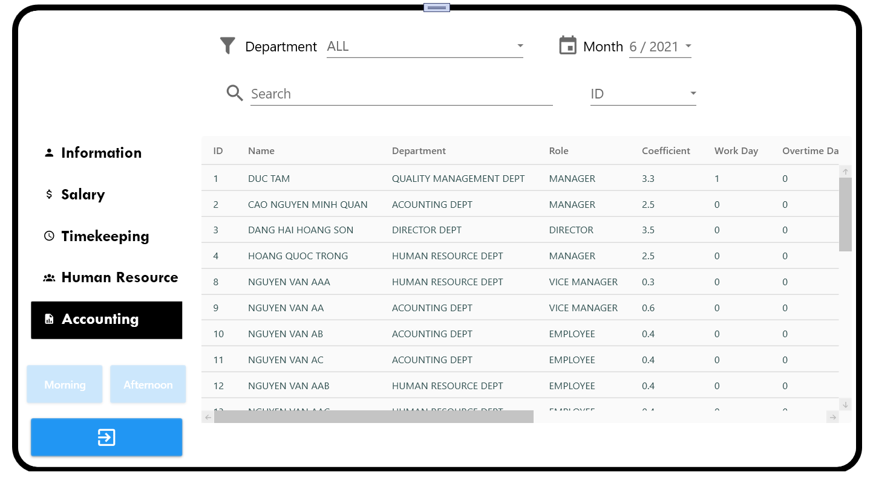

* The purpose of this tab is showing Salary List of the company by month.
* User can choose Month in combobox month to filter list by month and choose Department in combobox Department to filter list by department.
* User can search in Textbox by attribute in combobox beside (ID, Name, Department, Role).