Table of Contents

**OUR IT PROJECT** 4

**1.** **Team profile** 4

• **Team name** 4

• **Personal information** 4

➢ *Nguyen Luu Quoc Bao* 4

➢ *Nguyen Trong Minh Long* 5

➢ *Nguyen Dang Nhat* 5

➢ *Nguyen Quang Duy* 6

➢ *Do Duc Anh* 7

• **Group processes** 8

• **Career plans** 8

➢ *Nguyen Luu Quoc Bao* 8

➢ *Nguyen Trong Minh Long* 8

➢ *Nguyen Dang Nhat* 9

➢ *Nguyen Quang Duy* 9

➢ *Do Duc Anh* 9

**2.** **Tools** 10

**3.** **Project description** 10

• **Overview** 11

▪ **Topic** 11

▪ **Motivation** 11

▪ **Landscape** 12

• **Detailed description** 12

▪ **Aims** 12

▪ **Plans and progress** 12

▪ **Roles** 15

• **Scope and limits** 15

▪ **Tools and technologies** 16

▪ **Testing** 16

▪ **Timeframe** 17

▪ **Risks** 20

▪ **Group processes and communications** 20

▪ **Skills and jobs** 20

▪ **Feedback** 21

➢ *Nguyen Luu Quoc Bao* 21

➢ *Nguyen Dang Nhat* 21

➢ *Nguyen Trong Minh Long* 21

➢ *Nguyen Quang Duy* 22

➢ *Do Duc Anh* 22

**4.** **Group reflection** 22

➢ *Nguyen Luu Quoc Bao* 22

➢ *Nguyen Trong Minh Long* 22

➢ *Nguyen Dang Nhat* 22

➢ *Nguyen Dang Duy* 22

➢ *Do Duc Anh* 22

**5.** **References** 23

# **OUR IT PROJECT**

# **Team profile**

## **Team name**

Initially, we decided to name the group “Me and the boiz” after a thorough discussion. There are two reasons why we choose this special name. Firstly, all the group members are boys, which is a coincidence while forming the team as we have just known one another for roughly two months. The other reason is that we choose this name to show respect. The word “Me” put in the first place to symbolize the member, and “the boiz” afterward symbolize the other members.

## **Personal information**

### *Nguyen Luu Quoc Bao*

My full name is Nguyen Luu Quoc Bao, with the student ID of s3877698. I graduated from Nguyen Thi Minh Khai gifted high school with a math major in 2020. In 2017, I achieved a consolidation prize in a computer science competition, which motivated me to choose the IT major at RMIT (*Royal Melbourne Institute of Technology*). In terms of pastime jobs, I am keen on playing chess and basketball since chess helps me improve my mental mind while basketball keeps me fit, which is crucially important as those factors maximize my learning efficiency. Turning to my interest in IT, it emanated from the fact that I have loved playing games and using computers since I was a child. Progressively, my interest in computer and information technology is bigger and bigger. Finally, I decided to choose the university's IT pathway so that I can learn more about advanced technologies and have more knowledge about some interesting aspects such as security or artificial intelligence, which strongly attract me. As a freshman, I have some general understandings of necessary IT fields, such as running simple codes in Python or building a simple website with HTML and CSS. I know a bit about Pascal by being taught in secondary school. Otherwise, my pathway in IT is still in the future where I can study more and discover exciting aspects.

**Figure 1.** *Result on Bao’s Myers- Briggs test* (https://www.16personalities.com)

### *Nguyen Trong Minh Long*

Hi, my name is Nguyen Trong Minh Long, my student number is s3878694. I have studied in the AIS, which is an international here in Ho Chi Minh city. My hobbies are playing the piano and listening to music whenever I feel down, stress, or even happy. I started to pick up the interest in the IT world since my first code competition in my school in 2018. Sadly, I wasn’t able to win the first prize, I was only in the top five, but it gives me a lot of fun experiences as a coder and team member. From then, out of my curiosity, I decided to become an IT professional as a future career. Then I would start learning to code and start to do more research to find a path to become a professional Software developer. I am currently a beginner in database concepts about current knowledge, which means I have a basic knowledge about My SQL and Oracle Apex. What is more, I am learning to program using Python language. However, shortly, I will start to learn other languages such as HTML, CSS, JS for the front end, some Java, and C for back end purposes.

**Figure 2.** *Result on Long’s Myers- Briggs test* (https://www.16personalities.com)

### *Nguyen Dang Nhat*

My name is Nguyen Dang Nhat, an undergraduate IT student at RMIT. My id number is s3878292. Since I was in high school, I had soon developed a passion for IT and self-taught Python. One of the critical factors in life is that you have to balance your lifestyle, so my hobbies include learning to code, playing the harmonica, and reading novels. My hobbies enable me to control my emotions, balance learning and relaxing, study hard, and enjoy life. I plan to study Machine Learning and Big data for Engineering, maybe get an honor’s degree in RMIT Melbourne. My parent’s major in Economics and Finance. For me, it is IT. I think what if I combine two things, and that is why I choose Machine Learning and Big data because they are applied very much in the business field. Currently, I only have basic knowledge of Python and MySQL. In the future, I will have more knowledge and then go through internships to gain the experience working in the industry that I need.

**Figure 3.** *Result on Nhat’s Myers- Briggs test* (https://www.16personalities.com)

### *Nguyen Quang Duy*

My name is Nguyen Quang Duy, with student ID of s3877991. I was born in Russia, but my hometown is Hue City in Vietnam. I am an introverted person, and I am not confident enough to express my feelings to my schoolmates and even the public. Despite those weaknesses, I have had a talent for making PowerPoint animated videos and upload them on YouTube since 2016, and I usually do this work as my pastime every weekend. However, that hobby is not my primary goal because I intend to study IT for my future life and career. Talking about IT makes me remember the nightmare when I was in high school. During that time, I studied PASCAL as the first programming language. But it is such a challenging and complicated language that I barely understand algorithms, coding syntax, and command. Although I coded programs as correctly as possible, their outcomes were not what I had expected, and the worst situation is there are a bunch of errors while running, which is very frustrating. Nevertheless, not until I graduated high school and I was officially recruited in RMIT University did I recognize that programming was just a part of IT because there were various subjects related to it such as database, AI and machine learning, and cloud computing. The recruitment advisor told me that some programming languages are more comfortable and comprehensive than PASCAL and were widely used in other universities apart from RMIT. Those concepts surprised me a lot, and it also makes me get accustomed to IT gradually instead of getting bored with it, which makes me more willing to find out it more and more further, especially AI and cloud computing.

**Figure 4.** *Result on Duy’s Myers- Briggs test* (https://my-personality-test.com/)

### *Do Duc Anh*

My name is Duc Anh with student id s3847506. This is my first semester at RMIT University in Information Technology major. My family has been moving to Ho Chi Minh city from the capital of Hanoi since 1990. Gia Dinh is my high school. During the national high school exam, I used to enroll in medical school instead of technology-related professions. After a time of living in Boston in Massachusetts in America makes, I change my views. It encourages me to learn technology instead of pursuing my doctor’s dream. My hobby is playing sports with friends and hanging out with them. I usually play tennis, which allows me to relax after studying for a long time at high intensity. Honestly, I am a neutral guy, frankly, different from those in our team. Someone suspects that I am an introverted man because I feel nervous and lack faith when I demonstrate my thoughts in public spaces. It is partially extroverted from my mind, on the other hand, because I prefer hanging out and chilling in the bar club overnight with friends. In my learning, these elements affect my character and ability. I am a tactile and visual learner, but I prefer practicing and having my own experience instead of sitting in one position. Technology impacts every corner of our life. Every time I use a website or an application, I wonder how they can function and operate. That is why I like software development, coding. I am a new student, so I do not have many experiences with software development, but I believe that I can learn and join many events about technology in the future.

**Figure 5.** *Result on Anh’s Myers- Briggs test* (https://my-personality-test.com/)

## **Group processes**

Our team works very well together in Assignment 3. Being one of the teams that formed early in the course, we usually hang out and have many offline meetings, so each of us has understandings of the strengths and weaknesses of another team member. Therefore, we can support each other more effectively. Each member is assigned to their tasks, and in order not to be behind schedule, deadlines will also be given. The tasks are assigned based on that member’s strengths and weaknesses. We expected that everyone will meet the deadlines and still maintain clear communication to immediately support one another if any problems arise since our team is aiming for HD. If Assignment 3 is extended, we will have more time to consult our lecturer and improve our report and our app, which are showed in the timeframe section. There will not be many changes, but there will be many improvements so that we can reach our main objectives.

## **Career plans**

### *Nguyen Luu Quoc Bao*

Generally, we share a few points but significant differences. We all know coding Python as it is our first programming language. We will intersect one another at core courses such as UI design, web programming, or capstone. In terms of differences, Bao’s career plan is to be an app and website developer, which is similar to Long’s but in contrast to Nhat’s. He will work on mobile and website by following the courses such as Programming 1, Further programming, and IOS development. This pathway is similar to Long’s. However, Nhat plans to go on big data and AI developer, which is different from Bao’s and Long’s. Duy and Duc Anh share the same career path as a developer in cloud computing and IoT. Bao’s ideal job is to be a web and app developer in Bachysoletanche, an IT company in France. His potential work is to develop applications and web, based on the demand of the company. Similarly, Long can be a web and app developer of an international company, while Duc Anh plans to be a software developer and business analyst as he has some business experience. Nhat, in contrast, will be a data engineer who mainly works with statistics. Duy will be a game developer of an international company in the future as he has advantages in coding and creative work.

### *Nguyen Trong Minh Long*

My career plan is fairly different from other people. I choose to become a full-stack software developer. This means I would design both the UI, UX, front end, and back end. Moreover, sometimes I would use the template to design a website for the company or clients that require or need me to do it. One common element is that Duy is also an app and game developer, which means he needs to do both the front end and back end. Long would use HTML, CSS, and JavaScript to do the design for UI and UX for the front end. On the other hand, as for the back end, Long would mainly use Python, sometimes Java, PHP, or some small cases, HTML and CSS. On the contrary, Bao and Nhat are different from Long. They only do the front end, which prioritizes only UI and some other designs. Duy wants to develop game and apps, which is mainly the back end purposes and to develop as many functions for the game to run smoothly, he usually does not have to focus on UI, designing the front end and character design as much as me. However, the most transparent difference in my career path is that while others aim to be an elite coder or an IT professional, I want to have the overall knowledge to become a full-stack developer, and with that, not only can I become a free-lancer to have an extra income during some hard times, I can also work as a group leader and lead a group of software and web developers and help manage a big project, or to make it more transparent, to be able to lead a professional team.

### *Nguyen Dang Nhat*

In the future, I want to become a data engineer or business analyzer. My ideal job is in contrast to everyone in the team. Bao is going to be a web developer and application developer. Long is planning to be a full-stack developer and software engineer. Duc Anh will also be a software engineer in the future. As for Duy, he will become a software and game developer. My study pathway will be different from others. I plan to study Machine Learning and Big data for Engineering. Even though my plan is different from the rest of the team, we still have to go through SADI and Algorithms course.

### *Nguyen Quang Duy*

After graduating university, as I have learned Python as my programming language and had an in-depth knowledge of HTML, CSS, and JavaScript so far, I tend to be a game and website developer as my major with a view to creating games and websites, which means I will have to do both front-end and back-end tasks during the project development. Comparing with the other members in our team, like me, Quoc Bao and Minh Long also have a desire to be a developer, and they also have an understanding of Python and web programming languages. However, our positions and objects are different from each other. Quoc Bao wants to be a front-end application and website developer, Minh Long wants to be a full-stack software developer. In contrast, there is one member who does not have a dream to be a developer. To be specific, Dang Nhat will apply for data engineering and business analysis as his future job because he is focusing on big data. Meanwhile, Duc Anh plans to apply for two different occupations which are a software developer and business analyst.

### *Do Duc Anh*

After graduating from high school, I will be a doctor, but my parents advise me to think about information technology instead of following to study doctor. I tend to become a software developer and business analyst because the developer's salary has always been attractive and growing in recent years. To become a software developer, I need to know programming, coding and understanding computer science background. Besides other essential skills that support my jobs as problem-solving, logical reasoning skills, teamwork, and team management planning skills. All of us are learning python programming as a first language to develop, but we will have other decisions about our career in the future. Bao decides to become a front-end application developer, while Long is planning to become a full-stack developer to do back-end and front-end. Next, Duy dreams of being a game developer as his career in the future because he is interested in playing games and creativity. In contrast, Nhat is different from our team. He would like to be data engineering instead of becoming a developer. His job will be related to the data analysis.

# **Tools**

# **Project description**

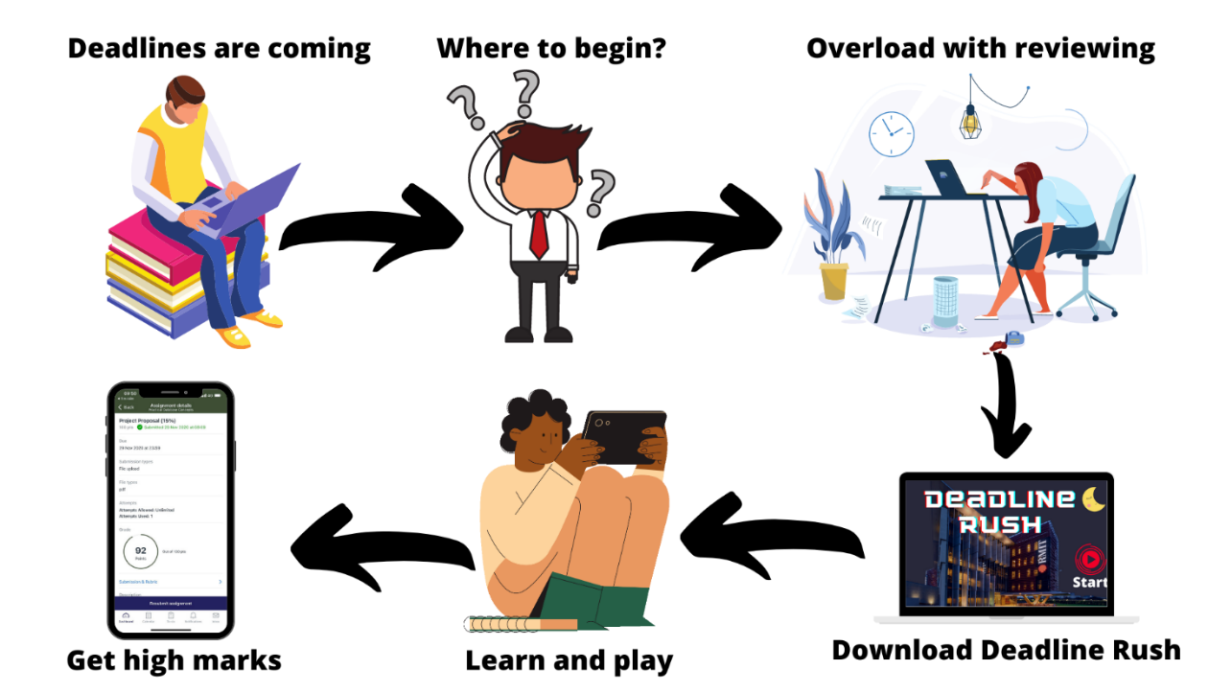

**Figure 6.**  *A brief description about or project*

**Figure 7.** *The game interfaces*

Our group tends to create a play-based learning game. This group aims to have as much fun and gain as much experience in making and developing an app. Our group eagers to learn as many things this semester as possible and have fun along the way, and for that reason, we decided to choose Bao's idea for this group project. Moreover, we get to use Pygame to develop a game, an entirely different experience, hence, learning many things along the way.

Many people recently prefer to play simple yet fun games to play, which is perfect for our group project since our team members are beginner coders and lack experience. Because our game is a 2D retro running game, it is fun and easy to place, yet it could help people gain many pieces of knowledge as well.

What is more, this project helps us a lot in terms of career plans and the future. First and foremost, creating this game encourages us to self-study more and helps us gain the experience required to become an IT professional. To make it more transparent, to have an IT professional's mind and think like them. Second of all, making this game means we get a chance to interact with other coding languages as well, such as C, Java. However, in this project, we only use Pygame because our time is limited.

## **Overview**

### **Topic**

On this project, we will create a game called “Deadline Rush.” This endless running game is about a story of an RMIT student chased down by a monster named “Deadline.” While running, there will be many objects that appear to prevent the student from continuing running. To help the student overcome those objects, the player must correctly answer a multiple-choice question related to their major chosen in the pre-game stage. Otherwise, the student will get stuck and be eaten by the “Deadline.”

After playing this game, RMIT students can review what they have learned so far or even learn new knowledge to master the ancient knowledge since playing this game will comprehensively test their understanding and memory about the lessons. Furthermore, they will also receive a chart, which points out their strengths and weaknesses in a particular aspect of knowledge after the game to choose what aspects to continue reviewing. Moreover, students can learn new knowledge by playing this game as the question source are consulted with the lecturers of RMIT.

### **Motivation**

Our motivation for creating this game is to provide RMIT students with a friendly way to review their lessons before deadlines or tests as we can see that RMIT students are always stressed sitting in one place and sticking their eyes into big books or lecture slides to review knowledge for deadlines and tests, which is a classical and tedious method of learning. We think we can change their habit of reviewing by offering them a more accessible way: play "Deadline Rush." Moreover, RMIT Vietnam has taken a significant number of students this semester, putting a tremendous strain on both lecturers and SAS as they will not have enough time to meet students in consultations. This game can also help them release stress as students will have one more option to review lessons or solve academic issues.

We hope that students will be interested in this game since it helps them review the learned knowledge effectively. While playing, they will passively absorb knowledge. Gradually, they can memorize the knowledge correctly and quickly. Furthermore, students can still relax while learning by looking at the cute monster or funny animations created in the game, which is not dull as looking at a book for two or three hours. They will also be offered recommendation documentation for reviewing their weaknesses after the game, which means they do not have to spend time in the library looking for suitable book books that may be on loan.

The application of games in education is now widely used as it helps students absorb knowledge passively while playing to not feel stressed or tired. This play to learn model is popularly used in developed countries' educations such as America and Canada. In terms of technical technology, this game is based on Python's library pygame, which is one of the programming languages that let you work more quickly and integrate your systems more effectively. Furthermore, this programming is taught in the Introduction to programming in RMIT, one of the most prestigious universities all over the world because of Python's basic and accessible syntaxes.

In the future, while meeting the employers, I can confidently show them about this project. Firstly, this will point out that I have experience in project work, which is one of the essential requirements of foreign companies. Moreover, they will infer that I have an understanding of Python and pygame, which means I can contribute to building software for them in big events such as company anniversaries. Furthermore, this will point out that I have programming mindsets, which means I can do well in coding. Therefore, I will stand a better chance of having employment in big and profitable companies in the future.

### **Landscape**

While finding the idea for this project, we played Subway surfers, a famous game published by Kiloo. In this game, the runner will continuously run until he fails to overcome an object. The operation of this game is quite similar to my game. Moreover, we have referenced the format of a famous game show called “Who is the billionaire?”. Our game is a combination of the two mentioned games. Through research, our games currently have no competitors as this idea is relatively new, and it was come up while playing game.

## **Detailed description**

### **Aims**

The primary aim of this project is to improve the academic performance of RMIT students as there is a fact that the deadline at RMIT puts a great strain on students since the workload is significant and students do not know how to review lessons comprehensively. Most of them review by scanning the lecture slides or books borrowed from the library, which may be boring as there is no direct interaction between them and knowledge. Therefore, this game will help them review lessons effectively by announcing to them whether they are on the right path of understanding problems. Furthermore, once losing, students will realize their weaknesses and get some useful material for reviewing the knowledge gaps. Gradually, the result in their assignment will be improved, leading to the university's improvement.

To successfully achieve the aim, we need to complete the game's library question, comprehensively providing students with various majors and knowledge. Moreover, this will facilitate the review progress as all needed information is covered in the game. If we can provide a question library with key and explanation, the game will strongly attract a great number of students to download and play the game as a method of reviewing lessons.

Another necessary goal is to complete the game with animations, sounds, and effects to make it more attractive, which can help get more players. This action is essential as suitable sounds and attractive animations are two key components deciding the game's success.

Marketing for the game is also an important goal in this project. When we have finished the project, we will launch the game for SST students before launching it to widely RMIT Vietnam. Letting others know about the game will make the game gain traction and be more famous for students. Moreover, letting a significant number of students download the game is also an excellent way to check if any bugs exist on the game, which will immediately be fixed to make the game perfect.

### **Plans and progress**

The idea of this game incidentally came up while Bao was under a tremendous amount of pressure at the deadline time. He turned on the phone for relaxing, surfing the AppStore for exciting games. When he was playing Subway Surfer, an endless running game created by Kiloo, an idea came up. He thought of combining an endless running game with the appearance of objects in which there is a question about academic knowledge. He decided to follow the “Play-based learning” model, whose efficiency has been proved by numerous education- developed countries such as Poland, France, and the UK. Thanks to this idea, students can review knowledge more effectively and comfortably, which is not as stressful as sitting at the table and spend several hours reading books or lecture slides.

In this project, we will create a game called “Deadline Rush.” The game is about a story of an RMIT student who is being chased by a monster called “Deadline.” There will be numerous objects on the road, in which there is a question about academic knowledge. If the player can answer the question correctly, the student will get past that object and may get some boost items such as hints for the next questions. Otherwise, the student will get stuck and be eaten by the Deadline. After finishing, the screen will pop up a chart of what has been reviewed today and recommend students some useful summarize of their weaknesses, which should be improved.

Moreover, the project will enhance the student quality of RMIT as this game effectively help the student review lessons by playing. Furthermore, this leases the strain on the staff as the demand for querying will decrease dramatically.

To create a game, we need to find tools. Through research, there are two main tools for creating games, including Unity and Pygame. Unity is the most popular game tool in the world. However, it required a deep understanding of C#, which is not our advantage. Therefore, we will use Pygame, which requires a general understanding of Python. As we have learned Python in Introduction to programming course, we will access the problem easier.

Next, we will find essential components such as images and icons needed to code and fix bugs in the game. We will mainly use Canva and Flaticon to get the free source of those images and icons. In case of lacking, we will ourselves create those things by using adobe illustrator and photoshop.

After that, we will execute the code to create the game using PyCharm Professional as the IDE for coding pygame in Python. This stage will take a great deal of time. As estimated, it will take about two months to perfect the game. Finally, we can share the game with other SST people for testing and feedback before launching it to all RMIT students.

To this end, we need some support from other schools. We need a person who is a master’s in design to choose the most suitable color mixture and images. Furthermore, we also need students in professional communication to make a video for advertising this game to make it more popular.

Bao made a particular plan to execute this game with the initial motivation of helping RMIT students to review the lessons effectively by playing. He started to make a research and development plan and list some skills and tools for making this game. In terms of the plan, he divides it into four main stages.

The first stage is to think of essential functions and make a survey of students. In terms of function development, some core functions are crucial, such as quit function, moving function, and answer choosing function. Those functions are compulsory as the game will not run if lacking one of these functions. Furthermore, Bao plans to create some functions that can increase players' experiences, such as restart, pause, major choosing, and boost items. The pause function is to stop the game for a while until the players click on the button again if they are interrupted by something. The restart function is to start over the game if the player is lost or want to replay for review the knowledge again. Moreover, the primary choosing function helps the player focus on their particular major, which facilitates them to profoundly and effectively review a field of knowledge. This function is beneficial when a student wants to try hard for incoming tests or exams as they can concentrate on expected aspects, which will boost their score significantly. Furthermore, Bao has done some surveys about students' opinions about play-based learning methods and some students' demands while playing a game to navigate the plan on the right path. Through survey and research, he got much agreement that play-based learning is the right way of learning as there is not too much pressure put on the students. That agreement put a great motivation on him to complete this game.

The next stage is to create a question library. As the game will continuously pop-up questions, we need a library with more than a million multiple choice questions in one primary. The question will be created based on the lecture slide and books from the library, with the lecturer's supervising. Furthermore, the questions will be gotten from the free source on the Internet to save a great deal of time. In the game, Bao will use Python's random module to randomly generate the question, which avoids dull feelings from the player and makes the game flexible. In the future, when getting a higher level in building database, he will change the operation of the question library to query languages by combining the game with a big database of the question so that the game will run smoother, which increases the experiences of the players.

The pre-final stage of making this game is to complete the UI design and launch a prototype version for only SST students. In terms of UI design, we will complete editing the background and choose appropriate icons of objects consistent with the question inside. For instance, when players interact with a Python object, it will pop up a question related to Python, which helps them know what they are reviewing. Moreover, we will add some animations to attract the players as it avoids dull feelings. We will also perfect the expanded functions such as material recommendation, learning- chart reflection, and Q&A function. Those functions facilitate the reviewing progress of the students. Furthermore, those functions also help the team optimize the game so that every student will get access to a perfect game, which helps them review knowledge effectively. In terms of prototypes for SST students, we will launch the game for those students for prototypes and get feedback. Once receiving feedback, we will fix bugs, update some more functions before launching it for all RMIT students.

The final stage of this project is to push it online and get revenue per download. After we perfect the game, we will launch it on the Internet with free downloading. We will get revenue back for each download so that we can get the income and help everyone enhance their knowledge, which gradually pushes the development of society.

So far, Bao has completed the first stage of the progress. He surveyed by using a google form to collect SST students' answers, which is used to navigate the next step. If they all agree about this model, we will gain a lot of traction and motivation. Otherwise, we will change the plan suitably. Bao has completed the demo with pygame in Python. He has exported essential functions such as moving function by using key (>), answering by clicking on the answer, and quitting on the quit button. This is enough for presentation as it can fully express the operation of the game. After that, if we receive more encouragement, we will push the speed of the progress.

Until now, we have completed stage one of the projects, which means we have complete 25% of the project. We have been sticking to the initial plan, which helps us work on good progress. However, we have to change a bit about the concept of the game. Firstly, we decided to change the 3-D concept to a 2-D concept as our knowledge is still limited, and we do not have much time to learn about 3D design. Therefore, we change the game to the 2D concept for easier management and coding. Furthermore, we have changed the tools from unity to pygame as unity requires a general understanding of C#, and we do not have enough time for learning a new programming language. Therefore, using pygame offered by Python is a suitable solution at this stage. We decided to change the background from a mono color to an anime background, which is more beautiful and attractive. This change will prevent players from being dull looking at just a grey background.

### **Roles**

In our team, each member plays an important role, which is divided based on each person's skills and strength. The project is decided based on Bao's idea through thorough discussion. Therefore, Bao must be the lead developer who writes code and designs and motivates the teammate and manages the project. Besides, Bao is also the technician designer and user-interface designer as he is the one who understands the game deepest. He writes code in pygame and designs the appearance of the character as well as background since he has some experience in pygame and designing. Nhat takes after the role of algorithms supervisor to support him effectively, who provides some useful algorithms when Bao gets into trouble with coding. Thanks to his advice, Bao can solve problems in coding and make the code cleaner. Long is also a supervisor in designing as he has some art experience, and he has a good vision about layout and color combination. Duy and Duc Anh are supporters in finding source code, images, and material, which are extremely useful in creating a game.

So far, Bao has created the demo game and ready for demonstration. He will gradually add some more functions in the future if we have enough time. The contribution of all members is progressively completing the report. Our team's role will stay unchanged until the end of the deadline, as we all agree that it is hard to take after the role of the person who is on satisfactory progress. We will follow the role until the end to get the highest consistency of the project.

## **Scope and limits**

### **Tools and technologies**

We will use a laptop with a suitable configuration and other accessories such as a mouse for fast operation and earphones for edit sounds and audios to develop this ideal project. We will use PyCharm Pro 2020.2.1 as IDE and especially Pygame to program the game in terms of software. Pygame is a library supported by Python, which provides us with syntaxes to program games with ease. Because we have had vital knowledge about Python, we find Pygame not too challenging to learn to create a simple game. Due to a short time being exposed to Pygame, we have just created a basic demo project. However, it is enough for everyone to understand our idea. And in the future, we are trying to promote our programming skills so that we can develop other games and application.

### **Testing**

Testing is one of the most important processes during our game development, and it decides our project outcome. To make sure that the game runs properly, and its outcome is to meet the users’ entertaining and learning efficiency as our expectation, we have to test it to find out bugs or other unusual problems, and we have to fix it from that. This process repeats many times, and it depends on the number, types, severity of bugs occurring in our project. To test the game, firstly, we try playing the game to test its features and functions to ensure its friendliness to users in many aspects. In this game, its UI must be comprehensive and straightforward, symbolized buttons such as pause, restart, play, the exit must have the right functions so that users can control the game properly without facing against some glitches, characters’ animation must be operated correctly. Next, soak testing is necessary for this game to determine if there will be some RAM leaks or other bugs or if this game is still stable when this game is left paused very long. Finally, it will be a disaster if this game is not secured, which means security testing is critical. This test is done to check if its security is strong enough to protect its data when it operates in an environment with foreign threats, flawed operation systems, and weak-coded algorithms. Besides, during the testing process from the simple to the complex, we always record testing histories and bugs occurring in our project to remember and learn how to fix them properly, which makes us improve our testing skills and use them to test other games and applications. However, because every game has its bugs, we cannot fix all the bugs in our project. Therefore, we have to do our best to make the game consist of as few errors as possible, but it still meets expectations.

Until our project runs properly, and its bugs are restricted as much as possible, we will invite about two hundred students on campus to test our game. Moreover, these students may be SST students, our old friends, or even our relatives who also study on the same campus. If they feel relaxed and they can review the lessons effectively, our project will be successful, and we will popularize it to all students from not only in this campus but also RMIT Universities from other locations such as Hanoi and Australia.

### **Timeframe**

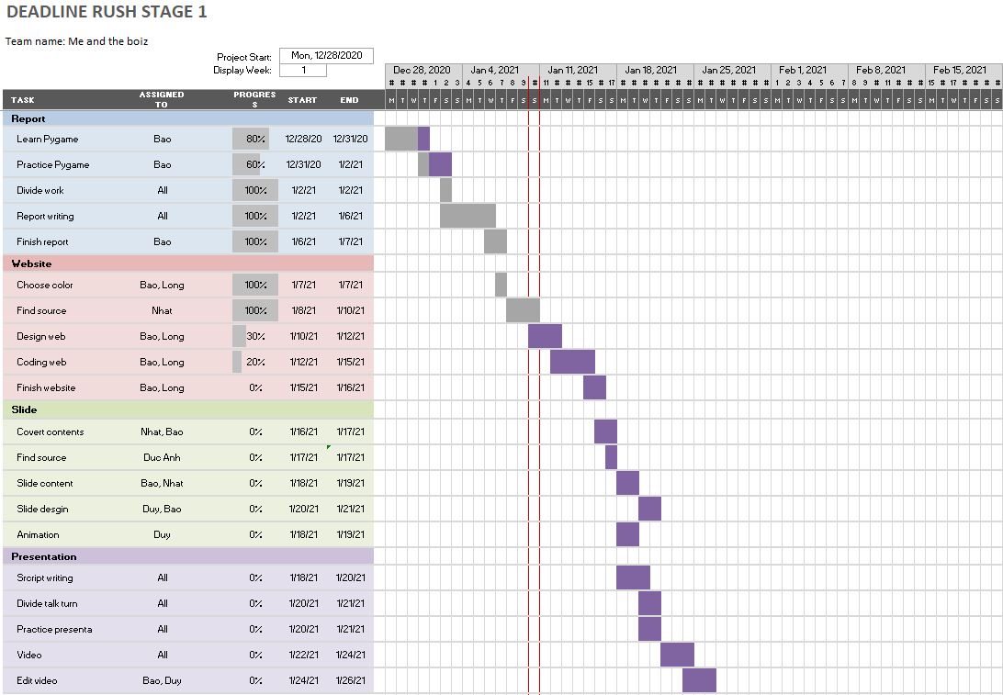

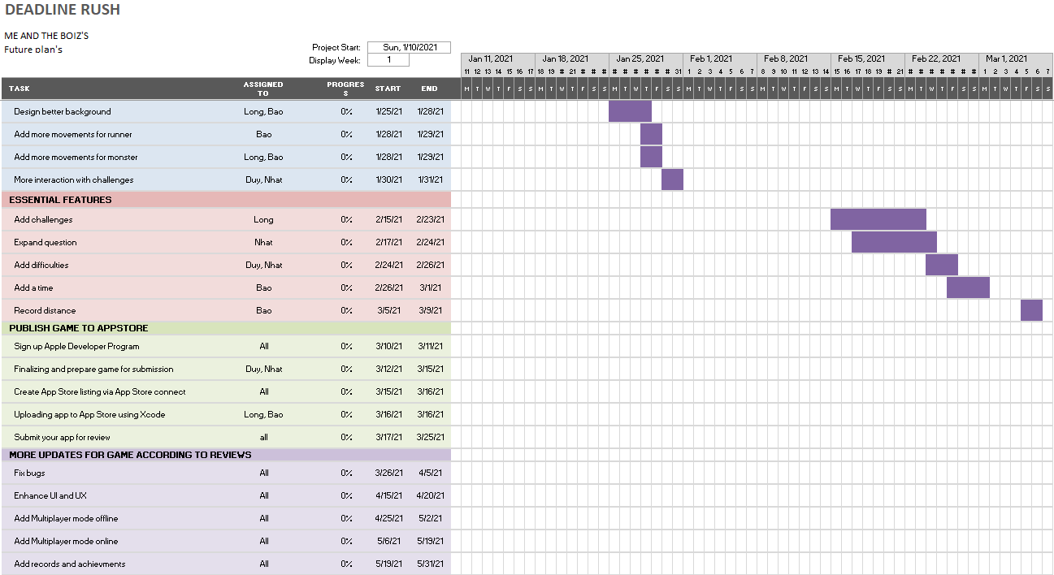

### **Risks**

This is the first time that we have carried out a game project, so we may not have a fair amount of experience with scenarios. Game programming requires several steps, such as story planning, movie character formation, code writing, error testing. It is not easy to complete the game project, but it requires all team members' contributions. There are some problems that impact our results. Firstly, there seems to be a dispute among members because of heterogeneous perspectives. We do not exclude the risk that individual team members would leave their jobs in the middle, putting pressure on the remainder. Secondly, not enough knowledge is available to overcome software risk issues. Programming is a new area for us, so we need to acquire a specific programming language, such as C, Java, and Python, to do a game programming project. I have some simple mistake effects on my work during python programming, such as syntax errors, runtime errors, index errors. We are also writing the code attached without breaking it into several files, resulting in time-consuming to correct errors. On the other hand, capacity and software are not compatible with the computer, which leaves one of the significant problems. These errors left me unable to run the software successfully.

### **Group processes and communications**

Clear communication must be maintained throughout every member of the team. Miscommunication, misconceptions can lead to unexpected consequences and results in bad grades. Every member of our team already friends in real life, and we also study other courses together, so we have a considerable advantage to explore the strengths and weaknesses of one another. We have two main ways to communicate: offline and online.

As for my team, face-to-face meetings take place every day for a minimum duration of 15 minutes. Each member is expected to attend at least three times a week. We encourage every member to go to offline meetings rather than online because it is easier to convey our ideas. However, not all of us can be at school all the time.

Online meetings are necessary to maintain communication when we are at home, or one of our team members cannot go to school. There are many technologies at our disposal. For texting, we have Facebook Messenger, Discord. For making video calls, we have Microsoft Teams, Zoom. For sharing code or working on a project, we have GitHub, Codeshare. Each member is expected to maintain clear communication with other team members. Should there be any problems, we can address them quickly and, therefore, having more time to resolve them. If there is one member who does not respond to communication, at first, we still try to reach out to that person. If the situation continues, we have no choice but to talk to the lecturer about this, and that person has to leave the team.

### **Skills and jobs**

A game project requires many steps to become a product, so we will divide tasks into sections to suit each person's abilities. It is divided into four sections: design, art, development, test. The game designer is considered a game's soul who raises the game's challenge, the plot, the dialog, the functions, ideas, and the levels. The game artist's role is to design characters, objects, buildings, and game environments. Moreover, develop a more beautiful picture and vibrant character picture. A game artist requires sophistication, creativity, and the latest art trends to be continually updated. Bao and Long will develop the game's content and functions, but Bao will go into detail about the game's plot and concept, and Long will design the graphics of the game. Basically, Bao and Long can properly organize thoughts, and they also enjoy playing games while having strong imagination and independent analysis. After that, a game developer is a man who writes code, makes software run successfully, and is compatible with several platforms. Nhat will be responsible for this work since he has the experience and understands programming languages such as C and Java. Finally, Duy and I will search and test how many errors are found in our products and report with team members to fix and replace better options.

### **Feedback**

### *Nguyen Luu Quoc Bao*

So far, we have been working with one another for ten weeks. We have overcome many challenges. In those challenges, I contributed a great effort to make the assignments and reports look nice. I am also the one to summarize information for mistake checking and edit format. Besides, I am writing the description sections as the team decided to choose my idea for execution. About Nhat, he contributes a lot in writing complicated sections such as Scope and limit, which takes much time to launch an excellent report. He is also the one to divide tasks among the other members. Long is also a useful member since he can suggest various critical solutions and ways to execute that. Moreover, Long is also the one to remind members of deadlines. Duy is a cool student as he has some problems communicating. He can do well in writing short paragraphs and tables. Duc Anh is a student who has high-level skills in the presentation. He passed down his experiences and showed us how to present and transmit information directly and virtually to the audiences.

### *Nguyen Dang Nhat*

Being one of the first teams formed early in the course, we have much time working and evaluating each other. Overall, I think the group is performing well, although we have some drawbacks. As for technical writing skills, Bao and Long perform best in our team. They work with each other very well. Primarily Bao can design beautiful layouts and structure the report. As for the app, I am the primary creator, and Duy acts like a supporter to me. Four of us know each other very well and can support each other’s weaknesses. Duc Anh is still new to the RMIT environment and needs a lot of help. He has a reasonable tone of voice, body gesture, which results in a decent presenter. My team views me as a person of work. I always try my best, finish the tasks before the deadline. Sometimes I can be unstable, but most of the time, I am good progress.

### *Nguyen Trong Minh Long*

Overall, everybody is working hard on this project. We have a meeting every week, and everybody would attend without missing any section. For my part, I have contributed to many parts of this final assignment, such as writing reports, noting time frames, designing slides with Bao, and a little help in project idea. For Bao, he is the leader and the one who summarizes the report for everyone. He has done an outstanding job in leading the team and connecting every group. Bao helps me design a logo for our team, design slide, and overall, very hard work. However, sometime during the presentation, his pronunciation is not so clear. Nhat is a shy boy from the very beginning. He helps every member to finish before the deadline. Although his design skill is not good and he is a little bit hard to communicate, he gets the work well done in report and developing app. As for Duy, he is an introvert. He has some issues communicating and talking to the rest of the group members, making it a little difficult for me to reach out to him. However, Duy can work and study all by himself, which means that whatever tasks are given to him. He has done a spectacular job. For Duc Anh he has been working hard lately. However, he rarely meets up with us, and as for the report part, he basically has done and finished the report. However, he makes a lot of grammar mistakes and does not have the skills and means to write a report. Moreover, Bao and I have to help him cite all references because he forgot to cite them, which can lead to plagiarism.

### *Nguyen Quang Duy*

Overall, our team performance is good, and we also have good interaction with one another. To be specific, as a team leader, Quoc Bao contributes more than the rest of us because he has not just written, modify some parts of the report, formatted and designed its document and presentation slide but also have a general comprehension of Pygame while the rest of us have only written other parts of that report which he has assigned us. Furthermore, it is sensible to ask the rest of us for some updates, which means he has great interaction. However, he should improve his presentation skills as well as his fluency and word choice. Minh Long is a fast-thinking and productive person in our team as he offers us a variety of ways to solve problems properly and effectively. Dang Nhat is very hard working, so he always tries his best to finish his assigned tasks, and he can even handle some complicated writing topics and other complex problems. On the other hand, Duc Anh has communicated very well with his teammates, but his technical writing skill is limited, and that weakness needs to enhance. Although I am very good at doing some individual tasks, I have a problem with my communication during teamwork. Therefore, I need to improve my communication so that I can break the ice with my teammates to contribute my working performance to my team in a better way.

### *Do Duc Anh*

Honestly, I feel that every member of my team has their own strong points and weak points. We are both very sociable, though, and do our jobs well. I will justify some points about our team members. Firstly, Bao has beautiful slide design, the skill of writing essays, and reasonably decent report making, mastery of content awareness. But his weakness is the accent when speaking English. About Duy, he can write codes and understand the lesson quickly. He can also apply the lesson to practice. However, he cannot do well in communication and report writing. In terms of Nhat, he is a cautious and persistent person who writes well. However, he cannot communicate very well. Turning to Long, he is a fast taker who is good at communication and presentation. Nevertheless, he is not good at writing. About me, I think I am good at communication. However, my writing is terrible, and I lack expression in public.

# **Group reflection**

### *Nguyen Luu Quoc Bao*

In general, our group can work together effectively. We not only do well in communication but also support one another. Firstly, we communicate through social media such as Facebook and messenger. Also, we use GitHub to contribute to the team members’ work for easy tracking. Moreover, we are always ready for support when a member gets into trouble. We offer him helps through online and offline methods. However, some points need improving. Firstly, we should increase the number of offline meetings for face-to-face discussion as we are leaning towards online meetings, which may cause some misunderstandings while discussing. Next, we should allocate the tasks more suitably as we can feel the pressure while dividing tasks. At the initial stage, I was afraid of team communication as we hardly talk to one another in the first weeks. However, I have found that our team is one of the most talkative team, enhancing working efficiency. By working together, I have learned a myriad of knowledge from my teammates. One of the essential knowledge is communicating effectively by using body language and spoken languages. While working, GitHub plays an important role in our progress. It helps us commit files and manage them easily. It not only shows how hard we work on this project but also provides us a method to host our website.

### *Nguyen Trong Minh Long*

Overall, our group works well until the end of the project. Everything went well according to the plan and the time frame we planned at the beginning of the course. The first thing that I like about this group is that everybody is ready and prepared for the group meeting and prepare a slide for group participation and presentation. Second, although there are some small issues in dividing and giving tasks to all group members, all the people have done their tasks well and finished them before the group deadline. Moreover, not only the group is hard working but also very efficient. The most surprising thing when working with my group is that when there are unexpected problems, the group leader has had that part cover for the whole team. Moreover, from that, working as a group means that we work with each other, if one is not able to finish one’s tasks, then the other would help to cover for them, or to make it more transparent, working in this group has shown me how teamwork is going to help the group develop further. As for activity on GitHub, we use one personal computer to design the website together, so although it is a group repository, we only use one account to commit and push the whole thing up to GitHub.

### *Nguyen Dang Nhat*

### *Nguyen Dang Duy*

In my working performance, I have contributed much to our group's working progress. As I am assigned some tasks by our group leader, I always try my best to complete and turn them into him on time. When he asks us for our feedback on his draft, I always comment that we should edit some parts of that draft in detail, from grammar to meaning, and especially formally. However, during that process, I have usually faced some weaknesses that I have to improve. I am an introverted member and am not confident enough to our team members. Therefore, my communication skill is still limited. The other is that my technical writing skills are not good, which makes me have difficulties in expressing my words. Therefore, after ten weeks of working long-term group project, I have learned how to communicate and combine well with each other in some aspects of group works, such as presentation, writing the report, and even coding the website. Although each of us has one's different personality, there is one surprising thing, which is that we always complete our task on time, makes our working progress and productivity enhanced and improved gradually

### *Do Duc Anh*

I have been working in skills and work, risks sections in this project. This helps me to understand the information technology industry in a more general way. This work allows me to generalize more about any role in the job. At the same time, it helps me consider the threats or challenges faced in an essay. In the following essay writing pieces, I think I can do better. I can also consider my strengths and limitations to help direct my future career through this work with this team. I learned in the group the ability to self-study, solve problems, arrange a better working time. Increase confidence when presenting problems, be more responsible at work. As each person has their strengths and weaknesses that they can back up for each other, we can cover one another to enhance productivity. One surprising point is that we are all united to finish the job on time and not challenges or denials.

# **References**

Python, n.d, viewed 29 December 2020, < <https://www.python.org/> >

Welcome to the Jungle, n.d, viewed 1 January 2021 < <https://www.welcometothejungle.com/en/articles/excel-lead-developer> >

Learn & play, n.d, viewed 1 January 2021 <<https://www.learn-and-play.com/>>

Cision, n.d, viewed 2 January 2021 < <https://www.prnewswire.com/news-releases/subway-surfers-first-game-in-history-to-run-past-one-billion-downloads-on-google-play-300614758.html>>

Resilent Educator, n.d, viewed 2 January 2021, < <https://resilienteducator.com/classroom-resources/play-based-learning/>>

Wikipedia, n.d, viewed 2 January 2021, < <https://en.wikipedia.org/wiki/Learning_through_play>>

Wikipedia, n.d, viewed 2 January 2021, < <https://en.wikipedia.org/wiki/Who_is_the_Millionaire_(Vietnamese_game_show)>>

Testing Hero, n.d., December 31, 2020, <<https://www.testinghero.com/single-post/beginners-guide-to-game-testing>>

Viblo, n.d., December 31, 2020, <<https://viblo.asia/p/game-testing-cach-test-cac-ung-dung-game-tren-dien-thoai-va-may-tinh-aWj53O7P56m>>

Top Dev, what is a Full-Stack programmer, Top Dev Top IT Jobs, n.d., <<https://topdev.vn/blog/the-nao-la-mot-lap-trinh-vien-full-stack/>>

Edu2Review, 2020, what is the right discipline to want to be a game programmer? Khue Lam, viewed 1 January 2020, < <https://edu2review.com/reviews/muon-tro-thanh-nha-lap-trinh-game-hoc-nganh-gi-moi-dung-11397.html>>

365TimViec2020, what is data engineer? All the information you need to know, Nguyen Loan, viewed 3 January 2020, <<https://timviec365.vn/blog/data-engineer-la-gi-new8907.html>>

Codelearn.io, 2020, 8 Common Newbie Mistakes in Programming, Rikikudo, viewed 2 January 2020, <<https://codelearn.io/sharing/8-sai-lam-thuong-gap-trong-lap-trinh>>

ITguru.vn Blog2018, what jobs do software engineers do? Minh Vu, viewed 2 January 2021, <[https://itguru.vn/blog/ky-su-phan-mem-solfware-developer-lam-nhung-cong-viec-gi/](https://itguru.vn/blog/ky-su-phan-mem-solfware-developer-lam-nhung-cong-viec-gi/%20) >

