TOOLS
Link to our group repository: https://github.com/s3877698/Me-and-the-boiz
Link to our website: http://me-and-the-boiz.github.io/
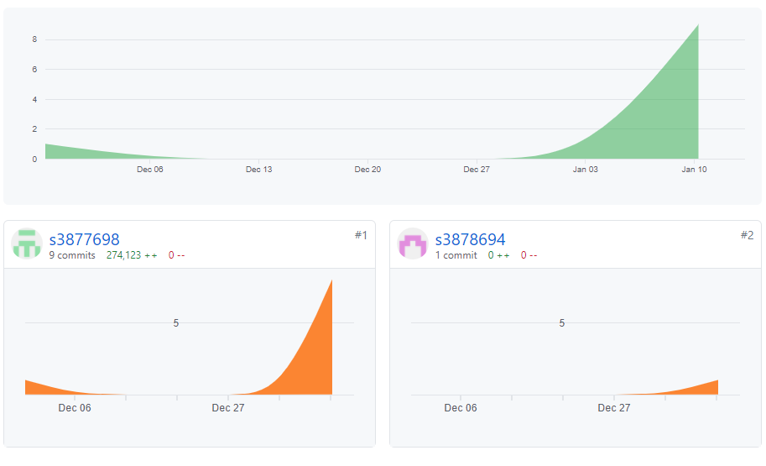
Overall, Github accurately reflects all of our group work and process until now. So far, only Long and Bao have commit and push to exchange files with each other. However, that does not mean the other group members do not contribute at all. As you can see, we started to create our group repository in around December 6th , but only until the late December that we start uploading files because at that point, we have finished all of our our tasks and begun to push the website into Github.

