R Markdown Library

Kevin Foley

2022-07-13

# R info… vectors and atomic vectors

vector <- stores item  
atomicVector <- c(“this”, “stores”, “lists”, “of”, “the”, “same”, “data”, “type”)  
atmomicVector2 <- c(1,2,3,4,5,6,7,8,9,0)  
**to change the element in a given spot in an atomicVector:**  
AtomicVector[3] <-9   typeof(vector)   
**To print out a variable, data frame**  
Write(variable_dataframe_ect, “destinationName.txt”)  
dev.print(pdf, “destination.pdf”)

## R dataFrames

df <- data.frame(firstColumn = c(“one”, “two”, “Three”), secondColumn = c(1,2,3), thirdColumn = c(“Some”, “Thing”, “Else”))  
view(df)

### to manipulate within the dataFrame:

df[3,3] ***this will display or allow you to manipulate the dataFrame[row, column]***  
df[3,2] <- “newValueOfSameType”

# to manipulate the data in a plot:

qplot (dataFrameName $desiredRow,dataFrameName$ desiredColumn)

# R Markdown Library

### Global library and .csv loading

beaver1 <- datasets :: beaver1  
library(tidyverse)  
library(readr)  
Marketing <- read.csv(“Marketing.csv”)

# script manipulation and manual line breaks

*italic* *italic*, **bold** **bold**. superscript2 ~~strikethrough~~

Comma at the end gives one spaces, while a period at the end. gives one space,  
but two blank spaces after a line begins a new line  
\does also

# header

## header

### header

#### header

# lists

* list_item1
* list_item2
  + item2a
  + item2b

1. list1
2. list2
   * item2a
   * item2b

# adding code inline and display equations

We go forth and multiply.  
This is how to 36.76 have inline code to access the element in the 20th row and 3rd column.

$$equation$$

$equation$

# operators

$2×2$ $2÷2$

# links

[List of free data sets](https://r-dir.com/reference/datasets.html)  
[Github](www.gethub.com)  
[StacksOverflow](www.stacksoverflow.com)  
[Hand-on Programming with R](https://rstudio-education.github.io/hopr/)  
[R CookBook](https://rc2e.com/)  
[R Markdown The Definitive Guide](https://bookdown.org/yihui/rmarkdown/)  
[Python Data Science](https://jakevdp.github.io/PythonDataScienceHandbook/)

# inbed images



This guy loves it!

# blockquotes

Beginning End

# plain code blocks

Displayed but not run

# Graphs with R markdown

#==Question2  
library(tidyverse)

## ── Attaching packages ─────────────────────────────────────── tidyverse 1.3.1 ──

## ✔ ggplot2 3.3.6 ✔ purrr 0.3.4  
## ✔ tibble 3.1.7 ✔ dplyr 1.0.9  
## ✔ tidyr 1.2.0 ✔ stringr 1.4.0  
## ✔ readr 2.1.2 ✔ forcats 0.5.1

## ── Conflicts ────────────────────────────────────────── tidyverse_conflicts() ──  
## ✖ dplyr::filter() masks stats::filter()  
## ✖ dplyr::lag() masks stats::lag()

sales <- c(50,150,200,100,300,250)  
month <- c(1,2,3,4,5,6)  
qplot(month,sales)

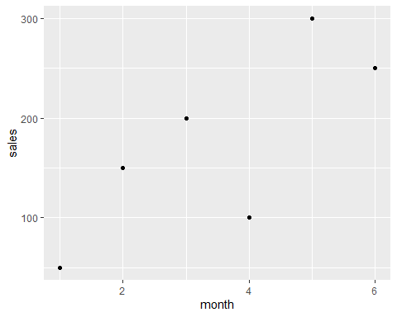

## do some more manipulations:

df1 <- data.frame(sales = c(50,150,200,100,300,250), month = c(1,2,3,4,5,6))  
What were the highest sales? max(df$sales), ” and in which month did those sales occur:“, which(max(df$sales)).

**finding the stores that are 22 years old, filtering out duplicates and showing the storeID for the stores that are 22 years old**

Marketing <- read.csv("Marketing.csv")  
Marketing2 <- Marketing  
Marketing2 <- Marketing[ which(Marketing$AgeOfStore == 22),]  
Marketing2 <- Marketing2[!duplicated(Marketing2$LocationID),]  
print(paste("The Stores that are 22 years old are:", Marketing2[1:3,3]))

## [1] "The Stores that are 22 years old are: 101"  
## [2] "The Stores that are 22 years old are: 103"  
## [3] "The Stores that are 22 years old are: 705"

WorkingWithDataFrames <- data.frame(month = c("Jan","Feb","Mar","Apr","May","Jun","Jul","Aug","Sep","Oct","Nov","Dec"),  
 sales = c(150.25, 258.54, 268.55, 122.52, 987, 458.82, 667.23, 845.54, 586.78, 888.58, 756.12, 456.84))  
  
WorkingWithDataFrames$month <- factor(WorkingWithDataFrames$month,level = month.abb)   
  
qplot(WorkingWithDataFrames$month, WorkingWithDataFrames$sales, color = WorkingWithDataFrames$sales, xlab = "Months", ylab = "Sales") + theme(legend.position = "none")

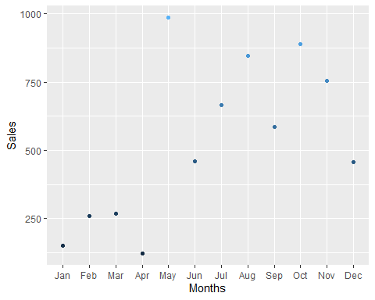

print(paste("Which month had the most sales?",which.max(WorkingWithDataFrames$sales)," and the sales were:",max(WorkingWithDataFrames$sales), "Which month had the least sales?",which.min(WorkingWithDataFrames$sales),"and the sales were:",min(WorkingWithDataFrames$sales)))

## [1] "Which month had the most sales? 5 and the sales were: 987 Which month had the least sales? 4 and the sales were: 122.52"