2 Đúng

Đúng 2

1.75

(i chạy từ 1 rồi mới tách)

Đúng (2)

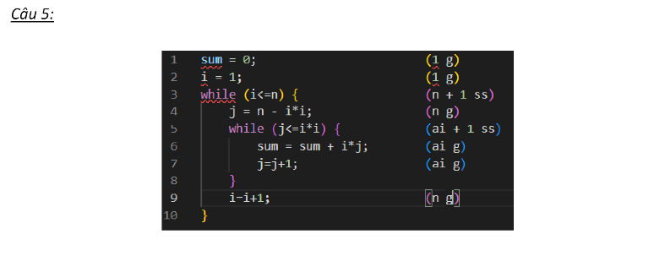

1.75

(i chạy từ 1 rồi mới tách)