## Bài 1:

### Bảng cơ sở dữ liệu quan hệ

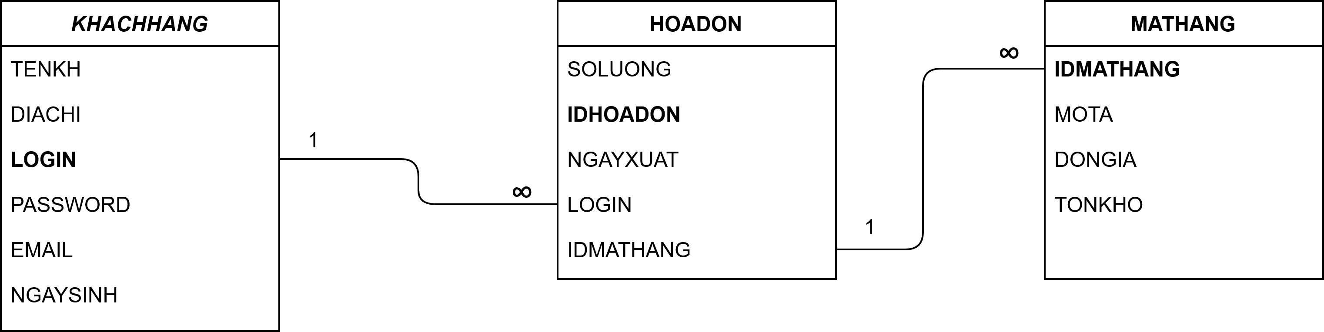

### Bảng sơ đồ ER

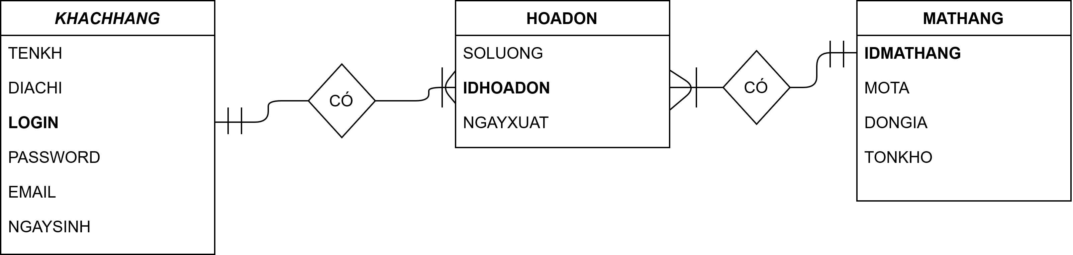

## Bài 5:

### Bảng cơ sở dữ liệu quan hệ

## https://www.draw.io/?open=G1UsBWpEgepS0NmgGBVpMWlLpWf78nVsUl&local-data=%7B%22type%22%3A%22Drive%22%2C%22id%22%3A%221UsBWpEgepS0NmgGBVpMWlLpWf78nVsUl%22%2C%22lastModifiedDate%22%3A%222020-05-19T15%3A48%3A17.372Z%22%2C%22pageId%22%3A%22C5RBs43oDa-KdzZeNtuy%22%2C%22layers%22%3A%5B0%5D%7D

### Bảng sơ đồ ER

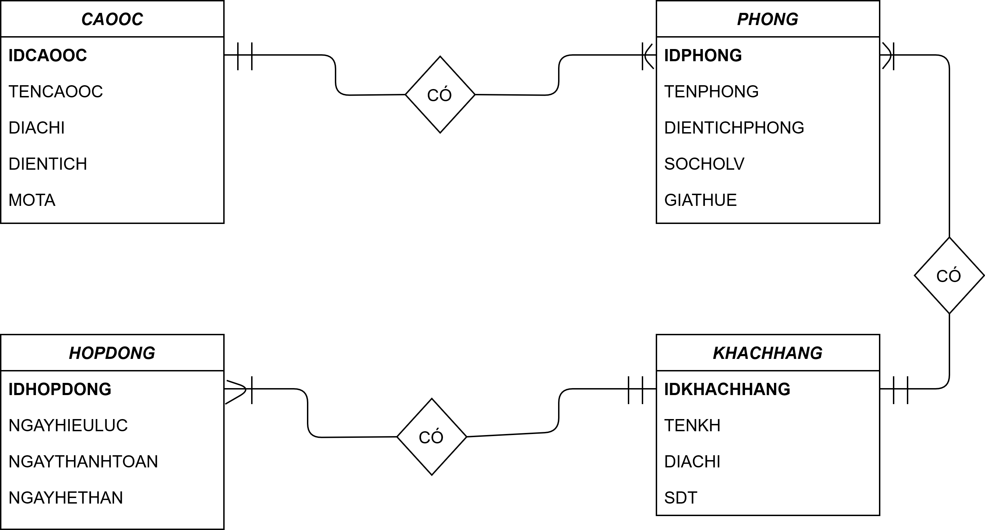

## Bài 9:

### Bảng cơ sở dữ liệu quan hệ

## https://www.draw.io/?open=G1UsBWpEgepS0NmgGBVpMWlLpWf78nVsUl&local-data=%7B%22type%22%3A%22Drive%22%2C%22id%22%3A%221UsBWpEgepS0NmgGBVpMWlLpWf78nVsUl%22%2C%22lastModifiedDate%22%3A%222020-05-19T15%3A48%3A17.372Z%22%2C%22pageId%22%3A%22C5RBs43oDa-KdzZeNtuy%22%2C%22layers%22%3A%5B0%5D%7D

### Bảng sơ đồ ER

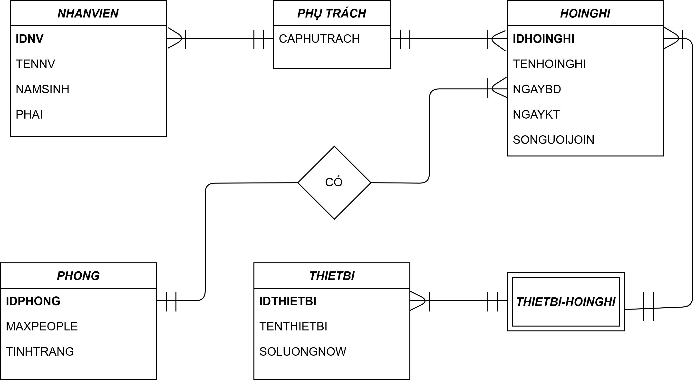

## Bài 10:

### Bảng cơ sở dữ liệu quan hệ

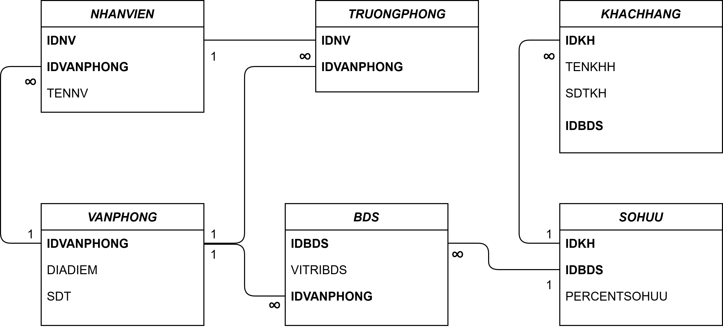

### Bảng sơ đồ ER

## https://www.draw.io/?open=G1UsBWpEgepS0NmgGBVpMWlLpWf78nVsUl&local-data=%7B%22type%22%3A%22Drive%22%2C%22id%22%3A%221UsBWpEgepS0NmgGBVpMWlLpWf78nVsUl%22%2C%22lastModifiedDate%22%3A%222020-05-19T15%3A48%3A17.372Z%22%2C%22pageId%22%3A%22C5RBs43oDa-KdzZeNtuy%22%2C%22layers%22%3A%5B0%5D%7D

