TOURISM EXPERIENCE ANALYTICS
Classification, Prediction, and Recommendation System
Complete Project Report

Deliverables: Data Cleaning • SQL • EDA • Regression • Classification • Recommendation • Streamlit
Generated from the supplied Tourism Dataset and project requirements
52,930 | 33,530 | 30 | 1,698
Transactions | Users | Historical attractions | Expanded catalog

Executive Summary
This project implements the complete tourism-analytics workflow in the supplied brief: data cleaning and preprocessing, exploratory data analysis (EDA), visualization, SQL analysis, rating regression, visit-mode classification, personalized recommendations, evaluation, and Streamlit deployment.
The historical dataset contains 52,930 visits from 33,530 users and 30 attractions with ratings. An additional updated catalog expands recommendation coverage to 1,698 attractions. The average rating is 4.158/5 and 45.22% of transactions are five-star ratings. Most users have only one interaction, which makes content-based recommendation particularly important.
XGBoost is the best tested supervised model for both tasks. Visit-mode classification achieves 49.0% held-out accuracy and 0.444 weighted F1. Rating regression achieves RMSE 0.902, MAE 0.710, and R² 0.136. Content-based recommendation produces the strongest MAP@10 (0.208), followed by hybrid (0.191) and collaborative-only (0.095).

1. Business Problem and Objectives
Tourism platforms need to understand travel behavior, estimate satisfaction, segment visitors, and recommend relevant attractions. The project addresses personalized recommendations, tourism analytics, customer segmentation, and retention-oriented use cases.
- Regression: predict attraction ratings on a 1–5 scale.
- Classification: predict visit mode (Business, Couples, Family, Friends, Solo).
- Recommendations: rank attractions from user history and attraction attributes.
- Analytics: identify popular attractions, segments, time patterns, geography patterns, and stakeholder actions.
- Deployment: expose predictions, recommendations, dashboards, metrics, and SQL analysis through Streamlit.

2. Dataset Assessment and Cleaning
The raw package includes transaction, user, geography, visit-mode, attraction-type, attraction item, and updated attraction-catalog tables. All 52,930 historical transactions map to valid supplied users and to one of the 30 historical attraction IDs.
Control | Result
Raw / clean transaction rows | 52,930 / 52,930
Exact transaction duplicates removed | 0
Missing user CityId values | 4 → mapped to placeholder 0
Historical attraction IDs | 30
Expanded catalog IDs | 1,698
Historical user join coverage | 100%
Historical attraction join coverage | 100%
Rating validation | 1–5
Visit month validation | 1–12

The expanded `Updated_Item.xlsx` file contains mixed type representations: the historical rows use numeric attraction-type IDs while 1,668 expanded rows use text labels such as Beach, Market, Museum, Park, and Temple. The project preserves the source value and derives safe text features instead of manufacturing unsupported numeric identifiers.

3. Exploratory Data Analysis
The EDA combines static figures, SQL summaries, and interactive Streamlit visualizations. Core findings are shown below.
KPI | Observed value
Average rating | 4.158 / 5
Median rating | 4.0
Five-star share | 45.22%
Largest visit mode | Couples (40.85%)
Peak year | 2016
Peak month | August
Most visited attraction | Sacred Monkey Forest Sanctuary (13,198 visits)
Highest-volume user continent | Asia

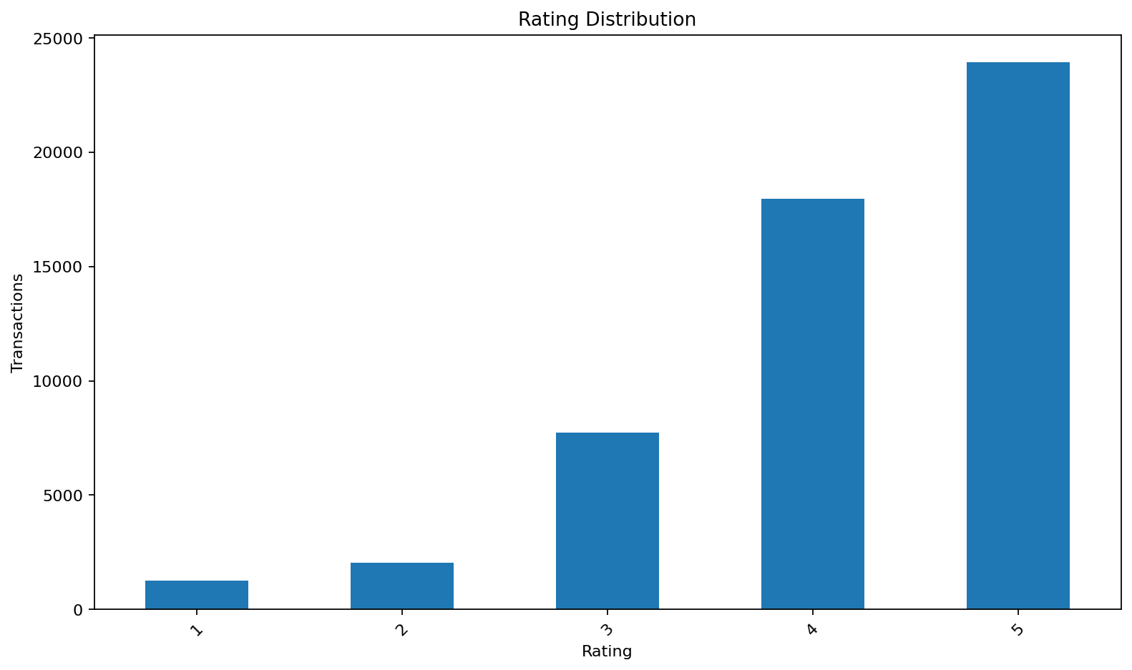
Figure 1. Rating distribution.
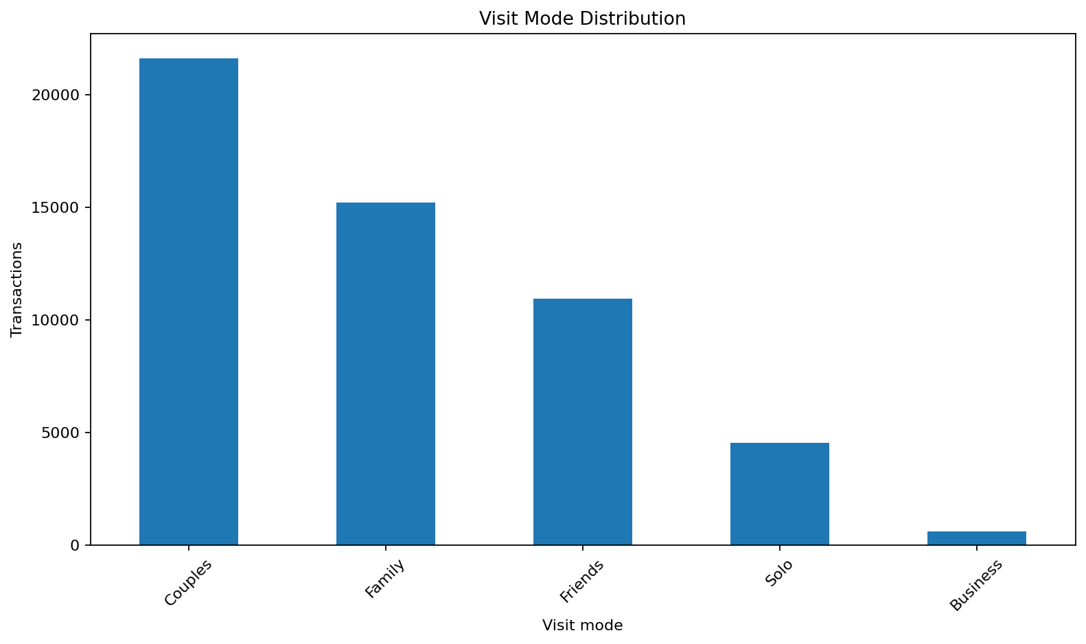
Figure 2. Visit-mode distribution.
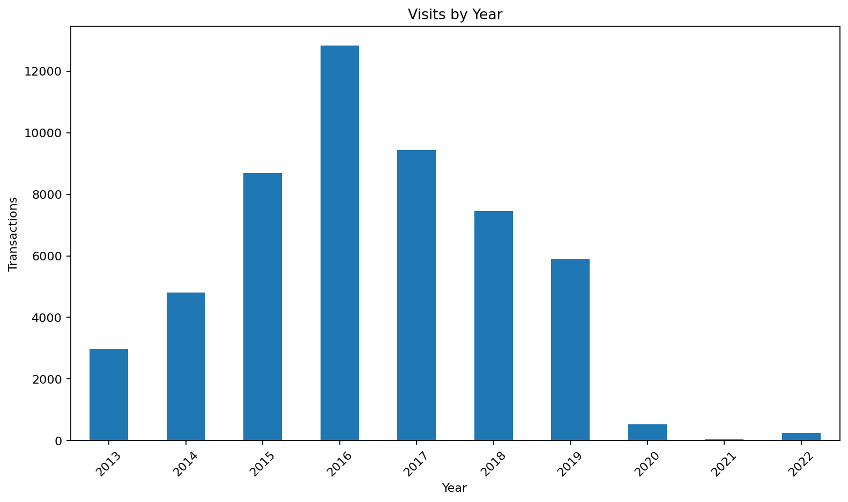
Figure 3. Historical visit volume by year.
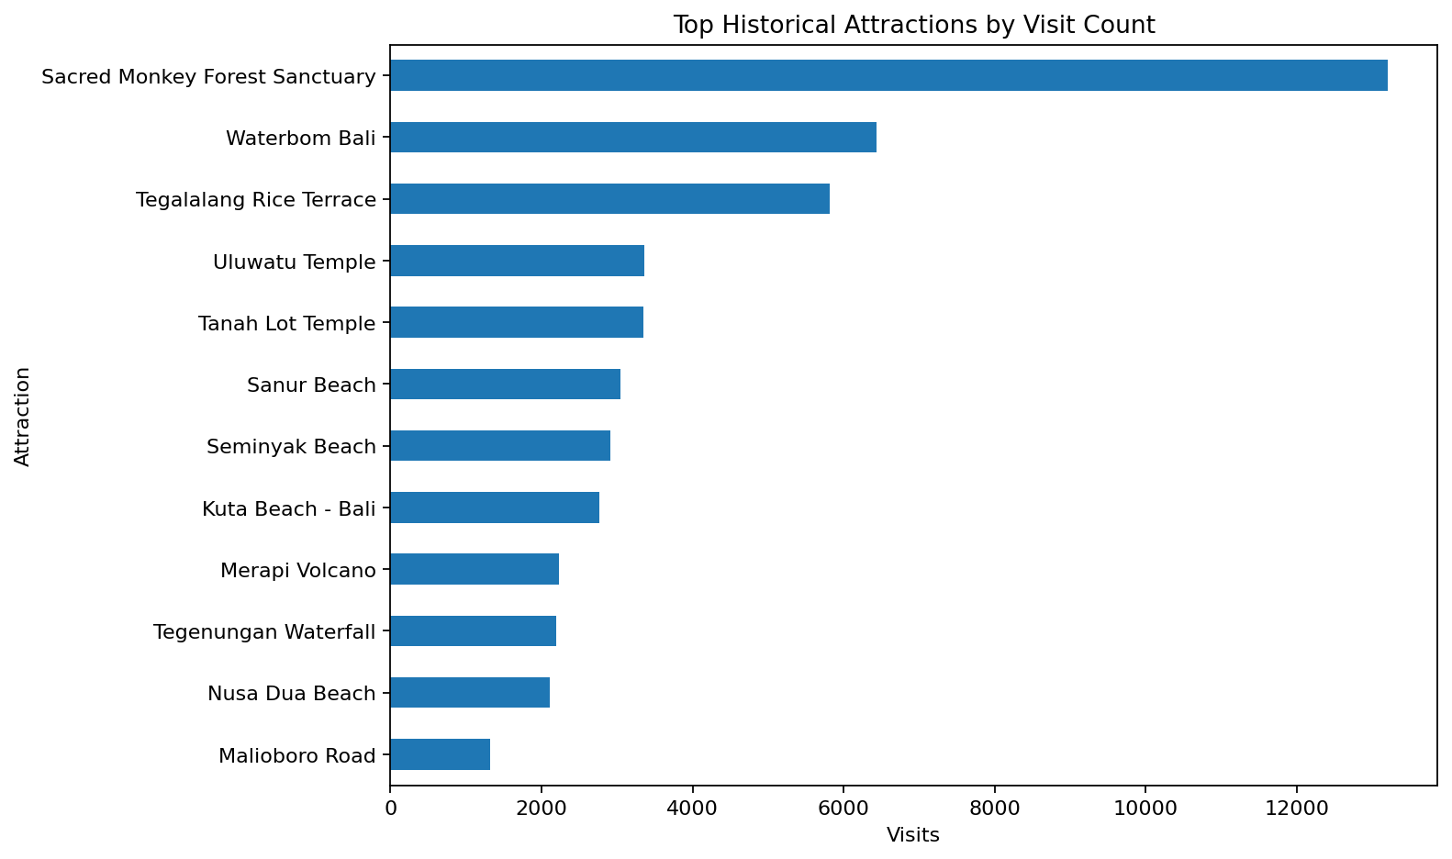
Figure 4. Top historical attractions by visit count.
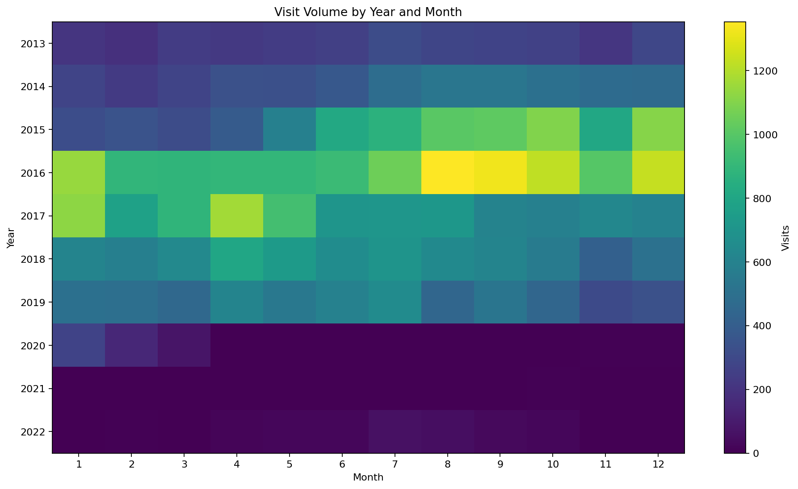
Figure 5. Year-month transaction-volume heatmap.
The sharp decline in recorded volume after 2019 is treated cautiously because the project has no evidence that the supplied data represents complete market coverage in those years.

4. SQL Analytics
The processed data is written to `database/tourism.db`. The SQL layer supports attraction ranking, segmentation, geography analysis, type performance, seasonality, and time-series summaries. The app includes a curated SQL Analytics page and the full query set is stored in `sql/analysis_queries.sql`.
Attraction | Visits | Average rating
Sacred Monkey Forest Sanctuary | 13,198 | 4.267
Waterbom Bali | 6,429 | 4.647
Tegalalang Rice Terrace | 5,815 | 4.158
Uluwatu Temple | 3,359 | 4.219
Tanah Lot Temple | 3,352 | 4.195

5. Visit-Mode Classification
Features include user geography, visit year/month, and attraction identity/type/location. Rating is excluded to avoid using information that would not be available at the time of visit-mode prediction; UserId is excluded to avoid identity memorization.
Model | Val. Accuracy | Val. Precision (weighted) | Val. Recall (weighted) | Val. F1 (weighted) | Val. F1 (macro)
XGBoost | 0.502 | 0.498 | 0.502 | 0.455 | 0.316
Random Forest | 0.448 | 0.463 | 0.448 | 0.453 | 0.348
Logistic Regression | 0.325 | 0.422 | 0.325 | 0.352 | 0.265

Selected model: XGBoost. Held-out test accuracy = 0.490, weighted precision = 0.480, weighted recall = 0.490, weighted F1 = 0.444, macro F1 = 0.294.
The model has useful segmentation signal but minority-class performance remains limited. The Streamlit app therefore presents class probabilities rather than hiding uncertainty.

6. Rating Regression
Regression uses the classification context plus VisitModeName. Three model families are compared on the same 70/15/15 design.
Model | Val. RMSE | Val. MSE | Val. MAE | Val. R²
XGBoost | 0.905 | 0.819 | 0.709 | 0.131
Random Forest | 0.913 | 0.833 | 0.713 | 0.116
Ridge Regression | 0.922 | 0.850 | 0.723 | 0.098

Selected model: XGBoost. Held-out test RMSE = 0.902, MSE = 0.814, MAE = 0.710, and R² = 0.136.
The modest R² is an important business result: individual satisfaction is only partly explained by the supplied geography/time/attraction variables. Richer trip, spend, amenities, party composition, weather, and review-text data would likely improve the model.

7. Recommendation System
The project implements collaborative, content-based, and hybrid recommendation. Collaborative filtering uses item-item rating similarity with mean-rating fallbacks. Content-based filtering creates user profiles from attraction type and location attributes and can rank the full 1,698-item catalog. Hybrid recommendation blends content, collaborative estimates, and Bayesian-smoothed popularity.
Metric | Result
Collaborative RMSE | 1.094
Collaborative MAP@10 | 0.095
Content MAP@10 | 0.208
Hybrid MAP@10 | 0.191
Leave-one-out test users | 10,618
MAP relevant-user evaluation sample | 1,000

Content-based recommendation performs best on MAP@10. This aligns with the data: 22,912 users have only one recorded interaction, so collaborative user histories are sparse, and only 30 attractions have transaction histories. Content features are therefore the strongest current mechanism for catalog expansion and cold-start support.

8. Streamlit Application
- Executive Dashboard: KPIs and tourism visualizations.
- Visit Mode Prediction: user/attraction inputs and class probabilities.
- Rating Prediction: 1–5 rating estimate.
- Recommendations: known-user content/collaborative/hybrid results plus cold-start preferences.
- Model Evaluation: comparison tables and held-out metrics.
- SQL Analytics: stakeholder queries and returned tables.
The application runs with `streamlit run app.py`. A Dockerfile is also included for container deployment.

9. Business Insights and Actionable Recommendations
- Use content-based recommendation as the primary method for the expanded catalog until more multi-attraction user histories are collected.
- Use visit-mode probabilities as marketing/segmentation inputs, not as hard rules, because class uncertainty is material.
- Protect and promote high-volume/high-satisfaction anchor attractions such as Waterbom Bali while preserving personalization.
- Investigate high-volume attraction categories with comparatively lower average ratings for service, expectation-setting, and audience-fit opportunities.
- Collect richer trip and experience context to strengthen rating prediction and explain individual satisfaction.
- Treat post-2019 volume changes as a dataset-coverage question before converting them into market conclusions.

10. Limitations
- Only 30 attractions have historical rating transactions.
- Most users have only one recorded interaction, creating a sparse collaborative matrix.
- Visit-mode classes are imbalanced; minority modes remain harder to classify.
- The expanded attraction-type field mixes numeric IDs and broad text labels.
- The rating model has modest R², indicating omitted preference and experience variables.
- No external validation is included; results describe the supplied dataset and evaluation splits.

11. Reproducibility and Deliverables
The project includes raw input files, cleaned CSVs, SQLite database, SQL queries, EDA figures, trained models, evaluation artifacts, Streamlit application, Dockerfile, tests, report, requirement checklist, data dictionary, presentation notes, and user guide.
The full pipeline can be regenerated with `python run_pipeline.py`. Automated quality checks run with `pytest -q`; the final submission test run completed with 4 passing tests.

12. Conclusion
The implementation completes the requested end-to-end workflow and explicitly connects technical outputs to tourism business use cases. The strongest current operational recommendation is to use content-based personalization for the expanded attraction catalog while collecting richer user histories and trip context. Predictive outputs are useful as decision-support signals but should be communicated with their measured uncertainty.

