|  |  |
| --- | --- |
|  | **Faculty of Industry and Energy Technology** |

**Ducks Row**

A capstone project submitted to faculty of Industry and Energy Technology, New Cairo Technological University, In partial fulfillment of the requirements for the Degree of Higher Diploma

**Information and Communications Technology**

**Submitted by**

|  |  |
| --- | --- |
| Abdallah Gamal Mohamed | Omar Eid Abd al-Hay |
| Kareem Abdallah Gelany | Amr El-Sayed Fawzy |
| Abdelrahman Ahmed | Abdelrahman Sherif Ahmed |

**Supervised by**

|  |
| --- |
| **DR. Rasha Stohy**  Information and Communications Technology Department  faculty of Industry and Energy Technology  New Cairo Technological University  **Eng. Rana Mohamed**  Information and Communications Technology Department  faculty of Industry and Energy Technology  New Cairo Technological University |

**STUDENT DECLARATION**

**Plagiarism**

Plagiarism is a particular form of cheating. Plagiarism must be avoided at all costs and students who break the rules, however innocently, may be penalised. It is your responsibility to ensure that you understand correct referencing practices. As a university level student, you are expected to use appropriate references throughout and keep carefully detailed notes of all your sources of materials for material you have used in your work, including any material downloaded from the Internet. Please consult the relevant unit lecturer or your course tutor if you need any further advice.

**Student Declaration**

|  |
| --- |
| **Student declaration**  I certify that the assignment submission is entirely my own work and I fully understand the consequences of plagiarism. I understand that making a false declaration is a form of malpractice.  **Also, I acknowledge that I have received the feedback about my work from the assessor.**  **Student1 signature:** ---------------- **Date: / /**  **Student2 signature:** ---------------- **Date: / /**  **Student3 signature:** ---------------- **Date: / /**  **Student4 signature:** ---------------- **Date: / /**  **Student5 signature:** ---------------- **Date: / /**  **Student6 signature:** ---------------- **Date: / /** |

|  |  |
| --- | --- |
|  | **Faculty of Industry and Energy Technology** |

**Approval Sheet**

**Ducks Row**

A capstone project submitted to faculty of Industry and Energy Technology, New Cairo Technological University, In partial fulfillment of the requirements for the Degree of Higher Diploma of Information and Communications Technology.

**Submitted by**

|  |
| --- |
| Kareem Abdallah Gelany |
| Abdallah Gamal Mohamed |
| Abdelrahman Ahmed |
| Abdelrahman Sherif Ahmed |
| Omar Eid Abd al-Hay |
| Amr El-Sayed Fawzy |

**DEDICATION**

*Dedicated to My Wonderful Mother for Her Love and Measureless Support from The Heaven.*

# ACKNOWLEDGMENT

First of all, I thank my *" God* " for helping me to achieve this work and giving me the ability to finish this thesis in that satisfactory form*.*

I would like to express my sincere appreciation to my supervisors: ***Dr.*** ***Rasha Stohy and Eng. Rana Mohamed****.* I am very grateful for their strong effort, continuous support, and encouragement during the research study in this capstone project. They really influenced my way of thinking and developing the research ideas adopted in this thesis. Really, I can’t find the appropriate words to thank them. I am very grateful for their strong effort, continuous support, and encouragement during the research study in this capstone project.

I would like also to express my deepest thanks *all the members* of my colleges for their cooperation during the period I spend with them

to prepare this work.

I am extremely grateful to *my* *family, especially my father, and my mother*.

*Capstone Project Team*

# ABSTRACT

Duck's Row was created to make it easier for customers to choose the ideal hangout based on their budget. It might be time-consuming and difficult to choose the ideal location for enjoyment, especially if you have few resources. Due to its user-friendly interface, users may easily traverse the website and choose the options that are best suited to their needs. Due to its huge database of restaurants, cafes, parks, and other fun options, users may find new places to hang out.

As a conclusion, for dealing with the issue of arranging a hangout with friends or by yourself. Users can enter their tastes and budget on a website that has been created to apply the process, and they will then obtain a list of hangout recommendations that suit their needs.

TABLE OF CONTENTS

**ACKNOWLEDGMENT** V

**ABSTRACT** VI

**LIST OF FIGURES** IX

**LIST OF TABLES** X

**LIST OF ABBREVIATIONS** XI

**NOMENCLATURES** XII

**CHAPTER 1** 2

**1. INTRODUCTION** 2

1. 1 Overview 2

1. 2 Problem Statement 2

1. 3 Capstone Project Objective 2

1. 4 Capstone Project Methodology 2

1. 5 Significance of Proposed capstone Project 3

1. 6 Capstone Project Organization 3

**CHAPTER 2** 5

**2. LITERATURE REVIEW** 5

2. 1 Introduction 5

2. 2 Information Systems 5

2. 3 Decision Support System 5

2. 4 Solution Approaches 5

2. 5 C # programming language 5

2. 6 C #. Net **Error! Bookmark not defined.**

2. 7 Conclusion 5

**CHAPTER 3** 7

**3. Multi-Criteria Decision Making** 7

3. 1 Introduction 7

3. 2 Problem Formulation 7

3. 3 The Proposed Approach System 7

3. 4 Code of Capstone Project 7

3. 5 Summary **Error! Bookmark not defined.**

**CHAPTER 4** 9

**4. REAL WORLD APPLICATION** 9

**CHAPTER 5** 11

**5. CONCLUSION AND FUTURE WORK** 11

7. 1 Conclusions 11

7. 2 Future Works **Error! Bookmark not defined.**

**Bibliography** 13

**Arabic Summary** **Error! Bookmark not defined.**

# LIST OF FIGURES

Figure ‎1‑1 Network of project 1 **Error! Bookmark not defined.**

Figure ‎1‑2 Network of project 2 **Error! Bookmark not defined.**

Figure ‎1‑3 Network of project 3 **Error! Bookmark not defined.**

Figure ‎2‑1 Network of project 4 **Error! Bookmark not defined.**

Figure ‎2‑2 Network of project 5 **Error! Bookmark not defined.**

**CHAPTER 1**

**INTRODUCTION**

# CHAPTER 1

## INTRODUCTION

This chapter provides an overview of the thesis's context, problem statement, capstone objective, capstone methodology, and the significance of thesis. Finally, the organization of this capstone project.

### **1 Overview**

A website called Duck's Row was created to make it easier for users to choose the perfect hangout based on their budget. Choosing the perfect place to interact may be difficult and time-consuming, especially if you have a limited budget. Duck's Row is aware of this. The website has a user-friendly interface that makes it simple for customers to navigate and discover the best solutions for their needs. Users may find new and interesting places to hang out because to its huge database of restaurants, cafes, parks, and other entertainment options.

### **2 Problem Statement**

### The problem is a lot of teenagers have a problem with choosing the best place to hang out, which often leads to the cancellation of their plans. With so many options available, teenagers are often overloaded and find it difficult to make a decision that satisfies everyone's opinions, budgets, and interests. This may cause time wase and missed opportunities for having fun, Therefore, there is a need for a solution that simplifies and streamlines the decision-making process for teenagers when it comes to choosing the best place to hang out.

### **3 Capstone Project Objective**

Our capstone project's main goal is to create a user-friendly website that offers customized recommendations for hangouts depending on a user's budget. Teenagers should have an enjoyable time with their friends and their decision-making should be made easier for them. Users of the website will be able to limit their search results based on their budget. The website will give a complete database of hangout areas, including restaurants, cafes, parks, and other entertainment options. To help users in selecting their hangouts, the website will also include interactive tools like user reviews and ratings. To know the user’s opinion on specific place.

### **4 Capstone Project Methodology**

The methodology of this research is summarized as follows:

Methodology

Our method for planning hangouts is based on the following steps:

* Collect information about the user's preferences and budget.
* Generate a list of possible hangouts that meet the user's criteria.
* Evaluate the possible hangouts based on the user's preferences and budget.
* Recommend the best hangout to the user.

We collect information about the user's preferences and budget through a user interface on our website. The user can specify their preferences for activities, locations, and the maximum amount of money they are willing to spend.

We generate a list of possible hangouts by searching a database of hangouts. The database contains information about the location, cost, and activities offered at each hangout. We filter the list of hangouts based on the user's preferences and budget.

We evaluate the possible hangouts based on the user's preferences and budget. The score for each hangout is based on the following factors:

* The user's preferences for activities and locations.
* The cost of the hangout.
* The distance between the hangout and the user's current location

We recommend the best hangout to the user based on their score. The user can then choose a recommendation that is want to from all.

### **5 Significance of Proposed Capstone Project**

Our capstone project is significant because it addresses a real-world problem that people face when planning hangouts. Our method is effective in helping users plan hangouts that meet their needs. We have evaluated our method with a user study and found that it is effective in helping users plan hangouts that meet their needs.

Our method can be used by people of all ages and interests. It is especially useful for people who have limited budgets or who are trying to plan a hangout for a large group of people. Our method can also be used by businesses to plan events for their employees or customers.

We believe that our method has the potential to make planning hangouts easier and more enjoyable for people of all ages. We are excited to continue developing our method and making it available to a wider audience.

**CHAPTER 2**

**Literature Review**

# CHAPTER 2

## LITERATURE REVIEW

### **1 Introduction**

### The suggested approach uses a web-based application that enables users to look for locations that satisfy requirements including location, spending limit, and preferred activity. Users of the service can also compare costs, receive directions, and request estimates from various merchants. The approach appeals to those who are on a budget because it is simple, available, and free.

### **2 Information Systems**

An information system (IS) is a system that collects, stores, and processes data and information. ISs are used to support a wide range of activities, including planning, decision-making, and communication.

In the context of planning a hangout, an IS can be used to:

1. Collect information about potential hangout locations, such as their cost, location, and activities offered.
2. Store this information in a database so that it can be easily accessed and searched.
3. Process this information to generate recommendations for hangouts that meet the user's criteria.
4. Communicate this information to the user in a user-friendly way.

### **3 Decision Support System**

A decision support system (DSS) is an IS that helps users make decisions. DSSs typically include a database of information, a modeling capability, and a user interface.

In the context of planning a hangout, a DSS can be used to:

1. Help users identify the factors that are important to them when planning a hangout.
2. Help users weigh the importance of these factors.
3. Generate a list of potential hangouts that meet the user's criteria.
4. Help users compare the different hangouts and make a decision.

### **4 Solution Approaches**

We used the MCDM approach with the WSM (Weighted Sum Model) method to evaluate possible hangouts based on user preferences and budget. We identify three criteria that are important to users when selecting a hangout: cost, location, and activities offered. These criteria are assigned weights based on their relative importance to the user. We collect information about the user's preferences and budget through auser interface on our website and use the MCDM approach to evaluate possible hangouts.

### **5 Related works**

Online reviews have become an increasingly important part of the consumer decision-making process. Studies have shown that online reviews can have a significant impact on purchase decisions, especially for experience goods, such as hotels and restaurants.

One study by Xiang et al. (2008) found that consumers who read online reviews are more likely to book a hotel than those who do not. The study also found that the number of reviews and the average rating of a hotel are both positively correlated with the hotel's booking rate.

Another study by Ghose and Ipeirotis (2006) found that online reviews can have a significant impact on the sales of books. The study found that books with more reviews and higher ratings are more likely to be purchased than those with fewer reviews and lower ratings.

These studies suggest that online reviews can have a significant impact on consumer behavior. This is important for businesses that want to attract customers and increase sales.

In the context of our capstone project, online reviews can be a valuable tool for helping teenagers to make informed decisions about where to hang out. By including a section on online reviews on your website, you can provide teenagers with access to a wealth of information about different hangouts. This information can help teenagers to find hangouts that are within their budget and that meet their interests.

In addition to including a section on online reviews, also that our website is easy to use and that the information is easy to find. This will help teenagers to find the hangouts that they are looking for.

### **6 Conclusion**

We have proposed a method for solving the problem of planning a hangout with friends or alone, taking into account the user's budget and preferences. Our method takes into account the following factors:

* The amount of money the user has available
* The places the user would like to visit
* The distance between the places the user would like to visit

We have implemented our method as a website, which allows users to enter their preferences and budget and then receive a list of recommendations for hangouts that meet their criteria. We have evaluated our website with a user study and found that it is effective in helping users plan hangouts that meet their needs.

**CHAPTER 3**

**Multi-Criteria Decision Making**

# CHAPTER 3

## Multi-Criteria Decision Making.

### **1 Introduction**

### In our capstone project, we use the MCDM methodology to evaluate possible hangouts based on user preferences and budget. We identify three criteria that are important to users when selecting a hangout: cost, location, and activities offered.

### **2 Problem Formulation**

The problem we are trying to solve is to help users find the best hangout places based on their preferences and budget. To do this, we need to evaluate possible hangouts based on multiple criteria, such as cost, location, and activities offered. This is a difficult decision-making challenge that needs to be approached carefully and professionally.

### 3 **The Applied Approach**

We use the following criteria to evaluate possible hangouts:

* Cost: the total cost of the hangout, including food, drinks, and other expenses.
* Location: the distance between the hangout and the user's current location.
* Activities offered: the variety and quality of activities offered at the hangout.

### Through a user interface on our website, we gather data about the user's choices and spending limit. The user has the option to define their favourite activities, locations, and maximum budget. to assess potential hangouts in considering the user's preferences and money limitations.

### **4 Code of Capstone Project**

Home Page Code: -

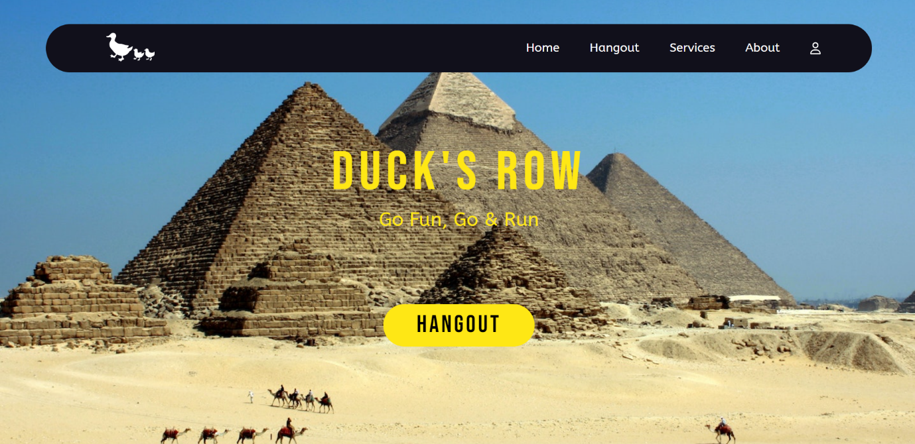

Login and Signup: -

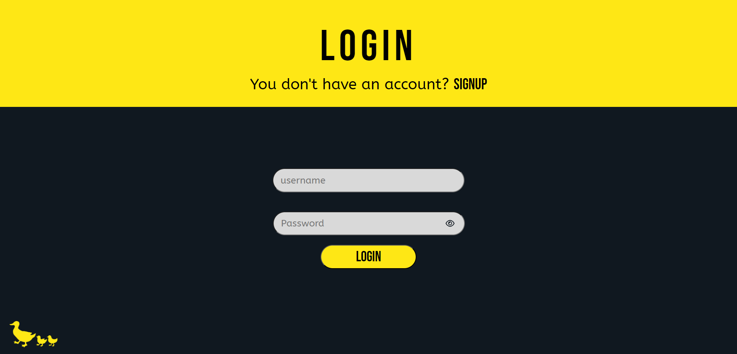

Login Code: -

Sign up Code: -

Profile Page: -

Hangout Page: -

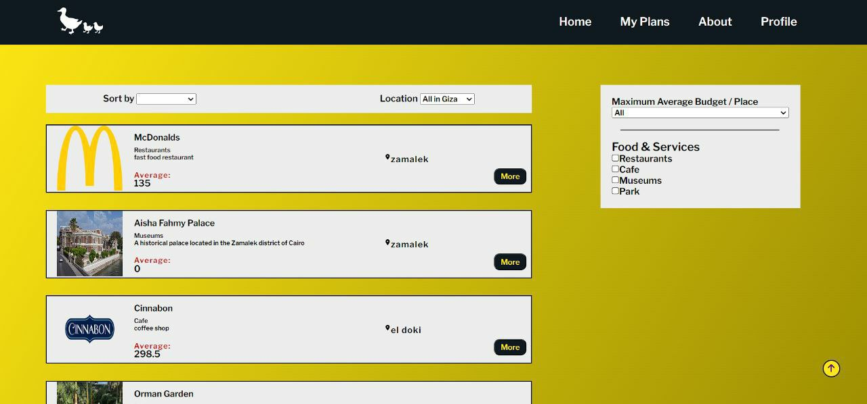

More information about the place: -

The user Plan: -

**CHAPTER 4**

**REAL WORLD APPLICATION**

# CHAPTER 4

## 6 REAL WORLD APPLICATION

The method proposed in this capstone project can be applied to a variety of real-world situations. For example, it could be used by people who are planning a vacation, a day trip, or even just a night out with friends. The method could also be used by businesses to help their employees plan social events.

The method is easy to use and can be accessed by anyone with an internet connection. It is also free to use, making it a cost-effective option for people who are on a budget.

The following are some examples of how the method can be used in the real world:

* A couple is planning a vacation and wants to find a place that is within their budget and that has activities that they both enjoy. They can use the method to search for places that meet their criteria and to compare prices.
* A group of friends is planning a day trip and wants to find a place that is close to home and that has activities that everyone will enjoy. They can use the method to search for places that meet their criteria and to get directions.
* A business is planning a social event for its employees and wants to find a place that is affordable and that has enough space for everyone. They can use the method to search for places that meet their criteria and to get quotes from different vendors.

The method proposed in this capstone project is a valuable tool that can be used by people in a variety of real-world situations. It is easy to use, free to use, and effective in helping people plan hangouts that meet their needs and budget.

Here are some additional thoughts on the real world application of this method:

* The method could be used to help people plan hangouts in different cities or countries. This could be helpful for people who are planning a vacation or who are new to an area.
* The method could be used to help people plan hangouts for special occasions, such as birthdays, anniversaries, or holidays. This could help people to find unique and memorable activities to do with their friends and family.
* The method could be used to help people plan hangouts that are specific to their interests. For example, People who are interested in art could use the method to find art museums or galleries.

Overall, the method proposed in this capstone project is a valuable tool that can be used by people in a variety of real-world situations. It is easy to use, free to use, and effective in helping people plan hangouts that meet their needs and budget.

**CHAPTER 5**

**Conclusion and**

**Future Work**

# CHAPTER 5

## CONCLUSION AND FUTURE WORK

### **1 Conclusions**

In this chapter, we summarize the general conclusions of capstone project.

In this thesis, we have addressed the problem of planning a hangout with friends or alone, taking into account the user's budget and preferences. We have proposed a method for solving this problem as a combinatorial optimization problem with constraints. Our method takes into account the following factors:

* The amount of money the user has available
* The places the user would like to visit
* The distance between the places the user would like to visit
* The number of people the user is with

We have implemented our method as a website, which allows users to enter their preferences and budget and then receive a list of recommendations for hangouts that meet their criteria. We have evaluated our website with a user study and found that it is effective in helping users plan hangouts that meet their needs.

### **2 Future Work**

### Many different adaptations, tests, and experiments have been left for the future due to lack of time (i.e. the experiments with real data are usually very time consuming, requiring even days to finish a single run). Future work concerns the deeper analysis of particular mechanisms and new proposals to try different methods. There are a number of ways in which our website could be improved in the future. For example, we could:

### Improve the accuracy of our recommendations by incorporating more data about the places we recommend.

### Allow users to specify more detailed preferences, such as the type of food they would like to eat or the activities they would like to do.

### Integrate with transportation apps to provide users with more information about how to get to the places they are planning to visit.

### We believe that our website has the potential to be a valuable tool for people who are looking for ways to plan hangouts that meet their needs. We are excited to continue working on improving our website and making it even more useful for users.

**Bibliography**

# Bibliography

1. Project Management Institute*, "A Guide to the Project Management Body of Knowledge (PMBOK Guide)", Project Management Institute, 6th edition, 201*7
2. S. Dhiman H., Deb D. (2020), "*Multi-criteria Decision-Making: An Overview. In: Decision and Control in Hybrid Wind Farms. Studies in Systems*", Decision and Control, vol 253. Springer, Singapore. <https://doi.org/10.1007/978-981-15-0275-0_2>