Specification book

Subject of the order: DuckTalk WebGui
Class: 4AHIT
School year: 2022/23
- Project team
Name | Individual task | Username | E-Mail
Alexander Rath-Kienreich | Backend | rath190134 | rath190134@ sr.htlweiz.at
Simon Puntigam | Frontend | puntig190080 | puntig190080 @sr.htlweiz.at
- Contact Person
Role | Name | Phone number | E-Mail
Customer | Robert Ulmer |  | robert.ulmer@htlweiz.at
- Versions
Ver. | Date | Authors | Reason for change / Remark | git-tag
0.1 | 09.03.2023 | KZ1, KZ2 | Initial creation as a discussion template
0.2 |  | KZ1 | First revision
1.0 |  | KZ2 | Final version as a basis for discussion
1.1 |  | KZ1, KZ2 | Final version
- Certification
Date | Customer | Date | Team

- Table of Contents
Inhalt
1. Project team 1
2. Contact Person 1
3. Versions 1
4. Certification 1
5. Table of Contents 2
6. General – purpose and aim of this document 2
6.1. Investigation concerns of the individual topic 2
6.2. Objective 2
6.3. Planned result 2
6.4. Project reference 2
7. Target criteria 2
7.1. Hardware specification 2
7.1.1. Human Machine Interface (HMI) 3
7.2. Software specification 3
8. extended target or desire criteria 3
9. Efforts 3
9.1. Timing milestones in project execution 3
9.1.1. diploma student 1 4
9.1.2. diploma student 2 4
9.2. Financial expenses 4

- General – purpose and aim of this document
This document records the work to be done as part of the project. Concrete cases are explicitly included or excluded. For a better overview the appendix contains a key word list of the work to be done. The requirements are divided into mandatory and optional points.
The implementation is not discussed in the specification book
  - Investigation concerns of the individual topic
It is part of a bigger project and this is the Web

In this project an Android-App is created for stocktaking in a hardware store. The App scans a barcode and checks the database if the stock in the store is right, if not the App has to tell how many items are missing or too much. The database in the background has the right number of items it needs to be able to remove item and add new items. Save the users how scans were stocktaking.
  - Objective
- Access to the camera for Barcode scan. o Order the barcodes to the right products.
- Database with the items of the store.
o Add function for new products o Remove function for sold products
- Function to check which items are missing
- Database for the user
  - Planned result
The planned result is a mobile app which connects to a backend server and shows inventory of a hardware store, you can also scan QR Codes to add new products.
  - Project reference
A stocktaking App for hardware shops, you should scan the barcode and it will check how many items should be there. I will be used in hardware stores to do some stocktaking.

- Target criteria
  - Hardware specification
- Server, android mobile device
- You can access the server from everywhere but on the server its permanently installed
    - Human Machine Interface (HMI)
• User can scan QR Codes to add new products, View existing Products
  - Software specification
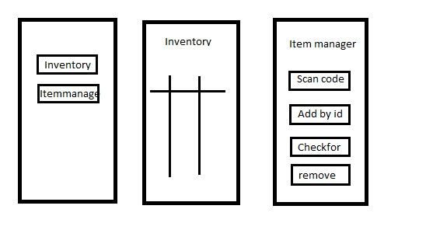
Here is described how the software should be structured, respectively what the device should be able to do software-wise!
- Python Backend, Kotlin Frontend
- Backend scan for barcodes, database to save the inventory of the store
- Frontend output of existing items, scan for barcodes
- Database for different users

- extended target or desire criteria
- Make the app more beautiful
- Develop App for IOS
- Efforts
  - Timing milestones in project execution
Estimation of the time required for the project implementation based on a simple tabular project schedule.
The planning does not have to be particularly detailed at the beginning. It can be refined later. A graphic from MS Project can also be inserted here.
    - diploma student 1
Date | Milestone
15.09.2022 | Connection in between Client and server
?? | Get a List of entries from the server to the mobile Device
    - diploma student 2
Datum | Milestone
  - Financial expenses
List of HW and SW components with initial estimate of costs.
Pos. | Description | Source of supply | Costs
1
2

List of figures
Bild 1: Blockschaltbild der HardwareFehler! Textmarke nicht definiert.
Bild 2: Detailschaltbild der HardwareFehler! Textmarke nicht definiert.
Bild 3: Beschreibung des Human Machine InterfacesFehler! Textmarke nicht definiert.
Bild 4: Struktogramm der SoftwareFehler! Textmarke nicht definiert.
Bild 5: ZustandsdiagrammFehler! Textmarke nicht definiert.
Bild 6: Beschreibung des Human Machine InterfacesFehler! Textmarke nicht definiert.

