ELECTRIC VEHICLE MARKET
PERFORMANCE & INSIGHTS
Project Documentation & Technical Report

Project detail | Information
Prepared by | Tanish Jain
Visualization platform | Tableau Public
Web integration | Python, Flask, HTML/CSS
Version control | GitHub
Data Analytics with Tableau

1. Executive Summary
This project explores electric-vehicle (EV) market data using Tableau Public. Seven worksheets examine sales trends, manufacturer sales, vehicle-category sales, battery-type distribution, price versus range, customer-rating distribution, and average range by category. The worksheets are combined in a dashboard and published to Tableau Public. A Flask web application embeds the published Tableau content, and GitHub hosts the application source and project documentation.

2. Problem Statement and Objectives
Raw EV data contains many attributes that are difficult to compare by reading individual rows. The project uses visual analytics to summarise the data and make comparisons easier to explore.
- Compare sales across model years and manufacturers.
- Compare aggregated sales across vehicle categories.
- Summarise the dataset's battery-type and customer-rating distributions.
- Explore category-level average price and range.
- Combine the worksheets into a dashboard and guided Story.
- Embed the published Tableau Story in a Flask website.

3. Tools and Technologies
Tool | Use
Tableau Public | Worksheets, dashboard, Story, and publishing.
Python | Application programming language.
Flask | Serves the website.
HTML/CSS | Page structure, navigation, and visual styling.
GitHub | Source control and project sharing.

4. Data Collection and Dataset
The analysis uses the college-provided file ev_market_train.csv. Fields visible in the workbook include Vehicle Id, Model Name, Manufacturer, Model Year, Manufacturing Country, Market Region, Category, Battery Capacity Kwh, Battery Type, Range Km, Efficiency Wh Per Km, Price Usd, Annual Sales Units, and Customer Rating, among others.
The Tableau status bar during development indicated approximately 200,000 records. Confirm the final row count in the data source before submission. If a second college-provided file was used, record its filename and role here.

5. Data Preparation Workflow
- Connect Tableau Public to the supplied CSV file.
- Review field names and data types; use categorical dimensions such as Manufacturer, Category, and Battery Type, and numerical measures such as Price Usd, Range Km, and Annual Sales Units.
- Use aggregations appropriate to each chart: SUM for annual sales, AVG for category-level price/range comparisons, and record count for battery-type distribution.
- Inspect visualizations for unexpected values. The customer-rating histogram shows a Null bin, which should be checked and described accurately.
- Arrange worksheets in the dashboard and publish the Story.
Report only cleaning steps that were actually performed. Do not claim that missing values or duplicates were removed unless that action was completed.

6. Visualizations
# | Worksheet | Unique chart type | Fields / purpose
1 | Sales Trend | Line chart | Model Year vs SUM(Annual Sales Units); compares aggregated sales across years.
2 | Top Manufacturers | Horizontal bar chart | Manufacturer vs SUM(Annual Sales Units); compares manufacturers.
3 | Category Sales | Treemap | Category and SUM(Annual Sales Units); rectangle size represents category sales.
4 | Battery Distribution | Pie chart | Battery Type and record count; slices compare the count of records by battery type.
5 | Price vs Range | Scatter plot | AVG(Price Usd) vs AVG(Range Km), coloured by Category; compares category-level averages.
6 | Customer Rating Distribution | Histogram | Customer Rating bins and record count; shows rating frequency.
7 | Average Range by Category | Packed bubbles | Category and AVG(Range Km); bubble size represents average range.
The three changed charts are Treemap, Pie Chart, and Packed Bubbles. Confirm the dashboard and published view show these chart types after republishing.

7. Dashboard
The dashboard titled “EV Market Performance Dashboard” combines the seven worksheets. It provides an overview of sales over time, manufacturer and category comparisons, battery-type distribution, price/range comparisons, rating frequencies, and average range by category.
During development, some worksheets displayed internal scroll bars or clipped labels. Review the final dashboard at a suitable size and adjust the layout if needed so labels are readable.
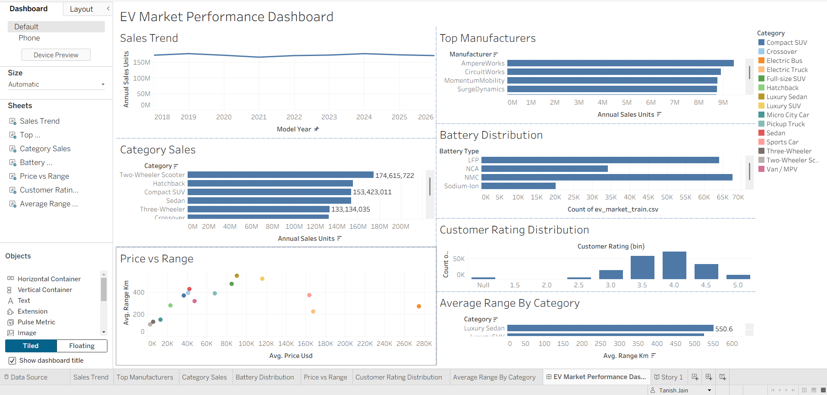
Figure 1. Dashboard screenshot captured during development; update this figure if the final layout differs.

8. Tableau Story and Published Link
The Tableau Story presents the dashboard with story points for guiding viewers through the EV market analysis.
Published Tableau dashboard:
https://public.tableau.com/app/profile/tanish.jain5883/viz/EV_Market_Performance_Dashboard_17932037663110/EVMarketPerformanceDashboard?publish=yes
Before submission, open this URL in a private/incognito browser window and verify that the dashboard loads and all three updated chart types appear.

9. Flask Web Integration
A Flask application serves the EV Insights website and embeds the published Tableau Story in the page. The site includes navigation and a direct link to Tableau Public.
Local test address: http://127.0.0.1:5000
To run on Windows: open a terminal in the project folder, run `py -m pip install -r requirements.txt`, then `py app.py`, and open `http://127.0.0.1:5000` in a browser. The terminal must remain open. The localhost URL is available on the local computer only; it is not a public hosting link.
Insert a screenshot of the Flask page with the embedded Story visible.

10. GitHub Repository
Repository: https://github.com/DuckThatCodes/EV-Market-Performance
The repository contains the Flask application, template, requirements file, README, and Git configuration. Include the packaged Tableau workbook (.twbx) and final report in the repository if they are not already present and the file size is within GitHub's limits.

11. Performance Testing
Complete this section using the final college dataset. Do not reuse results from the earlier synthetic dataset or invent measurements.
Test / metric | What to record | Evidence
Data volume | Exact row count in final Tableau data source; development status bar showed about 200,000 records. | Data Source or status-bar screenshot.
Filter utilization | List actual worksheet/dashboard filters; distinguish filters from colour legends. | Filters shelf and dashboard filter-card screenshot.
Calculated fields | Count calculated fields in the final workbook. | Data pane evidence.
Visualization count | 7 worksheets; now intended to use 7 distinct chart types. | Worksheet tabs and dashboard screenshot.
Rendering / interaction | Record whether dashboard and Story load, and whether any filters respond. Record timing only if actually measured. | Screenshot and brief test notes.
Results summary: [Fill with verified results and any observed limitations.]

12. Findings, Limitations, and Future Work
The dashboard brings several EV attributes into one interactive view. Use the actual chart values to state specific findings; avoid making claims that are not supported by the workbook.
- Check the Null bin in the customer-rating histogram.
- Verify that the model year 2026 is valid in the supplied data.
- Ensure chart labels are not clipped in the final dashboard.
- Verify that the seven unique chart types remain visible after publication.
- The Flask app has been tested locally; public hosting has not been established.

13. Conclusion
The project demonstrates a workflow from loading a supplied dataset and creating visualizations in Tableau, to assembling and publishing a dashboard/Story and embedding it in a Flask website. The final submission should include screenshots, verified performance-test results, the source repository, and the required explanation video.

Appendix A — Submission Checklist
- Verify the final Tableau Public dashboard and Story in a private browser window.
- Confirm the final dataset row count and document actual data-preparation steps.
- Verify the three changed chart types: treemap, pie chart, packed bubbles.
- Add screenshots of Tableau, Flask, GitHub, and performance tests.
- Complete the performance-testing table with real results.
- Add the final report to the GitHub repository.
- Record the required 5–7 minute screen-share explanation video.
- Confirm the GitHub and Tableau links are accessible to the instructor.

Appendix: Project Screenshots and Implementation Evidence
The following screenshots document the dataset connection, Tableau analysis, story, web integration, and source-code repository used in this project.
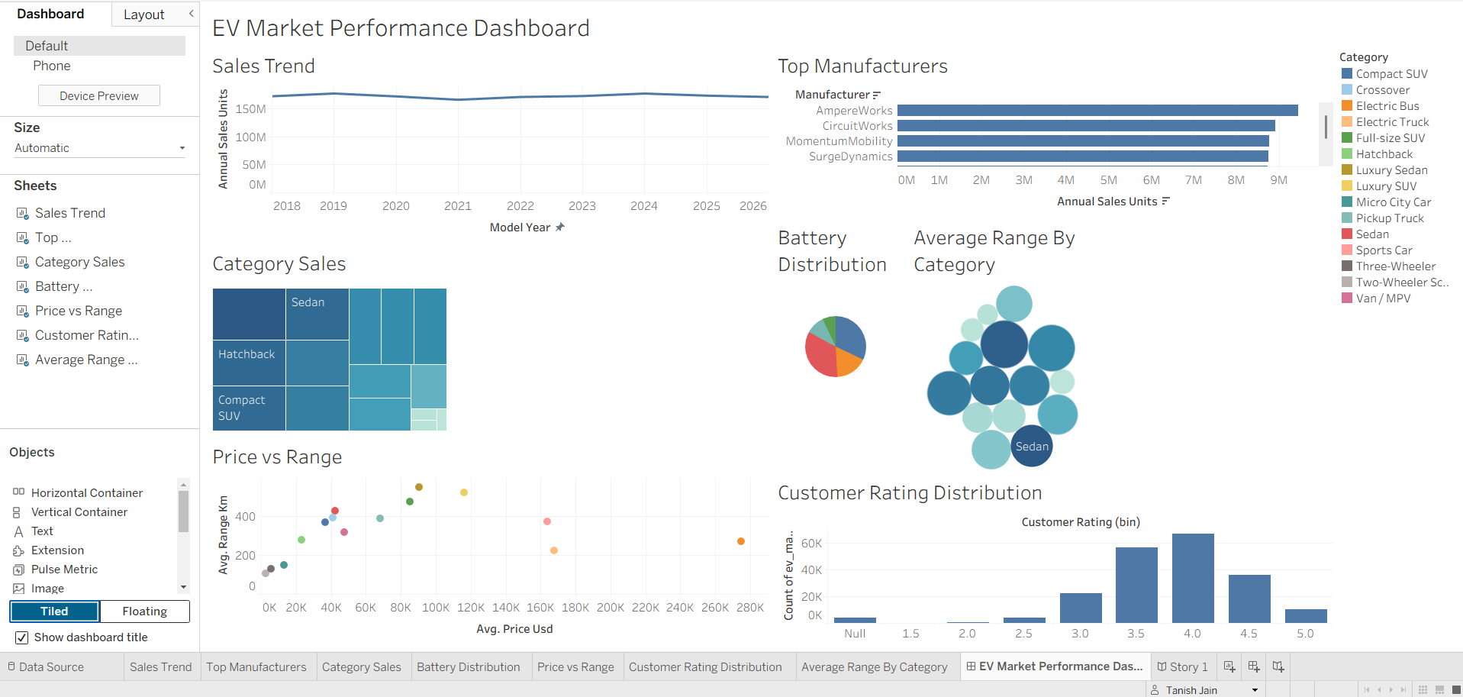
Figure 1. Figure: EV Market Performance Dashboard in Tableau.

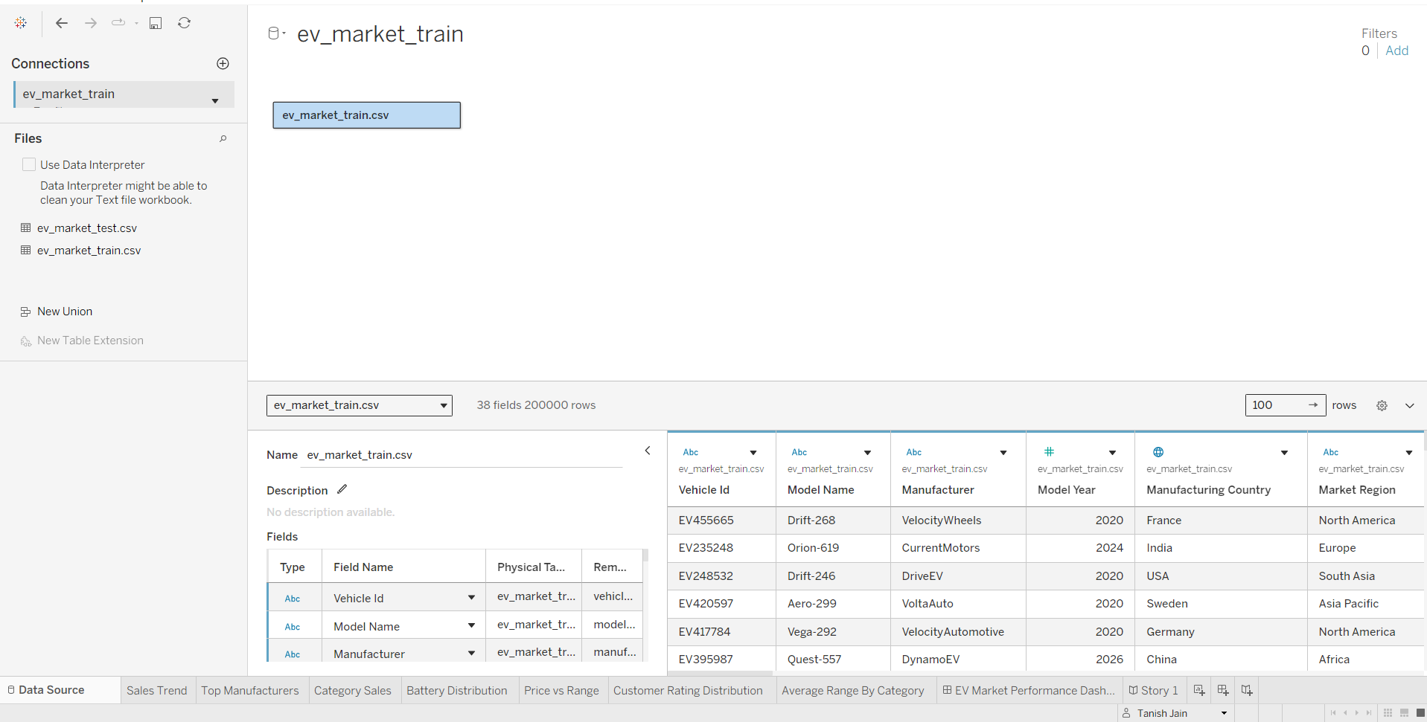
Figure 2. Figure: Dataset connected in Tableau — 38 fields and 200,000 rows.

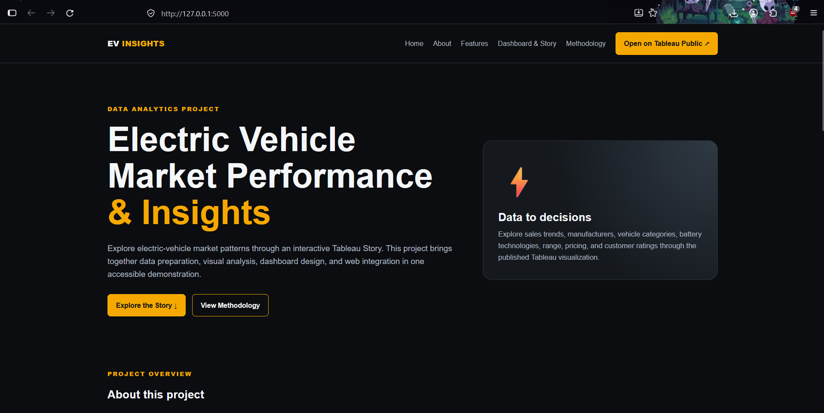
Figure 3. Figure: Flask web application landing page.

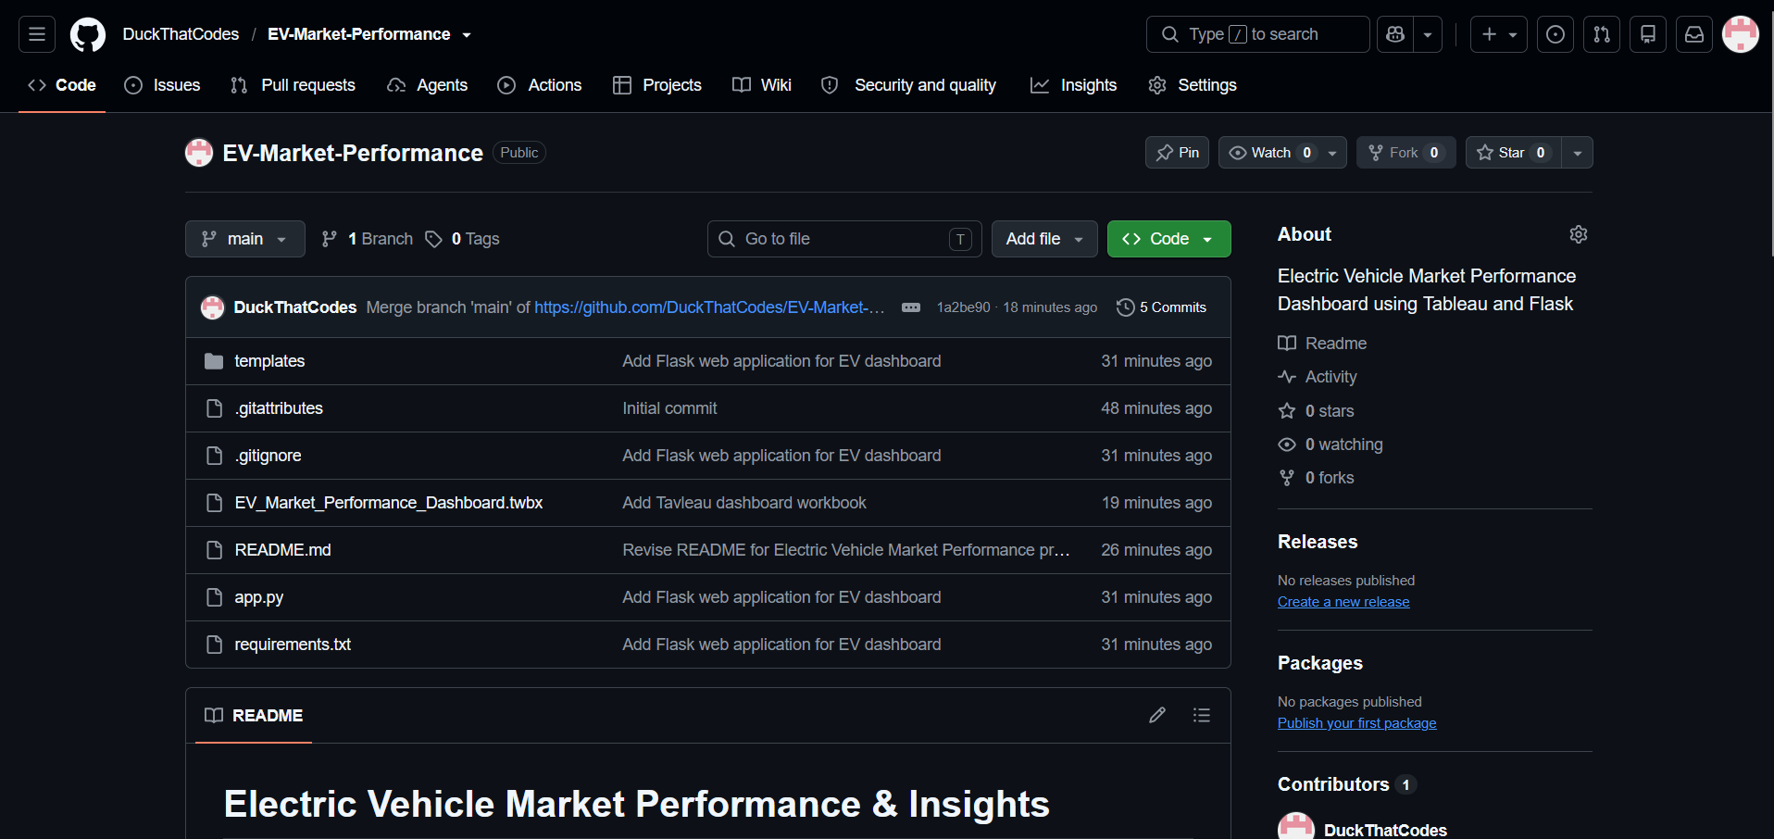
Figure 4. Figure: GitHub repository containing the project workbook and application files.

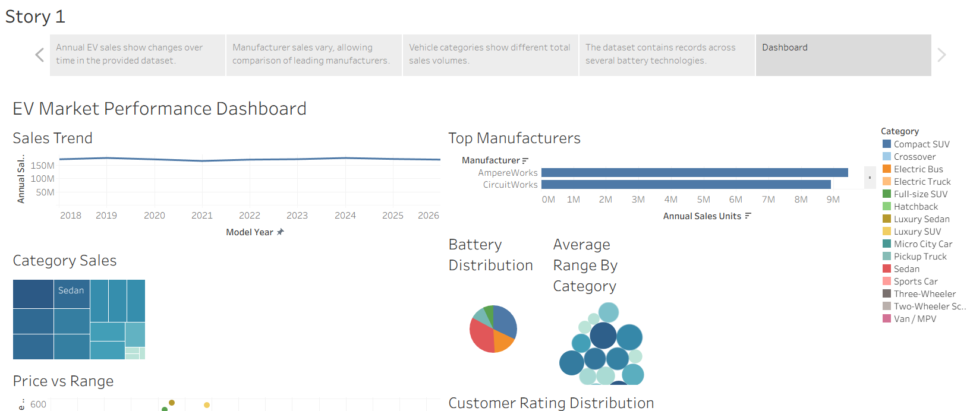
Figure 5. Figure: Tableau Story showing the narrative sequence and dashboard.

Performance Testing Evidence
A functional interaction test was performed on the Category Sales treemap. Selecting the Hatchback category highlighted the selected mark and displayed a tooltip with the category name and annual sales value.
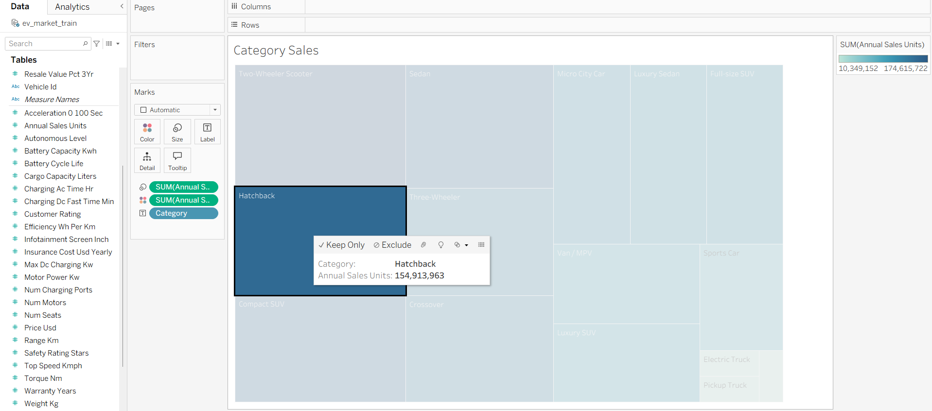
Figure 6. Functional testing of the Category Sales treemap through category selection and tooltip inspection.
Test result: The treemap selection and tooltip responded as expected in the captured test. This is a functional interaction check; it is not a measurement of dashboard loading time or a comprehensive performance benchmark.

