**Card Game Project**

by Assylbek Danyshbek and Makar Lezhnikov

The aim of our project is to develop fully functioning online multiplayer card game. We took the main idea from the game called "Hearthstone", so our interfaces are trying to mimic that of "Hearthstone".

All photos listed below are also contained in img folder of this archive.

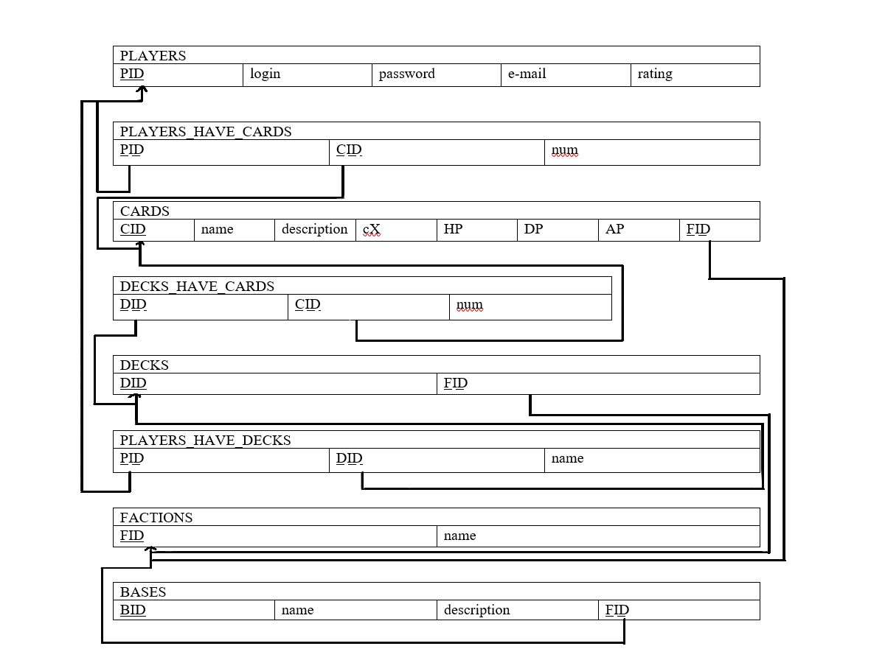The Database model is following (represented in relational model diagram):

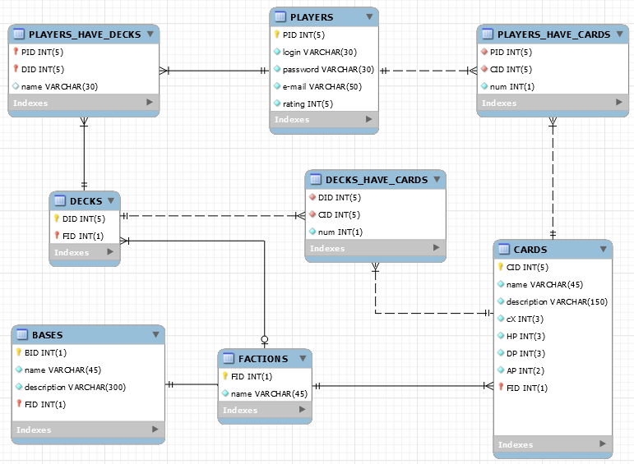Which resulted in the following MySql model:

Player sees the login window upon entering the game.

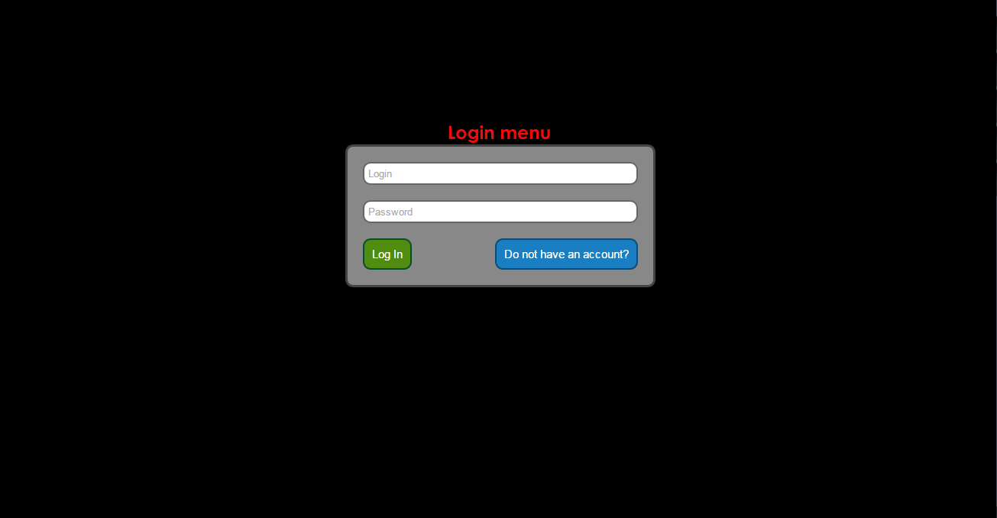

SELECT password, PID FROM PLAYERS WHERE login = '$login'; # checkUser.php

If he does not have an account, he presses corresponding button and registers:

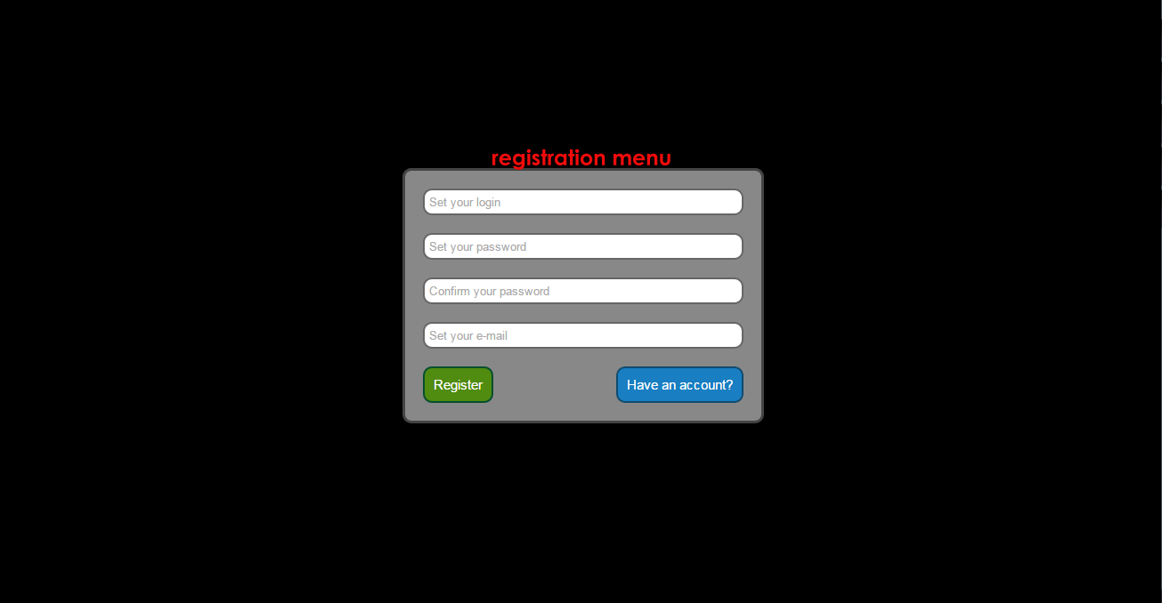

INSERT INTO PLAYERS VALUES (DEFAULT, '$login', '$pswd', '$email', 1000);

Actually, cards and decks are also added to the new player, for details see php/setNewPlayer.php

After logging in he sees the main menu. Here he has three options - go to battle, change his decks or logout.

At the same moment following queries are executed:

SELECT DISTINCT `num`, CARDS.* FROM PLAYERS_HAVE_CARDS INNER JOIN CARDS ON (`PID`=$pid) AND (PLAYERS_HAVE_CARDS.CID=CARDS.CID);

SELECT d.FID, phd.DID, phd.name FROM PLAYERS_HAVE_DECKS phd, DECKS d WHERE phd.PID=$pid AND phd.DID=d.DID;

for each DID { **#pseudocode, for real see getCardsAndDecksByPID.php**

SELECT dhc.CID, dhc.num, c.AP, c.name FROM DECKS_HAVE_CARDS dhc, CARDS c WHERE dhc.DID=$row2[DID] AND dhc.CID=c.CID;

}

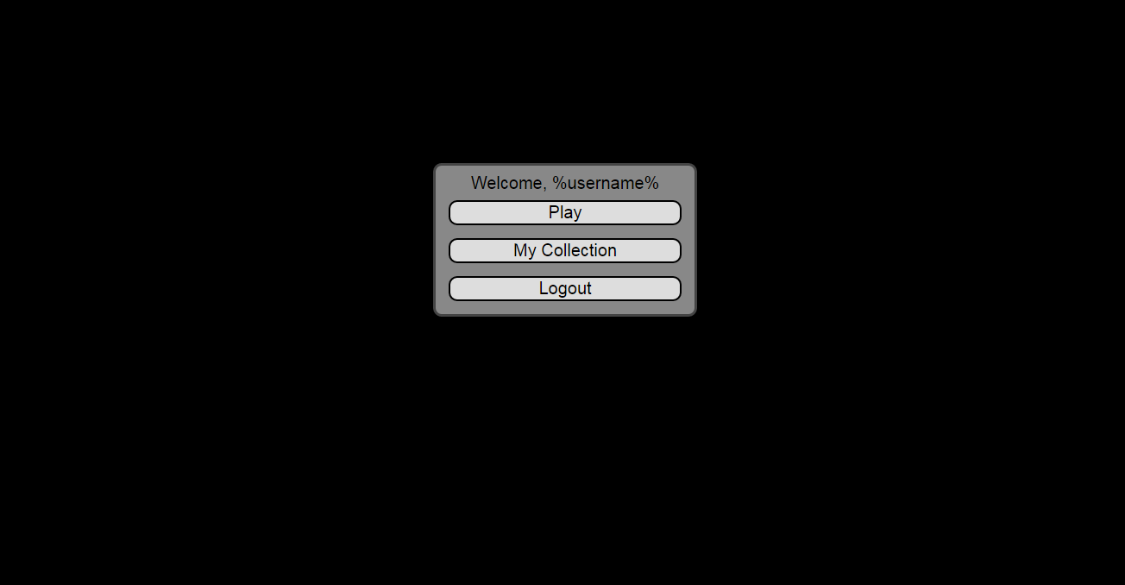

Deck menu (the image is resizable):

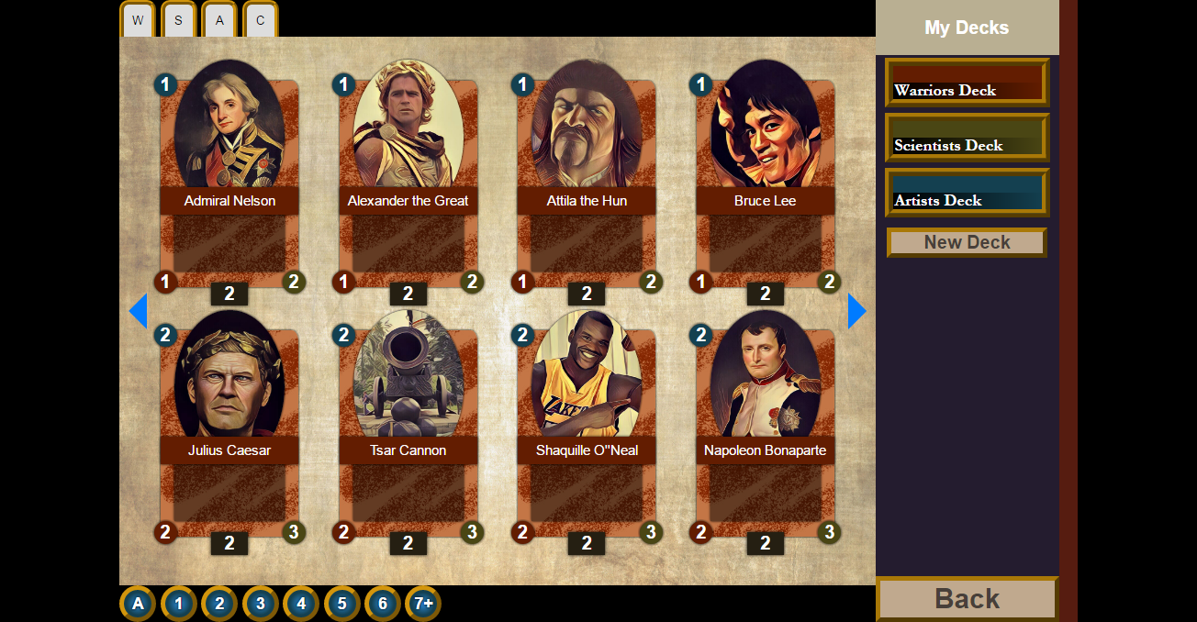

Mana Cost

Health

Damage

Player sees all cards available to him in the main part of screen, the decks are listed here ^. Cards have 3 properties: health (red circle), damage (green circle) and mana points (blue circle). Black square under denotes the amount of same cards that can be included in a deck.

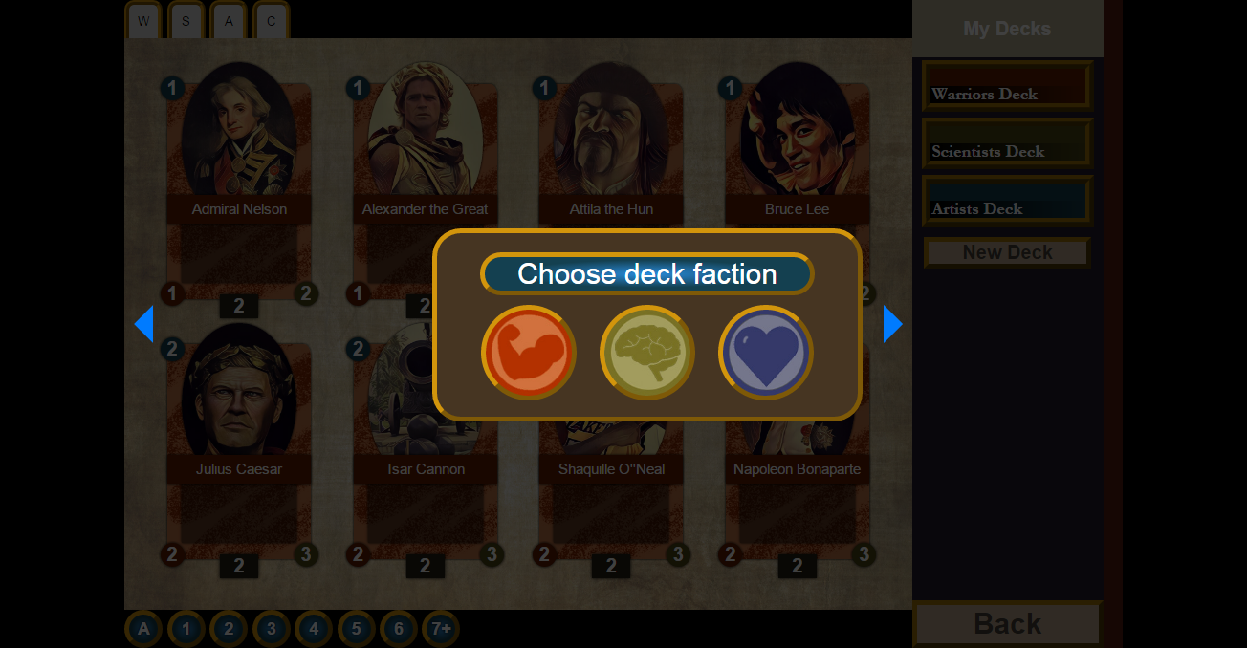

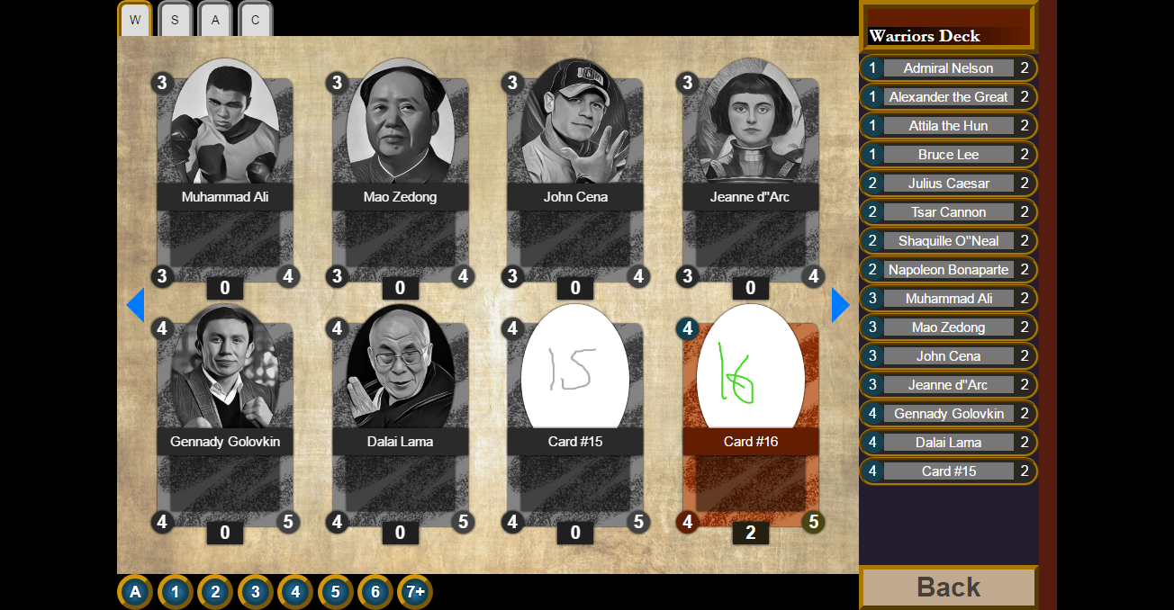

Cannot be included – no cards of this type left

When a player chooses a deck he wants to alter, the list of cards in this decks appears in place of list of decks. Player needs to click on a card from the main part to add it to the deck and to click on it in the cards list if he wants to remove it. He also can sort cards (described at the image). The following script saves the altered deck after all changes:

DELETE FROM DECKS_HAVE_CARDS WHERE `DID`=$did; # delete old cards

UPDATE PLAYERS_HAVE_DECKS SET `name`='$name' WHERE `DID`=$did; # update deck name

INSERT INTO DECKS_HAVE_CARDS VALUES (); # add new cards

# updateDeck.php

After managing his decks and cards, the player may proceed into battle:

1. Player chooses the deck he/she wants to play with

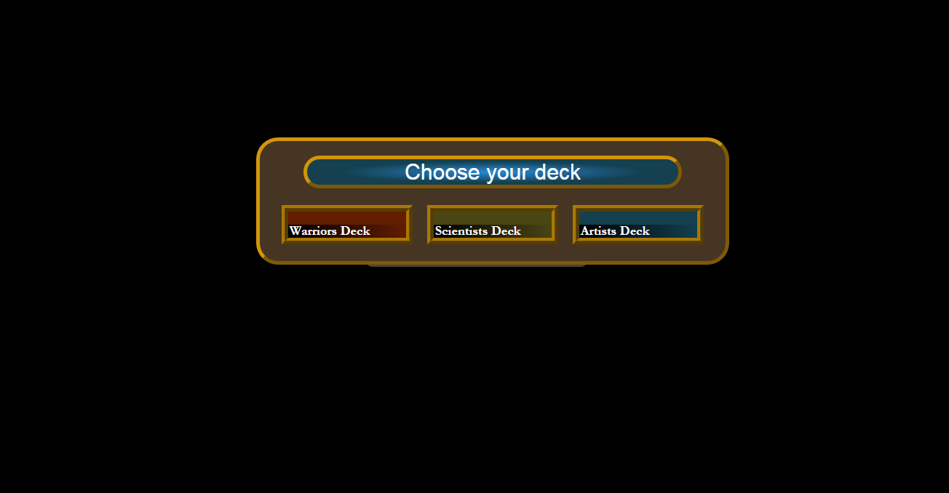

1. The player receives the initial hand of cards, but before he can choose which cards to keep and which to discard, discarded cards will be preplaced with another cards.

SELECT * FROM CARDS c, DECKS_HAVE_CARDS dc WHERE DID=$did AND dc.CID=c.CID;

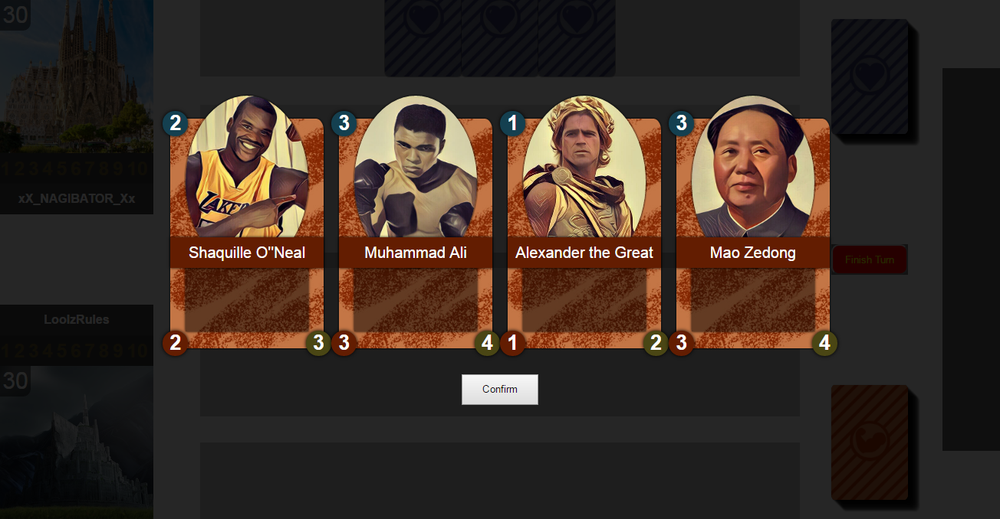

1. On each turn player receives a mana points. Player can put cards on the table whose sum of mana cost is no more than mana points for this turn.
2. Cards that are on the table can be played by damaging enemies or damaging the base.
   1. If player chooses to attack enemy`s card than it deals the damage equal to its damage points and receives that damage equivalent to the damage of the enemy`s card.
   2. If player attacks the base, the card simply deals damage to the base in amount of card`s damage.

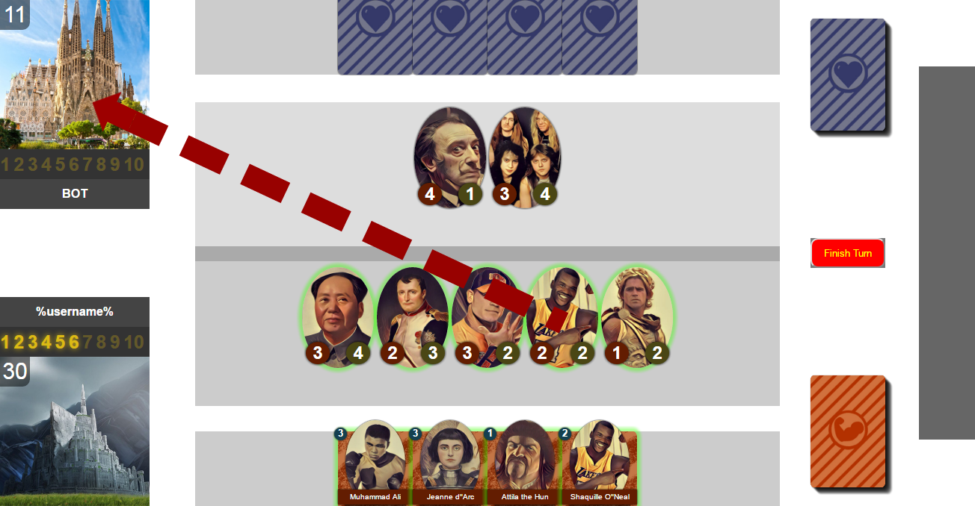

Green outline indicates that card can be played

Mana points of this turn

Base with health

1. The one whose base will lose all the health, will lose. Upon the end, the rating of player is either increased or decreased by 1 point.

UPDATE PLAYERS SET `rating`=`rating`+1 WHERE `PID`=$pid;

OR

UPDATE PLAYERS SET `rating`=`rating`-1 WHERE `PID`=$pid;

# changeRating.php

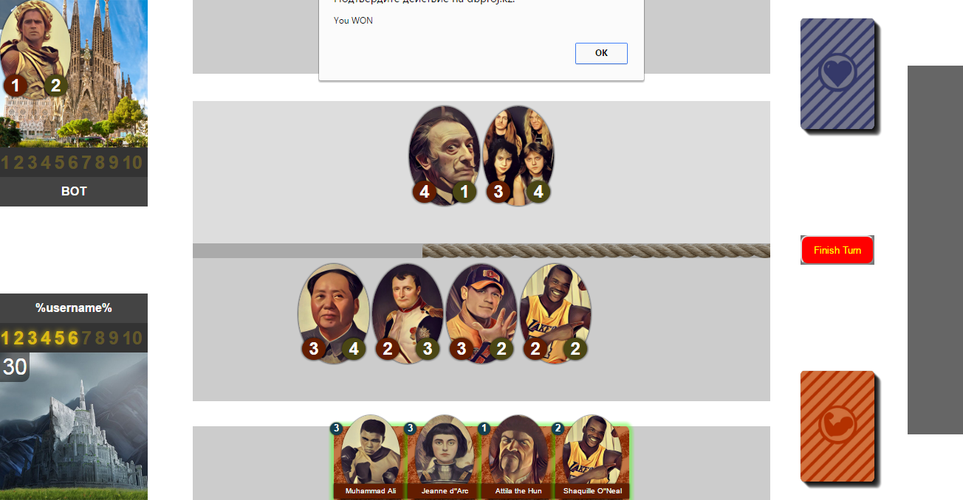

Tools list:

* Frontend:
  + HTML, CSS
  + JavaScript (in conjunction with jQuery and jQueryUI)
* Backend:
  + php
  + mySQL
  + apache

Limitations and problems:

1. The initial idea was to make card a 3D object to run animations such as flipping, turning and others. However, it was noticed that to do that, it takes a big amount of time to code. Afterwards we realized that it is simpler and faster to use jQuery to mimic 3D animation.
2. One of the problem we have encountered was portraits` design. Since the images` design should be consistent, the problem was that photos of all those personas are from different times, so the look of each picture can differ drastically. Initial solution was to draw by hand all the photos referring to existing ones. Later it was clear that it takes too much time from coding. So, it was decided to use mobile application called “Prisma” which filters images. By filtering every image through the application and then after small tweaking in photoshop, all photos got similar look.