Grey Goose Sales

### Serving our Customers Better

We produce Grey Goose Vodka, the top super premium vodka brand in the United States. In being a super premium brand, our customer service should reflect this consideration by providing the right amount of merchandise for each of our retail sellers.

By looking at the stores in which Grey Goose is sold, we can clearly see there are five category of stores to cater to.

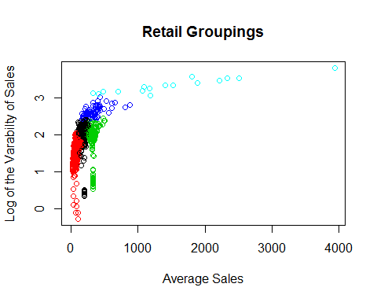

## AverageSold VarofSales Group  
## 1 169.91240 116.46090 Small and Variable  
## 2 77.77791 45.89681 Small and Steady  
## 3 313.45206 80.81233 Large and Steady  
## 4 338.46037 444.80176 Large and Variable  
## 5 1504.64328 2405.73295 Whales

We need to focus on groups 1,4 and most importantly, 5.

Concurrently, there seems to be no pattern to the seasonality of our Vodka. Do note that the abnormally high horizontal steak is our Group 5 Retailers from above.

Crunching the numbers, we should aim for a higher production of Grey Goose Vodka during the following months: January,June, and October