Actions

1. Fill 7l {X,Y} => {7, Y}
2. Fill 4L {X,Y} => {X,4}
3. fill 7L from 4l {X,Y} => {7,X+Y-7} (X+Y>7)
4. fill 4L from 7L {X,Y} => {X+Y-4, 4} (X+Y>4)
5. empty 7L into 4l {X,Y} => {0, X+Y} (X+Y<=4)
6. empty 4L into 7L {X,Y} => {X+Y,0} (X+Y<=7)
7. Empty 4L {X,Y} => {X,0}
8. Empty 7L {X,Y} => {0, Y}

Goal = [5,X]

Start = [0,0]

Current Position Open Closed

{[0,0]} {}

[0,0] {[7,0], [0, 4]} {[0,0]}

[7,0] {[7,4], [3,4], [0,4]} {[0,0], [7,0]}

[7,4] {[3,4], [0,4]} {[0,0], [7,0], [7,4]}

[3,4] {[3,0], [0,4]} {[0,0], [7,0], [7,4], [3,4]}

[3,0] {[0,3], [0,4]} {[0,0], [7,0], [7,4], [3,4], [3,0]}

[0,3] {[7,3],[0,4]} {[0,0], [7,0], [7,4], [3,4], [3,0],[0,3]}

[7,3] {[6,4],[0,4]} {[0,0], [7,0], [7,4], [3,4], [3,0],[0,3], [7,3]}

[6,4] {[6,0],[0,4]} {[0,0], [7,0], [7,4], [3,4], [3,0],[0,3], [7,3], [6,4] }

[6,0] {[2,4] ,[0,4]} {[0,0], [7,0], [7,4], [3,4], [3,0],[0,3], [7,3], [6,4], [6,0] }

[2,4] {[2,0] ,[0,4]} {[0,0], [7,0], [7,4], [3,4], [3,0],[0,3], [7,3], [6,4], [6,0], [2,4] }

[2,0] {[0,2] ,[0,4]} {[0,0], [7,0], [7,4], [3,4], [3,0],[0,3], [7,3], [6,4], [6,0], [2,4], [2,0] }

[0,2] {[7,2] ,[0,4]} {[0,0], [7,0], [7,4], [3,4], [3,0],[0,3], [7,3], [6,4], [6,0], [2,4], [2,0], [0,2] }

[7,2] {[5,4] ,[0,4]} {[0,0], [7,0], [7,4], [3,4], [3,0],[0,3], [7,3], [6,4], [6,0], [2,4], [2,0], [0,2], [7,2]}

[5,4] {[0,4]} {[0,0], [7,0], [7,4], [3,4], [3,0],[0,3], [7,3], [6,4], [6,0], [2,4], [2,0], [0,2], [7,2] , [5,4]}

[5,4] = GOAL

[0,4] {[4,0]} {[0,0], [7,0], [7,4], [3,4], [3,0],[0,3], [7,3], [6,4], [6,0], [2,4], [2,0], [0,2], [7,2], [5,4], [0,4]}

[4,0] {[4,4]} {[0,0], [7,0], [7,4], [3,4], [3,0],[0,3], [7,3], [6,4], [6,0], [2,4], [2,0], [0,2], [7,2], [5,4], [0,4], [4,0]}

[4,4] {[7,1]} {[0,0], [7,0], [7,4], [3,4], [3,0],[0,3], [7,3], [6,4], [6,0], [2,4], [2,0], [0,2], [7,2], [5,4], [0,4], [4,0], [4,4]}

[7,1] {[0,1]} {[0,0], [7,0], [7,4], [3,4], [3,0],[0,3], [7,3], [6,4], [6,0], [2,4], [2,0], [0,2], [7,2], [5,4], [0,4], [4,0], [4,4], [7,1]}

[0,1] {[1,0]} {[0,0], [7,0], [7,4], [3,4], [3,0],[0,3], [7,3], [6,4], [6,0], [2,4], [2,0], [0,2], [7,2], [5,4], [0,4], [4,0], [4,4], [7,1], [0,1]}

[1,0] {[1,4]} {[0,0], [7,0], [7,4], [3,4], [3,0],[0,3], [7,3], [6,4], [6,0], [2,4], [2,0], [0,2], [7,2], [5,4], [0,4], [4,0], [4,4], [7,1], [0,1], [1,0]}

[1,4] {[5,0]} {[0,0], [7,0], [7,4], [3,4], [3,0],[0,3], [7,3], [6,4], [6,0], [2,4], [2,0], [0,2], [7,2], [5,4], [0,4], [4,0], [4,4], [7,1], [0,1], [1,0], [1,4]}

[5,0] {} {[0,0], [7,0], [7,4], [3,4], [3,0],[0,3], [7,3], [6,4], [6,0], [2,4], [2,0], [0,2], [7,2], [5,4], [0,4], [4,0], [4,4], [7,1], [0,1], [1,0], [1,4], [5,0]}

[5,0] = GOAL No more paths to explore

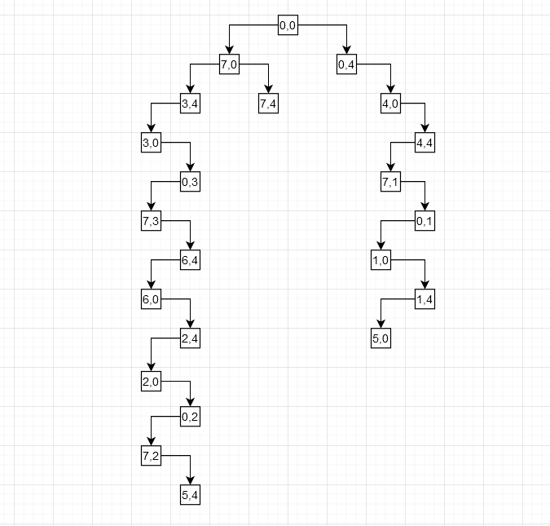

6).

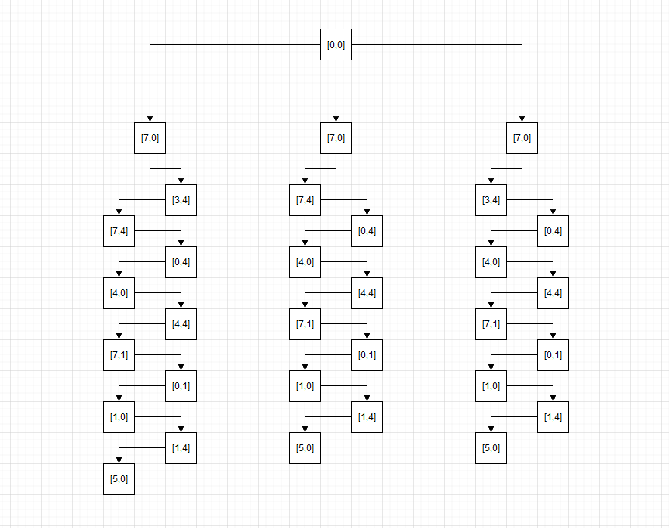

7).

The program uses the fill 7 first for as long as it can sense there is another way to complete the task. Each branch does not repeat that of a previous branch but it does have similarities. The program tries different ways to get onto the same path at 0,4 as it is a clear shot to get to 5,0 from there its just how the program gets to that point that changes as well. The same goes for an ending of 5,4 which is found in later results. It gets to a certain point on each branch and repeats after. Each branch is unique from the others in that there is not an identical solution but there are similarities.