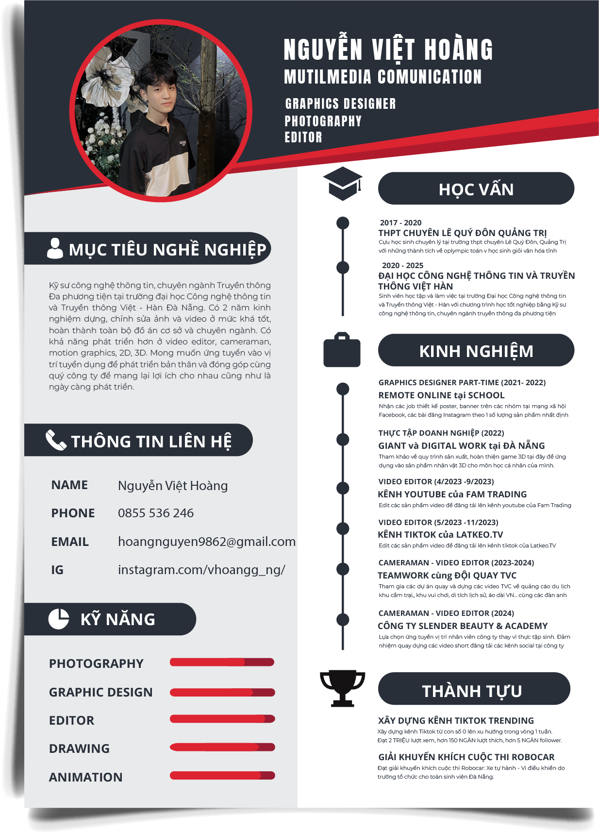

Link portfolio: <https://drive.google.com/file/d/1L4ZYC25sZXXojvWIFeuR6wxqRQq3vWSP/view?usp=sharing>