AIRPATH-AI: Time-Constrained Route Comparison Using Hourly PM2.5 Forecast-Bucket Exposure Estimation in Ho Chi Minh City
Le Minh Duc¹ and Tran Duong Minh Tam¹
¹High School for the Gifted, Vietnam National University, Ho Chi Minh City, Vietnam
Abstract—Urban route-choice systems generally prioritize travel time or distance, whereas pollution-aware routing also depends on the spatial and temporal variation of air quality. This paper presents AIRPATH-AI, a pilot framework for pedestrians and motorbike users in Ho Chi Minh City (HCMC) that combines hourly PM2.5 forecasting, sparse-monitoring spatial estimation, segment-level estimated arrival time (ETA), a time-weighted PM2.5 exposure proxy, and absolute travel-time-constrained route selection. The empirical basis is the HealthyAir HCMC dataset from six fixed monitoring stations. Current-PM XGBoost is fixed for downstream forecasting, and inverse distance weighting (IDW) with p = 1 is used for spatial estimation. Two focused experiments are reported. First, under identical candidate-route sets and identical time constraints, a departure-time PM2.5 snapshot (Method A) is compared with an ETA-based assignment using the HealthyAir hourly bucket obtained by ceiling the ETA to the next available hour (Method B). In P0-2A, 19/300 route-selection cases change (6.33%); in P0-2B, 20/1,500 change (1.33%), and the overall conclusion remains MIXED/WEAK. Second, an exhaustive audit over 1,500 cases finds 43/1,500 cases (2.87%) with at least one feasible alternative that is both slower and lower-exposure than the fastest route; the maximum modeled reduction is 0.831%. The results support AIRPATH-AI as a transparent decision-support and route-comparison framework for a sparse, hourly HCMC monitoring setting, not as a system that guarantees cleaner routes, health protection, or minute-level road-pollution accuracy.
Index Terms—PM2.5, air-quality forecasting, spatial interpolation, exposure, route selection, time constraint, Ho Chi Minh City, XGBoost.

I. INTRODUCTION
Urban air pollution varies over both space and time. A route that is shortest or fastest may therefore differ from a route associated with lower modeled exposure. Prior research has established the feasibility of pollution-aware routing, including the Clean Air Routing (CAR) approach [4], healthier-route planning [5], active-travel route planning with air-pollution exposure [6], and routing that jointly considers air quality and congestion [7]. These studies also indicate that route-level decisions depend strongly on the spatial detail of the pollution field and the temporal resolution of available observations.
AIRPATH-AI focuses on a constrained HCMC pilot for pedestrians and motorbike users. A user provides an origin, destination, travel mode, and an absolute maximum additional travel time, denoted by δ. Candidate routes satisfying the constraint are retained and compared using a time-weighted PM2.5 exposure proxy. The system is designed as decision support: the user can see the fastest route and feasible alternatives and retains the final choice.
The study deliberately avoids broad novelty claims. AIRPATH-AI is not positioned as the first pollution-aware or dynamic routing system. Instead, it addresses two specific questions. Gap 1 examines whether the route decision changes when hourly PM2.5 is assigned using a departure-time snapshot rather than an hourly bucket selected from the predicted ETA. Gap 2 examines how often the absolute time budget creates a feasible lower-exposure detour and how large the modeled exposure benefit is. The current web prototype operationalizes these calculations but is not treated as independent evidence for either gap.
II. RELATED WORK
A. HCMC PM2.5 Data and Forecasting
HealthyAir provides an HCMC-specific empirical foundation. Rakholia et al. reported air-quality observations from six monitoring stations and multiple pollutant and meteorological variables [2]. A subsequent study evaluated AI-based PM2.5 forecasting for HCMC over multiple horizons [3]. These studies justify the use of a local historical data source and a forecasting layer. AIRPATH-AI uses a narrower downstream horizon of +1 h, +2 h, and +3 h.
B. Pollution-Aware Routing
CAR demonstrated route planning with minimal PM2.5 exposure [4]. Zou et al. developed healthier-route planning and emphasized dynamic risk updates and fine-scale spatial information [5]. Wang et al. studied active travel with air-pollution exposure and used mobile monitoring to support a higher-resolution pollution field [6]. Choudhary et al. incorporated air quality and congestion into a multimodal routing framework [7]. These studies provide the conceptual basis for integrating pollution with routing while using different spatial and temporal data structures from the present HCMC pilot.
C. Research Positioning
The present work therefore positions AIRPATH-AI as a framework and evaluation study. Its methodological focus is the interaction among hourly station data, temporal assignment to route ETAs, spatial interpolation, and an absolute user time budget. Reporting a weak result for the temporal-assignment experiment is intentional: a visually attractive demonstration is not sufficient evidence of a route-selection effect.
III. MATERIALS AND METHODS
A. Frozen System Architecture
The research pipeline is intentionally modular. HealthyAir station observations are passed to Current-PM XGBoost; the resulting station-level forecasts are spatially estimated with IDW p = 1 inside the pilot area. OpenStreetMap provides the road graph and candidate route geometry. Segment ETAs determine the temporal PM2.5 bucket used for exposure aggregation. The constrained selector keeps only routes satisfying the user budget and ranks feasible routes by exposure.
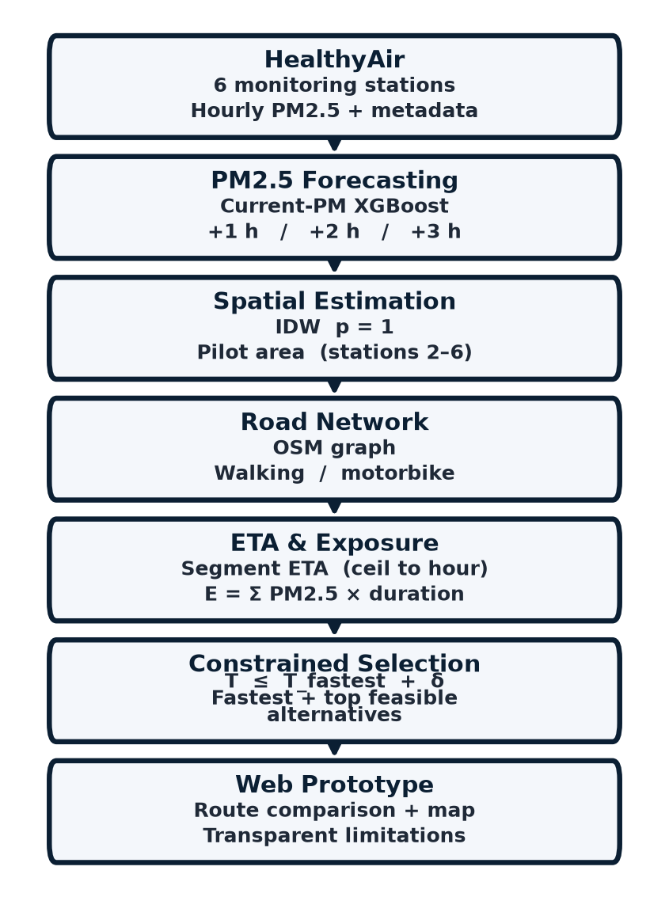
Fig. 1. AIRPATH-AI frozen research pipeline: station observations → forecasting → spatial estimation → road network/ETA → exposure → constrained route selection → web prototype.
B. Dataset and Data Audit
The HealthyAir dataset contains 52,548 station-level records from six stations, covering 23 February 2021 21:00 to 21 June 2022 17:00. Rakholia et al. [2] describe minute collection; the file analyzed here is hourly. Variables include PM2.5, TSP, O₃, CO, NO₂, SO₂, temperature, and humidity. PM2.5 has 0% missingness. Secondary variables have substantial missingness, and 207 PM2.5 observations equal zero, 205 of them at Station 5. IQR-flagged PM2.5 observations were not automatically deleted. The dataset is split chronologically into training, validation, and test sets.
TABLE I. Summary of the HealthyAir HCMC dataset.
Item | Value
Station-level records | 52,548
Stations | 6
Temporal coverage | 23/02/2021 21:00–21/06/2022 17:00
Nominal interval | 1 h
PM2.5 missingness | 0%
PM2.5 zero observations | 207 (205 at Station 5)
Chronological split | 35,601 / 8,740 / 8,207
C. PM2.5 Forecasting
Persistence predicts y_hat(t+h) = PM2.5(t). XGBoost V1 uses PM2.5 lags t−1, t−2, and t−3 together with time and station features. Current-PM XGBoost adds PM2.5(t), removing the feature mismatch in the initial comparison. Validation is used for model selection; the test set is not used for post-locking tuning. Current-PM XGBoost is fixed for downstream analysis because it has lower RMSE and higher R² than persistence at each reported horizon, although persistence has lower MAE.
TABLE II. Validation MAE / RMSE / R² for Persistence and Current-PM XGBoost (+1 h, +2 h, and +3 h).
Horizon | Persistence MAE / RMSE / R² | Current-PM XGBoost MAE / RMSE / R²
+1 h | 3.04 / 7.03 / 0.652 | 3.21 / 6.52 / 0.700
+2 h | 4.64 / 9.45 / 0.367 | 4.73 / 8.12 / 0.533
+3 h | 5.79 / 10.79 / 0.176 | 5.86 / 9.25 / 0.394

D. Spatial Estimation
Nearest station, IDW p = 1, and IDW p = 2 are compared using leave-one-station-out development evaluation. IDW p = 1 provides the best pooled result and is fixed for downstream use. Reliability diagnostics include nearest-station distance, second-nearest distance, contributing-station count, and IDW weight concentration. These diagnostics are not calibrated uncertainty intervals.
TABLE III. Development evaluation of spatial estimation methods.
Method | MAE | RMSE
Nearest station | 8.704 | 15.461
IDW p = 1 | 7.061 | 12.721
IDW p = 2 | 7.174 | 12.898
E. Road Network and ETA
The OpenStreetMap pilot graph contains approximately 62,463 nodes and 141,161 directed edges. Walking uses a baseline speed of 5 km/h and motorbike uses 25 km/h. Segment-level durations and cumulative ETAs are computed under these baseline speeds. The present ETA model does not include live traffic, signal delay, or turn delay. Candidate generation keeps the true fastest path and then repeatedly penalizes already-used directed edges to generate additional OSM-valid alternatives. This procedure is inspired by k-shortest-path logic but does not require a formal loopless-k-shortest implementation. Candidate routes are capped so that their total travel time remains within the supported hourly forecast horizon.
F. Target-Time PM2.5 Assignment
The desired road-level quantity PM2.5_road(x_D, t_arrival) is not directly observed in HealthyAir. The dataset provides hourly fixed-station measurements. AIRPATH-AI therefore compares two explicit temporal assignment methods rather than claiming direct road-level measurement. Method A uses the six observed station values at departure time T0, spatially estimated with IDW p = 1 and applied to all route segments. Method B first computes the ETA for each segment, then maps the ETA to the next available HealthyAir hourly bucket by ceiling. If the ETA is exactly on the hour, that hour is retained; otherwise, the next hour is used. No minute-level interpolation is performed; for example, 17:03 maps to 18:00. The station values for Method B are generated by Current-PM XGBoost and then spatially estimated with IDW p = 1. The origin forecast is one hour before departure, and supported horizons are t+1, t+2, and t+3 h.
G. Exposure and Constrained Selection
Route exposure is defined as the time-weighted PM2.5 proxy E(route) = Σ_i PM2.5_i × Δt_i, with units of (µg/m³)·min. This metric is not inhaled dose and is not a medical risk score. Let T_fastest be the fastest candidate-route travel time. For user budget δ, the feasible set is F(δ) = {r : T(r) ≤ T_fastest + δ}. The selector ranks routes in F(δ) by predicted exposure. The evaluated budgets are δ ∈ {0, 1, 2, 3, 5, 10} min.
H. Origin–Destination Sampling and Statistical Units
The 30 origin–destination (OD) pairs are not a purposeful shortlist of interesting streets, nor a random sample of all Ho Chi Minh City trips. They were generated by seeded uniform rejection sampling (NumPy Generator seed 42) inside the convex hull of HealthyAir stations 2–6 (approximately 54.9 km²). Candidate coordinates were drawn uniformly in the bounding box, retained only if both endpoints lay inside the pilot polygon, and further required a straight-line separation of 2–6 km. The realized distances range from 2.29 km to 5.65 km (mean 3.50 km). The same 30 pairs are reused in P0-2A, P0-2B, and Gap 2 so that temporal assignment can be isolated from OD redraw. The panel therefore represents walkable/motorbike trips inside the five-station inner-city hull; it does not represent suburban HCMC, the distant Station-1 industry/university area, or city-wide geographic diversity. Distance-stratified web-demo subsets (8 of 30) are a display choice and are not the experimental panel.
The primary unit of analysis is an OD × mode × extra-time-budget cell, and, in P0-2B, that cell crossed with departure clock time. These cells are not independent: the five positive δ values share the same candidate set, and walking/motorbike share the same endpoints. Counts and percentages are therefore descriptive of the designed panel, not of a simple random sample of HCMC travelers. Wilson 95% confidence intervals are reported as a transparency device under a Bernoulli approximation and should not be read as design-based survey inference. No p-value is used to claim a beneficial routing effect.

IV. EXPERIMENT 1 — GAP 1: TEMPORAL ASSIGNMENT
Gap 1 asks whether changing only the temporal assignment of PM2.5 changes the selected route. The candidate set, OD pair, travel mode, ETA, δ, exposure definition, and selector are fixed. The analysis is performed from constrained_selection_comparison.csv. Rows with delta_time_allowed_minutes = 0 are excluded because δ = 0 leaves only the fastest route under the stated constraint. A route-change event is selections_differ = TRUE.
A. P0-2A
P0-2A uses the 30 seeded in-polygon OD pairs, two modes, and five positive budgets {1, 2, 3, 5, 10} min at 2022-02-28 06:00. This produces 30 × 2 × 5 = 300 nontrivial cases (δ > 0). Spearman rank correlation between Method A and Method B is 0.992. The selected route changes in 19/300 cases, or 6.33% (Wilson 95% CI 4.09–9.68%): 9/150 for walking and 10/150 for motorbike. The mean oracle improvement when the selected route differs is approximately 0.11%.
B. P0-2B
P0-2B holds the same 30 OD pairs and changes the observation clock on 2022-02-27: 06:00, 08:00, 12:00, 17:00, and 20:00. This is a limited date/time robustness check against diurnal confounding, not a multi-week calendar sample. 2022-02-27 is used because 2022-02-28 lacks complete Station-4 +1/+2/+3 h tables. This produces 30 × 2 × 5 × 5 = 1,500 nontrivial cases (δ > 0). Spearman correlation is 0.997. The selected route changes in 20/1,500 cases, or 1.33% (Wilson 95% CI 0.86–2.05%). These 20 changes arise from four OD × mode × departure-time cells, each differing at all five positive δ values (4 × 5 = 20). At 12:00, 17:00, and 20:00, no route change is observed, even though midday |ΔE| can be large (about 17%) without reselection. The mean oracle improvement when the selected route differs is approximately 0.02%.
TABLE IV. Gap 1 temporal-assignment comparison; all counts exclude δ = 0, which leaves only the fastest route.
Metric | P0-2A | P0-2B
Date / departure times | 2022-02-28 06:00 | 2022-02-27; 06:00, 08:00, 12:00, 17:00, 20:00
Spearman ρ | 0.992 | 0.997
Route changes (δ > 0) | 19/300 (6.33%) | 20/1,500 (1.33%)
Oracle gain when route differs | ≈0.11% | ≈0.02%
12:00, 17:00, 20:00 | — | 0 route changes
Overall conclusion | MIXED/WEAK | MIXED/WEAK
C. Interpretation of Gap 1
The five-clock replication on a second calendar day does not strengthen the gap. P0-2B is weaker than P0-2A in route-change frequency, and three of the five departure times show zero changes. Changing the observation hour therefore acts as a negative-control / confound check: if rush-hour clocks had produced a large, stable reselection effect, that would have been visible here. They do not. The correct conclusion is therefore MIXED/WEAK. The experiment provides a sensitivity result: under the tested hourly HealthyAir setting, route selection is usually unchanged when moving from a departure-time snapshot to ETA-based hourly assignment. This should not be interpreted as evidence that arrival-time awareness always improves route quality.
V. EXPERIMENT 2 — GAP 2: TIME–EXPOSURE TRADE-OFF
Gap 2 addresses a different question: when a user accepts an absolute additional-time budget, how often does the feasible set contain a route that is both slower and lower-exposure than the fastest route? The audit uses 30 OD pairs, two modes, five departure times, and five positive budgets, yielding 1,500 cases.
TABLE V. Gap 2 exhaustive trade-off audit.
Metric | Result
Cases with ≥1 feasible lower-exposure alternative | 43/1,500 (2.87%; Wilson 95% CI 2.14–3.84%)
Maximum modeled exposure reduction | 0.831%
Only 43 of 1,500 cases contain at least one feasible alternative that is both slower and lower-exposure than the fastest route (2.87%; Wilson 95% CI 2.14–3.84%). The maximum modeled reduction is 0.831%, and no case exceeds 1%. Treating the 1,500 cells as Bernoulli trials (an approximation, because δ is nested in OD), a one-sided binomial test of H0: the detour rate is at least 10% yields p ≪ 0.001; the same test against a 5% null also rejects (p ≈ 2.9×10⁻⁵). These tests are used only to reject a “common cleaner detour” claim, not to assert a beneficial effect. The result therefore does not justify saying that AIRPATH-AI routinely finds materially cleaner detours. Rather, the absolute-time constraint is a transparent mechanism for testing when a trade-off exists.
A route-diversity audit reports that 84% of alternatives have edge Jaccard similarity below 0.30 relative to the fastest route and 70% below 0.10. At δ = 10 min, every OD × mode combination has at least one alternative with clearly different geometry. Thus, candidate-route diversity is not the dominant bottleneck; the modeled exposure field from six fixed stations is a more direct limitation.
The 0.831% figure must be read against the pipeline’s own error, not against zero. Mean HealthyAir PM2.5 is about 21.1 µg/m³. Leave-one-station-out IDW p = 1 has MAE 7.061 µg/m³ (about 33% of that mean). The earlier XGBoost V1 + IDW end-to-end development MAE is 6.912 µg/m³ (also about 33%). Even the frozen Current-PM XGBoost +1 h validation MAE of 3.21 µg/m³ is about 15% of the mean concentration. Because exposure is Σ PM × minutes, a concentration error of that size dominates a 0.831% contrast between two modeled routes. On P0-2A, the mean absolute percentage difference between Method A and Method B exposures is only 0.72%, comparable to 0.831% and far below midday |ΔE| of about 17% that still produces no reselection. Therefore 0.831% is smaller than, or of the same order as, assignment noise already present in the hourly six-station substitute; it is not larger than measurement/model error and cannot be treated as a detected on-road benefit.
VI. END-TO-END VALIDATION
The pooled development end-to-end result of MAE 6.912 and R² 0.242 is attributable to the earlier XGBoost V1 + IDW p = 1 configuration (n = 20,664) and is not a Model C test score. The combined forecast-plus-spatial error increases with horizon, from approximately 6.38 at +1 h to 7.41 at +3 h, and Station 5 remains difficult to generalize. For downstream route selection, the frozen forecaster is Current-PM XGBoost (Model C), but the reported 6.912 / 0.242 figure must not be interpreted as its end-to-end performance.
An early ranking diagnostic reported mean Spearman correlation 0.875 and top-1 agreement of 4/4 on four scenario/mode combinations. This is a small Milestone-4 check, not the 30-OD evaluation. Final constrained-selection validation on 1,800 decisions, including δ = 0, reaches 98.1% agreement with the modeled IDW oracle, with mean regret 0.00013 and maximum regret 0.019. A global multiplicative PM2.5 perturbation from 0.80 to 1.20 preserves top-1 and top-3 ordering at 100%; this is treated only as a mathematical consistency check because uniform scaling preserves route order, not as evidence of ranking robustness to realistic spatial or temporal uncertainty. The oracle is itself derived from IDW and is not independent road-level ground truth.
VII. WEB PROTOTYPE
The web prototype is a user-facing rendering of the research pipeline rather than an independent validation instrument. It uses a frontend based on Vite, React, TypeScript, and Leaflet and a FastAPI backend. Demonstration scenarios are precomputed so the interface remains stable and reproducible. The user selects origin, destination, walking or motorbike, maximum additional travel time, and a demonstration time-of-day control with three windows: morning peak, midday, and evening peak. The interface displays the fastest route and up to three feasible alternatives together with travel time, extra minutes, and predicted exposure.

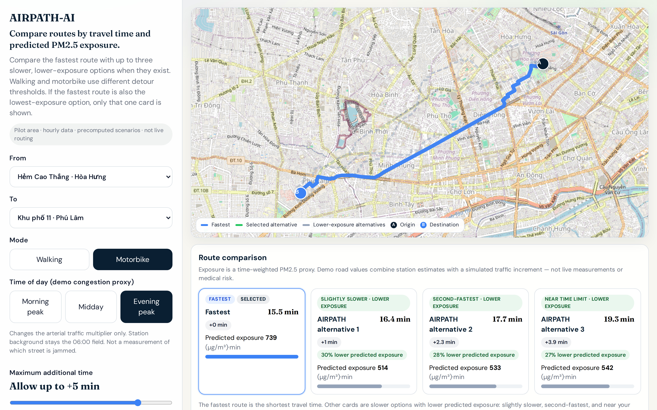
Fig. 2. AIRPATH-AI web prototype (motorbike, evening-peak demo window, +5 min): Hẻm Cao Thắng · Hòa Hưng to Khu phố 11 · Phú Lâm. High-resolution interface screenshot; the three-session control is a demo congestion proxy only (not Gap 1 or Gap 2).
The prototype illustrates the intended decision logic: the fastest route remains visible, while feasible alternatives are displayed only when they satisfy the time budget and have the relevant exposure comparison. The interface labels the exposure metric as estimated/predicted and makes clear that the current pilot uses hourly data, a sparse monitoring network, and modeled road-level values.
In the screenshot of Fig. 2 (evening-peak demo window, +5 min budget), the fastest motorbike route is 15.5 min with predicted exposure 739 (µg/m³)·min, and alternative 1 is 16.4 min with 514 (µg/m³)·min (about 30% lower on the demo scale). These values are demonstration outputs only. They are not panel-level Gap 1 or Gap 2 statistics, are not on-road measurements, and must not be cited as evidence that evening peak changes the scientific selection result.
The three-window control is labeled in the interface as “Time of day (demo congestion proxy).” It is a product illustration, not a Gap 1 or Gap 2 experiment. Travel times, candidate geometry, and the station-IDW background remain the frozen 06:00 field. Only a deterministic arterial OSM-class multiplier changes (about 1.12 at the morning window, 1.04 at midday, and 1.20 at the evening window); residential and alley ways are left unchanged. The control therefore does not measure which street is congested, does not move HealthyAir to 12:00 or 18:00, and usually does not redraw the selected polyline—as expected when the same candidates and the same selector see only a small arterial scale factor. In the packaged demo scan, the number of cases with a lower-exposure alternative is 41/80 at morning and evening peak and 40/80 at midday. Those counts must not be substituted for the frozen Gap 1 rates 19/300 and 20/1,500 or the Gap 2 rate 43/1,500.
VIII. DISCUSSION
The most important finding is that hourly temporal assignment has a limited effect on route selection in the tested pilot. Several factors can explain this result. First, HealthyAir is hourly, so multiple ETAs collapse into the same bucket. Second, IDW from only six stations generates a comparatively smooth spatial field. Third, a slower route must gain enough exposure benefit to compensate for the added travel time under the constrained selector. The present data often do not create sufficiently strong spatial–temporal contrast for that condition.
Gap 2 complements this finding. Even across 1,500 cases and budgets up to 10 min, a slower but lower-exposure feasible alternative occurs in only 2.87% of cases (Wilson 95% CI 2.14–3.84%), and the maximum modeled reduction is 0.831%—smaller than the pipeline’s relative concentration error (about 15–33% of mean PM2.5). Thus, the current framework is better described as route comparison and decision support than as a guarantee of a materially cleaner route.
These results also clarify the relationship between the research engine and the web product. The scientific evidence comes from the controlled experiments and validation procedures. The web prototype communicates those calculations to a user. It should not be used to infer population-level or field-level performance from a single visually compelling route example.
IX. LIMITATIONS AND FUTURE WORK
The study has six central limitations. First, HealthyAir provides hourly observations from six fixed stations and therefore cannot establish minute-level road-segment ground truth. Second, the spatial field and the oracle depend on IDW interpolation, so the oracle is not an independent road-level reference. Third, the ETA model uses constant baseline speeds and omits traffic dynamics, signals, and turn delays. Fourth, the exposure metric is a time-weighted concentration proxy rather than inhaled dose. Fifth, the web prototype is a precomputed pilot and not a live navigation service for the whole of HCMC. Sixth, the 30 OD pairs are a seeded 2–6 km sample inside the stations 2–6 hull and do not represent the geographic diversity of HCMC; changing clocks on 27 February is only a limited diurnal confound check, not a multi-date observational design.
The most direct future step is to collect GPS-tagged mobile PM2.5 observations with synchronized timestamps and coordinates. This would allow finer spatial and temporal validation and a direct test of whether sub-hourly arrival-time assignment can produce a stronger route-selection effect. A second step is to integrate authorized traffic data into ETA estimation. More complex models such as deep learning, graph neural networks, or Kriging should only be considered if richer data and a clearly motivated research question justify them.
X. CONCLUSION
AIRPATH-AI provides an interpretable pilot framework linking HCMC station observations, PM2.5 forecasting, sparse-monitoring spatial estimation, segment ETA, time-weighted exposure, and absolute travel-time-constrained route selection for pedestrians and motorbike users. Current-PM XGBoost and IDW p = 1 are fixed for downstream analysis. Gap 1 compares departure-time PM2.5 assignment with ETA-based hourly assignment using an explicit ceiling-to-the-next-hour rule. Route changes are uncommon: 19/300 (6.33%) in P0-2A and 20/1,500 (1.33%) in P0-2B, with zero changes at 12:00, 17:00, and 20:00; the conclusion is MIXED/WEAK. Gap 2 finds 43/1,500 (2.87%) cases with a feasible slower lower-exposure alternative, with a maximum modeled reduction of 0.831%.
Accordingly, AIRPATH-AI should be interpreted as a transparent decision-support and route-comparison framework under sparse, hourly HCMC data. The study does not establish minute-level road-pollution accuracy, medical benefit, or guaranteed cleaner routes. The web prototype demonstrates how the constrained comparison can be presented to end users while preserving these scientific limitations.
ACKNOWLEDGMENT
The authors thank the research environment and supervisory support that enabled the construction, validation, and refinement of AIRPATH-AI.
GENAI DISCLOSURE
Generative AI tools were used as development and research assistants for coding support, debugging, pipeline organization, literature search and synthesis, and web-prototype refinement. The authors controlled and checked the research question, dataset selection, model-selection decisions, experimental design, numerical results, and scientific conclusions. GenAI output was not treated as scientific evidence by itself.
REFERENCES
[1] World Health Organization, “WHO global air quality guidelines: Particulate matter (PM2.5 and PM10), ozone, nitrogen dioxide, sulfur dioxide and carbon monoxide,” 2021.
[2] R. Rakholia, Q. Le, K. H. N. Vu, B. Q. Ho, and R. S. Carbajo, “Outdoor air quality data for spatiotemporal analysis and air quality modelling in Ho Chi Minh City, Vietnam: A part of HealthyAir Project,” Data in Brief, vol. 46, p. 108774, 2023, doi: 10.1016/j.dib.2022.108774.
[3] R. Rakholia, Q. Le, K. Vu, B. Q. Ho, and R. S. Carbajo, “AI-based air quality PM2.5 forecasting models for developing countries: A case study of Ho Chi Minh City, Vietnam,” Urban Climate, vol. 46, p. 101315, 2022, doi: 10.1016/j.uclim.2022.101315.
[4] S. Mahajan, Y. S. Tang, D. Y. Wu, T. C. Tsai, and L. J. Chen, “CAR: The Clean Air Routing Algorithm for Path Navigation with Minimal PM2.5 Exposure on the Move,” IEEE Access, vol. 7, pp. 147373–147382, 2019, doi: 10.1109/ACCESS.2019.2946419.
[5] B. Zou, S. Li, Z. Zheng, B. F. Zhan, Z. Yang, and N. Wan, “Healthier routes planning: A new method and online implementation for minimizing air pollution exposure risk,” Computers, Environment and Urban Systems, vol. 80, p. 101456, 2020, doi: 10.1016/j.compenvurbsys.2019.101456.
[6] Y. Wang, Y. Wu, Z. Li, K. Liao, C. Li, and G. Song, “Route planning for active travel considering air pollution exposure,” Transportation Research Part D: Transport and Environment, vol. 103, p. 103176, 2022, doi: 10.1016/j.trd.2022.103176.
[7] R. Choudhary, S. Ratra, and A. Agarwal, “Multimodal routing framework for urban environments considering real-time air quality and congestion,” Atmospheric Pollution Research, vol. 13, no. 9, p. 101525, 2022, doi: 10.1016/j.apr.2022.101525.
[8] T. Chen and C. Guestrin, “XGBoost: A scalable tree boosting system,” in Proc. 22nd ACM SIGKDD Int. Conf. Knowledge Discovery and Data Mining, 2016, pp. 785–794, doi: 10.1145/2939672.2939785.
[9] OpenStreetMap contributors, “OpenStreetMap,” accessed 2026. https://www.openstreetmap.org/

