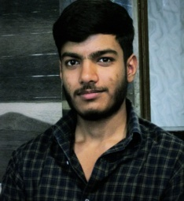

# Education

**Shreyansh Tripathi** +91-8808900003

B.Tech. [tripathishreyansh88@gmailcom](mailto:hardiksharma02102003@gmail.com)

Computer Science Engineering [Github](https://github.com/Ductblue)

Jaypee University of Engineering and [Linkedin](https://www.linkedin.com/in/hardiksharma02/)

Technology, Guna [Leetcode](https://leetcode.com/u/tripathi_ru/)

[Geeks For Geeks](https://www.geeksforgeeks.org/user/tripathishmjxr/)

|  |  |  |  |
| --- | --- | --- | --- |
| **Degree/Certificate** | **Institute/Board** | **CGPA/Percentage** | **Year** |
| B.Tech. | Jaypee University of Engineering and Technology,Guna | 7.6 (Current) | 2023-Present |
| Senior Secondary | ISC Board | 95.5% | 2021-22 |
| Secondary | ICSE Board | 94% | 2019-20 |
| JEE | Mains | 96%ile | 2022-23 |

# Projects

# Amazon front-end clone

# Tick Tack Toe Game

# Stone Paper Scissor Game

# Skills

* **Programming**: Java, Java Script, CSS, Python, C, HTML, React Js,
* **Tools**: Logisim, Git/GitHub, Figma, Microsoft [Excel](https://udemy-certificate.s3.amazonaws.com/pdf/UC-c3f253a6-c835-4ca6-b15b-62560af60bb5.pdf), VS Code, IntelliJ IDEA, BlueJ, CodeBlocks
* **Operating Systems**: Windows, Linux
* **Non Technical**: Team Management, Canva, Marketing, Leadership, Problem Solving
* **Coursework**: Data Structures & Algorithms, Object Oriented Programming, DBMS , Operating System,

Certifications

* **Digital Marketing**: GEEKS FOR GEEKS [Certificate](https://media.geeksforgeeks.org/courses/certificates/b614faf62b4f46a58b6ce5afba7e812e.pdf)