**Sentenças a serem analisadas:**

1. Good Hotel and staf The Royal Hotel, London, UK 3/2/2018 Clean rooms, good service, great location near Buckingham Palace and Westminster Abbey, and so on.
2. We thoroughly enjoyed our stay.
3. The courtyard is very peaceful and we went to a restaurant which is part of the same group and is Indian ( West coast so plenty of fish) with a Michelin Star.
4. We had the taster menu which was fabulous.
5. The rooms were very well appointed with a kitchen, lounge, bedroom and enormous bathroom. Thoroughly recommended.

**Resultados:**

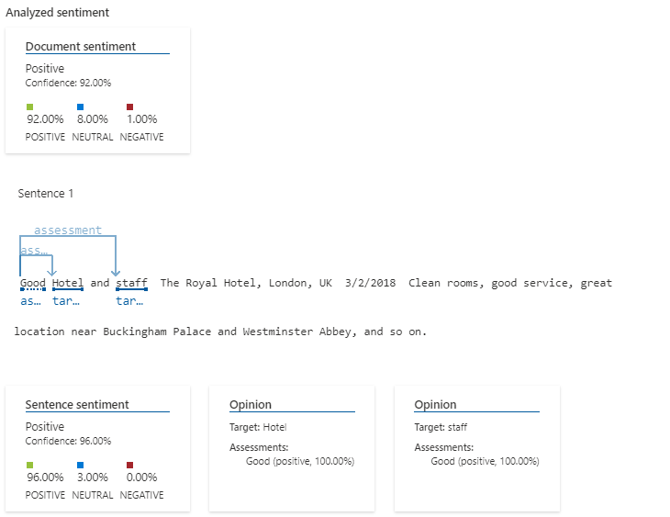

Figura 1 - Frase 1

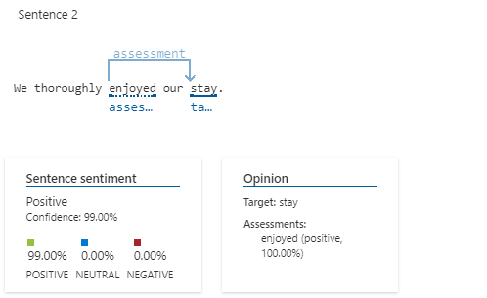

Figura 2- Frase 2

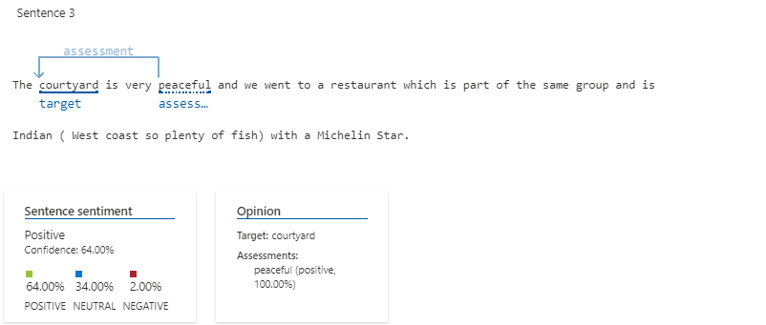

Figura 3 - frase 3

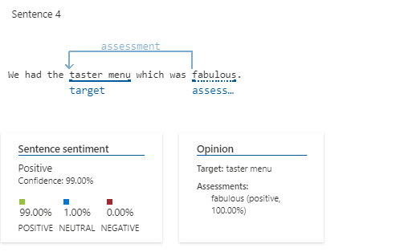

Figura 4- frase 4

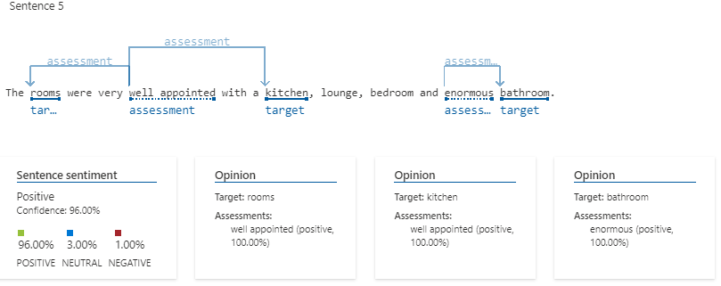

Figura 5 - frase 5

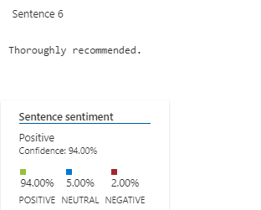

Figura 6 - frase 6