LINUX COMMANDS
- ls command:

What it is:
ls shows the contents of a directory (files and folders).

Why it is used:
It helps users see what files and directories are present in a directory.

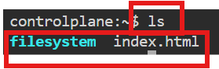
- touch command:

What it is:
touch creates a new empty file if it does not exist.

Why it is used:
To quickly create a file. To update access and modification time of a file

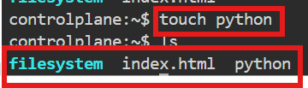
- vi command:

What it is:
vi is a text editor available in Unix/Linux systems.

Why it is used:
To create or edit files from the terminal. Commonly used to edit configuration files and scripts.
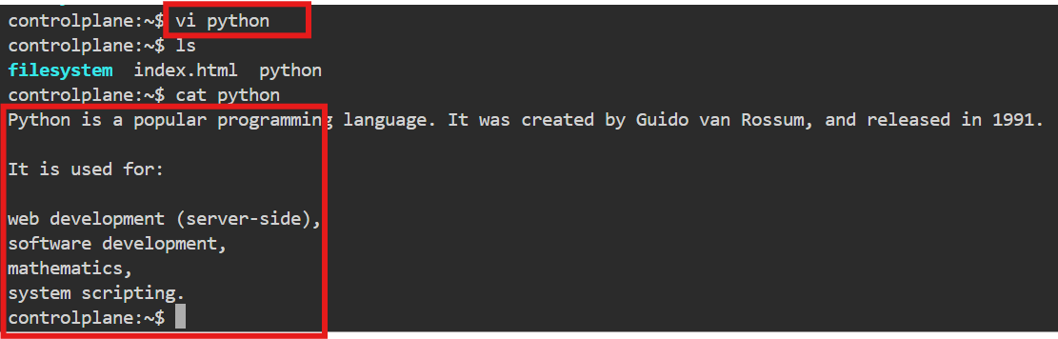
Exit commands:
Used for after inserting the any text
:w → save
:q → quit
:wq → save and quit
:q! → quit without saving

- Cat command:

What it is:
- cat stands for concatenate.
Why it is used:
    - To view the contents of a file
    - To create a file
    - To merge multiple files into one

- Nano command:

What it is:
nano is a simple, user-friendly text editor in the terminal.
Why it is used:
- Easy to use for beginners
- Quickly edit configuration files and scripts
- No complex modes like vi
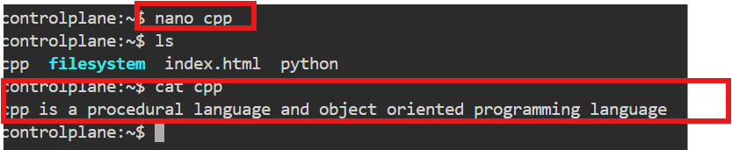

Common Nano shortcuts:

- Ctrl + O → Save
- Ctrl + X → Exit
- Ctrl + K → Cut line
- Ctrl + U → Paste line

- Mkdir command:
What it is:
mkdir stands for make directory.
Why it is used:
      - To create new folders
      - To organize files and directories
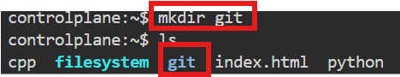
- mv command:
What it is:
mv stands for move.

Why it is used:
- To move files/directories from one location to another
- To rename files or folders

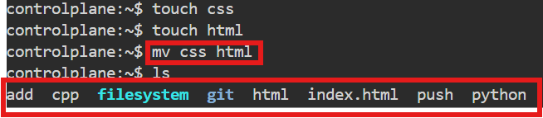
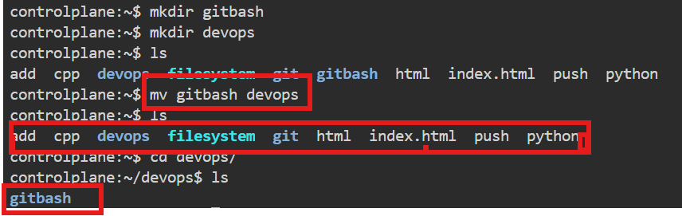

- Cd command:

What it is:
cd stands for change directory.

Why it is used:
- To navigate between directories
- To move to a specific folder location

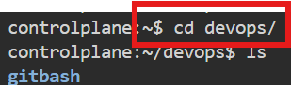

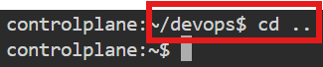
- Pwd command :

What it is:
pwd stands for print working directory.
Why it is used:

- To know your current location in the filesystem
- Helps avoid confusion while navigating directories
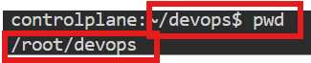
- rmdir command:

What it is:
rmdir stands for remove directory.
Why it is used:

- To remove directories that are empty
- Helps clean up unused folders

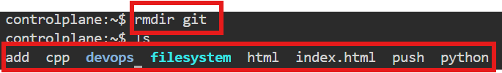

- Rm command:
What it is:
rm stands for remove.
Why it is used:
- To delete files
- To delete directories (with options)
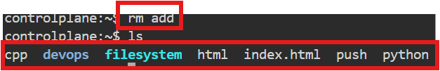

- Copy command:

What it is:
cp stands for copy.

Why it is used:
- To duplicate files
- To copy files or folders from one location to another

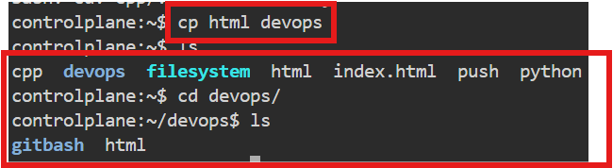

- wget command:

wget stands for web get.
Why it is used:

- To download files using a URL
- Works in the background
- Commonly used to download software, packages, or data
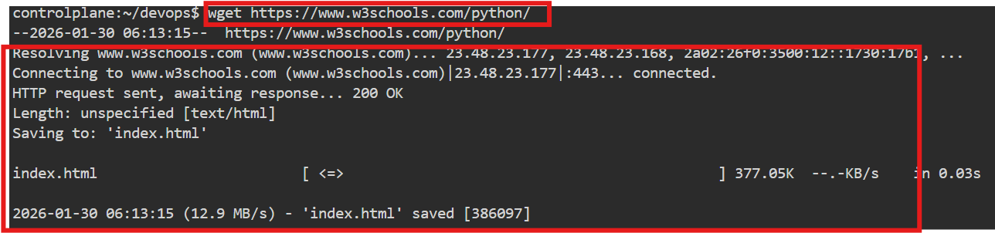
- Ping command:

The ping command is a network utility used to test the reachability of a host (like a server or website) on a network and measure the round-trip time for messages sent from your computer to that host. It’s available on Windows, Linux, and macOS.

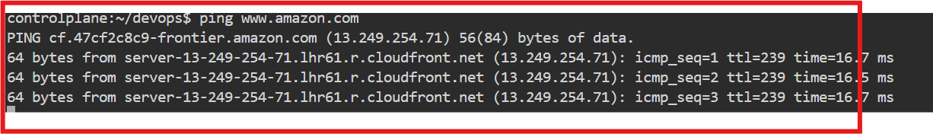
- Rm -rf command:

The rm -rf command is a Linux/Unix command used to delete files and directories recursively and forcefully. It is very powerful and dangerous if used incorrectly, because it can permanently delete important data without confirmation.
Breakdown
- rm → Remove files or directories.
- -r → Recursive; deletes all files and subdirectories inside a directory.
- -f → Force; ignores warnings and does not prompt for confirmation.

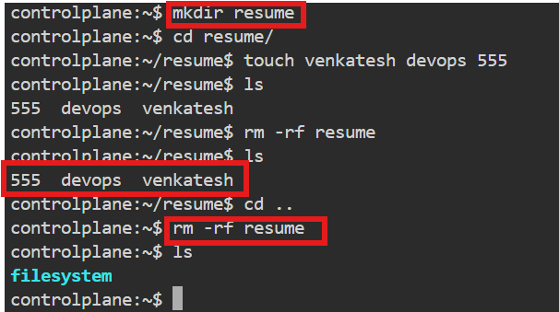

- History command:

The history command is a Linux/Unix command used to display a list of commands that you have previously executed in the terminal. It helps you review, reuse, or repeat commands without retyping them.
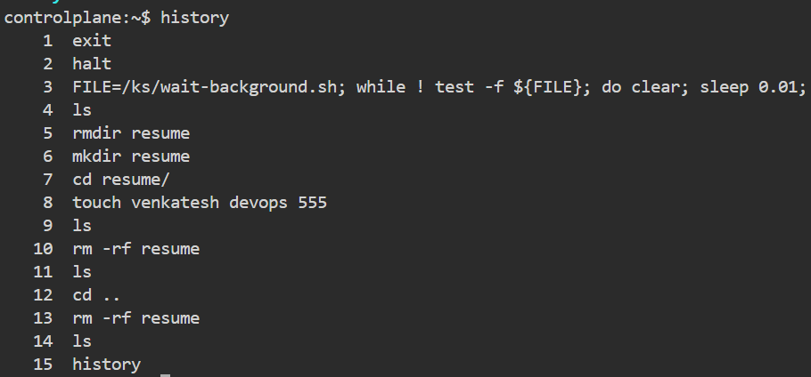
- ls -l command:
This command shows detailed information about a specific file.
What it does
- ls → lists files
- -l → long listing format
- filename → the particular file you want details about
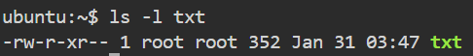

- Chmod command:
There are two ways to change the filename using chmod command
Symbolic model:
Syntax: chmod who operator permission file

Chmod- command
Who- whether user/group/other
Operator - + for add, - to removing
Permission – read/write/execute
Filename – filename
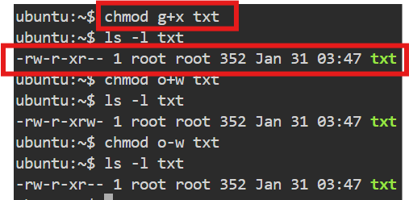
Numeric mode:
Each permission has a number value
We have to add number depends on permission
R- 4
W- 2
X-1

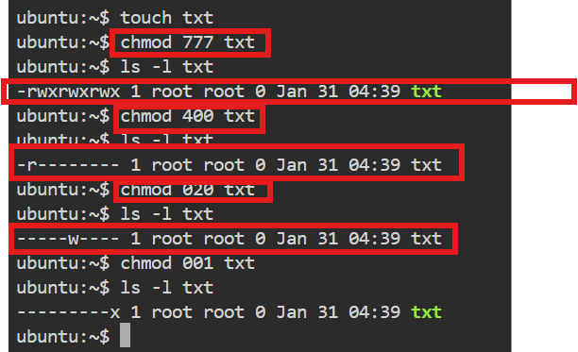

- To create users and passwords by using sudo command:
Method -1:
Syntax: sudo adduser<username>

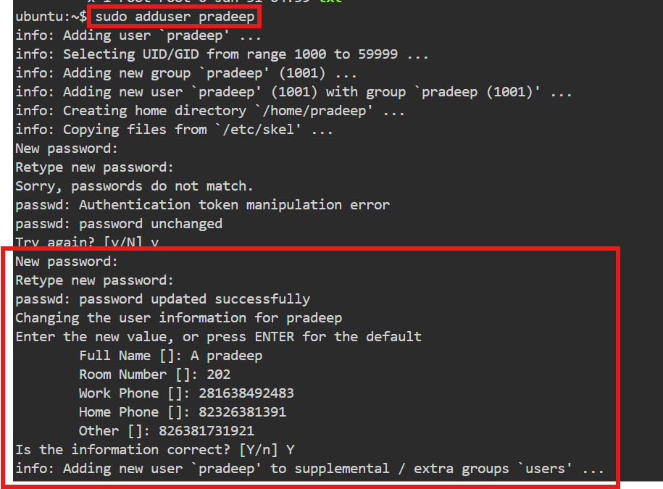

Method 2:
Syntax: sudo userdd<username>
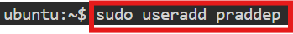
- Su – username:
su - username is used to switch to another user with a full login environment, allowing us to work exactly as that user.
To work as another user
Admins use it to:
- Check user permissions
- Run commands as that user
- Debug issues

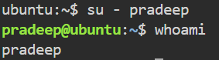
- To display username only:
Syntax: cut -d: -f1 /etc/passwd
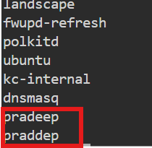
- To delete username:
Syntax: sudo userdel username
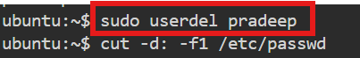
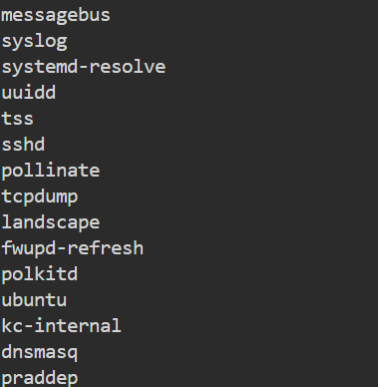
- User specific details:
To display user specific details
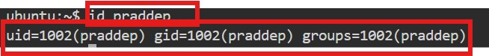
- Uname command:
uname stands for Unix Name.
It displays system information about the operating system.
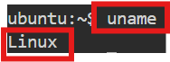
- uname -r:
uname -r shows the kernel release version of the operating system.
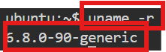
- uname -a:
uname -a displays all available system information in one line.
- uptime:
uptime shows how long the system has been running continuously, along with load information.
- uptime -p:
this will give only time
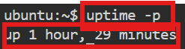
- hostname :
used to get private dns name of our system.
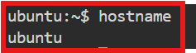
- hostname -i :
used to get private ip of our system.
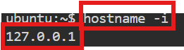
- ip addr :
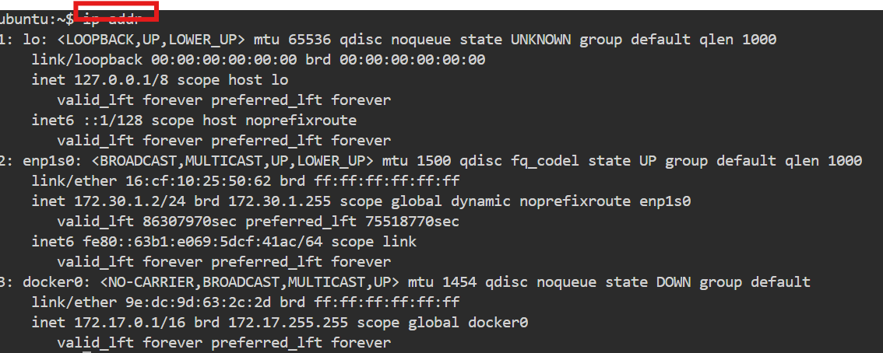
used to get private IP

- ip route : used to get private IP
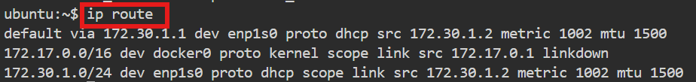

- ifconfig : used to get private IP
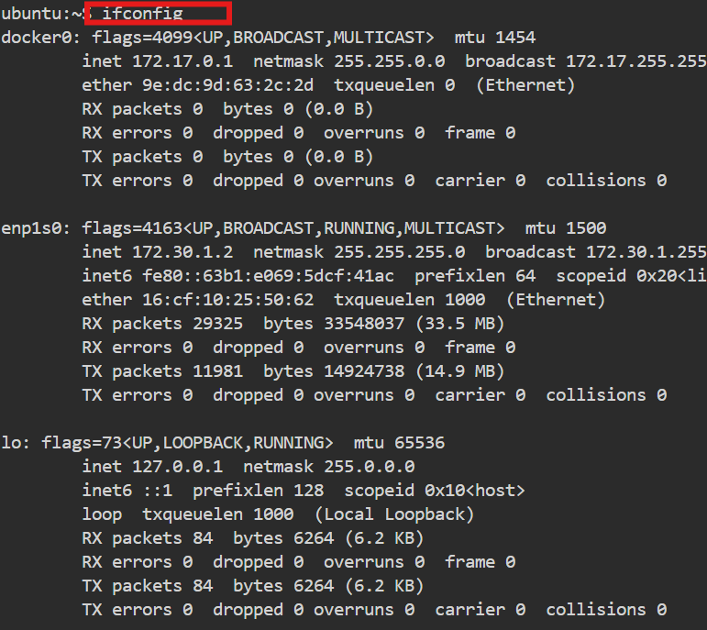
- date : to get todays date
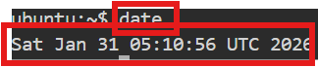
- timedatectl : used to get timezones
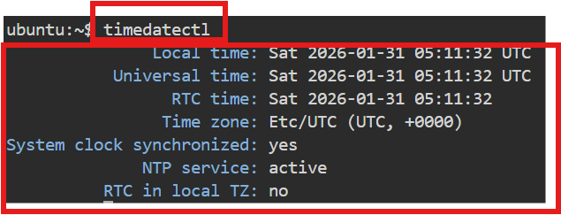

- whoami : used to see the current user.
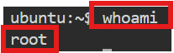
- ps : used to see the running processors in system
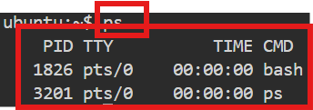
- kill -9 PID : used to kill a processor
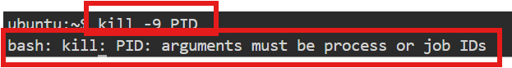
- date +”%d” : Prints day of the month (01-31)
- date +”%m” : Prints the month of the year 01-12
- date +”%y” : Prints only the last two digits of Year
- date +”%H” : Prints the hour 00-23
- date +”%M” : Prints the Minute of the hour 00-59
- date +”%S” : Prints the current seconds count in the minute (00-60)
- date +"%D" : Prints Date in MM/DD/YY
- date +”%F” : Prints only the Full date as YYYY-MM-DD
- date +”%A” : Prints the Day of the Week Saturday-Sunday
- date +”%B” : Prints the month between January-December
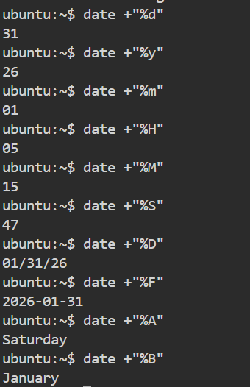
- lscpu (or) cat /proc/cpuinfo : Displays information about the CPU architecture.
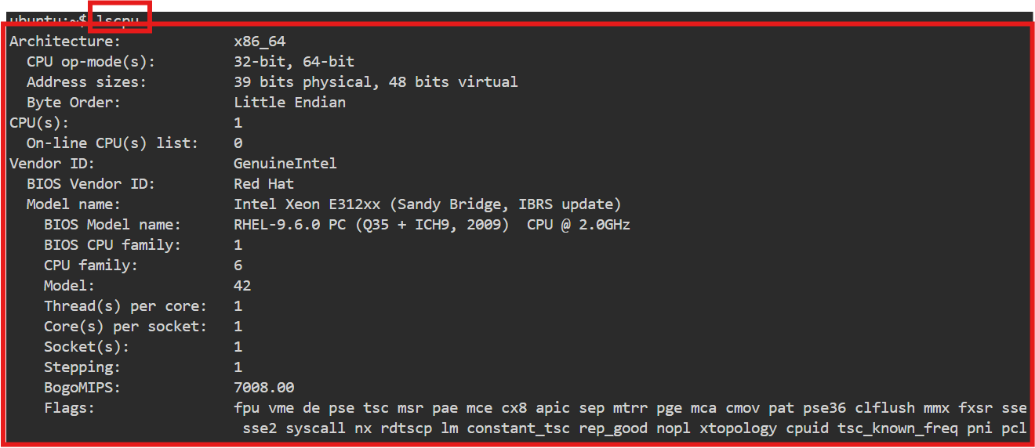
- lsblk -a : Lists the information about all the block devices attached to the system.
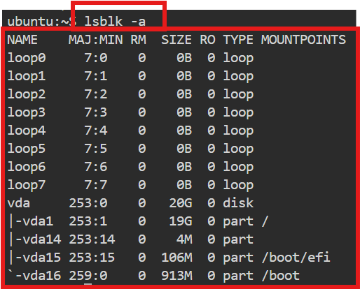
- free (or) cat /proc/meminfo: Displays system memory(RAM) details in KB
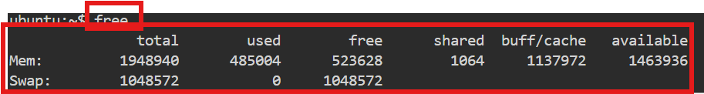
- free -m : Displays system memory(RAM) details in MB
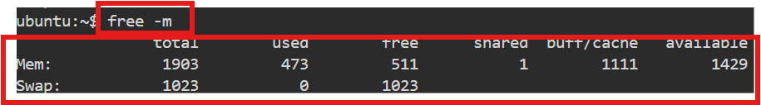
- df -h : Report file system disk space usage in human readable languages.
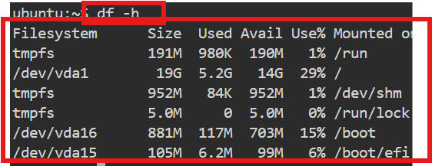
54. It is used to search for a word in a file
SYNTAX: grep “word” filename
- grep “word” filename : used to search for a word in a file

- grep -n “word” filename : it prints the data along with line numbers

- grep -c “word” filename : it prints no of occurances of a word

- grep -i “word” filename : used to search for a case-sensitive

