PlayfulOutings
Picnic Games & Getaways

eProject Documentation Report

Semester 1 eProject — HTML5 Web Development

Aptech Computer Education

Submitted by:
Chukwu Nathan Emeka
Daniel Fortune Rohi
Chukwu Stanley Ebuka
Daniel Chinonso Favour

Date: March 2026
Location: Abuja, Nigeria

Making every outing memorable • Abuja, Nigeria • March 2026

Table of Contents

1. Acknowledgements
2. eProject Synopsis
3. Problem Definition
4. eProject Analysis
5. eProject Design
— DFD — Context Diagram
— User Navigation Flowchart
— System Internal Flowchart
— Process Diagram
6. Design Specifications
7. Screenshots Description
8. Source Code with Comments
9. User Guide
10. Developer's Guide
— Module Descriptions

1. Acknowledgements
We would like to express our sincere gratitude to everyone who contributed to the successful completion of this eProject. First and foremost, we thank Aptech Computer Education and the eProjects Team for providing this structured learning opportunity and for guiding us through the practical application of web development concepts.

We are grateful to our course instructors and faculty members whose lessons on HTML5, CSS3, and JavaScript formed the foundation of everything we built in this project. Their support during lab sessions was invaluable.

Special thanks to our group members —
Chukwu Nathan Emeka, Daniel Fortune Rohi, Chukwu Stanley Ebuka, and Daniel Chinonso Favour — for their dedication, teamwork, and commitment throughout the development process.

Finally, we acknowledge the open-source community, YouTube content creators whose tutorial videos are embedded in our platform, and Google Maps for the mapping functionality that enhances our Contact section.

2. eProject Synopsis

Field | Details
Project Title | PlayfulOutings — Picnic Games & Getaways
Project Type | Single-Page Application (SPA) Website
Technology Stack | HTML5, CSS3, Vanilla JavaScript
Team Members | Chukwu Nathan Emeka, Daniel Fortune Rohi, Chukwu Stanley Ebuka, Daniel Chinonso Favour
Date | March 2026
Location | Abuja, Nigeria
Institution | Aptech Computer Education
Course | Semester 1 — HTML5 Web Development

PlayfulOutings is a fully client-side, responsive Single-Page Application designed to help families, couples, youth groups, and friends in Abuja discover and organize enjoyable picnic games and short outdoor getaways. The platform features 24 curated games across 6 categories, complete with materials, time requirements, step-by-step instructions, embedded tutorial videos, and downloadable Word document guides. It also includes Abuja-specific itinerary suggestions, geolocation integration, a live ticker, and a persistent visitor counter.

3. Problem Definition
In urban cities like Abuja, many families, couples, youth groups, and friends find it challenging to organize enjoyable picnics and short outdoor outings. Common issues include:

- Lack of ready-to-use games: No single platform provided age-appropriate games with clear instructions, required materials, and estimated playtime in one place.
- Repetitive gatherings: Without structured activities, picnics become boring and unmemorable, reducing the quality of social bonding time.
- No localized getaway plans: Existing resources did not cater to Abuja-specific popular outdoor locations like Jabi Lake, Millennium Park, or Usuma Dam.
- Difficulty organizing groups: Organizing games for mixed groups (kids, adults, males, females) required searching multiple sources with no unified solution.

Solution
PlayfulOutings solves these problems by providing a single, easy-to-use web platform that offers curated indoor and outdoor picnic games categorized for different groups, step-by-step game guides, Abuja-specific itinerary suggestions, and interactive features to enhance user engagement — all accessible from any device with a web browser.

4. eProject Analysis

Functional Requirements
- Display a categorized library of 24 picnic games (Indoor, Outdoor, Kids, Males, Females, Family).
- Provide Materials Needed, Time Required, and How-to-Play instructions for each game.
- Embed YouTube demo videos for every game with lazy loading for performance.
- Offer downloadable Word document (.docx) instruction sheets for each game.
- Include an Itinerary section with Abuja-specific short getaway suggestions.
- Display an About Us and Contact Us section with a Google Maps embed.
- Implement a category filter (sub-navigation) that shows only the selected game group.
- Show a persistent visitor counter using browser localStorage.
- Display a live scrolling ticker showing current date, time, and user location.
- Detect and display user geolocation in the Contact section and ticker.
- Provide a dropdown menu under 'Games' in the header for quick category access.

Non-Functional Requirements

Requirement | Description
Performance | Fast load time via lazy-loaded videos; no backend server required.
Responsiveness | Fully mobile-friendly layout using CSS Grid, Flexbox, and media queries.
Compatibility | Works across Chrome, Firefox, Edge, and Safari browsers.
Usability | Intuitive navigation with smooth scrolling, active link highlighting, and clear visual hierarchy.
Maintainability | Clean, well-commented code organized into three files (HTML, CSS, JS).

5. eProject Design

Data Flow Diagram (DFD) — Context Diagram
The Level 0 DFD shows the PlayfulOutings system as a single process and its interaction with all external entities: the User (browser), localStorage (visitor data), YouTube API (video embeds), and the Geolocation API (location data).

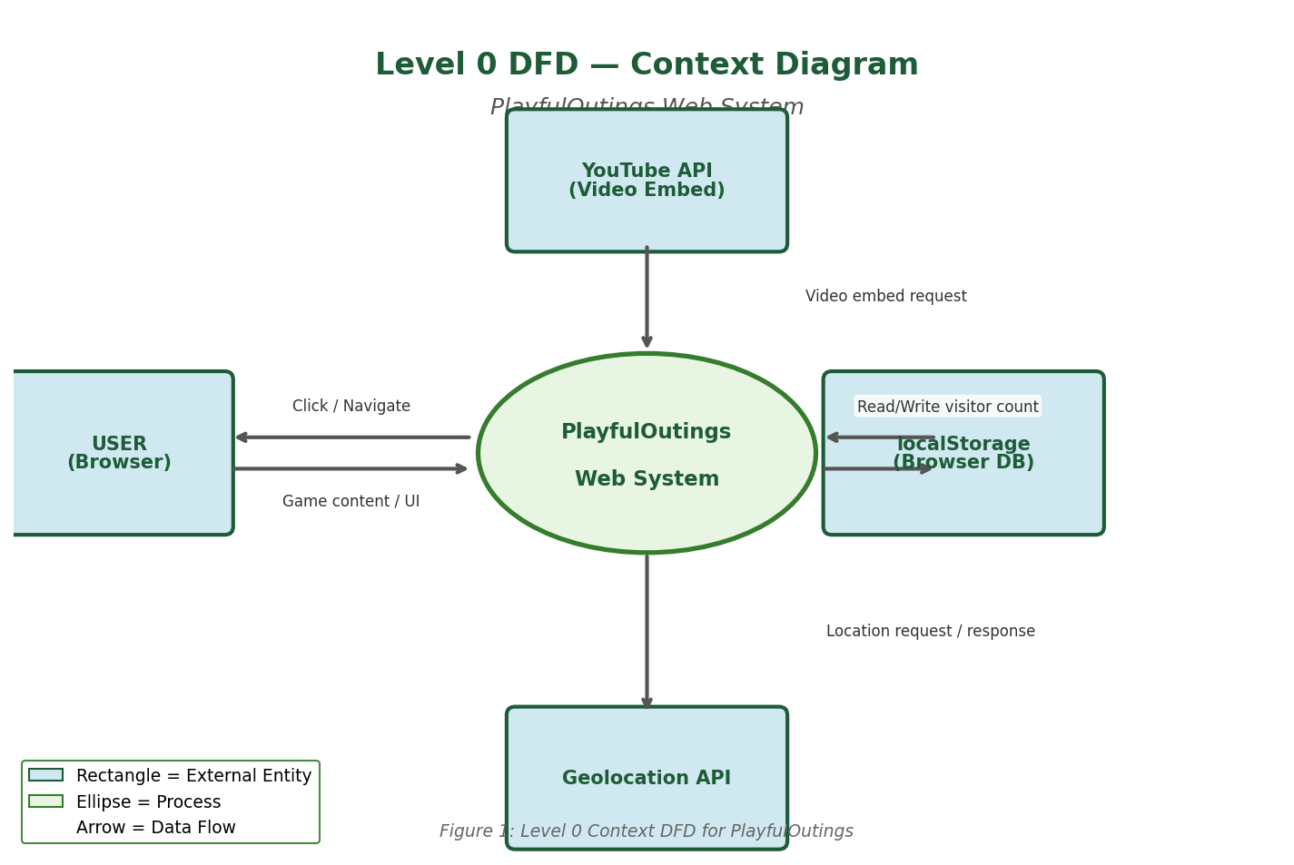

DFD Symbol Key
- Rectangle = External Entity (User, APIs, localStorage)
- Ellipse = Process (the PlayfulOutings system)
- Arrow = Data Flow direction

Flowchart 1 — User Navigation Flow
This flowchart shows how a user interacts with the website from opening it to consuming content. Standard flowchart symbols are used throughout: ovals for Start/End, rectangles for processes, and diamonds for decisions.

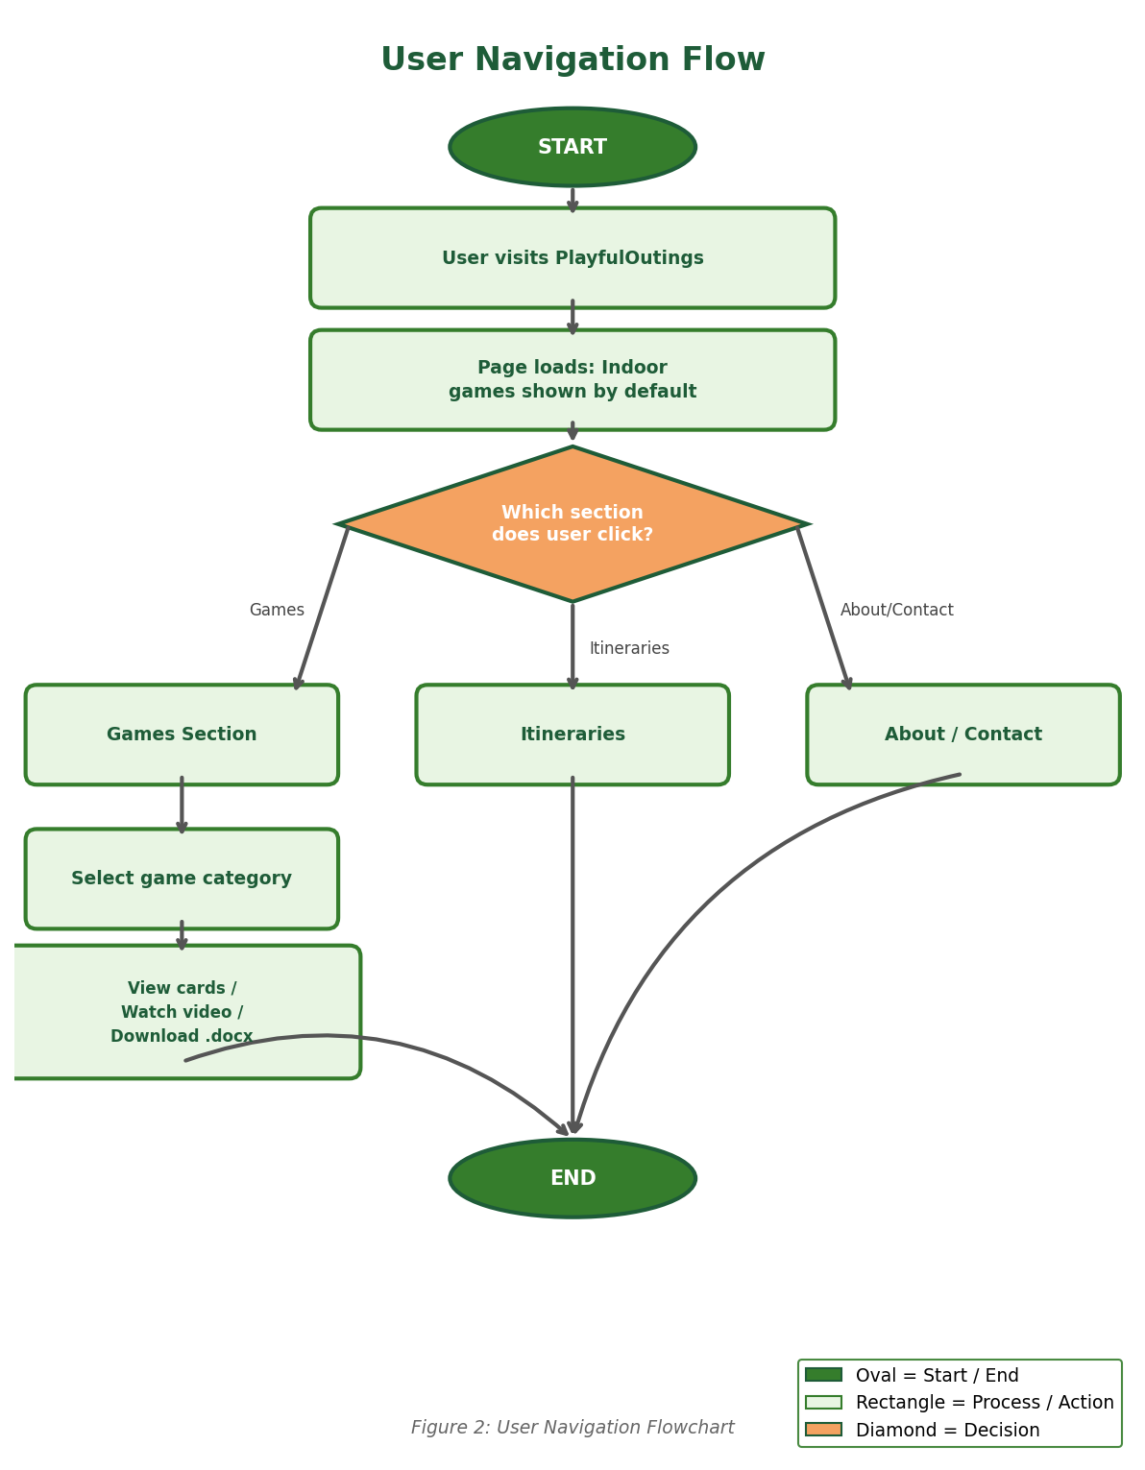

Flowchart Symbol Key
- Oval (green) = Start / End terminal
- Rectangle (light green) = Process / Action step
- Diamond (orange) = Decision point (branch)
- Arrow = Flow of control

Flowchart 2 — System Internal Flow
This flowchart shows what happens internally when the page loads — how JavaScript initialises the visitor counter, hides all game categories and shows Indoor by default, requests geolocation, and starts the live ticker.

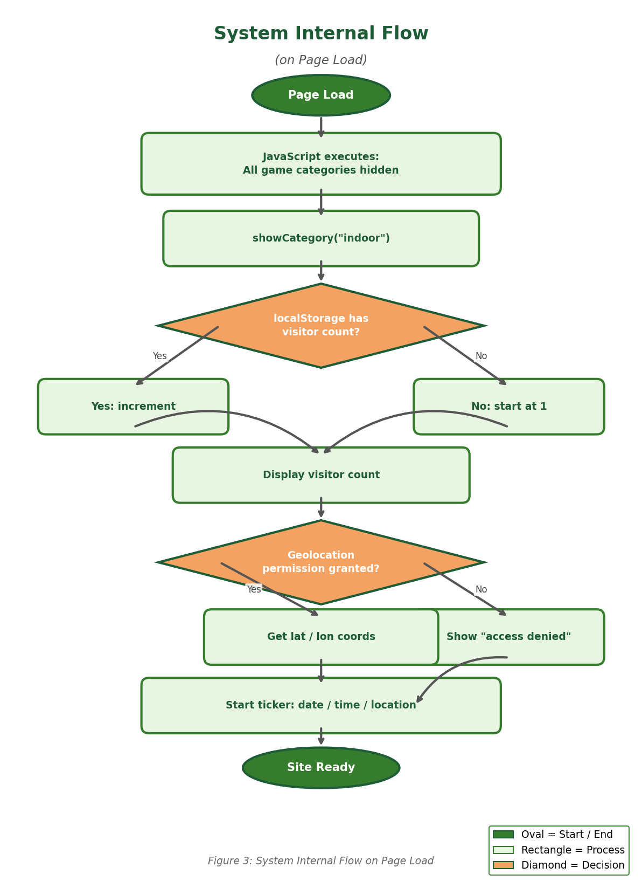

Process Diagram — Game Category Filter
This diagram illustrates the process flow when a user selects a game category either from the sub-navigation bar or the header dropdown menu.

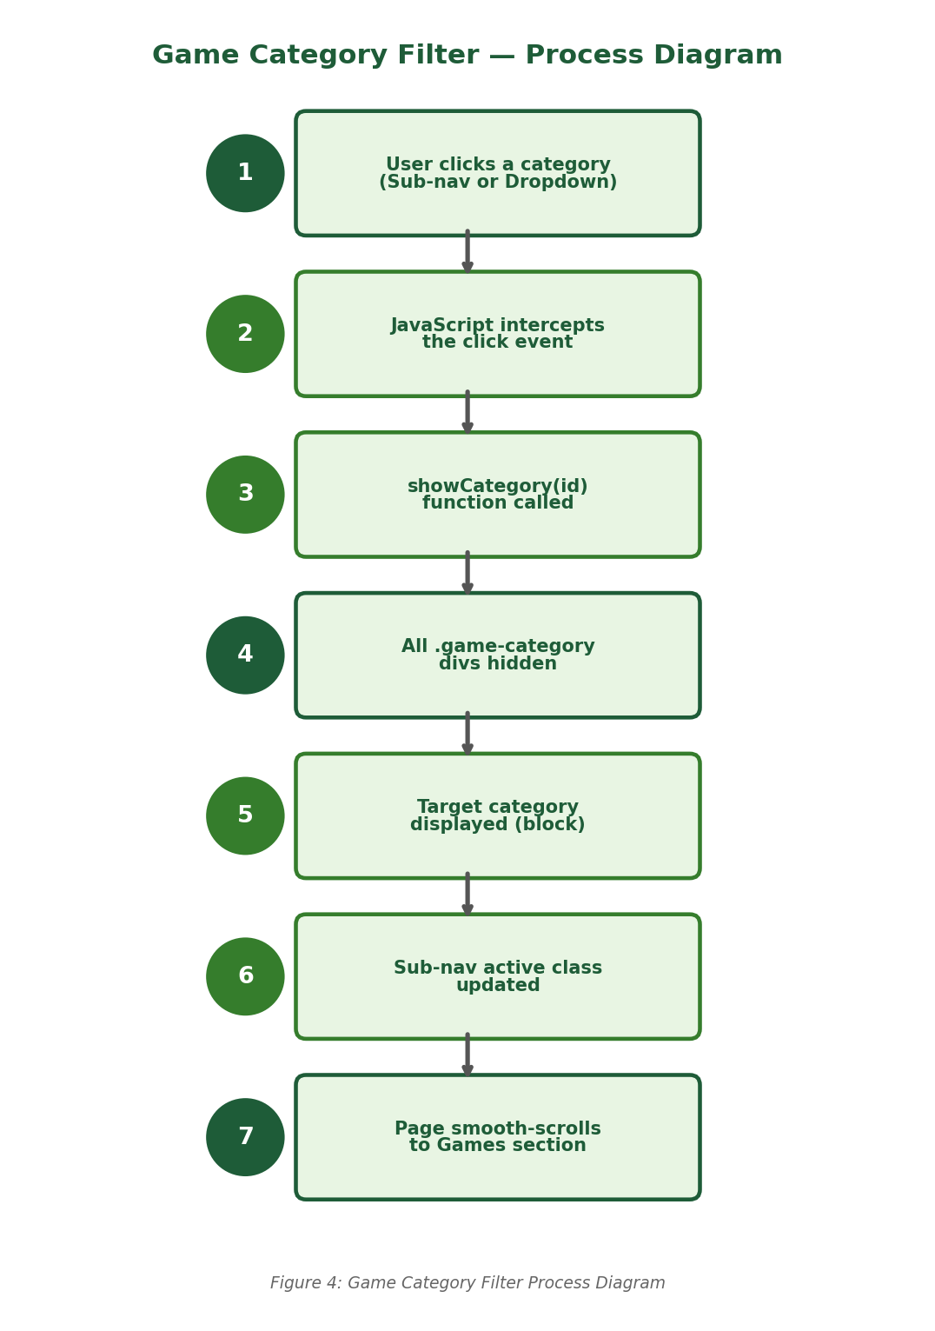

6. Design Specifications

Technology Stack

Technology | Purpose | Details
HTML5 | Structure | Semantic tags, sections, iframes, geolocation API
CSS3 | Styling | Glassmorphism, CSS Variables, Flexbox, Grid, Animations
JavaScript (ES6) | Interactivity | DOM manipulation, localStorage, Geolocation, Event listeners
Google Maps Embed | Location | Millennium Park map in Contact section
YouTube Embed API | Video | Lazy-loaded game tutorial videos
localStorage | Data Store | Persistent visitor count across sessions
Google Fonts | Typography | Poppins (body), Press Start 2P (hero title)

Color Scheme & Visual Design

CSS Variable | Hex Value | Usage
--primary | #357d2c | Buttons, labels, accents, card headers
--primary-dark | #1e5c38 | Hover states, darker accents
--accent | #f4a261 | Call-to-action highlights
--glass | rgba(255,255,255,0.12) | Glassmorphism navigation and sections
--glass-border | rgba(255,255,255,0.25) | Glass element borders
--text | #ffffff | Primary text on dark backgrounds

7. Screenshots Description
The following describes each key screen of the PlayfulOutings website, with actual screenshots from the live site.

Screen 1 — Hero / Home Section
The landing view features the 'Welcome to Playful Outings' title in Press Start 2P font over a full-screen looping outdoor picnic video. A glass-effect navigation bar sits at the top with the logo, nav links (including a Games dropdown), and visitor counter. An 'Explore Games' CTA button is centered below the title.

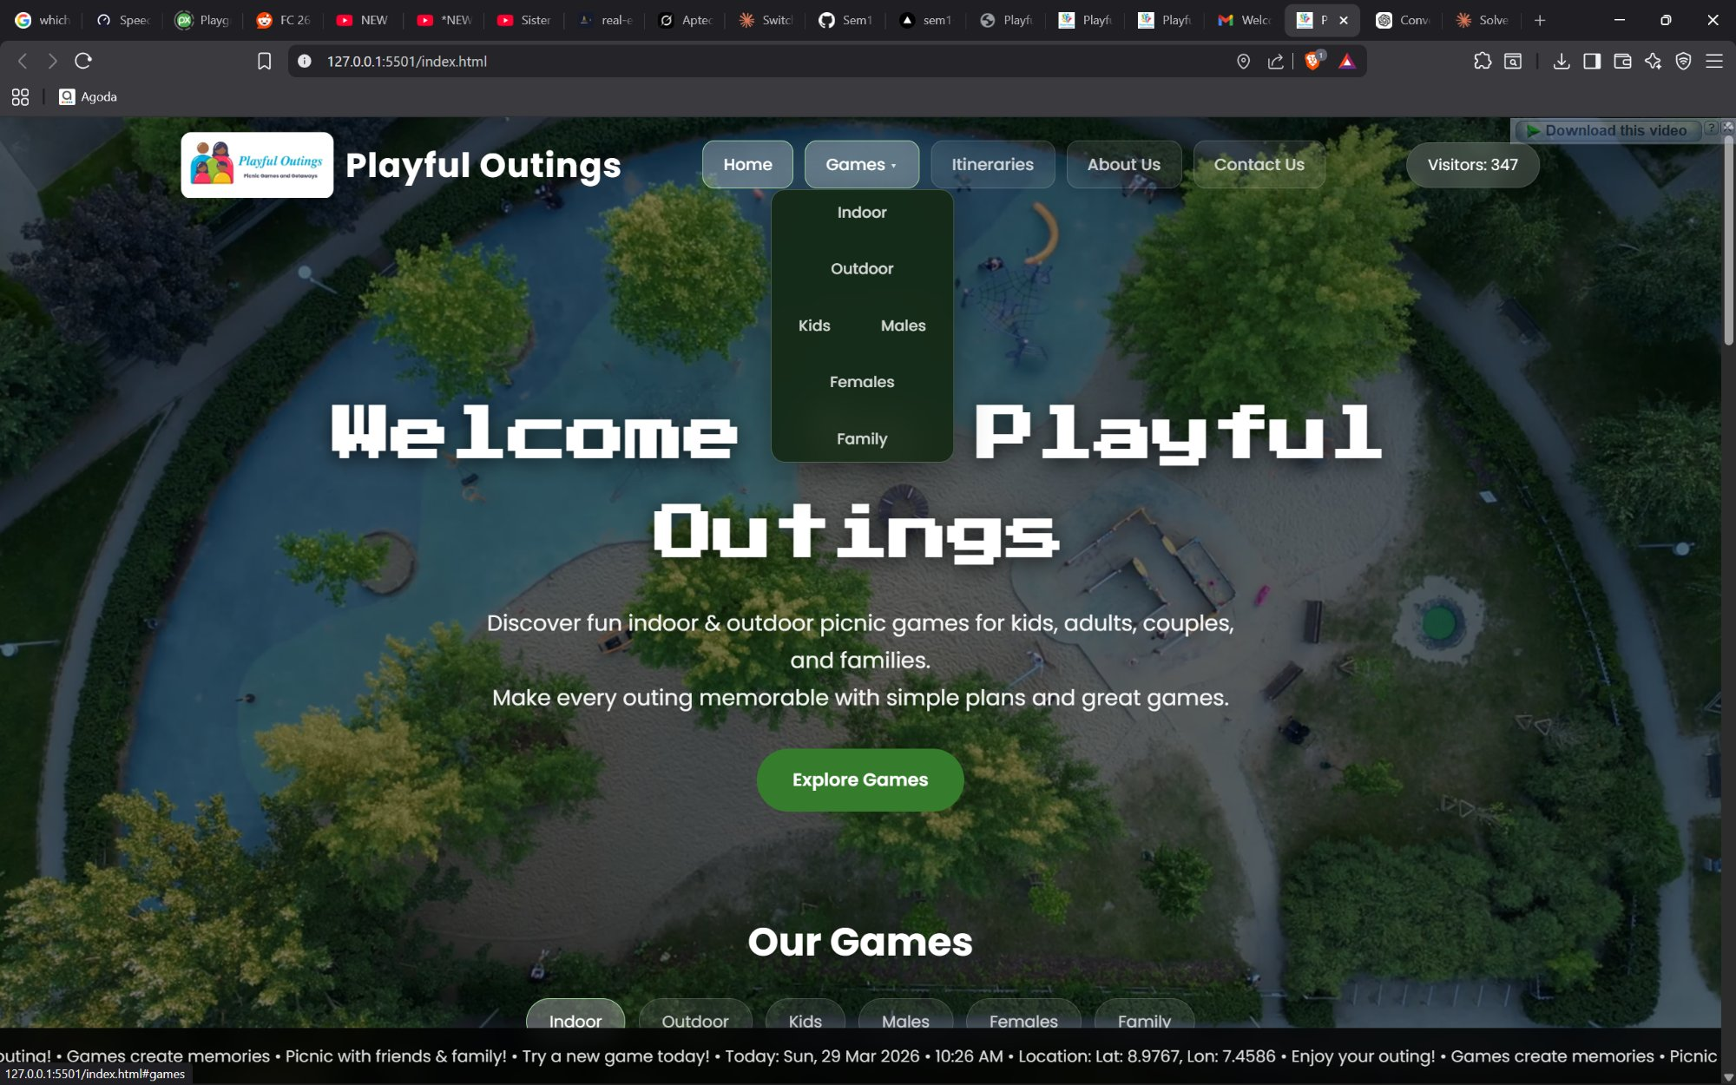
Screenshot 1 — Hero / Home Section with Games Dropdown visible

Screen 2 — Games Section with Filter
Below the hero, the Games section displays the sub-navigation pills (Indoor, Outdoor, Kids, Males, Females, Family). By default, Indoor games are shown. Each game card has a colored header bar, materials, time, how-to-play info, a YouTube thumbnail with red play button, and a green 'Download Instructions (.docx)' button.

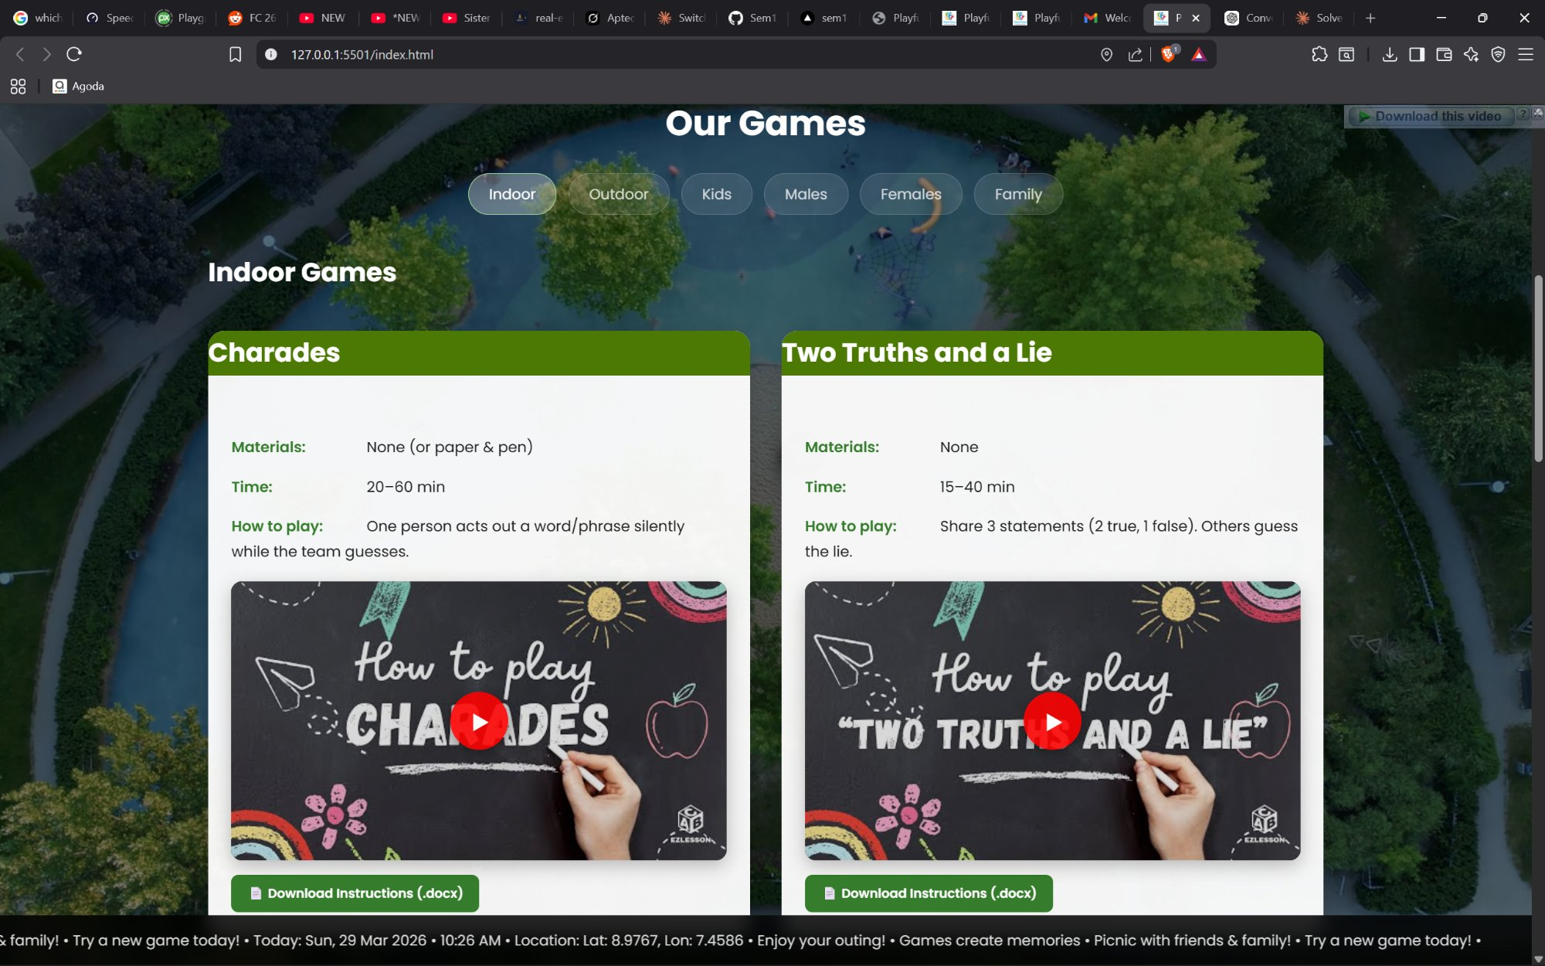
Screenshot 2 — Games Section showing Indoor games (Charades & Two Truths and a Lie)

Screen 3 — Category Filter Active (Outdoor)
When a user clicks 'Outdoor' in the sub-nav, only the 4 Outdoor game cards are visible. The active sub-nav pill is highlighted with a brighter background and green border. All other categories are hidden.

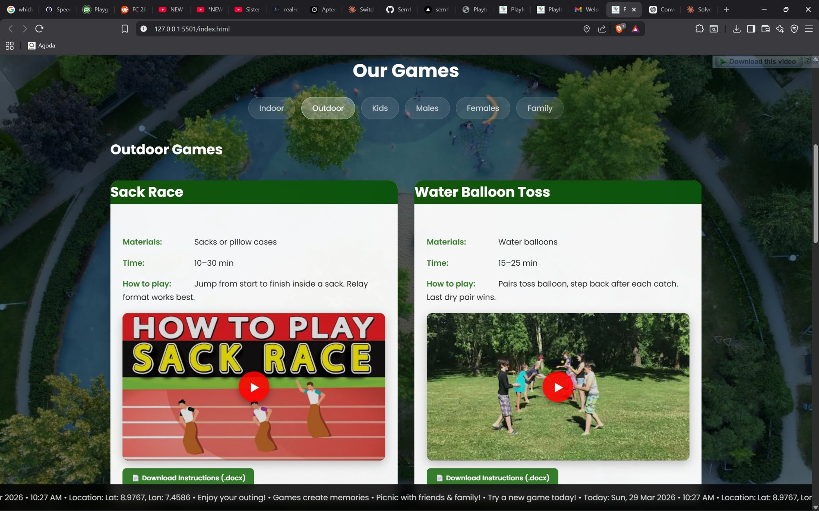
Screenshot 3 — Outdoor category selected showing Sack Race & Water Balloon Toss

Screen 4 — Itineraries Section
A glassmorphism card section listing three Abuja-specific getaway itineraries: Jabi Lake Day, Millennium Park Picnic, and Usuma Dam Outing, with suggested spots listed below. The About Us section is also visible beneath it.

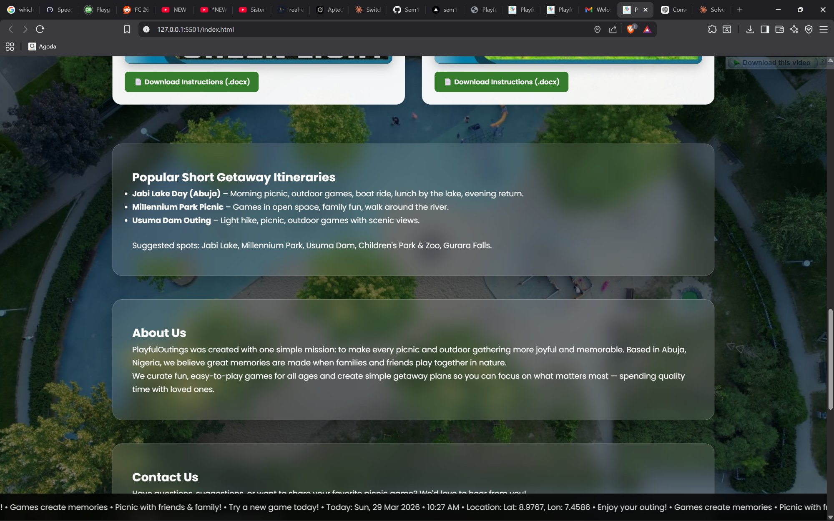
Screenshot 4 — Itineraries Section with About Us panel visible

Screen 5 — Contact Section
Displays contact email, phone, and a live geolocation readout. Below that is an embedded Google Maps iframe showing Millennium Park, Abuja. A simple contact form with name, message fields and a Send button rounds out the section.

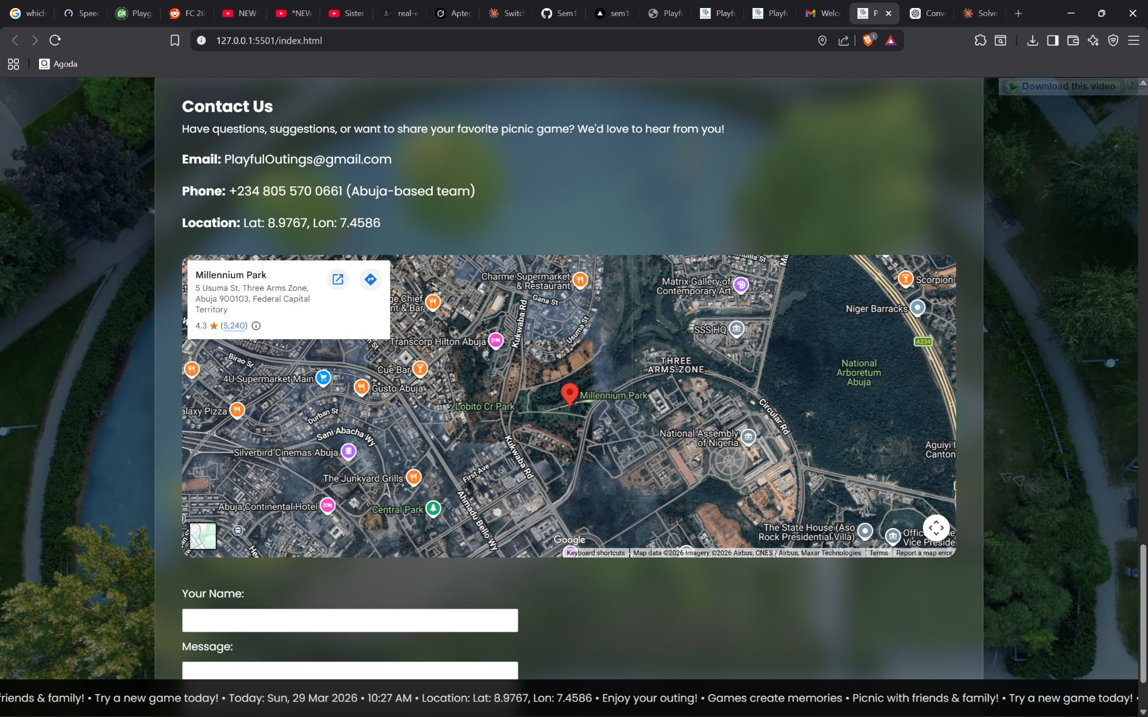
Screenshot 5 — Contact Section with Google Maps embed showing Millennium Park, Abuja

Screen 6 — Mobile View
On screens under 768px, the header stacks vertically, nav links become full-width, game cards go single-column, and the sub-nav wraps in a flex row. The ticker remains pinned at the bottom.

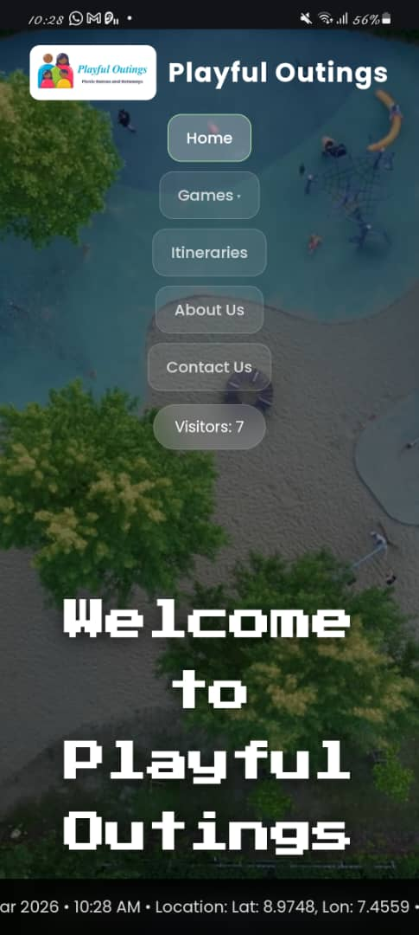
Screenshot 6 — Mobile view showing vertical stacked navigation and responsive layout

8. Source Code with Comments

index.html — Key Structure

<!-- BACKGROUND VIDEO: fixed full-screen looping picnic video -->
<video id="bg-video" autoplay muted loop playsinline>
<source src="videos/bg-video.mp4" type="video/mp4">
</video>

<!-- HEADER: Logo + Main Nav (with Games dropdown) + Visitor Counter -->
<header>
<nav class="main-nav">
<li class="has-dropdown">
<a href="#games">Games</a> <!-- Shows dropdown on hover -->
<ul class="dropdown-menu"> ... </ul>
</li>
</nav>
<div class="visitor-count">Visitors: <span id="visitorCount"></span></div>
</header>

<!-- GAMES SECTION: Sub-nav filter + 6 categories of 4 cards each -->
<section id="games">
<!-- Sub-navigation: clicking a pill triggers showCategory() in JS -->
<div class="sub-nav"> ... </div>
<div id="indoor" class="game-category"> ... </div>
<div id="outdoor" class="game-category"> ... </div>
</section>

<!-- TICKER: Fixed bottom bar with live date/time/location -->
<div class="ticker">
<div class="ticker-content" id="tickerContent"></div>
</div>

script.js — Annotated Key Functions

Visitor Counter
let visits = localStorage.getItem("playfuloutings_visits") || 0;
visits = Number(visits);
if (isNaN(visits)) visits = 0; // Guard against corrupted data
visits += 1;
localStorage.setItem("playfuloutings_visits", visits);

Game Category Filter
function showCategory(selectedId) {
const target = document.getElementById(selectedId);
if (!target) return; // Guard: id must exist
gameCategories.forEach(cat => {
cat.style.display = (cat.id === selectedId) ? "block" : "none";
});
}
// Hide all on load, default to "indoor"
gameCategories.forEach(cat => { cat.style.display = "none"; });
showCategory("indoor");

YouTube Lazy Load
wrapper.addEventListener("click", function () {
if (this.querySelector("iframe")) return; // No duplicate iframes
const iframe = document.createElement("iframe");
iframe.src = `https://www.youtube.com/embed/${videoId}?autoplay=1`;
this.innerHTML = "";
this.appendChild(iframe);
});

Geolocation + Ticker
navigator.geolocation.getCurrentPosition(
pos => { locEl.textContent = `Lat: ${pos.coords.latitude}...`; },
() => { locEl.textContent = "Location access denied"; }
);
setInterval(updateTicker, 1000); // Ticker refreshes every second

style.css — Key Design Rules

/* CSS Variables: central theme control for the whole site */
:root {
--primary: #357d2c; /* Main green */
--primary-dark: #1e5c38; /* Darker green for hovers */
--accent: #f4a261; /* Orange accent */
--glass: rgba(255,255,255,0.12); /* Glassmorphism background */
}

/* Fixed full-screen background video */
#bg-video { position: fixed; top:50%; left:50%;
transform: translate(-50%,-50%); object-fit: cover; z-index: -2; }

/* Game cards: white cards with hover lift effect */
.game-card { background: rgba(255,255,255,0.95);
border-radius: 18px; transition: all 0.4s ease; }
.game-card:hover { transform: translateY(-12px); }

/* YouTube lazy-load thumbnail wrapper (16:9 ratio) */
.yt-lazy { position: relative; padding-top: 56.25%;
cursor: pointer; background: #000; }
.yt-lazy iframe { position:absolute; top:0; left:0;
width:100%; height:100%; }

/* Ticker: fixed bottom scrolling bar */
.ticker { position: fixed; bottom: 0; z-index: 100;
animation: ticker-scroll 58s linear infinite; }

9. User Guide
This guide explains how to use the PlayfulOutings website. No installation or account is required — simply open the website in any modern web browser.

Getting Started
Open the file index.html in any modern browser (Chrome, Firefox, Edge, or Safari). The site loads immediately with the background video and Indoor games displayed by default. Allow location access when prompted for the full ticker experience.

Navigating the Site
- Use the top navigation bar to jump to Home, Games, Itineraries, About Us, or Contact Us.
- Hover over Games in the nav bar to reveal a dropdown with all 6 game categories.
- Click any dropdown item to jump directly to that game category.
- Use the sub-navigation pills (Indoor, Outdoor, Kids, etc.) inside the Games section to filter games.
- The page scrolls smoothly to the selected section.

Browsing Games
- Each game card shows: Materials Needed, Time Required, and How to Play instructions.
- Click the red play button on any video thumbnail to watch a demo video for that game.
- Click 'Download Instructions (.docx)' to download a Word document with full game details.
- Only the selected category's games are visible at one time — click another category pill to switch.

Contact & Location
- Scroll to the Contact Us section to find email, phone, and a Google Maps embed.
- If you allow location access, your coordinates will appear next to 'Location:'.
- Fill in your Name and Message in the contact form and click Send (demo mode).

Ticker & Visitor Count
- The scrolling ticker at the bottom shows the current date, time, your location, and fun messages.
- The visitor counter in the top-right corner tracks how many times the site has been opened on your device.

10. Developer's Guide
This guide is intended for developers who need to understand, maintain, or extend the PlayfulOutings codebase. The project is a fully client-side static website with no backend or build tools required.

Project File Structure

File / Folder | Description
index.html | Main HTML file — all sections and content
style.css | All styling — layout, components, animations, responsive
script.js | All JavaScript — filter, ticker, geolocation, lazy load
game_docs/ | Folder containing 24 .docx game instruction files
videos/ | Folder containing bg-video.mp4, bg-poster.png, Logo.png

Module Descriptions

Visitor Counter Module (script.js)
Uses window.localStorage to persist the visit count across sessions. On every page load, it reads 'playfuloutings_visits', increments it by 1, writes it back, and updates the #visitorCount span in the header. NaN protection is included to handle corrupted storage.

Game Category Filter Module (script.js)
Implements showCategory(id): queries all .game-category divs and sets display:none on all except the one whose id matches the argument. Updates the active class on .sub-link elements. Both .sub-link and .dropdown-link clicks invoke this function. On page load, all categories are hidden first, then showCategory('indoor') is called as the default.

YouTube Lazy Load Module (script.js)
Each game video is initially rendered as a thumbnail image with a red play button overlay (.yt-lazy div). On click, a YouTube iframe is created dynamically with autoplay=1 in the src, replacing the thumbnail. A guard check prevents duplicate iframes if clicked twice.

Geolocation & Ticker Module (script.js)
Calls navigator.geolocation.getCurrentPosition() on load. On success, coordinates are displayed in the #userLocation span. The updateTicker() function assembles a string with current date, time, and location, sets it as tickerContent.textContent (doubled for seamless scroll loop), and is called every 1000ms via setInterval.

Smooth Scroll & Active Nav Module (script.js)
All anchor links are intercepted with preventDefault() and replaced with scrollIntoView({behavior:'smooth'}). A scroll event listener tracks the current visible section and applies the .active class to the matching nav link.

CSS Variables & Theming (style.css)
All colors are defined as CSS custom properties in :root. This means changing --primary updates button colors, card headers, labels, and borders simultaneously. The glassmorphism effect uses backdrop-filter:blur() with semi-transparent backgrounds.

Responsive Layout Module (style.css)
Three media query breakpoints: 992px (stacks header vertically), 768px (single-column game grid, vertical nav links, flex-row sub-nav), 480px (smaller fonts). Game grid uses CSS Grid with auto-fit and minmax(480px,1fr) on desktop.

Dropdown Menu Module (style.css + HTML)
The .dropdown-menu is positioned absolutely under the Games nav item. It uses opacity:0 and pointer-events:none by default, transitioning to opacity:1 on :hover and :focus-within of the parent li. JavaScript handles clicks to trigger showCategory() and smooth scroll.

How to Add a New Game
- Add a new .game-card div inside the relevant .game-category div in index.html.
- Include .info-item divs for Materials, Time, and How to Play.
- Add a .yt-lazy div with the correct YouTube video ID as data-videoid.
- Add a .download-btn anchor pointing to a new .docx file in the game_docs/ folder.
- Create the corresponding .docx file with game details and place it in game_docs/.
- No changes to CSS or JS are needed — the filter and lazy-load work automatically.

Browser Compatibility

Browser | Version Tested | Status
Google Chrome | 120+ | Fully Supported
Mozilla Firefox | 121+ | Fully Supported
Microsoft Edge | 120+ | Fully Supported
Safari | 17+ | Fully Supported
Opera | 106+ | Fully Supported

PlayfulOutings — eProject Documentation | Aptech Computer Education | March 2026

