NOTE: For simplicity’s sake simple getter/setter methods for attributes have been omited from the class diagram

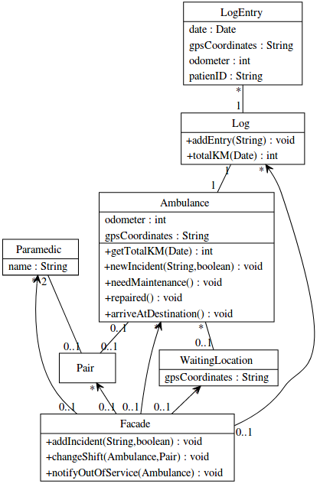
1. Class Diagram
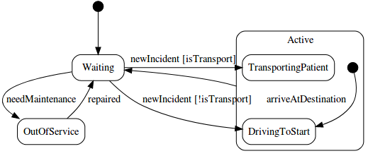
2. State Machine Diagram
3. Sequence Diagram
