Growth and Nutritional Status of Tribal Preschool Children: An Assessment Based on Body Circumferences

Biswajit Mahapatra* Kaushik Bose
______________________________________________________________________

Abstract
In India, undernutrition is the most prevalent health issue among tribal preschool children. The present study describes growth and nutritional status among tribal preschool children based on mid-upper arm circumferences (MUAC) and head circumference (HC). It utilizes the receiver operating characteristics (ROC) curve to determine cut-off points for body circumferences as a screening tool for growth and nutritional status. The present study surveyed 848 tribal preschool children aged 12-71 months from two districts of West Bengal, India. Undernutrition was assessed using WHO standard reference values of age and sex specific HC and MUAC z scores (< -2SD). The prevalence of undernutrition assessed by MUAC and head circumferences was 35.3% and 60.7%, respectively. The overall undernutrition prevalence is 70.9%, consisting of 45.8% with one type of undernutrition (MUAC or HC) and 25.1% with undernutrition on both measures. Body circumferences showed a higher mean value in healthy children compared to children with nutritional deficiencies, in both boys and girls. Boys had significantly higher mean body circumferences than girls. The study reveals that HC-based nutritional deficiencies are more prevalent than MUAC-based. Assessment of undernutrition using body circumferences and circumference-to-height ratios supports early detection of undernutrition and impaired growth status among tribal preschool children.
Keywords: Tribal nutrition, Preschool children, Growth, Nutrition, Body circumferences, Anthropometry
______________________________________________________________________

1. Introduction
In India, child undernutrition is a major health problem, particularly in tribal communities. Globally, malnutrition causes over 3.1 million child deaths annually, with one in every three under-five children being malnourished (Black et al., 2013; IFPRI, 2016). This malnutrition (under- and overnutrition) affects growth potential and future morbidity and mortality risks (Alderman et al., 2003). Undernutrition in India is a significant public health issue, which increases childhood mortality and morbidity (UNICEF, 2019). Under-five (0-5 years age) mortality rates are 34 per 1000 live births in India and 25 per 1000 in West Bengal (UNICEF, 2019). Undernutrition is a significant cause of child mortality in developing countries like India, with nearly half of preschool-aged deaths in low- and middle-income countries attributed to this issue (Black et al., 2013). In West Bengal, previous research indicates that approximately 50% of children experience various forms of undernutrition (Bose et al., 2008).

In India, head circumference (HC) and mid upper arm circumference (MUAC) are utilized in survey and screening programs to diagnose protein-energy malnutrition (Singh & Bisnoi, 2005). HC is a physical indicator of past nutritional status and brain or cognitive development among children (Rumsey & Rapoport, 1983). Neck circumference is a marker of malnutrition that assesses both undernutrition and obesity in children. Other circumferences like chest, thigh, and medial calf are useful indicators of nutritional status, but are rarely used due to lack of a standardized cut-off value. For these reasons, the present study attempts to provide an age- and sex-wise optimal cut-off value for assessing undernutrition among preschool children.

2. Methods
2.1. Study design and participants
The present study was conducted on tribal preschool children aged 12–71 months. Three blocks were studied; these are Nayagram block, the most populated tribal block in the Jhargram district, and its nearest two blocks (Dantan I and Keshiary) of Paschim Medinipur district. This study focused on the most populous Santal and Bhumij tribes, which belong to the Austro-Asiatic (Munda) speaking tribes of West Bengal. The present study included children from agriculture-related households, excluding physically challenged children, those who failed inclusion criteria, and parents unwilling to participate.
The present study included 13 villages (Amda, Bhadra, Bhumijsai, Dudhe budhe, Dakshindiha, Joykrishnapur, Julko, Junbalda, Kamarchowki, Kanpur, Salbani, Sarisa, Talbandh) from the Keshiary block, 8 villages (Antri, Bahalia, Beldiha, Borah, Dhuriya, Manikara, Markandapur, Uchudiha) from the Dantan-l block, and 15 villages (Barpat, Begunadahi, Bhaliaghati, Gulfa, Hasimpur, Jadukatha, Jagannathpur, Jarka, Kadokatha, Khanamuri, Marapada, Pungiri, Singdhui, Talakuldihi, Tufuria) from the Nayagram block. We conducted the research from April 2018 to March 2019. The 2011 Census reported a population of 17,598 in Nayagram block, with 41.01% of preschool children belonging to tribal peoples. The Keshiary block had 16,984 children under five, with 34.25% of scheduled tribes. The Dantan I block had 20,209 children aged 0-5, with 16.38% belonging to tribal peoples. In the three blocks combined, the total number of tribal children was 16,169 (Census, 2011). The study used stratified random sampling to select 848 under-five children from Santal and Bhumij ethnic groups, with 95% confidence level, 50% population proportion, and a 3.3% margin of error.

2.2. Anthropometric data
The anthropometric measurements were conducted in accordance with standard procedures (Lohman et al., 1988). The departmental ethics committees provided the ethical clearance, and the study adhered to the Declaration of Helsinki’s ethical guidelines (Touitou et al., 2004). Three kinds of anthropometric measurements were taken from each participant: height, weight, and several body circumferences. Weight was measured using digital weighing scales. The standing height was measured using an anthropometric rod, and the recumbent length was measured using an infantometer. Circumferences were measured using a measuring tape. The study participants provided six types of body circumferences (head circumference, neck circumference, mid upper arm circumference, chest circumference, thigh circumference, medial calf circumference) and six types of circumferences to height ratios (head to height ratio, neck to height ratio; mid upper arm circumference to height ratio; chest to height ratio; thigh to height ratio; medial calf to height ratio).

2.3. Assessments of undernutrition
The current study utilized the WHO 2006 guidelines to evaluate undernutrition using low HC for age (HCAZ) and low MUAC for age (MUACZ) z score (WHO, 2006). The WHO (2006) guidelines were used to calculate the Z-scores for two indices, with undernutrition defined as a value more than two standard deviations below the median (i.e., Z-score < -2 SD) (WHO, 1995). The Z score was determined using the standard equation: Z score=

3. Results
Tables 1 and 2 present the mean age- and sex-wise body circumferences and the differences in the circumference-to-height ratio. All body circumferences increased with increasing child age, and significant differences were observed (p < .001). However, mean values of circumference to height ratio decreased with increasing child age. In the case of body circumferences, boys show higher mean values than girls except for thigh circumference. Sex differences were statistically significant except for medial calf circumference. In circumference to height ratios, the chest, thigh, and medial calf show statistically significant sex differences.

Table 1. Age wise mean body circumferences and circumferences to height ratios (mean ± SD) among the participants.
 | Age wise differences (age in months)
Anthropometric variables | 12-23  (n = 205) | 24-35  (n = 179) | 36-47  (n = 140) | 48-59  (n = 180) | 60-71  (n = 144) | F test
Head circumference (HC) | 43.41 ± 1.69 | 45.23 ±1.64 | 46.08±1.56 | 47.02 ± 1.43 | 47.18 ± 1.75 | 168.50***
Neck circumference (NC) | 20.44 ± 1.01 | 21.31 ± 1.16 | 21.73±1.09 | 22.02 ± 0.96 | 22.31 ± 0.99 | 88.91***
Mid upper arm circumference (MUAC) | 12.53 ± 0.74 | 13.50 ± 0.85 | 13.52±0.91 | 13.80 ± 0.92 | 13.87 ± 0.83 | 81.05***
Chest circumference (CC) | 42.93 ± 2.13 | 45.40 ± 2.37 | 46.97±2.43 | 48.37 ± 2.16 | 49.20 ± 2.78 | 203.13***
Thigh circumference (TC) | 21.21 ± 1.55 | 22.13 ± 1.87 | 23.65±2.10 | 24.50 ± 2.06 | 24.91 ± 2.01 | 123.35***
Medial calf circumference (MCC) | 15.69 ± 1.11 | 16.82 ± 1.15 | 17.63±1.25 | 18.42 ±1.37 | 18.76 ± 1.24 | 187.57***
Head to height ratio (HHtR) | .5820 ± 0.03 | .5395 ± 0.03 | .5010±0.03 | .4753 ± 0.02 | .4513 ± 0.02 | 769.68***
Neck to height ratio (NHtR) | .2741 ± 0.02 | .2542 ± 0.02 | .2361±0.01 | .2225 ± 0.01 | .2133 ± 0.01 | 542.17***
MUAC to height ratio (AHtR) | .1680 ± 0.01 | .1556 ± 0.01 | .1468±0.01 | .1394 ± 0.01 | .1326 ± 0.01 | 352.04***
Chest to height ratio (CHtR) | .5754 ± 0.03 | .5413 ± 0.03 | .5102±0.03 | .4885 ± 0.02 | .4704 ± 0.03 | 439.76***
Thigh to height ratio (THtR) | .2844 ± 0.02 | .2630 ± 0.02 | .2566±0.02 | .2478 ± 0.02 | .2382 ± 0.02 | 129.26***
Medial calf to height ratio (MCHtR) | .2103 ±0.01 | .2005 ± 0.01 | .1914±0.01 | .1859 ± 0.01 | .1793 ± 0.01 | 163.02***
* p < .05, ** p < .01, *** p < .001

Table 2. Sex wise mean body circumferences and circumferences to height ratio differences (mean ± SD).
Anthropometric variables | All (Mean & SD)  n = 848 | Sex wise differences (Mean & SD)
 |  | Boys  n= 430 | Girls  n= 418 | t-test
Head circumference (HC) | 45.64 ± 2.16 | 46.09 ± 2.23 | 45.19 ± 1.99 | 6.22***
Neck circumference (NC) | 21.49 ± 1.24 | 21.69 ±1.22 | 21.28 ± 1.23 | 4.81***
Mid upper arm circumference (MUAC) | 13.30 ± 0.99 | 13.41 ± 0.97 | 13.19 ± 1.01 | 3.26***
Chest circumference (CC) | 46.34 ± 3.29 | 46.78 ±3.34 | 45.89 ± 3.19 | 3.98***
Thigh circumference (TC) | 23.14 ± 2.39 | 22.90 ±2.14 | 23.40 ± 2.61 | -3.03**
Medial calf circumference (MCC) | 17.35 ± 1.67 | 17.29 ±1.60 | 17.41 ± 1.74 | -1.05
Head to height ratio (HHtR) | .5148 ± 0.05 | .5180 ± 0.05 | .5115 ± 0.05 | 1.74
Neck to height ratio (NHtR) | .2424 ± 0.02 | .2438 ± 0.03 | .2409 ± 0.03 | 1.58
MUAC to height ratio (AHtR) | .1498 ± 0.02 | .1506 ± 0.02 | .1490 ± 0.02 | 1.48
Chest to height ratio (CHtR) | .5212 ± 0.05 | .5243 ± 0.05 | .5179 ± 0.05 | 1.99*
Thigh to height ratio (THtR) | .2599 ± 0.03 | .2567± 0.03 | .2631 ± 0.02 | -3.55***
Medial calf to height ratio (MCHtR) | .1947 ± 0.02 | .1935 ± 0.02 | .1958 ± 0.02 | -1.98*
* p < .05, ** p < .01, *** p < .001

Table 3 shows the prevalence of undernutrition based on two types of circumferences among the tribal preschool children. Overall, MUAC and HC-based undernutrition was 35.3% (boys: 34.4 and girls: 36.1%) and 60.7% (boys: 59.3 and girls: 62.2%), respectively. Most of the children had one type of undernutrition (45.8%). Only 25.1% were undernourished on both measures, MUAC and HC. On both measures, girls experienced a marginally higher prevalence of growth and nutritional deficiencies than boys, but differences were not statistically significant. Figure 1 represents the HC and MUAC based growth and nutritional status among the studied tribal preschool children. The frequencies of undernutrition were 35.6% for HC only, 10.2% for MUAC only, and 25.1% for both conditions.

Table 3. Sex-wise growth and nutritional status indicators among the studied preschool children. Numbers with percent in parentheses.
 | Growth and nutritional status | Overall | Boys | Girls | χ²
HC based | Undernutrition (<-2SD Z score) | 515 (60.7) | 255 (59.3) | 260 (62.2) | 0.75^{NS}
 | Normal (-2 SD to +2 SD) | 333 (39.3) | 175 (40.7) | 158 (37.8)
MUAC based | Undernutrition (<-2SD Z score) | 299 (35.3) | 148 (34.4) | 151 (36.1) | 0.27^{NS}
 | Normal (-2 SD to +2 SD) | 549 (64.7) | 282 (65.6) | 267 (63.9)
Types of nutritional deficiencies | Both HC and MUAC normal | 247 (29.1) | 133 (30.9) | 114 (27.3) | 1.39^{NS}
 | One type of undernutrition (HC or MUAC) | 388 (45.8) | 191 (44.4) | 197 (47.1)
 | Both types of undernutrition (HC and MUAC) | 213 (25.1) | 106 (24.7) | 107 (25.6)
NS means not statistically significant at p < .05.

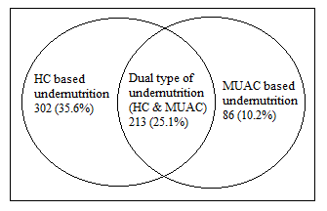
Figure 1. Mid upper arm circumference and head circumference-based growth and nutritional status among the studied tribal preschool children

The body circumferences and circumferences to height ratio differences observed between healthy and undernourished children are shown in Table 4. Normal or healthy children of both sexes showed higher mean values in height and weight and significant differences (except girls’ height) observed. Six types of circumferences showed a higher mean value in healthy children compared to nutritional deficiencies children, with significant differences observed in both boys and girls (p= <0.001). In both boys and girls, all circumference to height ratio shows statistically significant differences from normal to undernourished children (except head circumference to height ratio in boys).

Table 4. Nutritional status and sex-wise circumference differences among the studied preschool children
Anthropometric variables | Sex | Normal  (B=133 & G=114) | One type of undernutritionª (B=191 & G=197) | Dual type of undernutrition^{b}  (B=106 & G=107) | F test
Height | Boys | 94.36 ± 11.38 | 88.60 ± 11.72 | 87.62 ± 11.37 | 13.13***
 | Girls | 89.47 ± 12.55 | 89.40 ± 11.66 | 89.66 ± 10.41 | 0.02^{NS}
Weight | Boys | 13.28 ± 2.88 | 11.41 ± 2.84 | 10.53 ± 2.55 | 31.61***
 | Girls | 12.01 ± 3.24 | 11.37 ± 2.90 | 10.60 ± 2.29 | 6.71***
Head circumference (HC) | Boys | 47.84 ± 1.45 | 45.65 ± 1.97 | 44.67 ± 2.09 | 95.55***
 | Girls | 46.34 ± 1.75 | 44.91 ± 2.03 | 44.47 ± 1.61 | 32.07***
Neck circumference (NC) | Boys | 22.21 ± 1.15 | 21.71 ± 1.18 | 20.99 ± 1.05 | 33.44***
 | Girls | 21.79 ± 1.32 | 21.27 ± 1.15 | 20.78 ± 1.05 | 20.44***
Mid upper arm circumference (MUAC) | Boys | 14.07 ± 0.77 | 13.46 ± 0.85 | 12.49 ± 0.60 | 125.70***
 | Girls | 13.69 ± 0.99 | 13.31 ± 0.92 | 12.42 ± 0.69 | 60.35***
Chest circumference (CC) | Boys | 48.39 ± 3.11 | 46.58 ± 3.18 | 45.11 ± 2.97 | 33.50***
 | Girls | 46.67 ± 3.63 | 46.08 ± 2.93 | 44.70 ± 2.82 | 11.76***
Thigh circumference (TC) | Boys | 23.78 ± 1.99 | 22.89 ± 2.11 | 21.80 ± 1.87 | 28.47***
 | Girls | 23.88 ± 2.61 | 23.58 ± 2.60 | 22.55 ± 2.44 | 8.36***
Medial calf circumference (MCC) | Boys | 18.05 ± 1.52 | 17.24 ± 1.52 | 16.43 ± 1.39 | 34.93***
 | Girls | 17.90 ± 1.73 | 17.46 ± 1.74 | 16.81 ± 1.60 | 11.50***
Head to height ratio (HHtR) | Boys | .5132 ± 0.05 | .5222 ± 0.06 | .5163 ± 0.05 | 1.17^{NS}
 | Girls | .5258 ± 0.06 | .5090 ± 0.05 | .5011 ± 0.05 | 6.45**
Neck to height ratio (NHtR) | Boys | .2380 ± 0.02 | .2484 ± 0.03 | .2426 ± 0.02 | 6.23**
 | Girls | .2472 ± 0.03 | .2409 ± 0.03 | .2341 ± 0.02 | 6.96***
MUAC to height ratio (AHtR) | Boys | .1509 ± 0.02 | .1539 ± 0.02 | .1443 ± 0.01 | 11.58***
 | Girls | .1549 ± 0.02 | .1506 ± 0.01 | .1397 ± 0.01 | 34.14***
Chest to height ratio (CHtR) | Boys | .5175 ± 0.05 | .5314 ± 0.05 | .5202 ± 0.05 | 3.99*
 | Girls | .5275 ± 0.05 | .5207 ± 0.04 | .5026 ± 0.04 | 9.15***
Thigh to height ratio (THtR) | Boys | .2544 ± 0.03 | .2612 ± 0.03 | .2516 ± 0.03 | 4.56*
 | Girls | .2691 ± 0.03 | .2653 ± 0.02 | .2524 ± 0.02 | 17.59***
Medial calf to height ratio (MCHtR) | Boys | .1927 ± 0.02 | .1964 ± 0.02 | .1893 ± 0.02 | 5.47**
 | Girls | .2017 ± 0.02 | .1965 ± 0.01 | .1883 ± 0.01 | 24.25***
* p < .05, ** p < .01, *** p < .001
ªOne type of undernutrition = Children suffered nutritional deficiencies either MUAC based or HC based; ^{b}Dual type of undernutrition = Children suffered in both MUAC and HC based nutritional deficiencies.

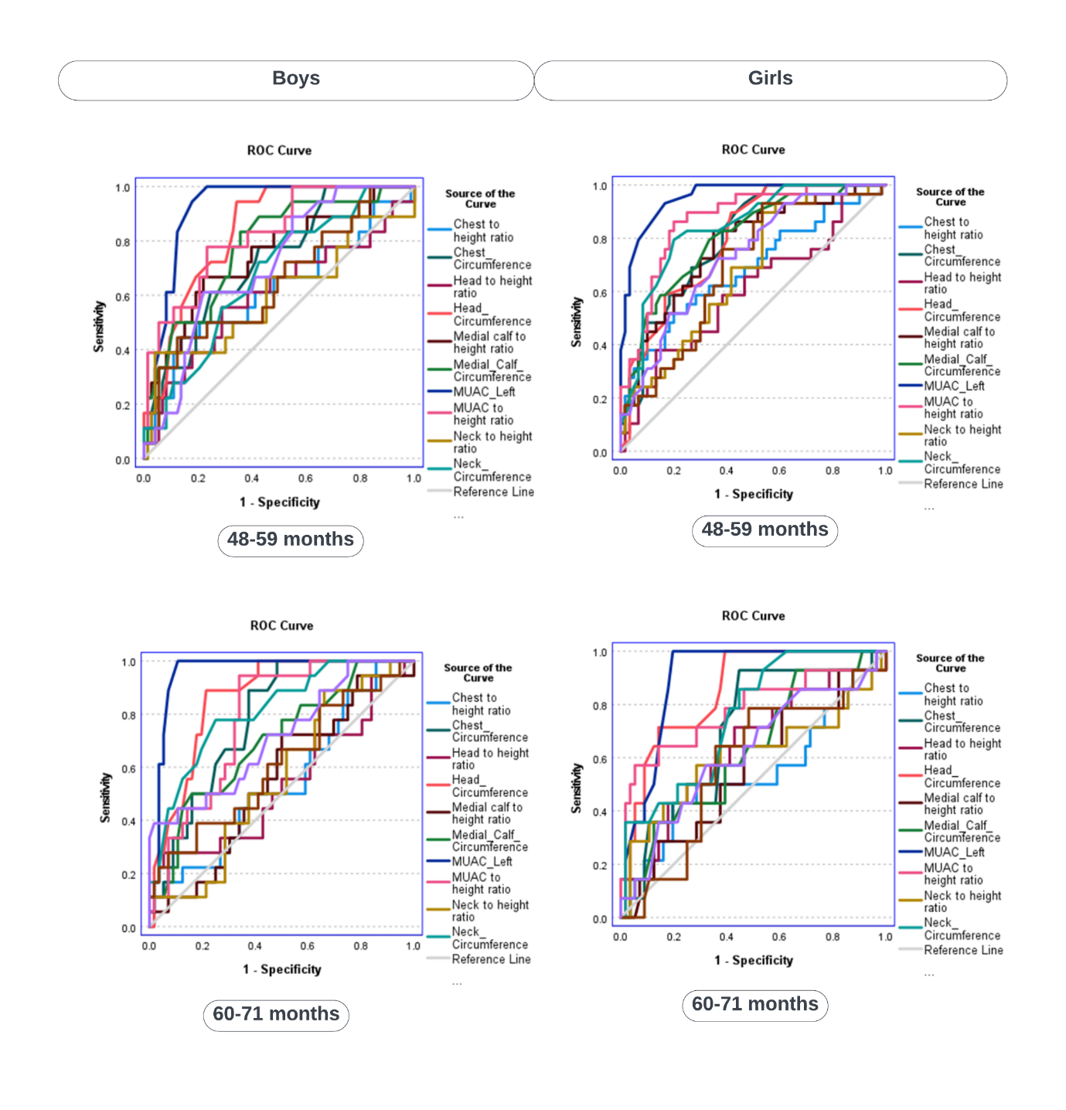
Figure 2. Age and sex wise ROC curve by using twelve types of parameters for predicting growth faltering and nutritional deficiencies

4. Discussion
Undernutrition is a significant global issue, causing 3.1 million child deaths annually, 45% of them in children under five years of age (UNICEF, 2018). A previous study reported that chronic undernutrition in children causes slower cognitive development, major health problems later in life, and reduced life expectancy (Scrimshaw, 1997). The current study found that boys have higher age-adjusted mean body circumferences than girls, with the exception of thigh circumferences. Differences between the sexes were statistically significant, except for medial calf circumferences. Similarly, a previous study in Midnapore town reported that boys had higher mean HC values than girls (Maiti et al., 2012). Many previous studies reported similar findings (Mandal & Bose, 2010; Mondal, 2019).
The present study observed that all body circumferences increased with increasing child age, but the circumference to height ratios decreased with increasing age. Earlier studies had observed that HC increases with age in both sexes (Maiti et al., 2012; Mondal, 2019), and the MUAC value also increases with age (Biswas et al., 2010).

5. Limitations
The present study, had some limitations, due to its cross-sectional nature and its small sample size in a small geographical region. Therefore, the results cannot be generalized to the entire state or country. The study design was such that it could not reveal any correlation between socioeconomic factors, mortality, morbidity, and undernutrition based on various parameters.

6. Recommendation
The present study found that undernutrition is a major issue among tribal children and a barrier to their growth and brain development. In India, two main government schemes, the Integrated Child Development Services (ICDS) and POSHAN Abhiyaan, are currently operating to provide supplementary food for preschool children. So, there is an urgent need for strengthening existing nutrition schemes, a requirement for regular monitoring of growth indicators, a quality assessment of food distribution, and timely interventions to address gaps. Ensuring community participation, capacity building of Anganwadi workers, and introducing digital tools for real-time monitoring can improve accountability and efficiency. Also needed are programs to raise parents’ awareness of their child’s growth and development, nutritional requirements and health. This study also provides cut-off values which can be used in future studies of tribal children.

7. Conclusion
The present study indicates that head circumference (HC)-based nutritional deficiencies are more prevalent than mid-upper arm circumference (MUAC)-based nutritional deficiencies among tribal preschool children. While low MUAC reflects a high prevalence of undernutrition, low HC indicates inadequate brain growth and development, thereby underscoring the multifaceted impact of malnutrition. The use of circumference-to-height ratios further provides critical insights into the proportional growth and development of children. By comparing twelve anthropometric parameters, MUAC emerged as the most reliable predictor of dual forms of child undernutrition across both sexes. It will aid in the early detection of undernutrition among tribal preschool children.

Acknowledgements: We gratefully acknowledge the assistance and cooperation of all preschool children who participated in this study. The authors are grateful to the Block Development Officer and Child Development Project Officer of the three blocks studied.

Declaration of conflicting Interests: The authors declare that there is no conflict of interest in publishing this paper.

Ethical approval: The institutional ethical review board of Vidyasagar University’s Department of Anthropology provided formal ethical approval. Verbal informed consent was obtained from all participants prior to data collection.

Author contributions: BM collected the data, analysed the data, prepared the first draft of the manuscript, and formatted the manuscript for submission as well. KB supervised the study and reviewed the manuscript.

Funding: No funds were received for this study.

References
Alderman, H., Hentschel, J., & Sabates, R. (2003). With the help of one’s neighbors: Externalities in the production of nutrition in Peru. Social Science & Medicine, 56(10), 2019-2031. https://doi.org/10.1016/S0277-9536(02)00183-1
Behera, J., Acharya, S. S., & Pal, G. C. (2024). Equity in access to nutrition through ICDS. Journal of Social Inclusion Studies, 10(1), 7-18. https://doi.org/10.1177/23944811241233716
Biswas, S., Bose, K., Mukhopadhyay, A., & Bhadra, M. (2010). Mid-upper arm circumference based undernutrition among Bengalee children of Chapra, West Bengal, India. Iranian Journal of Pediatrics, 20(1), 63-68.
Black, R. E., Victora, C. G., Walker, S. P., Bhutta, Z. A., Christian, P., De Onis, M., … & Uauy, R. (2013). Maternal and child undernutrition and overweight in low-income and middle-income countries. Lancet, 382(9890), 427-451. https://doi.org/10.1016/S0140-6736(13)60937-X
Bose, K., Bisai, S., Chakraborty, J., Datta, N., & Banerjee, P. (2008). Extreme levels of underweight and stunting among pre-adolescent children of low socioeconomic class from Madhyamgram and Barasat, West Bengal, India. Collegium Anthropologicum, 32(1), 73-77.
Briend, A., & Zimicki, S. (1986). Validation of arm circumference as an indicator of risk of death in one to four year old children. Nutrition Research, 6(3), 249-261. https://doi.org/10.1016/S0271-5317(86)80129-4
Census of India (2011). Office of the Registrar General & Census Commissioner, India. Ministry of Home Affairs, Government of India. https://censusindia.gov.in/census.website/
Giri, S. P., Biswas, S., & Bose, K. (2018). Head circumference based nutritional status of rural Bengalee preschool children from Sagar Island, West Bengal, India. Mankind Quarterly, 58(4), 599-610. https://doi.org/10.46469/mq.2018.58.4.5
IFPRI (2016). Global Nutrition Report 2016. From promise to impact ending malnutrition by 2030. International Food Policy Research Institute. https://doi.org/10.2499/9780896295841
Joseph, B., Rebello, A., Kullu, P., & Raj, V. D. (2002). Prevalence of malnutrition in rural Karnataka, South India: A comparison of anthropometric indicators. Journal of Health, Population, and Nutrition, 20(3), 239-244.
Klanjsek, P., Pajnkihar, M., Marcun Varda, N., & Povalej Brzan, P. (2019). Screening and assessment tools for early detection of malnutrition in hospitalised children: A systematic review of validation studies. BMJ Open, 9(5), e025444. https://doi.org/10.1136/bmjopen-2018-025444
Lohman, T., Roche, A., & Martorell, R. (1988). Anthropometric Standardization Reference Manual. Chicago: Human Kinetics Books.
Mahapatra, B. (2021). Anthropometric assessment of nutritional status of preschool children in Santal and Bhumij tribes of Paschim Medinipur. Vidyasagar University. http://hdl.handle.net/10603/365990
Mahapatra, B., Pal, S., Bose, K., & Sahoo, G. (2020). Undernutrition using anthropometric indices among the Bhumij preschool children of West Bengal, India. International Journal of Statistical Sciences, 20(1), 1-18.
Maiti, S., Ali, K. M., Ghosh, D., & Paul, S. (2012). Assessment of head circumference among pre-school children of Midnapore Town, West Bengal using WHO (2007) recommended cut-off points. International Journal of Preventive Medicine, 3(10), 742-744.
Mandal, G. C., & Bose, K. (2010). Undernutrition among the rural preschool children (ICDS) of Arambag, Hooghly district, West Bengal, India, using new head circumference cut-off points. International Journal of Current Research, 10, 7-11.
Mondal, N. (2019). Assessment of undernutrition using head circumference-for-age among Karbi preschool children (<5 years) of Karbi Anglong, Assam (India). Journal of Life Sciences, 11(1-2). https://doi.org/10.31901/24566306.2019/11.1-2.238
Myatt, M., Khara, T., & Collins, S. (2006). A review of methods to detect cases of severely malnourished children in the community for their admission into community-based therapeutic care programs. Food and Nutrition Bulletin, 27(3_suppl3), S7-S23. https://doi.org/10.1177/15648265060273S302
Planning Commission Report (2007). Strategies for under six: A framework for the 11th plan. Government of India.
Ray, S. K., Biswas, A. B., & Kumar, S. (2000). A study of dietary pattern, household food security and nutritional profile of under-five children of a community of West Bengal. Journal of the Indian Medical Association, 98(9), 517-523.
Rumsey, J., & Rapoport, J. (1983). Assessing behavioral and cognitive effects of diet in pediatric populations. Nutrition and the Brain, 6, 101-161.
Sachdeva, S., Dewan, P., Shah, D., Malhotra, R. K., & Gupta, P. (2016). Mid-upper arm circumference v. weight-for-height Z-score for predicting mortality in hospitalized children under 5 years of age. Public Health Nutrition, 19(14), 2513-2520. https://doi.org/10.1017/S1368980016000719
Scrimshaw, N. S. (1997). Nutrition and health from womb to tomb. Food and Nutrition Bulletin, 18(1), 1-21. https://doi.org/10.1177/156482659701800101
Singh, S., & Bisnoi, I. (2005). Trend of growth in mid-arm circumference and head circumference of pre-school female children of Faizabad district, Uttar Pradesh. Indian Journal of Preventive & Social Medicine, 36, 143-146.
Tigga, P., Mondal, N., & Sen, J. (2016). Head circumference as an indicator of undernutrition among tribal preschool children aged 2-5 years of North Bengal, India. Human Biology Review, 5(1), 17-33.
Touitou, Y., Portaluppi, F., Smolensky, M. H., & Rensing, L. (2004). Ethical principles and standards for the conduct of human and animal biological rhythm research. Chronobiology International, 21(1), 161-170. https://doi.org/10.1081/CBI-120030045
UNICEF (2018). Malnutrition rates remain alarming: Stunting is declining too slowly while wasting still impacts the lives of far too many young children. Retrieved from http://data.unicef.org/topic/nutrition/malnutrition/#.
UNICEF (2019). UNICEF-The World Bank: Joint child malnutrition estimates – levels and trends – 2019 edition. UNICEF Data. URL: https://data.unicef.org/resources/jme/.
WHO (1995). Physical status: The use of and interpretation of anthropometry. Report of a WHO Expert Committee. Technical Report Series no. 854. Geneva: World Health Organization.
WHO (2006). Child growth standards. Length/height for age, weight for age, weight for length, weight for height and body mass index for age. Methods and development. Geneva: World Health Organization.

het

het

het

Anthropological Survey of India, Central Regional Centre, Nagpur-440006, Maharashtra, India.
Department of Anthropology, Vidyasagar University, Midnapore-721102, West Bengal, India.
* Corresponding author: Anthropologist (Physical), Anthropological Survey of India, Central Regional Centre, Nagpur-440006, Maharashtra, India. Email: biswajitmahapatra20@gmail.com

