1.get all documents

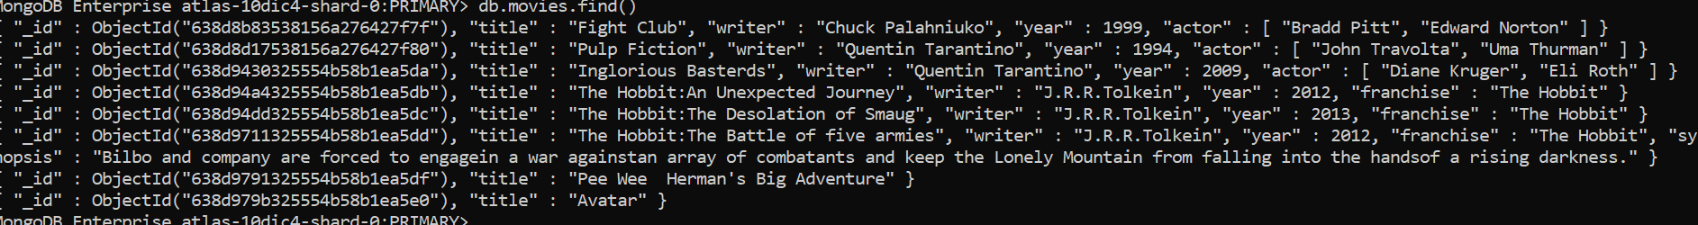

2.Get all documents with writer set to “Quentin Tarantino”

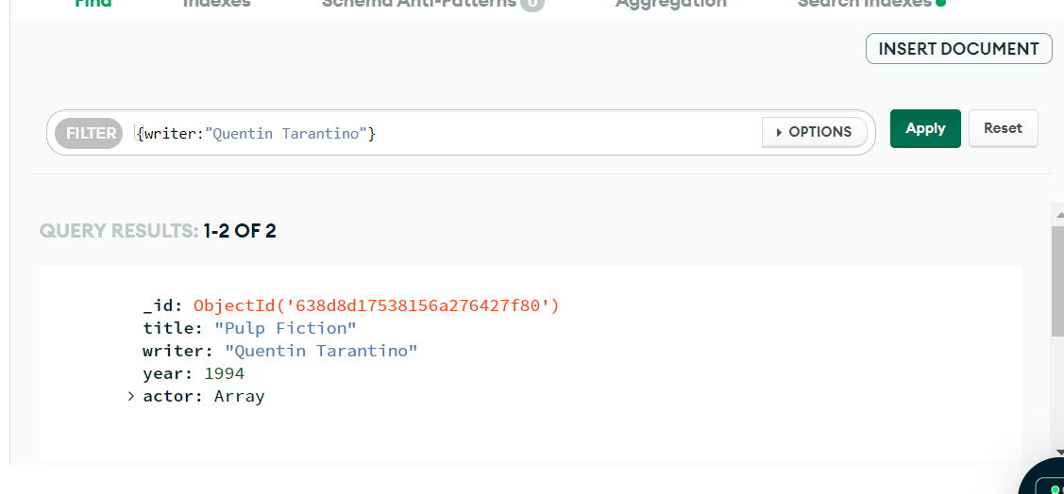

3.Get all doc where actor:”Brad Pitt”

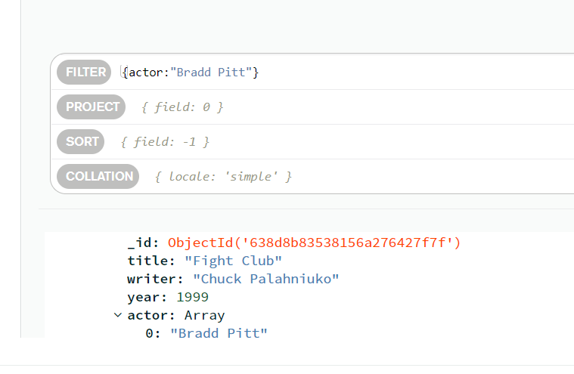

4.get all documents with franchise set to “The Hobbit”

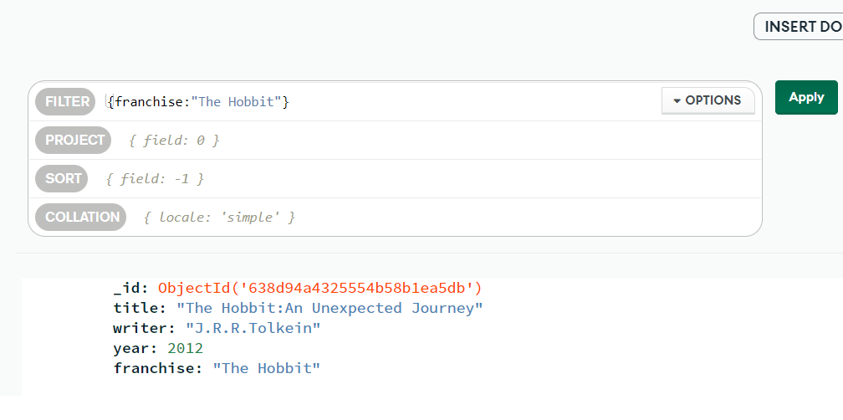

5.movies released in 90’s

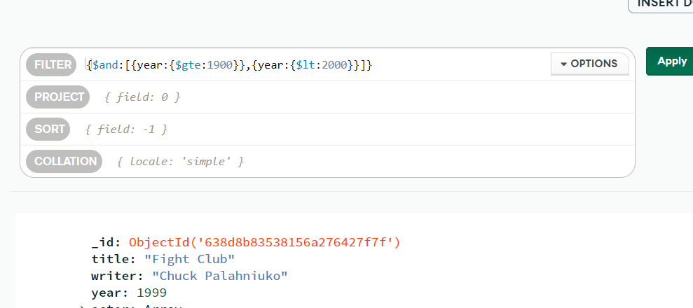

6.movies released before 2000,or after 2010

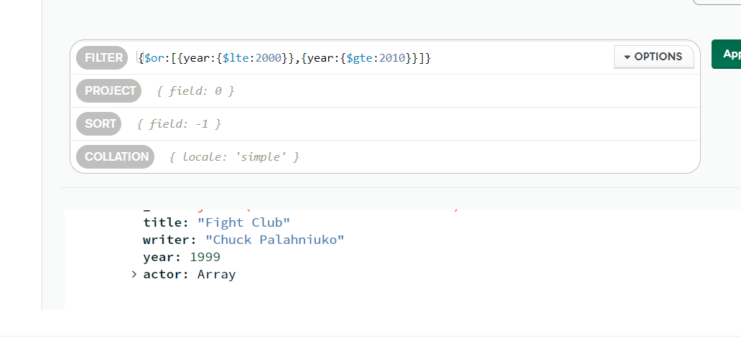

UPDATE DOCUMENTS

1.ADD SYNOPSYS TO title:”The Hobbit: An Unexpected Journey”

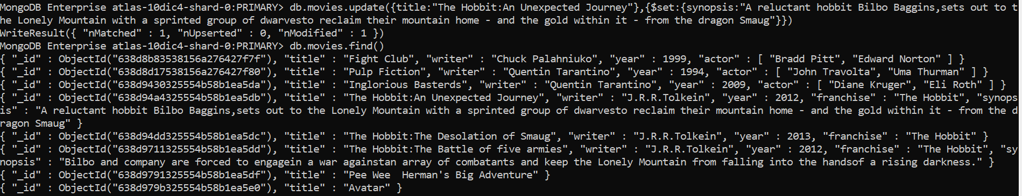

2.add synopsys to title:The hobbit:The Desolation of smaug

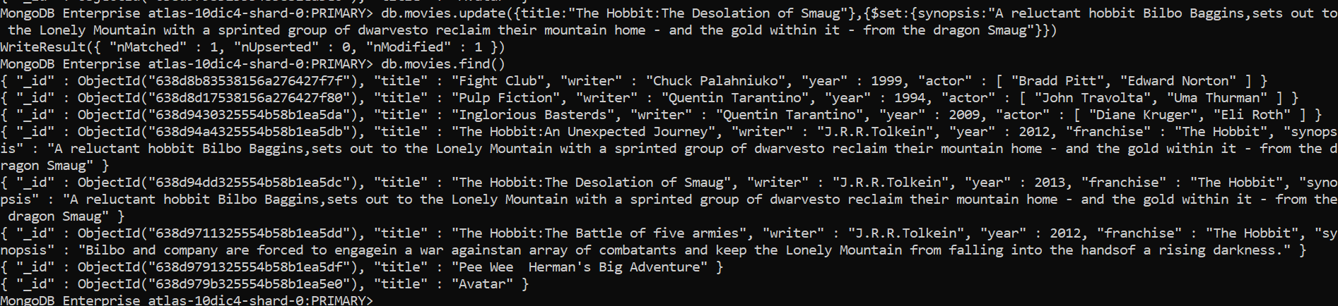

3.add an actor named “Samuel L.Jackson to the movie “pulp Fiction”

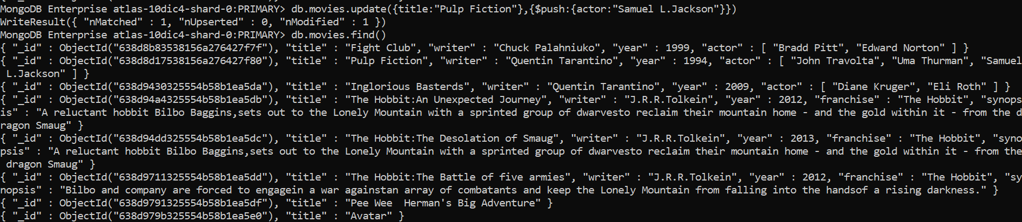

TEXT SEARCH

1.get all movies that contains the word Bilbo in synopsis

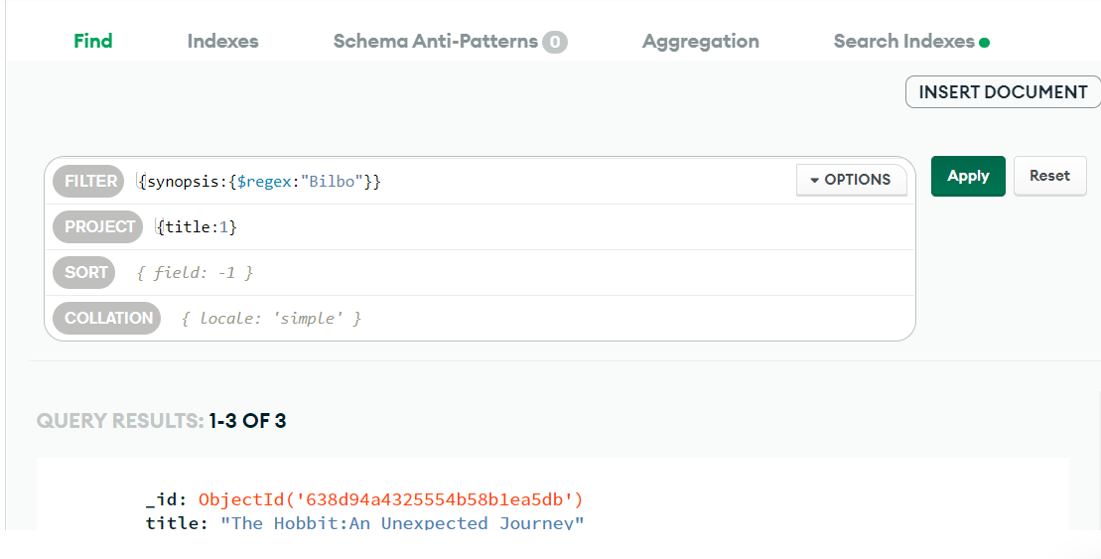

2.find all movies that contains the word “dwarves”

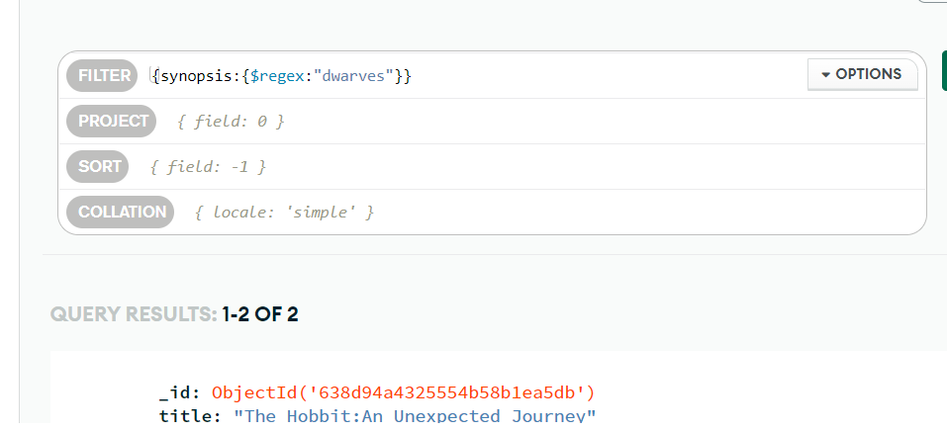

3.synopsis that contains the word bilbo not “dwarves”

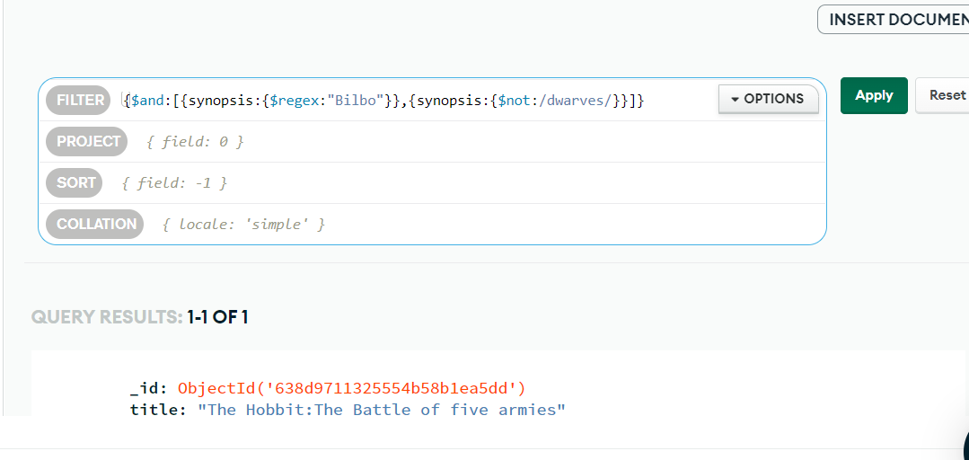

QUERIES RELATED COLLECTION

1.who was authord by”GoodBoyGrey”

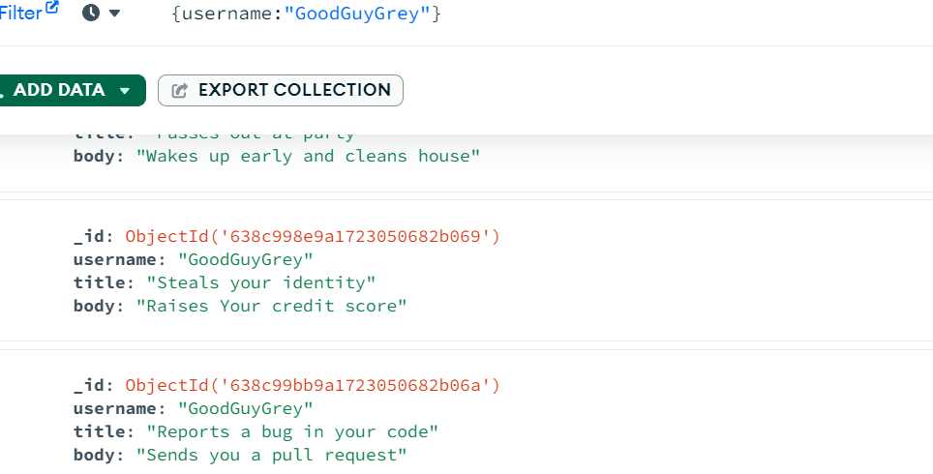

2. who was authord by”ScumbagSteve”

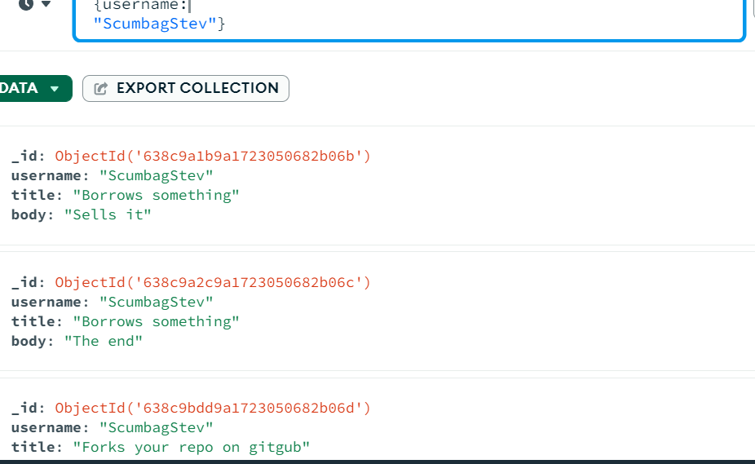

3.find all comments authored by “GoodBoyGrey”

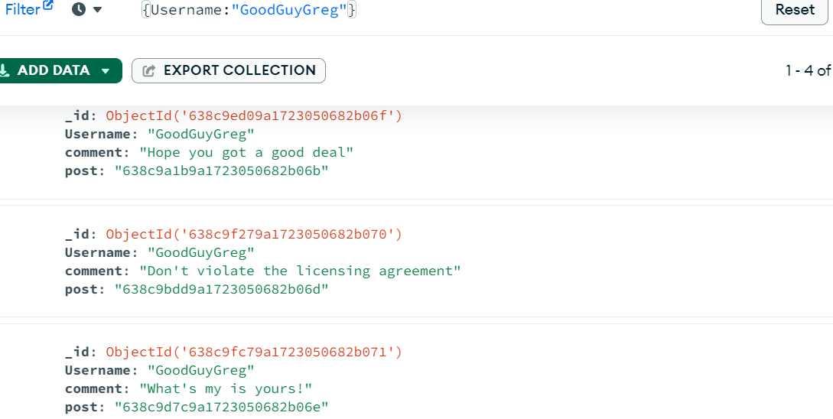

4.find all comments authored by “GoodBoyGrey”

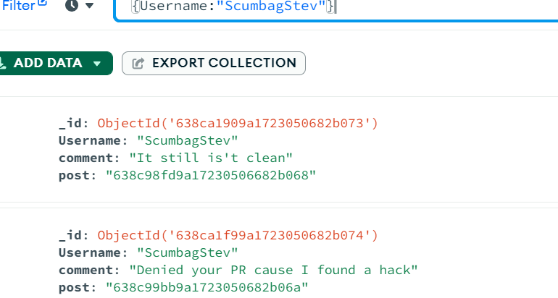

5.