1. display borough,restaurant_id,cuisin from all doc

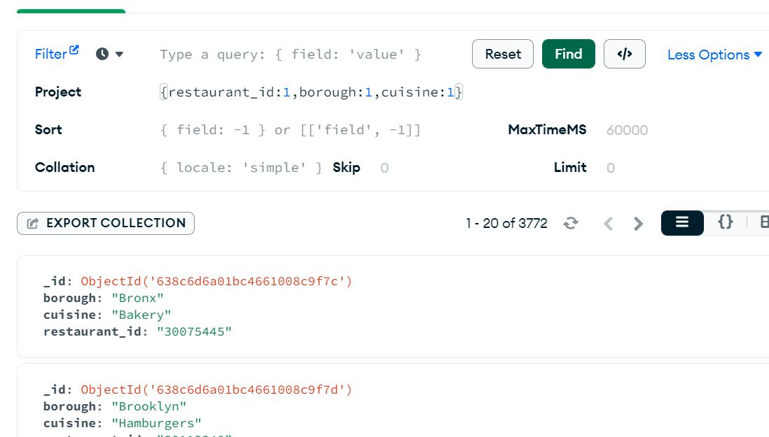

1. 2. display borough,restaurant_id,cuisin from all doc except _id

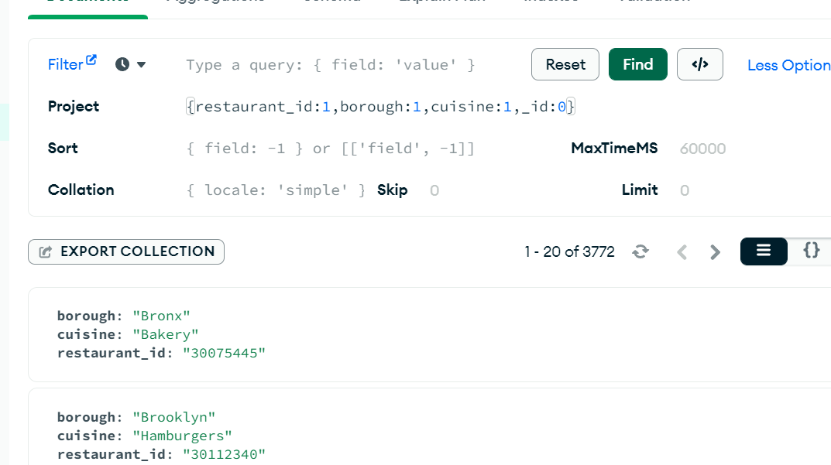

3.display restaurent_id,name,borough and zip code in address but exclude_id

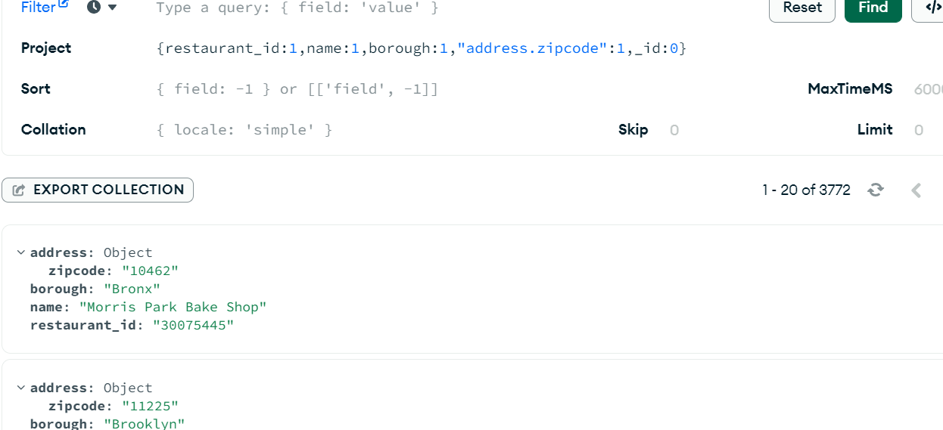

4.display first 5 restaurent which is in the borough Brox

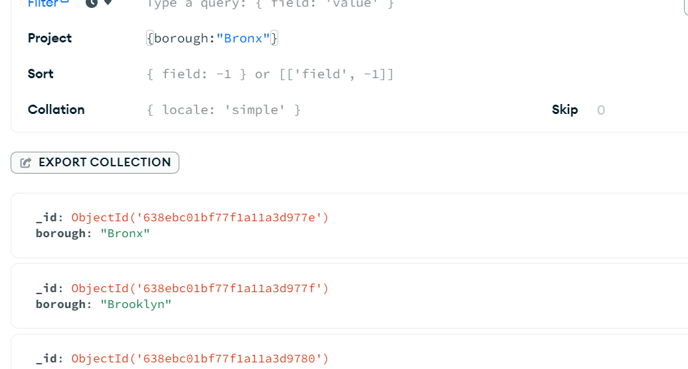

5. display all restaurent which is in the borough Brox

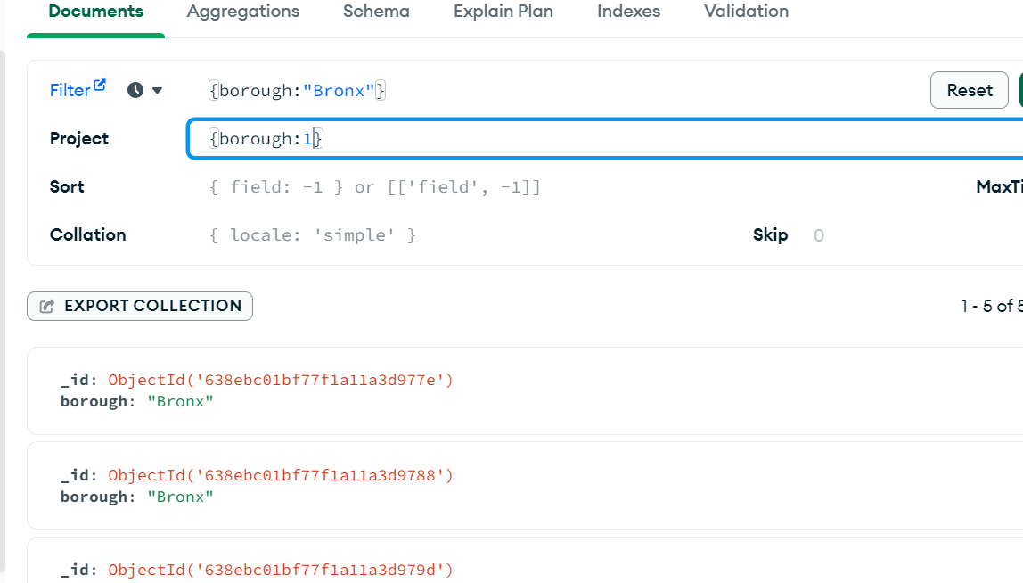

7. display next 5 restaurent which is in the borough Brox skipping first5

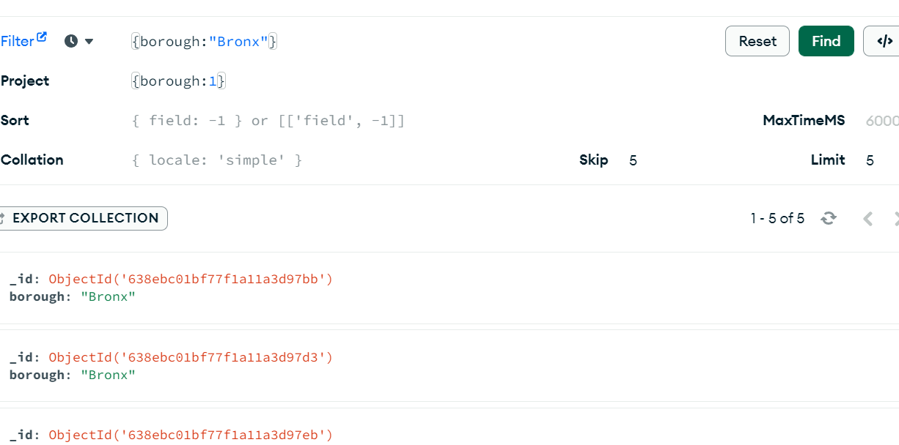

8.find restaurents who achieved a score more than 90