**1.**

**a)**

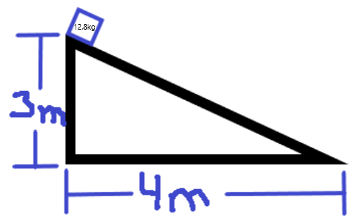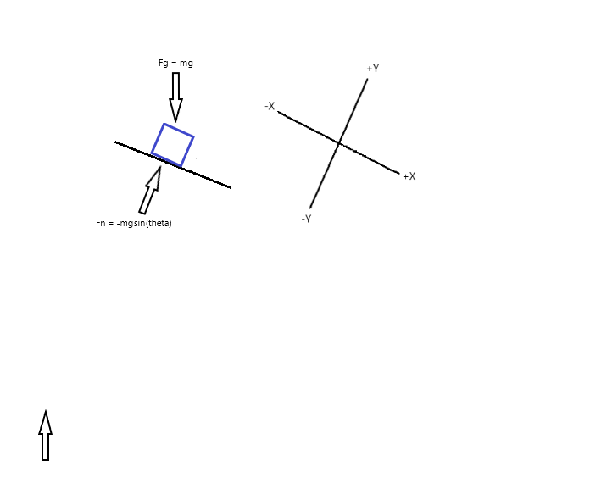

**b)**

Mass: 12.8kg

Ramp: rise of 3m, run of 4m

Ramp angle to the horizontal: tan(3/4) = 36.869⁰

**Net Force:**

$F=mg$

$F=12.8*9.8$

$F=125.44N$

$Fn=-mgsinθ$

$Fn=-12.8*\left(-9.8\right)*sin⁡(36.869)$

$Fn=75.264N$

**Acceleration:**

$A$ = g = -9.8m/s

$A=gcosθ=9.8\cos\left(36.869\right)=5.88m/s$

$Ax=gsinθ=7.84\cos\left(36.869\right)=4.704m/s$

$Ay=gsinθ=7.84\sin\left(36.869\right)=3.528m/s$

Ay would be going towards the ground so Ay = - $3.528$ m/s

**c)**

$$μk (steel on steel)=0.42$$

**Net Force:**

$F= μmg$

$F=$ 0.42 * 12.8 * 9.8

$$F= 52.685N$$

**Acceleration:**

$$A=F/m$$

$$A=52.685/12.8$$

$$A=4.116m/s$$

Ax would be friction slowly down the projectile so Ax = - $4.116m$/s on the x-axis

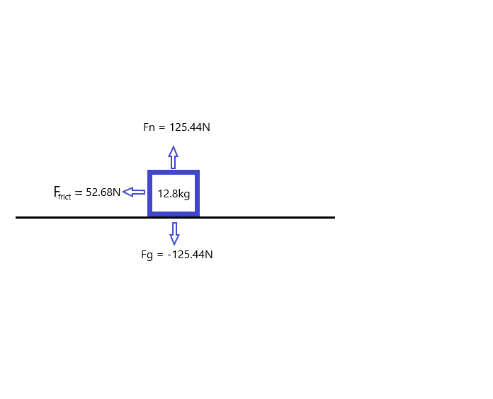

**d)**

Finding final velocity when the loot box leaves the ramp

$$A = 5.88m/s$$

$$Vi = 0m/s$$

$$Vf = ?$$

$$d = 5m$$

$$Vf^{2}={Vf}^{2}+2a*(df-di)$$

$${Vf}^{2}=0+2(5.88)*5$$

$$Vf =7.668m/s$$

Finding the time it takes to hit the end of the ramps

$$Ax=-5.88m/s$$

$$Vxf = 7.668$$

$$Vxi = 0$$

$$T = ?$$

$vf=vi+at$

$$7.668= 0+5.88t$$

$$t= 1.3041$$

Finding the distance the loot box travels after leaving the ramp

$$Xi = 0$$

$$Xf = ?$$

$Vxi=7.668cos⁡(36.869)$ = 6.1344m/s

$$Ax= 4.116m/s$$

$$Xf=Xi+Vxi*t+\frac{1}{2}*Ax*t^{2}$$

$$Xf=0+6.1344*1.3041+\frac{1}{2}*\left(-4.116\right)*{1.304}^{2}$$

$Xf= 4.5$ m



**e)**

A loot box sits still at the top of a ramp, with the ramp being 3m high and 4m long. The ramp has zero friction. The loot box slides down the ramp and leaves the bottom of the ramp with a velocity of 8.854m/s on the x-axis. After leaving the ramp, the loot box then slides along a flat surface with a friction co-efficient of 0.42 (steel on steel). The loot box slides for 2.148s before coming to a stop 9.493m past the end of the ramp.