Details of students:

204311997 - Or Mantzur

200441749 - Dudi Yecheskel

**Project - Ex03.ConsoleUI**

**Class Program:** Initial class for running the program.

**Class UserInterface:** Abstract class that defines all functions that any user interface must implement.

Holds a dictionary of all available functions for the application.

**Class ConsoleUI:** Class for managing all UI of the garage app. This UI is made for running the app using the console window.

**Class ConsoleUtils:** Generic class for managing console UI.

**Project - Ex03.GarageLogic**

**Class Garage**: The main class of the GarageLogic, is used to connect between the UI and the logic. Forwards all user requests to the functions needed.

**Class VehicleInGarage:** A class that connects between a customer of the garage and the vehicle itself. Also includes the current status of the vehicle.

**Class VehicleFactory**: The only class that can generate new vehicles, according to the input a matching type of Vehicle is created and returned.

**Class Vehicle:** A base class of all vehicles.

**Class Car:** A type of vehicle, can have an electric or fueled engine.   
Has two additional fields: car color and number of doors.

**Class Bike:** A type of vehicle, can have an electric or fueled engine.   
Has two additional fields: engine capacity and license type.

**Class Truck:** A type of vehicle, can have an only a fueled engine.   
has two additional fields: if it carries hazardous materials and max carrying weight.

**Class Wheel:** Each vehicle holds a collection of this class - the wheels of the vehicle.

**Class Engine:** Abstract class - functions as the base class of both "Electric" and "Fueled" engine types.

**Class FuelEngine:** A type of an engine that is a member in Vehicle.

**Class ElectricEngine:** A type of an engine that is a member in Vehicle.

**Class ValueOutOfRangeException:** Exception that will be thrown when an input is out of range, returns the minimal and maximal valid values as properties.

**Enum EnumUtils:** Class that provides generic functionality for enums.

**Enum eVehicleStatus:** Enum of all possible statuses of vehicles in the garage.

**Enum eFuelType:** Enum of all fuel types available for fueled engines.

**Enum eLicenseType:** Enum of all license types available for bikes.

**Enum eColor:** Enum of all colors available for cars.

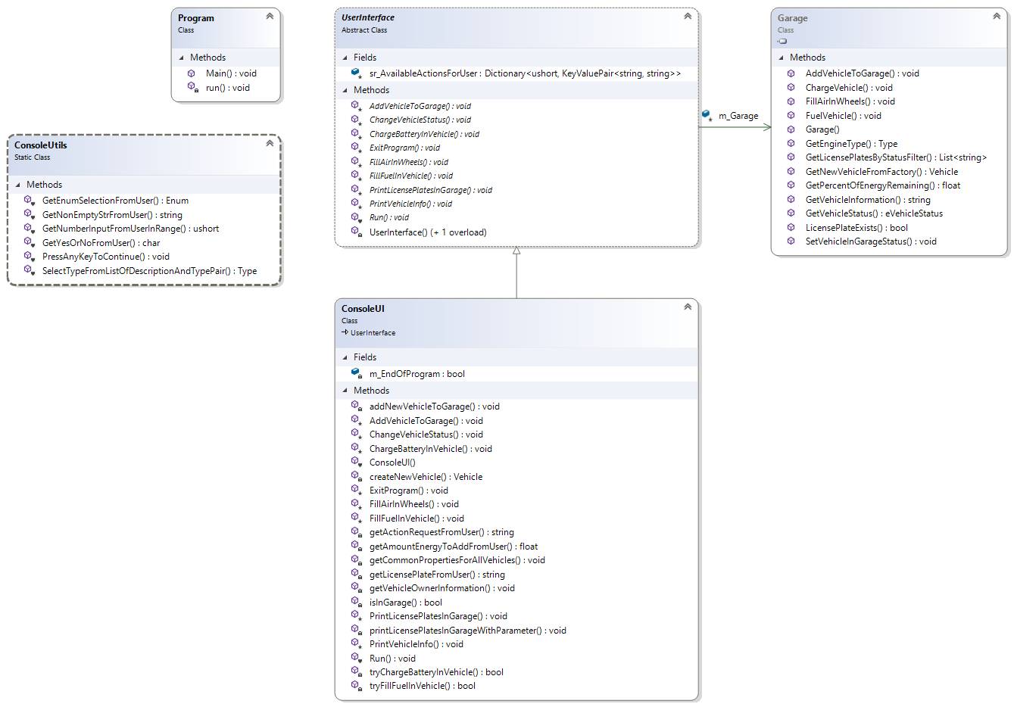**Class Diagrams:**

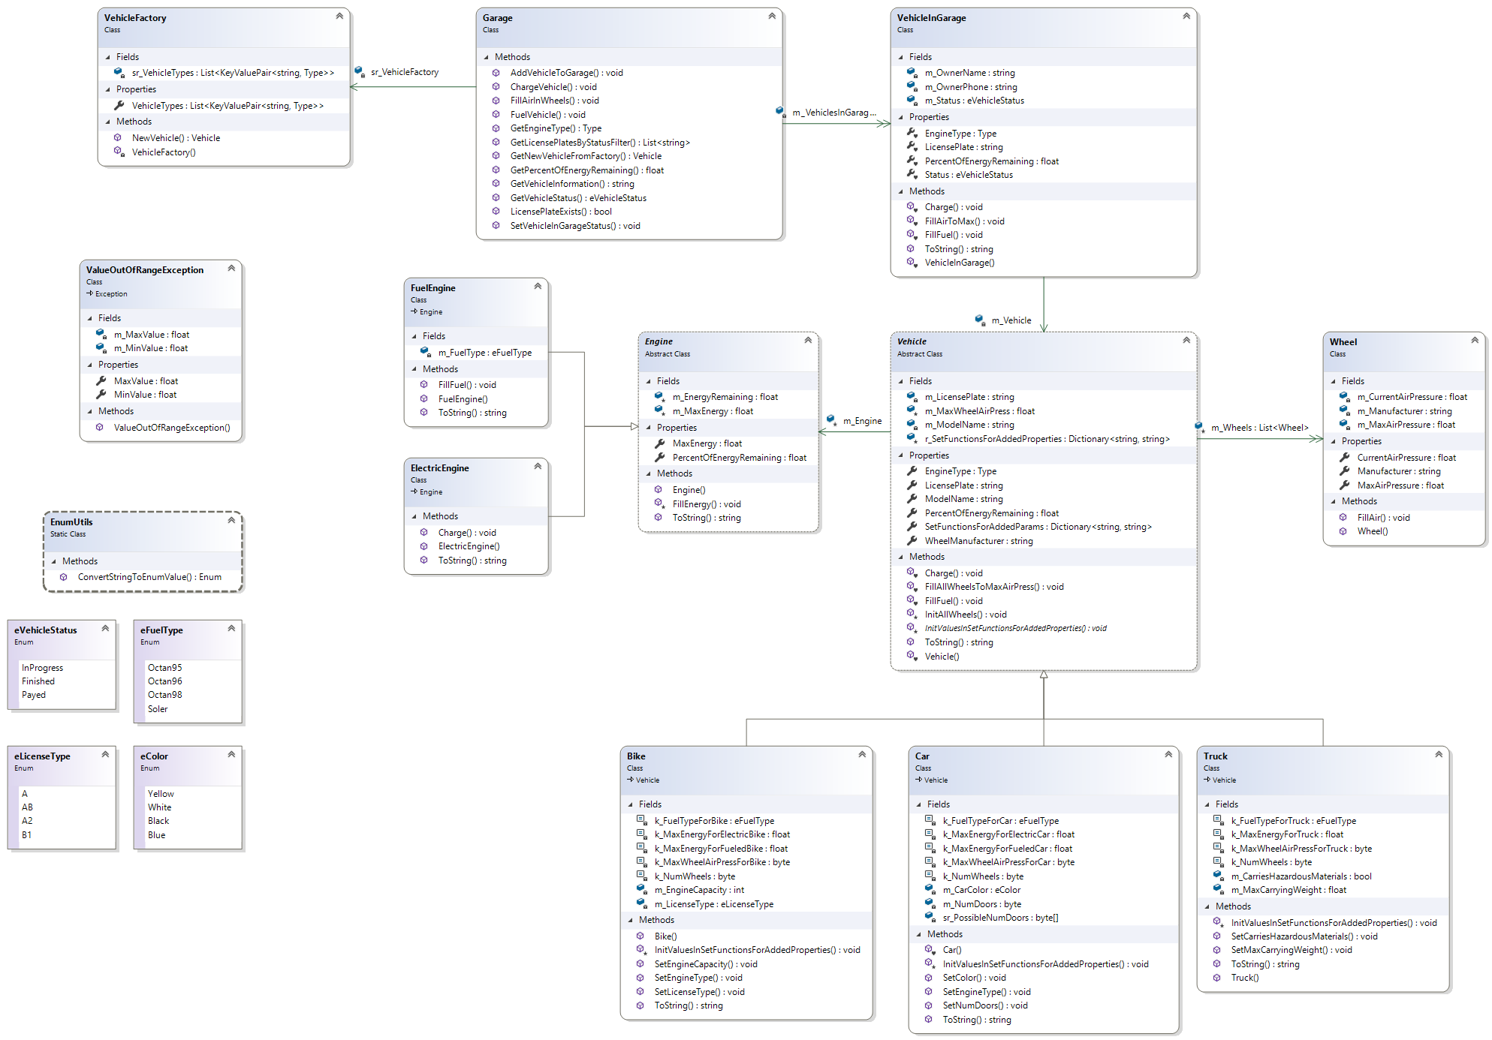

Figure 1: ConsoleUI Class Diagram

Figure 2: GarageLogic Class Diagram