Deliverable Four

David Udofia

Rasmussen College

CDA3801C: Fundamentals of Mobile Web Application Development

Christopher Mattie

October 27, 2019

Author Note

This paper is being submitted on 10/27/19 for Professor Christopher Mattie CIS3801C: Fundamentals of Mobile Web Application Development Course

The site currently has one level. There are currently no sub-pages.

Le”spy Cafe

([www.lespy.com](http://www.lespy.com))

1. Home
2. About
3. Coffee
4. Display
5. Contact
6. Location



More examples of the sitemap using a HTML Sitemap generator

Slickmap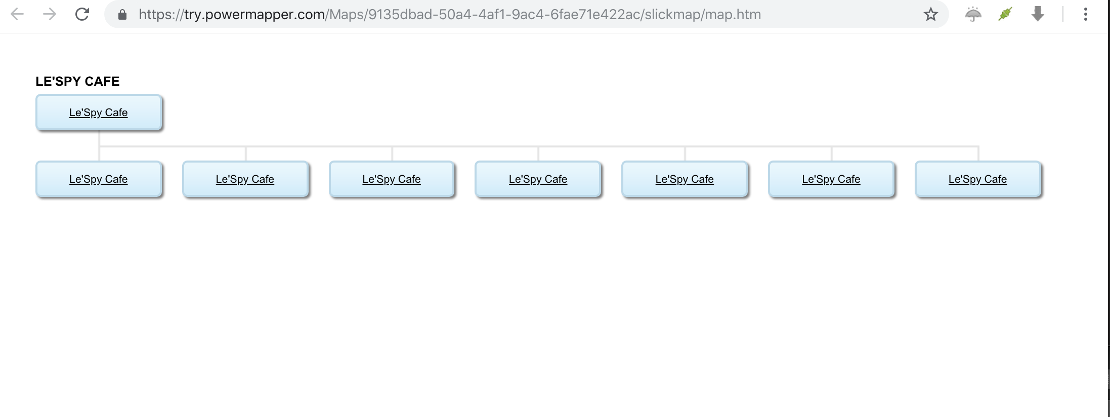

Table view

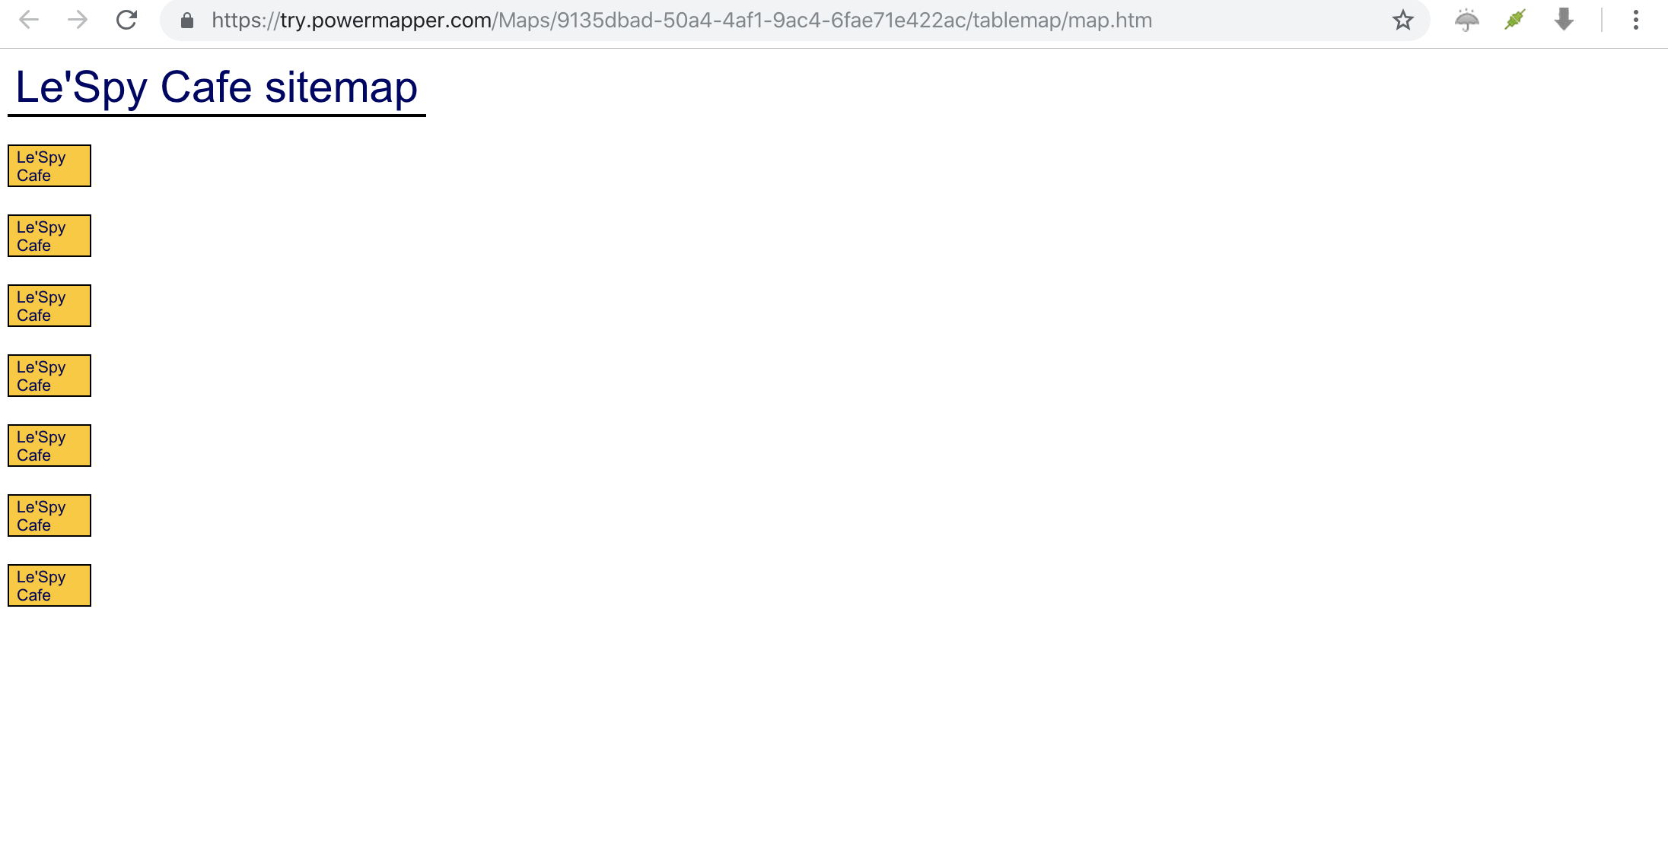

Tree View