Deliverable Five

David Udofia

Rasmussen College

CDA3801C: Fundamentals of Mobile Web Application Development

Christopher Mattie

November 1, 2019

Author Note

This paper is being submitted on 11/01/19 for Professor Christopher Mattie CIS3801C: Fundamentals of Mobile Web Application Development Course

**Site Description**

The site I will be creating for this class is for a coffee shop called Le’Spy. Le’Spy is a coffee roaster and retailer based out of uptown Minneapolis. Le’Spy aims to cultivate relationships with its clientele, and share their passion of ethical coffee sourcing, roasting, and serving exceptional coffees.

**GitHub Repository**

<https://github.com/Dudofia/CIS3801C_FundOfWebApp>

**Azure Information**

The site has not been built yet, as this is the first module, so I don’t have a site URL to provide. However, the following URL shows my Hello World example, the second URL shows sample code in my project folder. Screenshots are below for each of the URL examples listed.

<http://paris.centralus.cloudapp.azure.com/>

<http://paris.centralus.cloudapp.azure.com/CIS3801C/index.html>

**On an IPhone X (375 X 812)**

The site is responsive. However I didn’t like how the footer of the site looked, so I made adjustments to it. The best solution however, would be to go into my code in a text editor, and set media queries that adjust the footer or build just a mobile version of the site that is activated based on screen size or just make changes to the original code in the footer and test it on different sizes.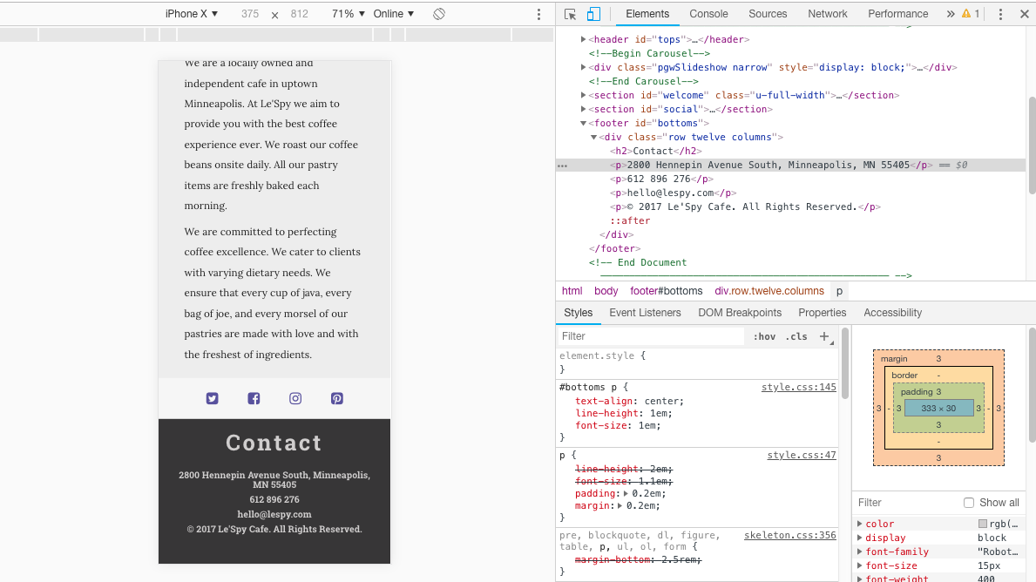

**Ipad Pro (1024 x 1366)**

The site looks really good on an Ipd Pro. However my only concern was with the text. My font size on my footer was initially set at 0.8 em, and I moved it to 1.5 em. The font-size on the body was set to 1.5em and I moved it to 2.5 em. I would want to test this some more just to make sure that it wouldn’t be too large.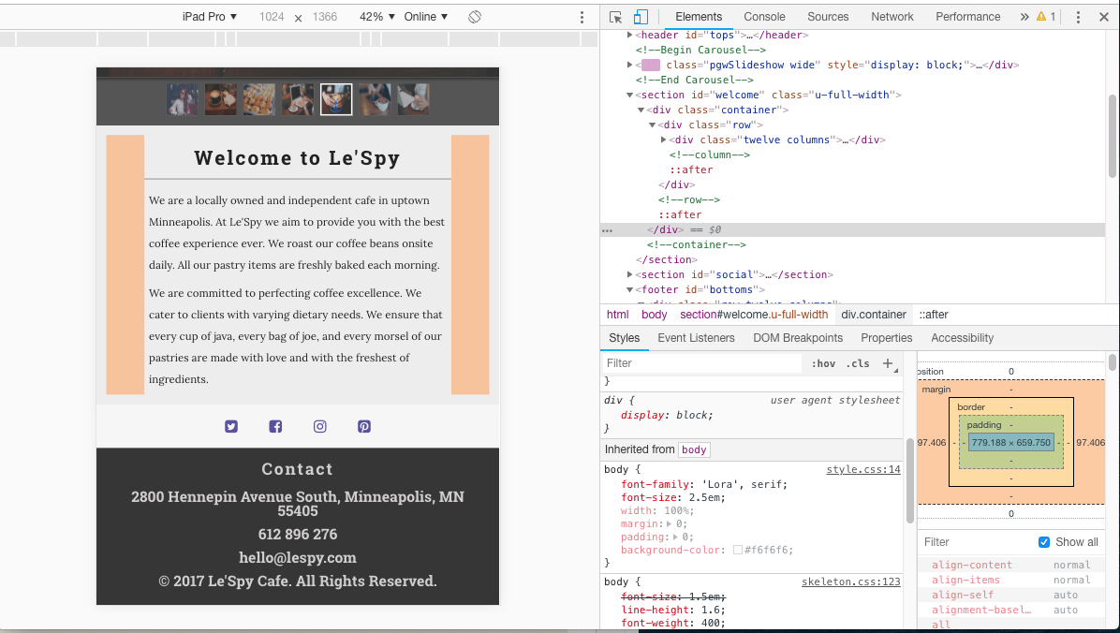

**On a Pixel 2**

The site looks good. No changes needed. However, I did play around with the carousel width a bit, but other than that, there was really no need to make any adjustments.