Deliverable Five

David Udofia

Rasmussen College

CDA3801C: Fundamentals of Mobile Web Application Development

Christopher Mattie

November 1, 2019

Author Note

This paper is being submitted on 11/01/19 for Professor Christopher Mattie CIS3801C: Fundamentals of Mobile Web Application Development Course

**Site Description**

The site I will be creating for this class is for a coffee shop called Le’Spy. Le’Spy is a coffee roaster and retailer based out of uptown Minneapolis. Le’Spy aims to cultivate relationships with its clientele, and share their passion of ethical coffee sourcing, roasting, and serving exceptional coffees.

**GitHub Repository**

<https://github.com/Dudofia/CIS3801C_FundOfWebApp>

**Azure Information**

The site has not been built yet, as this is the first module, so I don’t have a site URL to provide. However, the following URL shows my Hello World example, the second URL shows sample code in my project folder. Screenshots are below for each of the URL examples listed.

<http://paris.centralus.cloudapp.azure.com/>

<http://paris.centralus.cloudapp.azure.com/CIS3801C/index.html>

The first photo shows before, the second shows what happened after CSS changes are applied. What I did here was to adjust the font size, and to change the color of the menu to match the color in the logo.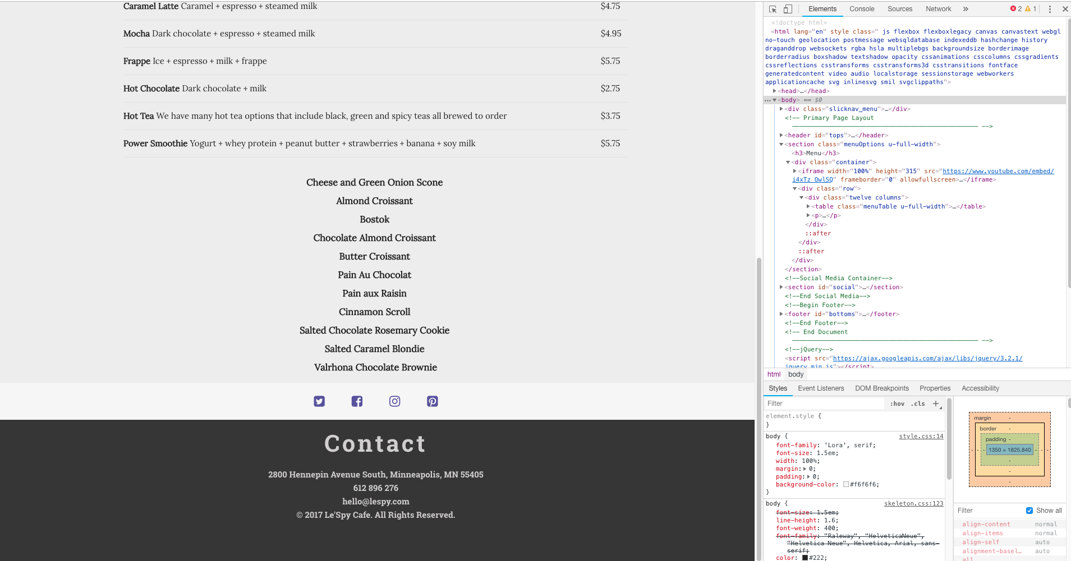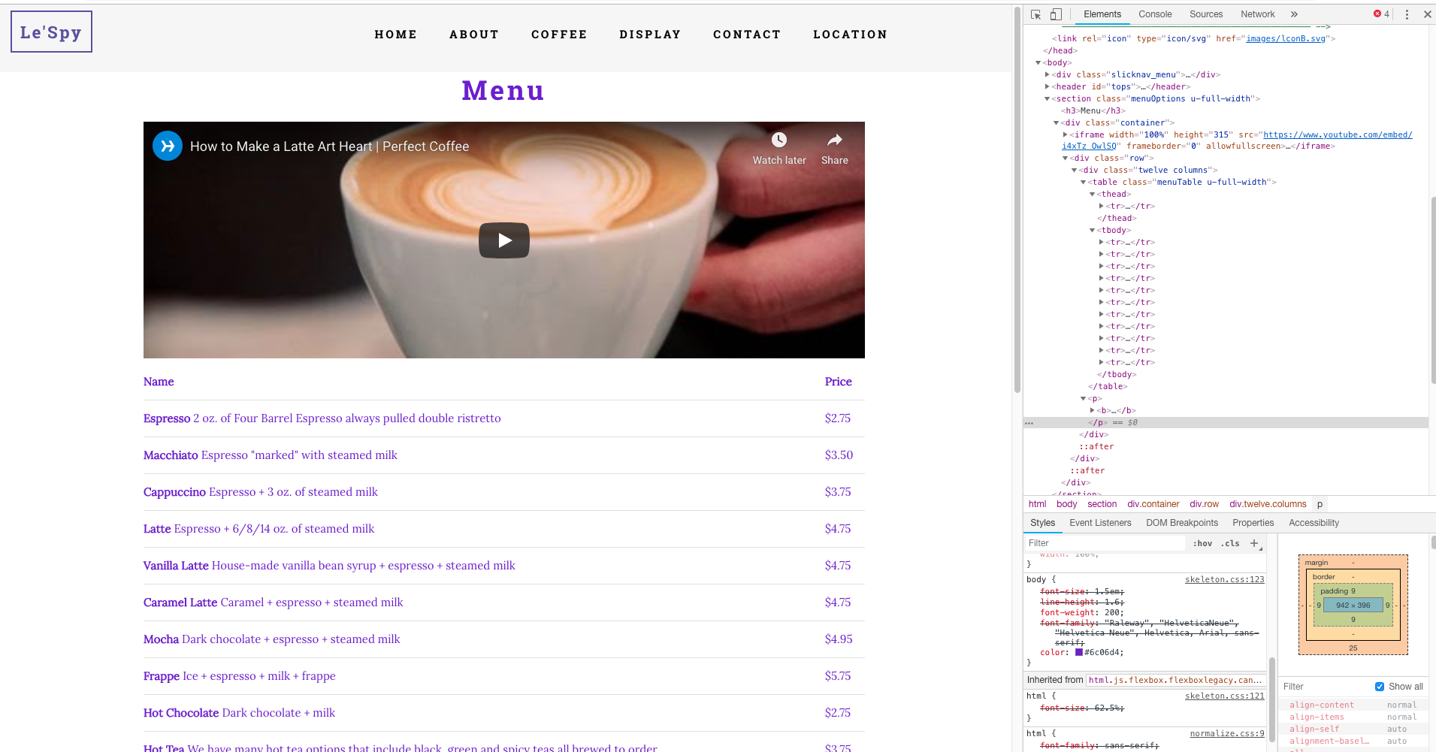

The first photo shows before, the second shows what happened after CSS changes are applied. The changes applied was to change the words in the button from submit to send, and then change the color of the button from blue to purple, as well as change the font color to black from white.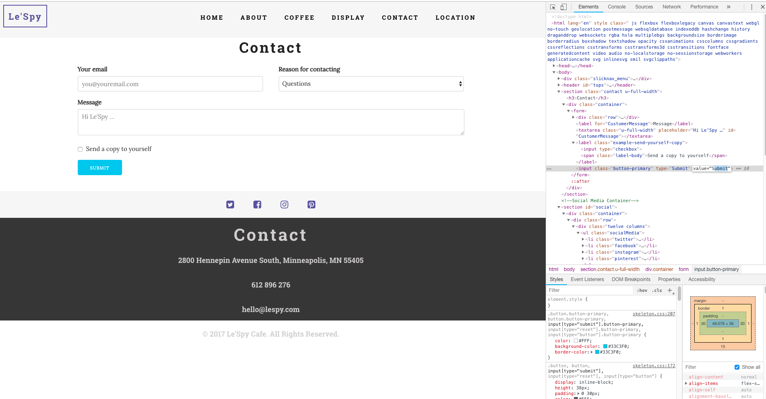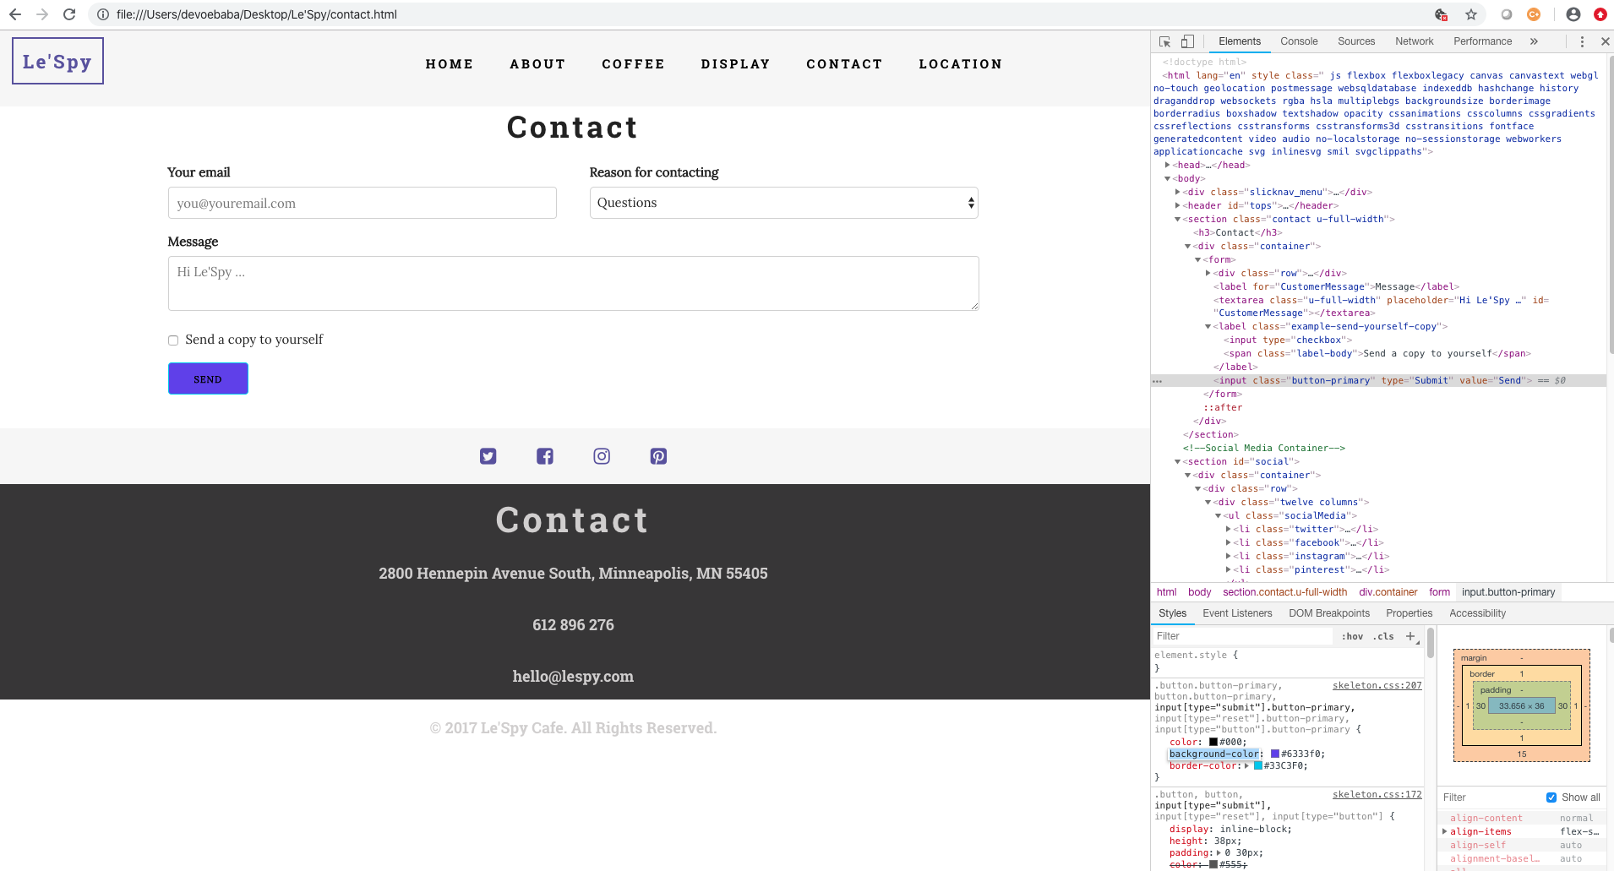

The first photo shows before, the second shows what happened after CSS changes are applied. For this third series, I was really just playing around with the CSS in the dev tools. I made a few changes to the font. I moved my footer text to the right from the center, and change the text fonts.