CHARACTER ART DIRECTION
LARA
Identity, appearance, clothing, and sprite consistency guide
STATUS  Approved | CANONICAL VIEW  South / front | BASE TEMPLATE  Female 128 x 128

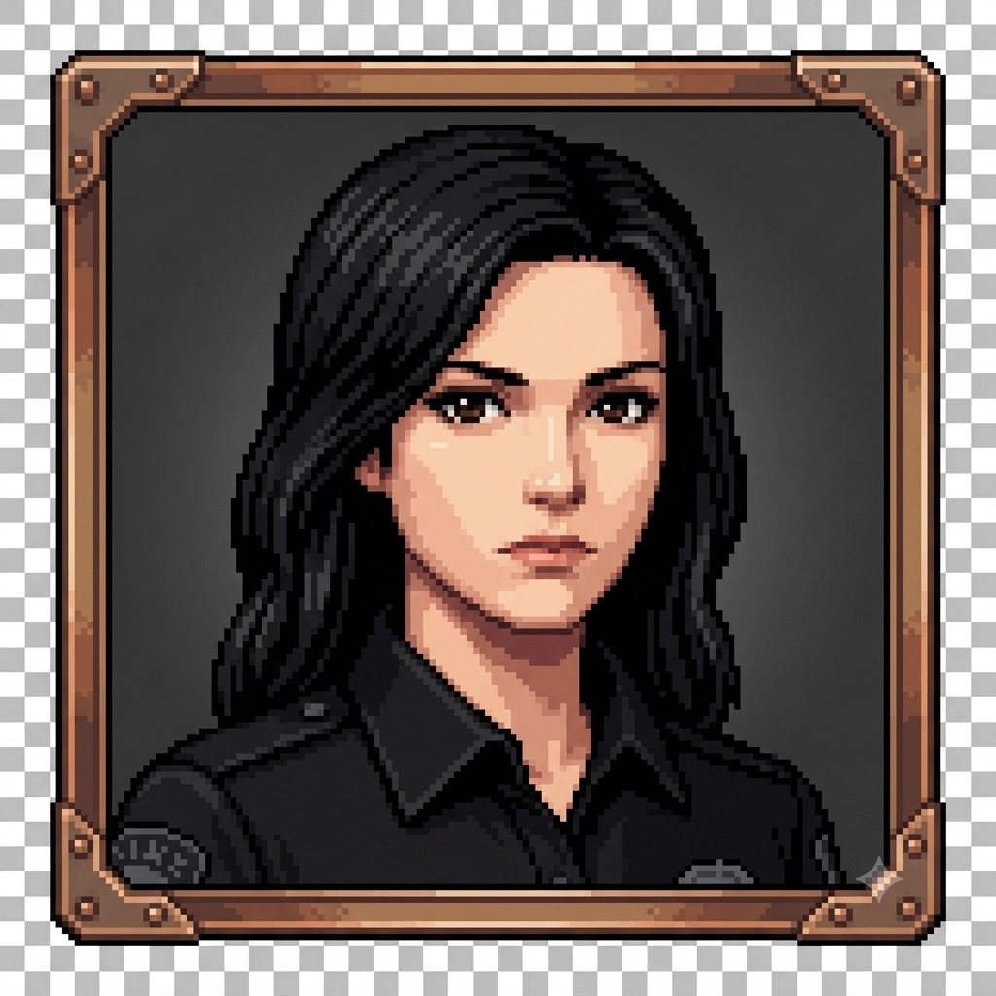 | 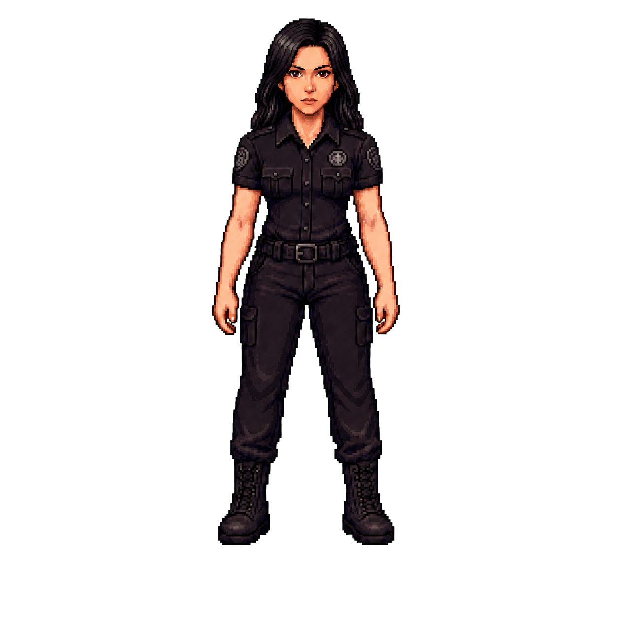
PORTRAIT IDENTITY REFERENCE | APPROVED SOUTH SPRITE - V4

Canonical default: Lara wears a black police uniform with no visible handgun and no handgun holster. This approved v4 sprite supersedes earlier holster experiments.

1. Core visual identity
Lara should read immediately as a composed police officer adapted to Outbreak's grounded survival setting. Her visual authority comes from posture, uniform structure, restrained insignia, and a direct gaze - not from oversized tactical equipment.
Visual read | Calm, serious, alert, self-possessed, and operationally capable.
Silhouette | Balanced female proportions from the approved female template; upright neutral stance with arms relaxed and feet set apart.
Canonical facing | True south/front view. Head, eyes, nose, and chin point straight toward the viewer.
Default equipment | Duty belt and compact utility pouches only. No handgun, no holster, and no weapon baked into the base sprite.

2. Facial characteristics
Face shape: Oval-to-tapered with a softly defined jaw and balanced chin.
Eyes: Dark brown, almond-shaped, level, and forward-looking. Keep the gaze centered in south-facing frames.
Brows: Dark, full, and cleanly defined with a restrained natural arch.
Nose: Straight and proportionate, with compact pixel highlights rather than a hard outline.
Mouth: Neutral closed lips with muted rose-brown color; avoid smiles or exaggerated sternness in the base state.
Skin: Warm light-to-medium complexion with peach highlights and muted reddish-brown shadow tones.

3. Hair
Color: Near-black with charcoal and cool gray highlights; never blue-black or glossy plastic black.
Style: Long, loose, straight-to-gently-wavy hair with an off-center side part and natural volume around the crown.
Length: Falls below the shoulders in the portrait and frames the upper torso in the sprite silhouette.
Directional behavior: Rotate the part, face-framing locks, and rear hair mass with the head while preserving overall length and volume.

4. Clothing and equipment

Police shirt
Black short-sleeve collared duty shirt with a structured but fitted silhouette.
Buttoned front and two symmetrical chest pockets with flap closures.
Subdued badge and shoulder-patch shapes; insignia should remain readable without bright colors or fine text.
Use dark charcoal highlights to separate seams, pockets, sleeves, and torso planes from the near-black base.

Duty belt and trousers
Black segmented duty belt with a centered rectangular metal buckle and compact belt modules.
No handgun holster on either hip in the approved default design.
No visible handgun or firearm. Weapon-specific art, if ever required, should be a separate explicit state rather than part of the base sprite.
Black duty trousers with a practical straight-to-tapered cut, subtle folds at the hips and knees, and compact rectangular outer-thigh utility pouches.

Boots
Black lace-up duty/combat boots with sturdy soles and restrained panel detail.
Boots establish the grounded footprint; keep their height, toe shape, and stance consistent across directions and animation frames.

5. Working palette
Use these sampled/working values as contrast anchors. Preserve their relationships when lighting or animation requires small adjustments.
SWATCH | ROLE | DIRECTION
#050308 | Hair / deepest outline | Near-black anchor
#0D0910 | Uniform shadow | Deep black-violet
#241920 | Uniform body | Warm charcoal
#2E2127 | Uniform highlight | Muted seam definition
#FDBB92 | Skin highlight | Warm peach
#E48A66 | Skin midtone | Warm coral-brown
#63372F | Skin shadow | Muted reddish brown

6. Directional sprite rules
Template fidelity: Use the female direction template for pose, proportions, stance, frame occupancy, and directional rotation.
Head alignment: South frames must remain truly front-facing. Side and diagonal views should rotate deliberately, without accidental three-quarter drift.
Hair continuity: Maintain the same part, length, and major highlight clusters as the head rotates. Rear views should emphasize the long dark hair mass without losing shoulder separation.
Uniform continuity: Keep collar, chest pockets, badge/patch placement, belt buckle, trousers, thigh pouches, and boots consistent from direction to direction.
Equipment rule: Do not introduce a handgun, holster, or new tactical gear in another direction unless a separate approved equipment state explicitly requires it.

7. Animation consistency
Keep Lara's body mass, shoulder width, head size, and leg length stable between frames.
Anchor the belt buckle and shirt center line to the torso; avoid lateral swimming during walk cycles.
Allow restrained secondary motion in the hair ends, but keep the part and face-framing locks recognizable.
Preserve boot contact and nearest-neighbor pixel edges; do not introduce soft scaling or motion blur.
Keep insignia readable as shapes, not flickering single-pixel noise.

8. Do / avoid
DO  Preserve her centered, direct gaze.  Use restrained charcoal highlights on black fabric.  Keep the silhouette practical and grounded.  Use subtle police identifiers without readable micro-text.  Validate every frame at 128 x 128 and in-game scale. | AVOID  Three-quarter drift in front-facing frames.  Blue/navy uniform substitutions or glossy fabric.  Exaggerated curves, oversized head, or bulky armor.  Hat, handgun, holster, or unapproved accessories.  Blurred resampling, antialiasing halos, or broken transparency.

9. Delivery checklist
128 x 128 RGBA PNG reference with genuinely transparent corners.
Nearest-neighbor presentation at runtime; no smoothing or filtering artifacts.
Character remains fully inside the frame with consistent foot placement and padding.
No unintended weapon, holster, added prop, broken patch, or missing pouch.
Face, hair, uniform, palette, and silhouette match the approved v4 south reference.
Source of truth: Approved reference: assets/sprites/lara/reference/lara_reference_south_v4.png. High-resolution transparent source: assets/sprites/lara/source/lara_south_transparent_v4.png.

